Supplementary Information for

A Kirigami-enabled Electrochromic Wearable Variable Emittance (WeaVE) Device for Energy-Efficient Adaptive Personal Thermoregulation

Ting-Hsuan Chen^{†1}, Yaoye Hong^{†2}, Ching-Tai Fu^{1,3}, Ankita Nandi^{1,4}, Wanrong Xie¹, Yin Jie^{2*}, Po-Chun Hsu^{1*}
Department of Mechanical and Aerospace
Engineering, North Carolina State University, Raleigh, NC 27695, USA.
¹Thomas Lord Department of Mechanical Engineering and Materials Science, Duke University, Durham, North Carolina 27708, United States
²Department of Mechanical and Aerospace Engineering, North Carolina State University, Raleigh, NC 27695, USA
³Ming Hsieh Department of Electrical and Computer Engineering, University of Southern California, Los Angeles, California 90089, United States
⁴Department of Applied Physics and Materials Science, California Institute of Technology, Pasadena, CA 91125, USA
† These authors contributed equally to this work.
*Corresponding author email: jyin8@ncsu.edu, pochun.hsu@duke.edu

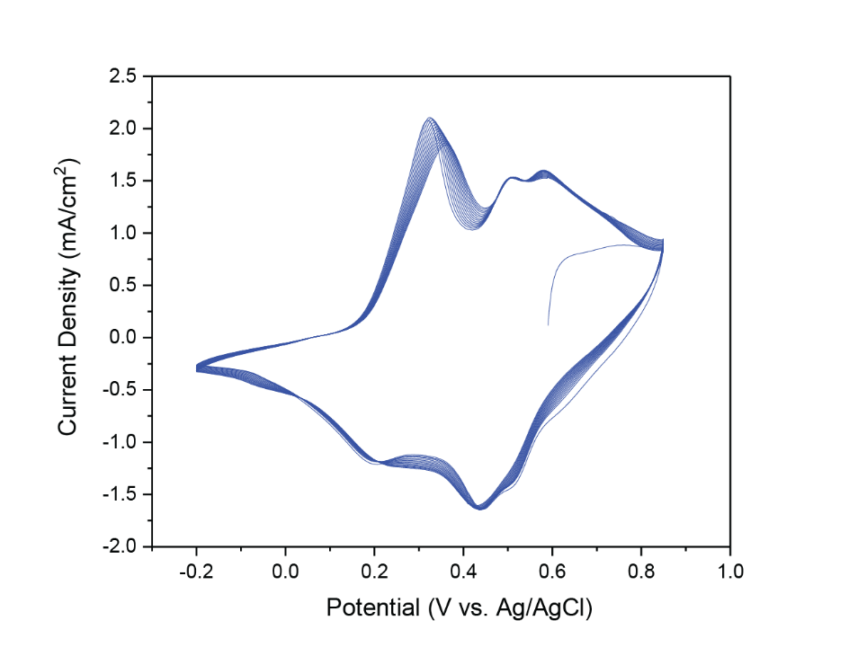
Fig. S1. Cyclic voltammogram of a WeaVE device electrode. The CV were scanned at 5 mV/s for 10 cycles continuously from -0.2 V to 0.85 V, using Ag/AgCl(3M NaCl) reference electrode. The anodic scan shows the presence of three oxidation peaks at 0.3V (leucoemeraldine, LE) to radical cationic polaron, 0.5V (oxidation of intermediate species) and 0.6V (polaronic to bipolaronic emeraldine salt, ES). The dark green color of ES is observed when the anodic scan is performed.

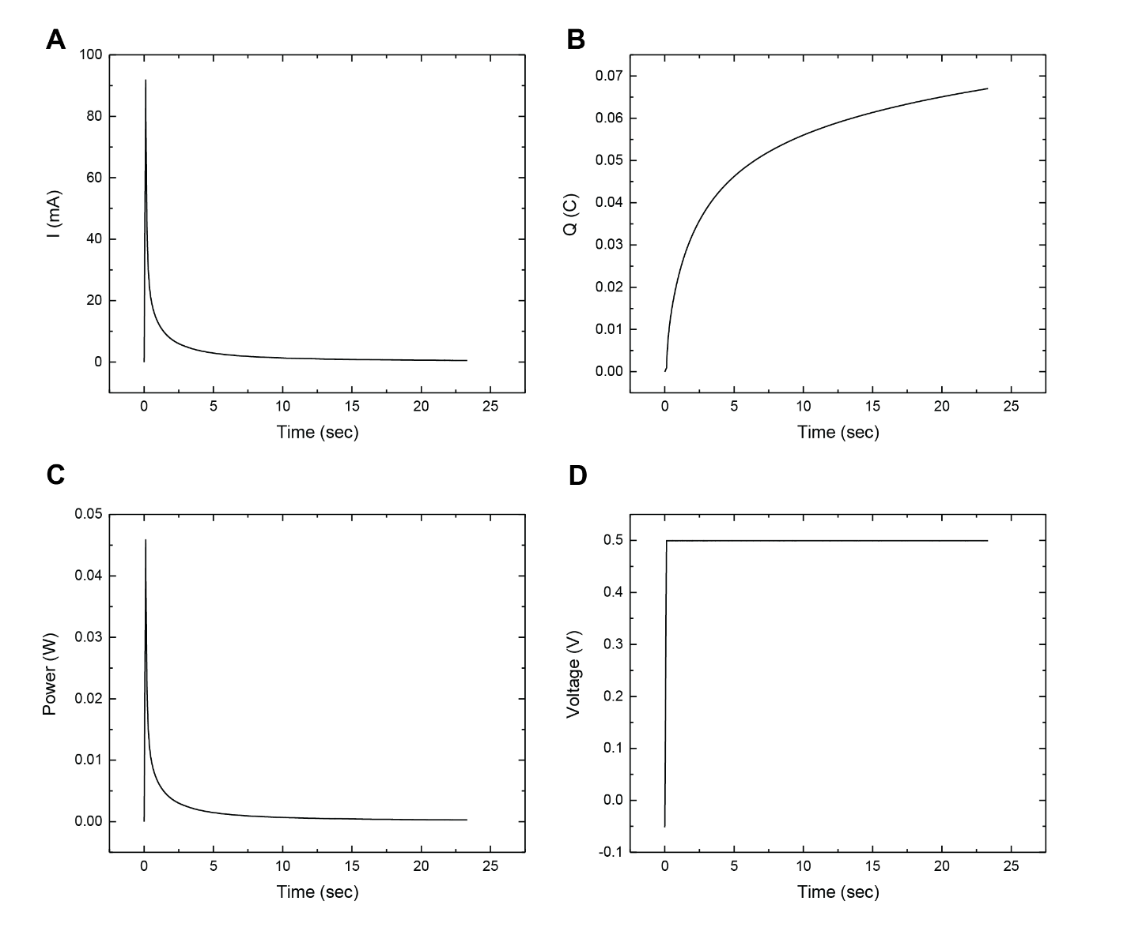
Fig. S2. Area energy density of WeaVE in a single switching process. (A) current, (B) charge (C) power and (D) voltage of working electrode vs. time. By multiplying the amount of charge and voltage applied, divided by the area of WeaVE, 6 cm², the area energy density is 0.067 C × 0.5 V / 6 cm² = 5.58 mJ/cm².
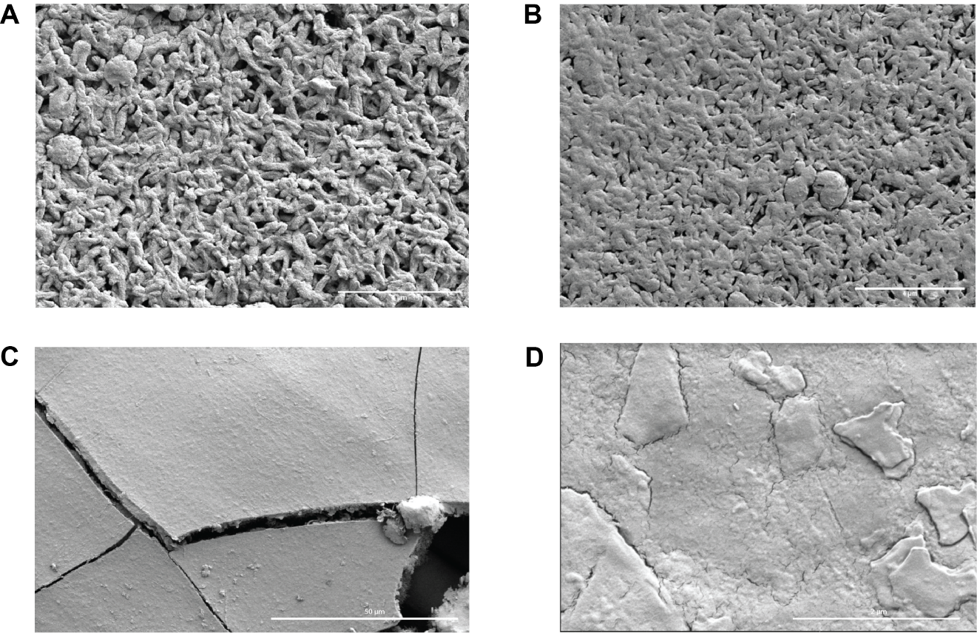
Fig. S3. SEM images of Au-sputtered (A) pristine and (B) roller-pressed nanoporous nylon substrate. Randomly distributed porous network structure with similar pore size can be observed on both samples, while the roller-pressed Au/nylon has a squeezed and smoother surface with smaller pores. (C-D) Morphology of electrodeposited PANI thin film on Au/nylon at different magnification under SEM. At a lower magnification, PANI film surface is compact, uniform and smooth. Minor cracks and roughness are presented on the film at the micrometer level.

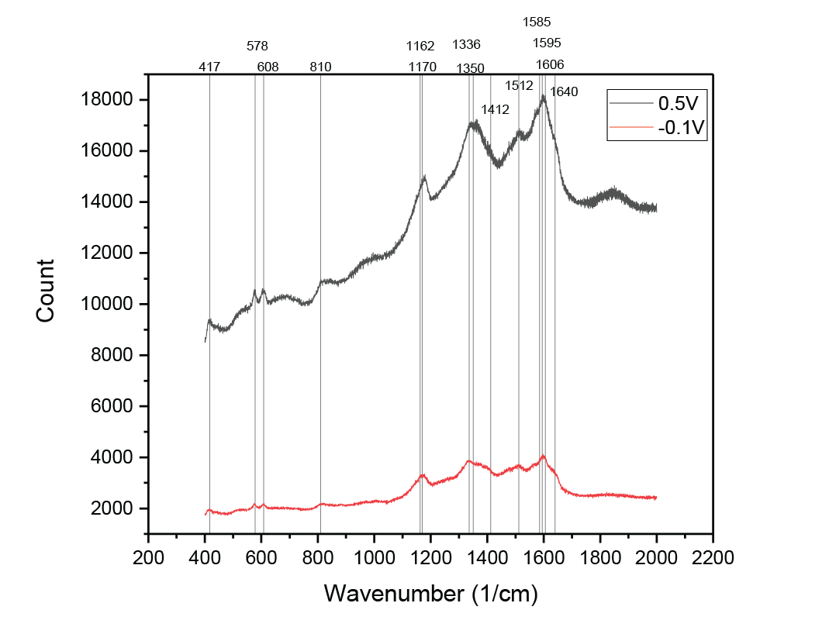
Fig. S4. Raman spectroscopy of emeraldine salt and leucoemeraldine. First, the peaks at 410, 578 and 608 correspond to the out-of-plane ring deformation, benzene ring deformation, and 𝜈(C–S)/SO₂, which is stronger in emeraldine salt due to its doping nature. The peaks at 810, 1162/1170, 1336/1350, 1512, and 1585/1595/1606 cm⁻¹ are assigned to the out of plane C-H motions, in-plane bending of C-H in semi-quinoid units, C-N stretching, N–H bending in semiquinoid rings, and C=C stretching in the semiquinoid rings, respectively. Quinoid and semiquinoid ring peaks are also stronger in emeraldine salt, but their presence in leucoemeraldine form suggests the incomplete reduction in PANI.
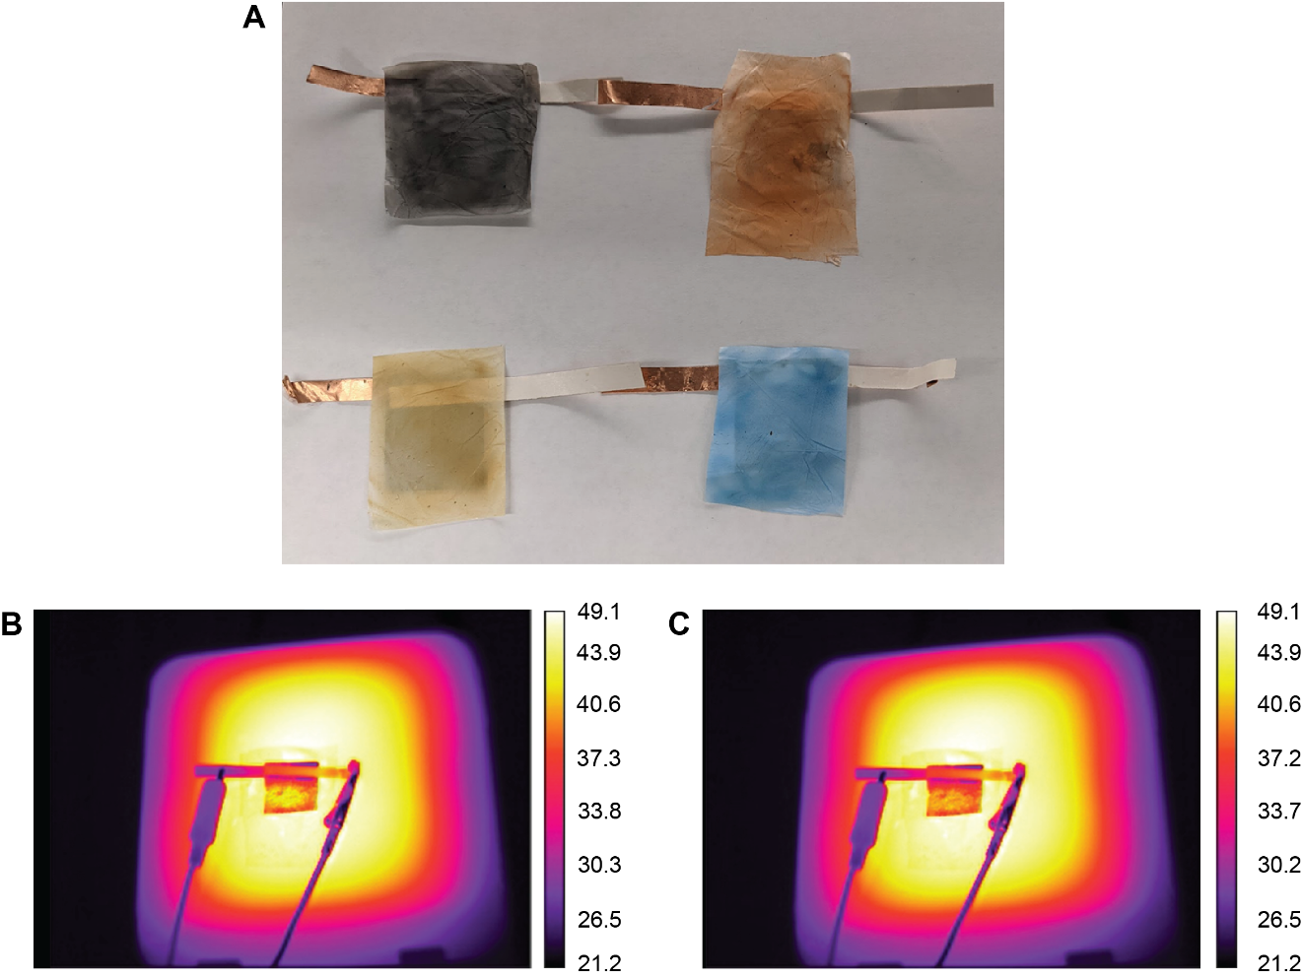
Fig. S5 (A) Optical image and thermal images of (B) high-e (cooling) and (C) low-e (heating) state of pigment-decorated WeaVE. This shows WeaVE is also functional with a colored IR-transmissive PE film covered on the top. The color is applied by spraying different nanoparticles on nanoporous PE.

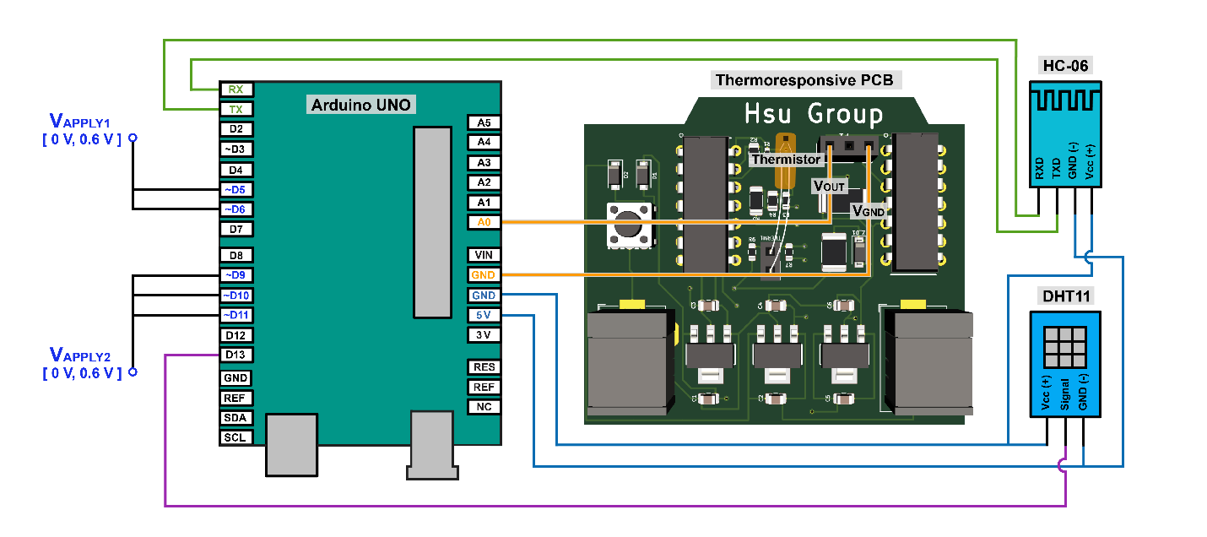
Fig. S6 Circuitry of the autonomous personal thermal management system. Arduino Uno, Thermoresponsive PCB, HC-06 Bluetooth module, and DHT11 are connected to construct the device. V_{out} and GND of the Thermoresponsive PCB are connected to A0 and GND pin of the Arduino Uno, respectively. HC-06 Bluetooth module’s VCC (+5 V), GND, TXD, and RXD pins are connected to 5 V, GND, RX, and TX pin of Arduino Uno, respectively. VCC (+5 V), GND, and Signal pin of DHT11 are connected to 5 V, GND, and #13 Digital pin of the Arduino, respectively. Digital pins #5 and #6 are connected in parallel (represented by V_{APPLY}1), and, similarly, Digital pins #9, #10, and #11 are also connected in parallel (represented by VAPPLY2), both of which are then connected to WeaVE.
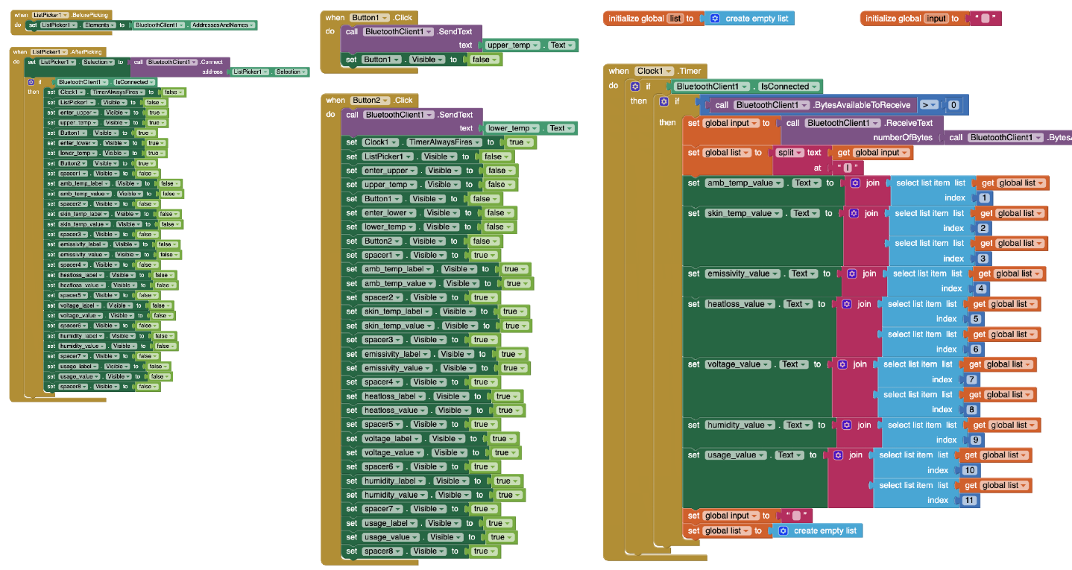
Fig. S7. Mobile App for the Autonomous Personal Thermal Management System. Placement of the MIT App Inventor logic blocks to function the mobile app. The mobile app consists of connecting to the Bluetooth client, transmitting the desired set points of upper and lower temperature tolerances to Arduino, and receiving thermal statuses of ambient temperature, skin temperature, WeaVE emissivity, estimated heat loss, applied voltage, relative humidity, and usage time that are displayed on the mobile app.

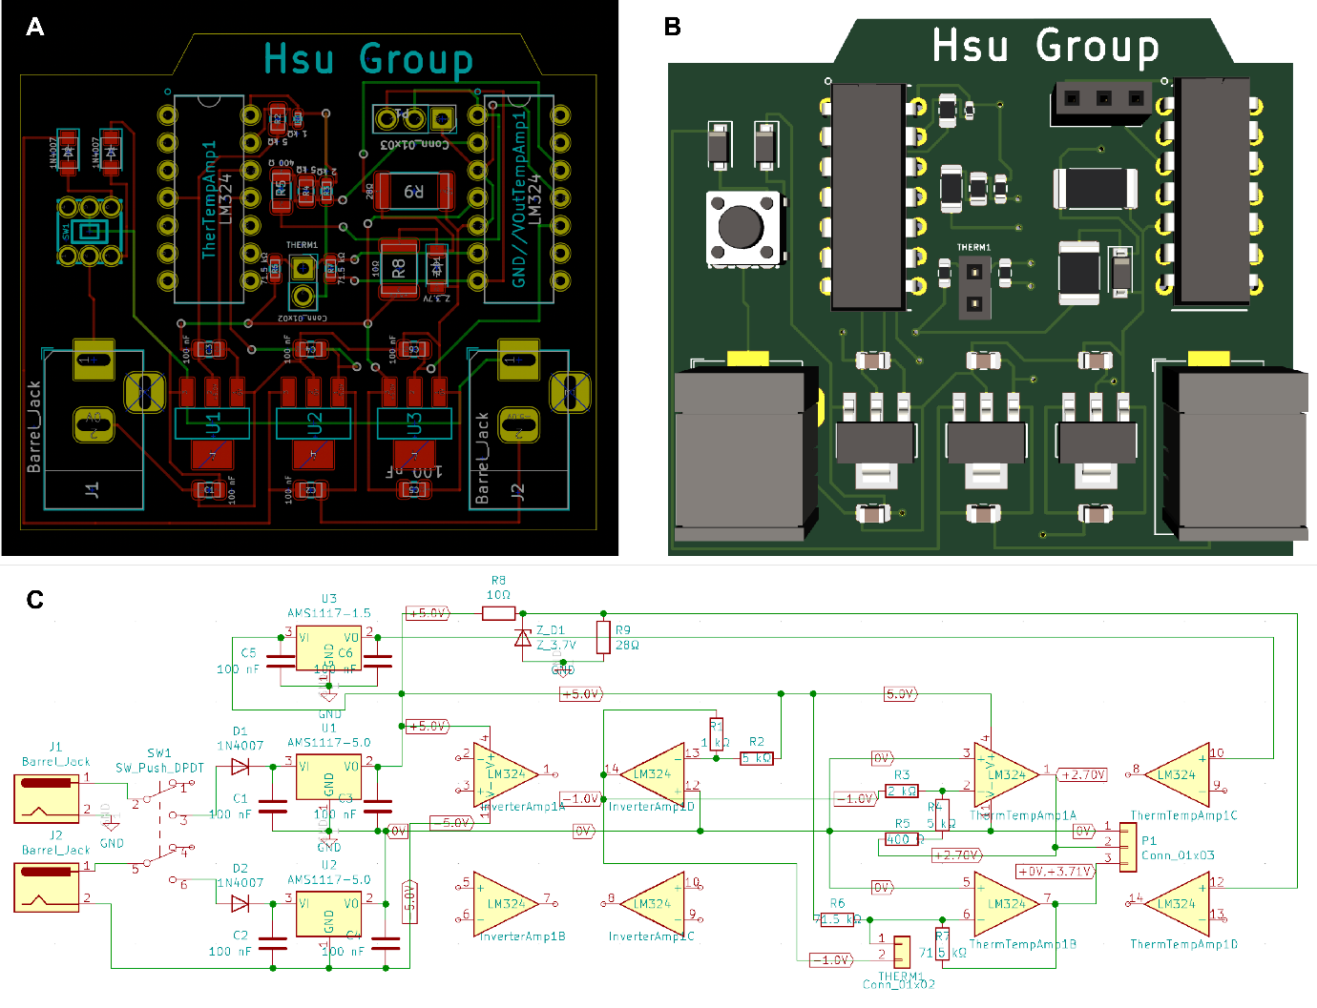Fig. S8. (A) Printed circuit board layout, (B) 3D schematic with placed components, and (C) circuitry of the thermoresponsive PCB. The LM324 on the left serves an inverter that outputs a voltage of -1 V with one of its operational amplifiers. The -1 V then passes through the thermistor and enters the inverting input of an operational amplifier of the other LM324 to output a positive voltage. Detailed calculations regarding circuitry calculations are further discussed in Figure S3. Two AMS1117 voltage regulators of 5 V are powered by individual 9 V batteries, providing voltages of +/-5 V when connected in series. The 1.5 V AMS1117 voltage regulator is powered by the battery supplying the +5 V AMS1117 voltage regulator. A 3.7 V Zener diode is employed for a desired 3.7 V output. Similarly, one of the operational amplifiers is set to output 2.7 V. These discrete voltages of 3.7 V, 2.7 V, and 1.5 V are designed to increase functionality and can be soldered to other operational amplifiers if necessary. Designed Thermoresponsive PCB are manufactured by JLCPCB.
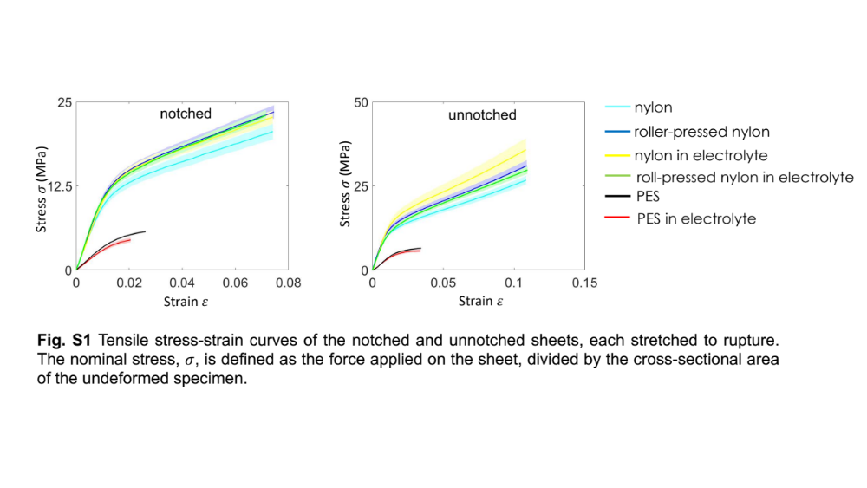
Fig. S9 Tensile stress-strain curves of the notched and unnotched sheets, each stretched to rupture. The nominal stress, σ, is defined as the force applied on the sheet, divided by the cross-sectional area of the undeformed specimen.

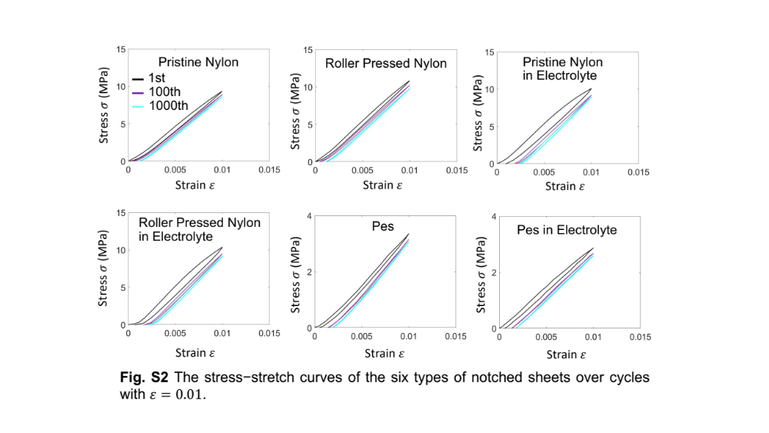

Fig. S10. The stress-stretch curves of the six types of notched sheets over cycles with ε = 0.01

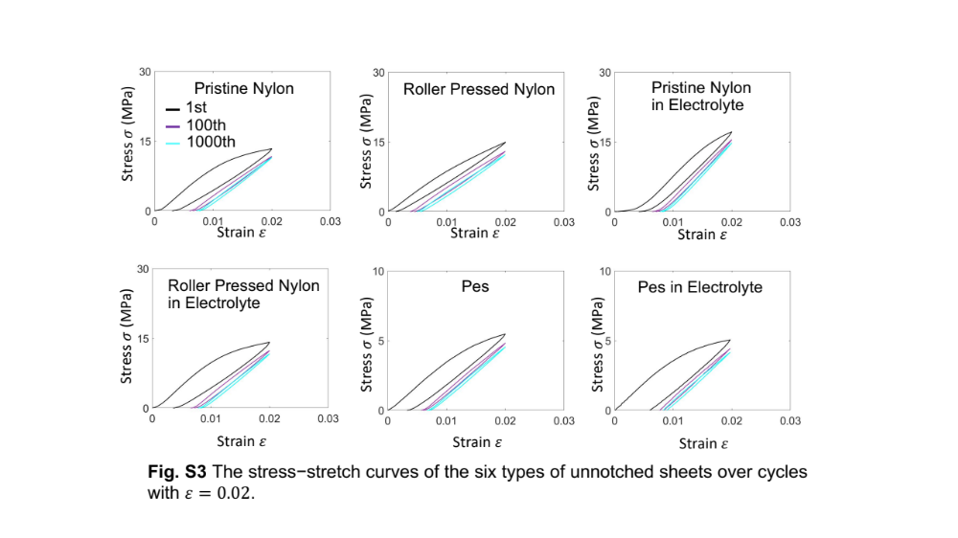
Fig. S11. The stress-stretch curves of the six types of notched sheets over cycles with ε = 0.02

