Supplementary information
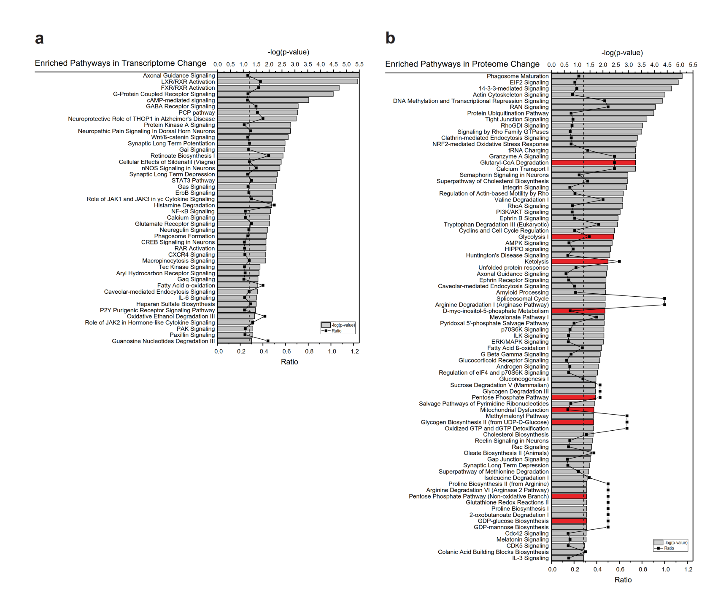
Figure S1.
a, b Differentially expressed canonical pathways identified by Ingenuity Pathway Analysis of the RNA-seq data¹⁴ and quantitative proteomics data. “Canonical pathways” are defined by a cluster of related signature genes, which constitutes the ratio’s denominator. The numerator is the number of signature genes that were significantly changed in the transcriptomics or proteomics data set. P-value is the probability that the ratio occurred by chance.

Table S1
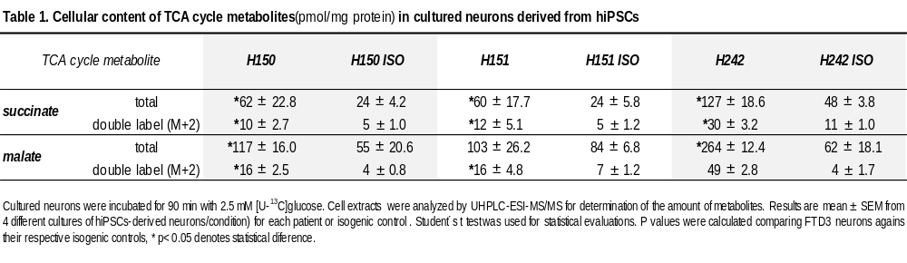

Supplementary methods
Quantitative determination of TCA cycle metabolite amounts and [¹³C] labeled metabolite isotopologues by UHPLC-ESI-MS/MS.

The quantification of the total amounts of succinate and malate was performed employing a Bruker Advance UHPLC system coupled to ESI-MS/MS (EVOQTQMS) for chromatographic separation, fragmentation and quantification as described in Larsen (Larsen, T.M. and Stürup, S. 2019. Development of an UHPLC-ESI-MS/MS method for simultaneous quantification of isotope labeled metabolites and investigation of their fragmentation patterns, University of Copenhagen, Denmark) The column used to separate the analytes was a Phenomenex Luna® Omega, 1.6 µm Polar C18, 100 x 2.1 mm thermostated at 30 ºC with a Phenomenex SecurityGuardTM ULTRA Cartridge precolumn. For separation, a mobile phase consisting of 15 mM glacial acetic acid in water and a mobile phase B of pure methanol were employed. The following gradient elution was applied: 0-5 min; 2 % B flow rate 300 µL/min, 6-8 min; 100 % B flow rate 400 µL/min, 9-11 min; 2 % B flow rate 300µL/min. Quantification of isotopologues in samples was performed with Single Ion Monitoring (SIM) scan whereas the fragmentation by tandem mass spectrometry (MS/MS) was performed with product ion scan. Matrix mathematics was used to calculate the abundance/quantity of each isotopologue from the data obtained from the MS analysis. Only two intermediates, succinate and malate, were detected due to the detection limit of the UHPLC-ESI-MS/MS system.

