Supporting information

Facile synthesis of activated carbon derived from rice husk and jatropha shell, characterization and its application in the enhanced adsorption of Cu²⁺ and Fe²⁺ in aqueous solution
Abia Daouda^{1,2,*}, Tinda Domga^{3,4}, Domga Richard³, Jacob Koyang ¹, Noumi Guy Bertrand¹, Harouna Massai^{1,2}
¹Department of Chemistry, Faculty of Science, The University of Ngaoundere, PO Box 454, Ngaoundere, Cameroon
²Chemical Engineering and Mineral Industries School, EGCIM, The University of Ngaoundere, PO Box 454, Ngaoundere, Cameroon
³Department of Applied Chemistry, ENSAI, The University of Ngaoundere, PO Box 454, Ngaoundere, Cameroon
⁴Process Engineering Division, CSIR-Central Electrochemical Reaserch Institute, Karaikudi, Tamil Nadu, 630003, India

2. Experimental
2.1 Materials
Rice husk (RH) and Jatropha Curcas shell (JS) were selected as the precursors for the synthesis of activated carbon and were collected in the district of Bourha, Mayo-Tsanaga division, Far-North region of Cameroon. CuCl₂.2H₂O (97%), FeSO₄.7H₂O (98%), Na₂S₂SO₃ (98%), H₂SO₄ (98%), I₂ (99.5%), H₃PO₄ (85 %) and CH₃COONa.3H₂O (99%) were obtained from Riedel-de-Haen. C₅H₁₂O₅ (99%) was purchased from Fischer. In this study, all reagents were analytical grade and the solutions required for experiments were prepared using distilled water.
2.4 Physicochemical characterization
A powder X-ray diffraction (XRD) measurement has been utilized to assess the phase purity and lattice space of the samples using Bruker D8 Advance X-ray Diffractometer in the 2θ range from 10 to 70°. Fourier Transform infrared (FT-IR), Bruker spectrometer (Model no TENSOR 27) has been used to determine the functional groups located in RH, JS, RH-Ac and JS-Ac. Mixture of potassium bromide (KBr) and sample have been used to make the pellet and the analysis were performed in the range from 400 to 4000 cm⁻¹. Laser Raman microscope (633 nm wavelength) has been used to determine the disorder/defects band in the samples using LabRam HR, Horiba. The spectra were recorded in the range from 1000 to 3000 cm⁻¹. Scanning electron microscopy (SEM) analysis has been used to determine the morphology and structure of the RH, JS, RH-Ac and JS-Ac using Tescan Vaga 3 microscope (accelerating voltage of 0.3-30 kV). The elemental composition of RH, JS, RH-Ac and JS-Ac was analyzed by X-ray photoelectron spectroscopy (XPS) using Escalab 250Xi model.
2.5 Adsorption study
Batch mode adsorption experiments of Cu²⁺ and Fe²⁺ on RH-Ac or JS-Ac were conducted. The study was assessed by mixing adsorbents (0.1 g of RH-Ac or JS-Ac) with Cu²⁺ or Fe²⁺ solutions (100 mL) of desired concentration and sealed followed by agitation for 120 minutes at room temperature. Afterward, suspended solid was filtered and the filtrate was analyzed using UV-visible spectrophotometer (CORNING) at wavelength of 600 or 510 nm for Cu²⁺ or Fe²⁺ solution, respectively. In this study, the suitable pH of the solution was adjusted with HCl (0.1 mol L⁻¹) or KOH (0.1 mol L⁻¹). The adsorption isotherms were studied as the initial concentration of Cu²⁺ and Fe²⁺ started from 0 to 150 mg.L⁻¹. Some others factors effecting adsorption including contact time (15 - 135 min), adsorbent dosage (0.1 - 0.6 g) and pH (2 –9), were studied. The amount of pollutant (Cu²⁺ and Fe²⁺) adsorbed per gram of adsorbent (RH-Ac or JS-Ac) at equilibrium, q_{e} is calculated as follow (Maguana et al. 2019):
q_{e} $=\frac{Co-Ce}{m}V$ (1)
Where C_{o}(mg L⁻¹) refers to the initial concentration of Cu²⁺ or Fe²⁺, C_{e} represent the concentration of Cu²⁺ or Fe²⁺ in the solution at equilibrium (mg. L⁻¹), V represent the volume of Cu²⁺ or Fe²⁺ solution (L) and m(g) refers to the mass of adsorbent .
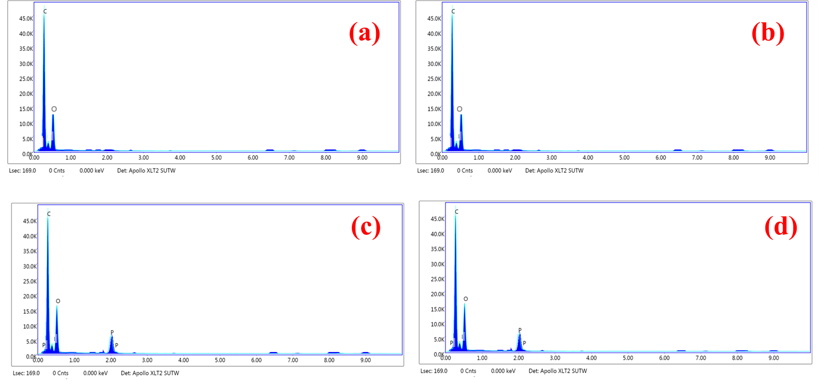
Figure S1: EDX spectrum of (a) RH, (b) JS, (c) RH-Ac and (d) JS-Ac

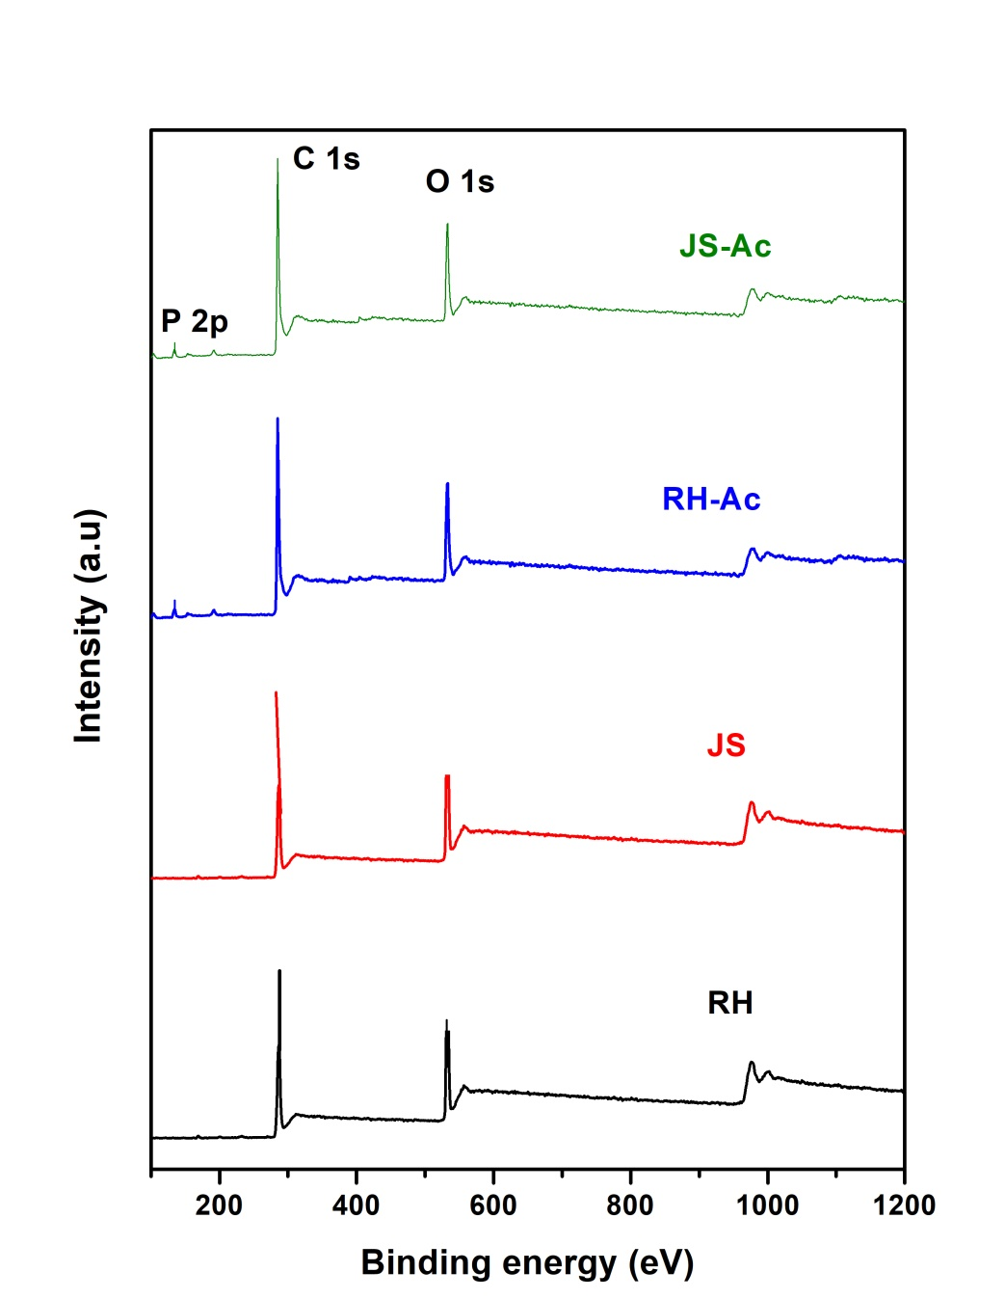
Figure S2: XPS spectrum survey of RH, JS, RH-Ac and JS-Ac

Table S1. Elemental composition of different activated carbon
 | Atomic % of element
Element | RH | JS | RH-Ac | JS-Ac
C K | 91.51 | 89.83 | 79.42 | 75.36
O K | 8.49 | 10.17 | 19.62 | 23.44
P K | - | - | 1.11 | 1.20

Table S2. Fe (II) and Cu (II) adsorption capacity and its comparison with the literature data
Adsorbent | Activation agents | ions | Adsorption capacity (mg/g) | References
Rice hush | H₃PO₄ | Fe (II) | 25.431 mg/g | This study
Rice hush | H₃PO₄ | Cu (II) | 22.773 mg/g | This study
Jatropha shell | H₃PO₄ | Fe (II) | 32.458 mg/g | This study
Jatropha shell | H₃PO₄ | Cu (II) | 56.179 mg/g | This study
Malawian baobab fruit shells | H₃PO₄ | Cu (II) | 3.0833 | (Vunain, Kenneth, and Biswick 2017)
Pine sawdust | H₃PO₄ | Cu (II) |  | (Peng et al. 2017)
corncobs | H₃PO₄ |  | 105.8 mg/g | (Moussa, Ali, and Sheha 2021)
lemon peel waste | NaOH | Fe (II) | 4.40 mg/g | (Meseldžija et al. 2020)
chitosan | (C₃H₄O₂)_{n} | Cu (II) | 201.79 | (Hao and Liang 2020)
Pecan Shell |  | Fe (II) | 41.66 | (Kaveeshwar et al. 2018)
wood | - | Fe (II) | 38.57 | (Kouakou et al. 2013)
White Lupine Husk | NaOH | Fe (II) | 9.81 | (Ketsela, Animen, and Talema 2020)
Xanthoceras Sorbifolia Bunge hull | H₃PO₄ | Fe (II) | 241.13 | (Zhang et al. 2017)
Limonia acidissima shell | H₃PO₄ | Fe (II) | 48.5 mg/g | (Das and Mishra 2020)

Das, Shilpi and Susmita Mishra. 2020. “Insight into the Isotherm Modelling , Kinetic and Thermodynamic Exploration of Iron Adsorption from Aqueous Media by Activated Carbon Developed from Limonia Acidissima Shell.” Materials Chemistry and Physics 245:1–20.
Hao, Dongliang and Yali Liang. 2020. “Adsorption of Cu 2+ , Cd2+ and Pb2+ in Wastewater by Modified Chitosan Hydrogel.” Environmental Technology 0(0):1–18.
Kaveeshwar, Aditya Rajeev, SenthilKumar Ponnusamy, Emmanuel D. Revellame, Daniel D. Gang, E. Zappi, and Ramalingam Subramaniam. 2018. “Pecan Shell Based Activated Carbon for Removal of Iron (II) from Fracking Wastewater: Adsorption Kinetics, Isotherm and Thermodynamic Studies.” Process Safety and Environmental Protection 114:107–22.
Ketsela, Getasew, Zenaw Animen, and Alemu Talema. 2020. “Adsorption of Lead ( II ), Cobalt ( II ) and Iron ( II ) From Aqueous Solution by Activated Carbon Prepared From White Lupine ( GIBITO ) HSUK.” Journal of Thermodynamics and Catalysis 11(2):1–8.
Kouakou, Urbain, Aimé Serge Ello, Jacques Aboua Yapo, and Albert Trokourey. 2013. “Adsorption of Iron and Zinc on Commercial Activated Carbon.” Journal of Environmental Chemistry and Ecotoxicology 5:168–71.
Maguana, Y. El, N. Elhadiri, M. Bouchdoug, M. Benchanaa, and A. Jaouad. 2019. “Activated Carbon from Prickly Pear Seed Cake : Optimization of Preparation Conditions Using Experimental Design and Its Application in Dye Removal.” International Journal of Chemical Engineering 2019:1–12.
Meseldžija, SLAĐANA, JELENA Petrović, ANTONIJE Onjia, TATJANA Volkov-husović, ALEKSANDRA Nešić, and NIKOLA Vukelić. 2020. “Removal of Fe2+, Zn2+ and Mn2+ from the Mining Wastewater by Lemon Peel Waste.” Journal of the Serbian Chemical Society 85(10):1371–82.
Moussa, S. I., M. M. S. Ali, and Reda R. Sheha. 2021. “The Performance of Activated Carbon / NiFe2O4 Magnetic Composite to Retain Heavy Metal Ions from Aqueous Solution.” Chinese Journal of Chemical Engineering 29:135–45.
Peng, Hongbo, Peng Gao, Gang Chu, Bo Pan, Jinhui Peng, and Baoshan Xing. 2017. “Enhanced Adsorption of Cu(II) and Cd(II) by Phosphoric Acid-Modified Biochars.” Environmental Pollution 1–8.
Vunain, Ephraim, Davie Kenneth, and Timothy Biswick. 2017. “Synthesis and Characterization of Low-Cost Activated Carbon Prepared from Malawian Baobab Fruit Shells by H3PO4 Activation for Removal of Cu (II) Ions : Equilibrium and Kinetics Studies.” Applied Water Science 7(8):4301–19.
Zhang, Xiaotao, Yinan Hao, Ximing Wang, and Zhangjing Chen. 2017. “Adsorption of Iron (III), Cobalt (II), and Nickel (II) on Activated Carbon Derived from Xanthoceras Sorbifolia Bunge Hull : Mechanisms , Kinetics and in Fl Uencing Parameters.” Water Science and Technology 75(8):1849–61.

