Supplementary Methods.

Plasmids
The pUCM-AAVS1-TO-hNGN2 construct, which was used to generate cortical neurons, was a gift from Michael Ward (Addgene plasmid #105840; http://n2t.net/addgene:105840 ; RRID:Addgene_105840). The pRR-EF1a-Puro is based on the pRR-Puro plasmid (Flemr and Buhler, 2015) and was ordered by gene synthesis (General Biosystems). The pRR-EF1a-Puro-PLCγ2_P522R plasmid was generated by annealing two oligonucleotides (supplementary Table2) containing the CRISPR target site followed by cloning in SalI and SpeI digested pRR-EF1a-Puro. The PLCγ2-P522R exchange matrix (template) was custom designed and synthesised (GeneArt, ThermoFisher), containing homology arms of 650bp upstream and downstream of the P522R conversion site. The PLCγ2^{WT} overexpression construct pCMV6-PLCG2-Myc-DDK was purchased from Origene (RC200442). The PLCγ2^{P522R} overexpression construct was generated using pCMV6-PLCG2-Myc-DDK, mutagenesis primers (supplementary Table2) and the Q5 site directed mutagenesis kit (E0554S, NEB), followed by transformation in DH5α chemically competent cells (ThermoFisher). The PLCγ2 control cDNA was designed with a frameshift mutation that disrupts the open reading frame followed by gene synthesis (TwistBioscience).

Flemr, M., and Buhler, M. (2015). Single-Step Generation of Conditional Knockout Mouse Embryonic Stem Cells. Cell Rep 12, 709-716. 10.1016/j.celrep.2015.06.051.

Supplementary Table 1: List of sequencing and cloning primers

GENE | FWD | REV
PLCG2 (Outside HA-sequencing primers) | AAAGGGGGATGTGCTGCAAGGC | GCTGTTTCCTTGCGTATTGGGCG
PLCG2 (Inside HA – sequencing primers) | CCTCATGGCTCTCAGACTTC | CTAGAAGAGCTAGACAAATGAAGC
PLCG2 (Over-expression plasmid – sequencing primers) | CGACGTCGTGCAGGCCATCAAA | TAGGAGTCGCTCCCCTCTCGCT
PLCG2-P522R (Mutagenesis Primers) | CAGGATATACgCCCTACAGAACTAC | GGGCACTTCCTCCTCCAT
PRR-Puro-PLCG2 primers | TCGACCCCCTACAGAACTACATT  TTGGGGATGCAAAGCGTGATGA | CTAGTCATCACGCTTTGCATCCC  CAAAATGTAGTTCTGTAGGGGG
(pRR-EF1a-Puro-[R495X]) | TCGACCCCCTACAGAACTACATT  TTGGGGATGCAAAGCGTGATGA | CTAGTCATCACGCTTTGCATCCC  CAAAATGTAGTTCTGTAGGGGG

Supplementary Table 2: List of primary and secondary antibodies

Antibody | Host | Reference number | Manufacturer | Dilution
Anti PLCG2 | Mouse | sc-5283 | Santacruz | WB 1:1000 | ICC 1:200
Anti TOMM20 | Rabbit | ab186735 | Abcam | WB 1:1000
Anti-Iba1 | Rabbit | 019-19741 | Waco |  | ICC 1:500
Anti TMEM119 | Rabbit | ab185333 | Abcam |  | ICC 1:200
MAP2 | Chicken | ab92434 | Abcam |  | ICC 1:2000
PSD95 | Mouse | MA1-045 | ThermoFisher |  | ICC 1:200
Hoechst |  | 62249 | ThermoFisher |  | ICC 1:12000
Anti B-Actin | Mouse | ab8226 | Abcam | WB 1:10000
Anti B-Actin | Rabbit | ab8227 | Abcam | WB 1:10000
Anti-Mouse-680 | Goat | 926-68070 | LICOR | WB 1:10000
Anti-Rabbit-680 | Goat | 926-68071 | LICOR | WB 1:10000
Anti-Mouse-800 | Goat | 926-32210 | LICOR | WB 1:10000
Anti-Rabbit-800 | Goat | 926-32211 | LICOR | WB 1:10000
Anti-Mouse-647 | Goat | A-21235 | ThermoFisher |  | ICC 1:500
Anti-Rabbit-647 | Goat | A-27040 | ThermoFisher |  | ICC 1:500
Anti-Mouse-488 | Goat | A-11001 | ThermoFisher |  | ICC 1:500
Anti-Rabbit-488 | Goat | A-11008 | ThermoFisher |  | ICC 1:500
Anti-Mouse-568 | Goat | A-11004 | ThermoFisher |  | ICC 1:500
Anti-Rabbit-568 | Goat | A-11011 | ThermoFisher |  | ICC 1:500
Anti-Chicken-568 | Goat | A-32932 | ThermoFisher |  | ICC 1:500

Supplementary Table 3: List of RT-qPCR Primers

GENE | FWD | REV
PLCG2 | CATCCTATATGGCACTCAGTTCG | TCCTGGTGTAAGATTTTCAAGCC
Plcg2 | GTGGACACCCTTCCAGAATATG | ACCTGCCGAGTCTCCATGAT
HEXB | GTCAGAGTGTGATGCTTTCCC | TAAACCTCGTAATGCTCCCCA
HK3 | GGACAGGAGCACCCTCATTTC | CCTCCGAATGGCATCTCTCAG
PFKFB3 | AGCCCGGATTACAAAGACTGC | GGTAGCTGGCTTCATAGCAAC
PFKFB1 | TACCAGAGAACGACGGTCACT | CTGCAATTATGCCAGGGTCATTA
TFB2M | GACCACTTACGTTCATTGACTCC | CAGGGTTTCATCATACAGCCAT
TSPO | TCTACTCAGCCATGGGGTAC | CAGCTGCCCAGTGTAGAGG
ABCA1 | AGCTACCCACCCTATGAACAAC | ACAGGGGTTGTTGGCATTAC
ABCA7 | GCTGCTGCTCTGGAAGAATTTC | AAGTGGCATTCATGGTGCTC
LIPA | TCTGGACCCTGCATTCTGAG | CACTAGGGAATCCCCAGTAAGAG
APOE | GTTGCTGGTCACATTCCTGG | GCAGGTAATCCCAAAAGCGAC
FABP5 | TGAAGGAGCTAGGAGTGGGAA | TGCACCATCTGTAAAGTTGCAG
PLIN2 | TTGCAGTTGCCAATACCTATGC | CCAGTCACAGTAGTCGTCACA
CTSB | CCCAGAGAGTTATGTTTACCG | TGGTCTCTGATCTCTTTGATG
CTSD | AGGGCGAGTACATGATCC | GGACAGCTTGTAGCCTTTG
LAMP1 | AGCTCCAAAGAAATCAAGAC | GGGTGCCACTAACACATC
LAMP2 | TGGTGTTGCAGCTGTTGTTG | CGCACAGCTCCCAGGACTA
CCLN7 | AAGGGCAATATCGACAAG | TCTATGAAAGCCACAATCAC
RAB7 | TGGTGTCCACGTTCTACAAGG | CCAGGGCTTCAAAAGACTCCA
RAB5 | CAAGGCCGACCTAGCAAATAA | GATGTTTTAGCGGATGTCTCCAT
CD68 | CTTCTCTCATTCCCCTATGGACA | GAAGGACACATTGTACTCCACC
TLR4 | AGTTGATCTACCAAGCCTTGAGT | GCTGGTTGTCCCAAAATCACTTT
CX3CR1 | AGTGTCACCGACATTTACCTCC | AAGGCGGTAGTGAATTTGCAC
P2RY12 | TTTGTGTGTCAAGTTACCTCCG | CTGGTGGTCTTCTGGTAGCG
NLRP3 | CCACAAGATCGTGAGAAAACCC | CGGTCCTATGTGCTCGTCA
CD52 | TCTTCCTCCTACTCACCATCAG | CCTCCGCTTATGTTGCTGGA
CD9 | TCCACTATGCGTTGAACTGCT | GGTTTCGAGTACGTCCTTCTTG
TREM2 | GGTCAGCACGCACAACTTG | CGCAGCGTAATGGTGAGAGT
TYROBP | ACTGAGACCGAGTCGCCTTAT | ATACGGCCTCTGTGTGTTGAG
B2M | GAGGCTATCCAGCGTACTCCA | CGGCAGGCATACTCATCTTTT
CD33 | GGCCACTCCAAAAACCTGAC | GACAACCAGGAGAAGATCGGG
C1QA | TCTGCACTGTACCCGGCTA | CCCTGGTAAATGTGACCCTTTT
IL1B | TTCGACACATGGGATAACGAGG | TTTTTGCTGTGAGTCCCGGAG
IFNγ | TCTTTGGGTCAGAGTTAAAGCCA | TTCCATCTCGGCATACAGCAA
IL4 | CCGTAACAGACATCTTTGCTGCC | GAGTGTCCTTCTCATGGTGGCT
IL6 | CCTGAACCTTCCAAAGATGGC | TTCACCAGGCAAGTCTCCTCA
IL10 | TCAAGGCGCATGTGAACTCC | GATGTCAAACTCACTCATGGCT
NF-KB | GTCAAAAACGCCACCTCTCAA | CTCGCATGGAATTTGGAACCG
AHR | ACATCACCTACGCCAGTCG | CGCTTGGAAGGATTTGACTTGA
ARNT | CTGCCAACCCCGAAATGACAT | CGCCGCTTAATAGCCCTCTG
AHRR | GCGCCTCAGTGTCAGTTACC | GAAGCCCAGATAGTCCACGAT
CYP1A1 | GGTCAGCATGTGCCCAATCA | TCGGCCACGGAGTTTCTTC
CYP1B1 | AAGTTCTTGAGGCACTGCGAA | GGCCGGTACGTTCTCCAAAT
SIRPa | GGCCTCAACCGTTACAGAGAA | GTTCCGTTCATTAGATCCAGTGT
CST3 | GTCGGCGAGTACAACAAAGC | CACCCCAGCTACGATCTGC
AIF1 | ATGAGCCAAACCAGGGATTTAC | GGGATCGTCTAGGAATTGCTTGT
CD14 | GACCTAAAGATAACCGGCACC | GCAATGCTCAGTACCTTGAGG
SPI1 | GTGCCCTATGACACGGATCTA | AGTCCCAGTAATGGTCGCTAT
TMEM119 | CGGCCTATTACCCATCGTCC | CTGGGCTAACAAGAGAGACCC
CSF1 | TGGCGAGCAGGAGTATCAC | AGGTCTCCATCTGACTGTCAAT

Supplementary Figures

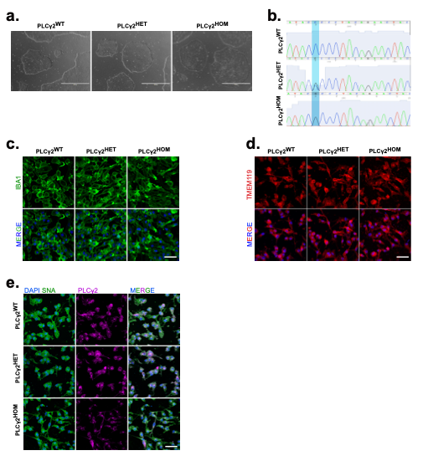

SFig 1: Validation of PLCγ2 ^{P522R} modified iPSC derived microglia
a, Representative brightfield image of healthy Bioni-10 iPSCs displaying characteristic robust colony formation. b, Representative sequencing trace of Bioni-10 WT, P522R heterozygote, and P522R homozygote iPSC line, highlighting a Proline (P) to Arginine (R) conversion after CRISPR editing. c-e, Representative confocal images of differentiated microglia expressing key microglia markers IBA1 (c) and TMEM119 (d), as well as PLCγ2 (e).

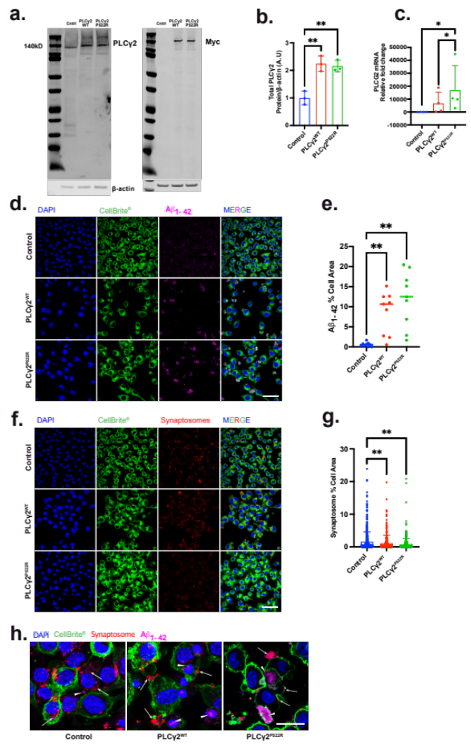

SFig.2: Overexpression of PLCγ2 result in increased Aβ uptake and reduced synaptosome uptake in BV2 cells.
a-c, Western blot (a-b) and RT-qPCR (c) analysis of PLCγ2 expression levels in BV2 cells transfected with a control, PLCγ2^{WT} or PLCγ2^{P522R} expression construct. Expression levels were normalised to β-actin. Data is presented as mean ± SD. Western blot data was analysed using one-way ANOVA with the Tukey multiple comparisons test, and RT-qPCR data was analysed using the Kruskal-Wallis test with Dunns multiple comparisons. d-e, Fluorescent confocal analysis of Aβ₁₋₄₂ HyLite Fluor 647 uptake (magenta) in BV2 cells following transfection with a PLCγ2^{WT} or PLCγ2^{P522R} expression construct. Internalised Aβ is expressed as a proportion of total cell area detected using CellBrite® (green) (Scale bar 50μM). f-g, Fluorescent confocal analysis of tdTomato-synaptosome uptake (red) in BV2 cells following transfection with a PLCγ2^{WT} or PLCγ2^{P522R} expression construct. Internalised synaptosome levels are expressed as a proportion of total cell area, detected using CellBrite® (green) (Scale bar 50μM). h, Representative high power confocal images of BV2 cells transfected with a control, PLCγ2^{WT} or PLCγ2^{P522R} expression construct and incubated with Aβ₁₋₄₂₋647 and synaptosomes, showing synaptosomes mainly localized to the membrane (arrows) while Aβ is fully internalised (arrowheads) (scale bar 20μm). Data is presented as mean ± SD and unless otherwise described was analysed using the Kruskal-Wallis with Dunns multiple comparisons test. (*p<0.05, **p<0.01, n=3-9).

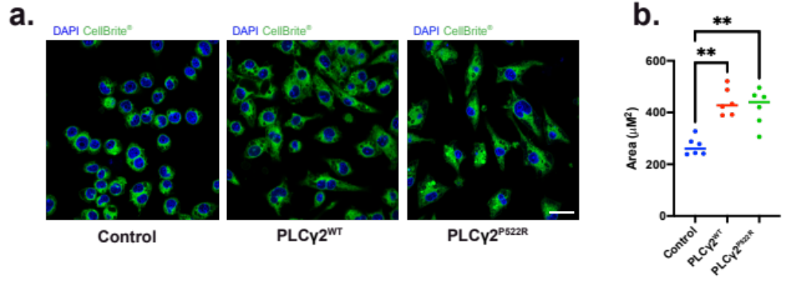

SFig.3: PLCγ2 overexpression in BV2 cells affects cells size.
a-b, Confocal imaging of BV2 cells following transfection with a control, PLCγ2^{WT} or PLCγ2^{P522R} expression construct. Total cell area was visualised and quantified using CellBrite® (green). Data is presented as mean ± SD and was analysed using the Kruskal-Wallis with Dunns multiple comparisons test. (*p<0.05, **p<0.01, n=6, Scale bar 50μm).

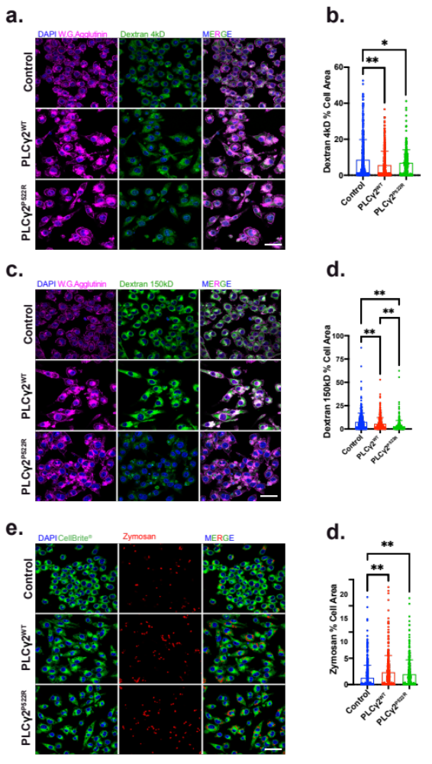

SFig.4: PLCγ2 overexpression size-dependently modulates uptake of non-biological cargoes.
a-d, Fluorescent confocal analysis of 4kDa (a-b) or 150kDa (c-d) FITC-dextran (green) uptake by BV2 cells following transfection with a control, PLCγ2^{WT} or PLCγ2^{P522R} expression construct. Internalised dextran is expressed as a proportion of total cell area, detected using Wheat Germ Agglutinin (magenta). e-f, Fluorescent confocal analysis of Alexa FluorTM 594-zymosan A BioparticlesTM (red) uptake by BV2 cells following transfection with a PLCγ2^{WT} or PLCγ2^{P522R} expression construct. Internalised zymosan particles are expressed as a proportion of total cell area, detected using CellBrite® (green). All data is presented as mean ± SD and was analysed using the Kruskal-Wallis with Dunns multiple comparisons test. (*p<0.05, **p<0.01, n=3, Scale bar 50μm).

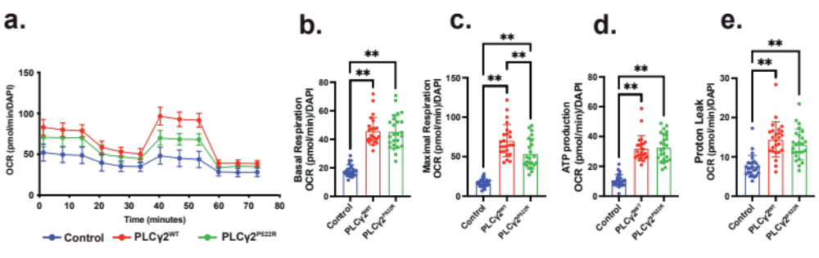

SFig.5: PLCγ2 modulates mitochondrial function in BV2 cells.
a-e, Real time oxygen consumption rate (OCR) at baseline and in response to oligomycin (ATP-synthase inhibitor), FCCP (mitochondrial membrane uncoupler) and rotenone/antimycin-A (Complex I and III inhibitors) in BV2 cells following transfection with a control, PLCγ2^{WT} or PLCγ2^{P522R} expression construct. Calculated basal respiration (b), maximal respiration (c) ATP production (d) and proton leak (e) are reported. Data is presented as mean ± SD and was analysed using the Kruskal-Wallis with Dunns multiple comparisons test. (*p<0.05, **p<0.01, n=3-4).

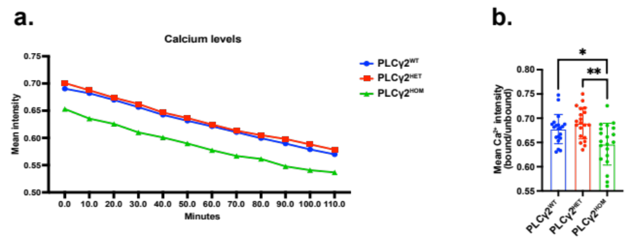

SFig.6: PLCγ2 modulates Ca²⁺ level in iPSC derived microglia.
a, Longitudinal assessment of Fura RedTM ratiometric analysis of bound vs. unbound Ca²⁺ levels in PLCγ2^{WT}, PLCγ2^{HET} and PLCγ2^{HOM} hiPSC derived microglia, monitored every 10 minutes for 120 minutes. b, Mean Ca²⁺ intensity across the whole 2h period. All data is presented as mean ± SD and was analysed using the Kruskal-Wallis with Dunns multiple comparisons test. (*p<0.05, **p<0.01, n=3).

