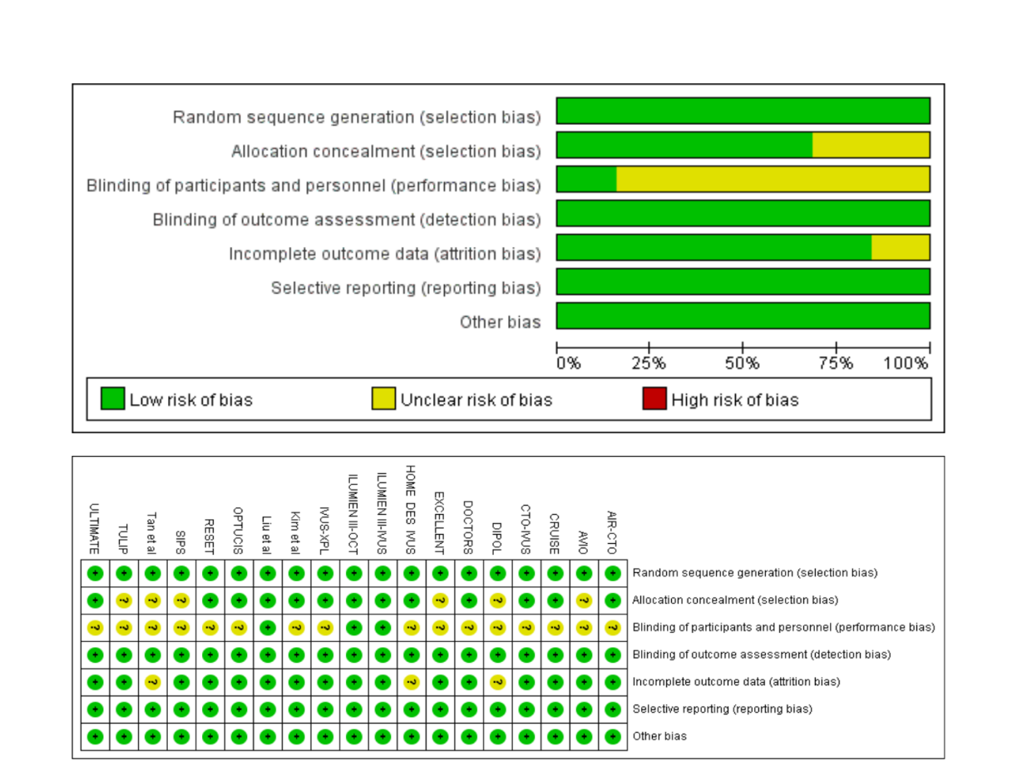
Figure S1. Assessment of bias risk for randomized controlled trials included.
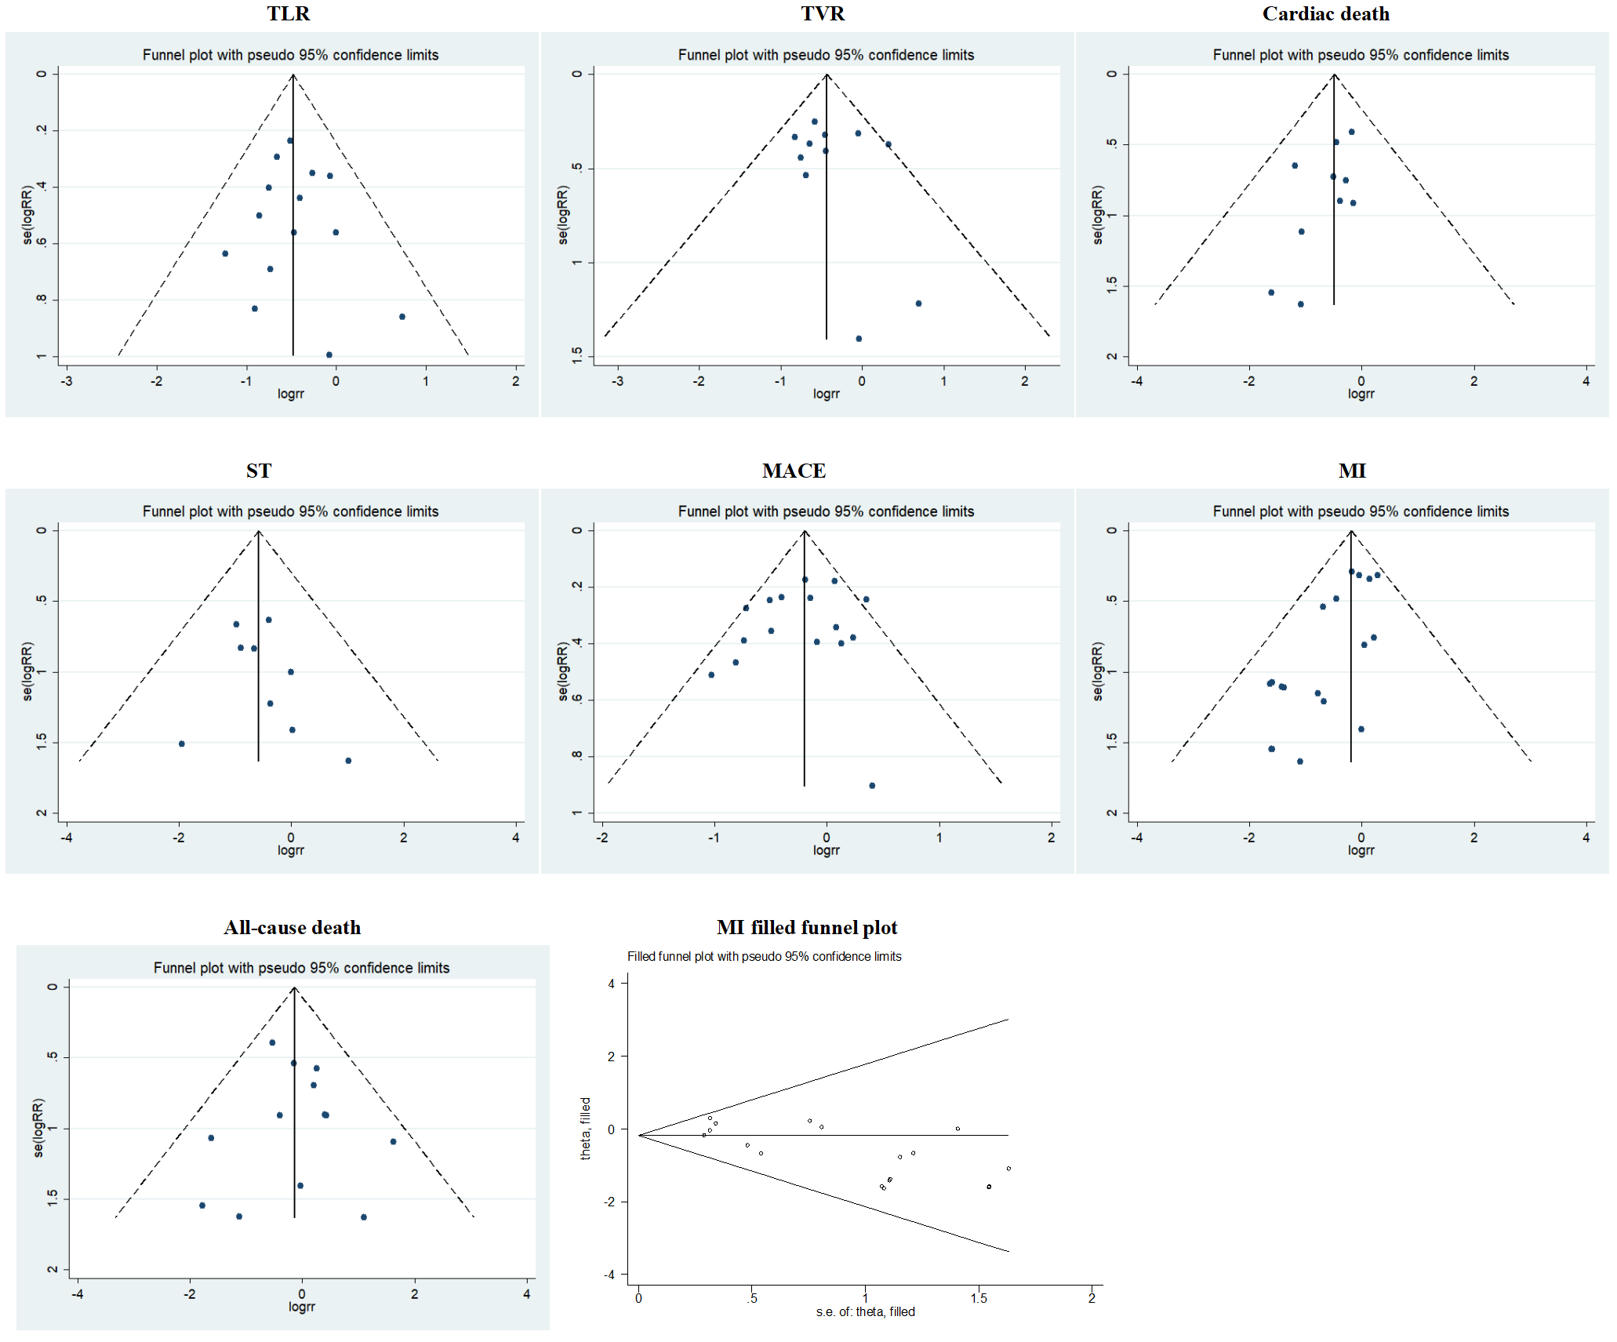
Figure S2. Funnel plot of each outcome.
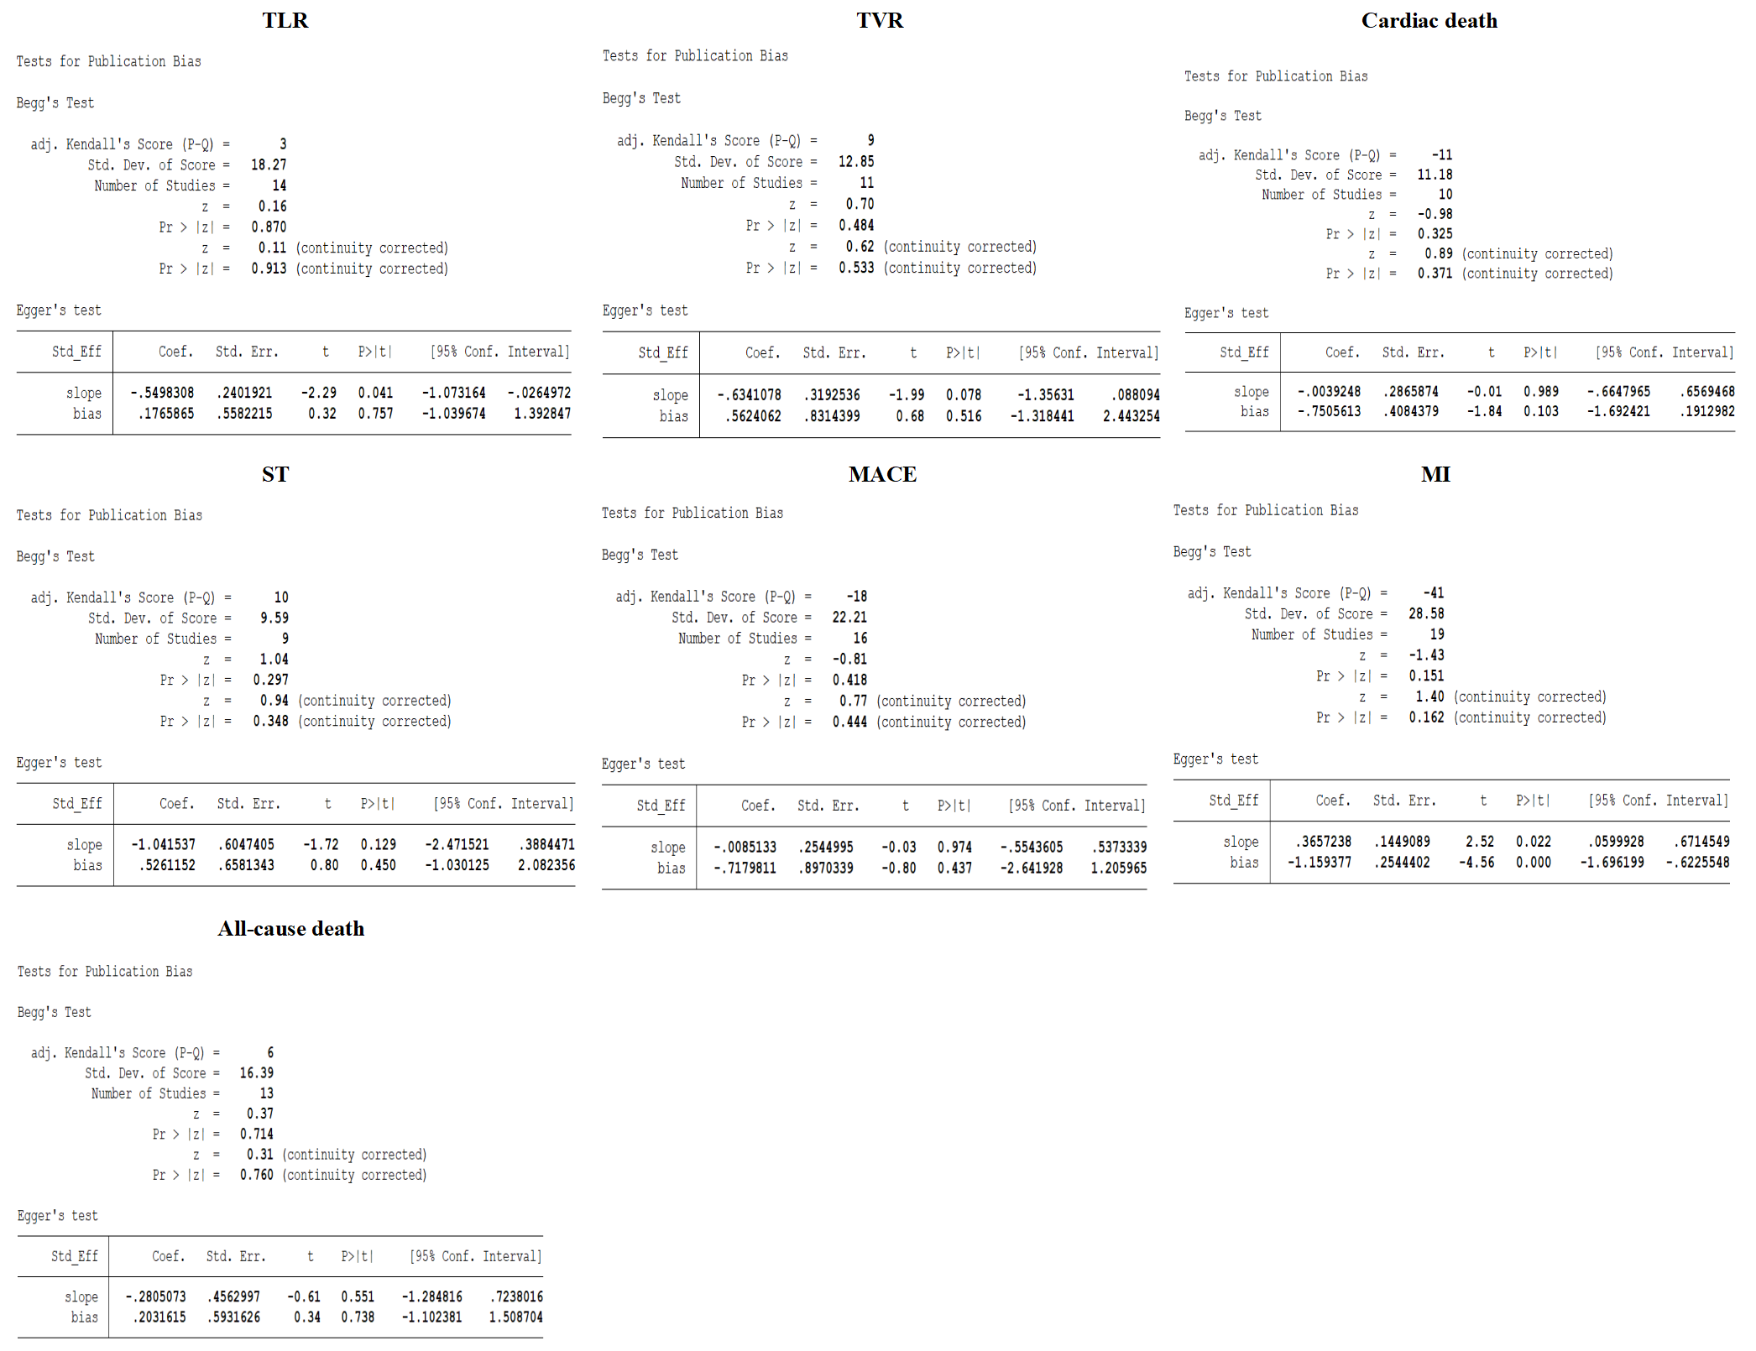
Figure S3. Begg’s and Egger’s test of each outcome.

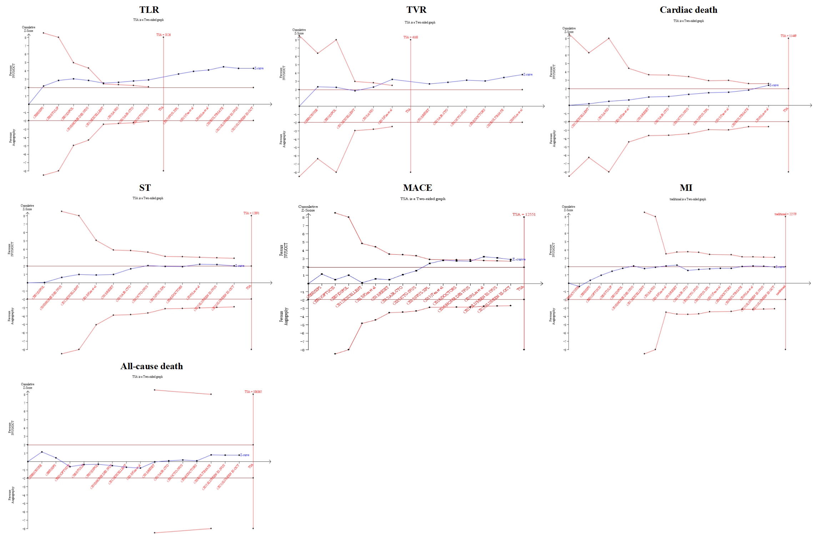
Figure S4. Trial sequential analysis for each outcome.
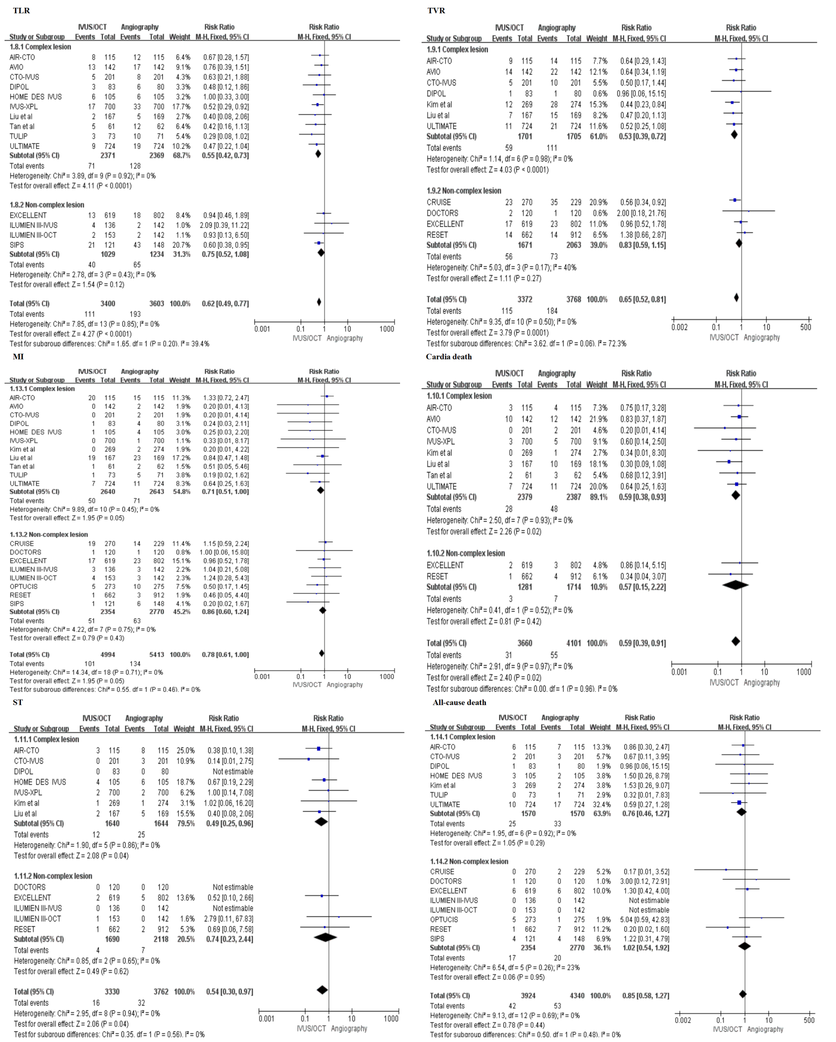
Figure S5. Subgroup analysis of primary and secondary outcomes between complex lesions and non-complex lesions.
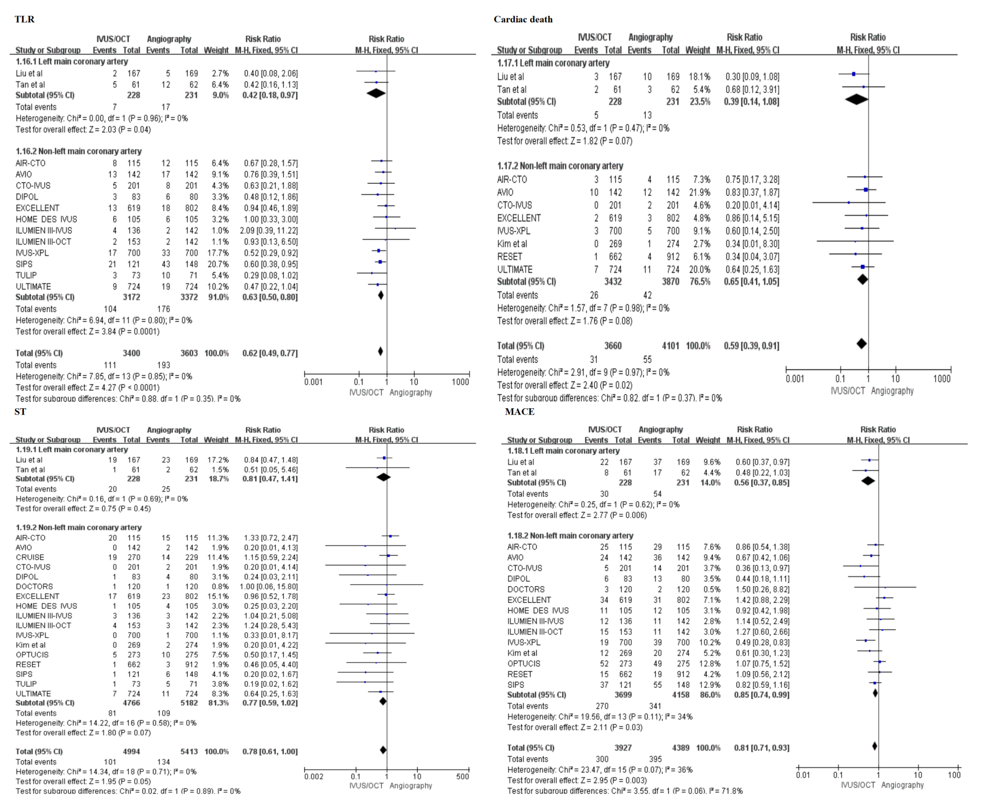
Figure S6. Subgroup analysis form TLR, Cardiac death, ST and MACE outcomes between left main coronary artery and non-left main coronary artery groups.

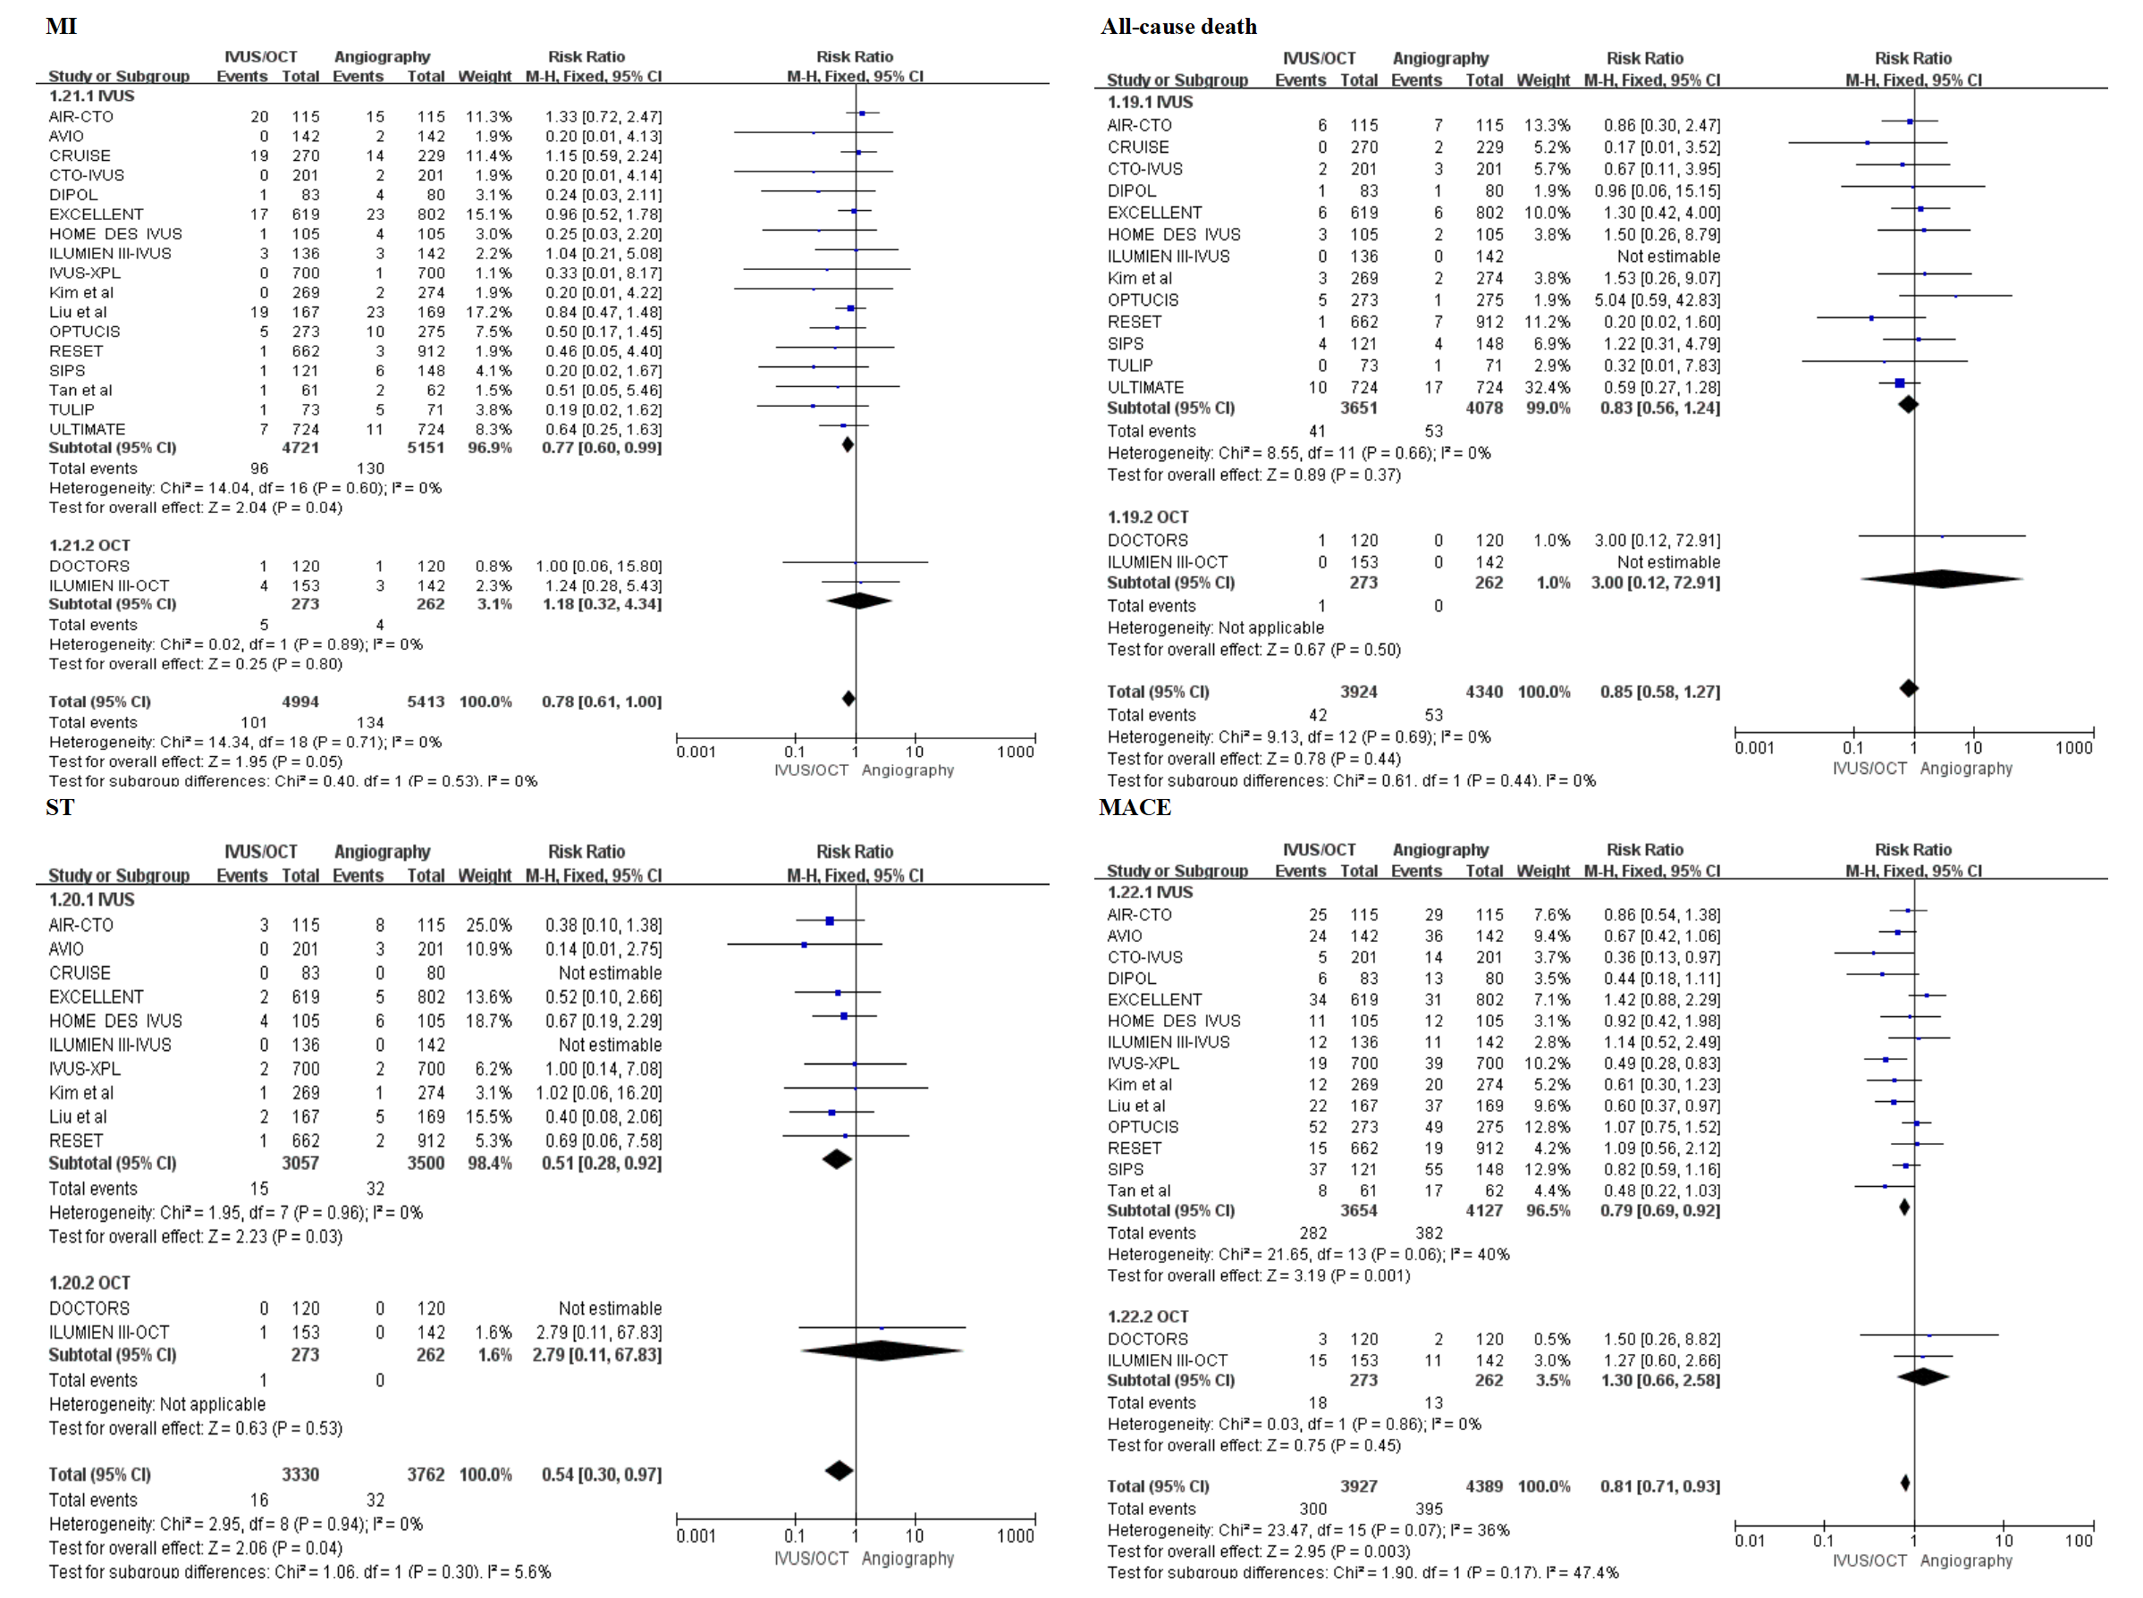
Figure S7. Subgroup analysis between IVUS and OCT groups.

Table S1. Search strategy of this meta-analysis.
Searches |  | Results
Search strategy of Pubmed database.
#5 | Search: (((angiography) OR (angiography guided)) AND (((((intravascular ultrasound) OR (intravascular ultrasound guided)) OR (IVUS)) OR (optical coherence tomography)) OR (optical coherence tomography guided)) OR (OCT))) AND (((stent implantation) OR (percutaneous coronary intervention)) OR (PCI)) Filters: Randomized Controlled Trial | 552
#4 | Search: (((angiography) OR (angiography guided)) AND (((((intravascular ultrasound) OR (intravascular ultrasound guided)) OR (IVUS)) OR (optical coherence tomography)) OR (optical coherence tomography guided)) OR (OCT))) AND (((stent implantation) OR (percutaneous coronary intervention)) OR (PCI)) | 6139
#3 | Search: ((stent implantation) OR (percutaneous coronary intervention)) OR (PCI) | 107217
#2 | Search: ((((intravascular ultrasound) OR (intravascular ultrasound guided)) OR (IVUS)) OR (optical coherence tomography)) OR (optical coherence tomography guided)) OR (OCT) | 3237071
#1 | Seaarch: (angiography) OR (angiography guided) | 330768
Search strategy of EMBASE database.
#6 | #4 AND #5 | 505
#5 | 'randomized controlled trial' OR 'randomized' OR rct | 1256156
#4 | 1# AND #2 AND #3 | 4294
#3 | 'percutaneous coronary intervention' OR 'stent imlantation' OR pci | 129053
#2 | 'intravascular ultrasound' OR 'intravascular ultrasound guided' OR 'ivus' OR 'optical coherence tomography' OR 'optical coherence tomography guided' OR oct | 784425
#1 | 'angiography guided' OR angiography | 409956
Search strategy of Cochrane Library database.
#1 | (angiography):ti,ab,kw OR (angiography -guided):ti,ab,kw | 16454
#2 | MeSH descriptor: [Angiography] this term only | 670
#3 | (intravascular ultrasound):ti,ab,kw OR (intravascular ultrasound-guided):ti,ab,kw OR (IVUS):ti,ab,kw | 1678
#4 | (optical coherence tomography):ti,ab,kw OR (optical coherence tomography-guided):ti,ab,kw OR (OCT):ti,ab,kw | 9003
#5 | MeSH descriptor: [Tomography, Optical Coherence] this term only | 1497
#6 | #1 OR #2 | 16454
#7 | #4 OR #5 | 9003
#8 | #3 OR #7 | 10465
#9 | (stent imlantation):ti,ab,kw OR (percutaneous coronary intervention):ti,ab,kw OR (PCI):ti,ab,kw | 15825
#10 | MeSH descriptor: [percutaneous coronary intervention] this term only | 2348
#11 | #9 OR #10 | 15825
#12 | #6 AND #8 AND #11 | 406
#13 | (randomized):ti,ab,kw OR (Randomized Controlled Trial):ti,ab,kw OR (RCT):ti,ab,kw | 1119173
#14 | MeSH descriptor: [Random Allocation] this term only | 20654
#15 | #13 OR #14 | 1119173
#16 | #12 AND #15 | 328
Search strategy of Web of science database.
#5 | #4 AND #3 AND #2 AND #1 | 256
#4 | TS= (randomized controlled trial OR randomized OR RCT) | 942587
#3 | TS= (percutaneous coronary intervention OR stent imlantation OR PCI) | 95368
#2 | TS= (intravascular ultrasound OR intravascular ultrasound guided OR IVUS OR optical coherence tomography OR optical coherence tomography guided OR PCI) | 100612
#1 | TS= (angiography guided OR angiography) | 157327

Table S2. Summary of GRADE evidence quality for each outcome.
