Ignoring socio-political realities in energy system models overplays coal power phaseout compared to other climate mitigation options

SUPPLEMENTARY INFORMATION

SI Section 1: Data on fastest historical energy transitions
SI Section 2: Additional results from TIAM-UCL
SI Section 3: Description of the TIAM-UCL model
SI Section 4: Fossil fuel representation in TIAM-UCL
SI section 5. TIMES model formulation

SI Section 1: Data on fastest historical energy transitions
Supplementary Table 1: Fastest energy transitions for individual countries and fuels. For each country, the fastest percentage-point reduction in a fuel’s share of power generation over any ten-year period is listed alongside the country’s total generation at the start of that period..
 | Fuel | Period | Decline | Total Generation, GWh
Albania | Oil | 1985-1995 | -26% | 3,147
Algeria | Oil | 1971-1981 | -34% | 2,229
Angola | Hydro | 1993-2003 | -32% | 950
Argentina | Oil | 1972-1982 | -45% | 25,306
Armenia | Oil | 1990-2000 | -69% | 10,362
Australia | Coal | 2005-2015 | -16% | 228,347
Austria | Hydro | 1966-1976 | -15% | 23,527
Azerbaijan | Oil | 2000-2010 | -72% | 18,699
Bahrain | Gas | 1996-2006 | -2% | 12,235
Bangladesh | Oil | 1981-1991 | -24% | 2,662
Belarus | Oil | 1991-2001 | -42% | 38,735
Belgium | Coal | 1962-1972 | -58% | 17,545
Benin | Oil | 2007-2017 | -43% | 220
Bolivia | Hydro | 1985-1995 | -23% | 1,776
Bosnia and Herzegovina | Hydro | 1995-2005 | -35% | 4,401
Botswana | Coal | 2002-2012 | -26% | 1,146
Brazil | Hydro | 2005-2015 | -22% | 403,033
Brunei Darussalam | Oil | 1975-1985 | -1% | 250
Bulgaria | Coal | 1971-1981 | -36% | 21,016
Cambodia | Oil | 2007-2017 | -91% | 1,492
Cameroon | Hydro | 2005-2015 | -39% | 4,004
Canada | Hydro | 1961-1971 | -18% | 115,295
Chile | Hydro | 1988-1998 | -29% | 16,915
China | Oil | 1980-1990 | -23% | 313,264
Colombia | Hydro | 2005-2015 | -17% | 50,337
Congo | Oil | 1978-1988 | -81% | 66
Costa Rica | Hydro | 1985-1995 | -25% | 2,816
Côte d'Ivoire | Oil | 1971-1981 | -68% | 588
Croatia | Oil | 2003-2013 | -23% | 13,192
Cuba | Oil | 1998-2008 | -12% | 11,002
Netherlands Antilles | Oil | 2007-2017 | -33% | 1,256
Cyprus | Oil | 2008-2018 | -9% | 5,079
Czech Republic | Coal | 2000-2010 | -17% | 72,911
Congo | Oil | 1980-1990 | -4% | 4,445
Denmark | Oil | 1972-1982 | -73% | 20,574
Dominican Republic | Oil | 2000-2010 | -38% | 13,114
Ecuador | Oil | 1979-1989 | -63% | 3,058
Egypt | Hydro | 1977-1987 | -41% | 14,132
El Salvador | Oil | 1975-1985 | -48% | 990
Eritrea | Oil | 1996-2006 | -1% | 193
Estonia | Oil shale and oil sands | 2007-2017 | -17% | 12,190
Ethiopia | Oil | 1972-1982 | -22% | 611
Finland | Hydro | 1962-1972 | -40% | 11,616
Former Soviet Union | Coal | 1971-1981 | -15% | 800,400
Former Yugoslavia | Hydro | 1979-1989 | -20% | 54,966
France | Oil | 1973-1983 | -35% | 182,508
Gabon | Oil | 1973-1983 | -72% | 165
Georgia | Gas | 1992-2002 | -30% | 11,154
Germany | Coal | 1964-1974 | -17% | 163,556
Ghana | Hydro | 1997-2007 | -46% | 6,886
Greece | Coal | 2007-2017 | -21% | 62,711
Guatemala | Oil | 1980-1990 | -77% | 1,952
Haiti | Hydro | 2006-2016 | -41% | 570
Honduras | Hydro | 1992-2002 | -55% | 2,343
Hungary | Coal | 1967-1977 | -25% | 12,490
Iceland | Hydro | 1997-2007 | -23% | 5,586
India | Hydro | 1978-1988 | -19% | 110,129
Indonesia | Oil | 1984-1994 | -59% | 13,622
Iran | Oil | 1985-1995 | -34% | 39,220
Iraq | Gas | 1976-1986 | -69% | 5,239
Ireland | Oil | 1978-1988 | -64% | 9,646
Israel | Oil | 1976-1986 | -56% | 10,361
Italy | Hydro | 1960-1970 | -47% | 55,990
Jamaica | Oil | 2007-2017 | -22% | 5,996
Japan | Oil | 1977-1987 | -38% | 529,371
Jordan | Oil | 1999-2009 | -81% | 7,081
Kazakhstan | Hydro | 2002-2012 | -7% | 58,342
Kenya | Hydro | 1990-2000 | -44% | 3,235
Kosovo | Coal | 2008-2018 | -3% | 5,162
Kuwait | Gas | 1973-1983 | -58% | 3,651
Kyrgyzstan | Gas | 1992-2002 | -16% | 13,789
Latvia | Hydro | 2005-2015 | -34% | 4,906
Lebanon | Hydro | 1971-1981 | -33% | 1,375
Libya | Oil | 2002-2012 | -39% | 17,531
Lithuania | Nuclear | 2003-2013 | -82% | 18,828
Luxembourg | Coal | 1990-2000 | -76% | 624
Malaysia | Oil | 1983-1993 | -57% | 12,758
Malta | Oil | 2008-2018 | -99% | 2,312
Mauritius | Oil | 1997-2007 | -36% | 1,399
Mexico | Oil | 1998-2008 | -30% | 182,304
Moldova | Coal | 1994-2004 | -38% | 9,483
Mongolia | Coal | 2007-2017 | -7% | 3,701
Montenegro | Hydro | 2007-2017 | -19% | 2,144
Morocco | Oil | 1992-2002 | -55% | 9,719
Mozambique | Oil | 1973-1983 | -50% | 641
Myanmar | Gas | 1999-2009 | -45% | 4,639
Namibia | Coal | 1994-2004 | -20% | 874
Nepal | Oil | 1973-1983 | -21% | 104
Netherlands | Coal | 1962-1972 | -69% | 19,255
New Zealand | Hydro | 1995-2005 | -22% | 36,061
Nicaragua | Oil | 2007-2017 | -27% | 3,208
Niger | Coal | 2006-2016 | -36% | 218
Nigeria | Hydro | 1974-1984 | -57% | 2,287
North Korea | Coal | 2006-2016 | -22% | 22,435
North Macedonia | Coal | 2008-2018 | -33% | 6,311
Norway | Hydro | 2000-2010 | -5% | 142,511
Oman | Oil | 1977-1987 | -79% | 404
Pakistan | Gas | 2004-2014 | -24% | 85,629
Panama | Oil | 1975-1985 | -73% | 1,251
Paraguay | Oil | 1978-1988 | -53% | 568
Peru | Hydro | 2001-2011 | -30% | 20,778
Philippines | Oil | 1976-1986 | -49% | 14,716
Poland | Coal | 2007-2017 | -13% | 158,761
Portugal | Hydro | 1966-1976 | -47% | 5,581
Qatar | Oil | 1975-1985 | -17% | 625
Romania | Gas | 1984-1994 | -23% | 71,667
Russia | Oil | 1991-2001 | -8% | 1,068,163
Saudi Arabia | Oil | 1971-1981 | -60% | 2,082
Senegal | Oil | 1993-2003 | -18% | 1,037
Serbia | Hydro | 1999-2009 | -8% | 30,834
Singapore | Oil | 1999-2009 | -61% | 29,520
Slovak Republic | Coal | 1972-1982 | -31% | 11,823
Slovenia | Coal | 2004-2014 | -12% | 15,271
South Africa | Coal | 1979-1989 | -7% | 89,748
South Korea | Oil | 1977-1987 | -82% | 26,587
Spain | Hydro | 1966-1976 | -49% | 37,679
Sri Lanka | Hydro | 1994-2004 | -57% | 4,387
Sudan | Oil | 2007-2017 | -48% | 5,021
Suriname | Hydro | 2001-2011 | -26% | 1,235
Sweden | Hydro | 1967-1977 | -32% | 53,822
Switzerland | Hydro | 1966-1976 | -26% | 28,361
Syria | Oil | 1971-1981 | -56% | 1,345
Taiwan | Oil | 1977-1987 | -72% | 30,968
Tajikistan | Gas | 1990-2000 | -8% | 18,146
Tanzania | Hydro | 2003-2013 | -67% | 2,661
Thailand | Oil | 1978-1988 | -70% | 12,637
Togo | Oil | 2006-2016 | -48% | 221
Trinidad and Tobago | Oil | 1979-1989 | -3% | 1,855
Tunisia | Oil | 1991-2001 | -53% | 6,030
Turkey | Coal | 1962-1972 | -34% | 3,560
Turkmenistan | Hydro | 1990-2000 | -5% | 14,610
Ukraine | Oil | 1990-2000 | -15% | 298,626
United Arab Emirates | Gas | 1971-1981 | -4% | 203
United Kingdom | Coal | 1987-1997 | -35% | 301,644
United States | Coal | 2008-2018 | -21% | 4,342,980
Uruguay | Oil | 1976-1986 | -53% | 2,702
Uzbekistan | Oil | 1998-2008 | -9% | 45,935
Venezuela | Oil | 1981-1991 | -30% | 38,750
Viet Nam | Coal | 1972-1982 | -43% | 2,200
Yemen | Oil | 2007-2017 | -49% | 6,027
Zambia | Coal | 1971-1981 | -20% | 1,216
Zimbabwe | Hydro | 1977-1987 | -75% | 6,491

SI Section 2: Additional results from TIAM-UCL

Alternative PPCA decline paths
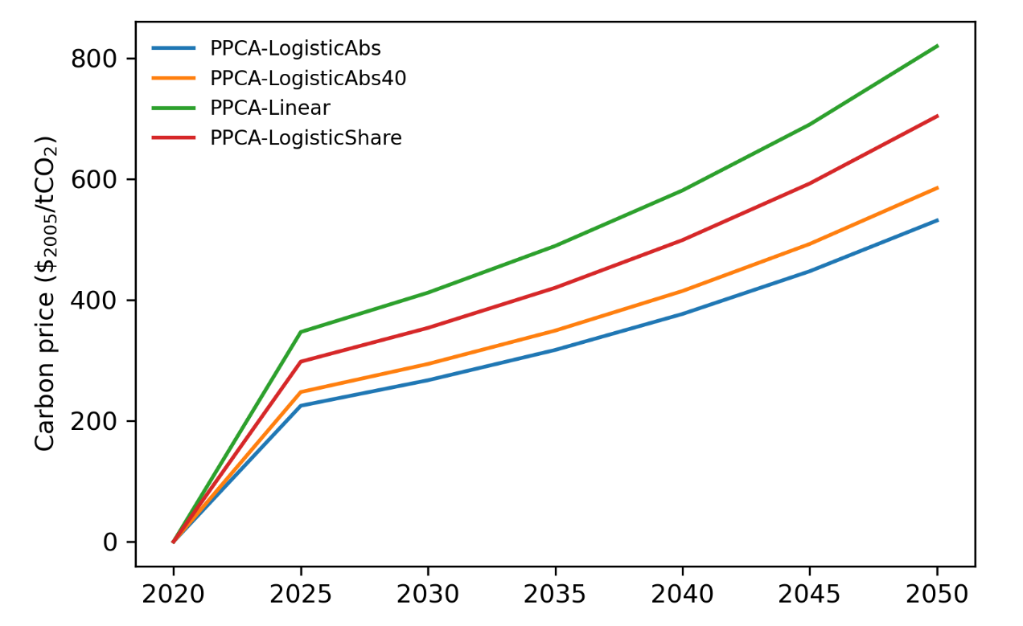
Supplementary Figure 1. Global carbon price output by our modelling for the four coal decline constraint formulations we explore. PPCA-LogisticShare is the central case we report in the main manuscript.
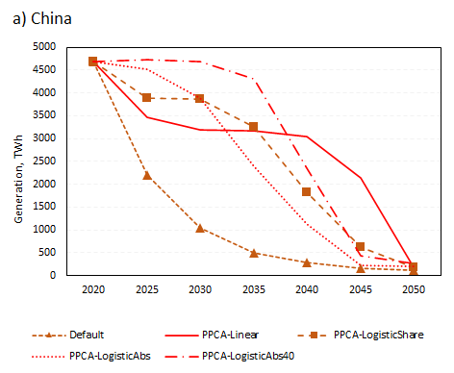 | 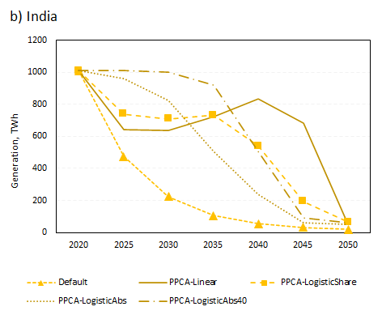
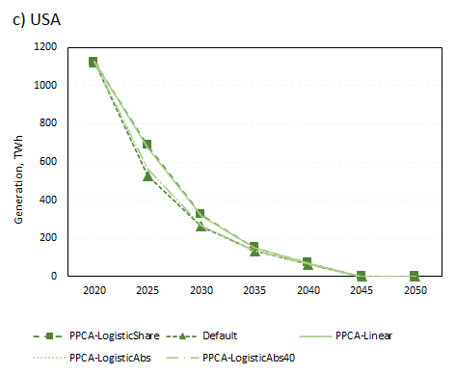 | 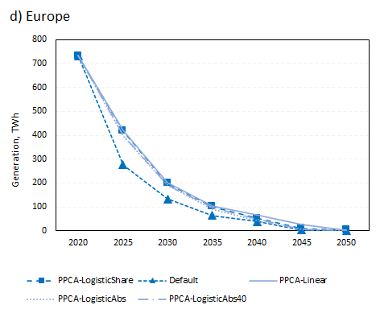
Supplementary Figure 2. Coal power generation for selected countries under a range of different approaches to PPCA implementation and the default case, 2020-2050.

Regional impacts of PPCA constraint
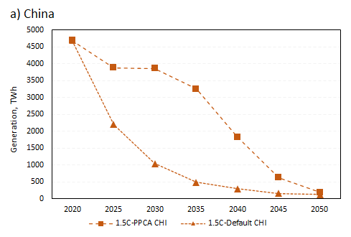 | 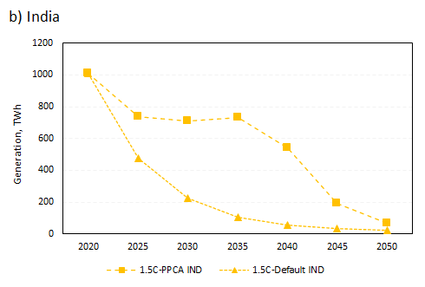
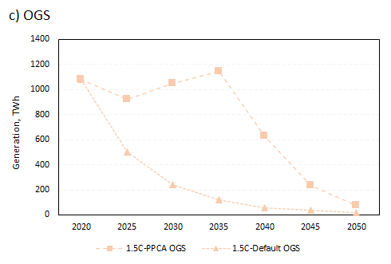 | 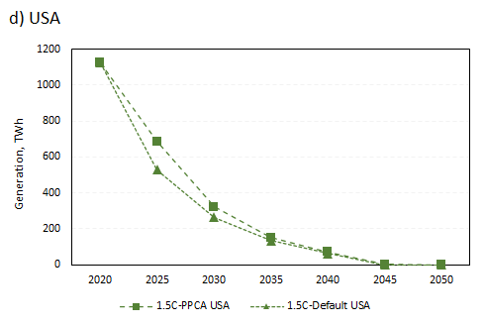
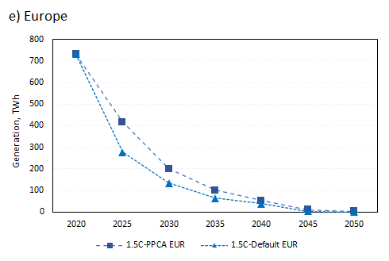 | 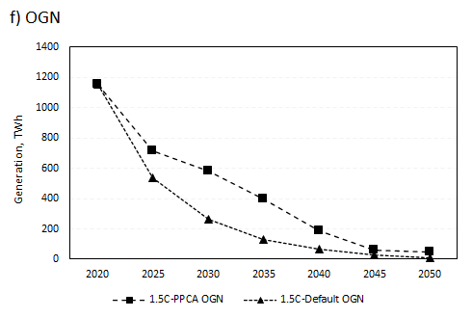
Supplementary Figure 3. Coal power generation by country / region under 1.5°C PPCA and default scenarios, 2020-2050. OGS = Other Global South (to include Africa, Latin America, Other Developing Asia, Mexico, and Middle East); OGN = Other Global North (to include Canada, Australia, Japan, South Korea, and Russia and former Soviet states)

SI Section 3: Key assumptions in the TIAM-UCL Model
This supplementary information describes some of the core assumptions used in this analysis. Many of the same model assumptions were used in Welsby et al (2021).

Demand drivers
Population and economic growth drivers are based on the SSP2 'Middle of the Road' scenario narrative. These drivers are used to construct the energy service demands across different sectors. Some adjustments have been made to energy service demands to ensure final energy demand globally falls within the SSP2 marker model (MESSAGE) range. As SSPs are independent of climate ambition, defining the socio-economic backdrop that a given climate ambition has to be achieved within, the demands for SSP2 in TIAM have been tuned to match the marker model's base / reference SSP2 run with no climate constraints. Region specific values are used but global values are shown in Supplementary Table 2.
Supplementary Table 2. Demand drivers used in TIAM-UCL scenarios
Category | Assumption | Values |  |  |  | Units
 |  | 2030 | 2050 | 2080 | 2100
SSP2 | Population | 8.3 | 9.2 | 9.4 | 9.0 | billion
SSP2 | GDP | 17 | 25 | 42 | 59 | 000 US$2005/cap

Bioenergy characterisation and availability
Bioenergy is characterised into first and second generation fuels. First generation fuels are represented as bioliquids (bioethanol and biodiesel from crops which might compete with food crops for land) and biomethane (gas captured from controlled landfill sites). Four types of second-generation bioenergy feedstock are distinguished: i) Solid biomass (BIOSLD), comprising woody residues from forestry and agriculture; ii) Energy crops (BIOCRP), comprising second generation purposely grown energy crops (grassy and woody bioenergy crops); iii) Municipal waste (BIOBMU), comprises wastes produced by households, industry, hospitals and the tertiary sector that are collected by local authorities; and iv) Industrial waste (BIOBIN), Solid and liquid products (e.g. tyres, sulphite lyes (black liquor), animal materials/wastes), usually combusted directly in specialised plants to produce heat and/or power. For each of these fractions cost supply curves are specified within the model for each of the 16 regions, i.e. amount of biomass available at different costs in each region. Cost ranges for solid biomass range between 4-16 $/GJ, and for energy crops between 9-15 $/GJ, with zero cost for waste fractions. To avoid competition for land, energy crops are assumed to be grown only on marginal and degraded land. Importantly, only solid biomass and energy crops fractions can be used for BECCS, and traded between regions. Supplementary Table 3 lists the global potentials for each bioenergy type.
Supplementary Table 3. Bioenergy availability (central estimates)
Bioenergy category | Values by year, EJ potential |  |  |  | Source
 | 2030 | 2050 | 2080 | 2100
Solid biomass | 43 | 45 | 48 | 50 | Daioglou et al. (2016)
Energy crops | 17 | 31 | 31 | 31 | Marginal land availability and energy crop yields from Ricardo-AEA. (2017). Biomass Feedstock Availability. Final report for BEIS. Supply cost curves based on Hoogwijk et al. (2009)
MSW | 17 | 27 | 27 | 28 | TIAM-ETSAP

Conversion technology assumptions
A key input into the TIAM-UCL model is the assumptions on costs and performance of different conversion technologies, which produce low carbon vectors. This section provides an overview of the key assumptions for different technology groups. Supplementary Table 4 provides information regarding the power generation sector.
The assumptions for the suite of BECCS technologies available in the model can be found in Supplementary Table 5. The main ‘brake’ on this technology set is the bioenergy resource availability. The other negative emission technology in TIAM-UCL is Direct Air Capture (DAC) which draws on heat and electricity inputs to capture CO2 directly from the atmosphere and sequester it. Supplementary Table 6 has the cost and technical lifetime assumptions used for DAC.
On the supply side, hydrogen production technologies are divided into three different scales: centralised large-scale, centralised medium and decentralised small-scale production. Large-scale plants are based on biomass, coal and gas with continuous production of hydrogen. These plants are available with and without CCS technology. Hydrogen produced from centralised plants are transported with two different transportation options: long-distance pipe line transportation (gaseous hydrogen) and liquefaction plus trucks (liquid hydrogen). Hydrogen production data is presented in Supplementary Table 7, and are based on the review by Dodds and McDowall, 2012.

Supplementary Table 4. Power generation costs and efficiency assumptions
 | CAPEX, $2005 /kW |  |  |  |  | Efficiency, %
Technology | 2010 | 2020 | 2030 | 2040 | 2050 | 2010 | 2020 | 2030 | 2050
MSW combustion | 5236 | 4862 | 4488 |  | 4114 | 23 | 27 | 30 | 33
Bioenergy combustion | 2618 | 2431 | 2244 |  | 2057 | 28 | 31 | 34 | 37
Bioenergy combustion (dcn) | 2880 | 2674 | 2468 |  | 2263 | 28 | 31 | 34 | 37
Bioenergy gasification | 3080 | 2860 | 2640 |  | 2420 | 31 | 34 | 37 | 40
Bioenergy gasification (dcn) | 3388 | 3146 | 2904 |  | 2662 | 31 | 34 | 37 | 40
Coal IGCC | 2376 |  |  |  |  | 44 | 48 | 51 | 54
Coal super critical | 1870 |  |  |  |  | 41 | 42 | 42 | 42
Coal ultra super critical | 2277 |  |  |  |  | 46 | 48 | 49 | 50
Gas CCGT | 990 |  |  |  |  | 56 | 59 | 61 | 63
Oil generation (dcn) | 659 |  |  |  |  | 31 | 31 | 31 | 31
Oil generation | 495 |  |  |  |  | 38 | 39 | 40 | 42
Coal IGCC w/CCS |  | 3802 | 3564 |  | 3326 |  | 38 | 43 | 48
Coal USC w/CCS |  | 3643 | 3416 |  | 3188 |  | 39 | 42 | 46
Gas CCGT w/CCS |  | 1584 | 1485 |  | 1386 |  | 49 | 53 | 57
Geothermal shallow | 2376 | 2310 | 2255 | 2200 | 2129
Geothermal deep | 3911 | 3644 | 3383 | 3108 | 2846
Geothermal very deep |  | 4978 | 4510 | 4015 | 3564
Hydro dam | 1650-6050 | 1623-5913 | 1595-5775 | 1568-5638 | 1540-5500
Solar CSP | 5850 | 3330 | 2700 | 2385 | 2070
Solar PV | 2587 | 667 | 437 |  | 288
Tidal | 6600 | 5500 | 4400 |  | 3432
Offshore wind |  | 3229 | 2507 | 1983 | 1591
Onshore wind |  | 1110 | 1011 | 949 | 919
Nuclear Advanced LWR | 4166 | 3939 | 3849 |  | 3623
Storage | 3300 | 1359 | 1051 | 700 | 510 | 80 | 80 | 80 | 80

Source: All costs presented above are averages across the 16 regions in TIAM-UCL, however in the model, costs are differentiated across the different regions. Fossil and CCS technologies (Ekins et al. (2017); Rubin et al. (2015)); CCS is available from 2030, and can see capacity growth of a maximum of 5% per annum. Power generation technologies have capture rates of 90%, which do not improve over time. Future solar PV and wind reductions based on BNEF estimates (unpublished), recent cost estimates based on IRENA. The maximum build rate of new solar PV and wind capacity each year is set at 30% of existing capacity in line with recent solar PV build rates. Range for hydro denotes different resource tranches and cost of exploitation. In the above table, ‘dcn’ denotes ‘decentralised’.

Supplementary Table 5. a) BECCS technology costs and efficiency assumptions and b) other assumptions
a)
Technology Group | Technology Group | Efficiency % |  | Investment cost $/kW |  | Fix cost $/kW |  | Variable cost $/GJ
 | Year | 2030 | 2050 | 2030 | 2050 | 2030 | 2050 | 2030 | 2050
Electricity | Energy Crop Combustion w CCS | 26 | 31 | 3060 | 2618 | 175 | 131 | 6.9 | 6.6
Electricity | Energy Crop Gasification w CCS | 29 | 34 | 3600 | 3080 | 206 | 173 | 1.7 | 1.7
Electricity | Solid Biomass Combustion w CCS | 26 | 31 | 3060 | 2618 | 175 | 131 | 6.9 | 6.6
Electricity | Solid Biomass Gasification w CCS | 29 | 34 | 3600 | 3080 | 206 | 154 | 1.7 | 1.7
Heat | Heat from biomass with CCS | 63 | 65 | 1671 | 1419 | 189
Hydrogen | Hydrogen from biomass gasification + CCS | 42 | 44 | 4594 | 3516 | 322 | 246
Advanced transport fuels | FT process w CCS using solid biomass | 34 | 42 | 2235 | 1565 | 27 | 27 | 0.8 | 0.8
Advanced transport fuels | FT process w CCS using energy crops | 34 | 42 | 2235 | 1565 | 27 | 27 | 0.8 | 0.8
b)
Technology Group | Technology Group | Start time | Life  yr | Availability / capacity factor | CO₂ Capture rate % | Build rate %
Electricity | Energy Crop Combustion w CCS | 2030 | 25 | 0.85 | 90 | 5
Electricity | Energy Crop Gasification w CCS
Electricity | Solid Biomass Combustion w CCS
Electricity | Solid Biomass Gasification w CCS
Heat | Heat from biomass with CCS | 2030 | 30 | 0.6 | 90 | 3
Hydrogen | Hydrogen from biomass gasification + CCS | 2030 | 30 | 0.9 | 90 | 5
Advanced transport fuels | FT process w CCS using solid biomass | 2030 | 30 | 0.9 | 50 | 5
Advanced transport fuels | FT process w CCS using energy crops

Source: Butnar et al. 2020

Supplementary Table 6. Direct Air Capture costs and technical lifetime assumptions
Technology | Life (yr) | Fixed O&M costs ($2005/tCO2/yr) | Capital investment costs ($2005/tCO₂)
Technology | Life (yr) | 2030 | 2030
Direct air capture | 20 | 120 | 2900

Supplementary Table 7. Hydrogen production technology costs and efficiency assumptions
Technology | Size | Fixed O&M costs (% capital costs) | Capital investment costs ($2005/GJ/y)
Technology | Size |  | 2025 | 2050
Coal gasification | Large | 0.05 | 27 | 24
Gas SMR | Large | 0.04 | 7 | 5
Gas SMR | Small / medium | 0.04 | 17 | 14
Biomass gasification | Large | 0.07 | 26 | 26
Biomass gasification | Medium | 0.07 | 34 | 34
Biomass gasification | Small | 0.07 | 43 | 43
Waste gasification | Medium | 0.07 | 34 | 34
Electrolysis | Large | 0.04 | 7.7 | 2.4
Electrolysis | Medium | 0.05 | 8.8 | 2.7
Electrolysis | Small | 0.05 | 10 | 3.1

Other key assumptions
- LULUCF emissions. Land use and forestry (LULUCF) emissions of CO₂ are based on a fixed trajectory, using outputs from the IMAGE model, based on the RCP2.6 SSP2 case. They are net CO₂ emissions from deforestation, and reforestation in line with SSP2 RCP2.6 assumptions (Supplementary Table 8).
- Non-CO₂ GHGs. Some non-energy sector sources of CH₄ and N₂O are not explicitly represented in TIAM-UCL but rather included as an emissions trajectory based on the RCP database. Such sources include CH₄ from landfill and waste water, and agriculture (manure, rice paddies) and N₂O from industry (nitric and adipic acid) and agriculture. In this modelling, the RCP2.6 trajectory is used. Emissions of these gases from the energy sector (e.g. CH₄ leakage from fossil methane gas extraction and transport) are capped under an overall constraint, which includes the sources above.
- Discount rate. The social discount rate used in the calculation of net present value (used as the basis for the objective function) is set at 3.5%.
- Base year. Model is calibrated based on 2005 IEA energy balances. Additional constraints have been introduced in the model to help represent the energy system in 2010 and 2015 - and to reflect projected emissions in 2020.

Supplementary Table 8. LULUCF and non-CO₂ GHG emissions
Emissions | Values by year |  |  |  | Units | Source
 | 2030 | 2050 | 2080 | 2100
CO₂ from LULUCF | 2.5 | 1.2 | -1.0 | -1.5 | GtCO₂ | Trajectory sourced from SSP Public Database (Version 1.1) hosted by IIASA https://tntcat.iiasa.ac.at/SspDb/dsd?Action=htmlpage&page=welcome. Model-Scenario: IMAGE SSP2-26
CH₄ | 275,467 | 212,033 | 178,996 | 157,291 | Kt
N₂O | 9297 | 8863 | 8320 | 7920 | Kt

Additional documentation for TIAM-UCL can be found on the Integrated Assessment Modelling Consortium (IAMC) wiki at https://www.iamcdocumentation.eu/index.php/Model_Documentation_-_TIAM-UCL.

Supplementary Table 9. List of regions and countries in the 16 region TIAM-UCL model
Region | Countries
Africa (AFR) | Algeria, Angola, Benin, Botswana, Burkina Faso, Burundi, Cameroon, Cape Verde, Central African Republic, Chad, Comoros, Congo, Côte d'Ivoire, Democratic Republic of the Congo, Djibouti, Egypt, Equatorial Guinea, Eritrea, Ethiopia, Gabon, Gambia, Ghana, Guinea, Guinea-Bissau, Kenya, Lesotho, Liberia, Libya, Madagascar, Malawi, Mali, Mauritania, Morocco, Mozambique, Namibia, Niger, Nigeria, Rwanda, Sao Tome and Principe, Senegal, Seychelles, Sierra Leone, Somalia, South Africa, South Sudan, Sudan, Swaziland, Togo, Tunisia, Uganda, United Republic of Tanzania, Zambia, Zimbabwe
Australia (AUS) | Australia, New Zealand
Canada (CAN) | Canada
Central and South America (CSA) | Anguilla, Antigua and Barbuda, Argentina, Aruba, Bahamas, Barbados, Belize, Bermuda, Bolivia, Brazil, Cayman Islands, Chile, Colombia, Costa Rica, Cuba, Dominica, Dominican Republic, Ecuador, El Salvador, Falkland Islands, Grenada, Guatemala, Guyana, Haiti, Honduras, Jamaica, Martinique, Netherlands Antilles, Nicaragua, Panama, Paraguay, Peru, Saint Kitts and Nevis, Saint Lucia, Saint Vincent and the Grenadines, Suriname, Trinidad and Tobago, Uruguay, Venezuela (Bolivarian Republic of)
China (CHI) | China, Taiwan, Tibet
Eastern Europe (EEU) | Bosnia and Herzegovina, Bulgaria, Croatia, Czech Republic, Hungary, Montenegro, Poland, Romania, Serbia, Slovakia, Slovenia, The former Yugoslav Republic of Macedonia
Former Soviet Union (FSU) | Armenia, Azerbaijan, Belarus, Estonia, Georgia, Kazakhstan, Kyrgyzstan, Latvia, Lithuania, Republic of Moldova, Russian Federation, Tajikistan, Turkmenistan, Ukraine, Uzbekistan
India (IND) | India
Japan (JAP) | Japan
Mexico (MEX) | Mexico
Middle-east (MEA) | Bahrain, Brunei Darussalam, Cyprus, Iran (Islamic Republic of), Israel, Jordan, Kuwait, Lebanon, Occupied Palestinian Territory, Oman, Qatar, Saudi Arabia, Syrian Arab Republic, Turkey, United Arab Emirates, Yemen
Other Developing Asia (ODA) | Afghanistan, American Samoa, Bangladesh, Bhutan, Cambodia, Democratic People's Republic of Korea, Fiji, French Polynesia, Indonesia, Kiribati, Lao People's Democratic Republic, Malaysia, Maldives, Mauritius, Mongolia, Myanmar, Nepal, New Caledonia, Pakistan, Papua New Guinea, Philippines, Samoa, Singapore, Solomon Islands, Sri Lanka, Thailand, Timor-Leste, Tonga, Vanuatu, Vietnam
South Korea (SKO) | Republic of Korea
United Kingdom (UK) | United Kingdom
USA (USA) | United States of America
Western Europe (WEU) | Albania, Andorra, Austria, Belgium, Denmark, Faroe Islands, Finland, France, Germany, Gibraltar, Greece, Greenland, Iceland, Ireland, Italy, Luxembourg, Malta, Monaco, Netherlands, Norway, Portugal, San Marino, Spain, Sweden, Switzerland, Vatican

SI Section 4: Fossil fuel characterisation in TIAM-UCL
This section briefly discusses the upstream representation of fossil fuels in TIAM-UCL. This includes the cost and availability of different categories of fossil fuels, and asymmetric constraints which constrain how quickly production can grow or decline.
Coal
Primary coal resources in TIAM-UCL are split into two categories, utilizing data collected by Remme et. al. -
- Brown coal (lignite): lower energy content, with average heating value ranging from 5.57-17 MJ/kg
- Hard coal (sub-bituminous, bituminous and anthracite): higher energy content, with average heating value ranging from 17.58-27.55 MJ/kg

As with oil and fossil methane gas, the extraction technologies for coal split the resource base into cost tranches, in order to reflect (albeit simplistically), cost depletion dynamics. In short, as the more accessible and higher quality resources are depleted, the model must move to more expensive extraction of (potentially) harder to exploit resources. Coal is split into hard coal and brown coal, with the representative mining technologies for both categories split into three cost categories. The distribution of resources/reserves assigned to each cost category varies by region, and is influenced by the proportion of the total resource base which can be considered reserves, with the remainder of resources split between the middle and highest cost categories.

Supplementary Figure 4 shows a cost depletion curve for global coal resources, and the corresponding global supply cost curve constructed from the cost depletion curve. Additionally, Supplementary Figure 5 shows a global supply cost curve broken down into the regions of TIAM-UCL.
a) | 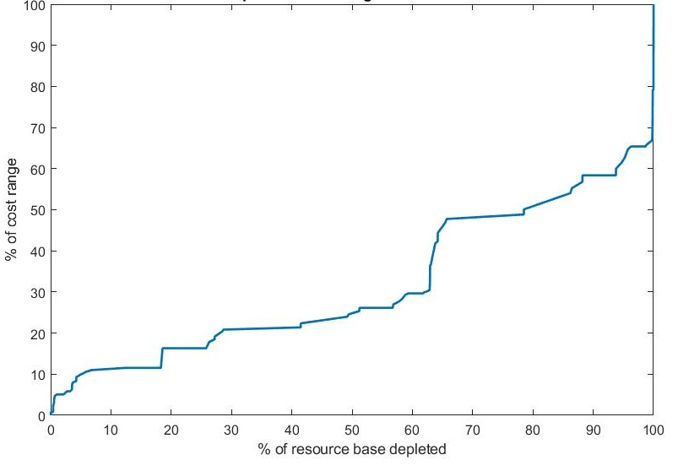
b) | 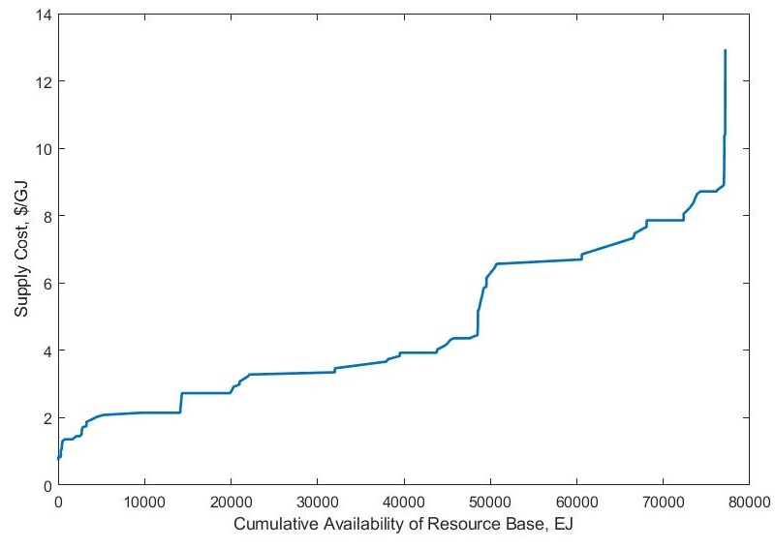
Supplementary Figure 4. a) Cost depletion curve derived from TIAM-UCL resources and costs for global coal; b) supply cost curve derived from the cost depletion curve. Source data are provided as a Source Data file.
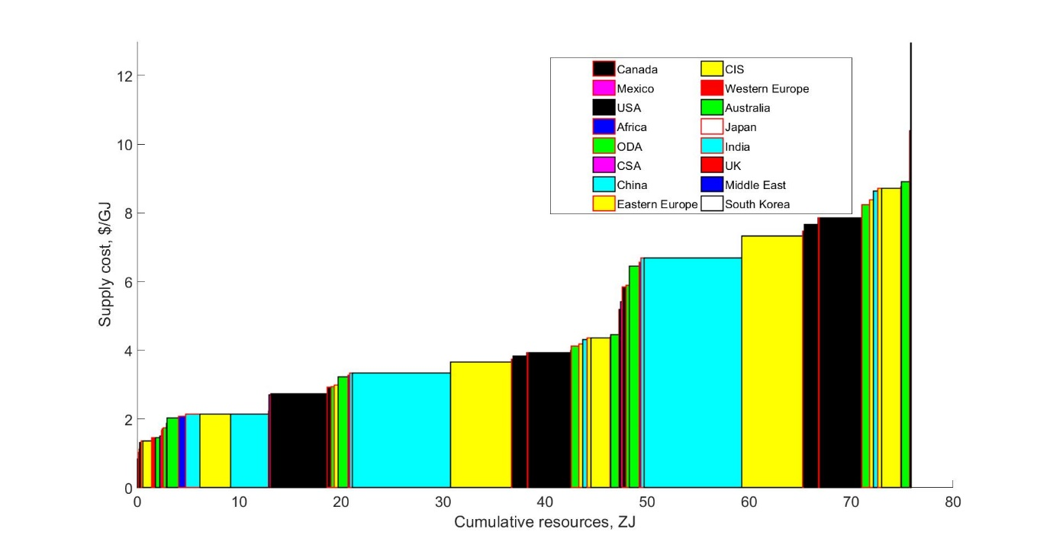
Supplementary Figure 5. Global supply cost curve for coal disaggregated into TIAM-UCL regions. Source data are provided as a Source Data file.

Fossil methane gas
The underlying availability and cost of fossil methane gas in TIAM-UCL is disaggregated into the following geological categories:
- Non-associated conventional gas proved reserves
- Non-associated conventional gas reserve additions
- Non-associated conventional gas new discoveries
- Associated fossil methane gas
- Arctic conventional fossil methane gas resources
- Shale gas
- Coal bed methane
- Tight fossil methane gas

As with oil, the disaggregation of fossil methane gas in TIAM-UCL is based on McGlade. This analysis has been extended in a forthcoming thesis by Welsby, with field-level assessments of resource availabilities and costs. On a regional level, supply cost curves are constructed using an approach developed in Welsby. Resource assessments were generally conducted at disaggregated field-/play-level, and then aggregated into the regions of TIAM-UCL using probability distributions, and taking into account any correlation between discrete estimates etc. These were then applied to depletion curves which were formed from a database of field-/play-level costs where possible. The database was extended to fields for which costs were either not known (i.e. no publicly available indication of field supply costs) or have not yet been developed.

Supplementary Figure 6 shows an example cost depletion curve for conventional non-associated fossil methane gas reserves. Aggregated regional supply cost curves (Supplementary Figure 7) were derived from field-/play-level cost depletion curves shown in Supplementary Figure 6 and have been aggregated into the TIAM-UCL regions. The three-step cost curves in TIAM-UCL mean that costs for each regions are aggregated from field-level data into weighted average costs for each cost step.
Additionally, Supplementary Figure 7 shows a) the regional breakdown of the resource distribution, and b) the supply cost with each resource category identified. For reference, none of the figures in this section include associated fossil methane gas resources in the supply cost curves, as these are calculated separately, with resource availabilities calculated by McGlade and Welsby. Additionally, improvements made by Welsby include an endogenous decision within the model of whether to produce the gas (which requires investment in new capacity if existing capacity is insufficient) or flare/vent it.

a)
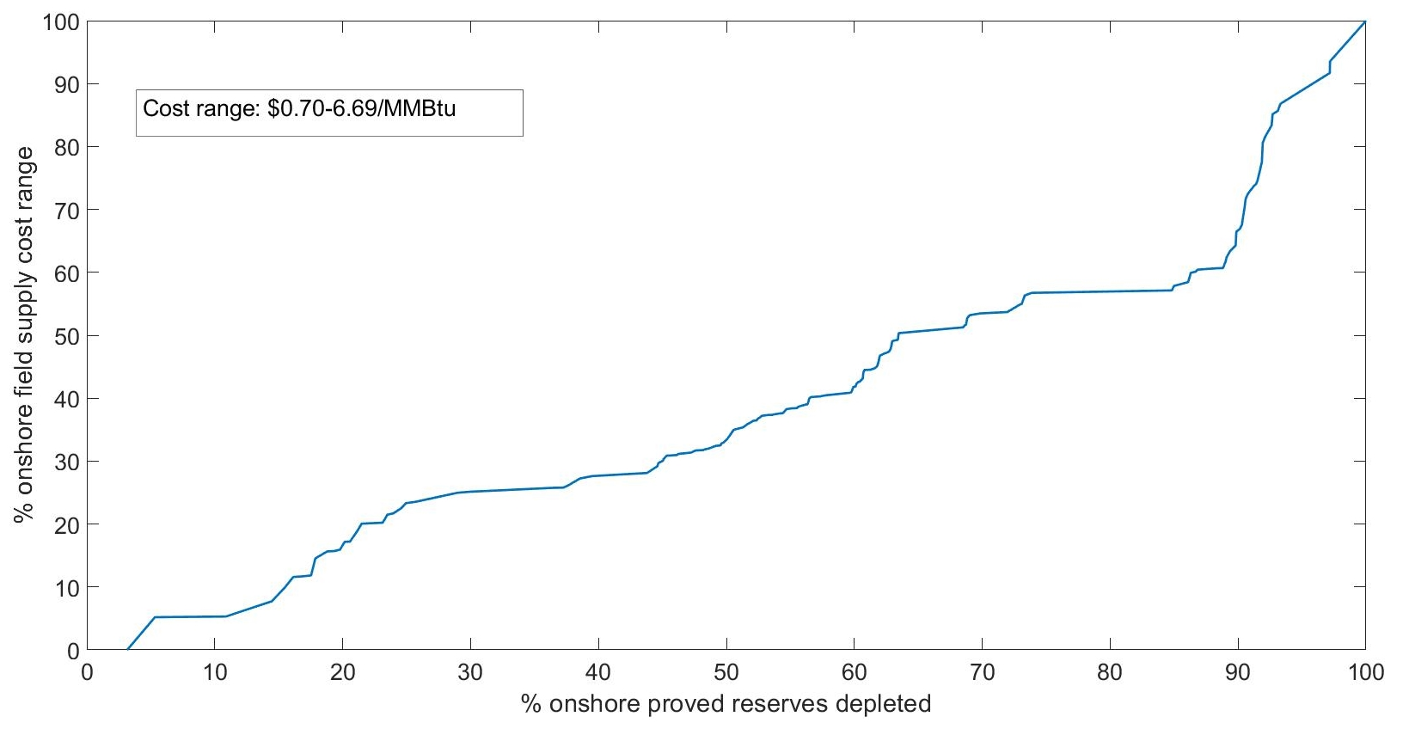

b)
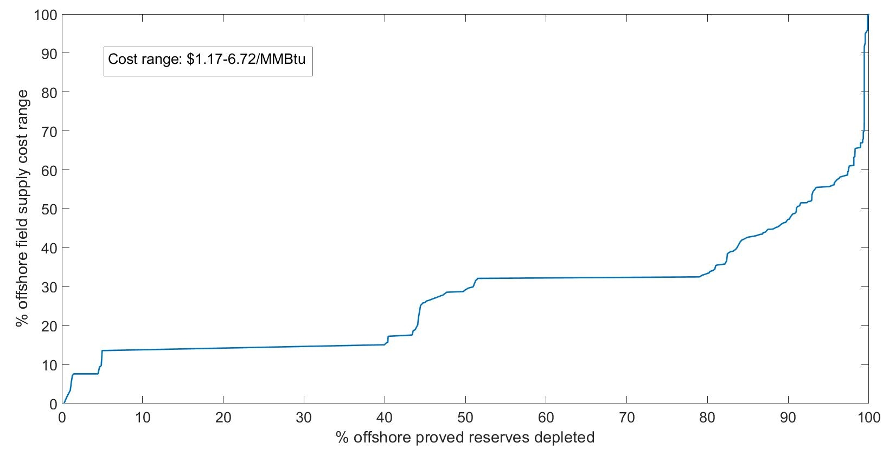
Supplementary Figure 6. Example cost depletion curve constructed by Welsby for proved onshore (a) and offshore (b) non-associated gas reserves.

a)
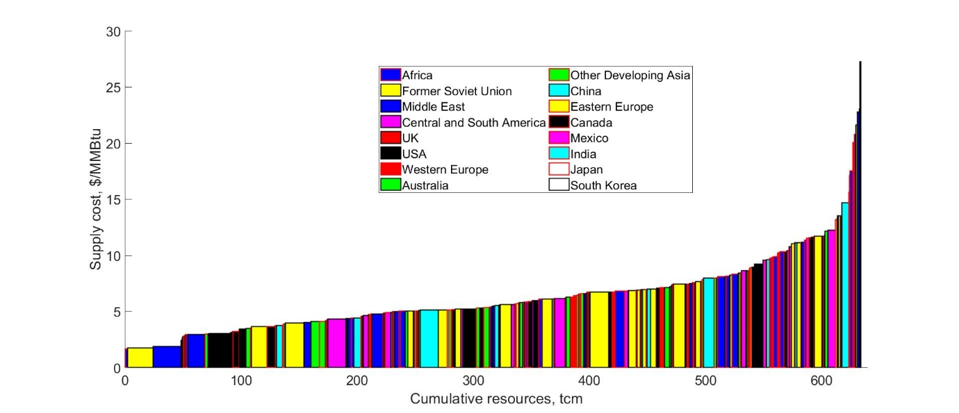
b)
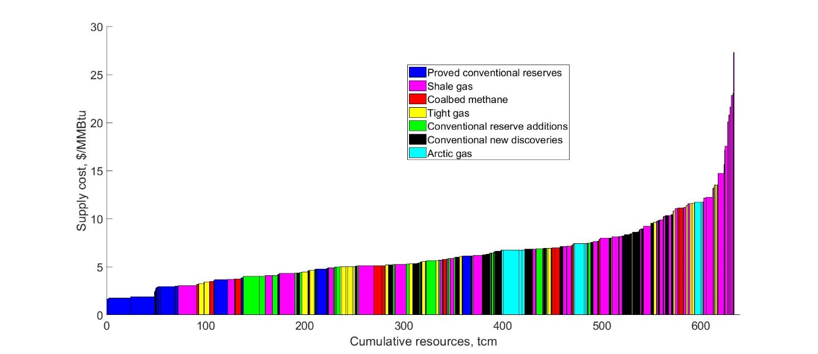
Supplementary Figure 7. Global gas supply cost curve from 2015 by a) region b) resource category. Source: Welsby, 2021, McGlade, 2013
Supplementary Table 10 shows a cost range for some key fossil methane gas mining technologies, generated using a field-level database and a linear regression model applied to geological parameters to generate cost depletion curves.
Supplementary Table 10. Cost range for individual fossil methane gas fields derived from the regression analysis by Welsby, and used to construct supply cost curves which were into TIAM-UCL

Resource category | Minimum cost, $/boe | Minimum cost region | Maximum cost, $/boe* | Maximum cost region
Proved non-associated onshore conventional reserves (includes sour) | 4 | FSU | 38 | FSU
Proved non-associated offshore shallow conventional reserves | 7 | Middle East | 37 | Europe
Proved non-associated offshore deep conventional reserves | 16 | Central and South America | 38 | USA
Conventional non-associated reserve additions | 10 | FSU | 45 | Middle East
Undiscovered non-associated conventional | 24 | Middle East | 58 | Central and South America
Sour fossil methane gas undeveloped | 29 | FSU | 45 | MEA_P
Arctic (undeveloped) | 36 | - | 63 | -
Shale gas | 14 | USA | 147 | MEA_P
Tight fossil methane gas | 18 | USA/CAN | 66 | Europe
CBM | 17 | USA | 60 | China, FSU

Oil
The representation of oil in TIAM-UCL is predominantly based on the work by McGlade, which focused on quantifying uncertainties in the outlook for oil and fossil methane gas, and in particular their availability and costs. As with fossil methane gas, oil is split into different geological categories, each with specific availabilities and supply cost dynamics:
- Conventional oil proved reserves
- Conventional oil reserve additions
- Conventional oil new discoveries
- Arctic oil
- Mined shale oil
- In-situ shale oil
- Light tight oil
- Mined oil sands
- In-situ oil sands (ultra-heavy oil)

The representation of uncertainty in TIAM-UCL for oil availability and costs differs between conventional and unconventional oil. For conventional oil, adapted country-level estimates of reserve and/or resource availability were taken from the literature and input into probability distributions, with corresponding assumptions on correlation between the estimates. For unconventional oil (e.g. mined bitumen), two parameters were assigned probability distributions: a range of estimates for original oil in-place (OOIP) and a range of estimates of a recovery factor (i.e. between 0 and 1, which determines the proportion of the in-place resource base which is technically recoverable). These two distributions were then combined using random repeated sampling (Monte Carlo simulations) to form regional estimates. The combination is the product of the OOIP and the recovery factor, repeated a large number of times to generate an aggregated distribution. These estimates of the resource base for each category of oil were then combined with cost depletion curves, mostly formed from IEA data on cost ranges, and used to generate supply cost curves. For reference, a detailed discussion around the construction of cost depletion and supply cost curves taking into account the inherent uncertainty in volumetric and cost estimates across different regions and oil resource categories can be found in McGlade. In general, the depletion analysis for unconventional oil exhibits significantly more rapid cost escalation (compared to conventional oil) as the resource base is depleted.
The mining processes for oil and fossil methane gas match the geological categories listed previously. Unconventional oil (tar sands and oil shale) has several more steps in the model to reflect the upgrading required to generate a barrel of crude oil (i.e. to get from bitumen/kerogen, to a barrel of synthetic crude oil). Supplementary Table 11 shows the range of costs in TIAM-UCL for the mining technologies in the upstream sector. Also included is the region in TIAM-UCL containing the minimum and maximum cost for each category. As with fossil methane gas represented in Supplementary Figure 6, the supply cost curves for each category of oil are split into three sections: the first 50% of the resource base considered the lowest cost, then the next 30%, and finally the most expensive oil representing the last 20% of the resource base.
Supplementary Table 11. Cost ranges for oil resources in TIAM-UCL

Resource category | Minimum cost, $/boe | Minimum cost region | Maximum cost, $/boe | Maximum cost region
Proved reserves | 11 | MEA_OPEC | 47 | CSA_N
Reserve addition | 21 | MEA_OPEC | 68 | CSA_N
New discoveries | 16 | MEA_OPEC | 94 | IND
Light tight oil | 30 | USA | 68 | Outside North America
Arctic | 46 | - | 97 | -
Bitumen (mining) | 51 | Canada | 89 | Central and South America
Bitumen (in-situ) | 43 | Canada | 88 | Central and South America
Ultra-heavy oil | 43 | Central and South America | 75 | Central and South America
Oil shale | 54 | Europe | 124 | Middle East
* Sourced from McGlade, 2013 with light tight oil updated by Welsby, 2021

Due to limited development outside of certain countries (e.g. Canada for bitumen production), costs have largely been applied homogenously across the relevant TIAM regions. Supplementary Figure 8 shows the global supply cost curve for oil in TIAM-UCL split by region (a) and resource category (b). It should also be noted that unconventional oil is split into three separate cost categories: variable O&M, fixed O&M, and an investment cost (i.e. capital cost). In order to incorporate these into a supply cost curve with conventional oil, a singular supply cost figure was required, therefore the O&M costs were summed, and then a per-unit investment cost was assigned to each category of unconventional oil (derived by dividing cumulative investment and cumulative production from each mining technology) which then yielded a supply cost figure.
a) | 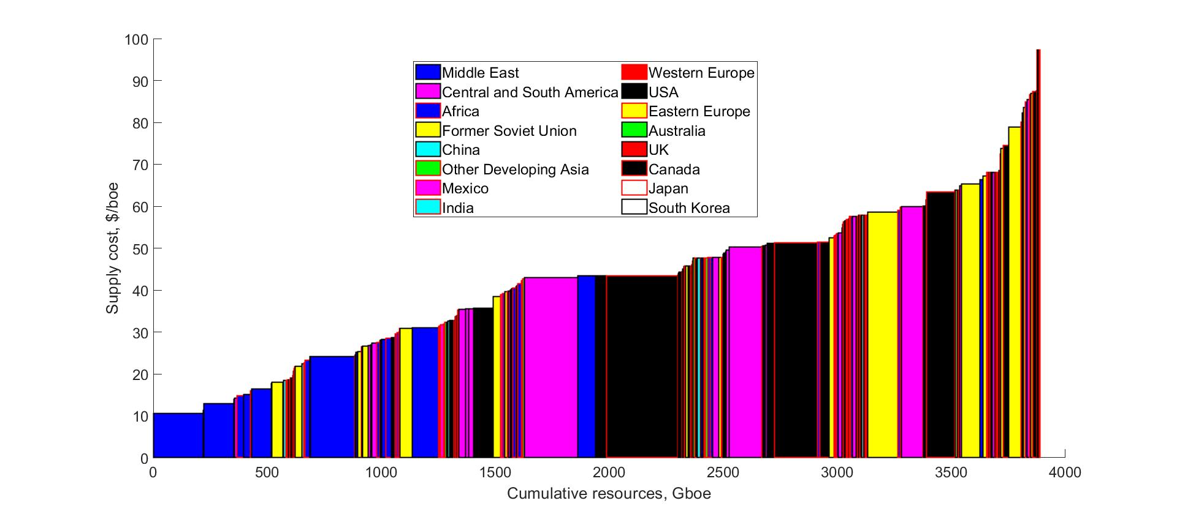
b) | 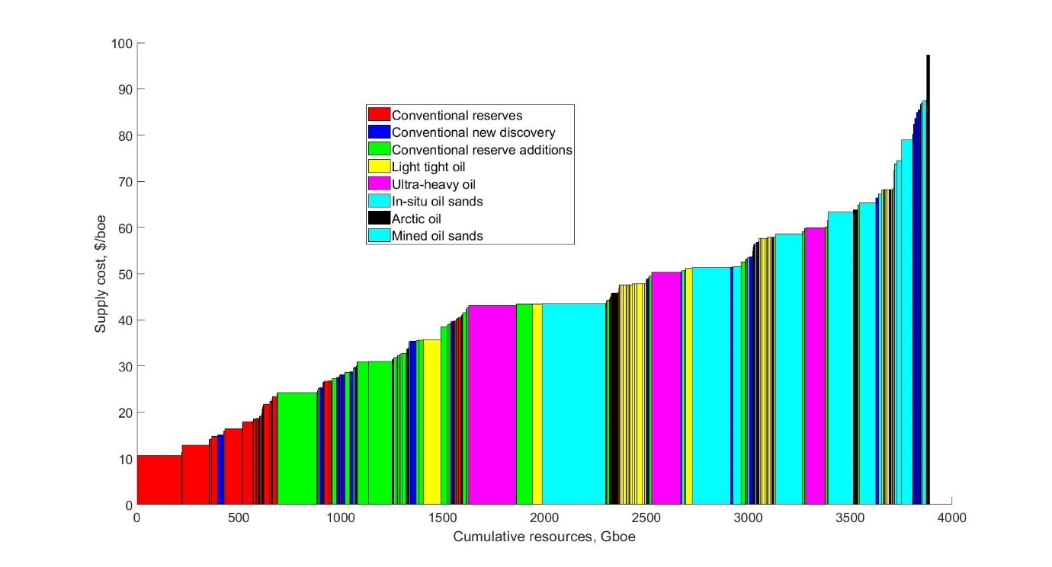
Supplementary Figure 8. Global supply cost curve for oil from 2015 by a) TIAM-UCL region and b) oil resource category. Source data are provided as a Source Data file.

Key upstream constraints on fossil fuel production
Coal
Upstream constraints for coal extraction are not as widely applied for two main reasons. Firstly, the extraction of coal does not follow the same geological production profile of oil and gas extraction; i.e. the growth and decline of production profiles through time and different geological structures. Secondly, for decarbonisation scenarios meeting 2ºC and below, coal is rapidly phased out of the energy mix. Traditionally, this decline has not been constrained in previous iterations of TIAM-UCL, however in this paper we have constrained the rate at which coal can be phased out of the energy system.
Oil and fossil methane gas
There are a range of upstream user constraints which control the rate at which production of different categories of oil and gas can grow/decline. In short, these user constraints model the natural growth and decline of oil and fossil methane gas. The predominant form of constraint is an exponential (constant) rate of growth/decline across a time-slice, using seed values if there is no residual (historical) productive capacity. Equation 1 shows the functional form of these growth (a) and decline (b) constraints, for extractive technologies with historical production, while (c) and (d) shows the same equations for technologies which have no historical production and therefore require a seed value.
(1 (a))

(1 (b))

(1 (c))

(1 (d))

Where,
Production_{i} = production of oil/gas for mining process i
Seed_{i} = seed value from which growth/decline coefficients are assigned to if no historical (i.e. t-1) volumes, and which is added to overall growth/decline constraint across each time-slice
t ₌ time period in the model (therefore t-1 is the previous time-slice)
Growth = growth coefficient, where Growth ≥ 1
Decline = decline coefficient, where Decline ≤ 1
ts = time-slice length (i.e. t – (t-1))

Therefore, for growth constraints, the production of an oil and/or gas mining technology in time slice t will be bounded (upper) by a maximum of production in time slice t-1 multiplied by the growth coefficient to the power of the length of the time-slice. For decline constraints, the inverse applies: production in t will be bounded (lower) by a minimum of production in t-1 multiplied by the decline coefficient to the power of the time-slice length. Supplementary Table 12 shows examples of the growth/decline coefficient parameters and seed values used in TIAM-UCL, for a range of oil (a) and gas (b) mining technologies.
Additional constraints have been input as a proxy for controlling the expansion of associated fossil methane gas. Whilst the production itself is a function of oil extraction (and oil economics), the infrastructural issues surrounding associated gas utilisation require some degree of user constraint. Therefore, an upstream constraint is placed on the speed at which associated gas processing and separation capacity can be added.
Supplementary Table 12. a) User constraints for a range of oil mining technologies extraction processes and b) gas extraction processes in TIAM-UCL

a)
Mining technology | Growth coefficient | Decline coefficient
Conventional proved reserves | 1.41 () | 0.93
Conventional reserve additions | 1.41 () | 0.93
Conventional undiscovered | 1.41 () | 0.93
Shale oil | 1.07 | 0.8
Mined bitumen | 1.07 | 0.8
In-situ bitumen | 1.1 | 0.85

b)
Mining technology | Growth coefficient |  | Decline coefficient
Conventional proved reserves | 1.41 () | 0.95
Conventional reserve additions | 1.41 () | 0.92
Conventional undiscovered | 1.41 () | 0.92
Shale gas | 1.27 | 0.83
Tight gas | 1.12 | 0.83
Coal bed methane | 1.12 | 0.83

Note: Regional variations are taken into account; therefore the numbers above may differ between regions. Additionally, the decline rate for conventional oil and gas fields will vary depending on the size of the field, the stage of decline, and the geological structure of the reservoirs (IEA, 2009). For example, larger fields generally exhibit slower rates of production decline, as shown with the value for conventional proved gas reserves which is taken from a representative decline parameter calculated from super-giant gas fields in the Former Soviet Union (e.g. Urengoy).

Supply chain emissions from upstream fossil fuel activity
TIAM-UCL accounts for methane leakage from the gas supply chain, with a user-defined percentage of total fossil methane gas supply being lost into the atmosphere (i.e. direct methane emissions). Distinctions are made between conventional and unconventional fossil methane gas. A central methane leakage rate was derived across a range of literature. The global warming potential of methane in TIAM-UCL is calculated over a 100-year time horizon (GWP-100), therefore where studies reported a different GWP time-period (e.g. 25 years), these were converted to GWP-100. For this study, our global average central leakage rate assumptions were 1.7% for conventional fossil methane gas and 2.1% for unconventional gas.
In addition to gas supply chains, TIAM-UCL also tracks methane emissions from oil and coal supply chains. For oil, fugitive methane emissions or intentional venting of methane is directly related to the presence of associated fossil methane gas. In short, if there is no infrastructure in place and/or demand downstream to absorb associated gas, the methane is either directly released into the atmosphere (venting) or flared (burnt-off) and released as CO_{2.} TIAM-UCL has various options for mitigating methane emissions from oil supply chains. Firstly, the model can build capacity to utilise rather than flare/vent fossil methane gas produced as a by-product of oil production.
Additionally, there is also a dummy option where the model can chose to flare rather than vent the methane if there is no demand for gas downstream/if building capacity is not cost optimal. Therefore, instead of methane being released into the atmosphere, CO₂ is instead emitted. As with oil, there are options available to minimise methane emissions from coal mining. These include an option to gather the methane and inject it into pipelines for use downstream, or a dummy option to flare the gas, therefore releasing CO₂ into the atmosphere rather than methane.

SI section 5. TIMES model formulation
TIAM-UCL uses the TIMES (The Integrated MARKAL-EFOM System) framework, a framework developed to explore and assess how energy systems may change over time, particularly in response to different policies e.g. climate or renewable energy targets, and drivers of energy demand e.g. economic growth. It is a partial equilibrium model, so balances supply and demand within the energy system, finding the least-cost solution for an energy system that meets future demand for energy services, such as space heating and cooling, mobility, and industrial production output.
A key feature of the model is that it is constructed from the technology level up, meaning that many of the system components e.g. refineries, vehicles, power stations, can be represented, including their performance and costs. An advantage of TIMES is that is can assess the role of these many different components within an interconnected system, exploring trade-offs, and dependencies, and providing a consistent assessment of the system as a whole. TIMES is also known as an E3 model, meaning that it provides metrics on the physical energy system (technology capacity, system operation, energy use totals), on the economics of the system (investment requirements, energy costs), and on the environmental impacts (GHGs).
TIAM-UCL, as typical of a TIMES model, is made up of five key components, as shown in Supplementary Figure 9. The first stage is the definition of what the system looks like (model structure), including the sectors to be included, typically from primary production through conversion to end use, types of technologies, and available energy resources. A Reference Energy System links all of these components together, allowing for the flow of energy through the system. Structure definition also include the spatio-temporal resolution e.g. number of regions, the number of time periods, and the time horizon over which the model is going to be run.
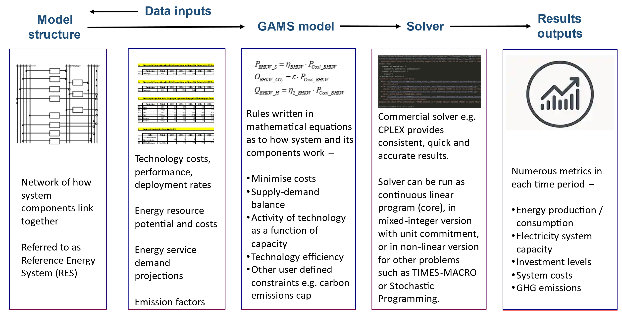
Supplementary Figure 9. Core components of the TIMES model framework
Each part of the model system is populated with data assumptions, including technology costs and performance, resource availability and cost, the demands that the system needs to meet today and in the future, and the associated emissions of different fuel-technologies.
The model input data are then used to construct a linear programme (using GAMS code), whereby the rules of the system operation and evolution are defined based on a set of mathematical equations. The linear programme is then solved to explore the least-cost energy system required to meet the energy service demands in the future, subject to constraints. A large number of metrics result that describe the emerging energy system, in terms of the physical system (number of vehicles, power system capacity, total bioenergy use), the costs of that system, and the emissions resulting from the system’s operation.
This section now focuses on the core equations used in the linear programme. This code is available on Github, with full documentation available on the ETSAP website.
In simple terms, an optimisation model such as TIAM-UCL will –
- Minimise the objective function (total system costs)
- whilst satisfying the energy service demand requirements
- and respecting the system constraints

The key equations that set the rules of the model LP (linear programming) problem are summarised below:
- Objective function (EQ_OBJ). The function is to minimise total discounted system costs.
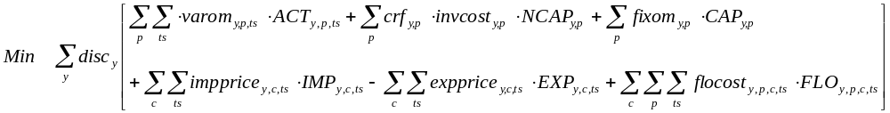

Where disc is the global discount rate, varom is the variable O&M costs associated with technology activity (ACT), invcost is the capital expenditure associated with new investment (NCAP), discounted using the crf (capital recovery factor), impprice is the price of imports, multiplied by import level (IMP), expprice is the price of exports, multiplied by export level (EXP), and flocost is the cost of other domestic energy commodities (FLO).
Where index y is year, p is process (technology), c is energy commodity, and ts is time segment.

- Commodity balance (EQ(l)_COMBAL). This equation ensures that the production of a commodity is equal to it consumption, to balance commodity markets.

- Transformation equation (EQ_PTRANS). This establishes the relationship between an input commodity to a technology and an output commodity e.g. technology efficiency
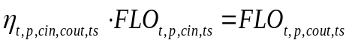

Where ɳ is the efficiency factor, and FLO_{cin} and FLO_{cout} represent the input and output commodities of a technology.

- Product allocation constraint (EQ(l)_INSHR/OUTSHR). Allows for the control of different commodity shares, where there are more than one input or output commodities into a technology.
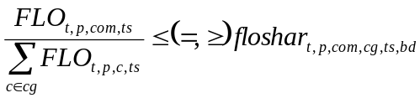
Where floshar defines the share of the single commodity (numerator) over the sum of commodities (denominator), or commodity group (index cg).

- Activity definition (EQ_ACTFLO). Activity of a technology is a function of the commodity flow, either of inputs but more typically outputs.
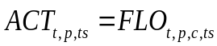

- Utilization constraint (EQ_CAPACT). Ensures that the activity of a technology is a function of its capacity
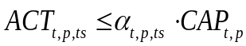
While the above equations constitute the key set used in the linear programme, a full listing can be found in Loulou et al. (2016), in Table 24. These include specific equations that bound capacity, activity and commodity production, set the rules for the operation of storage technologies, or ensures capacity exceeds demand for a selected commodity in a given time period (often used to ensure a peak margin for electricity systems).
User defined equations can also be built to provide more control over the model operation. Most are built using the standard LHS form, where the left hand side of the equation includes the variables to be controlled, while the right hand side (RHS) set the rule e.g. must be greater than 10% of total generation (share) or less than 50 GW capacity (absolute). Other user constraints are more dynamic in nature e.g. growth constraints that set % changes on the preceding period levels.

Welsby D. et al. Unextractable fossil fuels in a 1.5 °C world. Nature 597, 230–234 (2021).
Riahi, K. et al. The Shared Socioeconomic Pathways and their energy, land use, and greenhouse gas emissions implications: An overview. Glob. Environ. Chang. 42, 153–168 (2017).
Daioglou, V., Stehfest, E., Wicke, B., Faaij, A. & van Vuuren, D. P. Projections of the availability and cost of residues from agriculture and forestry. GCB Bioenergy 8, 456–470 (2016).
Ricardo Energy & Environment. Biomass Feedstock Availability, Final Report for BEIS. Ref ED662421043 - Issue Number 3 (2017).
Hoogwijk, M., Faaij, A., de Vries, B. & Turkenburg, W. Exploration of regional and global cost-supply curves of biomass energy from short-rotation crops at abandoned cropland and rest land under four IPCC SRES land-use scenarios. Biomass and Bioenergy 33, 26–43 (2009).
Dodds, P. & McDowall, W. A review of hydrogen production technologies for energy system models. https://www.lifestudy.ac.uk/bartlett/energy/research/themes/energy-systems/hydrogen/WP6_Dodds_Production.pdf (2012)
Ekins, P. et al. The role of CCS in meeting climate policy targets. https://www.globalccsinstitute.com/resources/publications-reports-research/the-role-of-ccs-in-meeting-climate-policy-targets/ (2017).
Rubin, E. S., Davison, J. E. & Herzog, H. J. The cost of CO2 capture and storage. Int. J. Greenh. Gas Control 40, 378–400 (2015).
International Renewable Energy Agency. Renewable Power Generation Costs in 2017. (2018). doi:10.1007/SpringerReference_7300.
IEA PVPS. Trends 2018 in Photovoltaic applications. Survey Report of Selected IEA Countries between 1992 and 2014 https://iea-pvps.org/wp-content/uploads/2020/01/2018_iea-pvps_report_2018.pdf (2018).
Butnar, I., Broad, O., Solano Rodriguez, B. & Dodds, P. E. The role of bioenergy for global deep decarbonization: CO2 removal or low-carbon energy? GCB Bioenergy 12, 198–212 (2020).
Remme, U., Blesl, M. & Fahl, U. Global resources and energy trade: An overview for coal, natural gas, oil and uranium. https://d-nb.info/1027991858/34 (2007).
McGlade, C. Uncertainties in the outlook for oil and gas. Doctoral thesis, UCL (University College London). (2013).
Welsby, D. Modelling uncertainty in global gas resources and markets (forthcoming). (University College London, 2021).
Welsby, D. Modelling uncertainty in global gas resources and markets (forthcoming). (University College London, 2021).
McGlade, C. Uncertainties in the outlook for oil and gas. Doctoral thesis, UCL (University College London). (2013).
Welsby, D. Modelling uncertainty in global gas resources and markets (forthcoming). (University College London, 2021).
Welsby, D. Modelling uncertainty in global gas resources and markets (forthcoming). (University College London, 2021).
Welsby, D. Modelling uncertainty in global gas resources and markets (forthcoming). (University College London, 2021).
Welsby, D. Modelling uncertainty in global gas resources and markets (forthcoming). (University College London, 2021).
McGlade, C. Uncertainties in the outlook for oil and gas. Doctoral thesis, UCL (University College London). (2013).
Welsby, D. Modelling uncertainty in global gas resources and markets (forthcoming). (University College London, 2021).
McGlade, C. Uncertainties in the outlook for oil and gas. Doctoral thesis, UCL (University College London). (2013).
McGlade, C. Uncertainties in the outlook for oil and gas. Doctoral thesis, UCL (University College London). (2013).
McGlade, C. Uncertainties in the outlook for oil and gas. Doctoral thesis, UCL (University College London). (2013).
Welsby, D. Modelling uncertainty in global gas resources and markets (forthcoming). (University College London, 2021).
Welsby, D. Modelling uncertainty in global gas resources and markets (forthcoming). (University College London, 2021).
Loulou, R., Lehtilä, A., Kanudia, A., Remme, U. & Goldstein, G. Documentation for the TIMES Model: Part II. https://iea-etsap.org/docs/Documentation_for_the_TIMES_Model-Part-II_July-2016.pdf (2016).
Loulou, R., Lehtilä, A., Kanudia, A., Remme, U. & Goldstein, G. Documentation for the TIMES Model: Part II. https://iea-etsap.org/docs/Documentation_for_the_TIMES_Model-Part-II_July-2016.pdf (2016).

