Supplementary Information

Title: Cervicovaginal microflora isolated from healthy women exhibited probiotic properties and antimicrobial activity against pathogens isolated from cervical cancer patients

Journal: Archives of Microbiology
Authors: Ashwini Kambleª, Shilpa Naik^{b}, Manju Talathi^{c}, Deepali Jadhav^{b}, Samradni Pingaleª, Ruchika Kaul-Ghanekar^{a*}
Affiliation: ªCancer Research Lab, Interactive Research School for Health Affairs (IRSHA), Bharati Vidyapeeth (Deemed to be) University, Katraj-Dhankawadi, Pune-Satara Road, Pune-411043, Maharashtra, India
^{b}Department of Obstetrics & Gynaecology, B. J. Govt Medical College & Sassoon General Hospitals, Pune
^{c}Department of Obstetrics &Gynaecology, Bharati Vidyapeeth (Deemed to be) University Medical College & Hospital, Pune

Author email address: Ashwini Kamble
E-mail: ashwini.kamble@bharatividyapeeth.edu
Shilpa Naik
E-mail: shilunnaik@yahoo.co.in
Manju Talathi
E-mail: manju.talathi@bharatividyapeeth.edu
Deepali Jadhav
E-mail:deepjadhav1988@gmail.com
Samradni Pingale
E-mail samradni.pingale@bharatividyapeeth.edu

* Correspondence: Ruchika Kaul-Ghanekar
E-mail:ruchika.kaul-ghanekar@bharatividyapeeth.edu
Phone: +91-020 –24366929/31
Fax: +91- 020 –24366931

Supplementary Table S1 Phenotypic characterization and hemolytic activity of vaginal microflora isolated from healthy individuals
Sample  Sr. no. | Sample number code | Isolate Sr. no | Isolate  Code | Colony morphology |  | Microscopic observation | Gram test | Catalase test | Hemolytic activity
 |  |  |  | Colony color | Colony type
 | P-1 |  | P1Mcs | Creamy | Small | Coccobacilli | + | - | Gamma
 |  |  | P1Bcb | Creamy | Big | Cocci | + | - | Beta
 |  |  | P1Bws | White | Small | Rods | + | - | Gamma
 |  |  | P1Tcs | Creamy | Small | Cocci | + | + | Beta
 | P-2 |  | P2Mct | Creamy | Tiny | Rods | + | - | Gamma
 |  |  | P2Mcs | Creamy | Small | Cocci | + | - | Gamma
 |  |  | P2Bopb | Opaque | Big | Cocci | - | + | Beta
 | P-3 |  | P3Mcb | Creamy | Big | Cocci | + | + | Beta
 |  |  | P3Bwb | Whitish | Big | Cocci | + | - | Gamma
 |  |  | P3Bws | Whitish | Small | Thin rods | + | - | Gamma
 |  |  | P3Bwm | Whitish | Medium | Long rods | + | - | Gamma
 |  |  | P3Tcs | Creamy | Small | Small cocci | - | - | Gamma
 | P-5 |  | P5Mcb | Creamy | Big | Cocci | + | + | Beta
 |  |  | P5Mcs | Creamy | Small | Short rods | + | - | Gamma
 |  |  | P5Bws | Whitish | Small | Rods | + | - | Gamma
 |  |  | P5Tcs | Creamy | Small | Cocci | - | + | Beta
 | P-6 |  | P6Mws | Whitish | Small | Rods | + | - | Gamma
 |  |  | P6Bops | Opaque | Small | Bacilli | + | - | Gamma
 |  |  | P6Bwt | Whitish | Tiny | Cocci | + | - | Alpha
 |  |  | P6Tcb | Creamy | Big | Cocci | + | - | Alpha
 | P-7 |  | P7Mcs | Creamy | Small | Long rods | + | - | Gamma
 |  |  | P7Bops | Opaque | Small | Bacilli | + | - | Gamma
 |  |  | P7Tcs | Creamy | Small | Cocci | + | + | Beta
 | P-8 |  | P8Mcs | Creamy | Small | Short rods | + | - | Gamma
 |  |  | P8Mcb | Creamy | Big | Big Cocci | + | + | Beta
 |  |  | P8Bws | Whitish | Small | Cocci | + | + | Beta
 | P-9 |  | P9Mws | Whitish | Small | Short rods | + | - | Gamma
 |  |  | P9Mops | Opaque | Small | Rods | - | - | Alpha
 |  |  | P9Bcb | Creamy | Big | Cocci | + | + | Beta
 |  |  | P9Twb | Whitish | Big | Cocci | + | + | Beta
 | P-10 |  | P10Mcb | Creamy | Big | Cocci | + | + | Gamma
 |  |  | P10Tct | Creamy | Tiny | Bacilli | + | - | Gamma
 | P-11 |  | P11Bws | Whitish | Small | Rods | + | - | Gamma
 |  |  | P11Mcb | Creamy | Big | Cocci | + | - | Gamma
 | P-12 |  | P12Mcb | Creamy | Big | Cocci | + | + | Beta
 |  |  | P12Bops | Opaque | Small | Coccobacilli | + | - | Gamma
 | P-13 |  | P13Mws | Whitish | Small | Rods | + | - | Gamma
 |  |  | P13Bops | Opaque | Small | Rods | + | - | Gamma
 | P-14 |  | P14Mcs | Creamy | Small | Rods | + | - | Gamma
 | P-15 |  | P15Mcm | Creamy | Medium | Cocci | + | - | Gamma
 |  |  | P15Mws | Whitish | Small | Rods | + | - | Gamma
 | P-16 |  | P16Mws | Whitish | Small | Rods | + | - | Gamma
 | P-17 |  | P17Mws | Whitish | Small | Rods | + | - | Gamma
 | P-18 |  | P18Mops | Opaque | Small | Rods | + | - | Gamma
 |  |  | P18Mct | Creamy | Tiny | Cocci | + | - | Gamma
 |  |  | P18Mcs | Creamy | Small | Cocci | + | - | Gamma
 |  |  | P18Topb | Opaque | Big | Cocci | + | - | Gamma
 | P-19 |  | P19Mws | Whitish | Small | Rods | + | - | Gamma
 |  |  | P19Mopm | Opaque | Medium | Rods | - | - | Alpha
 |  |  | P19Tcb | Creamy | Big | Cocci | + | - | Alpha
 | P-20 |  | P20Mopb | Opaque | Big | Coccobacilli | + | - | Gamma
 | P-21 |  | P-21Mcb | Creamy | Big | Rods | + | - | Gamma
 |  |  | P21Tcs | Creamy | Small | Cocci | + | + | Beta
 | P-22 |  | P22Mops | Opaque | Small | Bacilli | ₊ | - | Gamma
 |  |  | P22 Mws | Whitish | Small | Rods | - | + | Gamma
 |  |  | P22Twt | Whitish | Tiny | Cocci | + | + | Beta
 | P-23 |  | P23Mcs | Creamy | Small | Rods | + | - | Gamma
 |  |  | P23Tcb | Creamy | Big | Oval Cocci | + | - | Gamma
 |  |  | P23Tcm | Creamy | Medium | Cocci | + | - | Alpha
 | P-24 |  | P24Mwt | Whitish | Tiny | Rods | + | - | Gamma
 |  |  | P24Mcm | Creamy | Medium | Cocci | + | - | Alpha
 |  |  | P24Tcb | Creamy | Big | Cocci | + | + | Alpha
 | P-25 |  | P25Mws | Whitish | Small | Rods | + | _ | Gamma
 | P-26 |  | P26Mcm | Creamy | Medium | Cocci | + | - | Gamma
 |  |  | P26Mct | Creamy | Tiny | Cocci | + | - | Gamma
 | P-28 |  | P28Mws | Whitish | Small | Rods | + | _ | Gamma
 | P-31 |  | P31Mcs | Creamy | Small | Rods | + | - | Gamma
 | P-33 |  | P33Mcm | Creamy | Medium | Cocci | + | + | Gamma
 | P-34 |  | P34Mcs | Creamy | Small | Bacilli | + | - | Gamma
 |  |  | P34Mws | Creamy | Small | Rods | + | - | Gamma
 |  |  | P34Tcm | Creamy | Medium | Cocci | + | - | Alpha
 | P-35 |  | P35Mws | Whitish | Small | Rods | + | - | Gamma
 | P-36 |  | P36Mcb | Creamy | Big | Cocci | + | + | Beta
 |  |  | P36Mops | Opaque | Small | Bacilli | + | _ | Gamma
 |  |  | P36Mws | Whitish | Small | Rods | + | _ | Gamma
 | P-37 |  | P37Mcb | Creamy | Big | Cocci | + | + | Gamma
 |  |  | P37Mws | Whitish | Small | Rods | + | _ | Gamma
 | P-38 |  | P38Mops | Opaque | Small | Rods | + | - | Gamma
 |  |  | P38Mct | Creamy | Tiny | Rods | - | + | Beta
 | P-39 |  | P39Mops | Opaque | Small | Rods | + | - | Gamma
 |  |  | P39Tcb | Creamy | Big | Cocci | + | + | Alpha
 |  |  | P39Tcm | Creamy | Medium | Cocci | + | + | Beta
 | P-42 |  | P42Mcb | Creamy | Big | Cocci | + | + | Beta
 |  |  | P42Mcm | Creamy | Medium | Rods | + | - | Gamma
 |  |  | P42Tcm | Creamy | Medium | Cocci | + | + | Beta
 | P-43 |  | P43Mops | Opaque | Small | Rods | + | - | Gamma
 |  |  | P43Tcm | Creamy | Medium | Oval Cocci | + | - | Gamma
 | P-44 |  | P44Mcm | Creamy | Medium | Cocci | + | _ | Gamma
 |  |  | P44Mcs | Creamy | Small | Rods | + | _ | Gamma
 |  |  | P44Tpm | Pigmented | Medium | Cocci | + | + | Beta
 |  |  | P44Tcs | Creamy | Small | Cocci | + | _ | Gamma
 | P-45 |  | P45Bws | Whitish | Small | Rods | + | - | Gamma
 |  |  | P45Tcm | Creamy | Medium | Cocci | + | - | Gamma
 | P-46 |  | P46Mopb | Opaque | Big | Rods | + | _ | Gamma
 |  |  | P46Mops | Opaque | Small | Rods | + | - | Gamma
 |  |  | P46Bcm | Creamy | Medium | Cocci | _ | + | Beta
 | P-47 |  | P47Mops | Opaque | Small | Rods | + | - | Gamma
 |  |  | P47Bws | Whitish | Small | Rods | + | - | Gamma
 | P-49 |  | P49Mopb | Creamy | Big | Cocci | + | + | Gamma
 |  |  | P49Bcb | Creamy | Big | Oval shaped | + | - | Gamma
 | P-51 |  | P51Mcm | Creamy | Medium | Cocci | + | _ | Gamma
 |  |  | P51Mwt | Whitish | Tiny | Rods | + | - | Gamma
 |  |  | P51Tops | Opaque | Small | Rods | + | - | Gamma
 | P-52 |  | P52Mcm | Creamy | Medium | Cocci | + | - | Gamma
 |  |  | P52Tcb | Creamy | Big | Cocci | + | _ | Gamma
 |  |  | P52Twt | Whitish | Tiny | Rods | - | + | Beta
 | P-53 |  | P53Mcs | Creamy | Small | Cocci | + | - | Gamma
 |  |  | P53Tcm | Creamy | Medium | Cocci | + | - | Gamma
 | P-54 |  | P54Mcs | Creamy | Small | Cocci | + | - | Gamma
 |  |  | P54Tcb | Creamy | Big | Cocci | + | + | Gamma
 |  |  | P54Tcm | Creamy | Medium | Cocci | + | - | Gamma

Supplementary Table S2. Phenotypic characterization and hemolytic activity of vaginal microflora isolated from LSIL, HSIL and ICC patients
Subject group | Sample number | Sr. no | Isolate code | Colony morphology |  | Microscopic observation | Gram test | Catalase test | Haemolytic activity
 |  |  |  | Colony color | Colony type
LSIL | P-41 |  | P41Mws | Whitish | Small | Cocci | + | - | Gamma
LSIL | P-41 |  | P41Twm | Whitish | Medium | Oval cocci | + | - | Gamma
LSIL | P-41 |  | P41Tcs | Creamy | Small | Cocci | + | + | Beta
LSIL | P-41 |  | P41Twm | Whitish | Medium | Cocci | + | - | Alpha
HSIL | P-79 |  | P79Bcb | Creamy | Big | Cocci | + | + | Beta
HSIL | P-79 |  | P79Bcm | Creamy | Medium | Bacilli | - | + | Beta
HSIL | P-79 |  | P79Bopm | Opaque | Medium | Cocci | - | - | Gamma
HSIL | P-79 |  | P79Tws | Whitish | Small | Bacilli | + | - | Gamma
HSIL | P-79 |  | P79Twt | Whitish | Tiny | Bacilli | + | - | Gamma
ICC | P-29 |  | P29Mops | Opaque | Small | Cocci | + | - | Alpha
ICC | P-29 |  | P29Tcb | Creamy | Big | Cocci | + | + | Beta
ICC | P-30 |  | P30Tcs | Creamy | Small | Rods | - | + | Beta
ICC | P-30 |  | P30Twm | Whitish | Medium | Rods | - | - | Alpha
ICC | P-30 |  | P30Bws | Whitish | Small | Rods | + | - | Gamma
ICC | P-30 |  | P30Bwm | Whitish | Medium | Rods | + | + | Beta
ICC | P-48 |  | P48Tcs | Creamy | Small | Cocci | + | + | Beta
ICC | P-48 |  | P48Tcm | Creamy | Medium | Cocci | + | + | Beta
ICC | P-48 |  | P48Bws | White | Small | Rods | + | - | Gamma
ICC | P-48 |  | P48Bcb | Creamy | Big | Cocci | + | + | Beta
ICC | P-50 |  | P50Mops | Opaque | Small | Cocci | + | + | Beta
ICC | P-50 |  | P50Tws | Whitish | Small | Cocci | + | - | Alpha
ICC | P-50 |  | P50Bop | Opaque | Small | Rods | + | + | Beta
ICC | P-58 |  | P58Mcs | Creamy | Small | Ovalcocci | + | _ | Gamma
ICC | P-58 |  | P58Mcm | Creamy | Medium | Ovalcocci | + | - | Gamma
ICC | P-58 |  | P58Bcb | Creamy | Big | Cocci | + | + | Beta
ICC | P-58 |  | P58Bcm | Creamy | Medium | Cocci | + | - | Gamma
ICC | P-68 |  | P68Bcm | Creamy | Medium | Cocci | + | + | Beta
ICC | P-68 |  | P68Bwm | Whitish | Medium | Bacilli | + | - | Gamma
ICC | P-68 |  | P68Tcb | Creamy | Big | Cocci | + | - | Alpha

Supplementary Table S3.Zone of inhibition of the standard antibiotics (against vaginal pathogens isolated from LSIL, HSIL and ICC patients)
Sr. no. | Antibiotics | Zone of inhibition (mm) against vaginal pathogens
Sr. no. | Antibiotics | E. coli |  | S. haemolyticus |  |  | E. faecalis
Sr. no. | Antibiotics | P30Tcs | P79Bcm | P41Tcs | P58Bcb | P48Bcb | P29Mops | P50Tws | P68Tcb
 | Carbencillin  (CB) | - | - | - | - | - | 24.33±1.15 | 18.67±2.89ª | 19.33±1.15^{d}
 | Cefoxitin  (CX) | - | - | 17.00±1.73^{d} | 15.33±0.58^{d} | - | 14.00±0.00^{d} | 14.67±0.58^{d} | 13.33±1.15^{d}
 | Clindamycin (CD) | - | - | 24.67±0.58ª | 25.67±1.15^{b} | 28.33±2.89ª | - | - | 8.67±1.15^{d}
 | Chloramphenicol (C) | 30.00±0.00 | 25.67±2.08 | 23.33±2.89^{b} | 25.00±0.00^{c} | 25.00±0.00^{d} | 10.33±0.58^{d} | 11.33±0.58^{d} | 23.67±1.15ª
 | Erythromycin  (E) | - | 15.00±0.00^{d} | 23.33±2.89^{b} | 25.00±0.00^{c} | 12.67±1.15^{d} | 12.00±0.00^{d} | 12.67±0.58^{d} | 10.33±2.52^{d}
 | Metronidazole (MT) | - | - | - | - | - | - | - | -
 | Penicillin G  (P) | - | - | 13.33±2.52^{d} | 17.00±0.00^{c} | 12.00±1.73^{d} | 20.00±0.00^{c} | 21.33±3.21ª | 24.67±0.58ª
 | Tetracycline  (TE) | 20.00±0.00^{d} | 16.67±2.89^{d} | 26.67±2.89ª | 29.33±1.15ª | 30.67±1.15ª | 16.67±0.58^{d} | 15.33±1.15^{d} | 12.67±0.58^{d}
Note: “-‘ noactivity observed. Antibiotic concentrations per disc: CB: carbencillin (100μg); CX: cefoxitin (30μg); CD: clindamycin (2μg); C: chloramphenicol (30μg); E: erythromycin (15μg); MT: metronidazole (5μg); P: penicillin G (10 unit); and TE: tetracycline (30 μg). Each value has been represented as the mean± SD of the data (n=3). Statistically different results within the column were labelled with various lowercase letter (a:p>0.05; b:p<0.05; c:p<0.005; d:p<0.0001)

Supplementary Figure S1. Liquid chromatography–mass spectrometry pattern of common metabolites identified in CFSs of the four probiotic strains: a) N-(1-deoxy-1-fructosyl)valine, b) homoarecoline, c) conhydrine, d) 1-acetoxy-2-hydroxy-16-heptadecen-4-one, e) taraxinic acid glucosyl ester, f) nigellicine, g) (+)-O-methylarmepavine, h) 6-methylquinoline, i) ephedrine
(a)
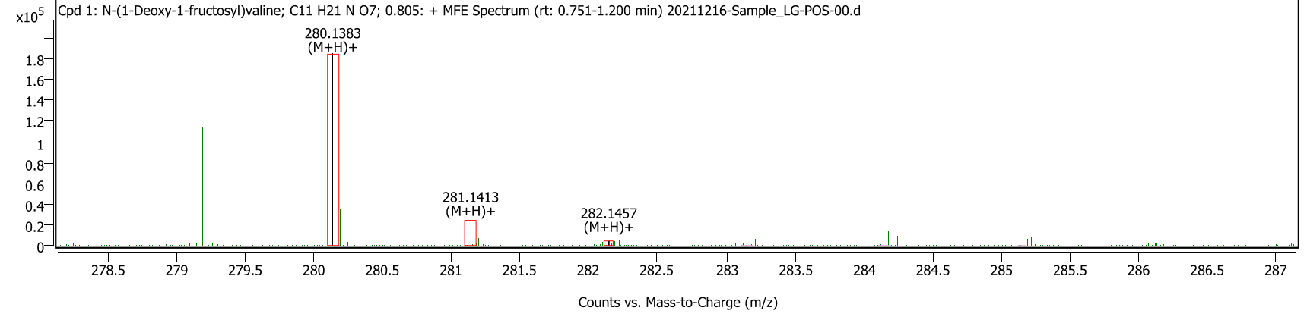
(b)
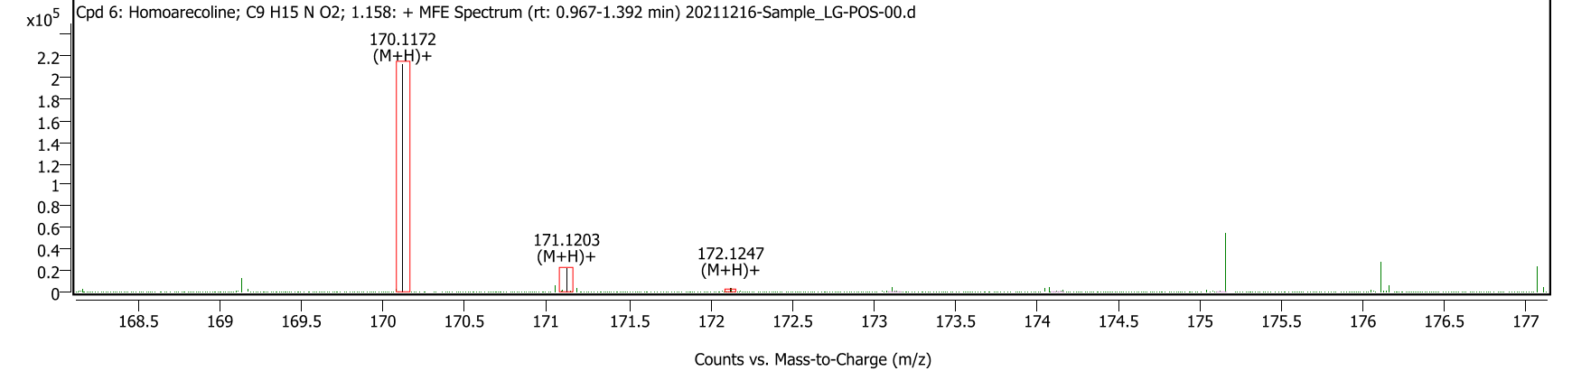
(c)
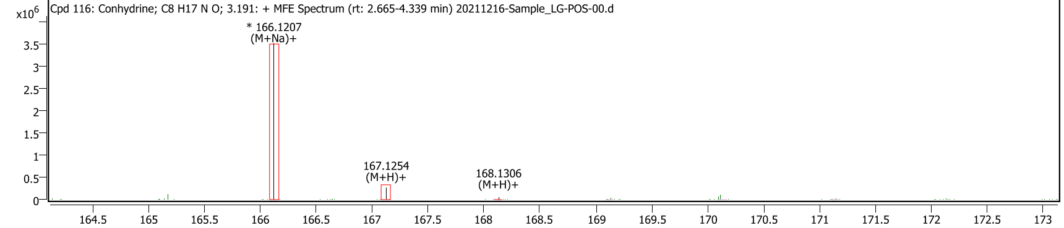

(d)
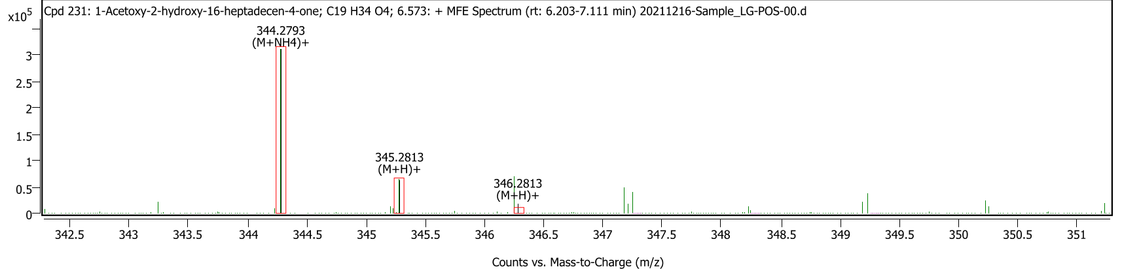
(e)
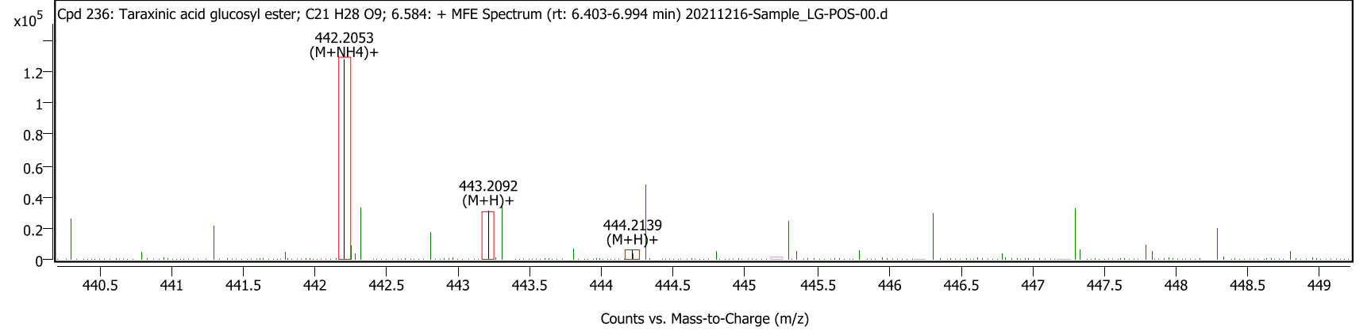

(f)
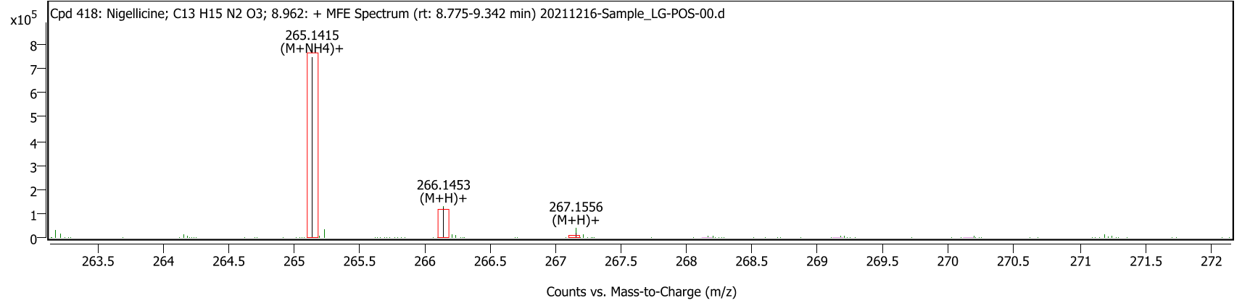

(g)
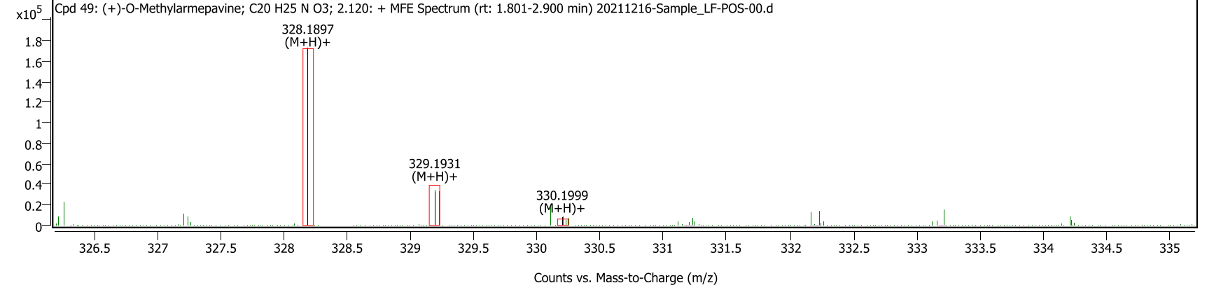
(h)
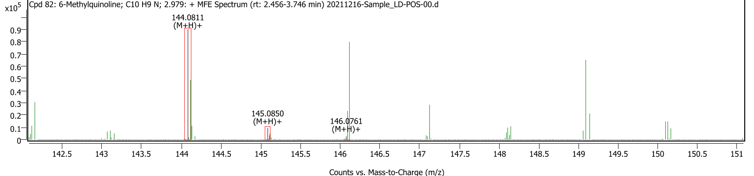
(i)
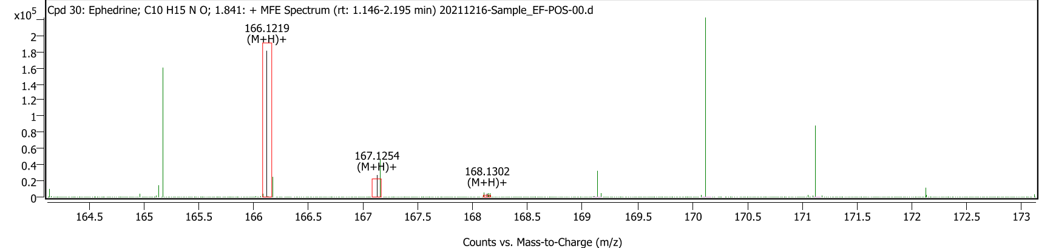

Supplementary Figure S2. Phylogenetic tree of L. gasseri P36Mops

Supplementary Figure S3. Phylogenetic tree of L. fermentum P37Mws

Supplementary Figure S4.Phylogenetic tree of L. delbrueckiiP31Mcs

Supplementary Figure S5.Phylogenetic tree of E. faecium P15Mcm

