Title: In vitro anti-inflammatory compounds from Viburnum coriaceum show inhibition of epileptic seizures in rat model
Supplementary Information
Fig. S1: Increase in enzyme inhibition with increasing concentration of extracts (a) trypsin inhibition (b) LOX inhibition
Fig. S2: Analytical TLC plates (a) hexane (hex), chloroform (chlo), methanol (meth) extracts; (b) column fractions, (c) purified band
Fig. S3: GC MS spectrum of the purified band from the active fraction
Fig. S4: MS/MS fragmentation pattern of the compounds with retention time 28.42 and 38.59

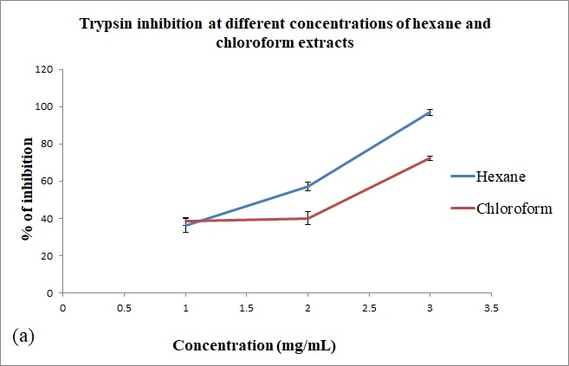
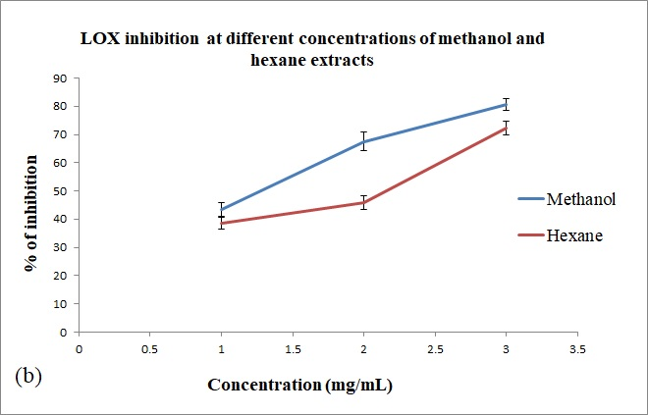
Fig. S1: Increase in enzyme inhibition with increasing concentration of extracts (a) trypsin inhibition (b) LOX inhibition
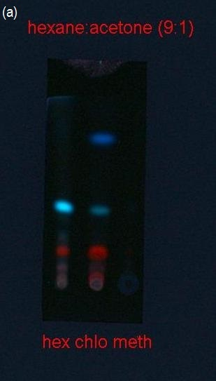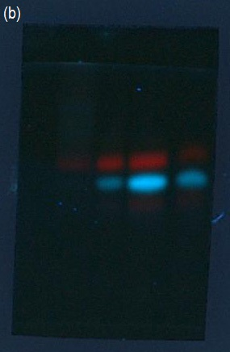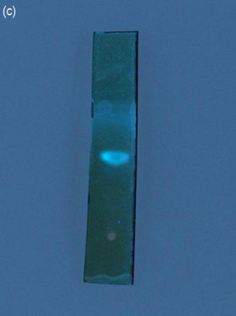
Fig. S2: Analytical TLC plates (a) hexane (hex), chloroform (chlo), methanol (meth) extracts; (b) column fractions, (c) purified band

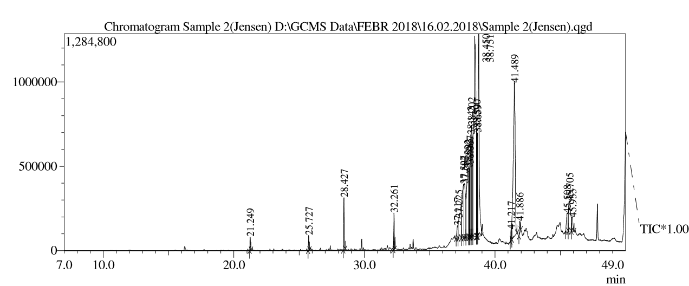
Fig. S3: GC MS spectrum of the purified band from the active fraction
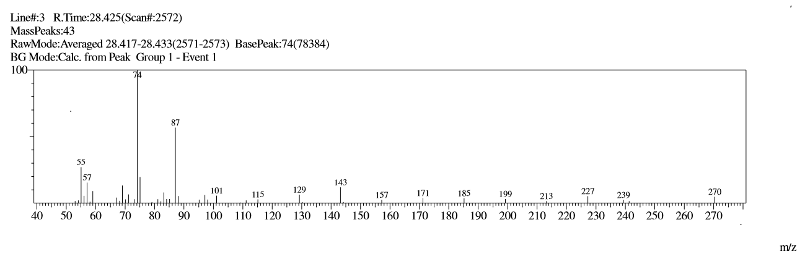
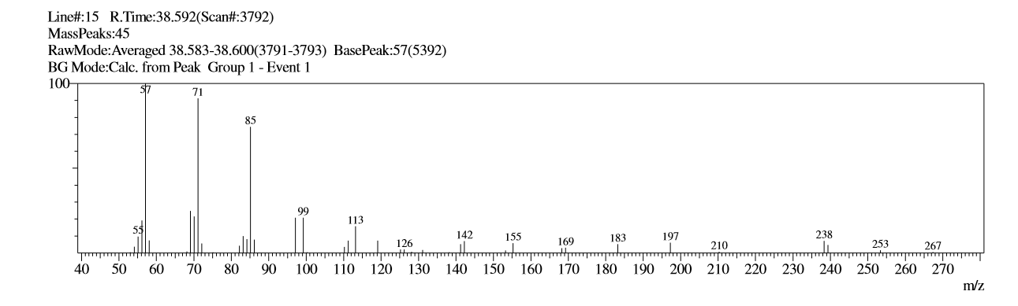
Fig. S4: MS/MS fragmentation pattern of the compounds with retention time 28.42 and 38.59

