Supplementary Figure
Figure1. The uncropped images of Fig3B in manuscript.

Figure2. The uncropped images of Fig4B-4D in manuscript.

Figure3. The uncropped images of Fig5A in manuscript.

Figure1
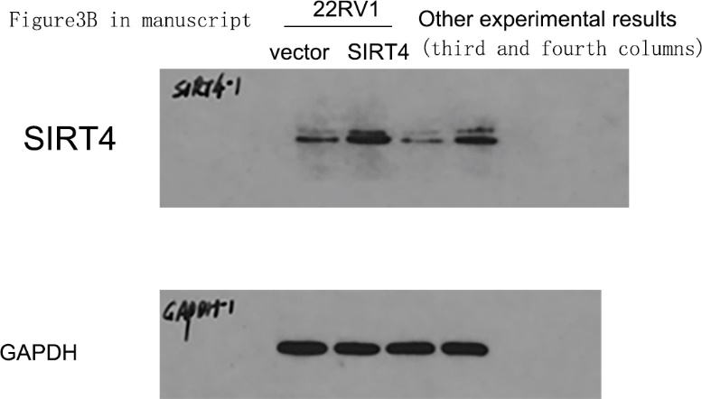

Figure2
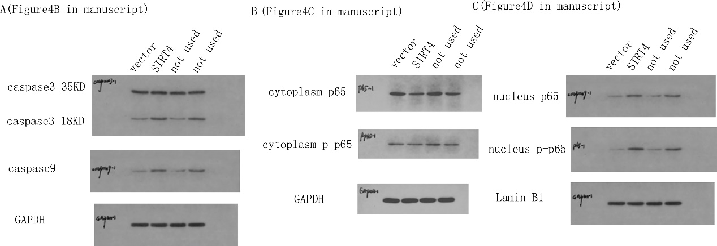

Figure3
