Supplementary material
Nanoplastics induce more severe apoptosis through mitochondrial damage in Caco-2 cells compared to sub-micron plastics
Zifan Lu, ª Yuanyuan Zhang, ^{b} Lei He, ª Chunxia Zhou, ^{a, b} Pengzhi Hong, ^{a, b} Zhong-Ji Qian, ^{a, b} Xianghong Ju, ^{a, b} Shengli Sun ª and Chengyong Li*^{a, b}
ªSchool of Chemistry and Environment, CollegeofFoodScienceandTechnology,Guangdong Ocean University, Zhanjiang 524088, P.R. China
^{b}Shenzhen Institute of Guangdong Ocean University, Shenzhen, Guangdong 518114, P.R. China
Correspondingauthors:
Chengyong Li, cyli@gdou.edu.cn


Video 1. Endocytosis of PS by Caco-2 cells in blank group.
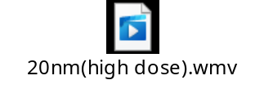
Video 2. Endocytosis of PS by Caco-2 cells in PS20 (80 μg/mL) group.
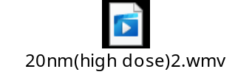
Video 3. Endocytosis of PS by Caco-2 cells in PS20 (80 μg/mL) group.
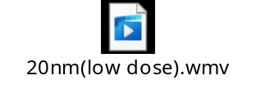
Video 4. Endocytosis of PS by Caco-2 cells in PS20 (20 μg/mL) group.
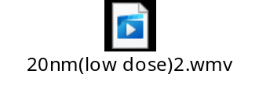
Video 5. Endocytosis of PS by Caco-2 cells in PS20 (20 μg/mL) group.
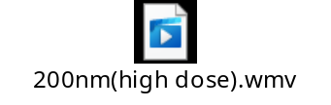
Video 6. Endocytosis of PS by Caco-2 cells in PS200 (80 μg/mL) group.
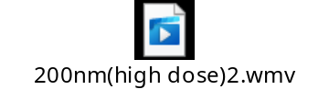
Video 7. Endocytosis of PS by Caco-2 cells in PS200 (80 μg/mL) group.
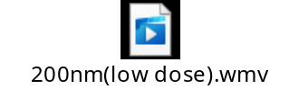
Video 8. Endocytosis of PS by Caco-2 cells in PS200 (20 μg/mL) group.
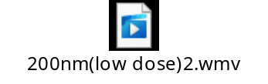
Video 9. Endocytosis of PS by Caco-2 cells in PS200 (20 μg/mL) group.

