Additional file 1: Criteria for Screening and Triaging for Appropriate aLternative care (CriSTAL)
 | Sex 1. □ Male 2. □ Female Date of birth_____/_____/_____________
☐  ☐ | Age >65 (1 point)  Eligible for admission via emergency Department or at least 1 night in the ED (1 point)
☐ | Nursing home resident / or in supported accommodation (either: max 1 point)
☐ | Clinical Frailty Score >= 5 ☐ Yes (1 point if Yes) ☐ No Actual CFS score ____ *
☐ | Meets 2 or more selected deterioration criteria on admission (max 1 point if it meets >2 RRT criteria)
 | ☐ | 1-Decreased LOC: Glasgow Coma Score change >2 or AVPU =P or =U
 | ☐ | 2-Respiratory rate <5 or >30 or Oxygen Saturation <90%
 | ☐ | 3-Hypoglycaemia: BGL 1.0 - 4.0 mmol/L
 | ☐ | 4-Repeat or prolonged seizures (single episode >5 minutes or >2 episodes 24 hrs)
 | ☐ | 5-Low urinary output (<15 ml/hour or <0.5 ml/kg/hour)
AND | OTHER RISK FACTORS /PREDICTORS (tick as many as relevant- max 7 points)
☐  ☐  ☐  ☐  ☐  ☐  ☐ | Personal history of active disease:  1-Advanced malignancy  2-Chronic kidney disease  3-Chronic heart failure  4-Chronic obstructive pulmonary disease  5-New cerebrovascular disease  6-History of Or New myocardial infarction  7-Moderate/severe liver disease
☐ | Evidence of cognitive impairment (tick as many as relevant – only 1 point if >1 mental condition)  ☐ Dementia ☐ Long term mental disorder ☐ Behavioural Alterations ☐ Mental disability from stroke
☐ | Proteinuria on a spot urine sample: ++ or >30 mg albumin/g creatinine  ☐ Yes (1 point) ☐ No ☐ Don’t know
☐ | Abnormal ECG (atrial fibrillation, ventricular tachycardia, other abnormal rhythm or >5 ectopics/min, changes to Q or ST waves) (tick as many as relevant – only 1 point if >1 abnormality)  ☐ Yes ☐ No abnormality ☐ Don’t know
☐  ☐ | Previous hospitalisation for at least one night in past year (only 1 point if >1 hospital admission)  ☐ Yes ☐ No ☐ Not documented  ICU admission at previous hospitalisation in the past year (only 1 point if >1 ICU admission)  ☐ Yes ☐ No ICU admission at all □ Unknown
☐  ☐ | Fall in the past 3 months (1 point)  Polypharmacy (6 or more medications) before admission (1 point if >6 medications)

CriSTAL score ______________________ (out of a maximum of 19)
CriSTAL Score: If = 6 or more, then high risk of death over next 3-6 months
* Clinical Frailty Score. Refer to diagram and definitions in Rockwood K, Song X, MacKnight C, Bergman H, Hogan DB, McDowell I, et al. A global clinical measure of fitness and frailty in elderly people. CMAJ : Canadian Medical Association journal. 2005;173(5):489-95.
1 Very fit
2 Well
3 Managing well
4 Vulnerable
5 Mildly frail
6 Moderately frail
7 Severely frail
8 Very severely ill
9 Terminally ill

Additional file 2: Sample screenshots of former COPD module
Removed from the prototype following clinicians’ feedback.
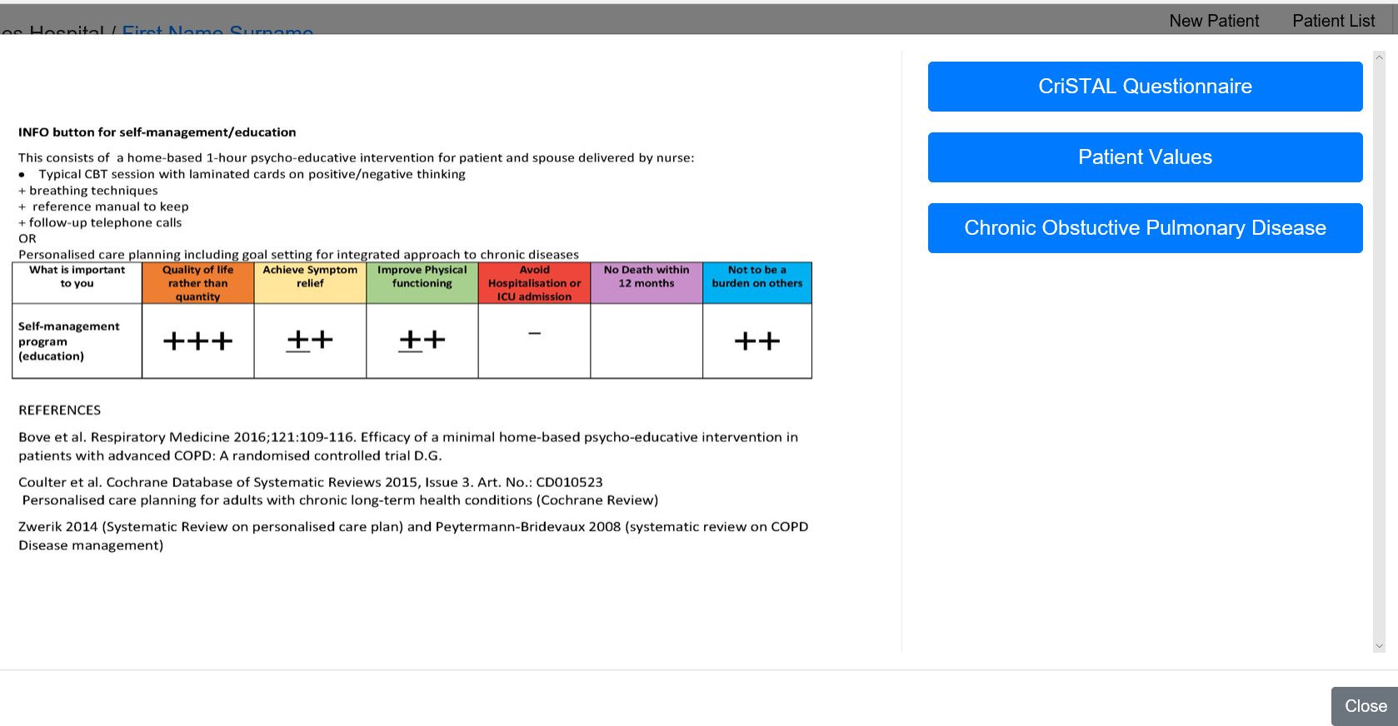
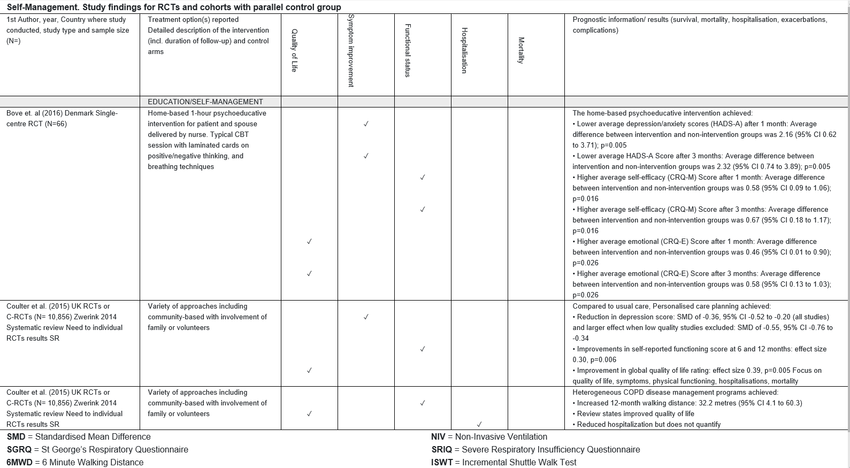

Additional file 3: CHAT back-end

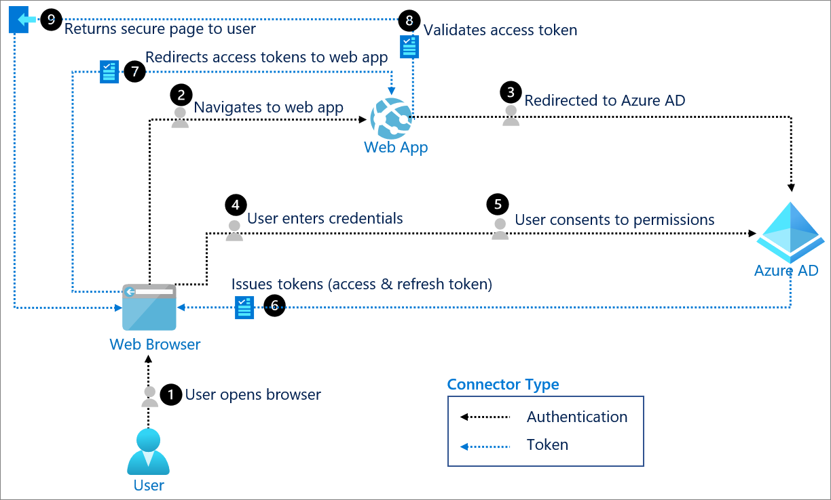

Additional file 4a: Feedback Questionnaires used during pilot sessions
System feedback from clinicians:
Question | Response Options
I think that I would like to use this system frequently | Strongly Agree  Agree  Neutral  Disagree  Strongly Disagree
I found the system unnecessarily complex | Strongly Agree  Agree  Neutral  Disagree  Strongly Disagree
I thought the system was easy to use | Strongly Agree  Agree  Neutral  Disagree  Strongly Disagree
I think that I would need the support of a technical person to be able to use this system | Strongly Agree  Agree  Neutral  Disagree  Strongly Disagree
I found the various functions in this system were well integrated | Strongly Agree  Agree  Neutral  Disagree  Strongly Disagree
I thought there was too much inconsistency in this system | Strongly Agree  Agree  Neutral  Disagree  Strongly Disagree
I would imagine that most people would learn to use this system very quickly | Strongly Agree  Agree  Neutral  Disagree  Strongly Disagree
I found the system very cumbersome to use | Strongly Agree  Agree  Neutral  Disagree  Strongly Disagree
I felt very confident using the system | Strongly Agree  Agree  Neutral  Disagree  Strongly Disagree
I needed to learn a lot of things before I could get going with this system | Strongly Agree  Agree  Neutral  Disagree  Strongly Disagree
What do you like least/most about our product website? | Open ended free-text question
What do you feel like is missing from the product that could make the experience better? | Open ended free-text question
Additional Comments | Open ended free-text question

Content feedback questionnaire
Question | Answer Options
The length of the consultations was: | Too long  Too short  Just right  Comments: ___________________
How clear was the information? | Everything was clear  Most things were clear  Some things were clear  Many things were clear  If parts were unclear, please explain:
How appropriate were the questions? | Completely appropriate  Somewhat appropriate  Somewhat inappropriate  Completely inappropriate  If questions were inappropriate, please explain:
Did you feel the decision aid consultation was trying to persuade patients to one treatment choice over the other? If so, which choice? | Clearly slanted towards comfort care  A little slanted towards comfort care  Completely Balanced  A little slanted towards having medical treatments  Clearly slanted towards have medical treatments
What do you think we are missing that would be helpful to patients? | Open ended free-text question
What do you think we are missing that would be helpful to clinicians? | Open ended free-text question
Additional comments: | Open ended free-text question

Additional file 4b Patient/surrogate Feedback Questionnaire
Question | Answer Options
- The length of the consultation was: | Too long  Too short  Just right
- The amount of information was: | Too much  Too little information  Just right
- How clear was the information? | Everything was clear  Most things were clear  Some things were clear  Many things were clear  If parts were unclear, please explain: ________________________
- Was the information upsetting? | Not upsetting  Slightly upsetting  Very upsetting  If upsetting, please explain:  ____________________________
- Did you feel the decision aid consultation was trying to persuade you to one treatment choice for (COPD or CKD or dementia) over the other? If so, which choice? | Clearly slanted towards not having medical treatments  A little slanted towards not having medical treatments  Completely balanced  A little slanted towards having medical treatments  Clearly slanted towards having medical treatments
- How helpful is the decision aid in helping you decide about treatment for (COPD or CKD or dementia? | Very helpful  Somewhat helpful  A little helpful  Not helpful
- What did you like about the decision aid consultation? | Comments (optional): _________________
- What suggestions do you have to improve the decision aid consultation? | Comments (optional): _________________
- Additional Comments | Comments (optional): _________________

