Supporting Information

Reversing the Irreversible: Thermodynamic Stabilization of Lithium Aluminum Hydride Nanoconfined Within a Nitrogen-Doped Carbon Host

YongJun Cho^{1,2}, Sichi Li³, Jonathan L. Snider¹, Maxwell A. T. Marple³, Nicholas A. Strange⁴, Joshua D. Sugar¹, Farid El Gabaly¹, Andreas Schneemann¹, Sungsu Kang^{5,6}, Min-ho Kang^{5,6}, Hayoung Park^{5,6}, Jungwon Park^{5,6}, Liwen. F. Wan³, Harris E. Mason³, Mark D. Allendorf¹, Brandon C. Wood³*, Eun Seon Cho²*, Vitalie Stavila¹*
¹Sandia National Laboratories, 7011 East Avenue, Livermore, CA 94550, United States
²Department of Chemical and Biomolecular Engineering (BK21+ Program), Korea Advanced Institute of Science and Technology (KAIST), Daejeon, 34141, Republic of Korea
³Lawrence Livermore National Laboratory, 7000 East Avenue, Livermore, CA 94550, United States
⁴SLAC National Accelerator Laboratory, Menlo Park, California 94025, United States
⁵Center for Nanoparticle Research, Institute for Basic Science (IBS), Seoul 08826, Republic of Korea
⁶School of Chemical and Biological Engineering and Institute of Chemical Process, Seoul National University, Seoul 08826, Republic of Korea
Fig. S1 Pore size distributions of a, CMK-3, LiAlH₄@CMK-3; b, NCMK-3, and LiAlH₄@NCMK-3.

Fig. S2 Fourier-transformed infrared spectra (FT-IR) of CMK-3/NCMK-3 and LiAlH₄@CMK-3/NCMK-3. A broad band located at 1500-1650 cm⁻¹ was assigned to C-C axial deformation band,^{1,2} and an additional band at 1100-1300 cm⁻¹ observed only for the NCMK-3 corresponds to a broad C-N stretching mode centering at 1105 cm⁻¹.³ Two pairs of active infrared vibration bands−Al-H stretching (1760 cm⁻¹ and 1615 cm⁻¹) and Li-Al-H bending (900 and 830 cm⁻¹)−were present for the recrystallized LiAlH₄,⁴ and the equivalent bands were detected for both the LiAlH₄@CMK-3 and the LiAlH₄@NCMK-3 samples. No wide bands at 3000-3500 cm⁻¹ indicating hydroxyl group were observed.

Fig. S3 PXRD patterns of a, physical mixture of LiAlH₄ and NCMK-3, b, LiAlH₄@CMK-3 and LiAlH₄@NCMK-3 synthesized without kinetic control, and LiAlH₄@NCMK-3 infiltrated by THF solution. LiCl phase is an impurity from commercial LiAlH₄.^{5,6} The physical mixture was prepared by grinding NCMK-3 and LiAlH₄ powders for 30 minutes with the same nominal loading (20 wt. %).

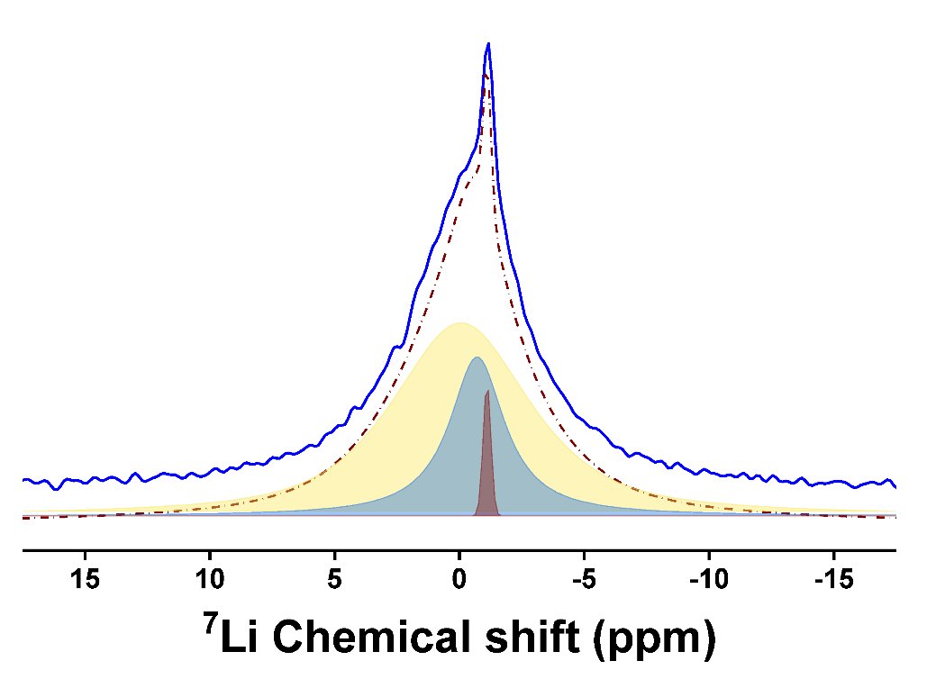
Fig. S4 ⁷Li MAS NMR spectrum of as-synthesized LiAlH₄@NCMK-3. The deconvolution components are LiAlH₄ (broad blue peak and narrow red peak) and LiH (yellow peak).

Fig. S5 N 1s spectra and schematic illustration of N-functionalities (right) a, NCMK-3, LiAlH₄@NCMK-3 b, and LiAlH₄-treated NCMK-3. Note that LiAlH₄ was washed out with the same solvent (Et₂O) used for the infiltration, but the N configuration resembles that of LiAlH₄@NCMK-3.
Fig. S6 a, Brightness analysis for the nanochannels present in LiAlH₄@NCMK-3 b, HAADF-STEM line profile of LiAlH₄@NCMK-3 and its corresponding EDS signal (scale bar: 50 nm).

Fig. S7 EELS profile of Al particles (area 1, cyan filled plot) and scaffold part (area 3, red lined plot) in LiAlH₄@NCMK-3. Peaks at ~15, 30, and 45 eV represent characteristic harmonic peaks of Al metal.

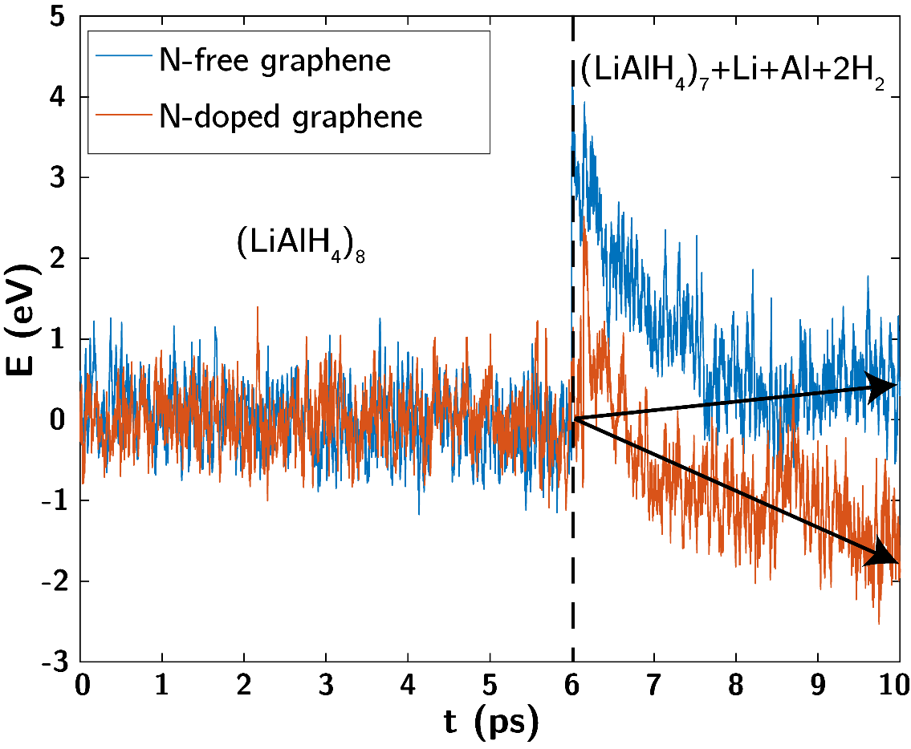
Fig. S8 Energy (in unit eV) trajectories, referenced to the energy averaged over the first 6 ps, of AIMD simulations for (LiAlH₄)₈ on N-free pristine graphene and pyridinic-N-doped graphene sheets. The formation of Al is spontaneous over a N-doped graphene surface; in the case of pristine graphene, the final structure from the first run of AIMD simulation was manually modified by moving four hydrogen atoms from the (LiAlH₄)₈ cluster to the vacuum space to mimic the reaction above with the formation of an Al atom and dihydrogen, which was continued with a separate run of AIMD simulation.

Fig. S9 Ex-situ ⁷Li MAS NMR spectra with representative deconvolutions of the central transition ⁷Li MAS NMR line shapes for the non-metallic species in the a, LiAlH₄@CMK-3 and b, LiAlH₄@NCMK-3 samples. Recrystallized bulk LiAlH4 is shown in black. The deconvolution parameters are shown in Table S3. The deconvolution components are LiAlH₄ (broad blue peak and narrow red) LiH (yellow), adsorbed LiH (pink), LiOH (green), and LiCl (dark red peak in b). LiOH and LiCl are minor impurities. Table S3 presents deconvolution details of ⁷Li MAS NMR.
Fig. S10 a, High angle annular dark field EDS map image of rehydrogenated LiAlH₄@NCMK-3 and b, EDS spectra scanned in two area (area 1: green, area 2: red)

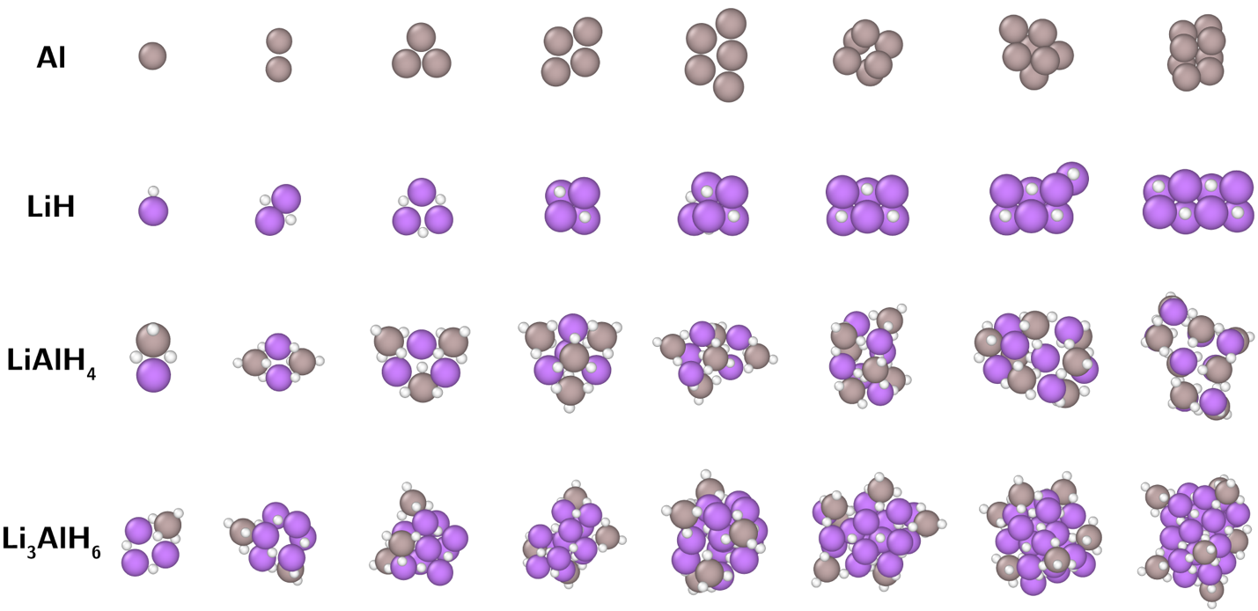
Fig. S11 Relaxed geometries of isolated Al, LiH, LiAlH₄, and Li₃AlH₆ clusters. H, Al, and Li atoms are shown in white, gray, and purple, respectively.

Fig. S12 Schematic representation of spontaneous interdiffusion of (LiH)₆ and Al₆ cluster to form an alloyed (LiH+Al)₆ phase and its energy profile. The difference in energy is normalized to one formula unit of LiH + Al.

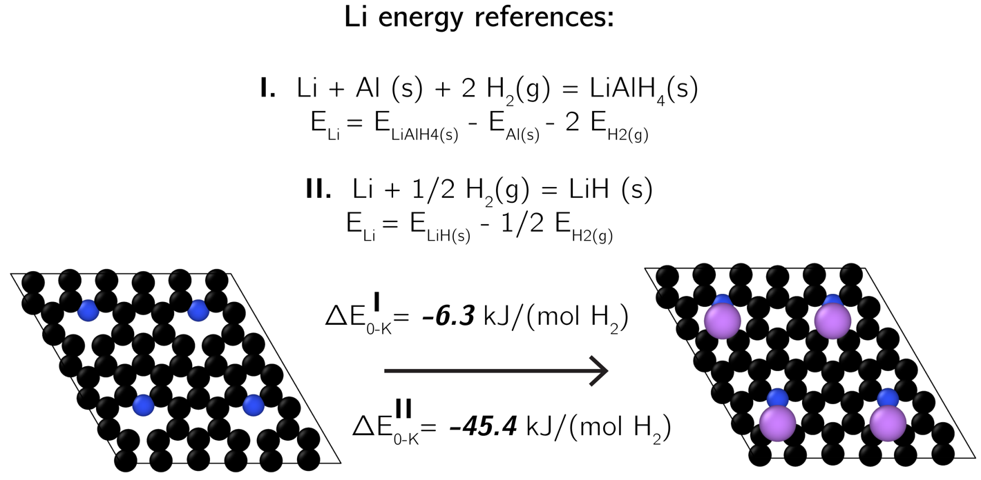
Fig. S13 Coordination and formation of lithium adatoms on pyridinic nitrogen defect sites of graphene (carbon is shown in black, nitrogen in blue and lithium in purple). The Figure shows the optimized structures of graphene sheets with 4 pyridinic N defect sites before and after Li adatom formation. ∆E is the reaction energy of Li adatom formation. Here, E_{4Li@N-doped-graphene} and E_{N-doped-graphene} are DFT-computed energies of the two graphene sheets shown in the figure. To obtain a ∆E value that is relevant to the reversible Li-Al-H interconversion, we use DFT-computed energies of bulk LiAlH₄, Al, LiH and gas-phase H₂ as corresponding references to derive E_{Li}. Two sets of references were employed.
i. using bulk LiAlH₄, Al, and gas-phase H₂ as an energy reference:
E_{Li} = E_{LiAlH4(s)} – E_{Al(s)} – 2 E_{H2(g)}
∆E = E_{4Li@N-doped-graphene} - E_{N-doped-graphene} – 4 (E_{LiAlH4(s)} – E_{Al(s)} – 2 E_{H2(g)})
normalized to per mole of Li adatom formation, ∆E/4 = -12.6 kJ/(mol Li)
ii. using bulk LiH and gas-phase H₂ as energy reference:
E_{Li} = E_{LiH(s)} – 1/2 E_{H2(g)}
∆E = E_{4Li@N-doped-graphene} - E_{N-doped-graphene} – 4 (E_{LiH(s)} – 1/2 E_{H2(g)})
normalized to per mole of Li adatom formation, ∆E/4 = -22.7 kJ/(mol Li)
Fig. S14 Ex-situ N K-edge soft TEY X-ray absorption spectra of LiAlH₄@NCMK-3. The black and red lines represent simulated spectra of pristine host and Li-coordinated host.

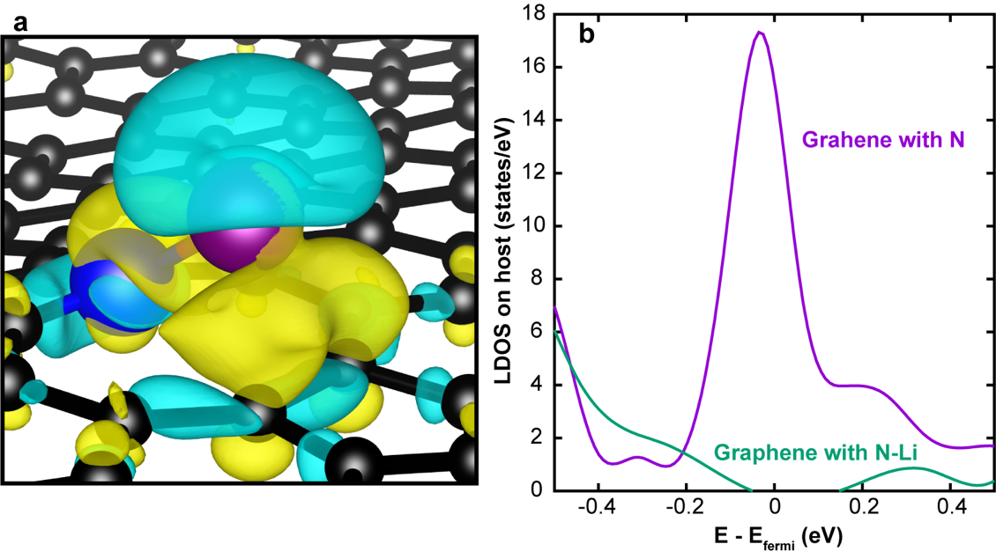
Fig. S15 a, Isosurface of charge density difference (yellow = accumulation; cyan = depletion; isosurface value 0.003 e) obtained by comparing a single Li atom adsorbed on a pyridinic N defect to its isolated constituents. b,Electronic density of states of pyridinic N-doped graphene before and after incorporation of Li adatoms.

Table S1. BET surface areas and total volumes of functionalized/non-functionalized scaffolds and LiAlH₄ loaded scaffolds.

Table S2. Relative amount of nitrogen functionalities in NCMK-3 and LiAlH₄@NCMK-3 samples determined by deconvolutions of N 1s XPS spectra.

Table S3. NMR parameters used for deconvolution of the a, ²⁷Al central transition non-metallic species and b, ⁷Li central transition line shapes. δ_{iso} is the isotropic chemical shift, lb is the line broadening, C_{Q} is the quadrupolar coupling constant, η is the asymmetry parameter for the quadrupolar coupling constant, xG/(1-x)L is the ratio of Gaussian/Lorentzian character of the line shape, and Rel. % is the relative area of the phase. A Czjzek distribution was used for the amorphous Al₂O₃ deconvolution where Δδ_{CS} denotes the full width at half maximum of the isotropic chemical shift gaussian distribution.

Supplementary note 1.
Synthesis and storage of LiAlH₄@NCMK-3 and LiAlH₄@CMK-3
A loading of 20wt% of LiAlH₄ was achieved by infiltrating a solution of 25 mg of freshly recrystallized LiAlH₄ in 1.25 mL dry diethyl ether into 100 mg of the pretreated mesoporous carbon scaffolds (CMK-3 and NCMK-3). The obtained powder samples were stored in a -30 °C refrigerator within the Ar glovebox (Innovative Technology Inc.).
Supplementary note 2.
Identification of the origin of LiAlH₄ decomposition upon solvent infiltration
To understand the reason for LiAlH₄ decomposition during synthesis, the samples were prepared under different infiltration conditions and analyzed with PXRD. First, to determine whether improved kinetics of reactions R1 and R2 in Table 1 drives the decomposition, the effect of infiltration temperature was investigated. The original composites were synthesized at low temperature (below -50 ℃) to decelerate the reaction kinetics (“kinetic control”). Another set of nanoconfined composites were prepared without kinetic control by infiltrating the LiAlH₄ solution for a prolonged time at room temperature. Both LiAlH₄@CMK-3 and LiAlH₄@NCMK-3 infiltrated at room temperature show some metallic Al peaks (Fig. S6b). Among those without kinetic control, the LiAlH₄@NCMK-3 exhibits greater metallic Al intensities than LiAlH₄@CMK-3, suggesting that the NCMK-3 scaffold plays a role in catalyzing the decomposition of LiAlH₄.
To probe the effect of solvent on decomposition, LiAlH₄ was dissolved in THF instead of diethyl ether and infiltrated into NCMK-3 to form the composite (LiAlH₄@NCMK-3-THF). Interestingly, Al metallic peaks are still observed in the LiAlH₄@NCMK-3-THF, even though THF is known to strongly stabilize LiAlH₄ by forming a solvent adduct.⁷ We therefore conclude that NCMK-3 exhibits both a kinetic and thermodynamic influence on the decomposition of the loaded metal hydride.

Supplementary note 3.
Detailed description of MAS NMR measurements
All samples were handled within an Ar glovebox and packed within 2.5 mm ZrO₂ rotors. To ensure stable spinning at 25 kHz, the samples were diluted by mixing with PCTFE (polychlorotrifluoroethylene) powder in a mortar and pestle. If this was not done, the free electrons inherent to carbon in CMK-3 produce eddy currents and consequently a braking torque preventing stable spinning above 10 kHz. A single pulse experiment was used for all collected ²⁷Al spectra with a 10s recycle delay, sufficiently long enough to allow the anticipated phases (LiAlH₄, Li₃AlH₆, and metallic Al) to fully equilibrate.⁸ Initially, using two-pulse phase modulation (TPPM) ¹H decoupling was investigated however it was not used for acquisition as the resolution of the ²⁷Al line shape did not improve, likely due to the high spinning speeds (25 kHz) used were sufficient to average out the ¹H-²⁷Al heteronuclear coupling. A 60° pulse length of 1.83 µs was used (radio frequency field of approximately 140 kHz) for all experiments. A larger tip angle was chosen for these measurements to maximize the signal acquisition rate, as the nanoconfined LiAlH₄ in NCMK-3 makes up a fraction of the total volume and is exasperated further by the PCTFE dilution. Using these parameters, relatively high-resolution spectra were obtained by collecting data overnight (approximately 5600 scans). Additional tests using a small tip angle of 9° (pulse length of 0.275 µs) were carried out to determine how quantitative the 60° tip angle spectra were by comparison. The nutation frequency of quadrupolar nuclei like ²⁷Al is dependent on the strength of the quadrupolar interaction, using small tip angles diminishes the nutation frequency differences leading to quantitative spectra. In the tests with 9° tip angle, the intensity of the metallic Al peak was about 1.8 times higher than that in the 60° tip angle spectra. The other non-metallic Al sites had comparable intensities between the two tip angles and because the samples contain the same Al environments across the de/rehydrogenation process, the 60° tip angle spectra can be considered semi-quantitative. Each ⁷Li spectra was collected using a single 60° pulse length of 2 µs (RF field of approximately 125 kHz) with a recycle delay of 60 s and is the accumulation of 32 scans. The ²⁷Al and ⁷Li spectra were externally referenced to 0.1M AlCl₃ (aq) solution (δ_{iso}=0 ppm) and 1M LiCL (aq) solution (δ_{iso}=0 ppm), respectively. Deconvolution of the quadrupolar ²⁷Al MAS line shapes was carried out using the software package Dmfit.⁹

Supplementary note 4.
Detailed description of theoretical calculations
Plane-wave, periodic supercell DFT calculations were performed with the Vienna ab initio simulation package (VASP), version 5.4.4,¹⁰ using the projector augmented wave treatment of core-valence interactions^{11,12} with the Perdew-Burke-Ernzerhof (PBE)¹³ generalized gradient approximation for the exchange-correlation energy, and van der Waals dispersion forces described with D3 correction method.¹⁴A 20 Å x 20 Å x 20 Å cubic supercell was used to model isolated nanoclusters. Each structure was first sampled with 20 ps NVT ab initio molecular dynamics (AIMD) with the energy cutoff for a plane-wave basis set of 400 eV and the Brillouin zone sampled at the Γ-point only. Timestep was set to 1 fs and a Nose-Hoover thermostat was used to maintain the temperature at 373 K, chosen arbitrarily for annealing effect. Low-energy configurations in each trajectory were quenched to 0-K with the energy cutoff for a plane-wave basis set increased to 500 eV, self-consistent-field electronic energies converged to 10⁻⁶ eV and atomic forces to less than 0.03 eV/Å. A supercell of 6x6 graphene sheet with periodic images separated by 20 Å vacuum space (a=b=14.65 Å, c=20 Å, α= β=90º, γ=120º) was used to model interactions between carbon materials and nanoclusters of lithium(aluminum) hydride an aluminum. Structures were first annealed with AIMD at 373 K and optimized to ground states at 0 K. AIMD and geometry optimizations were performed with the nearly the same setup as for the isolated nanoclusters in vacuum except that a Γ-centered 2×2×1 k-point mesh was used to sample the Brillouin zone during geometry optimizations. Bader charge analyses were performed using the algorithm developed by Henkelman et al.¹⁵⁻¹⁷
The N K-edge X-ray absorption (XAS) spectra are calculated using the quantum espresso source code package with the Shirley reduced basis for efficient Brillouin zone sampling.^{18,19} Within the excited core-hole approximation²⁰, a modified ultrasoft pseudopotential²¹ for N is used where a core electron is removed from its 1s core state and placed at the first available empty state above the Fermi level. Standard PBE-GGA approximation is used to approximate the exchange-correlation functional in DFT. A smooth XAS spectrum is obtained by applying a Gaussian convolution (0.2 eV width) to the calculated transition probabilities at discrete energies. Finally, the spectrum is shifted according to a previously established alignment scheme²² that uses molecular N₂ as a reference.²³

References:
1 Almeida, V. C. et al. N-doped ordered mesoporous carbons with improved charge storage capacity by tailoring N-dopant density with solvent-assisted synthesis. Journal of Materials Chemistry A 2, 15181-15190 (2014).
2 Monkman, A. & Adams, P. Optical and electronic properties of stretch-oriented solution-cast polyaniline films. Synthetic Metals 40, 87-96 (1991).
3 Liu, L. et al. Ordered mesoporous carbons: citric acid-catalyzed synthesis, nitrogen doping and CO₂ capture. Journal of Materials Chemistry 21, 16001-16009 (2011).
4 Fernandez, J. A. et al. Mechanical and thermal decomposition of LiAlH₄ with metal halides. International Journal of Hydrogen Energy 32, 1033-1040 (2007).
5 Liu, S.-S. et al. Effect of ball milling time on the hydrogen storage properties of TiF3-doped LiAlH₄. international journal of hydrogen energy 34, 8079-8085 (2009).
6 Ares, J. et al. Thermal and mechanically activated decomposition of LiAlH₄. Materials Research Bulletin 43, 1263-1275 (2008).
7 Graetz, J., Wegrzyn, J. & Reilly, J. J. Regeneration of Lithium Aluminum Hydride. Journal of the American Chemical Society 130, 17790-17794 (2008).
8 Wiench, J., Balema, V., Pecharsky, V. & Pruski, M. Solid-state 27Al NMR investigation of thermal decomposition of LiAlH₄. Journal of Solid State Chemistry 177, 648-653 (2004).
9 Massiot, D. et al. Modelling one‐and two‐dimensional solid‐state NMR spectra. Magn. Reson. Chem. 40, 70-76 (2002).
10 Kresse, G. & Furthmüller, J. Efficient iterative schemes for ab initio total-energy calculations using a plane-wave basis set. Phys. Rev. B 54, 11169 (1996).
11 Blöchl, P. E. Projector augmented-wave method. Phys. Rev. B 50, 17953 (1994).
12 Kresse, G. & Joubert, D. From ultrasoft pseudopotentials to the projector augmented-wave method. Phys. Rev. B 59, 1758 (1999).
13 Perdew, J. P., Burke, K. & Ernzerhof, M. Generalized gradient approximation made simple. Phys. Rev. Lett. 77, 3865 (1996).
14 Grimme, S., Antony, J., Ehrlich, S. & Krieg, H. A consistent and accurate ab initio parametrization of density functional dispersion correction (DFT-D) for the 94 elements H-Pu. The Journal of chemical physics 132, 154104 (2010).
15 Henkelman, G., Arnaldsson, A. & Jónsson, H. A fast and robust algorithm for Bader decomposition of charge density. Computational Materials Science 36, 354-360 (2006).
16 Sanville, E., Kenny, S. D., Smith, R. & Henkelman, G. Improved grid‐based algorithm for Bader charge allocation. J. Comput. Chem. 28, 899-908 (2007).
17 Tang, W., Sanville, E. & Henkelman, G. A grid-based Bader analysis algorithm without lattice bias. J. Phys.: Condens. Matter 21, 084204 (2009).
18 Giannozzi, P. et al. QUANTUM ESPRESSO: a modular and open-source software project for quantum simulations of materials. J. Phys.: Condens. Matter 21, 395502 (2009).
19 Prendergast, D. & Louie, S. G. Bloch-state-based interpolation: An efficient generalization of the Shirley approach to interpolating electronic structure. Phys. Rev. B 80, 235126 (2009).
20 Prendergast, D. & Galli, G. X-ray absorption spectra of water from first principles calculations. Phys. Rev. Lett. 96, 215502 (2006).
21 Vanderbilt, D. Soft self-consistent pseudopotentials in a generalized eigenvalue formalism. Phys. Rev. B 41, 7892 (1990).
22 England, A. H. et al. On the hydration and hydrolysis of carbon dioxide. Chem. Phys. Lett. 514, 187-195 (2011).
23 Drisdell, W. S. et al. Probing the mechanism of CO₂ capture in diamine-appended metal–organic frameworks using measured and simulated X-ray spectroscopy. Phys. Chem. Chem. Phys. 17, 21448-21457 (2015).

