Drivers of soil bacterial diversity in sandy grasslands in China
Chengchen Pan¹, Qi Feng^{1,}*, Yulin Li¹, Xiaoya Yu², Shilong Ren³

¹ Northwest Institute of Eco-Environment and Resources, Chinese Academy of Sciences, Lanzhou, Gansu 730000, PR China
² School of Tourism and Resource Environment, Qiannan Normal University for Nationalities, Duyun, Guizhou 558000, PR China
³ Environmental Research Institute, Shandong University, Qingdao, Shandong 266237, PR China

*Corresponding author
E-mail address: qifeng@lzb.ac.cn (Q. Feng)

Figure S1The sampling sites across the four sandy grasslands in the Inner Mongolia of China.

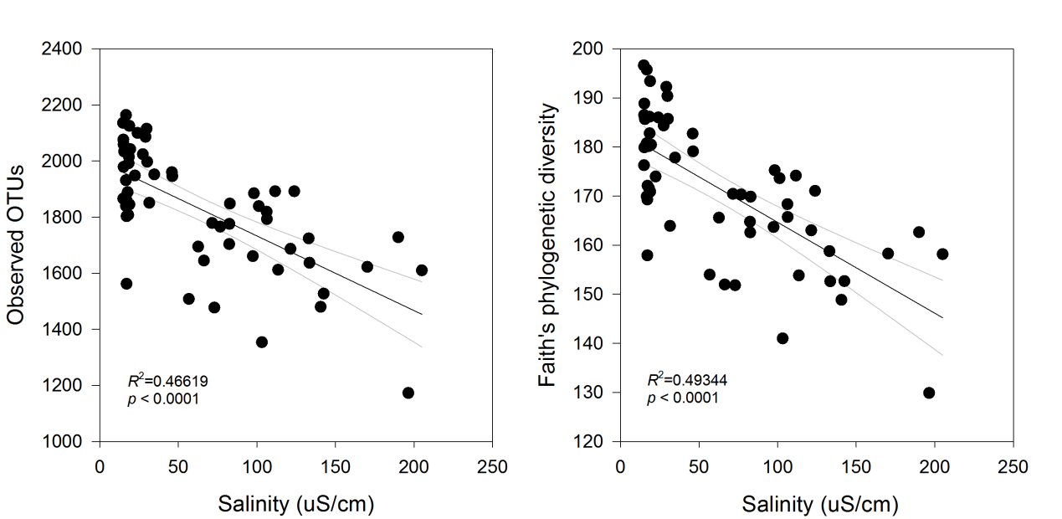
Figure S2Relationship between soilbacterial phylotyperichness and Faith’s phylogenetic diversity and soil salinity

Table S1 Pearson correlations between soil bacterial phylotype
richness and Faith’s phylogenetic diversity and vegetation and edaphic factors
 | Phylotyperichness | Phylogenetic diversity
SOM | 0.04 | -0.08
TN | 0.1 | 0.01
TP | -0.35** | -0.39**
AP | -0.18 | -0.28*
pH | -0.30* | -0.19
EC | -0.68** | -0.70**
PR | 0.40** | 0.34**
PB | 0.35** | 0.24
MAP | 0.25 | 0.29*
MAT | -0.26 | -0.16
MAT, mean annual temperature; MAP, mean annual precipitation; SOM, soil organic matter; TN, total nitrogen; TP, total phosphorus; AP, available phosphorus; EC, electrical conductivity; PR, plant species richness; PB, plant aboveground biomass

Table S2 Correlations of soil bacterial beta diversity with geographical distance and environment factors as revealed by Mantel test
 | R | p
GEODISTANCE | 0.71 | <0.001
SOM | 0.17 | 0.04
TN | 0.16 | 0.04
TP | 0.29 | <0.001
AP | 0.18 | 0.015
pH | 0.55 | <0.001
EC | 0.36 | <0.001
PR | 0.24 | 0.002
PB | 0.21 | 0.011
MAP | 0.32 | <0.001
MAT | 0.55 | <0.001
MAT, mean annual temperature; MAP, mean annual precipitation; SOM, soil organic matter; TN, total nitrogen; TP, total phosphorus; AP, available phosphorus; EC, electrical conductivity; PR, plant species richness; PB, plant aboveground biomass

Table S3 Correlation coefficients between soil bacterial groups and vegetation and soil factors
Groups | SOM | TN | TP | AP | pH | EC | PR | PB | MAP | MAT
Proteobacteria | -0.13 | -0.18 | -0.16 | 0.18 | -0.14 | 0.29* | 0.24 | 0.13 | 0.06 | -0.1
Actinobacteria | 0.04 | 0 | -0.15 | -0.11 | -0.40** | -0.38** | 0 | 0.06 | 0.1 | -0.01
Firmicutes | -0.26 | -0.26 | 0.03 | -0.04 | 0.32* | 0.22 | -0.06 | -0.29* | -0.27* | 0.03
Cyanobacteria | -0.13 | -0.08 | 0.2 | -0.17 | 0.43** | 0.05 | -0.40** | -0.37** | -0.02 | 0.34*
Acidobacteria | 0.52** | 0.62** | 0.27* | 0.03 | 0.16 | -0.21 | -0.03 | 0.26* | 0.14 | -0.04
Bacteroidetes | 0.14 | 0.25 | -0.04 | 0.03 | 0.12 | 0.01 | -0.01 | 0.2 | 0.31* | 0.11
Gemmatimonadetes | 0.01 | -0.01 | -0.04 | 0.04 | -0.15 | 0.02 | 0.24 | 0.11 | -0.21 | -0.36**
Chloroflexi | 0.09 | 0.13 | 0.21 | -0.17 | 0.14 | -0.24 | -0.09 | 0.16 | 0.02 | 0.02
Verrucomicrobia | 0.63** | 0.57** | 0.16 | 0.34** | -0.46** | -0.06 | 0.05 | 0.29* | -0.35** | -0.47**
unidentified_Bacteria | 0.03 | -0.06 | 0 | 0.36** | -0.31* | 0.37** | 0.12 | 0.15 | -0.19 | -0.34**
Armatimonadetes | -0.09 | 0.01 | 0.05 | 0.01 | 0.31* | 0.15 | -0.09 | 0.09 | 0.44** | 0.36**
Nitrospirae | 0.34* | 0.37** | 0.18 | 0.36** | 0.17 | 0.41** | 0.13 | 0.41** | -0.05 | -0.16
Rokubacteria | 0.23 | 0.26 | 0.11 | -0.08 | 0.16 | 0.11 | 0.06 | 0.11 | -0.2 | -0.01
Fibrobacteres | -0.26 | -0.25 | -0.29* | -0.21 | -0.01 | -0.28* | 0.12 | 0.07 | 0.2 | 0.08
MAT, mean annual temperature; MAP, mean annual precipitation; SOM, soil organic matter; TN, total nitrogen; TP, total phosphorus; AP, available phosphorus; EC, electrical conductivity; PR, plant species richness; PB, plant aboveground biomass

