III. Results

The distribution of the transition counts among the states was Poisson. This can obviously be seen from the dispersion index for each rate as well as the frequency distribution using STATA14 and StatGraphic 19 .The characteristics of the patients are shown in Table (1). Table (2) shows the stratified values for these variables. Summary of the categorical groups according to the participants’ characteristics are shown in Table (3).

Table (1): statistical summary of the patients’ characteristics
Variable | Observations | mean | Std. Dev. | Min | Max
Gender:  Female=0  Male=1 | 150
Gender:  Female=0  Male=1 | 69 (0.46)
Gender:  Female=0  Male=1 | 81(0.54)
Age | 150 | 40.2 | 4.93 | 27 | 53
LDL-chol | 150 | 94.81 | 15.41 | 59.89 | 133.1
HOMA2-IR | 150 | 2.28 | .71 | .49 | 4.36
BMI | 150 | 28.28 | 2.991 | 20.3 | 35.16
Sys.Bl.Pr. | 150 | 149.73 | 10.434 | 123.4 | 175.75
Dias.Bl.Pr. | 150 | 94.25 | 11.39 | 70 | 124

Table (2): summary of the categorical groups of patients according to the previous characteristics
Variable | Group1 (desirable) | Group2 ( borderline) | Group3 (high)
Age | Age ≤ 35 | 35 < age ≤ 45 | Age > 45
LDL-chol | LDL ≤ 70 | 70 < LDL < 100 | LDL ≥ 100
HOMA2-IR | HOMA < 1.22 | 1.22 ≤ HOMA < 2.7 | HOMA ≥ 2.7
BMI | BMI ≤ 25 | 25 < BMI < 30 | BMI ≥ 30
Systolic blood pressure | Sys.Pr. ≤ 130 | 130 < Sys.Pr. < 160 | Sys.Pr. ≥ 160
Diastolic blood pressure | Dias. Pr. ≤ 85 | 85 < Dias. Pr. < 100 | Dias. Pr. ≥ 100

Table (3): summary of categorical groups of the patients’ characteristics regarding age category, BMI category, LDL-chol category, systolic and diastolic blood pressure category
category | Age |  |  | BMI |  |  | LDL-chol
category | Frequency | Percent | Cum. | Frequency | Percent | Cum. | Frequency | Percent | Cum.
1 | 22 | 14.67 | 14.67 | 22 | 14.67 | 14.67 | 5 | 3.33 | 3.33
2 | 109 | 72.67 | 87.33 | 83 | 55.33 | 70 | 93 | 62.00 | 65.33
3 | 19 | 12.67 | 100 | 45 | 30 | 100 | 52 | 34.67 | 100
total | 150 | 100 |  | 150 | 100 |  | 150 | 100
category | HOMA2-IR |  |  | Systolic Blood Pressure |  |  | Diastolic Blood Pressure
category | Frequency | Percent | Cum. | Frequency | Percent | Cum. | Frequency | Percent | Cum.
1 | 10 | 6.67 | 6.67 | 4 | 2.67 | 2.67 | 33 | 22 | 22
2 | 93 | 62.00 | 68.67 | 123 | 82.00 | 84.67 | 69 | 46 | 68
3 | 47 | 31.33 | 100 | 23 | 15.33 | 100 | 48 | 32 | 100
total | 100 | 100 |  | 150 | 100 |  | 150 | 100

The distribution of the transition counts was Poisson as illustrated in the following figures (from Fig (1) to Fig (9)) using the Statgraphics-19 software. The dispersion indices for the rates ranged from 0.82 to 1.34 using STATA 14 software. The dispersion index for transition from F0 to F1 is 0.822, for transition from F1 to F2; it is 1.007, for transition from F2 to F3; it is 1.302, for transition from F3 to F4; it is 0.859, for transition from F1 to F0; it is 1.268, for transition from F2 to F1; it is 1.34, for transition from F3 to F2; it is 1.11, for transition from F2 to F0; it is 1.074, for transition from F3 to F1; it is 1.22.

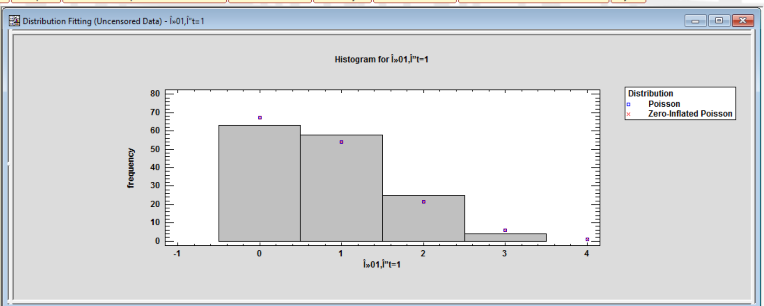
Figure (1): transition from F0 to F1 with dispersion index=0.822

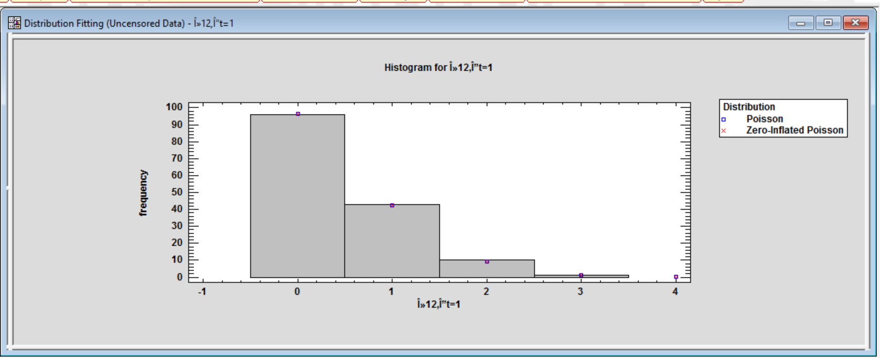
Figure (2): transition from F1 to F2 with dispersion index=1.007
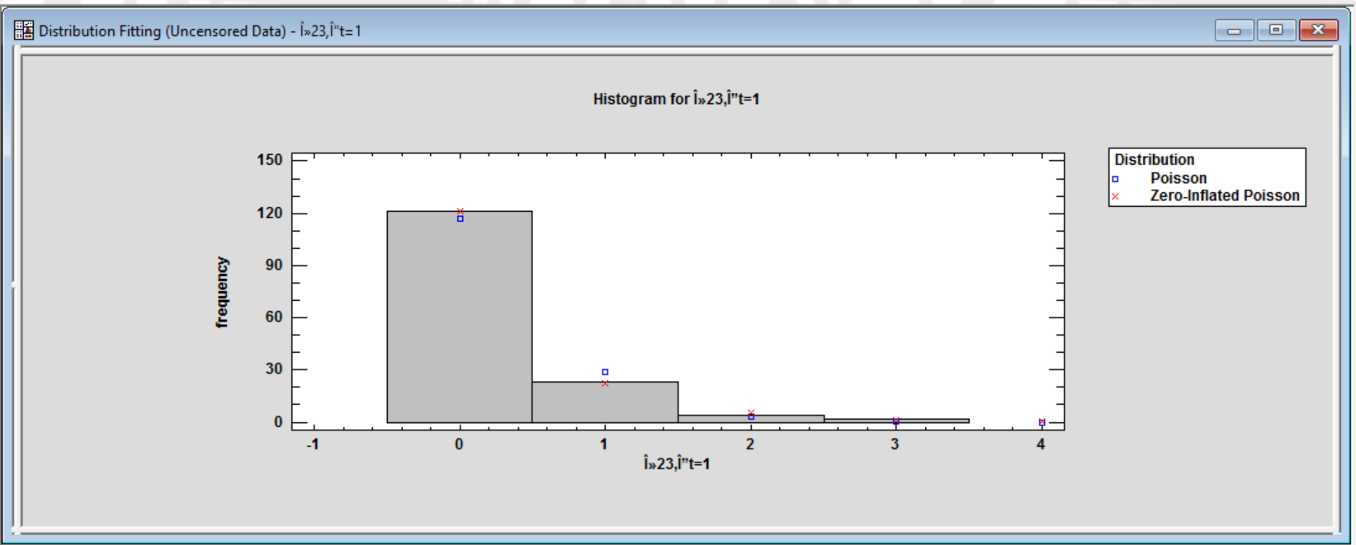
Figure (3): transition from F2 to F3 with dispersion index=1.302

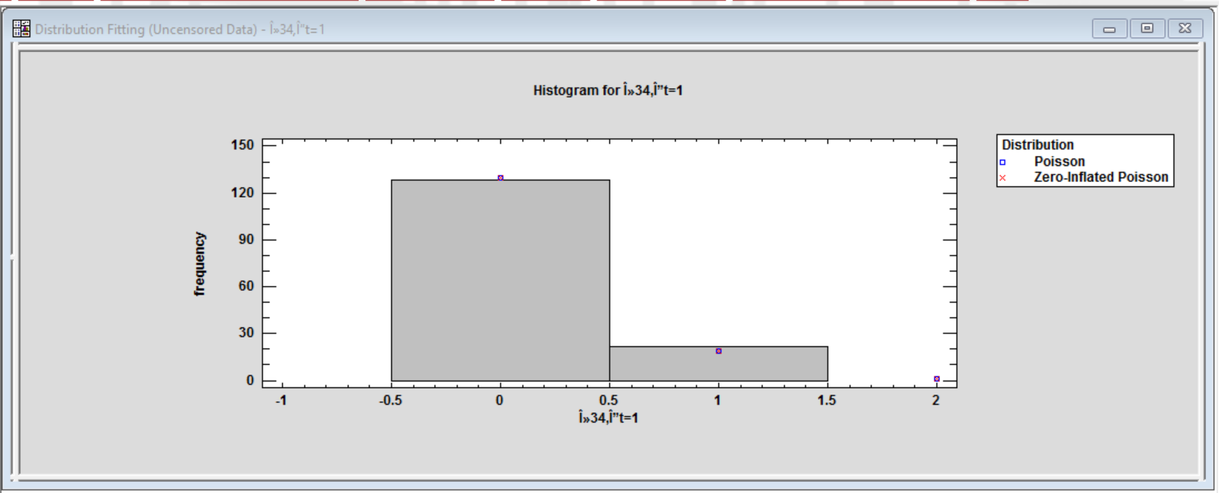
Figure (4): transition from F3 to F4 with dispersion index=0.859

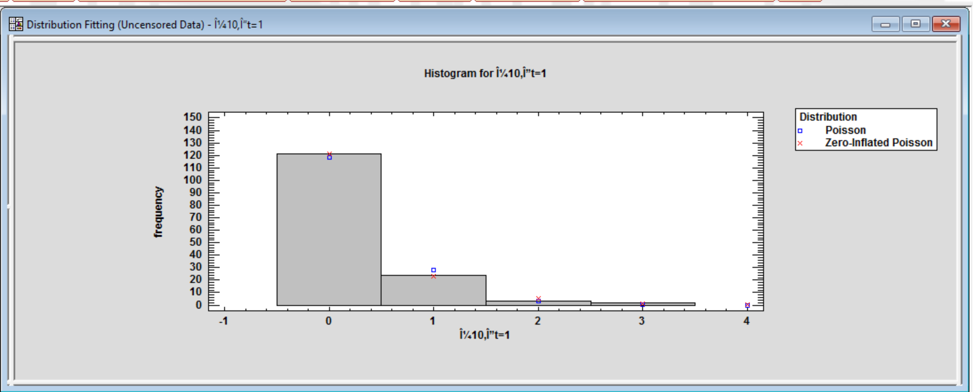
Figure (5): transition from F1 to F0 with dispersion index=1.268
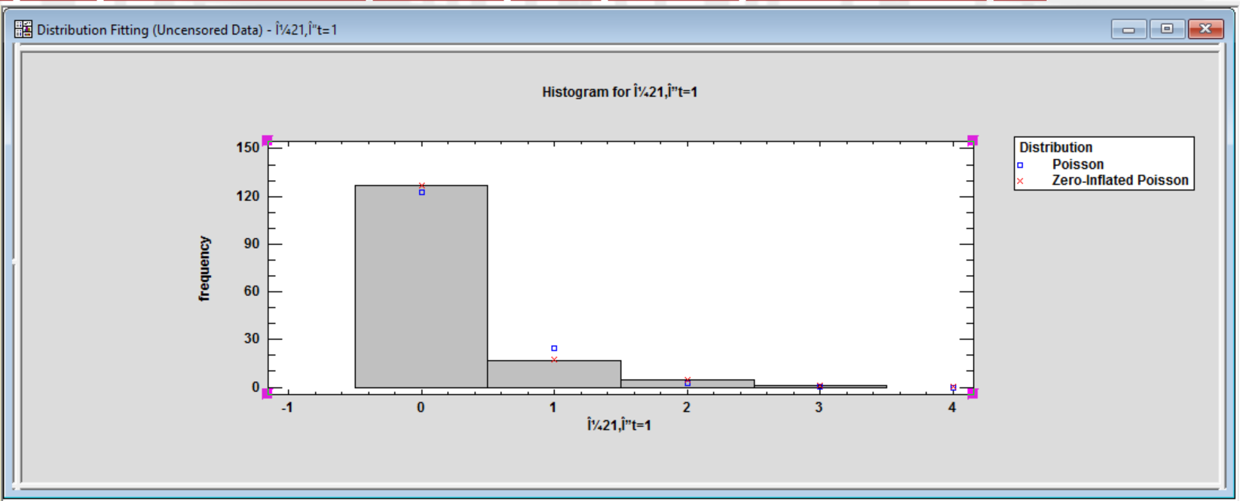
Figure (6): transition from F2 to F1 with dispersion index=1.342

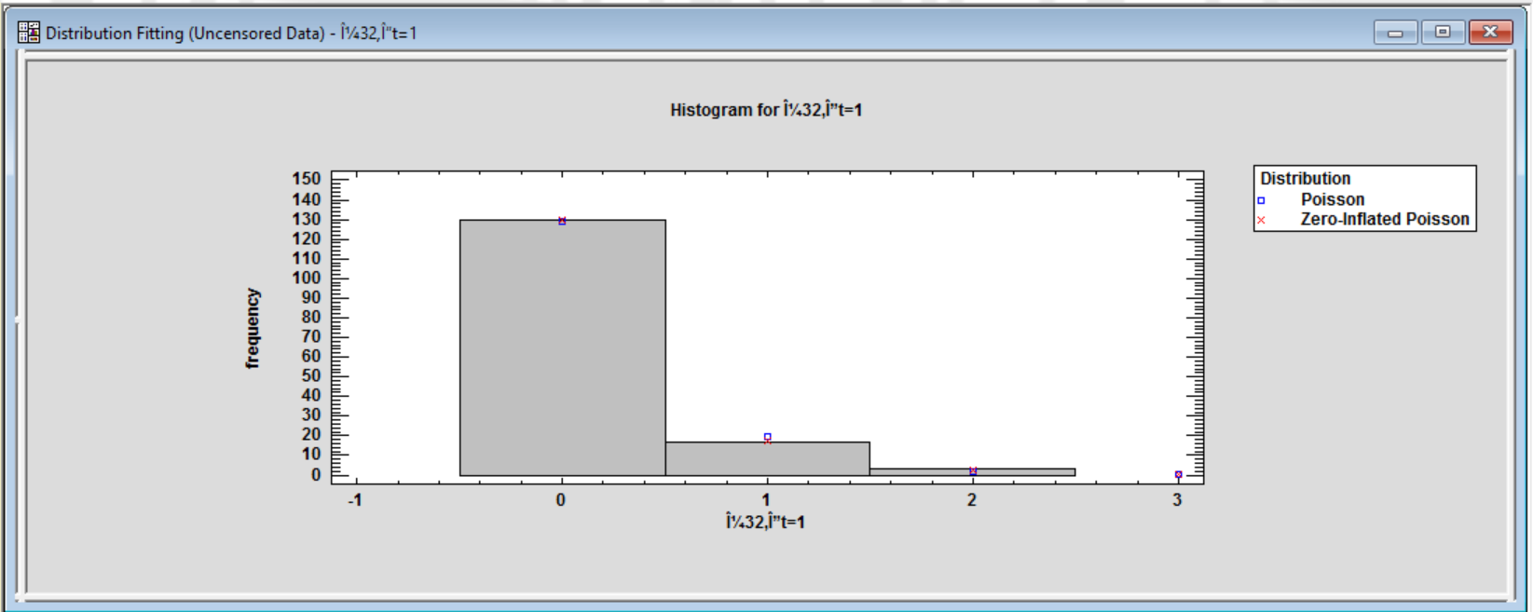
Figure (7): transition from F3 to F2 with dispersion index=1.1149

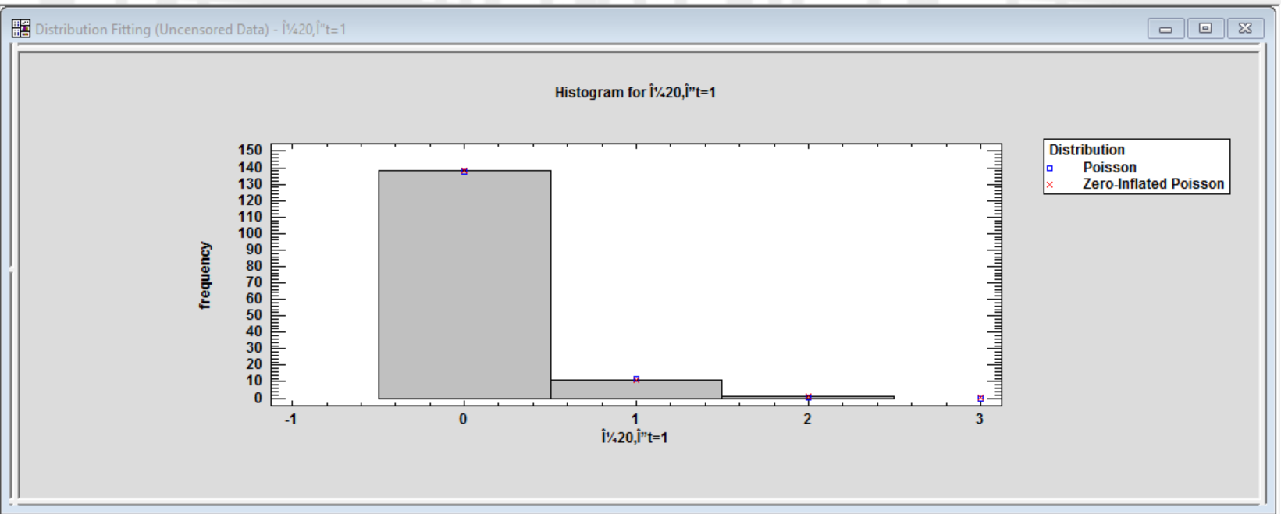
Figure (8): transition from F2 to F0 with dispersion index=1.074

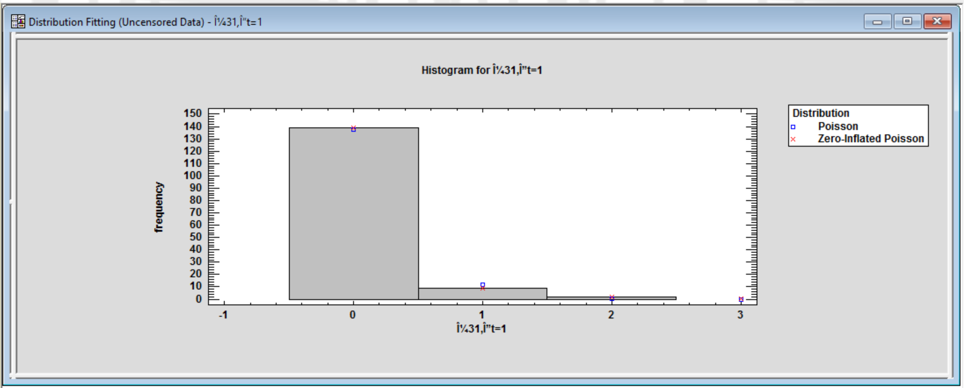
Figure (9): transition from F3 to F1 with dispersion index=1.229

Using STATA 14, the distribution of the transition counts among the states was Poisson as illustrated by the following histogram Fig (10).

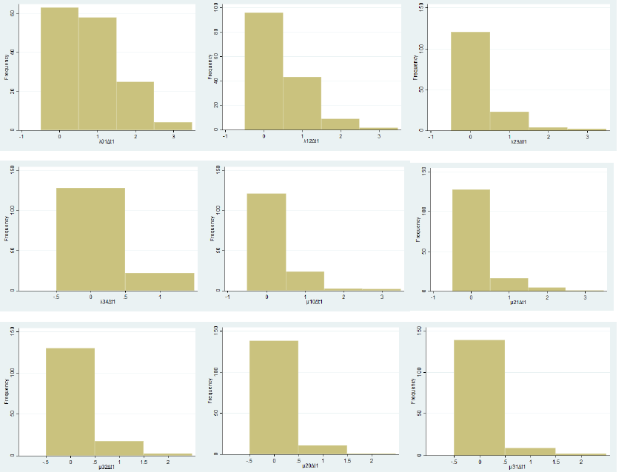

Figure 10: the histograms for the counts of transitions among different states.

The application of Lowess smoother showed the nonlinear relationship between the predictors and the response variables. From Fig. (11) to Fig. (19).
Table (4) demonstrated the location of knots using the restricted cubic spline (Harrell approach) for better functional form of the predictors to combat the multicollinearity problem between them.

Table (4): location of knots for specified variables using Harrell approach (the default used in STATA 14)
 | Knot 1 | Knot 2 | Knot 3 | Knot 4 | Knot 5
LDL-chol | 71.22 | 83.7 | 94.62 | 104.48 | 124.14
HOMA2-IR | 1.09 | 1.8 | 2.26 | 2.75 | 3.48
sysBloodPr. | 133.09 | 143.88 | 149.41 | 255.58 | 168.04
Dias blood Pr. | 74.45 | 87.44 | 94.07 | 101.11 | 114.49

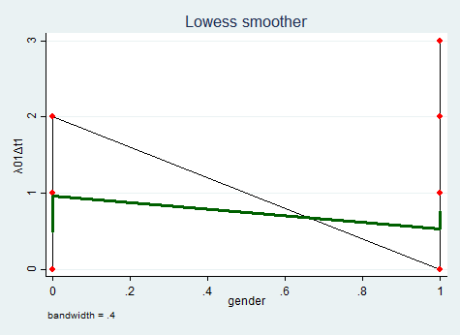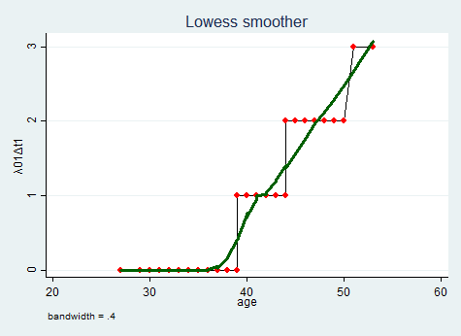
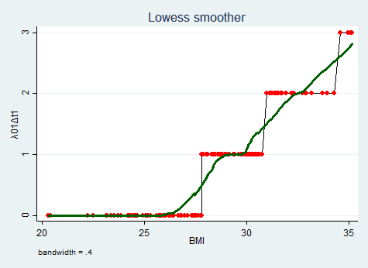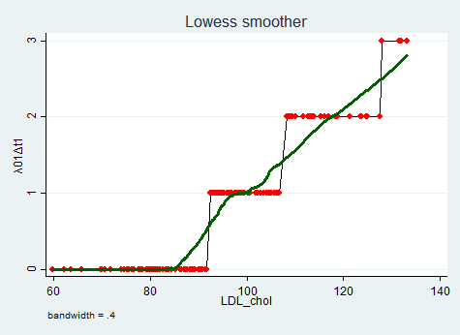
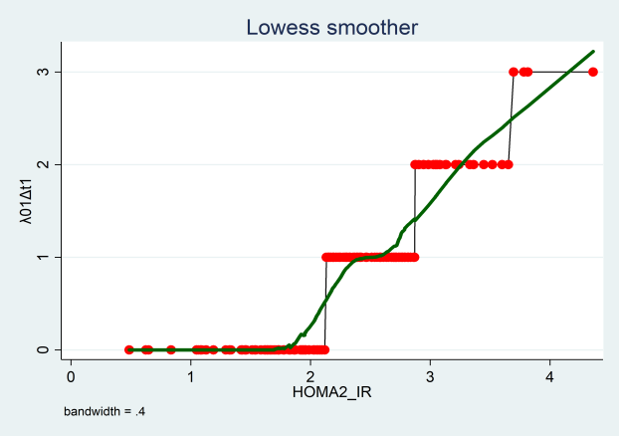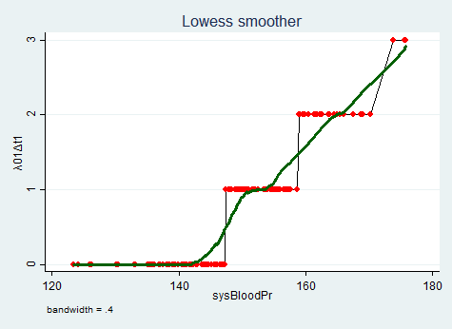
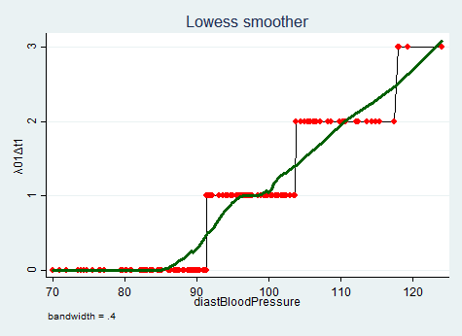
Figure (11): transition from F0 to F1
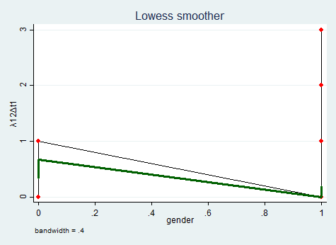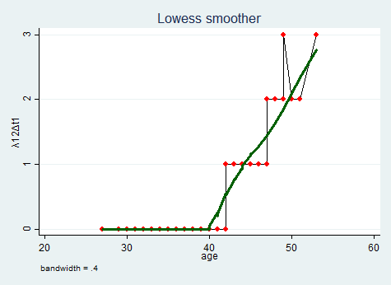
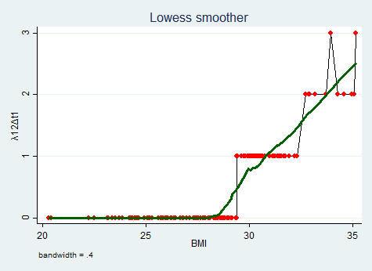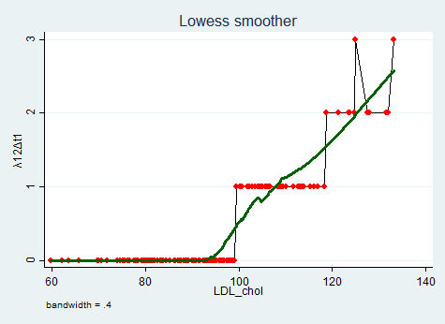
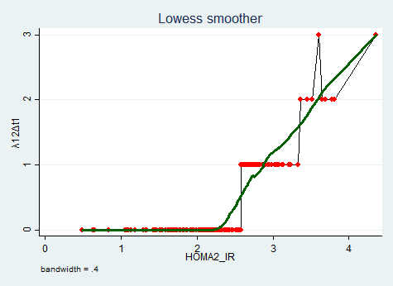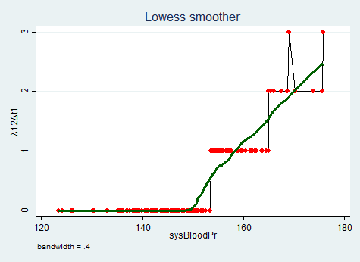
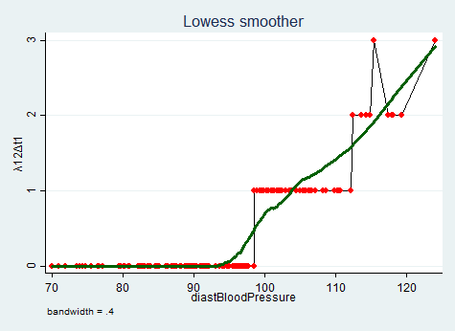
Figure (12): transition from F1 to F2

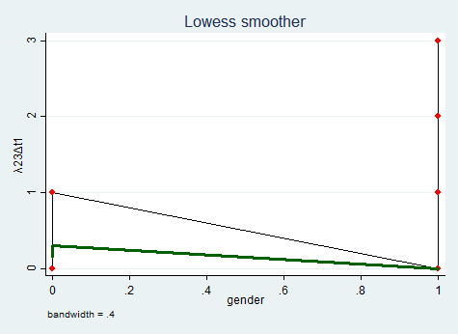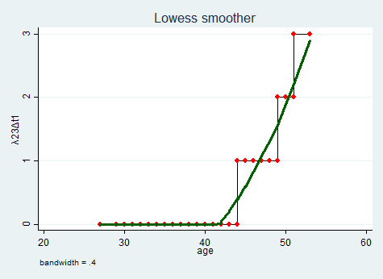
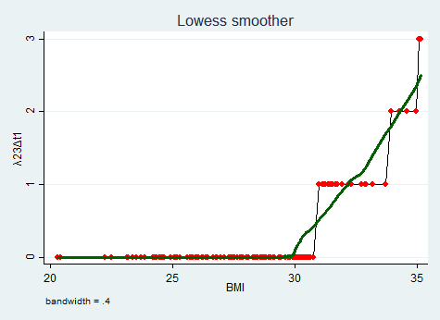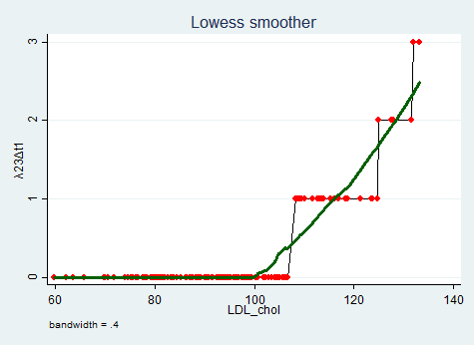
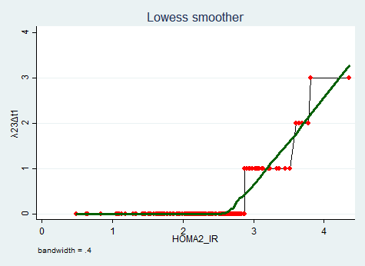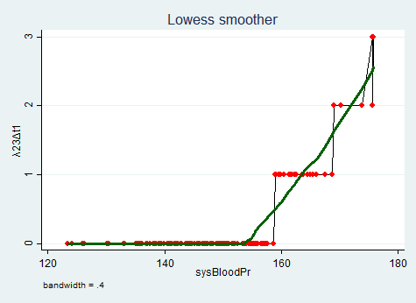
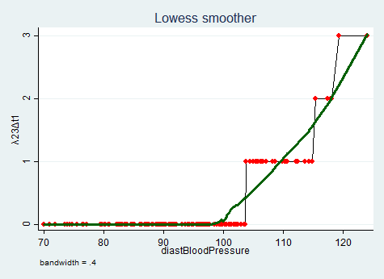
Figure (13): Transition F2 to F3
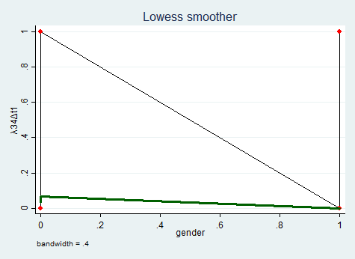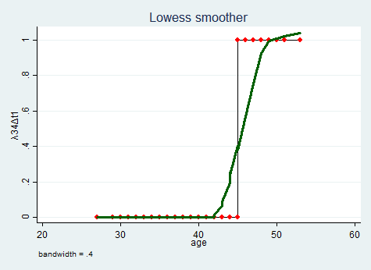
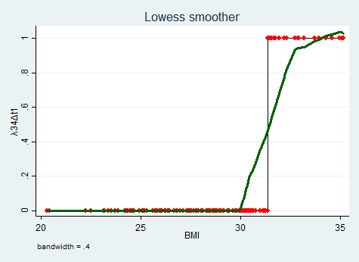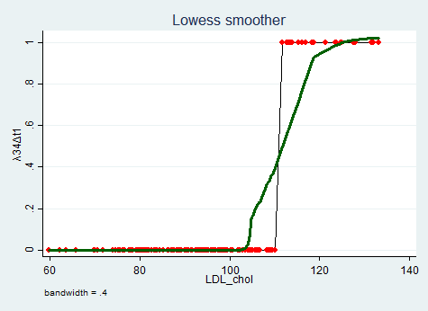
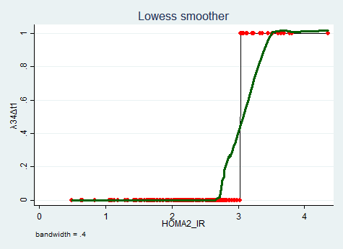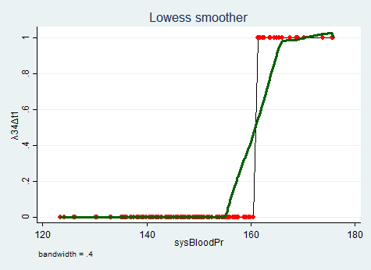
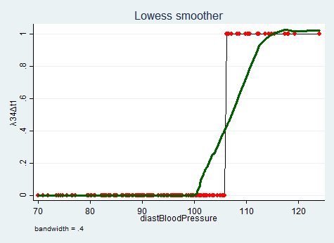
Figure (14): Transition F3 to F4
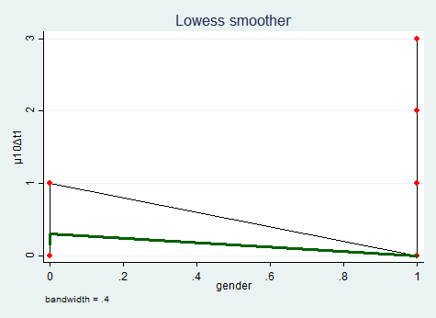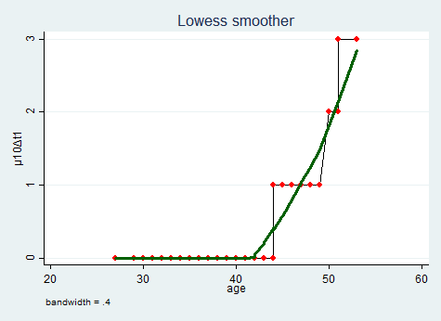
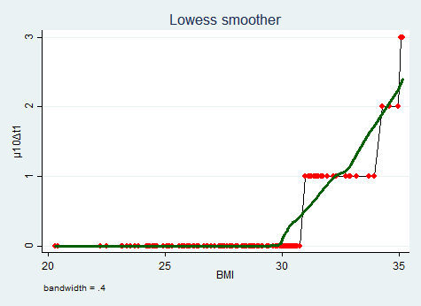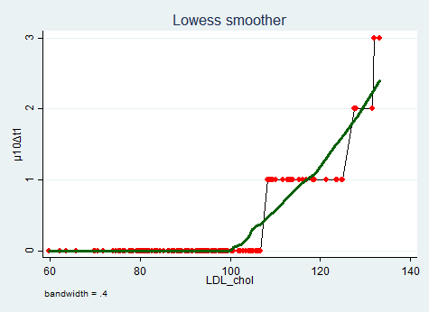
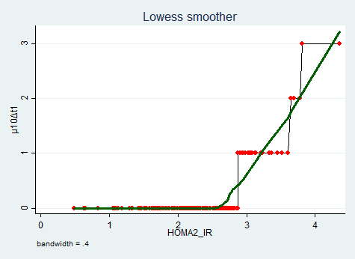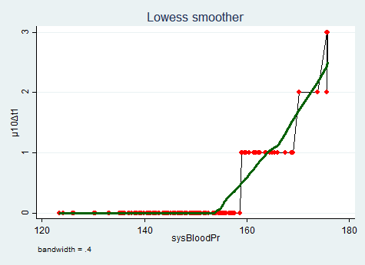
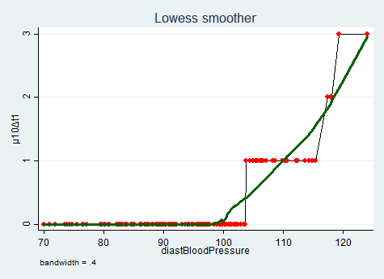
Figure (15): Transition F1 to F0
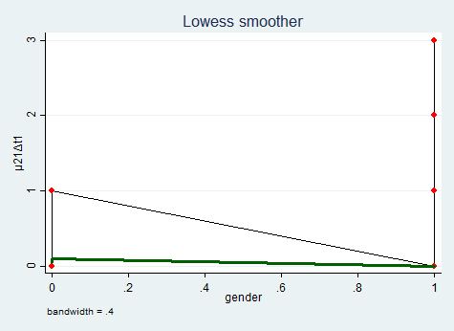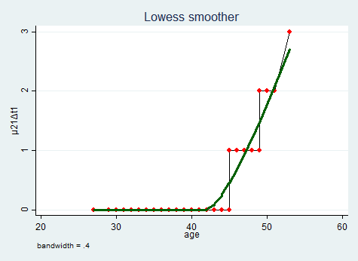
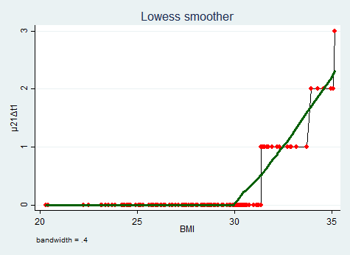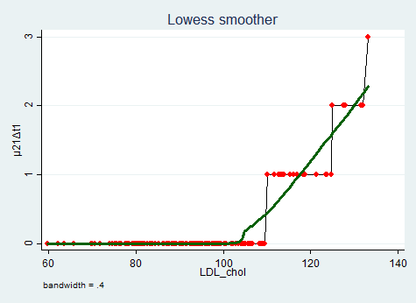
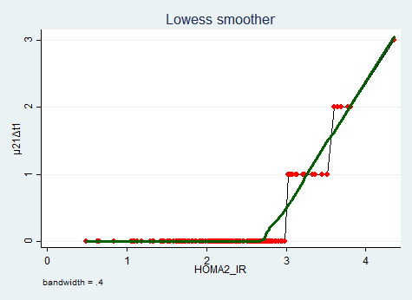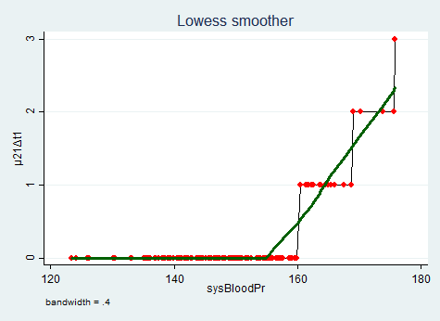
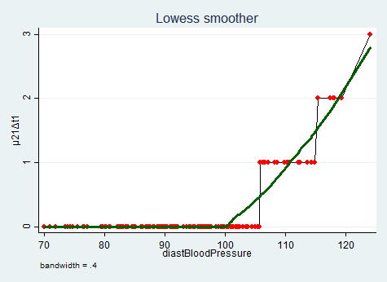
Figure (16): Transition F2 to F1
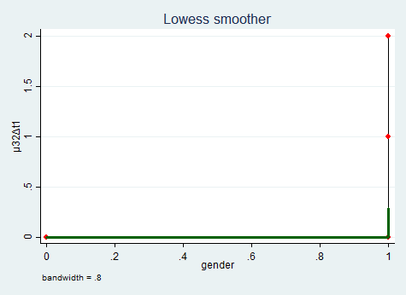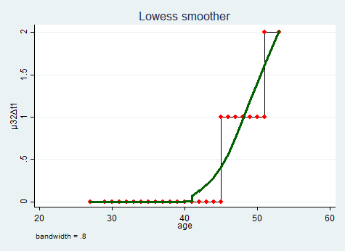
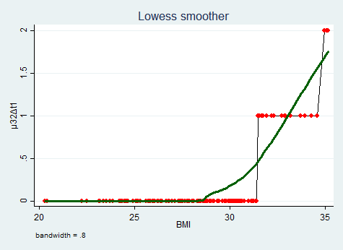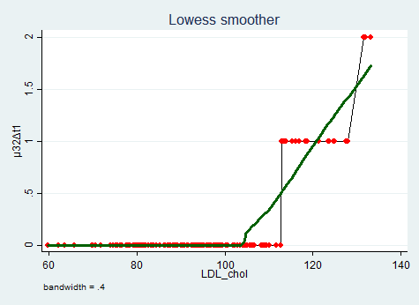
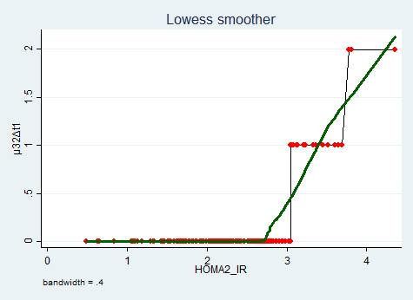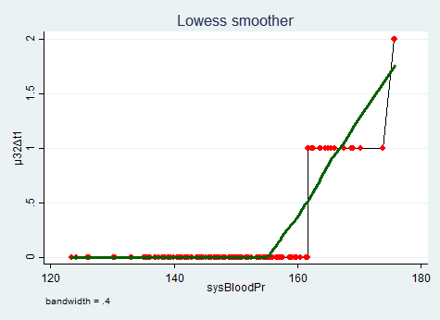
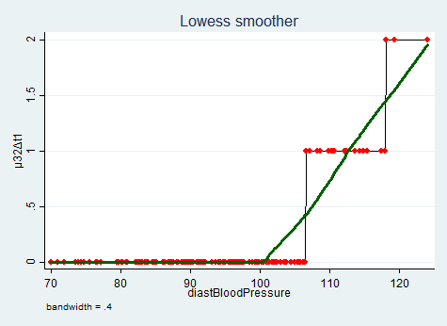
Figure (17): Transition F3 to F2
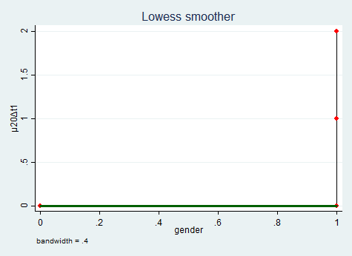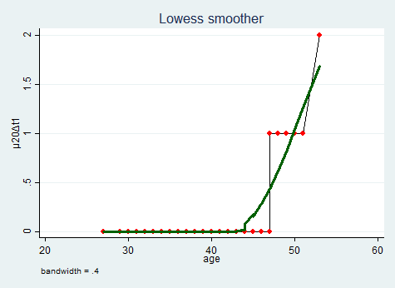
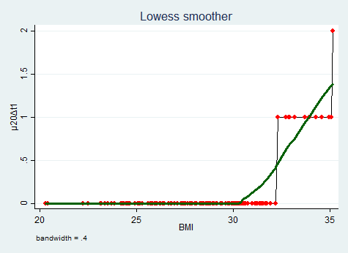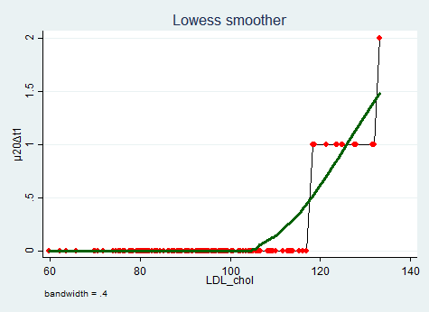
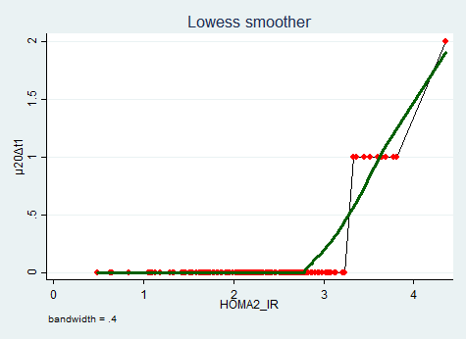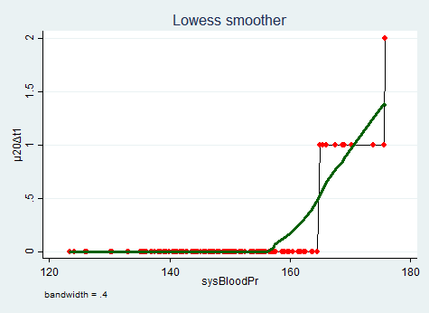
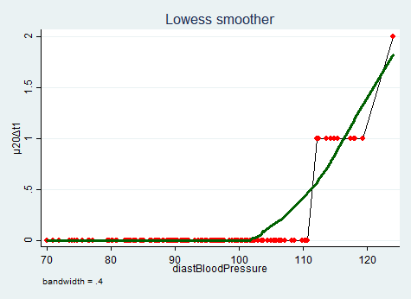
Figure (18): Transition F2 to F0
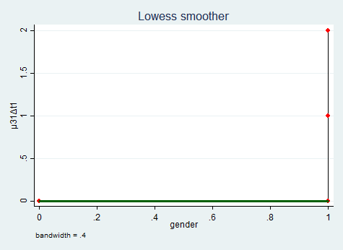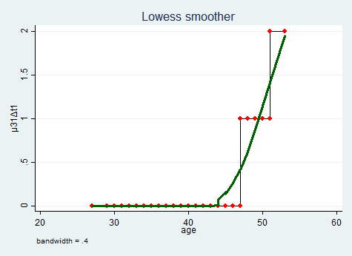
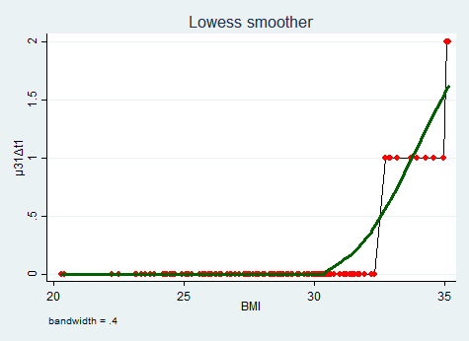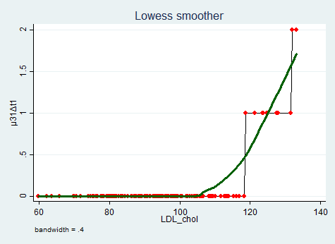
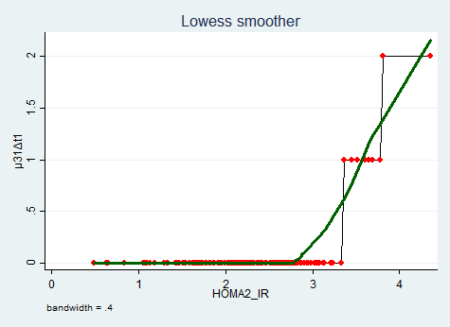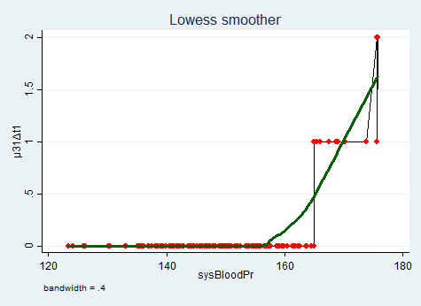
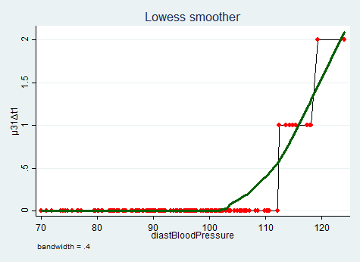
Figure (19): Transition F3 to F1

The transition counts for all the participants in the whole period of the study is shown in Table (5), for example, 63 participants did not move from F0 to F1, 58 participants moved once from F0 to F1, 25 participants moved 2 times from F0 to F1, and 4 persons moved 3 times from F0 to F1 in this 28 years of follow up. As regard the time line of all participants, the supplementary materials in Appendix A, demonstrated that the first 63 persons started at F0 and they had a stable course till the end of the study. They remained in F0 all through the whole period of the study. The next 33 patients started at F0, then after one year they moved to F1 and remained in F1 till the end of the study. The next 25 patients started at F0, then after one year they moved to F1, then in the following year they moved to F2 and thereafter they remained in this state till the end of the study. The last 29 patients exhibited the dynamic course of the disease, they moved back and forth among the states and the last 22 of them acquired liver cirrhosis (they reached F4). The first group of patients started and remained in F0 as they were almost in the desired group or in the early borderline group as regards the risk factors stratification. The second group of patients moved to F1 most probably as an effect of the high level of these risk factors in comparison with the previous group, this is also true for the third group, because the increased levels of risk factors such as increased insulin resistance, high LDL-chol and hypertension forced the patients to move from F0 to F1 and then to F2. These patients remained in the state where they had reached and did not advance to F3 or F4 which could be the influence of intermittent medical treatment and lifestyle modifications like weight loss and physical exercise. The last group manifested the back and forth movement among states because of the higher levels of their risk factors, they were also on intermittent medical treatment and lifestyle modification. Here it is important to emphasize that in F0, patients may have or not have steatosis, which itself may be associated with or without necroinflammatory changes in the liver cells. All liver biopsies in the study reported the grades of fibrosis and did not report the stages of steatosis and necroinflammation which is better to be achieved in real studies. Higher stages of steatosis and necroinflammation are positively related to the degree of fibrosis. The presence of steatosis and necroinflammation is also positively correlated with the levels of risk factors. The higher the levels of insulin resistance are, the greater the deposited amount of fat is (steatosis) and the greater the inflammatory reactions are. This is also true for higher levels of LDL-chol.

Table (5): summary transition counts between the states
Counts | Transition  0→1 | Transition  1→2 | Transition  2→3 | Transition  3→4 | Transition  1→0 | Transition  2→1 | Transition  3→2 | Transition  2→0 | Transition  3→1
0 | 63 | 96 | 121 | 128 | 121 | 127 | 130 | 138 | 139
1 | 58 | 43 | 23 | 22 | 24 | 17 | 17 | 11 | 9
2 | 25 | 9 | 4 |  | 3 | 5 | 3 | 1 | 2
3 | 4 | 2 | 2 |  | 2 | 1

A. Progressive Transitions

In table (6), (7), (8), (9), the coefficients of the transformed variables, their confidence intervals, incidence rate ratios (IRR) and their confidence intervals are shown.
The pathophysiological process that leads to fibrous tissue formation and deposits in the liver due to non-alcoholic fatty liver disease with its both phenotypes: non-alcoholic fatty liver (NAFL) and non-alcoholic steatohepatitis (NASH) is triggered by insulin resistance. It is the primary milestone and player in this whole process. Insulin resistant at the level of peripheral tissues forces the body to increase the secretion of plasma insulin to overcome this peripheral tissue resistance, thus enhancing entrance of insulin to the cells but at the expense of increased arterial blood pressure. So insulin exhibits selective insulin resistance to its action on different types of body cells. And the patients in this stage have normal plasma glucose and insulin sensitivity but they are hypertensive.
This hypertension as a causal effect of the increased peripheral insulin resistance does not directly affect fibrogenesis by itself. It is a reflection of increased insulin resistance which is the main detrimental effector for fibrogensis than the hypertension purse. Thus hypertension while controlling other factors was inversely proportional to the initialization of fibrous tissue formation and the transition from F0 to F1 in susceptible individuals ( p=0.07, which is not statistically significant). While other factors like increased level of HOMA2-IR and high plasma level of LDL-chol exerted separate deleterious effect on fibrous tissue formation and both were positively proportional to the rate of transition from F0 to F1 ( p= 0.000 for HOMA which was highly statistically significant and p=0.032 for LDL which was not highly statistically significant). The increased arterial systolic blood pressure forced HOMA2-IR and LDL-Chol to increase their effects, which were already high, on fibrous tissue formation, thus elevating the deleterious effect of both high HOMA2-IR and hyercholestrolemia on fibrogensis. This effect was more vigorous and highly statistically significant on hypercholesterolemia than on high HOMA2-IR level (p=0.000 vs p=0.122). Whereas their effect acting separately was harmful, their interactions ameliorated this effect of each other with p=0.011 which was statistically significant. In other words, the increased HOMA2-IR decreased the elevated effect of LDL-chol on fibrous tissue formation and transition from F0 to F1. This may be a defensive mechanism from the body to protect the hepatic cells from the dangerous effect of fibrous tissue formation in this milieu of metabolic disturbance. And as an overview of the defense of the body against the start of fibrogensis, the elevated blood pressure at the start of the pathophysiologicl process hampered the initial formation of the fibrous tissue, whilst the high HOMA2-IR and high LDL-chol increased and triggered its initial formation. The high blood pressure increased their high effects, while both high HOMA2-IR and high LDL-CHOL suppressed the effect of each other.
The elevated systolic blood pressure inhibited the transition from F1 to F2 because it is a consequence for the augmented body insulin resistance and its associated high plasma LDL-chol level, both boosted this transition to occur. This elevated blood pressure effect was not statistically significant (p=0.564) and the high LDL-chol also was not statistically significant, however; the high HOMA2-IR was highly statistically significant with p=0.000. In this transition the elevated blood pressure intensified the effect of high HOMA2-IR with p=0.616 which was not statistically significant, however its interaction with high LDL-chol was not obvious as shown in the initial fibrous tissue formation and transfer from F0 to F1. But the interaction between the high HOMA2-IR and high LDL-chol was well preserved like in the initial fibrous tissue formation. The excess level of HOMA2-IR was ameliorating or restraining the high effect of LDL-chol on transition from F1 to F2 with p=0.367 which was not statistically significant. There was an inverse relationship between its high level in the blood and the rate of transition from F2 to F3 with p=0.031, which was not highly statistically significant. The elevated systolic blood pressure increased the transition from F2 to F3 with p=0.01 which was statistically significant. In addition, the rising HOMA2-IR level magnified the transition from F2 to F3 with p=0.046 which was not highly statistically significant. The high systolic blood pressure hampered the deleterious effect of HOMA2-IR on this transition with p=0.017 which was statistically significant, as well as it decreased the attenuated effect of high LDL-chol on this transition with p=0.687 which was not statistically significant. So systolic hypertension decreased the effect of deleterious high HOMA2-IR level and decreased the effect of high LDL-chol on advanced fibrous tissue deposition which was more profound on HOMA2-IR than it was on the LDL-chol. Moreover, the high HOMA2-IR increased the attenuated effect of high LDL-chol on rate of transition from F2 to F3 with p=0.042 which was not highly statistically significant. These effects and interactions can be considered a mechanism to defer and delay the transition to advanced liver fibrosis state (F3). The transition from F3 to F4 occured due to the effect of increased LDL-chol, high HOMA2-IR level, and elevated systolic blood pressure. They were all statistically significant with p=0.000 for high LDL-chol and high HOMA2-IR, while; it was not statistically significant for elevated systolic blood pressure (p=0.141). The high level of HOMA2-IR repressed the promoting effect of high LDL-chol on the transition from F3 to F4, in attempt to preserve the if ever remaining healthy liver tissues. This interaction was statistically significant with p=0.000
It is worth-notable to mention that the process of fibrogenesis is under genetic control. It has been also shown that the main key player in the increment of fibrogenesis from a state to a more advanced state was mainly the promoting levels of HOMA2-IR.

Table (6): results for transitions from F0 to F1:
 | Coefficient | Robust  Std.dev. | z | p>|z| | 95%CI for  B coeff. | IRR | Robust  Std.dev. | 95%CI for  IRR
LDLsp2 | 0.523 | 0.243 | 2.149 | 0.032 | (0.046 , 1.000) | 1.687 | 0.411 | (1.047 , 2.718)
HOMAsp1 | 4.096 | 0.328 | 12.470 | 0.000 | (3.452 , 4.740) | 60.097 | 19.739 | (31.569 , 114.403)
sysSP2 | -0.628 | 0.347 | -1.809 | 0.070 | (-1.308 , 0.052) | 0.534 | 0.185 | (0.270 , 1.054)
c.LDLsp2#  c.HOMAsp1 | -0.179 | 0.070 | -2.540 | 0.011 | (-0.317 , -0.041) | 0.836 | 0.059 | (0.728 , 0.960)
c.LDLsp2#  c.sysSP2 | 0.003 | 0.000 | 8.144 | 0.000 | (0.002 , 0.003) | 1.003 | 0.000 | (1.002 , 1.003)
c.sysSP2#  c.HOMAsp1 | 0.151 | 0.098 | 1.547 | 0.122 | (-0.040 , 0.342) | 1.163 | 0.113 | (0.960 , 1.408)
cons | -9.510 | 0.725 | -13.122 | 0.000 | (-10.930 , -8.089) | 0.000 | 0.000 | (0.000 , 0.000)
Log pseudolikelihood = -110.43 |  |  |  |  | Pseudo R² = .355
Wald chi2(6) = 535.34 |  |  |  |  | Prob>chi2 =.000
Deviance gof = 27.55 |  |  |  |  | Prob>chi2(143) = 1
Pearson gof = 24.458 |  |  |  |  | Prob>chi2(143) = 1
Log pseudolikelihood(full model ) = -110.43 |  |  |  |  | Log pseudolikelihood(null model ) = -171.273
DF = 7 |  |  | AIC = 234.86 |  |  | BIC = 255.935

Using the above results to predict the $\ln{λ_{01}}=x_{i}^{'}B$ then calculating $E\left[y_{i} | x_{i}\right]=λ_{01}=exp\left(x_{i}^{'}B\right)$where $λ_{01}$ denotes the transition counts from state 0 to state 1 and as the time for the follow up was equal to all patients, the estimated counts for the transition from state 0 to state 1 were 120 transitions and the observed counts were 120. The expected increase in log count for one-unit increase in transformed LDL cholesterol was (0.523), which was not highly statistically significant (P=0.032), and for one-unit increase in transformed HOMA was (4.096), which was highly statistically significant (P=0.000), as both were considered risk factors for NAFLD to progress from F0 to F1. The expected decrease in log count for one-unit increase in transformed systolic blood pressure was (0.628) which was not statistically significant (P=0.07). For every unit increase in transformed LDL, the incident rate ratio increased (increase in transition counts) by 68.7%; while, for transformed HOMA, it increased by 5909.7%, with 95% confidence that this increase was between 3056.9% and 11340.3%. The expected decrease in log count for one unit increase in interaction between the transformed LDL and transformed HOMA was (0.179) with high statistical significance (P=0.11), in other word, the rise in one predictor variable decreased the rising effect of the other on the response variable (expected log count) but not reverse it. And for every unit increase in this interaction, the incident rate ratio decreased (i.e. decrease in transition counts) by 16.4%, with 95% confidence, that this decrease lied between 4% and 27.2%. While, the expected increase in log count for one unit increase in interaction between the transformed systolic blood pressure and transformed LDL was (0.003) with high statistical significance (P=0.000), and this increase in log count for one unit increase in interaction between transformed systolic blood pressure and transformed HOMA was (0.151) which was not statistically significant (P=0.122), in other word, the rise in one predictor variable increased the rising effect of the other on the response variable (expected log count).However, for every unit increase in the first interaction, the incident rate ratio only increased (i.e. increase in transition counts) by 0.3%, with 95% confidence, that this increase lied between 0.2% and 0.31%, while for the second interaction; the IRR increased by 16.3%. Poisson model was a good fit for the data as goodness of fit was not statistically significant (P=1).

Table (7): results for transitions from F1 to F2:
 | Coefficient | Robust  Std.dev. | z | p>|z| | 95%CI for  B coeff. | IRR | Robust  Std.dev. | 95%CI for  IRR
LDLsp2 | 0.311 | 0.396 | 0.785 | 0.432 | (-0.465 , 1.086) | 1.364 | 0.540 | (0.628 , 2.962)
HOMAsp1 | 5.486 | 0.571 | 9.599 | 0.000 | (4.366 , 6.606) | 241.179 | 137.821 | (78.690 , 739.192)
sysSP2 | -0.314 | 0.545 | -0.577 | 0.564 | (-1.383 , 0.754) | 0.730 | 0.398 | (0.251 , 2.126)
c.LDLsp2#  c.HOMAsp1 | -0.105 | 0.116 | -0.902 | 0.367 | (-0.332 , 0.123) | 0.901 | 0.105 | (0.717 , 1.131)
c.sysSP2#  c.HOMAsp1 | 0.079 | 0.158 | 0.502 | 0.616 | (-0.231 , 0.389) | 1.083 | 0.171 | (0.794 , 1.476)
cons | -14.884 | 1.363 | -10.923 | 0.000 | (-17.555 , -12.213) | 0.000 | 0.000 | (0.000 , 0.000)
Log pseudolikelihood = -67.887 |  |  |  |  | Pseudo R² = 0.481
Wald chi2(6) = 284.3 |  |  |  |  | Prob>chi2 = 0.000
Deviance gof = 20.27 |  |  |  |  | Prob>chi2(144) = 1
Pearson gof = 18.12 |  |  |  |  | Prob>chi2(144) = 1
Log pseudolikelihood( full model ) = -67.887 |  |  |  |  | Log pseudolikelihood( null model ) = -130.82
DF = 6 |  |  | AIC = 147.77 |  |  | BIC = 165.84

Using the above results to predict the $\ln{λ_{12}}=x_{i}^{'}B$ then calculating $E\left[y_{i} | x_{i}\right]=λ_{12}=exp\left(x_{i}^{'}B\right)$where $λ_{12}$ denotes the transition counts from state 1 to state 2 and as the time for the follow up was equal to all patients, the estimated counts for the transition from state 1 to state 2 were 64 transitions while the observed counts were 67 transitions . The expected increase in log count for one-unit increase in transformed LDL cholesterol was (0.311), which was not highly statistically significant (P=0.432), and for one-unit increase in transformed HOMA was (5.486), which was highly statistically significant (P=0.000), as both were considered risk factors for NAFLD to progress from F1 to F2. The expected decrease in log count for one-unit increase in transformed systolic blood pressure was (0.314), which was not statistically significant (P= 0.564). For every unit increase in transformed LDL the incident rate ratio increased (increase in transition counts) by 36.4%; while, for transformed HOMA it increased by 24017.9%, with 95% confidence that this increase was between 7769% and 73819.2%. The expected decrease in log count for one unit increase in interaction between the transformed LDL and transformed HOMA was (0.105) with no statistical significance (P=0.367), in other word, the rise in one predictor variable decreased the rising effect of the other on the response variable (expected log count) but not reverse it. While, the expected increase in log count for one unit increase in interaction between the transformed systolic blood pressure and transformed HOMA was (0.079) with no statistical significance (P=0.616). Poisson model was a good fit for the data as goodness of fit was not statistically significant (P=1).

Table (8): results for transitions from F2 to F3:
 | Coefficient | Robust  Std.dev. | z | p>|z| | 95%CI for  B coeff. | IRR | Robust  Std.dev. | 95%CI for  IRR
LDLsp2 | -1.480 | 0.685 | -2.159 | 0.031 | (-2.823 , -0.137) | 0.228 | 0.156 | (0.059 , 0.872)
HOMAsp1 | 6.174 | 3.093 | 1.996 | 0.046 | (0.112 , 12.237) | 480.318 | 1485.815 | (1.118 , 2.06e+5)
sysSP2 | 2.497 | 0.967 | 2.583 | 0.010 | (0.602 , 4.391) | 12.143 | 11.738 | (1.826 , 80.754)
c.LDLsp2#  c.HOMAsp1 | 0.390 | 0.192 | 2.032 | 0.042 | (0.014 , 0.766) | 1.477 | 0.283 | (1.014 , 2.151)
c.LDLsp2#  c.sysSP2 | -0.001 | 0.002 | -0.403 | 0.687 | (-0.005 , 0.004) | 0.999 | 0.002 | (0.995 , 1.004)
c.sysSP2#  c.HOMAsp1 | -0.655 | 0.274 | -2.392 | 0.017 | (-1.191 , -0.118) | 0.520 | 0.142 | (0.304 , 0.889)
cons | -20.866 | 7.293 | -2.861 | 0.004 | (-35.160 , -6.572) | 0.000 | 0.000 | (0.000 , 0.001)
Log pseudolikelihood = -37.87 |  |  |  |  | Pseudo R² = 0.6020
Wald chi2(6) = 191.48 |  |  |  |  | Prob>chi2 = 0.000
Deviance gof = 13.29 |  |  |  |  | Prob>chi2(143) = 1
Pearson gof = 12.42 |  |  |  |  | Prob>chi2(143) = 1
Log pseudolikelihood(full model ) = -37.87 |  |  |  |  | Log pseudolikelihood(null model ) = -95.15
DF = 7 |  |  | AIC = 89.73 |  |  | BIC = 110.81

Using the above results to predict the $\ln{λ_{23}}=x_{i}^{'}B$ then calculating $E\left[y_{i} | x_{i}\right]=λ_{23}=exp\left(x_{i}^{'}B\right)$where $λ_{23}$ denotes the transition counts from state 2 to state 3 and as the time for the follow up was equal to all patients, the estimated counts for the transition from state 2 to state 3 were 35 transitions while the observed counts were 37 transitions . The expected decrease in log count for one-unit increase in transformed LDL cholesterol was (1.48) which was not highly statistically significant (P=0.031). The expected increase in log count for one-unit increase in transformed HOMA was (6.174) which was not highly statistically significant (P=0.046), and for one-unit increase in transformed systolic blood pressure was (2.497) which was statistically significant (P=0.01), as both were considered risk factors for NAFLD to progress from F2 to F3. For every unit increase in transformed systolic blood pressure, the incident rate ratio increased (increase in transition counts) by 1114.3%, with 95% confidence that this increase was between 82.6% and 7975.4%. The expected increase in log count for one unit increase in interaction between the transformed LDL and transformed HOMA was (0.39) with no high statistical significance (P=0.042), in other word, the rise in one predictor variable increased the rising effect of the other on the response variable (expected log count). While, the expected decrease in log count for one unit increase in interaction between the transformed systolic blood pressure and transformed LDL was (0.001) with no statistical significance (P=0.687), and this decrease in log count for one unit increase in interaction between transformed systolic blood pressure and transformed HOMA was (0.655) which was highly statistically significant (P=0.017), in other word, the rise in one predictor variable decreased the rising effect of the other on the response variable (expected log count) but not reverse it. However, for every unit increase in the first interaction, the incident rate ratio only decreased (i.e. decrease in transition counts) by 0.1%, and for the second interaction; the IRR was decreased by 48%, with 95% confidence that this decrease was between 11.1% and 69.6%. Poisson model was a good fit for the data as goodness of fit was not statistically significant.

Table (9): results for transitions from F3 to F4:
 | Coefficient | Robust  Std.dev. | z | p>|z| | 95%CI for  B coeff. | IRR | Robust  Std.dev. | 95%CI for  IRR
LDLsp2 | 0.452 | 0.055 | 8.278 | 0.000 | (0.345 , 0.559) | 1.571 | 0.086 | (1.412 , 1.748)
HOMAsp1 | 10.866 | 1.402 | 7.753 | 0.000 | (8.119 , 13.613) | 52375.984 | 73411.34 | (3357.9 , 8.17e+5)
sysSP2 | 0.073 | 0.050 | 1.472 | 0.141 | (-0.024 , 0.171) | 1.076 | 0.054 | (0.976 , 1.187)
c.LDLsp2#  c.HOMAsp1 | -0.166 | 0.018 | -9.320 | 0.000 | (-0.201 , -0.131) | 0.847 | 0.015 | (0.818 , 0.877)
cons | -34.034 | 3.865 | -8.806 | 0.000 | (-41.608 , -26.459) | 0.000 | 0.000 | (0.000 , 0.000)
Log pseudolikelihood = -26.97 |  |  |  |  | Pseudo R² = 0.58
Wald chi2(6) = 122.33 |  |  |  |  | Prob>chi2 = 0.000
Deviance gof = 9.94 |  |  |  |  | Prob>chi2(145) = 1
Pearson gof = 8.96 |  |  |  |  | Prob>chi2(145) = 1
Log pseudolikelihood(full model ) = -26.97 |  |  |  |  | Log pseudolikelihood(null model ) = -64.23
DF = 5 |  |  | AIC = 63.94 |  |  | BIC = 78.99

Using the above results to predict the $\ln{λ_{34}}=x_{i}^{'}B$ then calculating $E\left[y_{i} | x_{i}\right]=λ_{34}=exp\left(x_{i}^{'}B\right)$ where $λ_{34}$ denotes the transition counts from state 3 to state 4 and as the time for the follow up was equal to all patients, the estimated counts for the transition from state 3 to state 4 were 20 transitions while the observed counts were 22 transitions . The expected increase in log count for one-unit increase in transformed LDL cholesterol was (0.452) which was highly statistically significant (P=0.000), this expected increase in log count for one-unit increase in transformed HOMA was (10.866) which was also highly statistically significant (P=0.000), and it was for one-unit increase in transformed systolic blood pressure was (0.073) which was not statistically significant (P=0.141), as all were considered risk factors for NAFLD to progress from F3 to F4. For every unit increase in transformed LDL, the incident rate ratio increased (increase in transition counts) by 57.1%, with 95% confidence that this increase was between 41.2% and 74.8%. Furthermore, for every unit increase in transformed HOMA, the incident rate ratio increased (increase in transition counts) by 5237498.4%, with 95% confidence that this increase was between 335691.1% and 81.7e+6%. For every unit increase in this interaction, the incident rate ratio decreased (i.e. decrease in transition counts) by 15.3%, with 95% confidence that this decrease was between 12.3% and 18.2%. Poisson model was a good fit for the data as goodness of fit was not statistically significant (P=1).

Table (10) shows expected counts and table (11) shows the comparison between the observed rates and the expected rates
Table (10): Expected transition counts after running Poisson regression
Counts | Transition  0→1 | Transition  1→2 | Transition  2→3 | Transition  3→4
0 | 75 | 102 | 125 | 133
1 | 34 | 35 | 18 | 14
2 | 37 | 11 | 4 | 3
3 | 4 | 1 | 3 | 0
4 | 0 | 1 | 0 | 0
Total | 150 | 150 | 150 | 150

Table (11): The comparison between observed and estimated response rate after fitting Poisson model
 |  | Observed  response rate | Estimated mean  response rate
0→1 | Mean | .8 | .8
0→1 | Variance | .658 | .619
1→2 | Mean | .45 | .45
1→2 | Variance | .45 | .45
2→3 | Mean | .25 | .25
2→3 | Variance | .32 | .318
3→4 | Mean | .15 | .15
3→4 | Variance | .126 | .126

B. Regressive Transitions

In table (12), (13), (14), (15), (16) the coefficients of the transformed variables, their confidence intervals, incidence rate ratios (IRR) and their confidence intervals are shown.
The transition from F1 to F0 can occur in patients even with elevated blood pressure if they leash the effect of both HOMA2-IR and LDL-chol, as stated in the pathogenesis of NAFLD, insulin resistant is the causing factor for high blood pressure. So even if the high blood pressure is not well managed, but the HOMA2-IR and the LDL-chol is well managed, reversal of fibrogenesis can occur. HOMA2-IR and LDL-chol exerted negative effects on the rate of transition which was not statistically significant for each of HOMA2-IR and LDL-chol (p=0.13 & p=0.063 rspectively), while; the high level of HOMA2-IR exhibited intensification to lower the effect of LDL-chol. This interaction between HOMA2-IR and LDL-chol was statistically significant with (p=0.002). This effect helps the liver to reverse the process of fibrogenesis especially if hyperinsulinemia and hypercholesterolemia are rigorously treated. In addition to the enhancing effect of hypertension to decrease the fibrous tissue formation, it dampened the beneficial effect of the low HOMA2-IR level and low LDL-chol level, this effect was statistically significant for LDL-chol (p=0.005) but not statistically significant for HOMA2-IR ( p=0.048). This effect needs further study to address the pathophysiology of fibrogenesis in a deeper manner.
These variables almost exerted similar effect on transition from F2 to F1. The high systolic blood pressure increased this transtion and helped to regress the rate of fibrosis progression which was statistically significant (p<0.000). Also low levels of each of HOMA2-IR and LDL-chol enhanced this transition which were not statistically significant (p=0.242 & P=0.499 respectively). This can be achieved with strict control of insulin resistance. The repressing level of HOMA2-IR increased the repressing effect of lowered LDL-chol on the transition which was statistically significant (p=0.022). The high systolic blood pressure dampened the lowering effect of LDL-chol on regression from F2 to F1 with statistical significance of p=0.003, and it also restrained the lowering effect of HOMA2-IR on this regression rate with (p=0.137) which was not statistically significant. In other words, hypertension by itself regressed the rate of progression of fibrosis but did not allow other factors such as the low levels of LDL-chol to exert its beneficial effect on regression (F2 to F1) and this was also true for HOMA2-IR which may mandate further study to address this issue.
The transition from F3 to F2 was enhanced by lowering the level of HOMA2-IR which was not statistically significant with (p=0.103). Reaching F3, which is an advanced stage of fibrosis, is mostly associated with bad management of the risk factors and a long lasting insulin resistance and hypertension. Although the high level of systolic blood pressure and the high level of LDL-chol increased the regression from F3 to F2, this effect was not statistically significant (p= 0.142 and p=0.154 respectively) and the interaction between them showed that the reduction of the level of one of them reduced the regressing effect of the other on the transmission from F3 to F2 and this interaction was statistically significant (p=0.006). The high level of HOMA2-IR was inversely related to this rate of transmission. The higher the HOMA2-IR level is, the lesser the rate of regression from F3 to F2 is, which was not statistically significant (p=0.103). This HOMA2-IR interacted positively with both LDL-chol and systolic blood pressure, that is to mean, decreasing the level of HOMA2-IR increased the regression of fibrous tissue formation and this HOMA2-IR effect augmented the regressing effect of both the increased level of LDL-chol and the repressing effect of high systolic blood pressure, but this interaction was not statistically significant (p=0.984 & p=0.375 respectively). That is to mean, controlling HOMA2-IR to reduce its level even in the presence of uncontrolled high LDL-chol level and high systolic blood pressure, is in favor of regressing the fibrous tissue formation. This effect may be due to the presence of vascular lesions consuming the LDL-chol and thus reducing the local availability of the LDL in the liver to enhance fibrous tissue formation. Further studies are needed to uncover these issues.
The regression from F2 to F0 is inversely proportional to HOMA2-IR and systolic blood pressure which was statistically significant (p<0.000 and p=0.01 respectively) and this was also true for regression from F 3 to F1 with (p<0.000 and p=0.004 respectively). For regression to more previous stages, more control should be imposed on HOMA2-IR level as well as on systolic blood pressure. However, these regression was increased by high level of LDL-chol which was not highly statistically significant for either regression (F2 to F0 & F3 to F1), and this was the same effect between these regression rates and diastolic blood pressure but with high significant level (p=0.001 and p=0.003 respectively). These effects need further studies as these are results for a depicted study not real one.

Table (12): results for transitions from F1 to F0
 | Coefficient | Robust  Std.dev. | z | p>|z| | 95%CI for  B coeff. | IRR | Robust  Std.dev. | 95%CI for  IRR
LDLsp2 | -0.454 | 0.244 | -1.862 | 0.063 | (-0.932 , 0.024) | 0.635 | 0.155 | (0.394 , 1.024)
HOMAsp2 | -4.489 | 2.962 | -1.515 | 0.130 | (-10.294 , 1.316) | 0.011 | 0.033 | (0.000 , 3.730)
sysSP2 | 1.340 | 0.312 | 4.301 | 0.000 | (0.729 , 1.951) | 3.820 | 1.190 | (2.074 , 7.034)
c.LDLsp2#  c.HOMAsp2 | 0.290 | 0.096 | 3.029 | 0.002 | (0.102 , 0.478) | 1.337 | 0.128 | (1.108 , 1.612)
c.LDLsp2#  c.sysSP2 | -0.010 | 0.004 | -2.789 | 0.005 | (-0.017 , - 0.003) | 0.990 | 0.004 | (0.983 , 0.997)
c.sysSP2#  c.HOMAsp2 | -0.286 | 0.145 | -1.974 | 0.048 | (-0.571 , -0.002) | 0.751 | 0.109 | (0.565 , 0.998)
cons | -5.916 | 0.508 | -11.651 | 0.000 | (-6.912 , -4.921) | 0.003 | 0.001 | (0.001 , 0.007)
Log pseudolikelihood = -38.14 |  |  |  |  | Pseudo R² = 0.59
Wald chi2(6) = 331.08 |  |  |  |  | Prob>chi2 = 0.000
Deviance gof = 14.46 |  |  |  |  | Prob>chi2(143) = 1
Pearson gof = 13.55 |  |  |  |  | Prob>chi2(143) = 1
Log pseudolikelihood(full model ) = -38.14 |  |  |  |  | Log pseudolikelihood(null model ) = -93.04
DF = 7 |  |  | AIC = 90.29 |  |  | BIC = 111.36

Using the above results to predict the $\ln{μ_{10}}=x_{i}^{'}B$ then calculating $E\left[y_{i} | x_{i}\right]=μ_{10}=exp\left(x_{i}^{'}B\right)$where $μ_{10}$ denotes the transition counts from state 1 to state 0 and as the time for the follow up was equal to all patients, the estimated counts for the transition from state1 to state 0 were 36 transitions while the observed counts were 36 transitions. The expected decrease in log count for one-unit increase in transformed LDL cholesterol is (0.454), which is not highly statistically significant (P= 0.063), and the expected decrease in log count for one-unit increase in transformed HOMA is (4.489), which is not statistically significant (P= 0.13). Thus, better management for these risk factors enhances the transition from F1 to F0. While the expected increase in log count for one-unit increase in transformed systolic blood pressure is (1.34), which is highly statistically significant (p=0.000). For every unit increase in transformed systolic blood pressure, the incident rate ratio is increased (increase in transition counts) by 282%, with 95% confidence that this increase is between 107.4% and 603.4%. This effect is not really explainable and further studies are needed to evaluate such effect as there may be some confounder substances that could induce such effect. The expected increase in log count for one unit increase in interaction between the transformed LDL and transformed HOMA is (0.29) with high statistical significance (p=0.002), in other word, the rise in one predictor variable increases the effect of the other on the response variable (expected log count). For every unit increase of this interaction, the incident rate ratio is increased (increase in transition counts) by 33.7%, with 95% confidence that this increase is between 10.8% and 61.2%. While, the expected decrease in log count for one unit increase in interaction between the transformed systolic blood pressure and transformed LDL is (0.01) with high statistical significance (p=0.005), and this decrease in log count for one unit increase in interaction between transformed systolic blood pressure and transformed HOMA is (0.286) which is not highly statistically significant (p=0.048), in other word, the rise in one predictor variable decreases the effect of the other on the response variable (expected log count). However, for every unit increase in the first interaction, the incident rate ratio is only decreased (i.e. decrease in transition counts) by 1%, with 95% confidence that this decrease is between 0.3% and 1.7%. Moreover, for the second interaction; the IRR is decreased by 24.9%. Poisson model fits the data as goodness of fit is not statistically significant (P=1).

Table (13): results for transitions from F2 to F1:
 | Coefficient | Robust  Std.dev. | z | p>|z| | 95%CI for  B coeff. | IRR | Robust  Std.dev. | 95%CI for  IRR
LDLsp2 | -0.128 | 0.189 | -0.675 | 0.499 | (-0.499 , 0.243) | 0.880 | 0.167 | (0.607 , 1.275)
HOMAsp2 | -3.288 | 2.812 | -1.169 | 0.242 | (-8.800 , 2.224) | 0.037 | 0.105 | (0.000 , 9.244)
sysSP2 | 0.913 | 0.201 | 4.546 | 0.000 | (0.519 , 1.307) | 2.492 | 0.501 | (1.681 , 3.694)
c.LDLsp2#  c.HOMAsp2 | 0.152 | 0.066 | 2.288 | 0.022 | (0.022 , 0.282) | 1.164 | 0.077 | (1.022 , 1.326)
c.LDLsp2#  c.sysSP2 | -0.010 | 0.003 | -2.950 | 0.003 | (-0.017 , -0.003) | 0.990 | 0.003 | (0.983 , 0.997)
c.sysSP2#  c.HOMAsp2 | -0.114 | 0.114 | -1.001 | 0.317 | (-0.338 , 0.109) | 0.892 | 0.102 | (0.713 , 1.116)
cons | -7.666 | 0.617 | -12.426 | 0.000 | (-8.875 , -6.457) | 0.000 | 0.000 | (0.000 , 0.002)
Log pseudolikelihood = -29.96 |  |  |  |  | Pseudo R² = 0.64
Wald chi2(6) = 304.94 |  |  |  |  | Prob>chi2 = 0.000
Deviance gof = 9.86 |  |  |  |  | Prob>chi2(143) = 1
Pearson gof = 8.97 |  |  |  |  | Prob>chi2(143) = 1
Log pseudolikelihood(full model ) = -29.96 |  |  |  |  | Log pseudolikelihood(null model ) = -83.54
DF = 7 |  |  | AIC = 73.92 |  |  | BIC = 94.99

Using the above results to predict the $\ln{μ_{21}}=x_{i}^{'}B$ then calculating $E\left[y_{i} | x_{i}\right]=μ_{21}=exp\left(x_{i}^{'}B\right)$ where $μ_{21}$ denotes the transition counts from state 2 to state 1 and as the time for the follow up was equal to all patients, the estimated counts for the transition from state2 to state1 were 26 transitions while the observed counts were 30 transitions. The expected decrease in log count for one-unit increase in transformed LDL cholesterol was (0.128) which was not statistically significant(P=0.499), and the expected decrease in log count for one-unit increase in transformed HOMA was (3.288) which was not statistically significant (P=0.242). Thus, better management of these risk factors enhances the transition from F2 to F1. While the expected increase in log count for one-unit increase in transformed systolic blood pressure was (0.913) which was highly statistically significant (P=0.000). For every unit increase in transformed systolic blood pressure, the incident rate ratio increased (increase in transition counts) by 149.2%, with 95% confidence that this increase was between 68.1% and 269.4%. This effect was not really explainable and further studies are needed to evaluate such effect. The expected increase in log count for one unit increase in interaction between the transformed LDL and transformed HOMA was (0.152) with high statistical significance (P=0.022), in other word, the rise in one predictor variable increased the effect of the other on the response variable (expected log count). For every unit increase of this interaction, the incident rate ratio increased (increase in transition counts) by 16.4%, with 95% confidence that this increase was between 2.2% and 32.6%. While, the expected decrease in log count for one unit increase in interaction between the transformed systolic blood pressure and transformed LDL was (0.01) with high statistical significance (P=0.003), and this decrease in log count for one unit increase in interaction between transformed systolic blood pressure and transformed HOMA was (0.114) which was not statistically significant (P=0.317), in other word, the rise in one predictor variable decreased the effect of the other on the response variable (expected log count) but not reverse it. However, for every unit increase in the first interaction, the incident rate ratio only decreased (i.e. decrease in transition counts) by 1%, with 95% confidence that this decrease was between 0.3% and 1.7%. Moreover, for the second interaction; the IRR was decreased by 10.8%. Poisson model was a good fit for the data as goodness of fit was not statistically significant.

Table (14): results for transitions from F3 to F2:
 | Coefficient | Robust  Std.dev. | z | p>|z| | 95%CI for  B coeff. | IRR | Robust  Std.dev. | 95%CI for  IRR
LDLsp2 | .302 | .211 | 1.427 | .154 | (-.113 , 0.716) | 1.352 | .286 | (0.893 , 2.047)
HOMAsp2 | -5.214 | 3.196 | -1.631 | .103 | (-11.478 , 1.05) | .005 | .017 | (0.000 , 2.859)
sysSP2 | .422 | .288 | 1.467 | .142 | (-0.142 , .987) | 1.526 | .439 | (.868 , 2.683)
c.LDLsp2#  c.HOMAsp2 | .002 | .102 | .019 | .984 | (-.198 , .202) | 1.002 | .102 | (.821 , 1.223)
c.LDLsp2#  c.sysSP2 | -.012 | .004 | -2.749 | .006 | (-.02 ,- .003) | 0.998 | .004 | (0.98 , .997)
c.sysSP2#  c.HOMAsp2 | .132 | .149 | 0.888 | .375 | (-0.16 , .425) | 1.142 | .17 | (.852 , 1.529)
cons | -7.363 | .761 | -9.671 | .000 | (-8.855 , -5.871) | .001 | .000 | (.000 , .003)
Log pseudolikelihood = -26.37 |  |  |  |  | Pseudo R² = .61
Wald chi2(6) = 175.47 |  |  |  |  | Prob>chi2 =.000
Deviance gof = 10.89 |  |  |  |  | Prob>chi2(143) = 1
Pearson gof = 9.77 |  |  |  |  | Prob>chi2(143) = 1
Log pseudolikelihood(full model ) = -26.37 |  |  |  |  | Log pseudolikelihood(null model ) = -68.21
DF = 7 |  |  | AIC = 66.74 |  |  | BIC = 87.81

Using the above results to predict the $\ln{μ_{32}}=x_{i}^{'}B$ then calculating $E\left[y_{i} | x_{i}\right]=μ_{32}=exp\left(x_{i}^{'}B\right)$where $μ_{32}$ denotes the transition counts from state 3 to state 2 and as the time for the follow up was equal to all patient, the estimated counts for the transition from state 3 to state 2 were 19 transitions, while the observed counts were 23 transitions . The expected increase in log count for one-unit increase in transformed LDL cholesterol was (0.302) which was not statistically significant (P=0.154), and the expected increase in log count for one-unit increase in transformed systolic blood pressure was (0.422) which was not statistically significant (P=0.142). This effect was not really explainable and further studies are needed to evaluate such effect. While the expected decrease in log count for one-unit increase in transformed HOMA was (5.214) which was not statistically significant (P=0.103). Thus, better management of HOMA enhances the transition from F3 to F2. The expected increase in log count for one unit increase in interaction between the transformed LDL and transformed HOMA was (0.002) with no high statistical significance (P=0.984), and this expected increase for one unit increase in interaction between transformed HOMA and transformed systolic blood pressure was (0.132), which was not statistically significant (P=0.375), in other word, the rise in one predictor variable increased the effect of the other on the response variable (expected log count). While, the expected decrease in log count for one unit increase in interaction between the transformed systolic blood pressure and transformed LDL was (0.012) with high statistical significance (P=0.006), in other word, the rise in one predictor variable decreased the effect of the other on the response variable (expected log count) but not reverse it. For every unit increase in this interaction, the incident rate ratio deceased (decrease in transition counts) by 1.2%, with 95% confidence that this decrease was between 0.3% and 2%. Poisson model was a good fit for the data as goodness of fit is not statistically significant.

Table (15): results for transitions from F2 to F0:
 | Coefficient | Robust  Std.dev. | z | p>|z| | 95%CI for  B coeff. | IRR | Robust  Std.dev. | 95%CI for  IRR
LDLsp2 | 0.076 | 0.079 | 0.965 | 0.335 | (-0.079 , 0.231) | 1.079 | 0.085 | (0.924 , 1.260)
HOMAsp2 | -2.713 | 0.709 | -3.829 | 0.000 | (-4.102 , -1.324) | 0.066 | 0.047 | (0.017 , 0.266)
sysSP2 | -0.123 | 0.047 | -2.593 | 0.010 | (-0.216 , -0.030) | 0.884 | 0.042 | (0.806 , 0.970)
DiasSP2 | 0.358 | 0.110 | 3.266 | 0.001 | (0.143 , 0.573) | 1.430 | 0.157 | (1.154 , 1.773)
cons | -7.034 | 0.501 | -14.052 | 0.000 | (-8.015 , -6.053) | 0.001 | 0.000 | (0.000 , 0.002)
Log pseudolikelihood = -15.63 |  |  |  |  | Pseudo R² = 0.656
Wald chi2(6) = 263.12 |  |  |  |  | Prob>chi2 = 0.000
Deviance gof = 6.65 |  |  |  |  | Prob>chi2(145) = 1
Pearson gof = 7.36 |  |  |  |  | Prob>chi2(145) = 1
Log pseudolikelihood(full model ) = -15.63 |  |  |  |  | Log pseudolikelihood(null model ) = -45.49
DF = 5 |  |  | AIC = 41.26 |  |  | BIC = 56.31

Using the above results to predict the $\ln{μ_{20}}=x_{i}^{'}B$ then calculating $E\left[y_{i} | x_{i}\right]=μ_{20}=exp\left(x_{i}^{'}B\right)$ where $μ_{20}$ denotes the transition counts from state 2 to state 0 and as the time for the follow up was equal to all patients, the estimated counts for the transition from state2 to state 0 were 12 transitions, while the observed counts were 13 transitions . The expected increase in log count for one-unit increase in transformed LDL cholesterol was (0.076) which was not statistically significant (P=0.335), and the expected increase in log count for one-unit increase in transformed diastolic blood pressure was (0.358) which was highly statistically significant (P=0.001). These effects were not really explainable and further studies are needed to evaluate such effects. For every unit increase of diastolic blood pressure, the incident rate ratio increased (increase in transition counts) by 43%, with 95% confidence that this increase was between 15.4% and 77.3%. While the expected decrease in log count for one-unit increase in transformed HOMA was (2.713) which was highly statistically significant (P=0.000), and the expected decrease in log count for one-unit increase in transformed systolic blood pressure was (0.123) which was highly statistically significant (P=0.01). Thus, better management of these risk factors enhanced the transition from F2 to F0. For every unit increase of transformed HOMA, the incident rate ratio decreased (decrease in transition counts) by 93.4%, with 95% confidence that this decrease was between 73.4% and 98.3%. For every unit increase of transformed systolic blood pressure, the incident rate ratio decreased (decrease in transition counts) by 11.6%, with 95% confidence that this decrease was between 3% and 19.4%. Poisson model was a good fit for the data as goodness of fit was not statistically significant (P=1).

Table (16): results for transitions from F3 to F1
 | Coefficient | Robust  Std.dev. | z | p>|z| | 95%CI for  B coeff. | IRR | Robust  Std.dev. | 95%CI for  IRR
LDLsp2 | 0.145 | 0.070 | 2.079 | 0.038 | (0.008 , 0.282) | 1.156 | 0.081 | (1.008 , 1.326)
HOMAsp2 | -2.476 | 0.660 | -3.754 | 0.000 | (-3.769 , -1.183) | 0.084 | 0.055 | (0.023 , 0.306)
sysSP2 | -0.129 | 0.045 | -2.899 | 0.004 | (-0.216 , -0.042) | 0.879 | 0.039 | (0.805 , 0.959)
DiasSP2 | 0.276 | 0.093 | 2.962 | 0.003 | (0.093 , 0.459) | 1.318 | 0.123 | (1.098 , 1.582)
cons | -7.584 | 0.688 | -11.017 | 0.000 | (-8.934 , -6.235) | 0.001 | 0.000 | (0.000 , 0.002)
Log pseudolikelihood = -14.18 |  |  |  |  | Pseudo R² = 0.693
Wald chi2(6) = 202.29 |  |  |  |  | Prob>chi2 = 0.000
Deviance gof = 5.14 |  |  |  |  | Prob>chi2(145) = 1
Pearson gof = 6.09 |  |  |  |  | Prob>chi2(145) = 1
Log pseudolikelihood(full model ) = -14.18 |  |  |  |  | Log pseudolikelihood(null model ) = -46.18
DF = 5 |  |  | AIC = 38.36 |  |  | BIC = 53.42

Using the above results to predict the $\ln{μ_{31}}=x_{i}^{'}B$ then calculating $E\left[y_{i} | x_{i}\right]=μ_{31}=exp\left(x_{i}^{'}B\right)$ where $μ_{31}$ denotes the transition counts from state 3 to state 1 and as the time for the follow up was equal to all patients, the estimated counts for the transition from state 3 to state 1 were 13 transitions with, while the observed counts were 14 transitions. The expected increase in log count for one-unit increase in transformed LDL cholesterol was (0.145) which was not highly statistically significant (P=.038), and the expected increase in log count for one-unit increase of transformed diastolic blood pressure was (0.276) which was highly statistically significant (P=0.003). These effects were not really explainable and further studies are needed to evaluate such effects. For every unit increase in diastolic blood pressure, the incident rate ratio increased (increase in transition counts) by 31.8%, with 95% confidence that this increase was between 9.8% and 58.2%. While the expected decrease in log count for one-unit increase in transformed HOMA was (2.476) which was highly statistically significant (P= 0.000), and the expected decrease in log count for one-unit increase in transformed systolic blood pressure was (0.129) which was highly statistically significant (P=0.004).Thus, better management of these risk factors enhances the transition from F3 to F1. For every unit increase of transformed HOMA, the incident rate ratio decreased (decrease in transition counts) by 91.6%, with 95% confidence that this decrease was between 69.4% and 97.7%. Furthermore, for every unit increase in transformed systolic blood pressure, the incident rate ratio decreased (decrease in transition counts) by 12.1%, with 95% confidence that this decrease was between 4.1% and 19.5%. Poisson model was a good fit for the data as goodness of fit was not statistically significant (P=1).

Table (17) shows expected counts and table (18) shows the comparison between the observed rates and the expected rates
Table (17): Expected transition counts after running Poisson regression
Counts | Transition  1→0 | Transition  2→1 | Transition  3→2 | Transition  2→0 | Transition  3→1
0 | 126 | 132 | 135 | 140 | 140
1 | 15 | 12 | 12 | 8 | 7
2 | 7 | 4 | 2 | 2 | 3
3 | 1 | 2 | 1 | 0 | 0
4 | 1 | 0 | 0 | 0 | 0
Total | 150 | 150 | 150 | 150 | 150

Table (18): the comparison between observed and estimated response rate after fitting Poisson model
 |  | Observed  response count | Estimated mean  response count
1→0 | Mean | .24 | .24
1→0 | Variance | .305 | .314
2→1 | Mean | .2 | .2
2→1 | Variance | .268 | .284
3→2 | Mean | .15 | .15
3→2 | Variance | .171 | .173
2→0 | Mean | .09 | .09
2→0 | Variance | .093 | .101
3→1 | Mean | .09 | .09
3→1 | Variance | .106 | .11

Poisson model fitted the data as goodness of fit was not statistically significant (P=1), and when compared to null model, there was a marked decreased in the deviance goodness of fit. Also the AIC and BIC were less than their values in the null model, which signified the improvement in the full model. In addition there was increase in the pseudo R² indicating the ability of the model to predict the outcome better than the null model. The output results of the null model for each of the transition counts are shown in Table (19) and (20):

Table (19): comparison between null and full model as regards the Progressive Transitions
 | Cons.  Co. | C.I.  of CO. | Log pseu.like | Pseudo R² | Deviance  GOF | Pearson  GOF | AIC | BIC
Transition F0 to F1 :
null model | -0.223  P=0.007 | (-0.385,-0.061) | -171.273 | 0.000 | 149.236  P=0.4792 | 122.5  P=0.944 | 344.55 | 347.56
Full model | -9.510  P=0.000 | (-10.930 , -8.089) | -110.43 | 0.355 | 27.55  P=1 | 24.458  P=1 | 234.86 | 255.94
Transition F1 to F2 :
null model | -.0806  P=0.00 | (-1.046,-0.566) | -130.82 | 0.000 | 146.133  P=0.551 | 150.16  P=0.458 | 263.64 | 266.65
Full model | -14.884  P=0.000 | (-17.555,-12.213) | -67.887 | 0.481 | 20.27  P=1 | 18.12  P=1 | 147.77 | 165.84
Transition F2 to F3 :
null model | -1.4  P=0.000 | (-1.767,-1.032) | -95.146 | 0.000 | 127.853  P=.894 | 194.08  P=0.007 | 192.29 | 195.3
Full model | -20.866  P=0.004 | (-35.160 , -6.572) | -37.87 | 0.6020 | 13.29  P=1 | 12.42  P=1 | 89.73 | 110.81
Transition F3 to F4 :
null model | -1.92  P=0.00 | (-2.307,-1.532) | -64.23 | 0.000 | 84.46  P=1 | 128  P=0.89 | 130.46 | 133.47
Full model | -34.034  P=0.000 | (-41.608, -26.459) | -26.97 | 0.58 | 9.94  P=1 | 8.96  P=1 | 63.94 | 78.99

Table (20): comparison between null and full model as regards the Regressive Transitions
 | Cons.  Co. | C.I.  of CO. | Log pseu.like. | Pseudo R² | Deviance  GOF | Pearson  GOF | AIC | BIC
Transition F1 to F0 :
null model | -1.427  P=0.000 | (-1.795.-1.059) | -93.039 | 0.000 | 124.25  P=0.931 | 189  P=0.015 | 188.08 | 191.08
Full model | -5.916  P=0.000 | (-6.912 , -4.921) | -38.14 | 0.59 | 14.46  P=1 | 13.55  P=1 | 90.29 | 111.36
Transition F2 to F1 :
null model | -1.609  P=0.000 | (-2.024,-1.195) | -83.54 | 0.000 | 117.021  P=0.975 | 200  P=0.003 | 169.08 | 172.09
Full model | -7.666  P=0.000 | (-8.875 , -6.457) | -29.96 | 0.64 | 9.86  P=1 | 8.97  P=1 | 73.92 | 94.99
Transition F3 to F2 :
null model | -1.875  P=0.000 | (-2.307,-1.444) | -68.208 | 0.000 | 94.574  P=0.999 | 166.13  P=0.16 | 138.42 | 141.43
Full model | -7.363  P=0.000 | (-8.855 , -5.871) | -26.37 | 0.61 | 10.89  P=1 | 9.77  P=1 | 66.74 | 87.81
Transition F2 to F0 :
null model | -2.446  P=0.000 | (-3.009,-1.882) | -45.487 | 0.000 | 66.3  p=1 | 160.  P=0.253 | 92.97 | 95.98
Full model | -7.034  P=0.000 | (-8.015 , -6.053) | -15.63 | 0.656 | 6.65  P=1 | 7.36  P=1 | 41.26 | 56.31
Transition F3 to F1 :
null model | -2.446  P=0.000 | (-3.048,-1.843) | -46.18 | 0.000 | 69.133  P=1 | 183.15  P=0.029 | 94.36 | 97.37
Full model | -7.584  P=0.000 | (-8.934 , -6.235) | -14.18 | 0.693 | 5.14  P=1 | 6.09  P=1 | 38.36 | 53.42

$$P\left(t=1\right)=exp\left(\hat{Q}×t\right)=\left[\begin{matrix}\begin{matrix}\begin{matrix}\begin{matrix}.9435 \\ .0274 \\ .0144\end{matrix} \\ .0023 \\ 0\end{matrix} & \begin{matrix}\begin{matrix}.0551 \\ .9247 \\ .0327\end{matrix} \\ .0863 \\ 0\end{matrix} & \begin{matrix}\begin{matrix}.0014 \\ .0469 \\ .9149\end{matrix} \\ .1245 \\ 0\end{matrix}\end{matrix} & \begin{matrix}\begin{matrix}0 \\ .0009 \\ .0348\end{matrix} \\ .6512 \\ 0\end{matrix} & \begin{matrix}\begin{matrix}0 \\ .0001 \\ .0032\end{matrix} \\ .1357 \\ 1\end{matrix}\end{matrix}\right]$$

Having a cohort of patient initially distributed in different states, transition probability matrix can be calculated as shown above. Of those patients starting at F0 ,only 5.51% will move to F1 in one year, this declines to 4.69%, of the patients starting at F1 and moving to F2, while 3.48% of patients starting at F2 will move to F3; however, 13.57% of patients starting in F3 will move to F4, and this high percentage of patients moving towards advanced fibrosis may be due to the fact that advanced fibrosis is considered to be F3 and F4 and once the patient reaches F3 , his chance to progress to F4 is higher than being in any starting stage considered less advanced fibrosis including F0 to F2 (by definition), and this is obvious as shown by incidence rate ratio of this transition being the highest (5.237e+6) . It is shown that progression from F0 to F1 and from F1 to F2 is approximately equal, while transition from F2 to F3 is less and this may be to more aggressive intervention taken by the patients to hinder the progression of fibrosis by applying more intensive lifestyle modifications, but once the patient reaches stage F3 the progression to F4 is by far the most among the progressive transitions. There are 2.74% of patients starting at F1 will move to F0 while this percentage decreases to 1.44% if starting at F2, and it is even less if starting at F3 (only 0.23 % of patients can achieve this task); hence it is more feasible to move from F1 to F0 than to move from F2 to F0 than to move from F3 to F0; that is to mean, the more advanced the stage of fibrosis the patient experiences, the less likely movement to F0 he affords to do. There is a paradox if the starting stage is F2 or F3 to F1. The movement to F1 is more obvious if the patient is in F3 ( 8.63% of patients move to F1) than if he is in F2 ( 3.27 % of patients move to F1); therefore, the more advanced fibrosis stage the patient recognizes , the more likely movement to F1 he can do, and may be this is due to the extensive lifestyle modification he performs to achieve less degree of fibrosis, but it still a little bit difficult to reach F0 ( only 0.23 % of patient can move from F3 to F0). It is also noted that 2.74% of patients move from F1 to F0 , 3.27% of patients move from F2 to F1 while 12.45% of patients move from F3 to F2, in other words; the more advanced the fibrosis stage is, the more likely the movement to the immediately previous stage is. Moreover, if the starting stage is F3, then 13.57% of these patients move to F4, a little bit higher than moving to F2 (12.45% of the patients); whereas, movement to F1 and F0 declines (8.63% of the patients and 0.23% of the patients respectively, approximately movement to F0 is 2.66% that to F1). Of those patients starting in F2, 3.48% move to F3, a little bit more than moving to F1 (3.27 % of patients); nevertheless, movement to F0 is almost 44% that to F1 ( 1.44% of the patients move to F0).
Mean time spent by the patient in state 0 is approximately 17 years that declines to 12 years and 6 months spent in state 1, which further declines to approximately 10 years and 9 months spent in state 2, and ultimately reaching 2 years and 3.7 months spent in state 3. It is shown that, there is a decrease in time spent in each stage as the disease process evolves over time. This huge rapid decline in time spent in state 3 is due to the advanced fibrosis induced by dead hepatocytes, especially if no treatment is introduced like: lifestyle modification ,risk factors treatment, as well as anti-inflammatory and anti-fibrotic drugs, and if so, it is a matter of time to reach state 4, which is irreversible stage of damaged liver cells that will soon manifest with reduction in liver cell functions, and may be to hepatocellular carcinoma, and eventually death, if not managed with liver transplantation.
To sum up, the precipitating factors should be rigorously and extensively treated and controlled by life style modifications. These modifications are represented by dietary restriction of high calorie diet and combat the sedentary life. Therefore, the predisposed persons should consume healthy diets and regularly practicing physical exercises suitable for their medical conditions. The newly discovered drugs like anti-fibrotic drugs that treat the fibrotic changes in the liver are promising drugs and await further longitudinal studies. The aim of these studies is to reveal the most effective protocol that should be applied to the patients for better control of the rate of progression of liver fibrosis. This control keeps the patient out of loss of liver functions, and subsequently away from end stage liver disease, which necessitates liver transplantation with all its accompanying post transplantation complications.

