Supplementary information

De Novo Design of a Nanopore for DNA Detection that Incorporates a β-Hairpin Peptide
Keisuke Shimizu¹, Batsaikhan Mijiddorj^{2,3}, Masataka Usami¹, Shuhei Yoshida⁴, Shiori Akayama⁴, Yoshio Hamada⁴, Akifumi Ohyama⁵, Kenji Usui⁴, Izuru Kawamura^{2,5,} and Ryuji Kawano^{1*}

¹Department of Biotechnology and Life Science, Tokyo University of Agriculture and Technology, Japan
²Graduate School of Engineering, Yokohama National University, Japan
³School of Engineering & Applied Sciences, National University of Mongolia, Mongolia
⁴Faculty of Frontiers of Innovative Research in Science and Technology, Konan University, Japan
⁵Graduate School of Engineering Science, Yokohama National University, Japan
Corresponding author: rjkawano@cc.tuat.ac.jp

- Materials and Methods 3
  - Reagents and chemicals…………………………………………………..…… 3
  - Solid-phase synthesis of SV28……………………………………………..….. 3
    - Fmoc-1-¹³C Tyrosine……………………………………………….…… 3
    - Fmoc-1-¹³C Tyr-OCH₂CCl₃………………………………………..…… 4
    - Fmoc-1-¹³C Tyr(tBu)-OCH₂CCl₃………………………………..……… 4
    - Fmoc-1-¹³C Tyr(tBu)-OH…………………………………………….…. 5
  - Solid-phase synthesis of O-isoacyl SV28 peptides…………………………… 6
  - Liposome preparation for CD measurements…………………………………. 7
  - CD spectroscopy ……………………………………………………………… 8
  - Solid-state NMR measurements………………………………………………. 8
  - Fabrication of microdevices of lipid bilayer system… ………………………. 9
  - Preparation of dsDNA with 1 kbp…………………………………………….. 10
- Confirmation of peptide structure in lipid bilayer membrane 11
  - MD simulations (Fig. S1) ……………………………………………………. 11
  - Secondary structure of SV28 in lipid bilayer membrane (Fig. S2 and S3) … 12
    - Pore state of 11-mer SV28 in lipid bilayer membrane……….………… 12
    - Intrapeptide distance between Val10 and Val22 in 5-mer and 11-mer… 13
  - CD spectra of incubated SV28 (Fig. S4) ………….…………….…………... 14
  - Solid-state NMR (Fig. S5 and S6) ….…………….…………….…………... 15
    - Confirmation of secondary structure of β-turn…….………………….. 15
    - REDOR for measuring distance between Val10 and Val22.…………… 16
- Channel current measurement (Fig. S7 – S10) 17
  - An image of droplet contact method and photos of microdevices……….…… 17
  - Definition of current signal classification……….…………….……………... 18
  - Typical current signals of SV28 nanopore under optimized conditions……… 19
- Detection of double stranded DNA using SV28 nanopore (Fig. S11 – S14) 21
  - Using short dsDNA (not detected) ……….…………….…………….………. 21
  - Using long dsDNA (detected) ……….…………….…………….…………… 22
- Detection of DNA with G4 structure using SV28 nanopore (Figs. S15, S16) ………25
- Method of MD simulation of SV28 nanopore (Fig. S17)………….…………….… 27
7. References …………………………………………………………………………29

Reagents and chemicals
The following reagents were used: 1,2-dioleoyl-sn-glycero-3-phosphocholine (DOPC; Avanti Polar Lipids, USA); cholesterol (Sigma-Aldrich); n-decane (FUJIFILM Wako Pure Chemical Industries, Ltd., Osaka, Japan); 3-morpholinopropane-1-sulfonic acid (MOPS, Nacalai Tesque, Kyoto, Japan); poly A 50 and poly T 50 single strand DNA (FASMAC); 1 kbp dsDNA (IDT); Forward and reverse primers (FASMAC); KOD SYBRⓇ qPCR Mix (TOYOBO CO., LTD.); NucleoSpinⓇ Gel and PCR Clean-up (Takara Bio Inc.); single strand DNA with and without G4 structure (Eurofins); potassium chloride (KCl; Nacalai Tesque); lithium chloride (LiCl; Nacalai Tesque); potassium hydroxide (KOH, FUJIFILM Wako Pure Chemical Industries); Tris(hydroxymethyl)aminomethane (Tris; Nacalai Tesque); and hydrochloric acid (HCl, FUJIFILM Wako Pure Chemical Industries). SV28 was synthesized and purified by Fmoc synthesis. DOPC was diluted to 10 mg/mL in n-decane. Buffered electrolyte solutions were prepared from ultrapure water, which was obtained from a Milli-Q system (Millipore, Billerica, MA, USA). SV28 was dissolved at a concentration of 67.1 μM in ultrapure water and stored at −30 °C.

Solid-phase synthesis of SV28
Fmoc-1-¹³C Tyrosine
1-¹³C Labeled Tyrosine (1,15 g, 6.35 mmol) was dissolved in water (40 mL), followed by stepwise addition of Fmoc-OSu (3.71 g, 1.16 mmol) and NaHCO₃ (2.96 g, 3.45 mmol), with stirring for 1 day at room temperature. After the reaction mixture was neutralized with 5% hydrochloric acid, EtOAc was added, and the mixture washed with saturated brine. The organic phase was dried over MgSO₃, and removed in vacuo. The residue was applied to a silica gel column and eluted with CHCl₃–MeOH (10:0.5) to give 2.35 g (75.7%) of the title compound as a white powder. ¹ H NMR (500MHz, CDCl₃). δ 3.019 (2H, m), 4.1-4.5 (5H, m), 5.370 (1H, d, J = 8 Hz), 6.691 (2H, s), 6.919 (2H, s), 7.318 (2H, d, J = 7 Hz), 7.501 (2H, d, J = 7 Hz), 7.689 (2H, s), 8.320 (1H, br.s)
Fmoc-1-¹³C Tyr-OCH₂CCl₃
To a solution of Fmoc-1-¹³C Tyrosine (2.35 g, 5.81 mmol), 1-(3-Dimethylaminopropyl)-3-ethylcarbodiimide hydrochloride (EDC·HCl, 1.59 g, 6.97 mmol), and 2,2,2-trichloroethanol (2.77 ml, 29.1 mmol) in acetonitrile was added N,N-dimethyl-4-aminopyridine (DMAP, 83.6 mg, 0.58 mmol), and the mixture stirred for 4 hours at room temperature. After the reaction mixture was neutralized with 5% hydrochloric acid, the mixture was concentrated in vacuo. EtOAc was added, and the mixture washed with saturated brine. The organic phase was dried over MgSO₃ and removed in vacuo. The residue was applied to a silica gel column and eluted with CHCl₃ to yield a quantitative amount of the title compound as an oil. ¹ H NMR (500MHz, CDCl₃). δ 2.852 (3H, t), 3.05-3.205 (2H, m), 4.196 (1H, m), 4.298 (2H, m), 4.779 (2H, m), 6.754 (2H, d, J = 8 Hz), 7.014 (2H, d, J = 8 Hz), 7.302 (2H, dd, J = 7.5 and 8 Hz), 7.398 (2H, dd, J = 8 and 8 Hz), 7.543 (2H, dd, J = 7.5 and 8 Hz), 7.760 (2H, d, 7.5 Hz)
Fmoc-1-¹³C Tyr(tBu)-OCH₂CCl₃
To a solution of Fmoc-1-¹³C Tyr-OCH₂CCl₃ (3.99 g, 7.44 mmol) in 19 mL of super dehydrated tetrahydrofuran (Fujifilm Wako Pure Chem. Corp., Japan) was added boron trifluoride diethyl etherate (150 μL, 1.19 mmol), and a solution of tert-butyl 2,2,2-trichloroacetimidate (3.35 g, 14.9 mmol) in cyclohexane (19 mL) stepwise and the mixture stirred at room temperature. After the reaction mixture was neutralized with sodium carbonate powder, the filtered solution was concentrated in vacuo. The residue was applied to a silica gel column and eluted with CHCl₃-MeOH gradient system to give 1.58 g (35.8%) of the title compound as a white powder. ¹ H NMR (500 MHz, CDCl₃). δ 1.20-1.40 (9H, m), 2.779 (1H, m), 3.10-3.20 (2H, m), 4.133 (2H, m) 4.388 (2H, m), 5.171(1H, br.s), 6.912 (2H, d, J = 8 Hz), 7.052 (2H, br.d, J = 8 Hz), 7.300 (2H, dd, J = 7.5 and 8 Hz), 7.392 (2H, dd, J = 8 and 8 Hz), 7.555 (2H, dd, J = 7.5 and 8 Hz), 7.755 (2H, d, 7.5 Hz).
Fmoc-1-¹³C Tyr(tBu)-OH
Fmoc-1-¹³C-Tyr(tBu)-OCH₂CCl₃ (1.05 g, 1.78 mmol) was dissolved in tetrahydrofuran (24 mL), and subsequently 50% aqueous acetic acid and zinc powder (5.14 g, 74.7 mmol) were added and stirred for 1 hour at room temperature. After filtration, ethyl acetate was added and the mixture washed sequentially with saturated aqueous sodium chloride and water. The organic phase was dried over MgSO₃ and removed in vacuo. The residue was applied to a silica gel column and eluted with a CHCl₃-MeOH gradient system to give 306 mg (8.6%) of the title compound as a freeze-dried white powder. ¹ H NMR (500 MHz, CDCl₃). δ 1319 (9H, s), 3.05-3.22 (2H, m), 4.203 (1H, br.t), 4.30-4,48 (2H, m), 4.665 (1H, br.s), 5.250 (1H, br.s), 6.913 (d, J = 8 Hz), 7.026 (2H, br.d, J = 8 Hz), 7.306 (2H, dd, J = 7.5 and 8 Hz), 7.399 (2H, dd, J = 8 and 8 Hz), 7.559 (2H, m), 7.763 (2H, d, 7.5 Hz).

O-isoacyl SV28 peptide

O-isoacyl SV28 peptide with (1-¹³C) labeled ¹²Y, (2-¹³C) labeled ¹⁶G and N¹⁵ labeled ²⁰V

*¹ (1-¹³C) labeled Y, *² (2-¹³C) labeled G, *³ N¹⁵ labeled V

O-isoacyl SV28 peptide with (1-¹³C) labeled ¹⁰V, (2-¹³C) labeled ¹⁶G, N¹⁵ labeled ²²V

*¹ (1-¹³C) labeled V, *² (2-¹³C) labeled G, *³ N¹⁵ labeled V

Solid-phase synthesis of O-isoacyl SV28 peptides
O-isoacyl SV28 peptides were synthesized by traditional 9-fluorenylmethoxycarbonyl (Fmoc)-based solid phase peptide method using Fmoc-NH-SAL-PEG resin (0.23 mmol/g). Peptide bonds were formed using 2-(1H-benzotriazole-1-yl)-1,1,3,3-tetramethyluronium hexafluorophosphate (HBTU, 10 eq.) and 1-hydroxybenzotriazole monohydrate (HOBt, 10 eq.) as a coupling reagent in the presence of Hünig's Base (N,N-diisopropylethylamine, 15 eq.) for 30 min at 37°C. In the case of isotopic labeled Fmoc-amino acids, synthesis was performed using 1-[bis(dimethylamino)methylene]-1H-1,2,3-triazolo[4,5-b]pyridinium 3-oxide hexafluorophosphate (HATU, 4 eq.) in the presence of Hünig's Base (8 eq.) for 30 min at 37°C, and in the case of O-acyl isodipeptide [Boc-Ser(Fmoc-Val)-OH], synthesis was performed using N,N'-diisopropylcarbodiimide (DIPCDI, 4 eq.), and (HOBt, 4.4 eq.) respectively. Each reaction was checked by Kaiser’s test. Although Fmoc groups were removed using 25% piperidine in N-methylpyrrolidone (NMP), it is to be noted that Fmoc-amino acids at the secondary O-acyl isodipeptide units should be removed using Aimoto reagent, that is 25% 1-methylpyrrolidine, 3% HOBt, and 2% hexamethyleneimine in NMP-DMSO (1:1), for 5min (5 times) at room temperature, because of the diketopiperazine formation. The final acetylation was performed using acetic anhydride (20 eq.) in NMP in the presence of Hünig's Base (10 eq.) and the cleavage from resin and deprotection were achieved by stirring with TFA in the presence of water, m-cresol, and thioanisol for 90 min. Crude O-isoacyl SV28 peptide was purified by preparative reverse phase HPLC (column: Inertsil ODS-3, detection: UV 220 nm, elution: 0.1% TFA in water and 0.08% TFA in an acetonitorile gradient system), and the product freeze dried to give a white powder. MALDI-TOF MS: m/z: 2978.6 (calcd. 2978.2) for O-isoacyl SV28 peptide; m/z: 2982.1 (calcd. 2981.2) for O-isoacyl SV28 peptide with (1-¹³C) labeled ¹²Y, (2-¹³C) labeled ¹⁶G and N¹⁵ labeled ²⁰V and O-isoacyl SV28 peptide with (1-¹³C) labeled ¹⁰V, (2-¹³C) labeled ¹⁶G, N¹⁵ labeled ²²V.

Liposome preparation for CD measurements
A 20× liposome stock solution (10 mM DOPC in 10 mM MOPS, pH 7.0) was made by the gentle hydration method. DOPC 31.4 μL (50 mg/mL in CHCl₃) was added to the vial bottle. CHCl₃ was vaporized under N₂ gas flow and a vacuum desiccator for 3 hours to form a lipid film at the bottom of the bottle. Buffer was added to the vial bottle and the solution sonicated at 50 °C for 30 s.

Measurements of CD spectroscopy
CD spectroscopy was performed at room temperature using the synthesized peptides. In the case of the incubated sample, 50 μM SV28 was incubated 24 hours at 37ºC in 1 M KCl and 10 mM MOPS with 50 μM DOPC liposome. The measurement solution contained 25 μM SV28, 50 μM liposome, 0.1 M KCl, and 1 mM MOPS. CD spectroscopy was conducted on the solutions of the peptide incubated with the liposome for 5 min. A J-820 spectropolarimeter (JASCO) with a thermoregulator at 25 °C and a quartz cell with a 0.1 cm path length was used. Molecular ellipticities represented mean residual values calculated by the number of peptide residues. Molecular ellipticity, [θ] (deg・cm²/dmol), was calculated from the observed ellipticity (mdeg) by the following equation.

$$\left[θ\right]=δ・0.001・\frac{1}{d}・\frac{100}{c}・\frac{1}{n}$$
[θ]: molar ellipticity (deg・cm² /dmol)
δ: ellipticity (mdeg)
d: optical path length (cm)
c: peptide concentration (M)
n: number of amino acids

Solid-state NMR measurements
The synthesized [1-¹³C]Val10, [2-¹³C]Gly16, [¹⁵N]Val22-labeled SV28 was reconstituted into DOPC liposome in a buffer (10 mM MOPS, mM KCl, pH 7.0) as a molar ratio of 1:25 (peptide : lipids). The hydrated liposome samples were directly packed into a 4.0 mm outer diameter zirconia rotor. ¹³C and ¹⁵N cross polarization magic angle spinning (CP-MAS) NMR experiments were performed on a 600 MHz solid-state NMR spectrometer (Bruker Avance III) equipped with a ¹H-¹³C-¹⁵N triple resonance E-free MAS probe at the temperature 277 K with contact time of 1.0 and 1.5 ms, and recycle time of 3.0 s. MAS frequency was set at 10.0 kHz during the measurements. REDOR and full echo experiments were performed to determine the ¹⁵N-¹³C internuclear dipolar interaction.¹ Here, ¹⁵N echo signals were detected because of smaller contributions from natural abundant ¹⁵N nuclei (0.37%). The error of the flip angle was compensated using the REDOR sequence, the xy eight-pulse program for irradiation of ¹³C nuclei to recouple the ¹⁵N-¹³C dipolar interaction. The temperature and MAS frequency were set at 263 K and 4.0 kHz. ¹⁵N REDOR (S) and full echo (S_{fullecho} =S₀) spectra were obtained at various dephasing times NcTr (Nc is the number of rotor cycle and Tr is the rotor cycle period). The normalized REDOR difference was obtained as DS/S₀. Plots of DS/S₀ against NcTr reflect the ¹⁵N-¹³C dipolar interaction and thus ¹⁵N-¹³C internuclear distance information as well. ¹³C chemical shifts were externally referenced to adamantane at 40.48 ppm (DSS: 0.0 ppm). ¹⁵N chemical shifts were externally referenced to ¹⁵NH₄Cl at 38.44 ppm.

Fabrications of microdevices of lipid bilayer system²
Microdevices were fabricated by machining a 6.0 mm thick, 10 × 10 mm polymethyl methacrylate (PMMA) plate (Mitsubishi Rayon, Tokyo, Japan) using computer-aided design and manufacturing by a three dimensional modelling machine (MM-100, Modia Systems, Japan) as shown in Fig. S7b. Two wells (2.0 mm diameter and 4.5 mm depth) and a chase between the wells were manufactured on the PMMA plate. Each well had a through-hole in the bottom and Ag/AgCl electrodes set into these holes (Fig. S7c). A polymeric film made of parylene C (polychloro-p-xylylene) with a thickness of 5 μm was patterned with single pores (100 μm diameter.) using conventional photolithography methods,³ and then fixed between PMMA films (0.2 mm thick) using an adhesive bond (Super X, Cemedine Co., Ltd, Tokyo, Japan). The films, including the parylene film, were inserted into the chase to separate the wells. High throughput measurement (Fig. S7d) was conducted using a JET patch clamp amplifier (Tecella, Foothill Ranch, CA, USA).⁴

Preparation of dsDNA with 1 kbp and ssDNA with and without G4 DNA
Two kinds of double stranded DNA were prepared: 50 bp and 1 kbp dsDNA were prepared by annealing dA50 and dT50. 1 kbp dsDNA, a part of lambda DNA (9346-10345: 1kbp), was purchased and amplified using polymerase chain reaction (PCR). PCR solution contained KOD SYBRⓇ qPCR Mix (half of total volume), template DNA (75 fM), and forward primer (1 μM) and reverse primer (1 μM). Then, the amplified dsDNA was purified by NucleoSpinⓇ Gel and PCR Clean-up. The concentration of purified dsDNA was measured by the absorbance at 260 nm using NanoDrop 2000c. The annealed dsDNA was added to buffer solution in a grand chamber before adding the solution to the recording chamber. The threshold of DNA translocation was decided as blocking of more than 1 nS from the open-pore current level as in a previous study.⁵ As for the G4 detection, the buffer solution (4.7 μL) with 24 hour incubated SV28 peptide (final concentration 1 μM) and single strand DNA (sequence as shown following table, final concentration 2 µM) were poured into the ground chamber. In this study, a buffer solution (50 mM KCl, 950 mM LiCl, 25 mM Tris, pH 7.9) was used.

With G4 structure | A₃₈-(TTAGGG)₂₀-TT
Without G4 structure | A₃₈-(TTATCG)-(TTATCA)₁₈-(TTATCG)TT

Fig. S1 Secondary structure profiles of half- (upper) and full (lower) length of SV28 peptides during the MD simulations of the monomer.

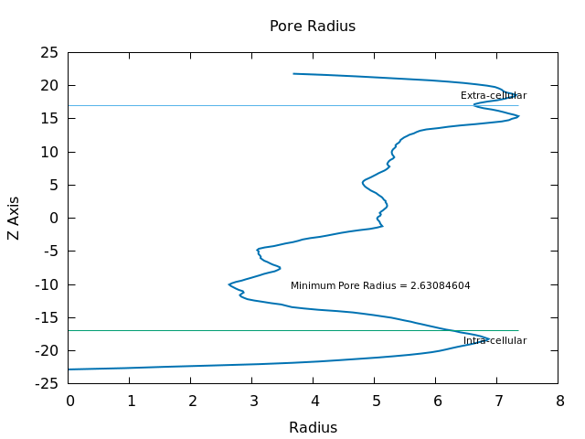
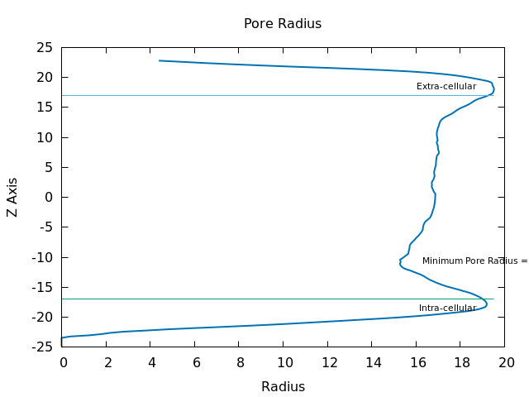
Fig. S2 Final snapshots of 11-mer structures of SV28 in a DOPC membrane in the MD simulation. Ribbons show the peptide structures, with the secondary structure indicated by the color of the ribbon (red: β-sheet, cyan: turn, white: random coil structure). Ribbon arrows indicate the direction of the backbone from N-terminal to C-terminal. The pore radius of 5-mer and 11-mer were shown. The pore structures were analyzed by HOLE software and displayed as blue surfaces inside of the barrels. Val10 and Val22 amino acids showing central rim of the pores were displayed as the licorice models. Cyan lines indicate water molecules, and the lipid molecules were omitted for clarity (excluding phosphorus atoms as orange spheres). Green and white spheres indicate the potassium and chloride ions respectively. Structures were displayed by VMD software.

Fig. S3 Intrapeptide distance between nitrogen of Val10 and carbon of Val22 during the simulations of 5-mer (black) and 11-mer (red). The distribution of the distance changing in the 5-mer was slightly larger than that in the 11-mer. 5-mer pore structures have shorter turns than 11-mer peptides, which can give structural distortion to the monomer structures. Because of this distortion, the distances in the 5-mer may become longer than that of 11-mer.

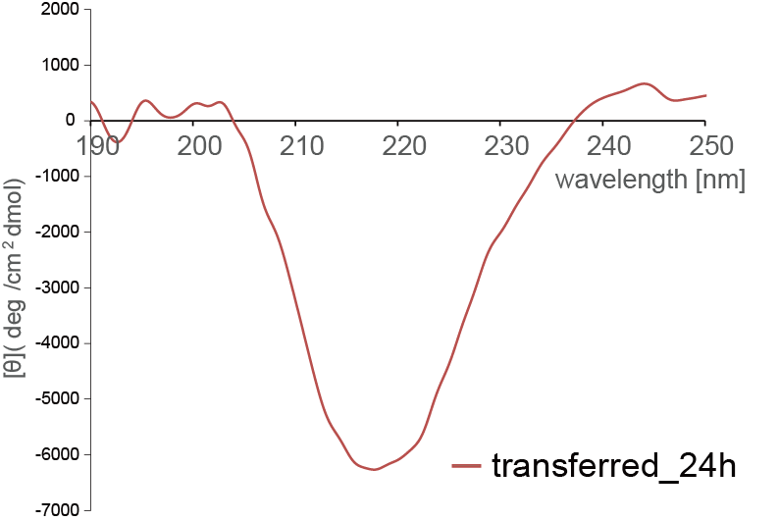
Fig. S4 The CD spectra of incubated SV28 with liposome after 24 hours. SV28 (50 µM) was incubated for 24 hours at 37°C in a solution of 50 µM DOPC liposome, 1 M KCl, and 10 mM MOPS. The measurement solution contained SV28 (25 µM), 50 µM DOPC liposome, 0.1 M KCl, and 1 mM MOPS.

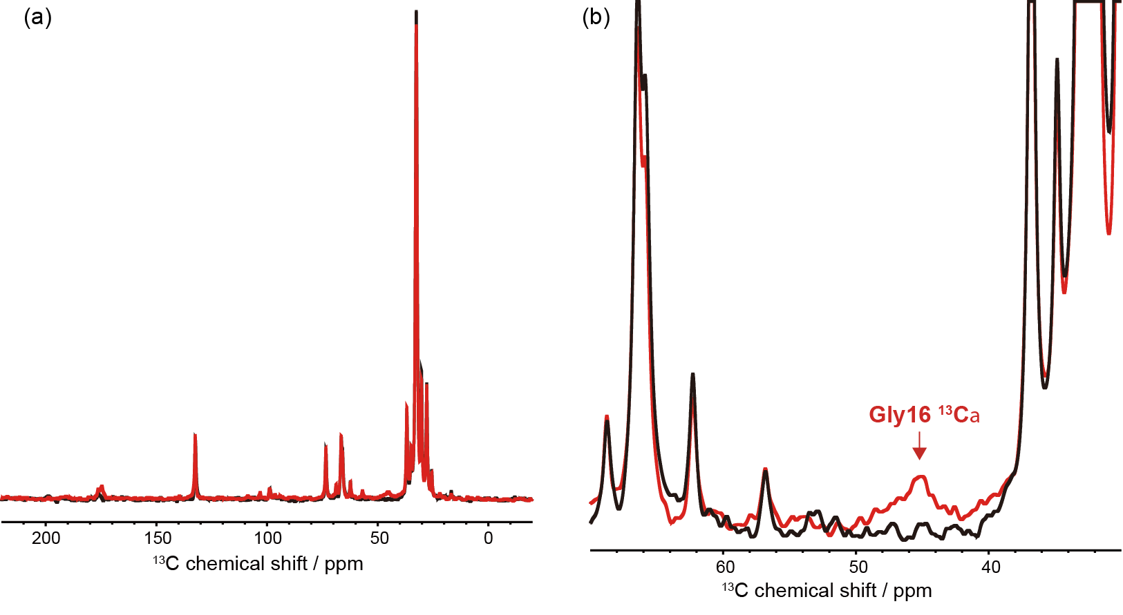
Fig. S5 Solid-state NMR spectra. (a, b) ¹³C and ¹⁵N CP-MAS NMR spectra of the triply isotope-labeled SV28 ([1-¹³C]Val10, [2-¹³C]Gly16, [¹⁵N]Val22-labeled SV28) in DOPC liposomes. The black lines indicate the spectra from DOPC liposomes, and the red lines indicate the spectra of isotope-labeled SV28 with DOPC liposomes.

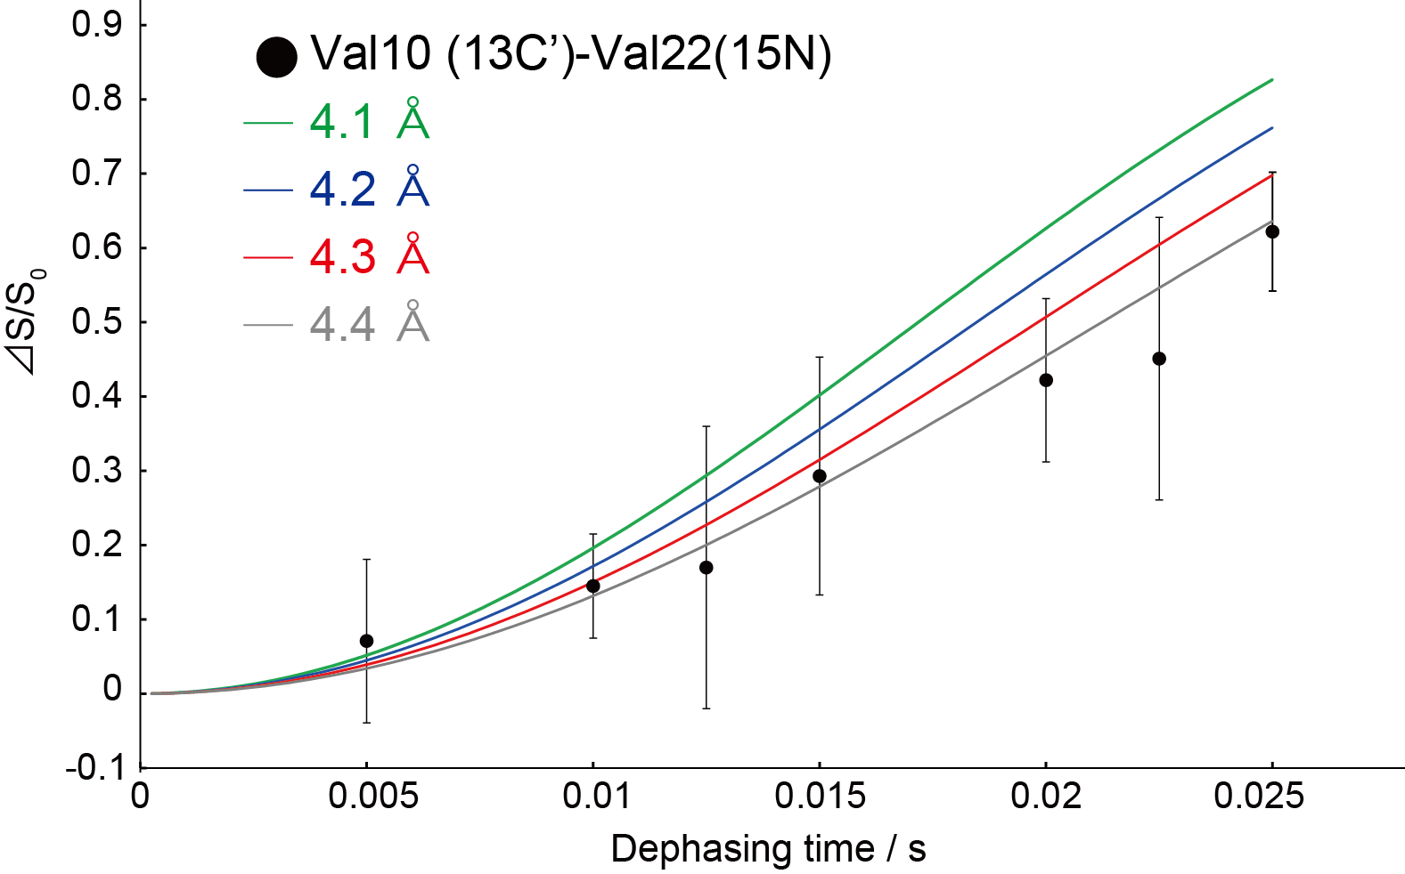

Fig. S6 REDOR difference plot of SV28 Val22(¹⁵N)-Val10(¹³C’) by observation of the ¹⁵N peak intensity. (S) and (S₀) are recorded under REDOR and full echo conditions. REDOR curves correspond to an isolated ¹⁵N-¹³C pair with varying distances (green, blue, red curves correspond to 4.1, 4.2, 4.3 and 4.4 angstroms). The distance between the backbone amide of Val22 and the carbonyl carbon of Val110 is estimated to be around 4.4 Å.

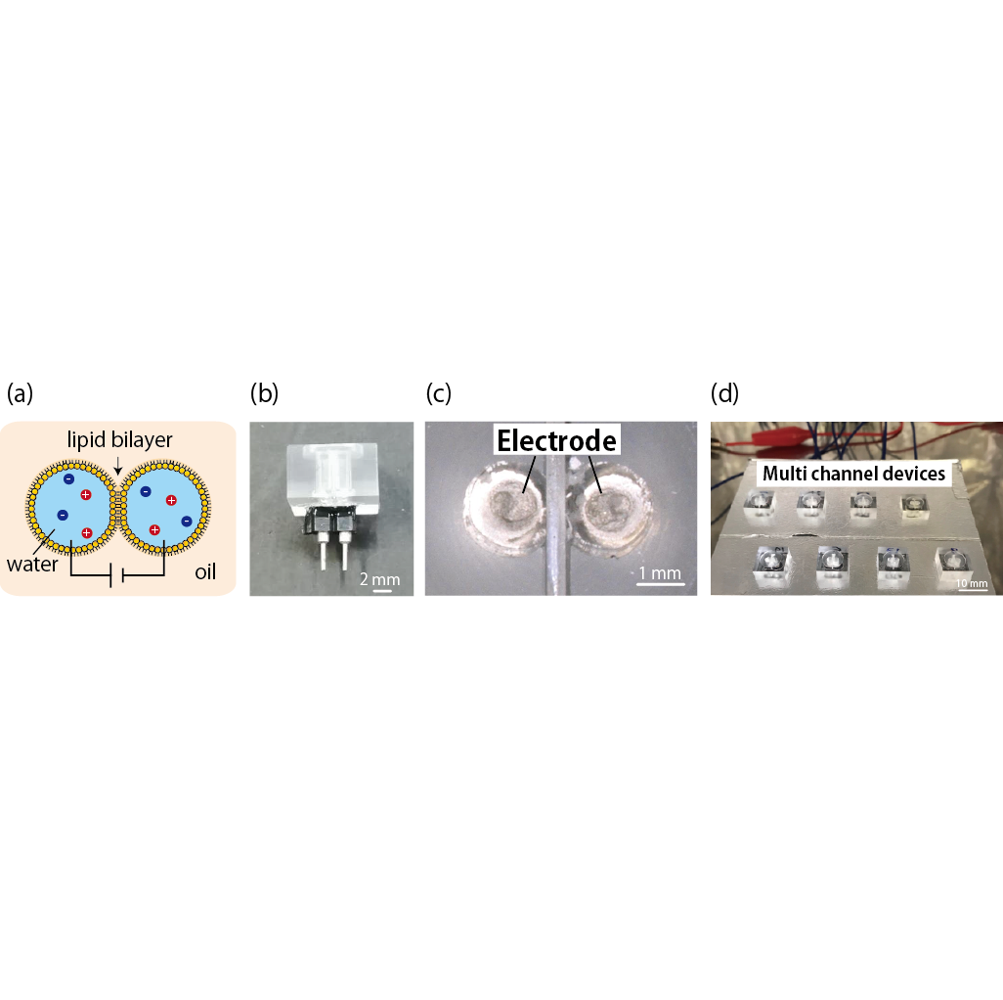
Fig. S7 Fabricated microarray device for a lipid bilayer system. (a) Schematic illustration of the droplet contact method. (b) A photograph of a microdevice for the droplet contact method and (c) its enlarged picture. (d) A photograph of a multiarray device that can form eight individual lipid bilayers simultaneously.

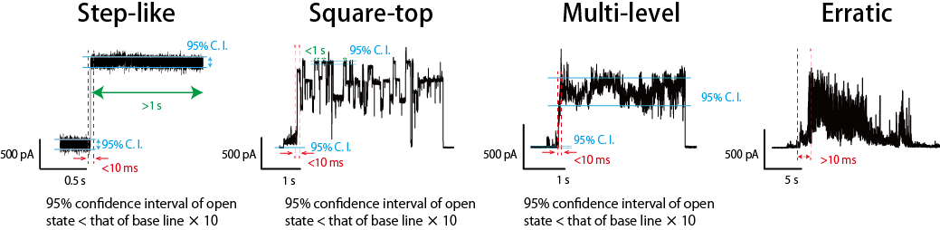
Fig. S8 The definition of current signal classification. Step-like signal: the current sharply increases (within 10 ms) and maintains a plateau state (longer than 1 s). Square-top signal: the current sharply increases (within 10 ms) and proceeds to transit plateau states (shorter than 1 s). Multi-level signal: the current sharply increases (shorter than 10 ms) and proceeds to fluctuate. Fluctuation defined as when the 95% confidence interval of the open level current is larger than that of the baseline. Erratic signal: the current randomly increases with fluctuation.

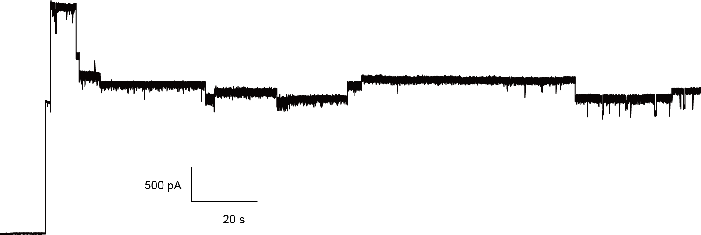
Fig. S9 The typical current and time trace of SV28. The signal was observed under optimized conditions: 1 μM SV28 (24 hours incubation at 37ºC with DOPC and 20 % cholesterol), 1 M KCl, 10 mM MOPS, and an applied voltage of +200 mV.

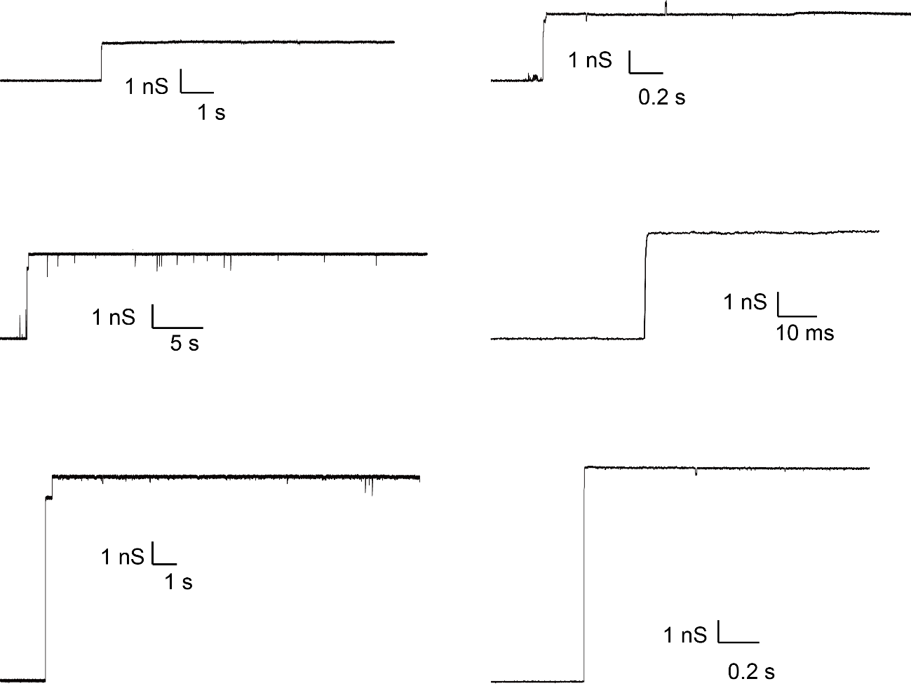

Fig. S10 Several conductance and time traces of the initial step signals of SV28. These step signals rose up from the baseline. These step signals were observed under the following conditions: 1 μM SV28 (24 hours incubation at 37ºC with DOPC and 20 % cholesterol), 1 M KCl and 10 mM MOPS. The applied voltages were +120 mV or +200 mV.

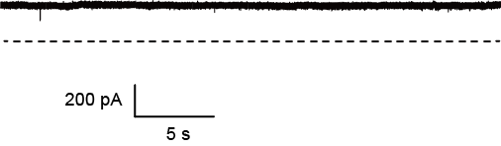
Fig. S11 The open level of the step signal of SV28 with 10 µM 50 bp dsDNA (short dsDNA). The dashed line indicates the baseline level. The current signal was measured under optimized conditions: 1 μM SV28 (24 hours incubation at 37ºC with DOPC and 20 % cholesterol), 1 M KCl, 10 mM MOPS, and an applied voltage of +200 mV.

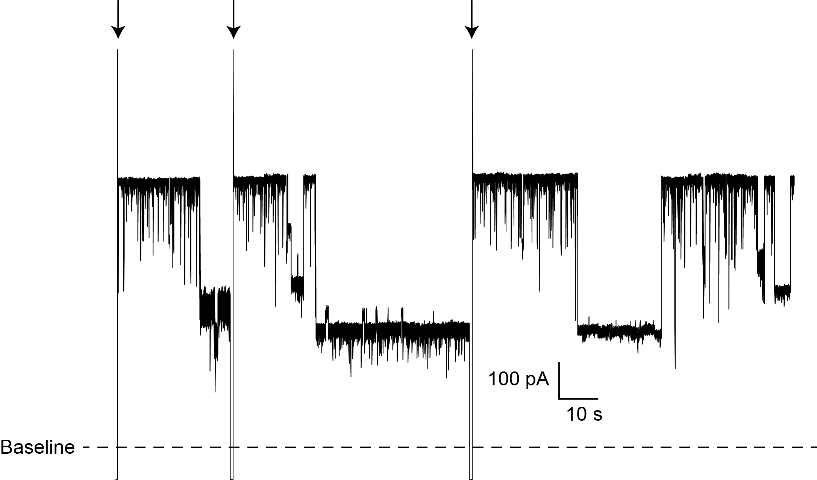

Fig. S12 Long time (3 minutes) traces of dsDNA translocation into SV28 nanopore. The long and deep blocking currents sometimes observed might be clocking of dsDNA in the nanopore, so the long and deep blocking were released by voltage transitions which were shown as the arrows. The trace was observed under below conditions: 1 μM SV28 (24 hours incubation at 37ºC with DOPC and 20 % cholesterol), 1 M KCl, 10 mM MOPS, an applied voltage of +100 mV, and 100 nM dsDNA with 1 kbp.

Fig. S13 Scatter plots of percent current blockage and duration for 1 kbp dsDNA translocation through an SV28 pore with diameter of around 5 nm. The typical current signal was observed under the following conditions: 1 μM SV28 (24 hours incubation at 37ºC with DOPC and 20 % cholesterol), 1 M KCl and 10 mM MOPS.
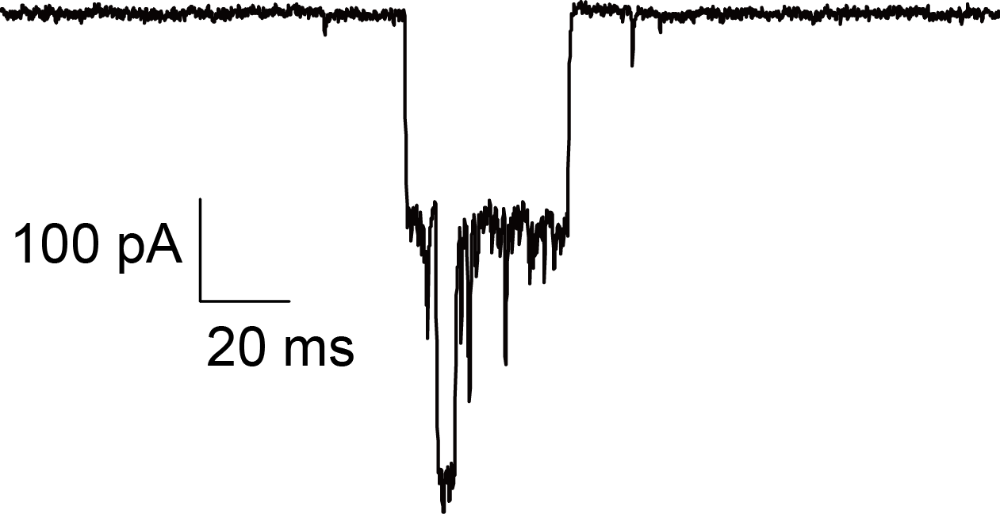
Fig. S14 Typical overlapping blocking currents. Two different current levels were occasionally observed, probably due to translocation of multiple dsDNA though the SV29 nanopores simultaneously. The current signal was observed under the following conditions: 1 μM SV28 (24 hours incubation at 37ºC with DOPC and 20 % cholesterol), 100 nM dsDNA, 1 M KCl, 10 mM MOPS and an applied voltage of +60 mV.

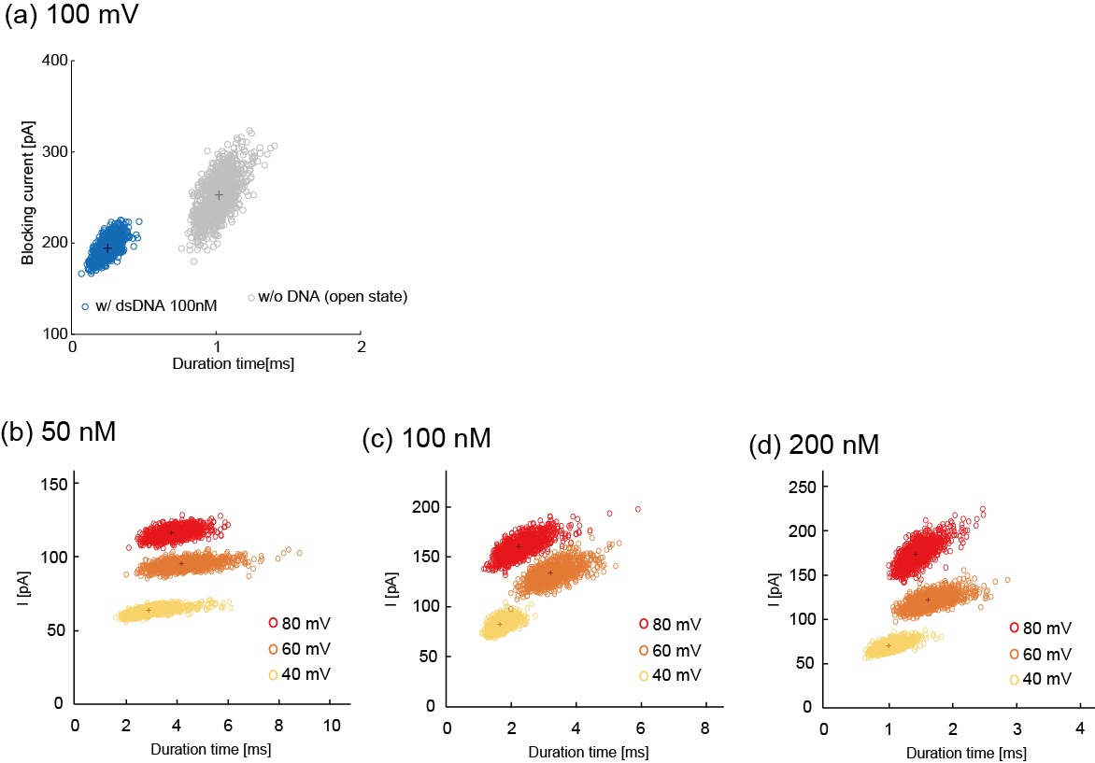

Fig. S15 Scatter plots of the duration and blocking current of dsDNA (1 kbp) through the SV28 nanopore (5 nm diameter) after bootstrapping. (a) The scatter plots comparison between presence and absence dsDNA. There are inherent current blockings in the pore open state in SV28 shown as gray plots. (b-d) Scatter plots of duration and blocking current of dsDNA (1 kbp) through SV28 nanopore (5 nm dia.) depended on the concentration of (b) 50 nM, (c) 100 nM, and (d) 200 nM under different voltage applications (40 mV to 80 mV).
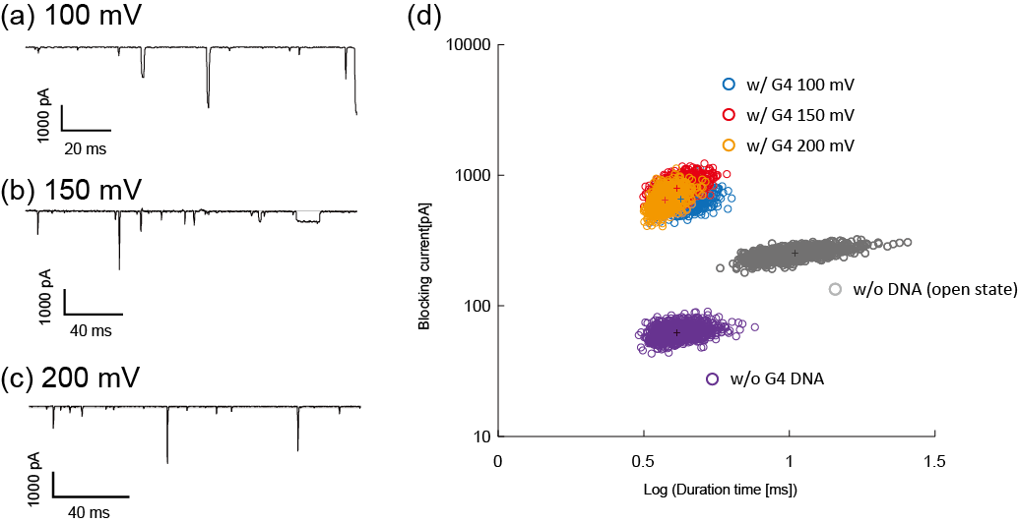
Fig. S16 Detection of DNA with G4 hybrid hold structure. (a-c) Current and time traces of G4 (2 μM) detection using SV28 nanopore (>6.2 nm in diameter) under different voltage applications: (a) 100 mV, (b) 150 mV, and (c) 200 mV. (d) The scatter plots of DNA with G4 under three different voltages, without G4 structure under 100 mV, and the pore open state of SV28 under 100 mV.
Fig. S17 (a) Sequence alignment of SV28 and HASR proteins (PDB ID: 3CSN, Chain A). Blue and red bold letters indicate the positively and negatively charged residues respectively. (b) A ribbon structure of the manually constructed initial model of 11-mer SV28. (c) An example of the 11-mer molecular system after a 100 ns long equilibration simulation. Red ribbons show the β-sheet regions of the structures with arrows pointing from the N-terminus to the C-terminus.
References.
1 Gullion, T. & Schaefer, J. Rotational-Echo Double-Resonance NMR. J. Magn. Reson. 81, 196-200, doi:10.1016/0022-2364(89)90280-1 (1989).
2 Kawano, R. et al. Automated Parallel Recordings of Topologically Identified Single Ion Channels. Sci. Rep. 3, doi:10.1038/srep01995 (2013).
3 Kawano, R. et al. A Portable Lipid Bilayer System for Environmental Sensing with a Transmembrane Protein. PLoS One 9, doi:10.1371/journal.pone.0102427 (2014).
4 Ohara, M., Sekiya, Y. & Kawano, R. Hairpin DNA Unzipping Analysis Using a Biological Nanopore Array. Electrochem. 84, 338-341, doi:10.5796/electrochemistry.84.338 (2016).
5 Sharma, R. K., Agrawal, I., Dai, L., Doyle, P. S. & Garaj, S. Complex DNA knots detected with a nanopore sensor. Nat. Commun. 10, doi:10.1038/s41467-019-12358-4 (2019).

