Additional file 1

Genomic portrait of community-associated methicillin-resistant Staphylococcus aureus ST772-SCCmec V lineage from India
¹Yamuna Devi Bakthavatchalam, ¹Karthick Vasudevan, ²ShomaVinay Rao, ³Santosh Varughese, ⁴Priscilla Rupali, ⁵Maki Gina, ⁵Marcus Zervos, ⁶John Victor Peter, ¹Balaji Veeraraghavan
¹Department of Clinical Microbiology, Christian Medical College, Vellore-632004
²Department of Surgical Intensive Care Unit (SICU), Christian Medical College, Vellore-632004
³Department of Nephrology, Christian Medical College, Vellore-632004
⁴Division of Infectious Disease, Christian Medical College, Vellore-632004
⁵Division of Infectious Disease, Henry Ford Health System, Detroit, Michigan - 48202
⁶Department of Critical Care Medicine, Christian Medical College, Vellore-632004
Corresponding author:
Dr Balaji Veeraraghavan
Professor
Department of Clinical Microbiology
Christian Medical College
Vellore – 632004
E-mail ID: vbalaji@cmcvellore.ac.in
Contact no: +91- 9442210555

This file includes:
Figures S1 to S3
Table S1 (Tables S2 and S3 are in separate Excel files)

Supplementary Figures
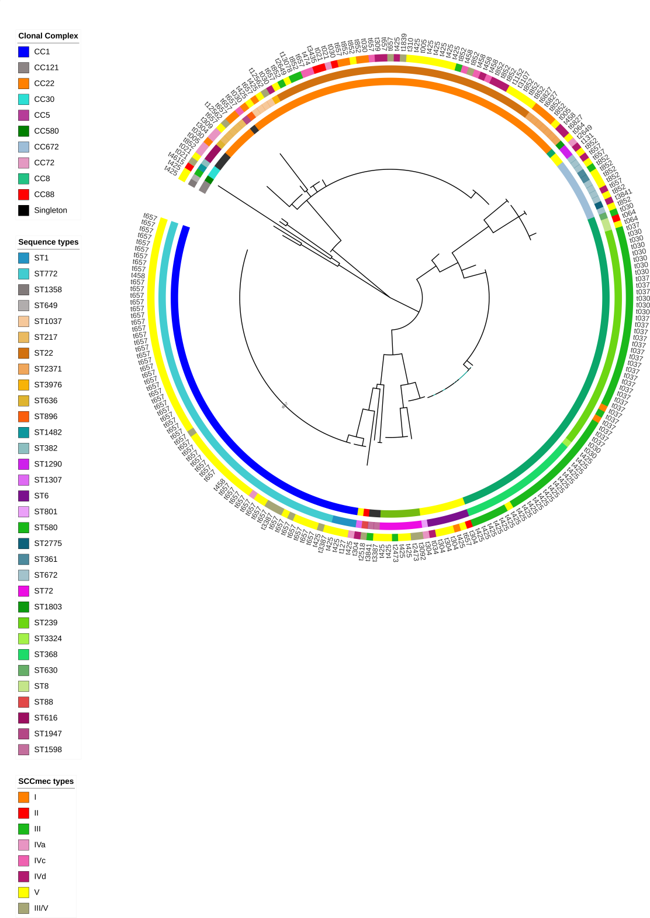
Fig S1: a) Maximum likelihood phylogeny was constructed based on the seven house-keeping genes of S. aureus. The tree was marked with the meta-data using interactive tree of life (iTOL.v.4). The inner most ring represents clonal complexes (CCs), the second ring denotes sequence types (STs), the third ring represents SCCmec types and the outer most ring represents the spa types. CCs, STs and SCCmec types are colour coded as mentioned in legends.
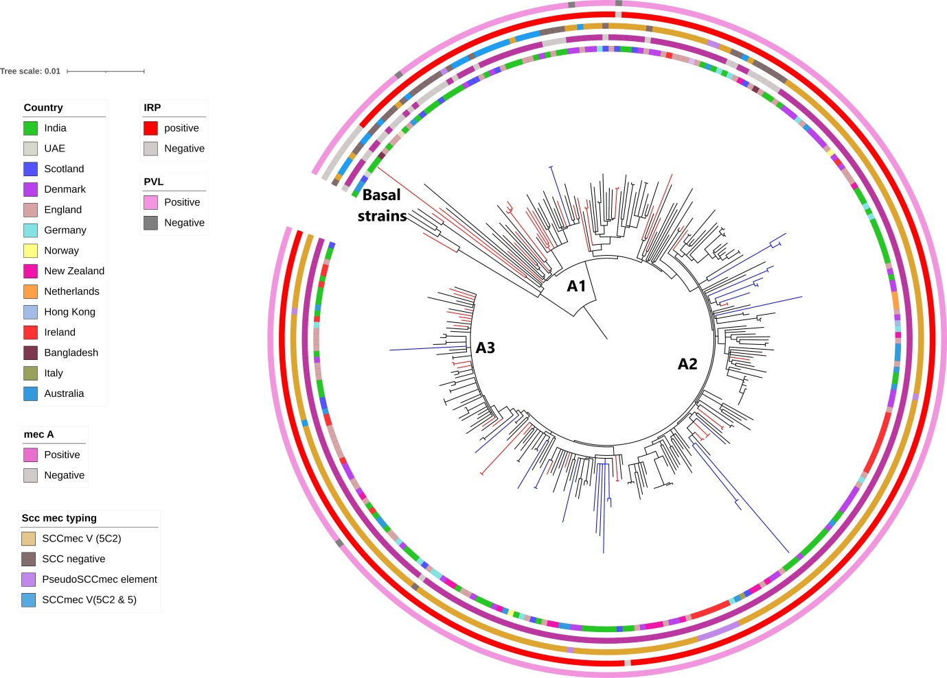

Fig S2: a) Maximum likelihood phylogenetic tree was constructed based on the core genome SNP of ST772 S. aureus lineage (n=305). The innermost ring represents the country of isolation. The second, third, fourth and fifth rings denotes the presence/absence of mecA gene, presence of various SCCmec types, presence/absence of integrated resistance plasmid (IRP) and the presence/absence of PVL gene respectively. Isolates in the clades are colour coded; study isolates are in blue colour and other Indian isolates are in red colour.

Fig S3: Root to tip genetic distance of the ST772 S. aureus isolates. The total number of SNPs present within each isolate compared to that in the index isolate was computed and plotted against the date on which each isolate was recovered. The graph includes regression lines with 95% CI for each group. Sizes of circles correspond to the number of isolates.

Table S1: Clonal complex, single locus and double locus variant of sequence types identified in MRSA.

Clonal complex (CC) | Arc | aroE | glpP | gmK | pta | tpi | ypi | ST
CC1 | 1 | 1 | 1 | 1 | 1 | 1 | 1 | 1
CC1 | 1 | 1 | 1 | 1 | 22 | 1 | 1 | ST772
CC22 | 7 | 6 | 1 | 5 | 8 | 8 | 6 | ST22
CC22 | 7 | 59 | 1 | 5 | 8 | 8 | 6 | ST1037
CC22 | 7 | 6 | 1 | 5 | 8 | 5 | 6 | ST217
CC22 | 258 | 6 | 1 | 5 | 8 | 8 | 6 | ST2371
CC22 | 464 | 6 | 1 | 5 | 8 | 8 | 6 | ST3976
CC22 | 7 | 4 | 1 | 5 | 8 | 5 | 6 | ST636
CC22 | 2 | 6 | 1 | 5 | 8 | 8 | 6 | ST896
CC5 | 1 | 4 | 1 | 4 | 12 | 1 | 10 | ST5
CC5 | 12 | 4 | 1 | 4 | 12 | 1 | 3 | ST6
CC5 | 1 | 4 | 1 | 1 | 11 | 1 | 3 | ST1290
CC5 | 1 | 4 | 1 | 5 | 12 | 1 | 10 | ST1307
CC5 | 1 | 4 | 1 | 4 | 12 | 1 | 5 | ST801
CC8 | 3 | 3 | 1 | 1 | 4 | 4 | 3 | ST8 (USA300)
CC8 | 3 | 6 | 1 | 1 | 4 | 4 | 3 | ST1803
CC8 | 2 | 3 | 1 | 1 | 4 | 4 | 3 | ST239
CC8 | 2 | 3 | 1 | 1 | 4 | 65 | 3 | ST368
CC8 | 12 | 3 | 1 | 1 | 4 | 4 | 3 | ST630
CC8 | 2 | 3 | 1 | 1 | 413 | 4 | 3 | ST3324
CC672 | 4 | 3 | 1 | 1 | 11 | 72 | 11 | ST672
CC672 | 4 | 3 | 1 | 1 | 11 | 72 | 64 | ST361
CC672 | 4 | 402 | 1 | 1 | 11 | 72 | 11 | ST2775
CC72 | 1 | 4 | 1 | 8 | 4 | 4 | 3 | ST72
CC30 | 2 | 2 | 2 | 2 | 6 | 179 | 2 | ST1482
CC30 | 2 | 2 | 2 | 2 | 6 | 3 | 69 | ST382
CC121 | 6 | 5 | 1 | 2 | 7 | 4 | 5 | ST1358
CC121 | 6 | 5 | 6 | 2 | 7 | 14 | 85 | ST649
CC580 | 3 | 35 | 48 | 19 | 20 | 26 | 39 | ST580
CC88 | 22 | 1 | 14 | 23 | 12 | 4 | 31 | ST88
Singleton | 1 | 6 | 1 | 5 | 8 | 8 | 64 | ST1947
Singleton | 7 | 6 | 1 | 5 | 13 | 8 | 3 | ST616
Singleton | 12 | 1 | 37 | 15 | 11 | 1 | 40 | ST1598

Tables S2 and S3 are in separate Excel files and the table legends are as following:

Table S2: List of the accession numbers of ST772 S. aureus genome used for comparative analysis
Table S3: Demographic models used for calculation of bayes factor and evolutionary analysis of Indian ST772 S. aureus

