Methods and Supplemental Material
A national diagnostic framework for patients with ultra-rare disorders: molecular genetic findings using phenotypic and sequencing data

Content

Supplementary Methods 2
Enrolment, research ethics, and consent 2
Clinical and laboratory phenotype data 2
Visualization of phenotype space using UMAP 2
DNA sequencing 2
ES data-processing pipeline 3
Data availability 3
Supplementary Results 4
Parental Mosaicism 4
Novel disease candidate genes 5
Case reports of particular interest 5
Comparison of reported disease genes in TRANSLATE-NAMSE to other cohorts 8
Predictor for diagnostic yield 8
Gene length calculation 9
Secondary Findings 9
References 12
Supplementary Figures 14
Supplementary Tables 20

Supplementary Methods

Enrolment, research ethics, and consent
Study participants were enrolled in TRANSLATE-NAMSE from 10 different centers for rare diseases (CRD/ZSE) in Berlin, Bochum, Bonn, Dresden, Duisburg/Essen, Hamburg, Heidelberg, Kiel/Lübeck, München, and Tübingen between January 2018 and December 2020 under the overall coordination of the Institute of Public Health Berlin. The study was approved by the internal review boards (IRBs) of all participating institutions and all patients or their legal guardians provided written informed consent.

Clinical and laboratory phenotype data
Multidisciplinary teams (MDTs) at hospitals responsible for enrolment were provided with the eligibility criteria for the study. The clinical and laboratory phenotype data were transferred to the sequencing laboratory through case report forms by paper questionnaires or by online data capture applications (Fac2Gene Clinic). Online data capture allowed for the free entry of Human Phenotype Ontology (HPO) terms, data from paper questionnaires and free-text entries were transformed into HPO terms. The phenotypes reported in this study are based on the phenotypes reported to the sequencing laboratories. On average, five HPO-terms were used per individual (Supplementary Figure 1).Since the TRANSLATE-NAMSE cohort represents a very heterogeneous group of patients with rare diseases, the clinical symptoms were first divided into six main disease categories. This allowed a more concrete statement on diagnostic yield in relation to the clinical symptoms of the patient. In the further course, all assigned HPO terms (n=1590) were compiled and divided into higher-order groups (12) and subcategories (49) by clinician experts. The following groups could be defined: 1-neurodevelopmental, 2-neuromuscular, 3-seizures, 4-growth disorders, 5-facial dysmorphism, 6-abnormality of connective tissue, 7-congenital malformations, 8-endocrine and metabolic abnormalities, 9-immune and hematological abnormalities, 10-sensory organs alterations, 11-abnormal findings of brain MRI, 12-others. Within the respective subgroups, further subdivisions (n=49) were applied.

Visualization of phenotype space using UMAP
First, diseases and their symptoms were downloaded from the HPO website (https://hpo.jax.org/app/download/annotation , file: genes_to_phenotype.txt, downloaded on 10 April 2021). The disease data were merged with the data of individuals from TRANSLATE-NAMSE by treating each disease-ID as one individual. Now the similarities of the HPO terms between all pairs of individuals could be calculated using the R package ontologySimilarity. The similarities were then converted to a distance matrix and projected into a four-dimensional space by UMAP. Subsequently, the first two dimensions of this projection were plotted using ggplot2 (version 3.3.4).

DNA sequencing
EDTA-treated whole-blood samples or saliva kits were delivered to one of five participating labs for further processing: After DNA extraction, fragment size and purity were assessed. If DNA fulfilled the quality criteria the sample was submitted to sequencing. Exome sequencing (ES) was performed on exon targets isolated by capture using Agilent SureSelect Human All Exon kits v6 or v7 (Agilent Technologies, Santa Clara, USA), or Human Core Exome kit (Twist Bioscience, San Francisco, USA). One microgram of DNA was sheared into 350- to 400-bp fragments, which were then repaired, ligated to adaptors, and purified for subsequent polymerase chain reaction (PCR) amplification. Amplified products were then captured by biotinylated RNA library baits in solution according to the manufacturer’s instructions. Bound DNA was isolated with streptavidin-coated beads and reamplified. The final isolated products were sequenced using the Illumina HiSeq 2500 or NovaSeq 6000 sequencing system with 100-bp, 125bp or 150-bp paired-end reads (Illumina, San Diego, CA). All sequencing centers have ensured coverage of over 20x in over 95% of the RefSeq target region (Supplemental Figure 2).

ES data-processing pipeline
All four data generating sites used ES processing pipelines that have been described in detail previously. The DNA sequence was mapped to the published human genome build GRCh37 reference sequence using Burrows-Wheeler Aligner (BWA) with the latest version at the time of sequencing, progressing from BWA v0.7.11 through BWA-Mem v0.7.17^{1,2}. Single nucleotide variants (SNVs) and small insertions and deletions (indels) were detected with HaplotypeCaller and SAMtools v.0.1.7^{3,4}. Also, Mitochondrial DNA variants were assessed on data from exome sequencing⁵. Copy number variations were detected with ExomeDepth and Pindel on short-read data or in advance to exome sequencing by array CGH^{6,7}.
Variants were annotated with VEP⁸ or Jannovar⁹ and analyzed in VarFish¹⁰ or EVAdb (https://brand-fabian.github.io/evadb-docs/). If patients consented to a computer-assisted analysis of their portrait photos, we evaluated the top-10 accuracy rate of the PEDIA prioritization results^{11,12}.
Autozygosity was estimated by RohHunter, bcftools/roh, or a sliding-window framework^{13–15}. A small subset of samples that were run on all three tools yielded comparable results for autozygosity.

Data availability
Genotype and phenotype data from 5652 participants enrolled in TRANSLATE-NAMSE can be accessed by application to the TRANSLATE-NAMSE following the procedure outlined at http://www.tnamse.de Reported alleles and their clinical interpretation have been deposited in ClinVar by the following submitters:

Institute for Genomic Statistics and Bioinformatics (University Hospital Bonn):
https://www.ncbi.nlm.nih.gov/clinvar/submitters/507028/,
Institute of Human Genetics, Klinikum rechts der Isar (Technical University Munich):
https://www.ncbi.nlm.nih.gov/clinvar/submitters/500240/,
Institute for Medical Genetics and Human Genetics (Charité- Universitätsmedizin Berlin):
https://www.ncbi.nlm.nih.gov/clinvar/submitters/505735/,
Institute of Medical Genetics and Applied Genomics (University Hospital Tübingen): https://www.ncbi.nlm.nih.gov/clinvar/submitters/506385/.
Genomics Facility (Ludwig-Maximilians-Universität München):
https://www.ncbi.nlm.nih.gov/clinvar/submitters/507363/

Supplementary Results

Parental Mosaicism
In a sub-cohort of 471 cases, all parental sequence reads were visually checked in IGV for the presence of corresponding variant reads (≥ 1) in all families with causative, presumably de novo variants. In this sub-cohort, we found three families with very probable or certain parental mosaics that affect at least the germ cells.
In the first family with only one affected person (case 432), a pathogenic, heterozygous nonsense variant in ASXL3 was detected leading to the diagnosis of an autosomal-dominant Bainbridge-Ropers-Syndrome (OMIM #615485). Two out of 69 exome sequencing reads of the mother and one out of 60 reads of the father also showed the variant. For the paternal sequence reads, low-quality scores pointed to an artifact. Additionally, three unrelated persons from the same sequencing run also had one read each with the variant, pointing to contamination of the batch. However, Sanger sequencing of maternal lymphocyte DNA detected the variant at low intensity while no signs of the variant were detected in paternal DNA.
In the second family, two brothers with the main symptom of intellectual disability carried a heterozygous (case 435), likely pathogenic variant in FOXG1 (autosomal dominant hereditary FOXG1 syndrome, OMIM #613454). DNA extracted from a blood sample of the mother was subjected to exome sequencing and the variant was found in one of 132 reads.
In the third family parental mosaicism could be established due to a heterozygous variant in the PUF60 that could explain the developmental delay in two brothers (case 443 and 444; Verheij syndrome, OMIM #615583). Although both parents were also subjected to exome sequencing, the variant could not be detected in their blood DNA, despite high coverage of 226 and 201 sequencing reads, respectively.
These examples again illustrate the frequency of low-level parental mosaicism and their relevance when counseling about recurrence risk. Only two of these three parental mosaics would have been detected in parental NGS reads applying the criteria presented by Gambin and colleagues according to which only variants present in at least two reads or in one read and absent in reference databases were classified as candidate low-level mosaic SNVs¹⁶. The third family again demonstrates that the apparent absence of the variant even in high coverage parental NGS data cannot exclude a gonadal mosaic. This is especially true when only one tissue is sequenced.
Three parental mosaics detected in the ES analysis of 471 patients correspond to a frequency of 0.64%, 0.21% of which have been discovered by the pedigree constellation only and not by the analysis of parental NGS reads. The remaining frequency of 0.41% is higher than in two previous studies investigating the frequency of low-level parental mosaics of pathogenic or likely pathogenic variants in their affected children. Wright and colleagues analyzed 4,293 ES trios and identified and validated eight low-level parental mosaics, six of which were diagnostic (corresponding to 0.14% of the trios)¹⁷. Cao and colleagues analyzed a cohort of approximately 12,000 samples submitted for clinical exome sequencing and identified 0.3% parental mosaics either by analysis of parental NGS reads or by Sanger sequencing of parental DNA¹⁸.
Our findings highlight the importance of eyeballing parental NGS data for low-level mosaicism. In addition, we emphasize the significance of recognizing pedigree constellations suggestive of parental gonadal mosaicism.

Novel disease candidate genes
We defined the following mandatory criteria for novel disease candidate genes: (1) gene was not previously robustly associated with a human phenotype; (2) no other clearly causative disease explanation was found; (3) allele frequency of the respective variant was below MAF cutoff or the variant was absent in controls; (4) inheritance was in accordance with the phenotype in the family and/or the variant co-segregated with the disease in multiple affected family members. Similar to the ClinGen approach, we defined characteristics, including gnomAD constraint metrics, inheritance, and functional data, by which the level of evidence of the candidates was assessed ¹⁹. We calculated an evidence score, which could reach a maximum value of 8. Four of the eight criteria can only be applied to genes underlying autosomal dominant inheritance, making the score less informative for autosomal recessive inheritance. For autosomal dominant inheritance, a score of 1-3 was ranked as medium evidence, a score of 4, and greater as high evidence. For recessive inheritance, a score of 3 and greater was ranked as high evidence, and below 3 as medium evidence. Published genes were classified as novel diagnostic grade genes.
We detected 55 different candidate genes in 61 affected individuals from 60 unrelated families with a score of ≥1 (Table x). Inheritance was autosomal dominant for 40 genes (evidence score range 1-7), autosomal recessive for 14 (evidence score range 1-5), and X-chromosomal for one (evidence score 1). During the course of TRANSLATE-NAMSE and after completion of the study, 15 of these novel disease-gene associations were published and we contributed to 11 of them. All of the published genes had a score in the high evidence range. (Supplemental Data table 2)
Variant consequences relative to the status of whether cases were solved, shown as bar graphs. Note the higher proportion of missense variants in unclear cases. ()

Case reports of particular interest

Next-generation phenotyping
In 88 out of 211 individuals who gave consent to computer-assisted prioritization of exome data by image analysis (PEDIA), a molecular diagnosis could be established. In 48 out of these 88 cases the underlying disease is supported by the AI DeepGestalt. That means the phenotype of the disorder has been learned by the AI in advance and the facial gestalt of a patient can be evaluated based on a portrait image. The resulting gestalt score can then be used in addition to other pathogenicity scores to interpret exome variant data. The PEDIA workflow ranked the disease-causing gene for 78% of those cases in the top 10, compared to 54% when only molecular and 37% when only phenotypic information was used for prioritization. In some cases the gestalt scores were particularly suggestive and facilitated the identification of mainly non-coding structural variants.
A female individual (case 393), that presented for the first time at the age of eight years with cognitive impairment, generalized muscle weakness, nevi, iron deficiency anemia, poor fine motor coordination, recurrent respiratory infections, and dysmorphic facies, portrait analysis suggested a high syndromic similarity to Kooled-De Vries syndrome (Supplementary Figure 3). Inconclusive ES was followed by WGS, which revealed a 4.7kb de novo deletion in KANSL1, NM_001193466:c.1849-4661_1895del. This example illustrates the value of high gestalt scores, which can be used as an indicator for a search of non-coding disease-causing mutations in a target region of the genome that is associated with the phenotype.
In total, DeepGestalt can quantify syndromic similarity to 299 genetic disorders while GestaltMatcher, which is a further development of DeepGestalt, can support 568 diagnoses, including ultra-rare disorders. Within the TRANSLATE-NAMSE, cohort 40 cases with a molecular diagnosis are not supported by DeepGestalt. In 25 of these cases, corresponding to 17 genes, deep phenotyping could be performed with GestaltMatcher. One individual (case 462) a dual diagnosis due to variants in TRIP12 and POLR2A could be established and GeestaltMatcher showed syndromic similarity to characteristic features of both phenotypes.

BICD2 and TANGO2 (dual diagnosis)
A 13-year-old boy (case 144), born at term to non-consanguineous parents, presented with a global developmental delay, muscular hypotonia, bilateral optic atrophy, cardiac arrhythmia, hypothyroidism, chronic urticaria and two episodes of rhabdomyolysis. After an uneventful pregnancy and normal postnatal adaptation, he developed the first atonic seizure at the age of one year. Following a bilateral masteoditis and subsequent mastoidectomy and paracentesis, a first episode of rhabdomyolysis occured at the age of 16 months and recurred in the context of febrile infections. His development was delayed with free walking and first words at the age of 5 years. At the age of 11 years, he was able to speak about 30 words and used 2-word sentences. At 18 months, there was an unexplained loss of consciousness associated with gastroenteritis. He developed intermittent loss of muscle tone with fixed gaze, ptosis, and hypersalivation consistent with atonic seizures at 25 months. At the age of 13 years, the patient had another episode of rhabdomyolysis, this time with cardiac arrhythmia. Since NGS panel sequencing as well as standard cytogenetic analysis revealed normal results, the Trio-Based Whole-Exome Sequencing was performed. A heterozygous de novo missense variant in BICD2 was detected: BICD2 (NM_001003800.1): c.2383C>T; p.(Arg795Trp). BICD2-associated SMALED2A syndrome (OMIM #615290) is characterized by motor developmental delay, muscle weakness, muscle atrophy, and distal hyporeflexia with onset in early infancy. Additionally, a homozygous deletion in TANGO2 (NM_152906.5):c.57-1743_*10769del, associated with autosomal recessive recurrent metabolic crises with rhabdomyolysis, cardiac arrhythmias, and neurodegeneration (MECRCN, OMIM #616878), was identified.

TRDN and GYG1 (dual diagnosis)
An 8-year-old boy (case 312) born to second-degree consanguineous parents presented with motor developmental delay as well as suspected cardiomyopathy and congenital myopathy after resuscitation due to ventricular fibrillation at the age of 4 years and 3 months. After secondary c-section at 39+2 weeks of gestation, he showed a normal postnatal adaptation. Motor milestones were delayed: he started turning at the age of 10 months, sat freely and crawled at the age of 16 months, and walked freely at 26 months. Muscular hypotonia was first documented at the age of 6 months. His cognitive and speech development were unremarkable. Since NGS panel sequencing, as well as standard cytogenetic analysis revealed normal results, the Trio-Based Whole-Exome Sequencing was performed. The following homozygous variants were detected in trio exome sequencing: TRDN (NM_006073.3):c.508G>T;p.Gly170* and GYG1 (NM_001184720.1):c.487del; p.Asp163Thrfs*5. Both variants were classified as pathogenic (PMID: 29422440). Biallelic pathogenic variants in TRDN are associated with the autosomal recessive cardiac arrhythmia syndrome with or without skeletal muscle weakness (OMIM #615441). The detected missense variant has been described previously (PMID: 29422440). Biallelic alterations in GYG1 are associated with two phenotypically overlapping syndromes: glycogen storage disease 15 (GSDXV, OMIM #613507) and polyglucosan body myopathy type 2 (OMIM #616199). The literature to date has reported high clinical variability and no specific genotype-phenotype correlation.

KMT2E and DDX3X (dual diagnosis)
Two children of a consanguineous couple (first cousins), a 15-year-old girl and a 7-year-old boy, presented with a similar phenotype consisting of global developmental delay, muscular hypotonia and microcephaly. Duo exome sequencing was initiated and analyzed under the assumption of an autosomal recessive disorder given the parental consanguinity and phenotypic overlap. As duo exome sequencing did not prioritize any variants shared by both siblings, exome sequencing of the parents with combined data analysis was started. While a heterozygous de novo stop-loss variant in KMT2E (NM_018682.3:c.4743_4744del, p.Phe1582Tyrfs*286) was identified in the brother, a heterozygous de novo nonsense variant in DDX3X (NM_001356.4:c.841C>T, p.Gln281*) was found in the sister leading to two different diagnoses ("O'Donnell-Luria-Rodan syndrome" and “Intellectual developmental disorder, X-linked, syndrome, Snijders Blok type”, respectively). Reverse phenotyping revealed distinct phenotypes between the children each aligning with the respective diagnosis. This case description is an excellent example of how parental consanguinity poses a pitfall in variant prioritization, in particular in families with more affected children. Moreover, it highlights the need for accurate pre-exome phenotyping as well as the advantage of a trio-approach for the detection of de novo variants.

Therapeutic consequences in Aicardi-Goutieres syndrome 4 (RNASEH2A)
A 10-month-old girl (case 892) presented with developmental regression, muscular hypotonia, and lack of maintaining visual fixation. Trio exome sequencing revealed a homozygous missense variant in RNASEH2A (NM_006397.2:c.859T>C, p.Tyr287His) classified as “variant of uncertain significance” in accordance with the current ACMG criteria. Subsequent reverse phenotyping showed laboratory findings highly suggestive of “Aicardi-Goutieres syndrome 4” (positive interferon signature in peripheral blood, increased interferon-alpha activity in the CSF, CSF leukocytosis) leading to the reclassification of the variant as “likely pathogenic”. Treatment with the JAK inhibitors Ruxolitinib, a treatment option proposed for selected interferonopathies, was started. This case illustrates the value of specific laboratory constellations for variant (re-)classification in selected disorders and the therapeutic consequences once a genetic diagnosis is made.
PIK3CA

Proteomics from patient-derived fibroblasts as functional validation (MDH2)
In a 4-year old girl (case 1127) from a non-consanguineous east Asian family with global developmental delay and muscular hypotonia compound heterozygous variants of uncertain significance c.755C>T, p.Ala252Val and c.884G>T, p.Gly295Val were identified in MDH2 (NM_005918.2). Additional clinical findings comprised ataxia, stereotypic movements and growth delay. She had progressive cerebellar atrophy as shown by serial MRI studies as well as delayed myelination. EEG displayed frontocentral spikes but she never had seizures.
The variants in MDH2 were classified as variants of uncertain significance. Subsequent RNA-sequencing from fibroblast RNA revealed no reduction of MDH2 transcripts and no aberrant splicing. However, subsequent proteomics showed a significant (P = 1,88E-05) protein reduction of 60% (FC = 0,402, Supplementary Figure 4). In comparison with 97 fibroblast proteome samples processed in parallel, the protein levels found in this case were the lowest (Supplementary Figure 4). To date, only three unrelated patients have been reported in the literature with MDH2 deficiency who presented with a more severe phenotype ²⁰. A discussion of molecular and clinical findings within a MDT concluded that the variants in MDH2 are the most likely the cause for the encephalopathy in this case, however, with an attenuated phenotype compared to the cases published.

Methylation analysis helped to reclassify variants in KMT2D
De novo heterozygous missense variants were identified in two individuals and initially classified as “likely pathogenic” based on the ACMG guidelines ²¹: The first case is a three months old otherwise healthy girl with neonatal hyperinsulinism. Since congenital hypoglycemia secondary to hyperinsulinism can be a feature of Kabuki Syndrome 1 in-depth phenotyping in the context of disease-associated features was recommended by the MDT ²². However, no Kabuki-like symptoms could be observed questioning a disease association of the variant identified. The second case is a two year old boy with mild motor delay and muscular hypotonia who was included in TRANSLATE-NAMSE due to a suspected neuromuscular disorder. Similarly, no Kabuki Syndrome associated features could be observed.
For a functional assessment of the variants, DNA methylation of these two cases along with positive (confirmed diagnosis of Kabuki syndrome) and negative controls was analyzed with EPIC arrays as previously described ²³. First, CpG sites which showed significant epigenome-wide association with Kabuki syndrome were identified in an epigenome-wide association. Second, a support vector machine (SVM) was employed to the epi-signature to distinguish between variants with an Kabuki-like methylation pattern and those without. Interestingly, both cases yielded a SVM score < 0,10 indicating that the variant has no typical effect on DNA methylation. Based on these findings the variants could be reclassified to “variant of uncertain” applying the ACMG criterion “BS3: Well-established in vitro or in vivo functional studies show no damaging effect on protein function or splicing”. Of note, Supplementary Figure 5 displays a case with a SVM score >0.3 but < 0.5. This case was found to have a pathogenic KMT2D variant as high grade mosaicism in blood DNA.

Comparison of reported disease genes in TRANSLATE-NAMSE to other cohorts
In the German healthcare system, genetic testing of the more common amongst the rare disorders is performed with gene panels, e.g. for retinitis pigmentosa, or hearing impairment.
For a comparison with other cohorts we first ordered all diagnostic grade genes (DGGs) by the frequency of submissions of pathogenic and likely pathogenic variants to ClinVar. Disorders caused by genes in the first quartile such as USH2A, ABCA4, and BMPR2, are more prevalent than phenotypes associated with genes in the 4th quartile. We also noted the year in which phenotype-gene associations were first reported to assess since when a diagnosis could be established. We then compared the characteristics of the variants identified to TRANSLATE-NAMSE to a cohort reported by Turro, et al in 2020.
Turro, et al. subjected 9,802 individuals with a suspected rare disease to WGS and reported pathogenic or likely pathogenic variants in 1,138 cases. About a quarter of these variants were assigned to genes with a high disease prevalence (Supplemental Figure 6 and 7). In contrast, in the TRANSLATE-NAMSE cohort most disease genes are ultra-rare, and more frequent diagnoses were underrepresented. The enrichment for ultra-rare diagnosis can be explained by gene panel sequencing that has been performed in advance to ES. Most of the diagnoses established in the TRANSLATE-NAMSE cohort also required medical knowledge that was generated in the last decade.

Predictor for diagnostic yield
1577 cases with ES were analyzed by using the least absolute shrinkage and selection operator (LASSO). The dataset was randomly divided into a training set incorporating 1256 cases (861 unsolved or unclear, 395 solved) and a test set incorporating 321 cases (222 unsolved or unclear, 99 solved). The binary response of a case being solved or not solved was regressed on 49 subcategories of clinical features using the logit function as a link function and controlling for age, sex, sequencing laboratory, and the use of the PEDIA workflow (https://github.com/Ax-Sch/TNAMSE_exomes/blob/main/resources/hpo_categorization_08_10_2021.txt). The model was fitted on the training data and the penalty parameter was tuned via ten-fold cross-validation. The resulting model was then applied to the independent test set and validated its predictive performance using the Receiver Operator Characsteristics (ROC) curve (Supplementary Figure 8). We then refitted the model on the whole cohort of 1577 cases and validated the resulting model on an external and independent cohort (Supplementary Figure 9). The results are available in a web service (www.tnamse.de). Users can specify the age, sex, and assigned HPO terms of their patient while the remaining confounders are estimated as the mean effect of the TRANSLATE-NAMSE cohort. The service provides a point estimate of the diagnostic yield as well as a relation to the densities of the diagnostic yields of TRANSLATE-NAMSE patients resulting from the model.

Gene length calculation
The lengths of the coding sequences of genes were calculated based on CCDS (CCDS.current.txt file downloaded from https://ftp.ncbi.nih.gov/pub/CCDS/current_human/ on 22 July 2021). Genes causing diseases according to OMIM (n=4369) were obtained using the files genemap2.txt and mimTitles.txt, which were downloaded on 15 July 2021. Boxplots comparing all genes (n=18,598), OMIM disease causing genes (n=4,369), TRANSLATE NAMSE diagnostic grade genes (n=347) and TRANSLATE NAMSE research variants (n=56) are displayed in Supplemental Figure 10.

Secondary Findings
Pathogenic (class 5) and likely pathogenic (class 4) variants were only reported if the patient had previously agreed on being informed about secondary findings (SF). The list of actionable genes was based on the recommendations by the ACMG v2.0 ^{24,25}. However, we reported variants in seven genes based on discussions within the MDTs as secondary findings as it was concluded that variants fulfilled the criteria to be reported as actionable findings: BAP1, PMS, DICER1, GHRHR, KCNJ11, SBDS and G6PD.
In total, we identified medically actionable incidental findings in genes unrelated to the phenotype, but with immediate implications for management in 17 patients (1.1%). In eight cases the incidental findings occurred in genes included in the ACMG list v2.0 ²⁵. Risk management was counseled according to the NCCN Guidelines ²⁶. The remaining cases, six had variants in cancer predisposition genes DICER1, PALB2, CHEK2, BRIP1, SBDS, and BAP1. One case of X-linked glucose-6-phosphate dehydrogenase deficiency (G6PD; OMIM305600) was reported given the current recommendations for mutation carriers to avoid exposure to specific agents. Similarly, the secondary finding of a pathogenic variant in KCNJ11 and in GHRHR has direct clinical benefit to the patient and family because of the clinical availability of enzyme therapy. Among the ACMG listed genes, the only recurrent finding was variants in BRCA2, which were detected in four patients.
In this multi-center study, we conducted a non-standardized practice with respect to identifying and reporting these findings reflecting different practices and policies among centers. Differences were in particular noted in trio-exome-analysis when variants were identified that predisposed for a disorder with onset in adulthood. Some centers returned medically actionable results for the proband only but do not automatically for the parents. Lists of analyzed genes appeared to be different as well as the spectrum of inheritance modes. For some conditions also variants of uncertain significance were reported if a simple clinical test was available for further clarification. This could include for instance an UV3 in a gene associated with Long QT with a recommendation for an ECG. Our rate of patients with pathogenic variants reported in the genes on the ACMG list is relatively low compared to other studies that found SFs in 1.2% to 11 % of the cases ^{27,28}; ^{29–31}. This high variability of SF rates of incidental findings are clearly related to the high discrepancy with respect to the genetic diagnoses considered as medically actionable, to the recruitment of probands (opt-out for non-ACMG incidental findings versus non opt out in patients consent form), to classification strategy, and to filtering procedures of variants in exome analysis. This underlines the need for an updated and curated set of genes, standards with respect to analysis procedures, determination of pathogenicity of variants, and guidelines for returning results to the patient.

References

1. Vasimuddin, M., Misra, S., Li, H. & Aluru, S. Efficient Architecture-Aware Acceleration of BWA-MEM for Multicore Systems. in 2019 IEEE International Parallel and Distributed Processing Symposium (IPDPS) 314–324 (2019).
2. Li, H. & Durbin, R. Fast and accurate short read alignment with Burrows-Wheeler transform. Bioinformatics 25, 1754–1760 (2009).
3. DePristo, M. A. et al. A framework for variation discovery and genotyping using next-generation DNA sequencing data. Nat. Genet. 43, 491–498 (2011).
4. Li, H. A statistical framework for SNP calling, mutation discovery, association mapping and population genetical parameter estimation from sequencing data. Bioinformatics 27, 2987–2993 (2011).
5. Wagner, M. et al. Mitochondrial DNA mutation analysis from exome sequencing-A more holistic approach in diagnostics of suspected mitochondrial disease. J. Inherit. Metab. Dis. 42, 909–917 (2019).
6. Ye, K. et al. Split-Read Indel and Structural Variant Calling Using PINDEL. Methods Mol. Biol. 1833, 95–105 (2018).
7. Plagnol, V. et al. A robust model for read count data in exome sequencing experiments and implications for copy number variant calling. Bioinformatics 28, 2747–2754 (2012).
8. McLaren, W. et al. The Ensembl Variant Effect Predictor. Genome Biol. 17, 122 (2016).
9. Jäger, M. et al. Jannovar: a java library for exome annotation. Hum. Mutat. 35, 548–555 (2014).
10. Holtgrewe, M. et al. VarFish: comprehensive DNA variant analysis for diagnostics and research. Nucleic Acids Res. 48, W162–W169 (2020).
11. Gurovich, Y. et al. DeepGestalt - Identifying Rare Genetic Syndromes Using Deep Learning. arXiv [cs.CV] (2018).
12. Hsieh, T.-C. et al. PEDIA: prioritization of exome data by image analysis. Genet. Med. 21, 2807–2814 (2019).
13. Pemberton, T. J. et al. Genomic patterns of homozygosity in worldwide human populations. Am. J. Hum. Genet. 91, 275–292 (2012).
14. Wang, S., Haynes, C., Barany, F. & Ott, J. Genome-wide autozygosity mapping in human populations. Genetic Epidemiology: The Official Publication of the International Genetic Epidemiology Society 33, 172–180 (2009).
15. Narasimhan, V. et al. BCFtools/RoH: a hidden Markov model approach for detecting autozygosity from next-generation sequencing data. Bioinformatics 32, 1749–1751 (2016).
16. Gambin, T. et al. Low-level parental somatic mosaic SNVs in exomes from a large cohort of trios with diverse suspected Mendelian conditions. Genet. Med. 22, 1768–1776 (2020).
17. Wright, C. F. et al. Clinically-relevant postzygotic mosaicism in parents and children with developmental disorders in trio exome sequencing data. Nat. Commun. 10, 2985 (2019).
18. Cao, Y. et al. A clinical survey of mosaic single nucleotide variants in disease-causing genes detected by exome sequencing. Genome Med. 11, 48 (2019).
19. Strande, N. T. et al. Evaluating the Clinical Validity of Gene-Disease Associations: An Evidence-Based Framework Developed by the Clinical Genome Resource. Am. J. Hum. Genet. 100, 895–906 (2017).
20. Ait-El-Mkadem, S. et al. Mutations in MDH2, Encoding a Krebs Cycle Enzyme, Cause Early-Onset Severe Encephalopathy. Am. J. Hum. Genet. 100, 151–159 (2017).
21. Richards, S. et al. Standards and guidelines for the interpretation of sequence variants: a joint consensus recommendation of the American College of Medical Genetics and Genomics and the Association for Molecular Pathology. Genet. Med. 17, 405–424 (2015).
22. Yap, K. L. et al. Congenital hyperinsulinism as the presenting feature of Kabuki syndrome: clinical and molecular characterization of 9 affected individuals. Genet. Med. 21, 233–242 (2019).
23. Mirza-Schreiber, N. et al. Blood DNA methylation provides an accurate biomarker of KMT2B-related dystonia and predicts onset. Brain (2021) doi:10.1093/brain/awab360.
24. Green, R. C. et al. ACMG recommendations for reporting of incidental findings in clinical exome and genome sequencing. Genet. Med. 15, 565–574 (2013).
25. Kalia, S. S. et al. Recommendations for reporting of secondary findings in clinical exome and genome sequencing, 2016 update (ACMG SF v2.0): a policy statement of the American College of Medical Genetics and Genomics. Genet. Med. 19, 249–255 (2017).
26. Daly, M. B. et al. NCCN Guidelines Insights: Genetic/Familial High-Risk Assessment: Breast and Ovarian, Version 2.2017. J. Natl. Compr. Canc. Netw. 15, 9–20 (2017).
27. Yang, Y. et al. Molecular findings among patients referred for clinical whole-exome sequencing. JAMA 312, 1870–1879 (2014).
28. Dorschner, M. O. et al. Actionable, pathogenic incidental findings in 1,000 participants’ exomes. Am. J. Hum. Genet. 93, 631–640 (2013).
29. Johnston, J. J. et al. Secondary variants in individuals undergoing exome sequencing: screening of 572 individuals identifies high-penetrance mutations in cancer-susceptibility genes. Am. J. Hum. Genet. 91, 97–108 (2012).
30. Cassa, C. A., Tong, M. Y. & Jordan, D. M. Large numbers of genetic variants considered to be pathogenic are common in asymptomatic individuals. Hum. Mutat. 34, 1216–1220 (2013).
31. Ding, L.-E., Burnett, L. & Chesher, D. The impact of reporting incidental findings from exome and whole-genome sequencing: predicted frequencies based on modeling. Genet. Med. 17, 197–204 (2015).

Supplementary Figures

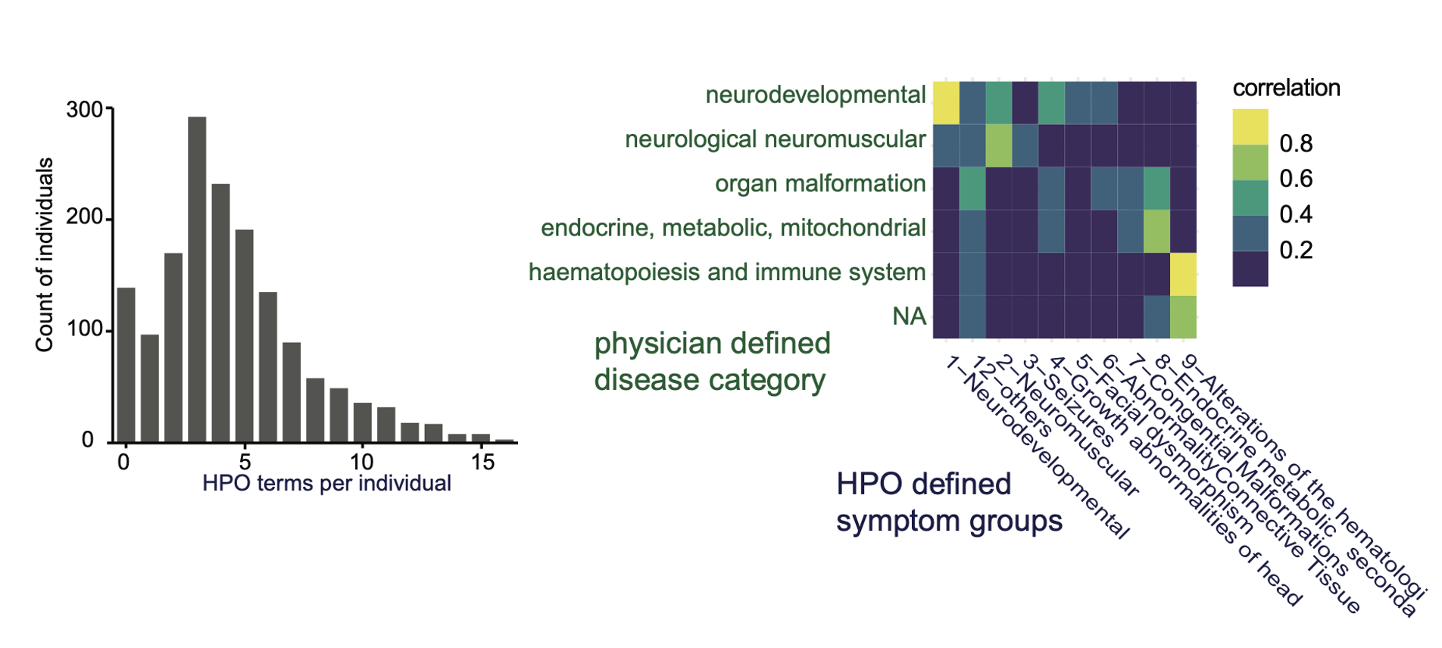
Supplemental Figure 1: The mean number of HPO-terms used to describe a patient was 5. Each HPO term was also assigned to a higher-order HPO groups in order to study their correlation with physician-reported disease groups. Individuals with neurodevelopmental disorders often also had neurological and neuromuscular abnormalities and vice versa.

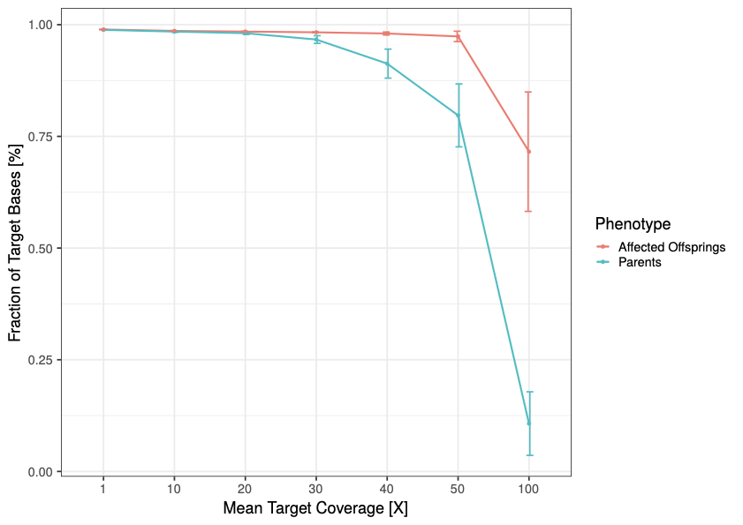

Supplemental Figure 2: The quality criteria for exome sequencing were fulfilled if at least 95% of the coding nucleotides of all RefSeq transcripts were covered by 20 or more reads.

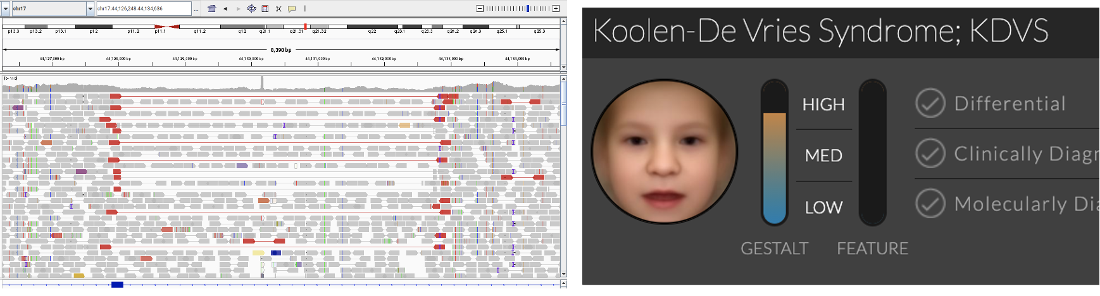
Supplemental Figure 3: Portrait analysis of case 393 with DeepGestalt suggested high similarity to Koolen-De Vries syndrome. After inconclusive ES, WGS was performed and revealed a causal 4.7kb de novo deletion in KANSL1.

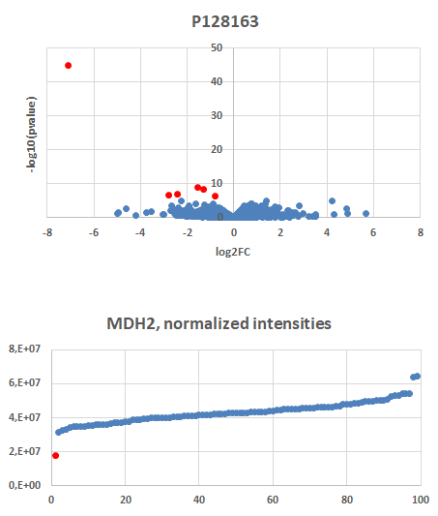
Supplemental Figure 4: ES in case 1127 revealed missense variants of unknown clinical significance in MDH2. Subsequent proteomics in fibroblasts showed significantly reduced intensities for MDH2 and resulted in a reclassification of the variants to likely pathogenic.
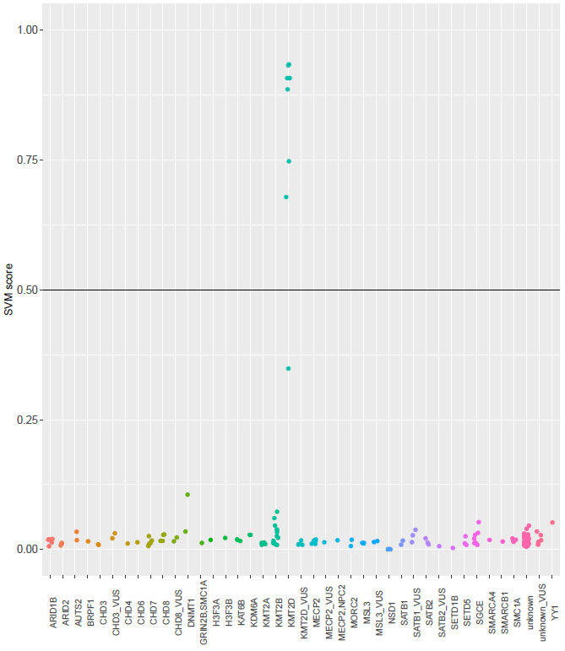
Supplemental Figure 5: Monogenic disorders of chromatin regulatory proteins cause characteristic methylation epi-signatures. These patterns can be identified on EPIC-array data by a support vector machine (SVM) that was trained on positive controls for each gene. A score above 0.5 is indicative for a pathogenic variant in the respective gene. Scores in between 0.3 and 0.5 can be caused by mosaicism of pathogenic variants.

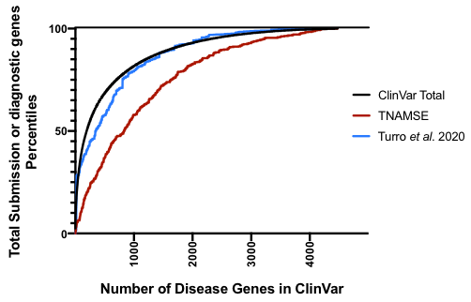
Supplemental Figure 6: Diagnostic grade genes (DGGs) in were ordered according to the number of pathogenic or likely pathogenic variants submitted to ClinVar. Phenotypes associated with DGGs close to the left can be regarded as more frequent than phenotypes associated with DGGs close to the right. A deviation of the cumulative distribution of a cohort to the lower right indicates an enrichment for ultra-rare phenotypes.

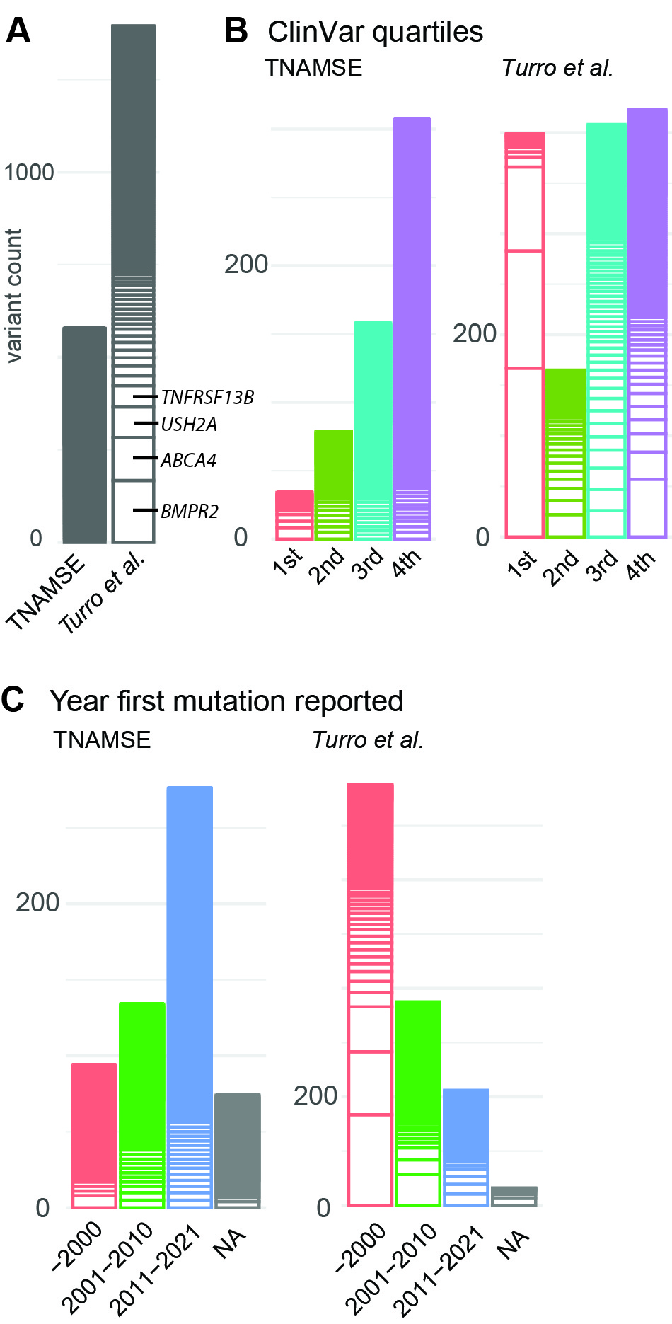
Supplemental Figure 7: Cases of the TRANSLATE-NAMSE cohort were enriched for ultra-rare diagnoses and required medical knowledge that was mostly generated in the last decade.

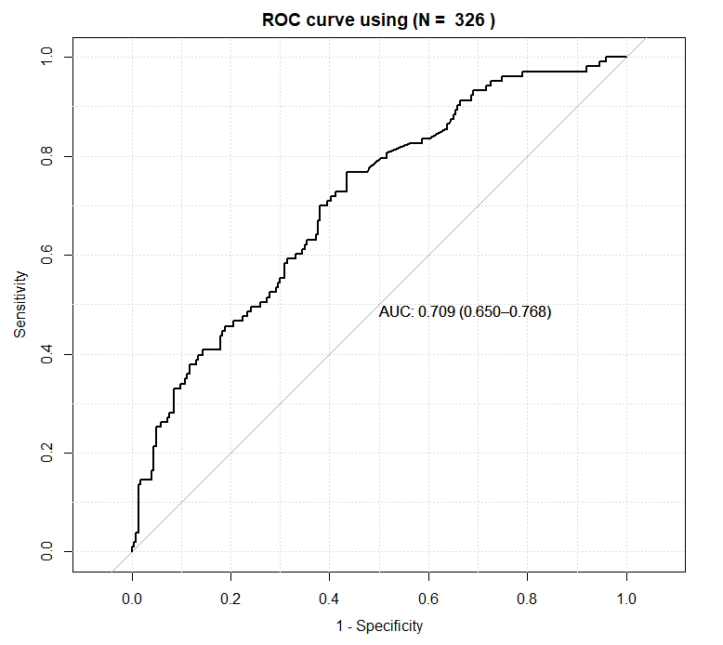
Supplemental Figure 8: Receiver Operator Characteristics (ROC) curve for Predictor of diagnostic yield on a TRANSLATE-NAMSE test set.
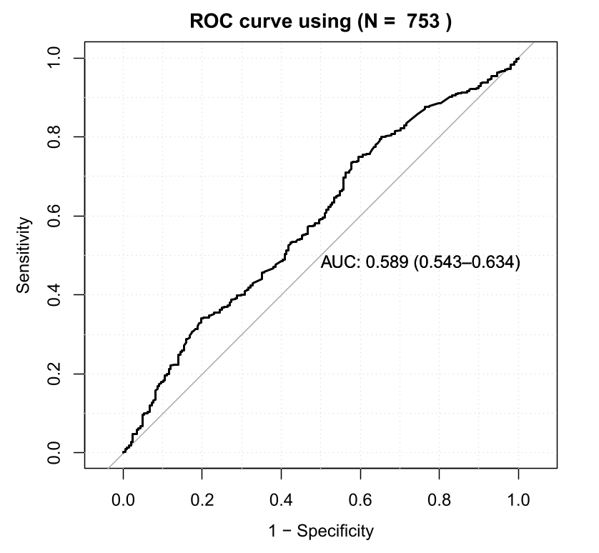
Supplemental Figure 9: Receiver Operator Characteristics (ROC) curve for Predictor of diagnostic yield on an independent and external cohort.

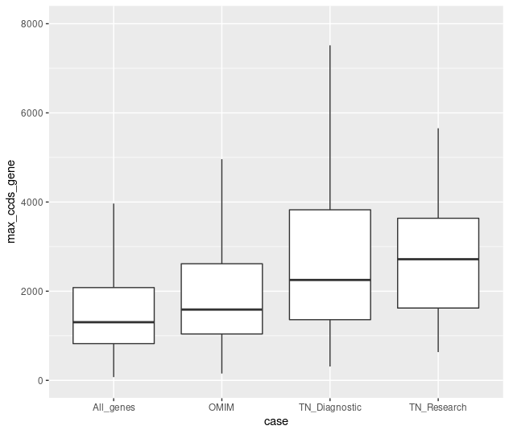
Supplemental Figure 10: The mean coding length of DDGs in the TRANSLATE-NAMSE cohort (TN_Diagnostic), as well, as novel DDGs (TN_Rsearch) was significantly longer than for all genes or all OMIM genes.

Supplementary Tables

Supplemental Table 1: The five most frequently used HPO terms per disease category

Disease Category | Most frequent HPO terms within disease categories
mental, behavioral or neurodevelopmental (N=734) | Global developmental delay (N=404) | Hypotonia (N=194) | Microcephaly (N=184) | Delayed speech / language development (N=176) | Intellectual disability (N=103) | Short stature (N=98) | Seizure (N=94)
neurological neuromuscular (N=282) | Seizure (N=60) | Dystonia (N=33) | Hypotonia (N=29) | Global developmental delay (N=28) | Ataxia (N=24) | Myopathy (N=22) | Focal dystonia (N=19)
ear, eye, skeleton, kidney, genitals, liver, skin, lung, intestines (N=181) | Short stature (N=28) | Global developmental delay (N=14) | Disproportionate short stature (N=12) | Decreased response to growth hormone stimulation test (N=12) | Premature birth (N=11) | Microcephaly (N=11) | Hypotonia (N=10)
endocrine, metabolic, mitochondrial nutritional (N=74) | Decreased response to growth hormone stimulation test (N=9) | Seizure (N=6) | Panhypopituitarism (N=6) | Short stature (N=6) | Hypoglycemia (N=5) | Ectopic posterior pituitary (N=5) | Abnormality of the mitochondrion (N=4)
haematopoiesis and immune system (N=65) | Immunodeficiency (N=18) | Recurrent infections (N=9) | Recurrent fever (N=8) | Decreased circulating antibody level (N=8) | Autoimmunity (N=6) | Recurrent otitis media (N=6) | Pneumonia (N=4)
Cardiovascular (N=17) | Hypotonia (N=7) | Abnorma corpus callosum morphology (N=2) | Microcephaly (N=2) | Abnormal heart morphology (N=2) | Atrial septal defect (N=2) | Hearing impairment (N=2) | Cardiomyopathy (N=2)

