Supplementary materials
Sampling site overview
Locations of sampling sites are indicated in Fig. S1, Sampling sites represented various types of land use with different locuswere selected as follows. Thus the extracellular viromes were named using sample name and intracellular viromes were named with an additional letter C before sample name. An overview of the clean sequencing data of metagenome and virome for each site is given in Table S1. The major environmental factors across in soil samples were showed in Table S1 as well.
Forest, T1 (Tianzhu mountain), T2 (Tianzhu mountain), SK1 (Tiejianshi mountain), SK2 (Tiejianshi mountain), T5 (Tianma mountain),
Road verge, J6 (Jimei avenue), J7 (Jianye Road), X8 (Xiahe Road), H9 (Huandao Road), H10 (Lakeside middle Road),
Vegetable field, G11 (Guankou town), G12 (Guankou town), G13 (Guankou town), C14 (Chaichang), C15 (Chaichang),
Urban park, Z16 (Zhonglun park), R17 (Ridong park), S18 (Shiming park), B19 (Bailuzhou park), Z20 (Zhongshan park)
Paddy field, G21 (Guankou town), G22 (Guankou town), G23 (Guankou town), C24 (Chaichang), C25 (Chaichang)

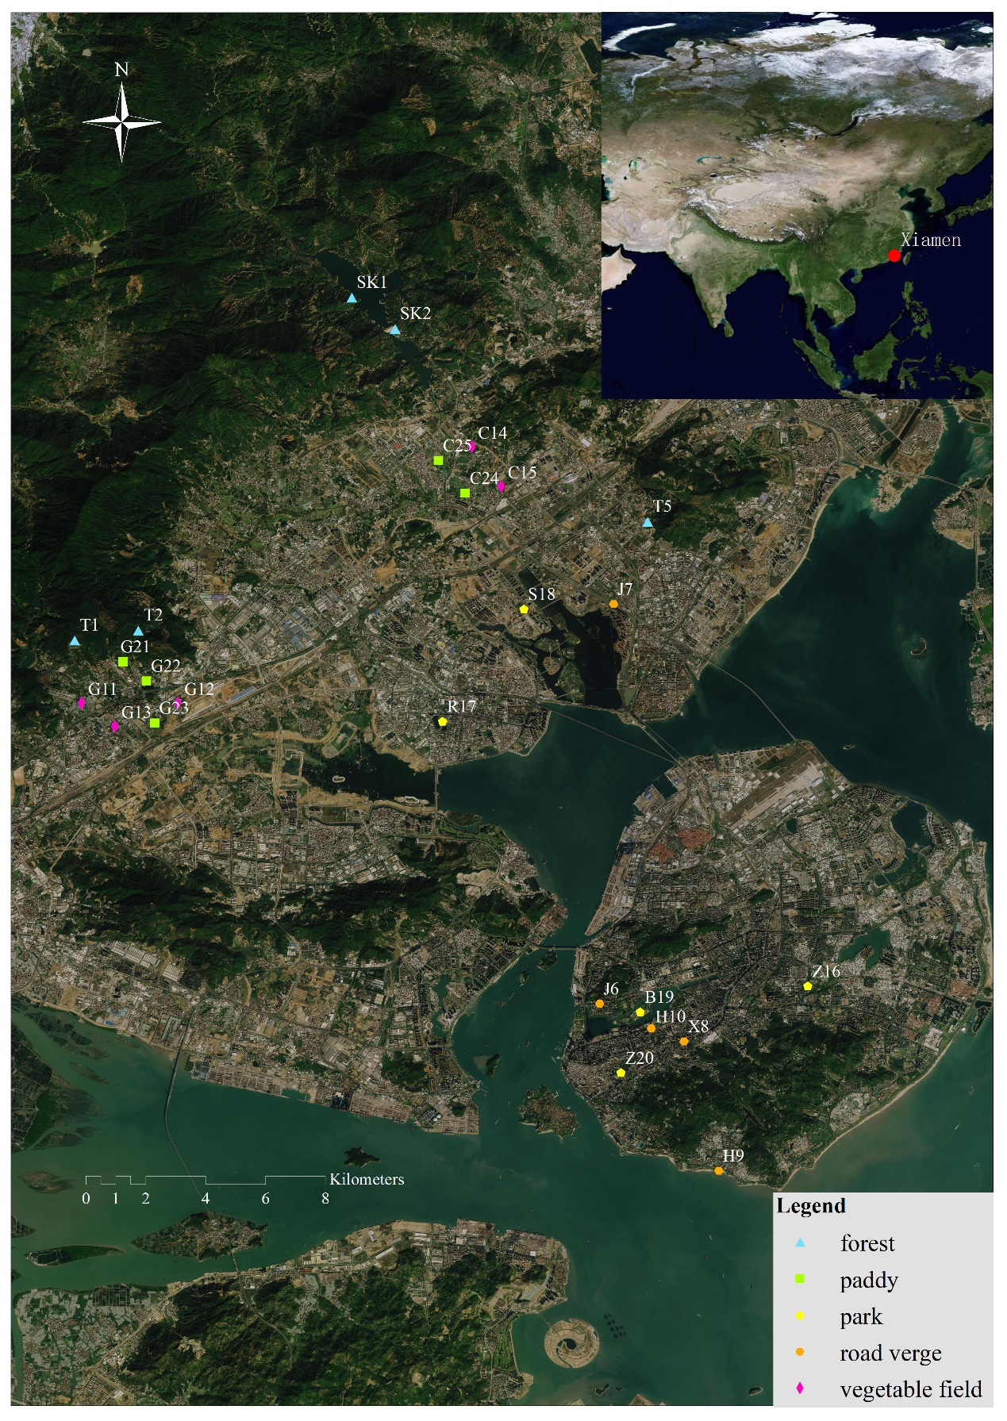
Figure S1. Geographic location of sampling sites with five land-use types in Xiamen.

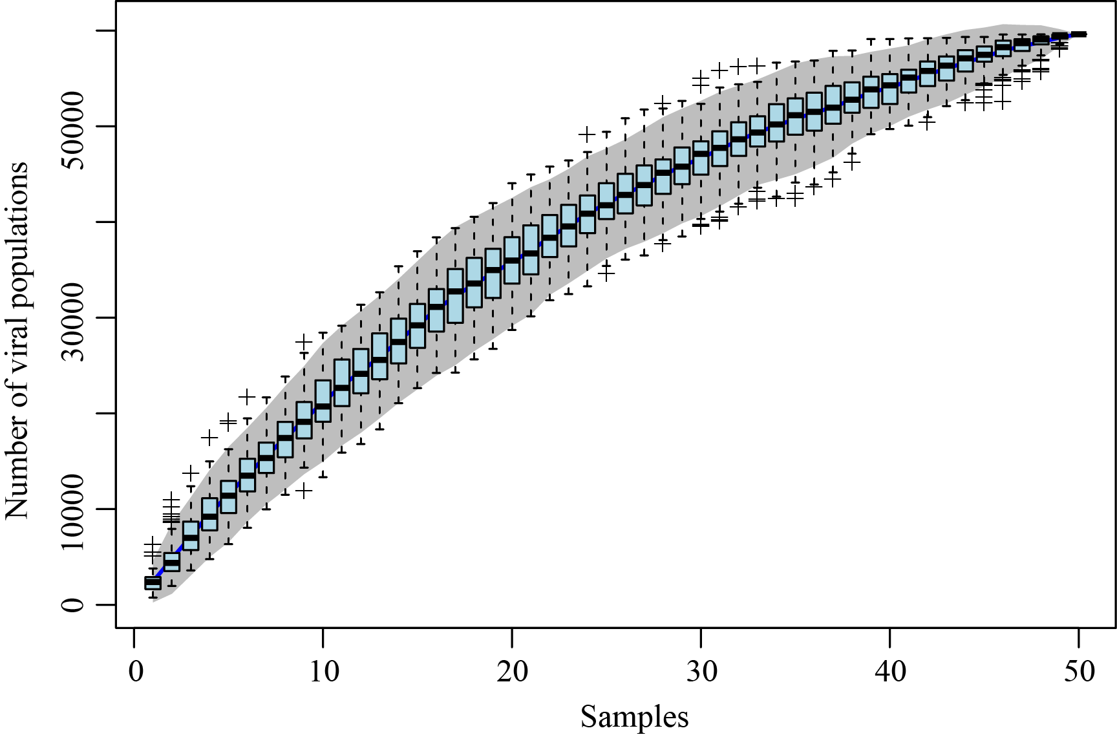
Figure S2. Accumulative curve of VPs detected from 50 viromes subsampled to 30M reads.

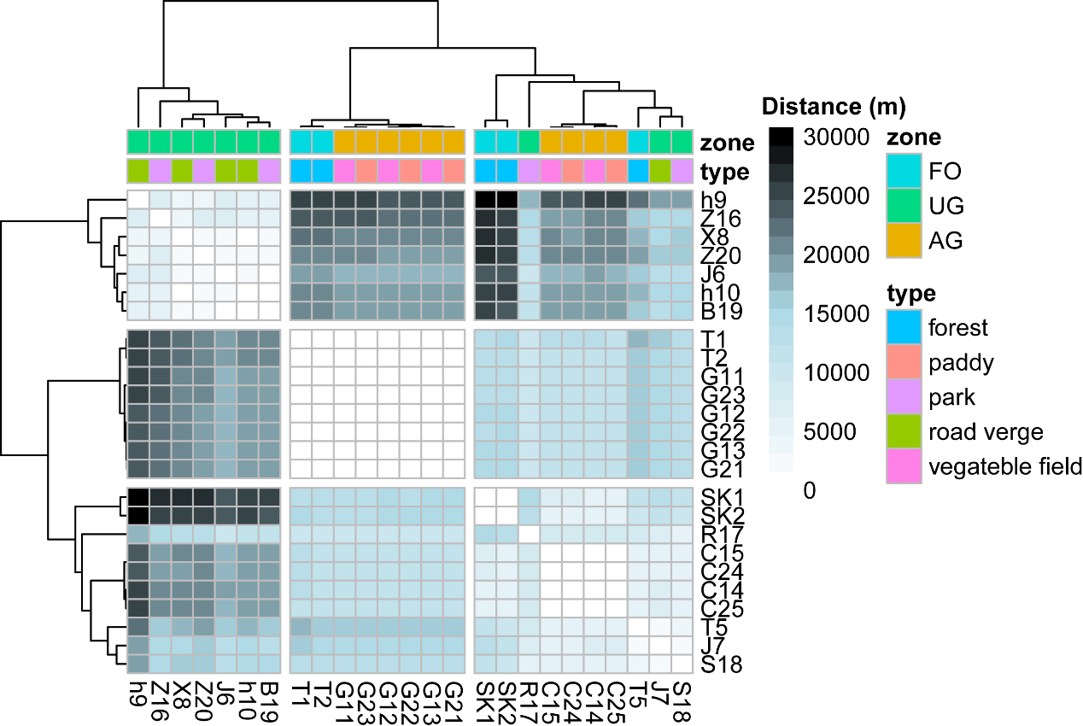
Figure S3. Heatmap showed the clustering of spatial distance (m) between different viral communities.

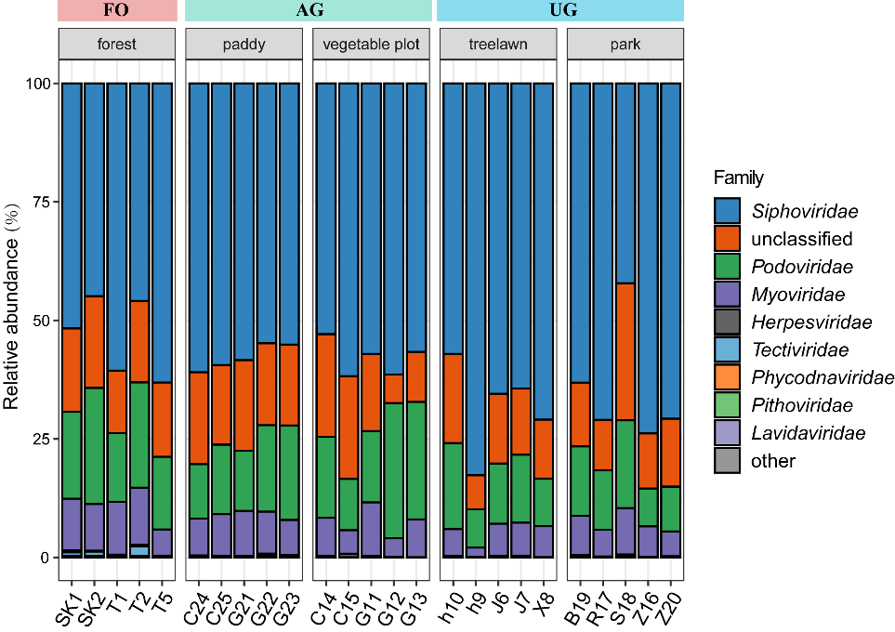
Figure S4. Family distribution of soil viral community compositions.

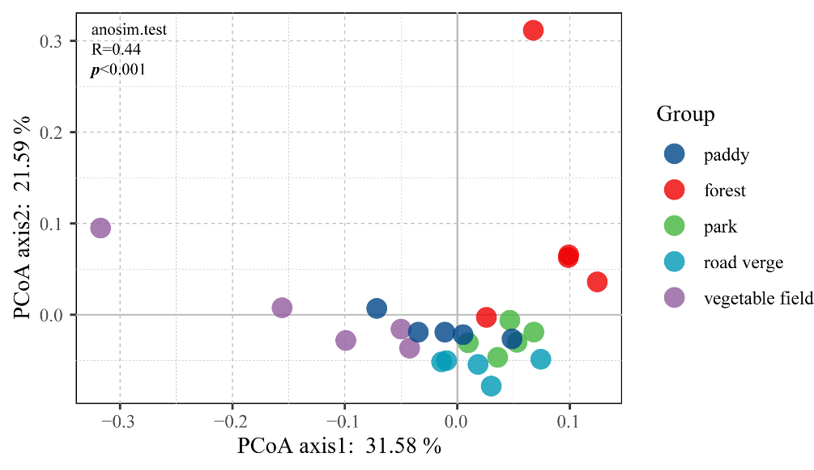
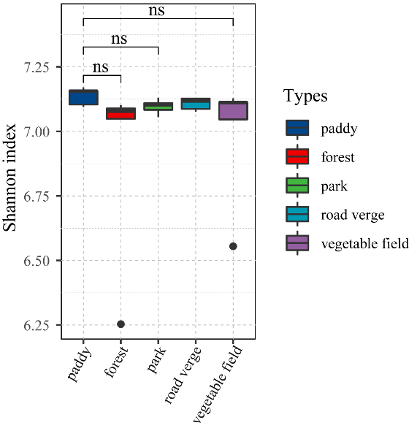
b
a
Figure S5. (a) Principal coordinates analysis (PCoA) of microbial community structures. The analysis of similarity (ANOSIM) was used to test the significance of difference among land use types. (b) Shannon index of microbial community structures for each land use. Median and quartiles were shown in boxplot. All pairwise comparisons shown were performed using Wilcox.test. p values lower than 0.05 were denoted as ‘‘ns.’’

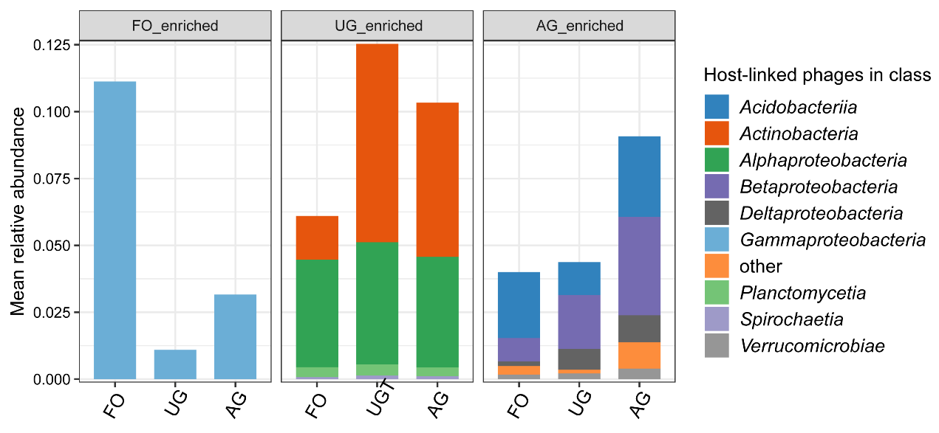
Figure S6. Shifts in the mean summed host-linked relative abundances of significantly FO-enriched, UG-enriched, and AG-enriched VPs in class-level across the three zones.

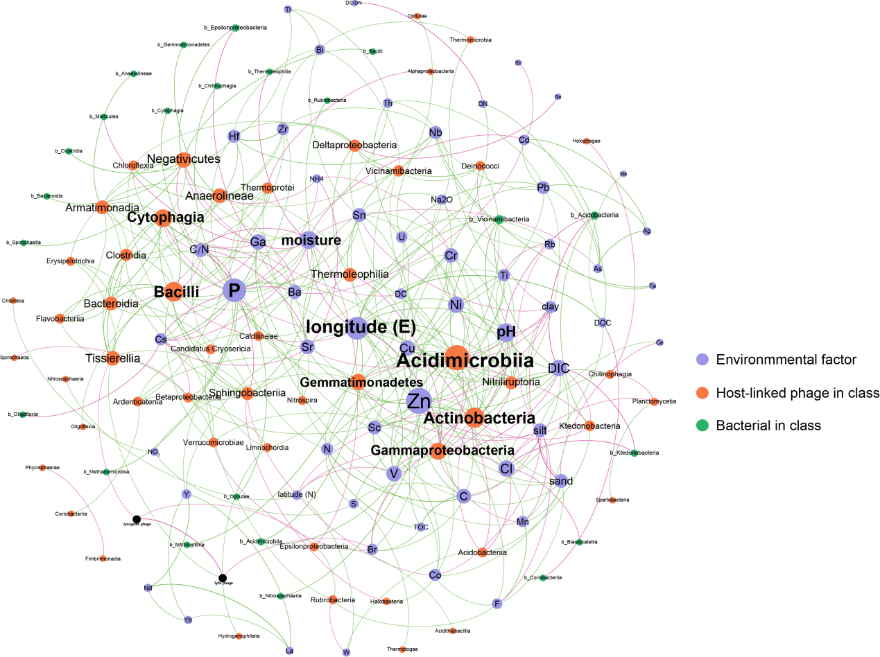
Figure S7. Network analysis depicting an interaction pattern among host-linked VPs in class, bacteria in class and environmental factor. The size of nodes and labels represents the degree of connection. The layout method of this network was Fruchterman Reingold. The blue line indicated the positive interaction and red line indicated negative interaction.

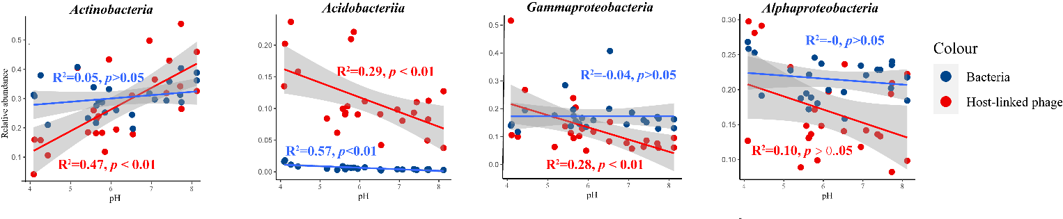
Figure S8. The linear model showing the relationship between the relative abundance of host-linked phage and bacteria and pH.

