Importance of urban green areas connectivity for the conservation of pollinators
Sofia Graffigna ^{abc*}, Rocío A. González-Vaquero^{d}, Juan P. Torretta^{d} and Hugo J. Marrero ^{bc}
ª Departamento de Biología, Bioquímica y Farmacia, Universidad Nacional del Sur, San Juan 670, 8000 Bahía Blanca, Argentina.
^{b} Laboratorio de Interacciones Bióticas en Agroecosistemas (LIBA – https://libagro.wixsite.com/liba )
^{c} Centro de Recursos Naturales Renovables de las Zonas Semiáridas, CONICET, Camino de la Carrindanga Km. 7, 8000 Bahía Blanca, Argentina.
^{d} Universidad de Buenos Aires, Facultad de Agronomía, Cátedra de Botánica General, Av. San Martín 4453, C1417DSE, Buenos Aires, Argentina.
Corresponding author: Graffigna S.
Email address: sgraffigna@agro.uba.ar
Orcid SG: 0000-0002-9205-5513
Orcid RGV: 0000-0001-7754-1815
Orcid JPT: 000-0001-8185-4822
Orcid HJM: 0000-0001-8515-3812

RICHNESS OF POLLINATORS
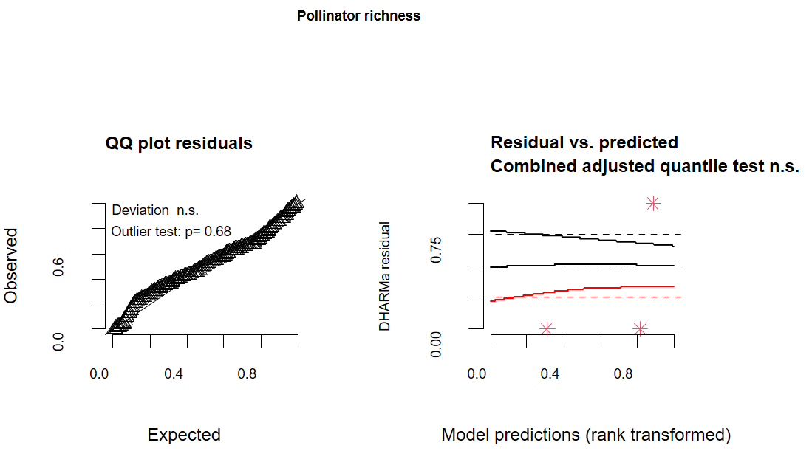
Fig. S1 Fit of the model for pollinator richness (Table 1, model a). Goodness of the models fit performed in DHARMa package (function: plotQQunif and plotResiduals). The package uses a simulation-based approach to create readily interpretable scaled (quantile) residuals for fitted (generalized) linear mixed models. The qq-plot detect overall deviations from the expected distribution, by default with added tests for correct distribution (Kolmogorov-Smirnov test), dispersion and outlier test. The residuals plot produces a plot of the residuals against the predicted value.

Table S3 Results of the multiple comparison made in model for pollinator richness (Table 1, model a). Comparison of means between different anthropogenic landscapes: Urban, Peri-urban and Non-urban. For this, the glht function of multcomp package was used (R Development Core Team, 2013). Significant differences are marked with asterisks.

Pollinator richness | Estimate | Std. Error | Z value | Pr(>|z|)
Peri-urban – Non urban | -1.0588 | 0.3670 | 2.885 | 0.0106*
Urban- Non urban | -1.2729 | 0.2921 | -4.357 | <0.001***
Urban – Peri-urban | -0.2141 | 0.3520 | -0.608 | 0.8145

Signif. codes: 0 ‘***’ 0.001 ‘**’ 0.01 ‘*’ 0.05 ‘.’ 0.1 ‘ ’ 1

ABUNDANCE OF POLLINATORS
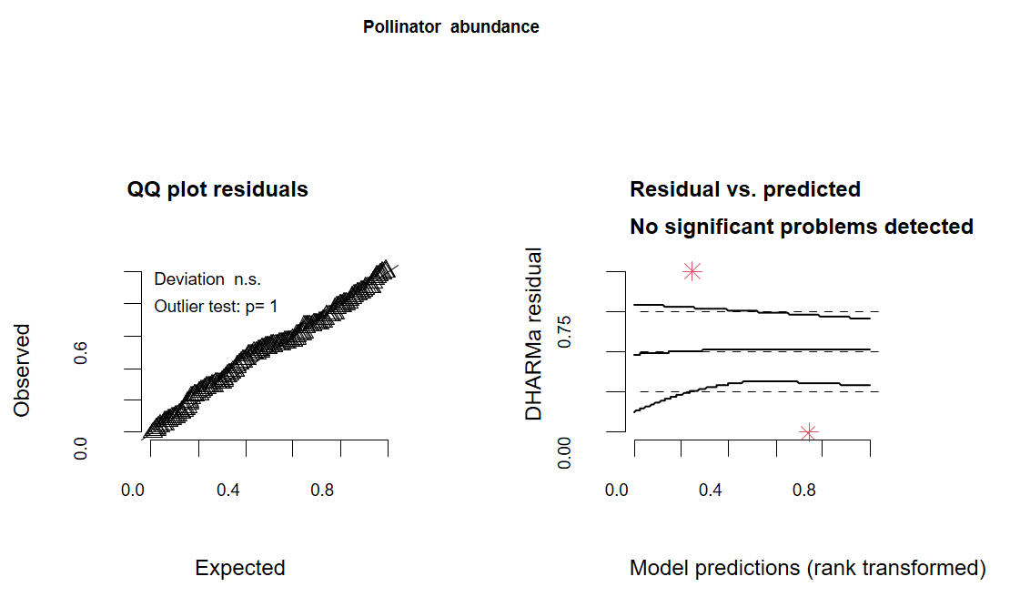
Fig. S2 Fit of the model for pollinator abundance (Table 1, model b). Goodness of the models fit performed in DHARMa package (function: plotQQunif and plotResiduals). The package uses a simulation-based approach to create readily interpretable scaled (quantile) residuals for fitted (generalized) linear mixed models. The qq-plot detect overall deviations from the expected distribution, by default with added tests for correct distribution (Kolmogorov-Smirnov test), dispersion and outlier test. The residuals plot produces a plot of the residuals against the predicted value.

Table S4 Results of the multiple comparison made for pollinator abundance (Table 1, model b). Comparison of means between the different anthropogenic landscapes: Urban, Peri-urban and Non-urban. For this, the glht function of multcomp package was used (R Development Core Team, 2013). Significant differences are marked with asterisks.

Pollinator abundance | Estimate | Std. Error | Z value | Pr(>|z|)
Peri-urban – Non urban | 1.7682 | 0.7102 | 2.490 | 0.0336*
Urban- Non urban | -2.2122 | 0.5552 | -3.985 | <0.001***
Urban – Peri-urban | -0.4440 | 0.6347 | -0.700 | 0.7617

Signif. codes: 0 ‘***’ 0.001 ‘**’ 0.01 ‘*’ 0.05 ‘.’ 0.1 ‘ ’ 1
(Adjusted p values reported -- single-step method)

