Importance of urban green areas connectivity for the conservation of pollinators
Sofia Graffigna ^{abc*}, Rocío A. González-Vaquero^{d} , Juan P. Torretta^{d} and Hugo J. Marrero ^{bc}
ª Departamento de Biología, Bioquímica y Farmacia, Universidad Nacional del Sur, San Juan 670, 8000 Bahía Blanca, Argentina.
^{b} Laboratorio de Interacciones Bióticas en Agroecosistemas (LIBA – https://libagro.wixsite.com/liba ).
^{c} Centro de Recursos Naturales Renovables de las Zonas Semiáridas, CONICET, Camino de la Carrindanga Km. 7, 8000 Bahía Blanca, Argentina.
^{d} Universidad de Buenos Aires, Facultad de Agronomía, Cátedra de Botánica General, Av. San Martín 4453, C1417DSE, Buenos Aires, Argentina.
Corresponding author: Graffigna S.
Email address: sofigraffigna@gmail.com
Orcid: 0000-0002-9205-5513

Author | Year | Title
Birdshire et al. | 2020 | Bee community response to local and landscape factors along an urban-rural gradient
Fortel et al. | 2014 | Decreasing Abundance, Increasing Diversity and Changing Structure of the Wild Bee Community (Hymenoptera: Anthophila) along an Urbanization Gradient
Garbuzov et al. | 2017 | Most ornamental plants on sale in garden centres are unattractive to flower-visiting insects
Geslin et al. | 2016 | Spatiotemporal changes in flying insect abundance and their functional diversity as a function of distance to natural habitats in a mass flowering crop
Geslin et al. | 2020 | Bee hotels host a high abundance of exotic bees in an urban context
Hofmann & Renner | 2020 | Bee species decrease and increase between the 1990s and 2018 in large urban protected sites
Hulsmann et al. | 2015 | Plant diversity and composition compensate for negative  effects of urbanization on foraging bumble bees
Kratschmer et al. | 2018 | Buzzing on top: Linking wild bee diversity, abundance and traits with green roof qualities
Lagucki et al. | 2017 | Urbanization alters communities of flying arthropods in parks and gardens of a medium-sized city
Micholap et al. | 2017 | Variability of bumblebee communities (Apidae, Bombini)  in urban green areas
Normandin et al. | 2017 | Taxonomic and functional trait diversity  of wild bees in different urban settings
Passaseo et al. | 2020 | Pollinator emerging from extensive green roofs: wild bees  (Hymenoptera, Antophila) and hoverflies (Diptera, Syrphidae) in Geneva (Switzerland)
Rocha-Filho et al. | 2020 | Green patches among a grey patchwork: the importance  of preserving natural habitats to harbour cavity‑nesting  bees and wasps (Hymenoptera) and their natural enemies  in urban areas
Sing et al. | 2016 | Urban parks: refuges for tropical butterflies in Southeast Asia?
Sing et al. | 2016 | Can butterflies cope with city life? Butterfly diversity in a  young megacity in southern China1
Sobreiro et al. | 2019 | Continuous Micro-Environments Associated Orchid Bees Benefit from an Atlantic Forest Remnant, Paraná State, Brazil
Stewart et al. | 2018 | Habitat and landscape factors influence pollinators in a tropical megacity, Bangkok, Thailand
Theodorou et al. | 2017 | The structure of flower visitor networks in relation to pollination across an agricultural to urban gradient
Wastian et al. | 2016 | Influence of the reduction of urban lawn mowing on wild bee diversity (Hymenoptera, Apoidea)
Zajdel et al. | 2019 | Bumblebee communities (Apidae, Bombini) in urban parks in  relation to park area and other characteristics
Table S1 Bibliographic list of papers used to perform the meta-analysis.

Table S2 Bibliographic list of papers used to perform the meta-analysis. The country and city where the study was carried out, taxonomic group, capture method, number of sites used for the study and measures taken (richness and abundance of pollinators and floral abundance) are detailed.



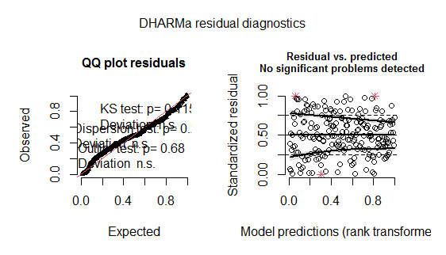
RICHNESS

Fig. S1 Fit of the model M1. Goodness of the models fit performed in DHARMa package (function: plotQQunif and plotResiduals). The package uses a simulation-based approach to create readily interpretable scaled (quantile) residuals for fitted (generalized) linear mixed models. The qq-plot detect overall deviations from the expected distribution, by default with added tests for correct distribution (Kolmogorov-Smirnov test), dispersion and outlier test. The residuals plot produces a plot of the residuals against the predicted value.

Table S3 Results of the multiple comparison made in M1. Comparison of means between different anthropic landscapes: Urban, Peri-urban and Non-urban. For this, the glht function of multcomp package was used (R Development Core Team, 2013). Significant differences are marked with asterisks.

M1 | Estimate | Std. Error | Z value | Pr(>|z|)
Periurban – non urban | -1.0219 | 0.3671 | -2.784 | 0.0144*
Urban- non urban | -1.2125 | 0.2917 | -4.156 | <1e-04***
Urban - periurban | -0.1906 | 0.3541 | -0.538 | 0.8514

Signif. codes: 0 ‘***’ 0.001 ‘**’ 0.01 ‘*’ 0.05 ‘.’ 0.1 ‘ ’ 1

ABUNDANCE
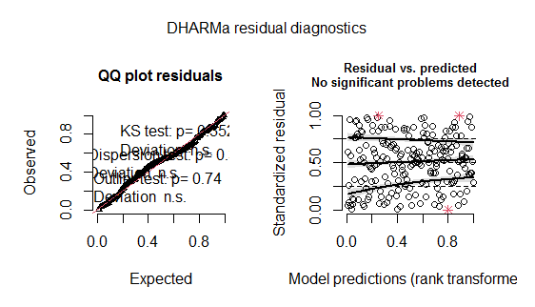

Fig. S2 Fit of the model M2. Goodness of the models fit performed in DHARMa package (function: plotQQunif and plotResiduals). The package uses a simulation-based approach to create readily interpretable scaled (quantile) residuals for fitted (generalized) linear mixed models. The qq-plot detect overall deviations from the expected distribution, by default with added tests for correct distribution (Kolmogorov-Smirnov test), dispersion and outlier test. The residuals plot produces a plot of the residuals against the predicted value.

Table S4 Results of the multiple comparison made in M2. Comparison of means between the different anthropic landscapes: Urban, Peri-urban and Non-urban. For this, the glht function of multcomp package was used (R Development Core Team, 2013). Significant differences are marked with asterisks.

M2 | Estimate | Std. Error | Z value | Pr(>|z|)
Periurban – non urban | -1.9742 | 0.7023 | -2.811 | 0.0135*
Urban- non urban | -2.2637 | 0.5719 | -3.958 | <0.001***
Urban - periurban | -0.2895 | 0.6638 | -0.436 | 0.8999---

Signif. codes: 0 ‘***’ 0.001 ‘**’ 0.01 ‘*’ 0.05 ‘.’ 0.1 ‘ ’ 1
(Adjusted p values reported -- single-step method)

