Supporting Information for

Cooperative Boosting Performance of Halide Perovskite Solar Cells between Photoelectric and Thermoelectric Effect

Ping Fu¹, Ruixue Lu^{1,2}, Md Azimul Haque³, Enming You⁴, Hui Li^{1,5}, Ruotian Chen¹, Yaoyao Han^{5,6}, Yanfeng Yin^{5,6}, Wei Qin¹, Fengtao Fan¹, Kaifeng Wu⁶, Derya.Baran³, Can Li^{1*}
¹State Key Laboratory of Catalysis, Dalian Institute of Chemical Physics, Chinese Academy of Sciences, Dalian National Laboratory for Clean Energy, 457 Zhongshan Road, Dalian 116023, China
²Department of Chemistry, Collaborative Innovation Center of Chemistry for Energy Materials (iChEM), Fudan University, 2205 Songhu Road, Shanghai 200438, PR China
³Physical Science and Engineering Division, KAUST Solar Center (KSC), King Abdullah University of Science and Technology (KAUST), Thuwal 23955-6900, Kingdom of Saudi Arabia
⁴State Key Laboratory of Physical Chemistry of Solid Surfaces, Collaborative Innovation Center of Chemistry for Energy Materials, College of Chemistry and Chemical Engineering, Xiamen University, Xiamen, China
⁵University of Chinese Academy of Sciences, Beijing 100049, China
⁶State Key Laboratory of Molecular Reaction Dynamics and Dynamics Research Center for Energy and Environmental Materials, Dalian Institute of Chemical Physics, Chinese Academy of Sciences, Dalian 116023, China

Correspondence to: Prof .Can Li: canli@dicp.ac.cn

Materials.
N,N-Dimethylformamide (DMF, anhydrous, 99.8%), dimethylsulfoxide (DMSO, anhydrous, 99.8%), chlorobenzene (CB, anhydrous, 99.8%), lithium bis(trifluoromethylsulphonyl) imide (Li-TFSI, 99.8%) and tert-butylpyridine (TBP, 96%) were used as received from Sigma-Aldrich. Lead iodide (PbI₂, 99.9985%) was purchased from Tokyo Chemical Industry (TCI). MAI, FAI, MABr and MACl and Spiro-OMeTAD were used as received from Xi’an Polymer Light Technology Corp., China without further purification.
Characterizations.
Steady state and time resolved Photoluminescence (PL) spectra were obtained by FLS980 (Edinburgh Instruments Ltd) equipped with a 450WXe lamp, a photomultiplier tube (PMT) detector, and a liquid nitrogen cryostat (Oxford Instruments, OptistatDN-V).
X-ray Diffraction (XRD) patterns were characterized by an X-ray powder diffraction system (PANalytical X’Pert Pro, Cu Kα: λ= 1.54 Å) at different temperatures from 290 K to 100 K at a voltage of 40 kV and 200 mA currents. The diffraction data were collected with angular range 5-60 degrees.
Scanning electron microscopy (SEM) was investigated on a Quanta 200F microscope (FEI Company) with an accelerating voltage of 20 kV.
Broadband scattering-type scanning near-field optical microscopy (s-SNOM) imaging was performed by a commercialized neaSNOM system (neaspec GmbH). The AFM was working under tapping mode, using Pt/Ir probes (Arrow-NCPt, Nanoworld) whose resonance frequency Ω was about 250 kHz. The tapping amplitude was kept as 100 nm in the experiment. A broadband mid-infrared (MIR) laser ranging from 650 to 1400 cm^{–1} was focused with a parabolic mirror to concentrate the IR light into a nanoscale region underneath the tip apex. The scattered signal was collected by the same parabolic mirror and guided to a mercury cadmium telluride (MCT) detector. During the broadband s-SNOM imaging, the reference mirror in the s-SNOM system was kept fixed at the white light position (WLP). The scattered signals were demodulated at nΩ, where n was chosen as 2 for efficient background suppression.
Femtosecond pump−probe transient absorption (TA) spectra was performed with different temperatures. The femtosecond laser pulse was generated by a Ti: sapphire femtosecond regenerative amplifier with 800 nm wavelength and 1 kHz repetition rate (Coherence) and served as both pump and probe beams. The pump pulse with a wavelength of 400 nm and duration of 50 fs generated via a second harmonic generator (SHG) was used to excite all the samples, and the probe beam was detected by a high-speed spectrometer (HELIOS, Ultrafast Systems). The wavelength range of the detector was set from 400 nm to 850 nm, and the spot size of the TA is approximately 0.5 mm² as evaluated by imaging the laser spot.
Supplementary Note 1: J_{ph} and V_{eff} measurements
To further investigate the photoexcitation behavior of the FAPbI₃ PSCs with or without ΔT, the charge collection behavior by checking the dependence of the photocurrent density (J_{ph}) versus effective voltage (V_{eff}) was conducted. J_{ph} is determined by the equation J_{ph} = J_{L}−J_{D}, where J_{L} and J_{D} are the current densities measured under AM 1.5G illumination and in the dark, respectively. And V_{eff} is defined as V_{eff} = V₀–V_{app}, where V₀ is the voltage when J_{ph} = 0 and V_{app} is the applied bias. The ratio of J_{ph}/J_{sat} can be used to estimate the charge collection efficiency under operation conditions, where J_{sat} is the saturation photocurrent density. Under short circuit conditions, the J_{ph}/J_{sat} ratios were calculated to be 0.928 and 0.931 for the FAPbI₃ PSCs with ΔT =0 ºC or ΔT =15 ºC, respectively. Under the maximal power output conditions, the J_{ph}/J_{sat} ratios were 0.955 for the FAPbI₃ PSCs with ΔT =0 ºC and 0.977 for the FAPbI₃ PSCs with ΔT =15 ºC. The larger value of J_{ph}/J_{sat} indicates a better charge collection efficiency, consisting with the higher FF.
Supplementary Note 2: TA measurements and data analysis
The pump pulse with a wavelength of 400 nm was used to excite all the samples, and the probe beam was detected using the band edge wavelength. The typical transient absorption (TA) spectra of FAPbI₃ films with (400 nm) pump-probe (796 nm) at different temperature of 0 ºC and 20 ºC vs laser to simulate the ΔT condition. There are two dominant features observed: photobleaching peaks (PB, ΔA/A < 0) and a photoinduced absorption (PIA; ΔA/A> 0) band. It is well accepted that the PB (~1.56 eV, 796 nm) originate from the state filling of the band edge. To be noted, the extracted individual TAS with (400 nm) pump-probe (796 nm) exhibits a PIA signal peak, which attributed to the presence of energetic hot carriers. These hot carriers so-called high-energy electrons (and holes) have to lose their excess energy in the form of heat through scattering until they match the conduction energy level of the semiconductor. The decay dynamics pumped at 400 nm does not slow hot carriers cooling with designed ΔT. Additionally, the PB signal peak for FAPbI₃ films at 0 ºC vs laser presents a slight red shift compared to that for 20 ºC vs laser. The longer charge carrier lifetime pumped at 780 nm is achieved for the FAPbI₃ films with ΔT. This might be due to the reduced non-radiative recombination.
Supplementary Note 3: Electrical conductivity and Seebeck measurements
For electrical conductivity measurements, parallel line-shaped Au electrodes were deposited as the top contact with a width and channel length of 2 mm and 250 μm, respectively. For thermal voltage measurements, a homemade setup was used with Peltier devices and thermocouples to apply the temperature gradient across the sample under N₂ environment, and the voltage was recorded using a Keithley sourcemeter.
Supplementary Note 4: Surface potential difference measurements
Surface potential difference (ΔCPD) and transient ΔCPD signals collected with 5 Hz modulated light were further investigated to verify the p-type and n-type properties for the MAPbI_{3,} FAPbI₃ and MAPbI_{1.5}Cl_{1.5} films. The ΔCPD can be determined by measuring the CPD under illumination and dark conditions. For the p-type semiconductor with downward surface band bending, owing to the separation and transfer of photo-generated electrons under illumination towards the surface, a decreased CPD and a negative ΔCPD are observed. In contrast, for the n-type semiconductor with upward band bending, the CPD increases under illumination and a positive ΔCPD is yielded.⁷ In this manner, the ΔCPD of the MAPbI₃ and FAPbI₃ films was decreased by 10-20 mV, whereas that of the MAPbI_{1.5}Cl_{1.5} films was increased by 5 mV under 680 nm laser illumination. Moreover, the ΔCPD signals for FAPbI₃, MAPbI₃ and MAPbI_{1.5}Cl_{1.5} show periodic changes of 5 Hz, but with opposite trends when the light was on and off, thus confirming that the FAPbI₃ and MAPbI₃ film is p-type property and MAPbI_{1.5}Cl_{1.5} film is n-type property.

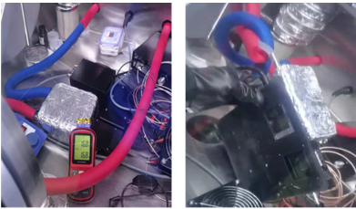
Fig.S1 Home-made refrigeration equipment to control the temperature differences.
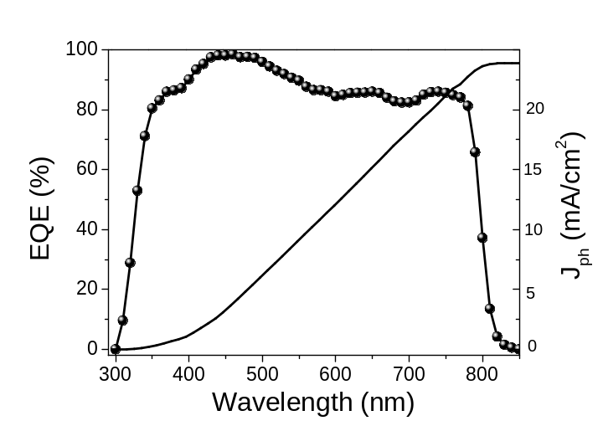
Fig.S2 EQE spectrum for FAPbI₃ PSCs with ΔT=0 ºC.

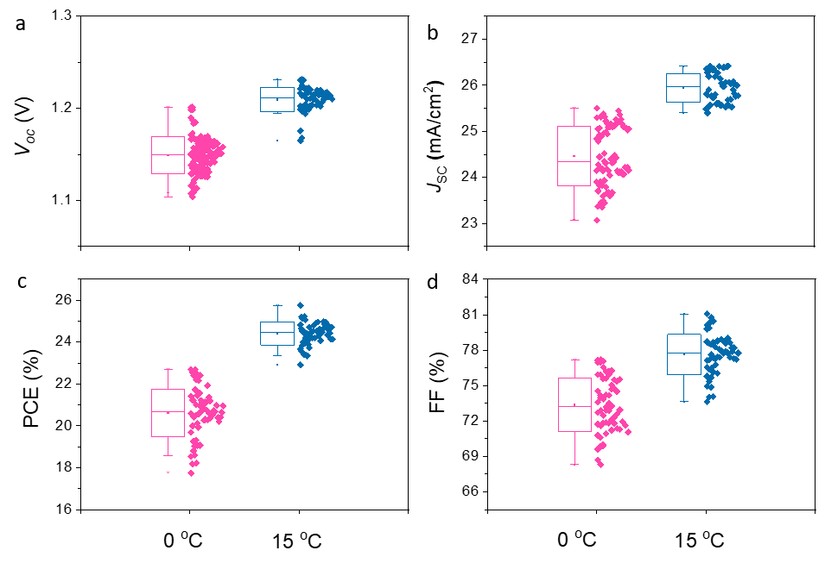
Fig. S3 Histograms of PCE distribution of the FAPbI₃ PSCs with ΔT of 0 ºC and 15 ºC, respectively.

Fig S4. Evolution of normalized PCEs of devices aged in (a) RH < 30% and RT; (b) 65% RH and RT; (c) 30%~65% RH and 65 ºC.

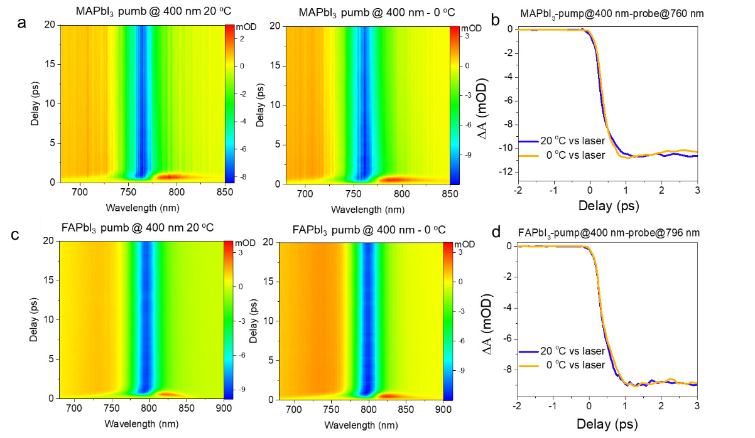
Fig S5. (a) Pseudo colour transient absorption (TA) and (b) decay dynamics curve of MAPbI₃ films with pump @400 nm under 20 ºC vs laser and 0 ºC vs laser, respectively. (c) Pseudo colour TA and (d) decay dynamics curve of FAPbI₃ films with pump @400 nm under 20 ºC vs laser and 0 ºC vs laser, respectively.
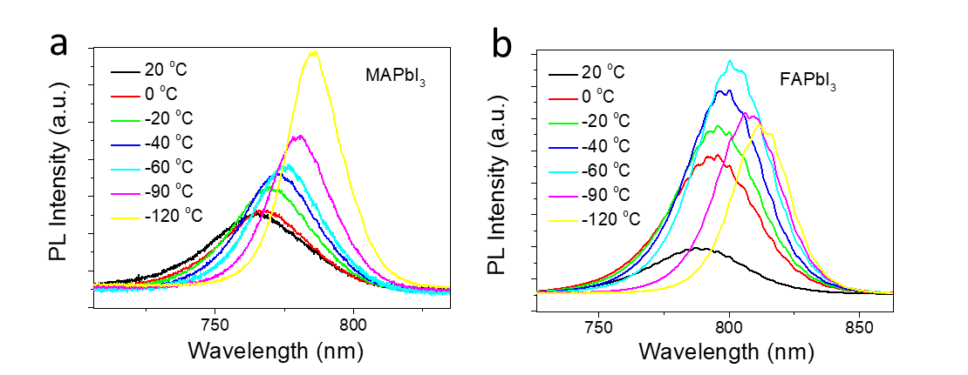
Fig.S6 PL spectra on (a) MAPbI₃ and (b) FAPbI₃ films at different temperatures from 20 ºC to -120 ºC.
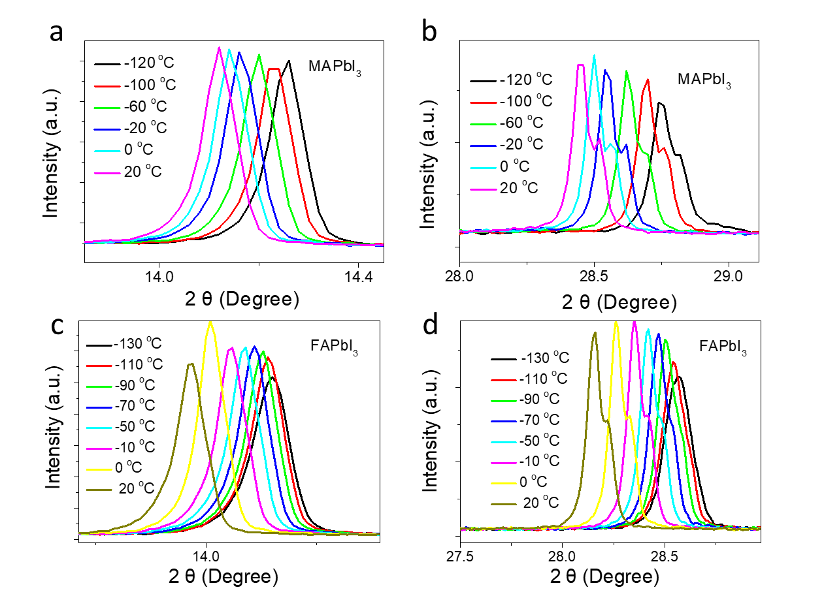
Fig.S7 Temperature dependent of XRD patterns for (a-b) MAPbI₃ and (c-d) FAPbI₃ films, respectively.
The temperature-dependent XRD illustrates that there is no phase change in the measured temperature region.
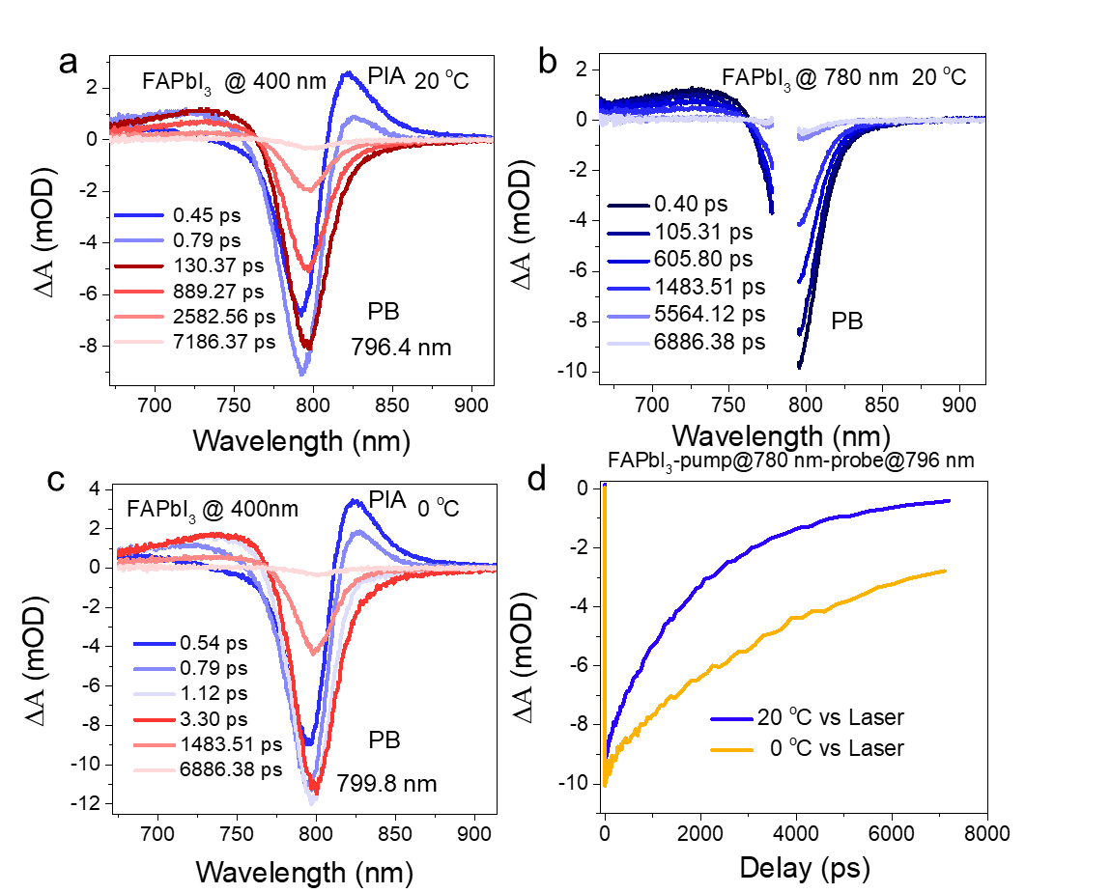
Fig.S8 Representative pump-probe TA spectra of FAPbI₃ films with pump (a) 400 nm under 20 ºC vs laser, (b) 780 nm under 20 ºC vs laser, (c) 400 nm under 0 ºC vs laser, respectively. Decay dynamics by (d) (780 nm) pump-probe at 796 nm.

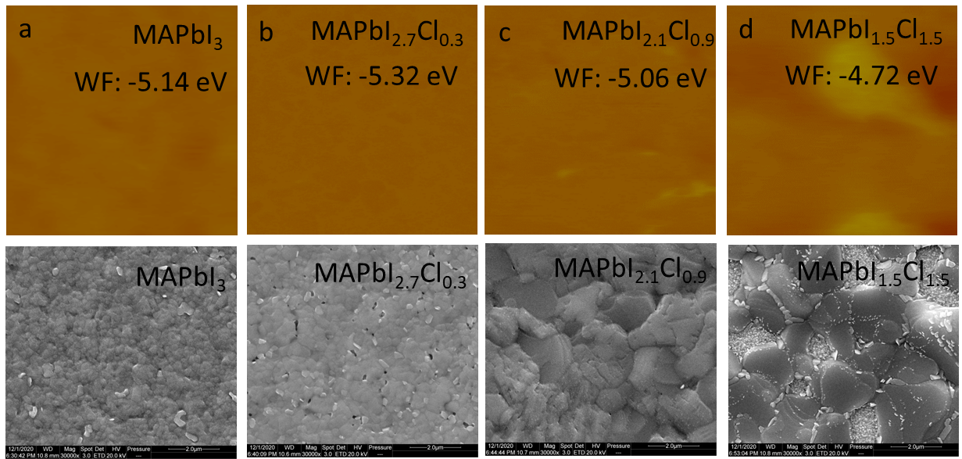
Fig.S9 Surface work functions (SWF) and top view SEM images of (a) MAPbI₃, (b) MAPbI_{2.7}Cl_{0.3} (c) MAPbI_{2.1}Cl_{0.9} and (d) MAPbI_{1.5}Cl_{1.5}, respectively.
The surface work function (SWF) for MAPbI₃ films is 5.14 eV, but it gradually decreases by increasing the concentration of chloride ions, indicating the change from p-type properties to n-type properties with the chloride ions dopant. Normally, the MA⁺ and Pb²⁺ vacancies trap sites are the primary factors to determine the p-type semiconducting characteristic of MAPbI₃, whilst introducing the chloride ions decreases the density of MA⁺ and Pb²⁺ vacancies, leading to a n-type semiconducting properties of MAPbI_{1.5}Cl_{1.5}. As a result, the SWF of MAPbI_{1.5}Cl_{1.5} decreases to 4.72 eV. From the scanning electron microscopy (SEM) images, it clearly shows larger grains but less compact for the MAPbI_{x}Cl_{3-x} films than that of the pure MAPbI₃ films.
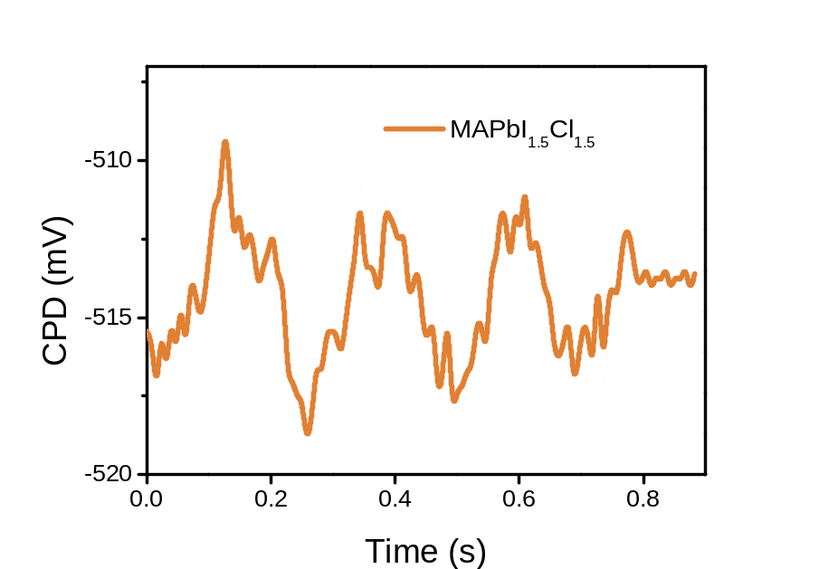
Fig.S10 Transient surface potential signals collected with 5 Hz modulated light for the MAPbI_{1.5}Cl_{1.5} films, respectively.
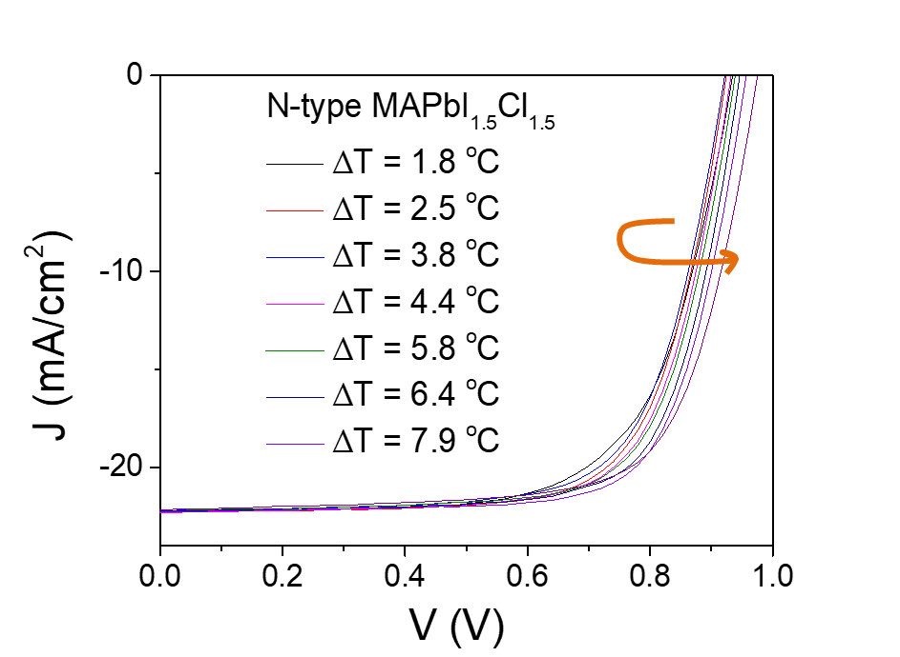
Fig.S11 J-V curves of PSCs based on the MAPbI_{1.5}Cl_{1.5} perovskite films with different ΔT.

Table S1 Summary of the photovoltaic parameters of the MAPbI₃ PSCs with different ΔT under 100 mW cm⁻² AM 1.5 G simulated irradiation.
ΔT (℃) | Scanning Mode | V_{oc} (V) | PCE (%) | FF (%) | J_{sc} (mA/cm²) | HF
1.8 | Reverse | 1.03 | 18.29 | 72.55 | 24.49 | 0.20
1.8 | Forward | 1.01 | 15.22 | 61.26 | 24.55 | 0.20
2.5 | Reverse | 1.05 | 18.79 | 72.92 | 24.65 | 0.16
2.5 | Forward | 1.01 | 15.71 | 62.97 | 24.59 | 0.16
3.8 | Reverse | 1.05 | 18.83 | 73.12 | 24.51 | 0.14
3.8 | Forward | 1.02 | 16.15 | 64.63 | 24.51 | 0.14
4.4 | Reverse | 1.06 | 19.00 | 73.07 | 24.65 | 0.13
4.4 | Forward | 1.01 | 16.57 | 66.48 | 24.58 | 0.13
5.8 | Reverse | 1.06 | 19.25 | 73.70 | 24.57 | 0.12
5.8 | Forward | 1.02 | 17.01 | 67.80 | 24.54 | 0.12
6.4 | Reverse | 1.07 | 19.30 | 73.70 | 24.55 | 0.10
6.4 | Forward | 1.03 | 17.42 | 69.31 | 24.51 | 0.10
7.9 | Reverse | 1.10 | 19.95 | 74.14 | 24.51 | 0.09
7.9 | Forward | 1.06 | 18.05 | 69.57 | 24.49 | 0.09
- The PCE with standard deviations for 10 devices. ^{b)} J–V hysteresis factor (HF) was deﬁned by (PCE_{RS} − PCE_{FS})/PCE_{RS}

Table S2 Summary of the photovoltaic parameters of the FAPbI₃ PSCs with ΔT under 100 mW cm⁻² AM 1.5G simulated irradiation, respectively.
Measurement | Scan | Voc (V) | FF (%) | Jsc (mA/cm²) | PCE (%)
ΔT = 0 ºC | Reverse | 1.17 | 78.48 | 24.77 | 22.81± 0.4
ΔT = 0 ºC | Forward | 1.14 | 67.14 | 24.78 | 19.04± 0.4
ΔT = 15 ºC | Reverse | 1.22 | 79.23 | 25.43 | 24.54± 0.4
ΔT = 15 ºC | Forward | 1.21 | 73.56 | 25.61 | 22.79± 0.4
^{a)} The PCE with standard deviations for 20 devices.

Table S3 Summary of the photovoltaic parameters of the PSCs based on MAPbI_{1.5}Cl_{1.5} with different ΔT under 100 mW cm⁻² AM 1.5 G simulated irradiation with the full spectra.
ΔT (ºC) | Scanning Mode | V_{oc} (V) | PCE (%) | FF (%) | J_{sc} (mA/cm²) | HF
1.8 | Reverse | 0.94 | 14.62 | 70.64 | 21.92 | -0.02
1.8 | Forward | 0.91 | 13.67 | 68.28 | 21.89 | -0.02
2.5 | Reverse | 0.93 | 13.84 | 67.94 | 21.91 | -0.02
2.5 | Forward | 0.91 | 13.90 | 69.86 | 21.87 | -0.02
3.8 | Reverse | 0.94 | 14.25 | 68.99 | 21.88 | -0.01
3.8 | Forward | 0.92 | 14.29 | 70.86 | 21.88 | -0.01
4.4 | Reverse | 0.95 | 14.58 | 69.62 | 21.95 | -0.01
4.4 | Forward | 0.93 | 14.58 | 71.37 | 21.90 | -0.01
5.8 | Reverse | 0.96 | 14.78 | 70.00 | 21.92 | -0.01
5.8 | Forward | 0.94 | 14.78 | 71.56 | 21.87 | -0.01
6.4 | Reverse | 0.97 | 14.81 | 69.94 | 21.86 | -0.01
6.4 | Forward | 0.95 | 14.89 | 71.55 | 21.89 | -0.01
7.9 | Reverse | 0.98 | 14.86 | 69.53 | 21.91 | -0.01
7.9 | Forward | 0.96 | 15.04 | 71.54 | 21.88 | -0.01
- The PCE with standard deviations for 10 devices. ^{b)} J–V hysteresis factor (HF) was deﬁned by (PCE_{RS} − PCE_{FS})/PCE_{RS}

