Supporting Information
KOH modification of fluorinated graphite and its reaction mechanism
Hao Li*, Xiaojing Yuan, Genliang Hou, Song Bi*, Yongzhi Song and Xuping Wang
Xi'an Research Institute of High-Tech, Xi'an, 710025, P. R. China.
Corresponding author: E-mail: xiaozhu-youyou@163.com, Tel: 86-29-8474-3375
Corresponding author: E-mail: 376467729lihao@163.com, Tel: 86-29-8474-1370

1、Element distribution of OFG65
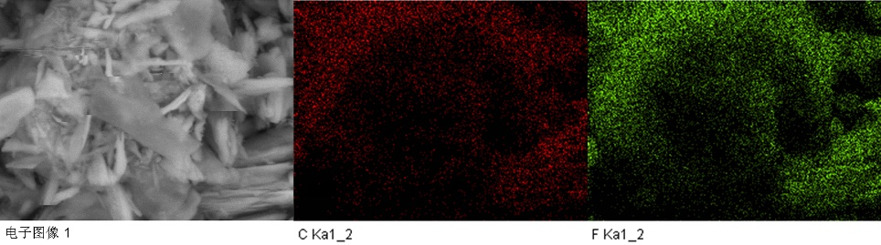
（a）OFG65-1
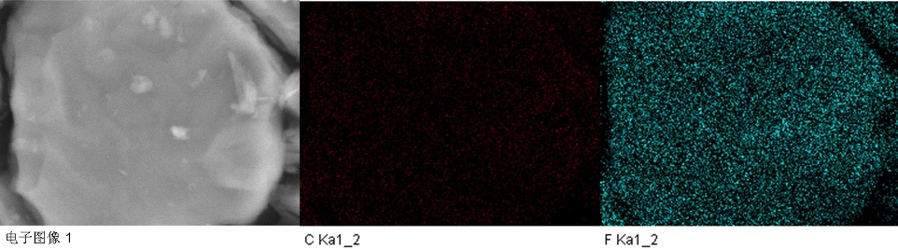
（b）OFG65-2
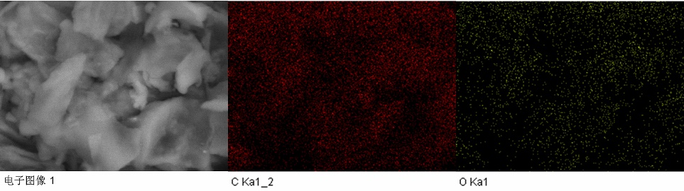
（c）OFG65-3
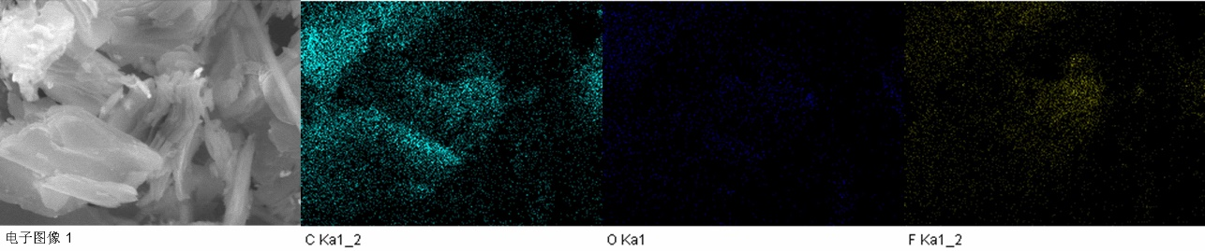
（d）OFG65-4
Fig. S1 C, O and F elemental mapping of OFG65 after KOH electrochemical method

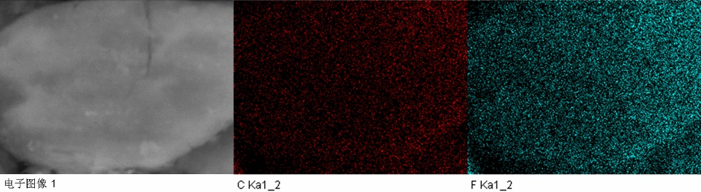
（a）OFG65-5
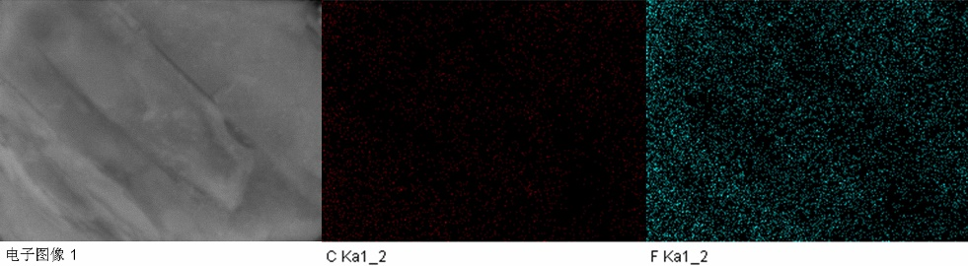
（b）OFG65-6
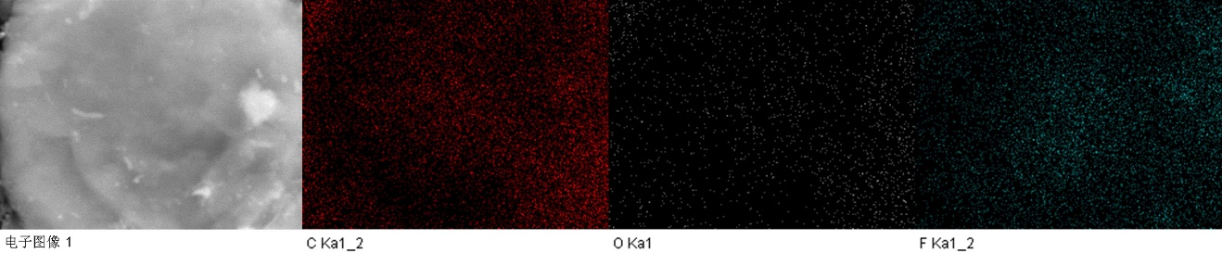
（c）OFG65-7
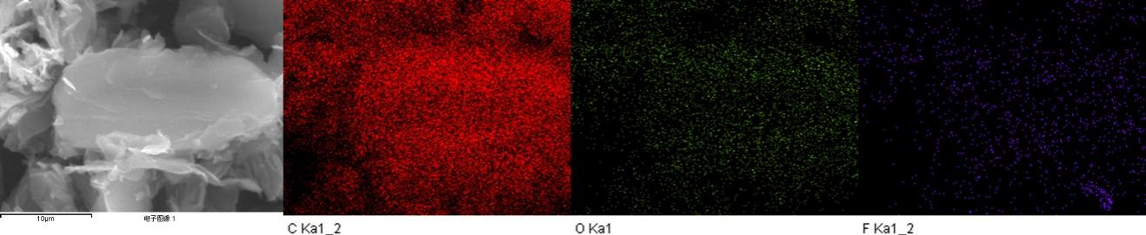
（d）OFG65-8
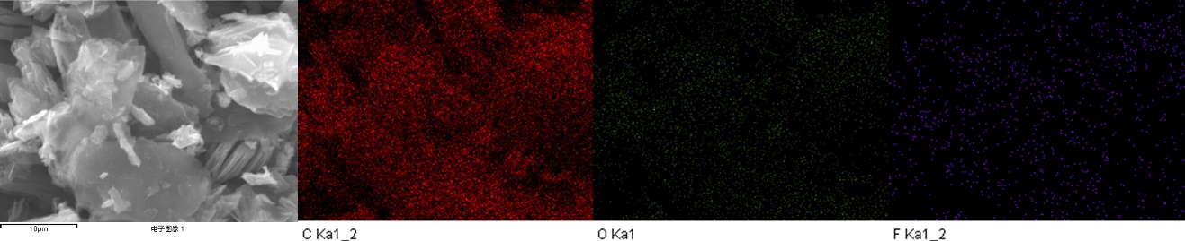
（e）OFG65-9
Fig. S2 C, O and F elemental mapping of OFG65 after KOH heating method

2、Morphology and Chemical Composition of OFG60 and OFG42
As previously described, the method of KOH modification was used to explore the influence on the FGi 60 wt% and FGi 42 wt%. When the anode was at the top, OFG60-1 was obtained after electrolysis until no current. OFG60-2 was synthesized by 100℃ heating.
Fig. S3 is FT-IR and XPS diagram of OFG60 modified by KOH. Following the reaction, the -CF₂ bond (1345 cm⁻¹) disappears, and the C-F bond (1190 cm⁻¹) almost disappears, indicating that most of them are destroyed. The presence of -OH vibration peak (3438 cm⁻¹) and C-O vibration peak (1041 cm⁻¹) shows the effectiveness of KOH modification. 1636 cm⁻¹ may be from the C-OH deformation vibration absorption peak or from the sp² C=C bond. The peaks of OFG60-1 and OFG60-2 at 1386 cm⁻¹ may belong to the O-H stretching vibration peak of residual KOH. Different from OFG60-2, the peak of OFG60-1 near 1564 cm⁻¹ may be the vibration peak of carbonate, which comes from the reaction of CO₂ and KOH. FT-IR results show that KOH can effectively modify FGi 60 wt%. The XPS spectrum of OFG60 is shown in Fig. S3b, mainly including C, O and F. Table S1 shows the content of C, O and F. Compared to FGi 60 wt%, the O content of OFG60-1 and OFG60-2 significantly increases, which is more than 10 at%, while the fluorine content reduced to about 14 at%, and their O and F content are relatively close. Figure S4 indicates the element distribution of OFG60-1 and OFG60-2. It can be seen that O and F elements are evenly distributed near C.
(a) FT-IR spectrum (b) XPS spectrum
Fig. S3 (a) FT-IR and (b) XPS spectra of OFG60-1 and OFG60-2
Table S1 Element content of OFG60-1 and OFG60-2
Products | C（at%） | O（at%） | F（at%） | others（at%）
FGi 60 wt% | 48.7 | 0.6 | 50.7
OFG60-1 | 68.9 | 13.7 | 13.3 | Na 0.4%; K 3.3%; Si 0.4%
OFG60-2 | 70.4 | 11.8 | 14.1 | Na 0.4%; K 3.1%; Si 0.2%;
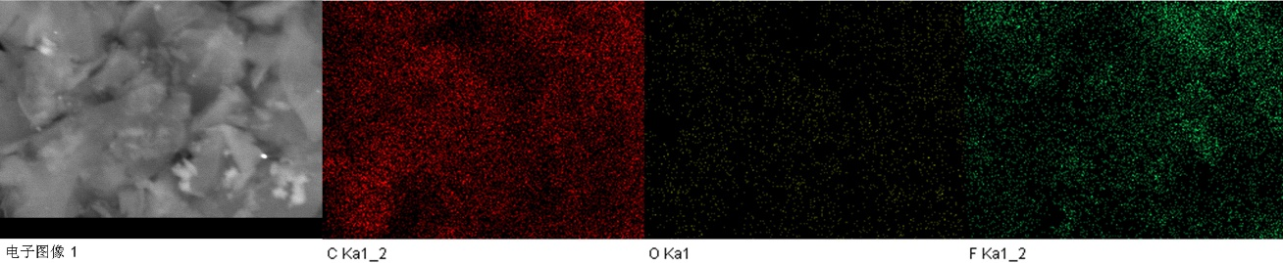
（a）OFG60-1
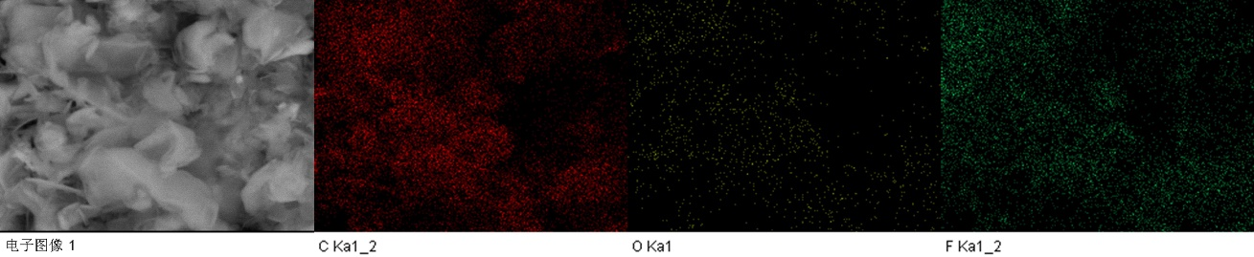
（b）OFG60-2
Fig. S4 C, O and F elemental mapping of OFG60-1 and OFG60-2

（a）FGi 60wt% | 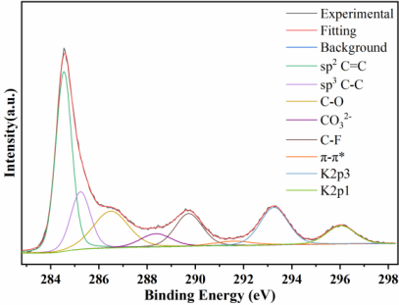  （b）OFG60-1 | 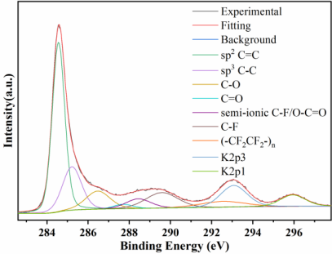  （c）OFG60-2
Fig. S5 High-resolution C1s spectra of OFG60-1 and OFG60-2
Table S2 Location, ascription and content of carbon-containing groups of OFG60-1 and OFG60-2
Products | sp² C=C 284.6eV | sp³ C-C 285.3eV | C-O 286.5eV | C=O 287.8eV | semi-ionic C-F 288.5eV | C-F 289.5eV | -CF₂ 291.6eV | PTFE  292.5eV
FGi 60 wt% | 4.1% | 1.7% | 3.9% | 7.0% |  | 79.2% | 4.1%
OFG60-1 | 42.4% | 16.7% | 19.1% |  | 6.1% | 13.1% | 2.6%
OFG60-2 | 47.1% | 18.4% | 9.9% | 2.0% | 5.5% | 11.2% |  | 5.9%
The C1s peak of OFG60 is shown in Fig. S5. According to the F1s and FT-IR results, the 288.5 eV peak of OFG60-1 belongs to a carbonate ion, which originates from K₂CO₃ formed by KOH reacting with CO₂ produced by electrolysis; the 291.7 eV peak of OFG60-1 is a π-π * bond; the 288.5 eV peak of OFG60-2 is partly attributed to semi-ionic C-F bond, partly to carboxyl group, and the peak at 292.5 eV comes from PTFE beaker. Table S2 shows the composition of different carbon bonds in C1s. The carbon-oxygen bond content of OFG60-1 and OFG60-2 has indeed increased, and most of them are C-O bonds, with less C=O bond content. Similar to OFG65, the increase of carbon-oxygen bond content is not consistent with the decrease of carbon-fluorine bond, indicating some carbon-fluorine bonds become carbon-carbon bonds. The carbon-oxygen bond content of the electrochemical method is 19.1%, almost twice that of the heating method, and the carbon-fluorine bond content is basically the same between the two methods. This shows that KOH is more likely to react with FGi 60 wt% in the electrochemical environment. See the reaction mechanism later for specific reasons.
（a）FGi 60wt% | 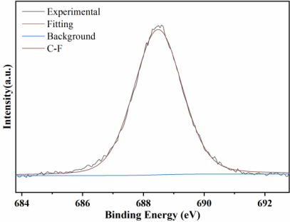  （b）OFG60-1 | 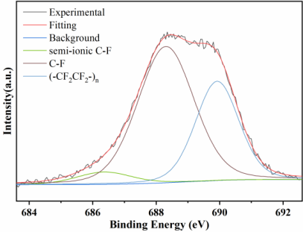  （c）OFG60-2

Fig. S6 High-resolution F1s spectra of OFG60-1 and OFG60-2
The F1s peak of OFG60 is depicted in Figure S6. OFG60-1 has only a C-F covalent bond at 688.5 eV, while OFG60-2 has 686.4 eV, 688.3 eV and 689.9 eV peaks corresponding respectively to semi-ionic C-F bonds, C-F covalent bonds and (-CF₂CF₂-)_{n}, which originates from the PTFE beaker debris during stirring.
Fig. S7 XRD spectrum of OFG60-1 and OFG60-2
Fig. S7 shows the XRD diagram of OFG60. The (001) diffraction peak of FGi 60 wt% at ~13.5 ° belongs to a highly fluorinated hexagonal system with a layer spacing of 6.52 Å, which is less than that of FGi 65 wt%. The (001) diffraction peaks of OFG60 almost disappeares, indicating that the fluorocarbon bond structure has been destroyed. The (002) diffraction peak of FGi 60 wt% at ~ 26.6 ° corresponds to the graphite phase. After modification, the (002) diffraction peak of OFG60-1 changes little, while the (002) diffraction peak of OFG60-2 becomes a broad and strong peak, indicating that KOH heating method has more graphene structure, but it is difficult to stacke together regularly, forming a wide (002) diffraction peak.
Fig. S8 shows the micromorphology of OFG60. OFG60-1 and OFG60-2 have a thinner and smaller sheet structure, indicating that the introduction of -OH in the process of oxygen doping increases the layer spacing and makes it easier to peel.
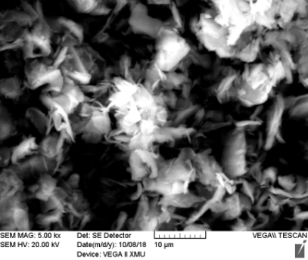  （a）FGi 60 wt% | 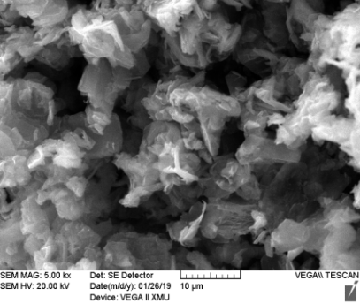  （b）OFG60-1 | 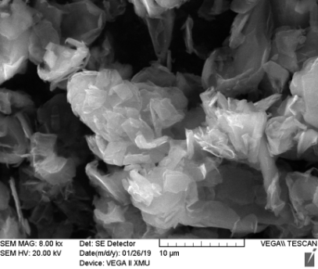  （c）OFG60-2
Fig. S8 SEM images of OFG60-1 and OFG60-2
KOH can also modify FGi 60 wt%, increasing the amount of -OH grafted onto the carbon skeleton while leaving only a small amount of carbonyl and carboxyl. The reason lies in the nucleophilic reaction between KOH and FGi 60 wt% and -OH replaces the F atom. As far as the modification conditions are concerned, the C-O bond content of OFG60-1 is 19.1%, which is twice that of the heating method, because the electrochemical method can promote the nucleophilic reaction more effectively.
In order to further study the effect of KOH on the oxygen doping of FGi 42 wt%, KOH was used to modify FGi 42 wt%. OFG42-1 and OFG42-2 are obtained by KOH electrochemical method of 60V electrolysis to no current (the top anode) and 100 ℃ heating method, respectively. Fig. S9 displays the FT-IR diagram of OFG42 under different reaction conditions. After the reaction, the C-F covalent bond of OFG42-1 and OFG42-2 almost disappears. In addition, the vibration peaks of - OH (3438 cm⁻¹) and C-O (1028 cm⁻¹) appears, indicating the effectiveness of KOH modification. The peaks of OFG42-1 and OFG42-2 at 1386 cm⁻¹ may belong to the O-H stretching vibration peak of residual KOH. FT-IR results shows that the oxygen-containing group appears after KOH modification, which indicated its effectiveness.
(a) FT-IR spectrum (b) XPS spectrum
Fig. S9 (a) FT-IR and (b) XPS spectra of OFG42-1 and OFG42-2
The XPS spectrum of OFG42 is shown in Fig. S9b. After KOH modification, the peak of O1s is obviously enhanced, while F1s is obviously weakened. Table S3 lists the content of C, O and F. The O content of OFG42-1 and OFG42-2 increases to 7.0 at% and 13.6 at%, respectively, while their fluorine content decreases to about 5 at%, indicating that the increase of oxygen content is not the same as the decrease of fluorine content. Fig. S10 shows the element distribution of OFG42-1 and OFG42-2. Although the content of O and F elements is low, they are evenly distributed on the carbon skeleton.
Table S3 Element content of OFG42-1 and OFG42-2
Products | C（at%） | O（at%） | F（at%） | others（at%）
FGi 42 wt% | 67.4 | 0.9 | 31.7
OFG42-1 | 86.1 | 7.0 | 5.3 | K 0.8
OFG42-2 | 78.3 | 13.6 | 3.3 | K 3.9
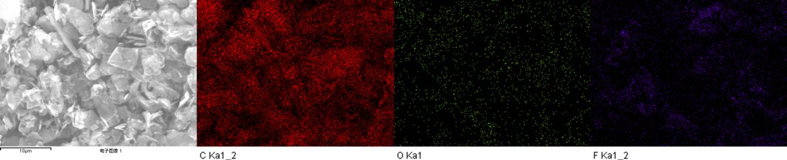
（a）OFG42-1
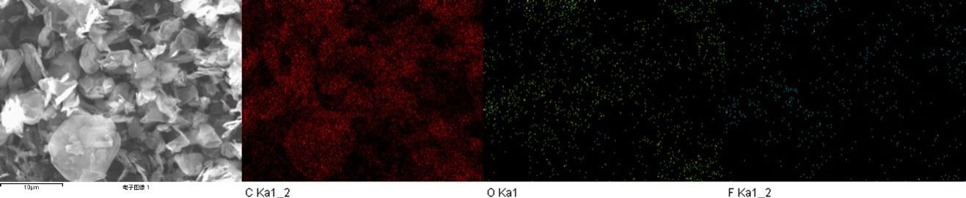
（b）OFG42-2
Fig. S10 C, O and F elemental mapping of OFG42-1 and OFG42-2
Fig. S11 depicts the C1s peak of OFG42. According to the F1s and FT-IR results, the peak at 291.7 eV of OFG42-1 is a π-π * bond, while the peak of OFG42-2 is a -CF₂ covalent bond. The composition of carbon bonds in all parts of C1s is shown in Table S4. After the modification, the content of carbon-oxygen bond increases, and there is only C-O bonds. The carbon-oxygen bond content of OFG42-1 is similar to that of OFG42-2, while the semi-ionic C-F bond of OFG42-2 is higher than that of OFG42-1, indicating that the semi-ionic C-F bond is easy to form under the heating conditions.
（a）FGi 42 wt% | 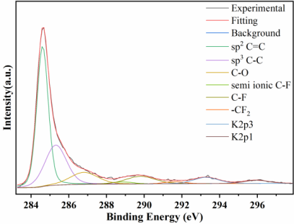  （b）OFG42-1 | 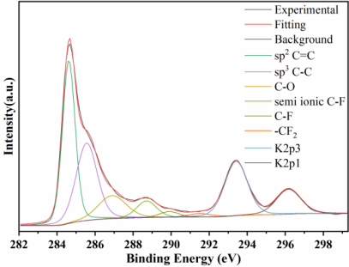  （c）OFG42-2
Fig. S11 High-resolution C1s spectra of OFG42-1 and OFG42-2
Table S4 Location, ascription and content of carbon-containing groups of OFG42-1 and OFG42-2
Products | sp² C=C ~284.6eV | sp³ C-C ~285.3eV | C-O ~286.5eV | semi-ionic C-F ~288.5eV | C-F ~289.5eV | π-π*/-CF₂ ~291.6eV
FGi 42 wt% | 38.7% | 13.2% | 4.3% | 3.5% | 36.2% | 4.1%
OFG42-1 | 51.4% | 27.7% | 10.8% | 1.5% | 7.2% | 1.4%
OFG42-2 | 42.4% | 33.5% | 13.2% | 6.9% | 2.3% | 1.7%
（a）FGi 42 wt% | 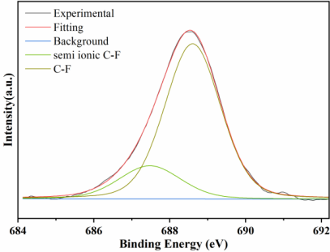  （b）OFG42-1 | 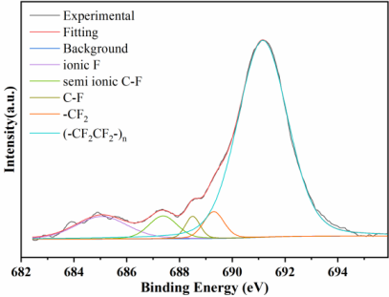  （c）OFG42-2
Fig. S12 High-resolution F1s spectra of OFG42-1 and OFG42-2
Fig. S12 shows the F1s peak of OFG42. OFG42-1 has two peaks of 687.5 eV and 688.6 eV, corresponding to the semi-ionic C-F bond and the C-F covalent bond, while OFG42-2 has five peaks, namely 685.1 eV, 687.4 eV, 688.5 eV, 689.3 eV and 691.2 eV, which corresponds to the F-ion bond (generated KF), semi-ionic C-F bond, C-F covalent bond, -CF₂ covalent bond and PTFE (the debris dropped from the PTFE beaker during the stirring process).
Fig. S13 is the XRD diagram of OFG42. OFG42-1 and OFG42-2 basically retain the graphite phase corresponding to (002) diffraction peak, while (001) diffraction peak corresponding to the carbon-fluorine structure and (100) diffraction peak corresponding to the length of the C-C plane in the mesh system disappear completely, indicating that the layered structure associated with carbon-fluorine bond disappears. Different from OFG42-1 obtained by KOH electrochemical method, OFG42-2 has a diffraction peak at ~ 17.9 °, which may correspond to graphene derivatives grafted with a small amount of O. The above analysis shows that FGi 42 wt% modified by KOH can only destroy the carbon-fluorine bond and not oxidize the unsaturated carbon-carbon bond.
Fig. S13 XRD spectrum of OFG42-1 and OFG42-2
Fig. S14 is the micrograph of OFG42-1 and OFG42-2 after KOH modification. Compared with FGi 42 wt%, the flake structure of OFG42-1 and OFG42-2 is thinner and smaller. The multilayer flakes are superposed together, indicating that the introduction of -OH during the process of oxygen doping modification expands the layer spacing, making FGi easier to peel off.
（a）FGi 42 wt% | 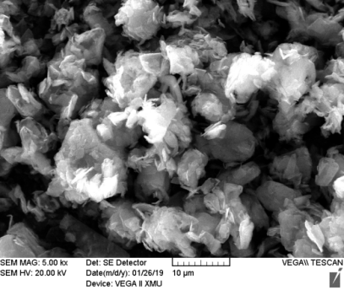  （b）OFG42-1 | 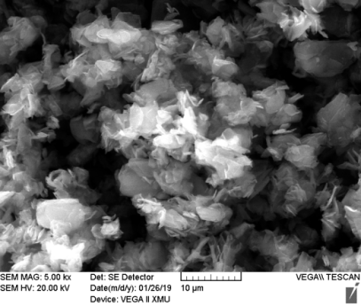  （c）OFG42-2
Fig. S14 SEM images of OFG42-1 and OFG42-2
The effect of FGi 42 wt% modification by KOH is relatively poor, only generating a small amount of C-OH and no carbonyl and carboxyl, resulting in a low oxygen content of OFG. The reason lies in the nucleophilic reaction between KOH and FGi 42 wt%, but the reduction of F content reduces the reaction probability, so the carbon-oxygen bond content is lower than OFG65 and OFG60 modified by the same method. In terms of modification conditions, KOH heating method can better promote the formation of semi-ionic C-F bond.

3、Chemical composition of residual products of OFG60 and OFG42
(a) FT-IR spectrum | (b) XPS spectrum
Fig. S15 (a) FT-IR and (b) XPS spectra of RP60-1 and RP60-2
RP60-1 and RP60-2 are the residual products of OFG60 by KOH electrochemical method and heating method, respectively. Fig. S15a shows the FT-IR spectrum of RP60-1 and RP60-2, which are basically the same. Similar to RP65, there exist the characteristic peaks of KOH (3200 cm⁻¹, 1377 cm⁻¹ and 1448 cm⁻¹). The XPS spectrum of RP60-1 and RP60-2 are shown in Fig. S15b, mainly including C, O, K and F. The C1s analysis of RP60-1 and RP60-2 is shown in Fig. S16. There are only carbon-carbon bonds and carbon-oxygen bonds, and no carbon-fluorine bonds, indicating that there are also small GO fragments in both of them. Fig. S17 shows the peak of F1s. The peaks at ~ 682.7 eV and ~ 684.4 eV of RP60-1 and RP60-2 correspond to the hydrated fluorine ion and fluorine ion, respectively, which is similar to the results of the previous modification, indicating that fluorine ion bond is also formed in the reaction process.
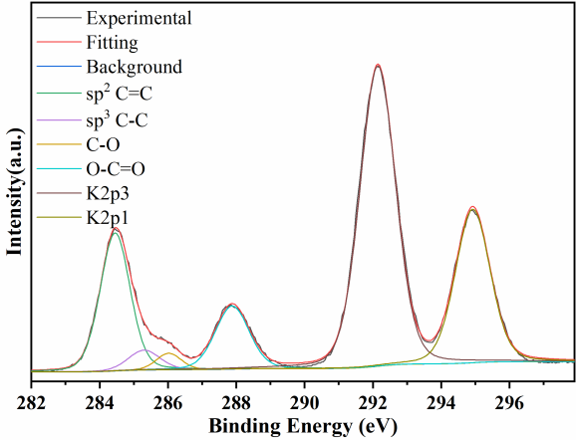  （a）RP60-1 | 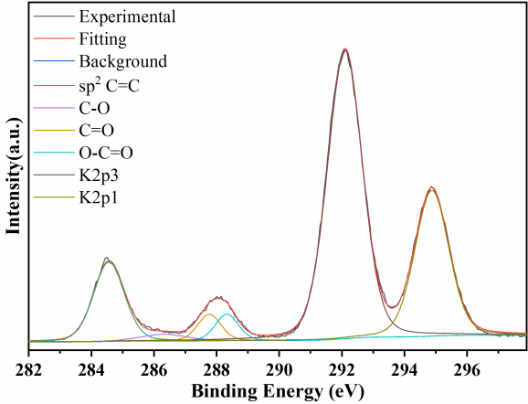  （b）RP60-2
Fig. S16 High-resolution C1s spectra of RP60-1 and RP60-2
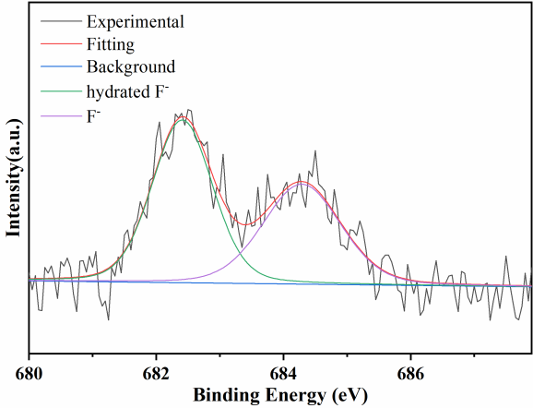  （a）RP60-1 | 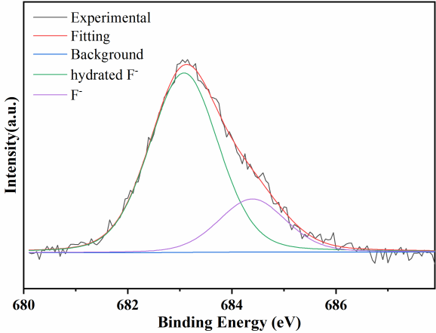  （b）RP60-2
Fig. S17 High-resolution F1s spectra of RP60-1 and RP60-2
Table S5 shows that the carbon bond content after modification by the two methods is not very different. Table S6 shows the F element content of different products obtained by the KOH modification of FGi 60 wt%. It is found that there are also a large number of F ions generated. FGi 65 wt% and FGi 60 wt% all contain a large number of carbon-fluorine bonds, whose difference lies in the content of carbon-oxygen bonds, so the reaction mechanism is basically the same as FGi 65 wt%. As for OFG60-1 and OFG60-2, there are still a large number of fluorocarbon bonds that are not reacted, because FGi 60 wt% is not fully fluorinated, and there are a large number of isolated fluorocarbon bonds connected with saturated carbon, so the reaction activity is relatively low, resulting in the inadequate reaction.
Table S5 Different carbon bond ratios in C1s of OFG60
Products | C C bond | C O bond | C F bond
FGi 60 wt% | 5.8% | 10.9% | 83.3%
OFG60-1 | 59.1% | 19.1% | 21.8%
OFG60-2 | 69.6% | 12.6% | 17.7%
Table S6 F content of all products of FGi 60 wt% before and after the modification
Raw material | OFG | F content | RP | F ion content
300 mg | OFG60-1 | 121.5 mg | RP60-1 | 149.9 mg
300 mg | OFG60-2 | 72.1 mg | RP60-2 | 201.2 mg
RP42-1 and RP42-2 are the residual products of OFG42. Fig. S18, S19 and S20 show the FT-IR, XPS, high resolution C1s and F1s spectra of RP42-1 and RP42-2, respectively. RP42-1 and RP42-2 mainly contain KOH and small GO fragments, and fluorine exists in the form of F ion, including hydrated fluorine ion and fluorine ion. This is similar to the results of KOH modification of FGi 65 wt% and FGi 60 wt%, indicating that fluorine ion bond is also formed during the reaction.
The F content of RP42-2 obtained by KOH heating method is 3.0 at%, while that of RP42-1 obtained by electrochemical method is 1.9 at%.
(a) FT-IR spectrum | (b) XPS spectrum
Fig. S18 (a) FT-IR and (b) XPS spectra of RP42-1 and RP42-2
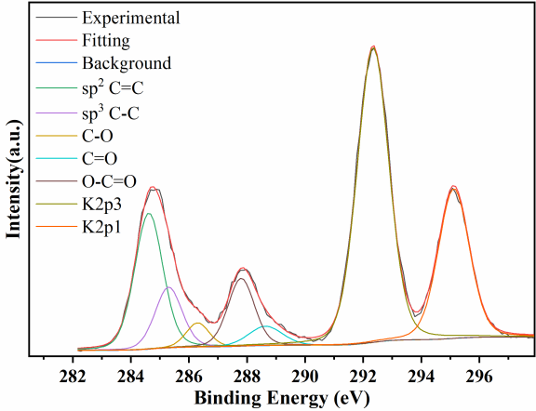  （a）RP42-1 | 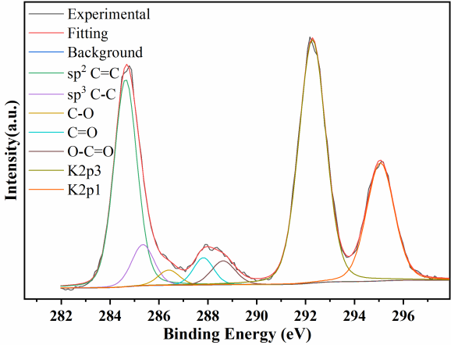  （b）RP42-2
Fig. S19 High-resolution C1s spectra of RP42-1 and RP42-2
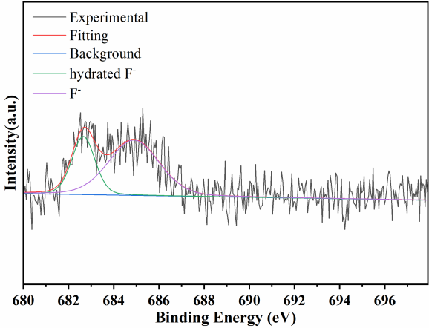  （a）RP42-1 | 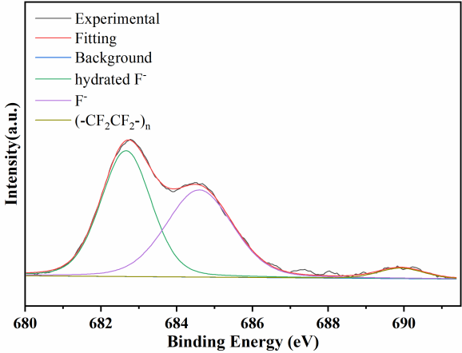  （b）RP42-2
Fig. S20 High-resolution F1s spectra of RP42-1 and RP42-2
Similarly, OFG42-1 and OFG42-2 are the modification products of FGi 42 wt%. Table S7 shows that the carbon bond content after modification by the two methods is close. There are a large number of carbon-carbon bonds, while a small number of carbon-fluorine bonds remain, indicating that only a part of carbon-fluorine bonds undergo nucleophilic reaction and become carbon-oxygen bonds, and some carbon-fluorine bonds become carbon-carbon bonds. In addition, there are residual fluorocarbon bonds that can’t react with KOH. Table S8 shows the content of F elements in different products after reaction, and the remaining products RP42 still contains F ions. The sum of F ion content in RP42 and F content in OFG42 is basically equal to the content of F elements in raw material FGi 42 wt%.
Table S7 Different carbon bond ratios in C1s of OFG42
Products | C C bond | C O bond | C F bond
FGi 42 wt% | 51.9% | 4.3% | 43.8%
OFG42-1 | 79.8% | 10.8% | 10.1%
OFG42-2 | 75.9% | 13.2% | 10.9%
Table S8 F content of all products of FGi 42 wt% before and after the modification
Raw material | OFG | F content | RP | F ion content
210 mg | OFG42-1 | 57.1 mg | RP42-1 | 142.6 mg
210 mg | OFG42-2 | 33.1 mg | RP42-2 | 167.9 mg

