DNA methylation may affect beef tenderness through signal transduction in Bos indicus
Marcela Maria de Souza^{1,2}, Simone Cristina Méo Niciura¹, Marina Ibelli Pereira Rocha^{1,3}, Zhangyuan Pan⁴, Huaijun Zhou⁴, Jennifer Jessica Bruscadin^{1,3}, Wellison Jarles da Silva Diniz^{1,5}, Juliana Afonso¹, Priscila Silva Neubern de Oliveira³, Gerson B. Mourão⁶, Adhemar Zerlotini⁷, Luiz Lehmann Coutinho⁶, James E. Koltes², Luciana Correia de Almeida Regitano^{1*}

¹Embrapa Pecuária Sudeste, Empresa Brasileira de Pesquisa Agropecuária, São Carlos, Brazil
²Department of Animal Science, Iowa State University, Ames, United States
³Department of Genetics and Evolution, Federal University of São Carlos, São Carlos, Brazil
⁴Department of animal Science, University of California, Davis, California, United States
⁵Department of Animal Science, Auburn University; Auburn, Alabama, United States
⁶Department of Animal Science, Luiz de Queiroz College of Agriculture, University of São Paulo, Piracicaba, Brazil
⁷Embrapa Informática Agropecuária, Empresa Brasileira de Pesquisa Agropecuária, Campinas, Brazil

Correspondence: luciana.regitano@embrapa.br

Additional file 1: Supplementary Figures

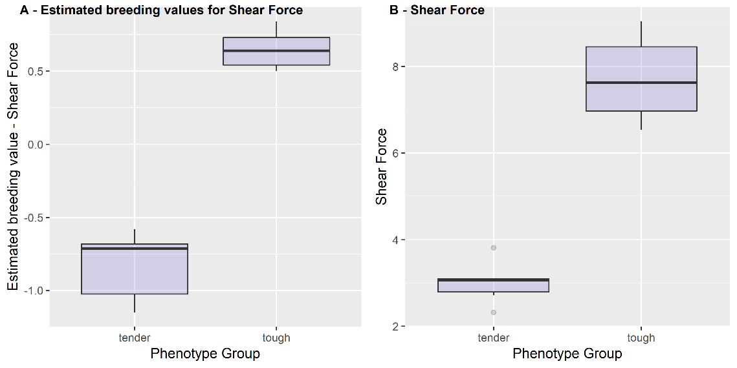
Figure S1. Box plot showing the distribution of shear force: (A) estimated breeding values for Shear Force and (B) Shear Force values.
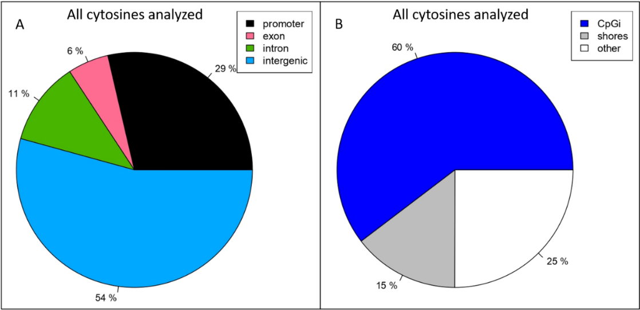
Figure S2. Locations of all CpGs used for differential methylation analysis (n=635469). A. Percent of CpGs in promoters, gene body (exons and introns) and intergenic regions. B. Percent of CpGs overlapping CpG islands (CpGi) and shore CpGs.

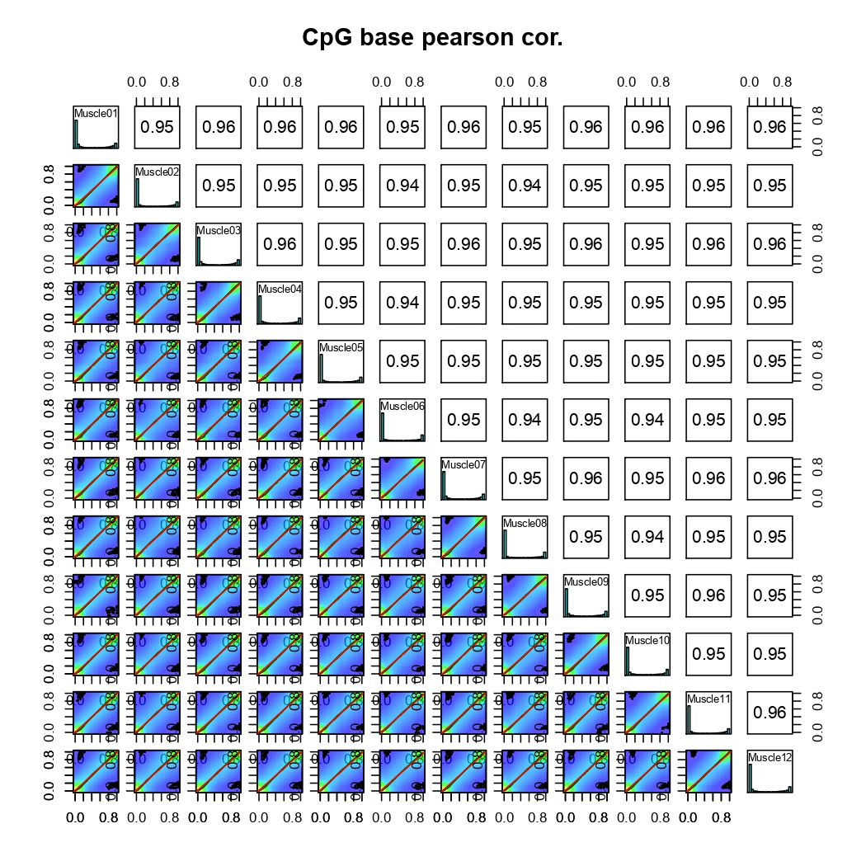
Figure S3. Sample correlation. Sample Correlation. Scatter plot and correlation coefficients among all samples.

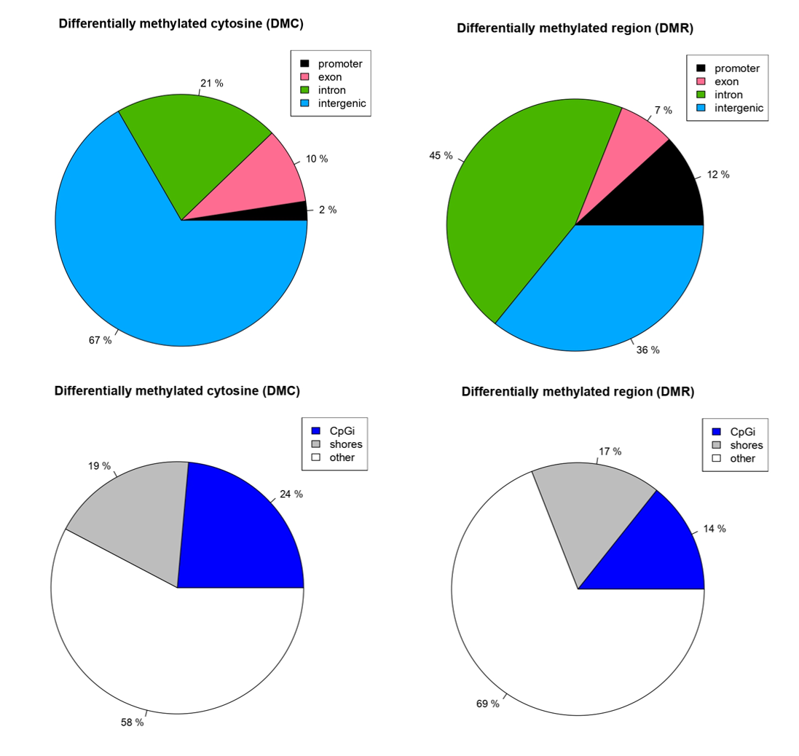
Figure S4. Proportion of differentially methylated cytosines (DMCs) (A) and differentially methylated regions (DMRs) (B) overlapping promoter, exon, intron or intergenic regions. C and D shows the proportion of DMCs and DMRs, respectively, overlapping CpG islands (CpGi), shore regions or other.
Figure S5. Venn Diagram showing the distribution of differentially methylated cytosines (DMCs) (A) and differentially methylated regions (DMRs) (B) overlapping promoters, exons, introns and CpG islands. This figure shows that some DMC and DMR were located in more than one functional location.

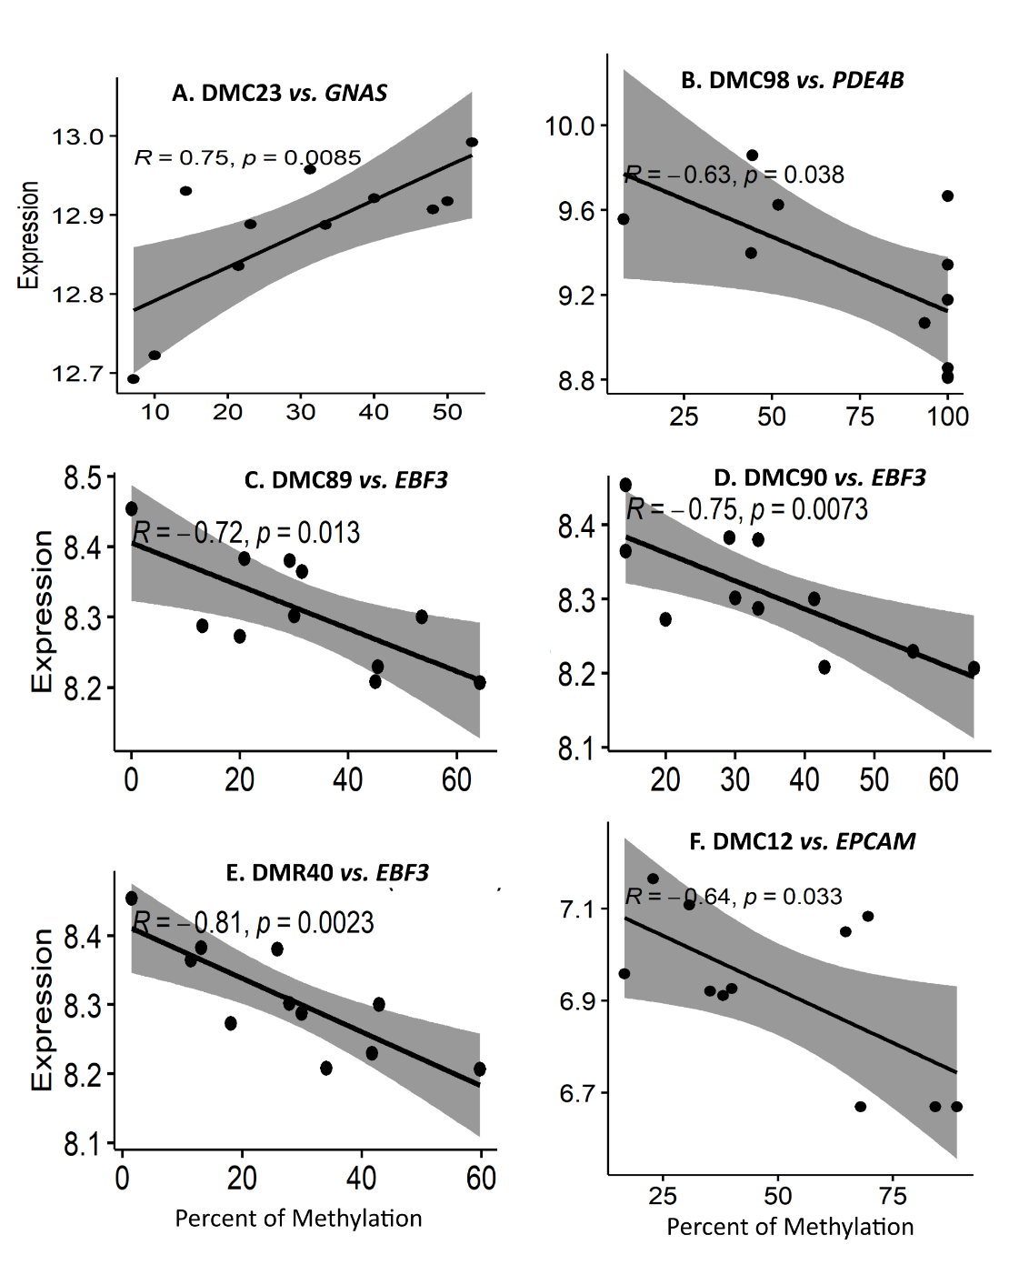
Figure S6. Significant Pearson coefficient correlation between the methylation percentage of DMCs and DMRs with the expression of its target genes (p < 0.05), using 11 RNA-Seq Nelore muscle samples. Percent of methylation of DMC89 (A), DMC90 (B) and DMR40 (C) were negatively correlated with expression of EBF3 gene. (D) Percent of methylation of DMC23 was positively correlated the expression of gene GNAS. (E) Percent of methylation of DMC12 was negatively correlated the expression of gene EPCAM. (F) Percent of methylation of DMC98 was negatively correlated the expression of gene PDE4B.

Figure S7. Box plot showing the expression (normalized counts) distribution of (A) GNAS gene and (B) PDE4B between the two extremes phenotypes of shear force (tender = lowest shear force, tough = highest shear force breeding values).

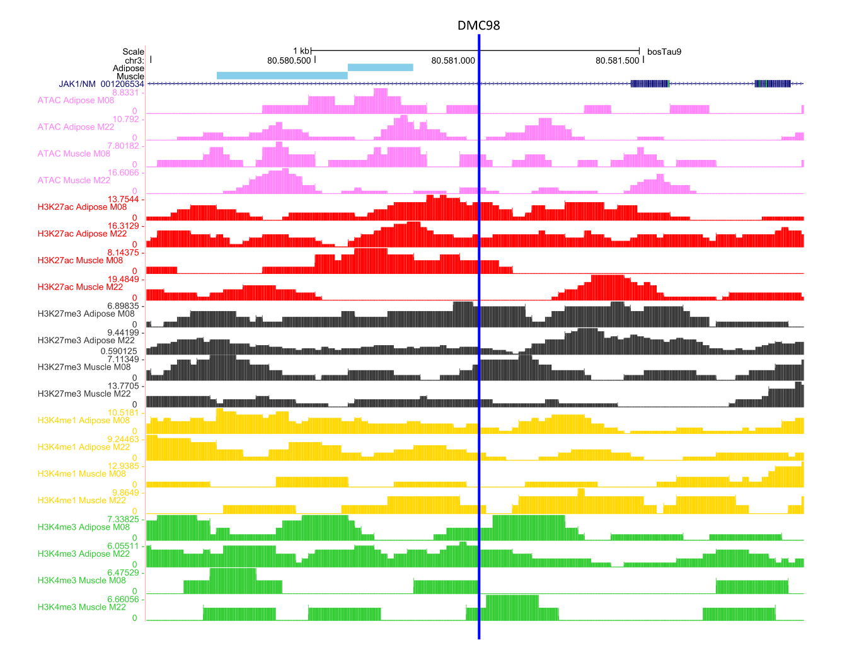
Figure S8. Regulatory element features of the region overlapped by the differentially methylated cytosines DMC98, which was correlated with PDE4B expression. DMC98 is located (represented by the vertical blue line) in an intron of JAK1 gene. Low enrichment of histone marks and ATAC peaks suggested that this region was classified as quiescente (#15) in muscle (M) and in adipose in two male Bos taurus (Kern et al., 2021). Pink tracks represent the ATAC peaks. The peaks of histone marks H3K27ac, H3K27me, H3K4me1 and H3K4me3 are represented by the red, black, yellow, and green tracks, respectively. The image was obtained from UCSC Genome Browser and edited by the present authors.
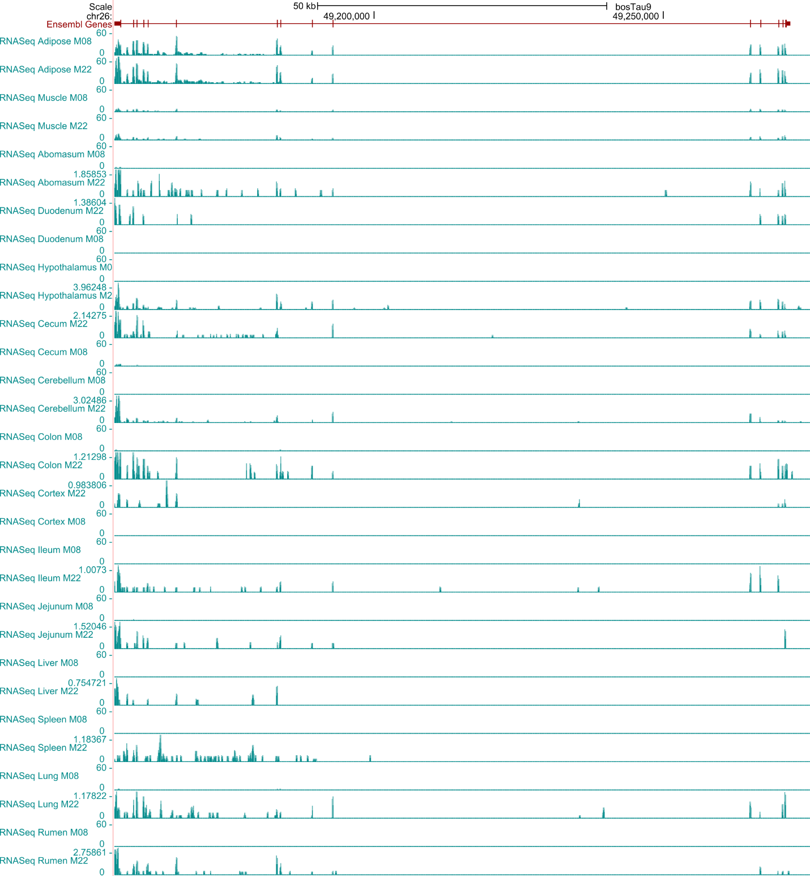
Figure S9. EBF3 Expression using RNA-Seq data of 15 tissues obtained from two male Bos taurus. Data available in Kern et al., 2021.

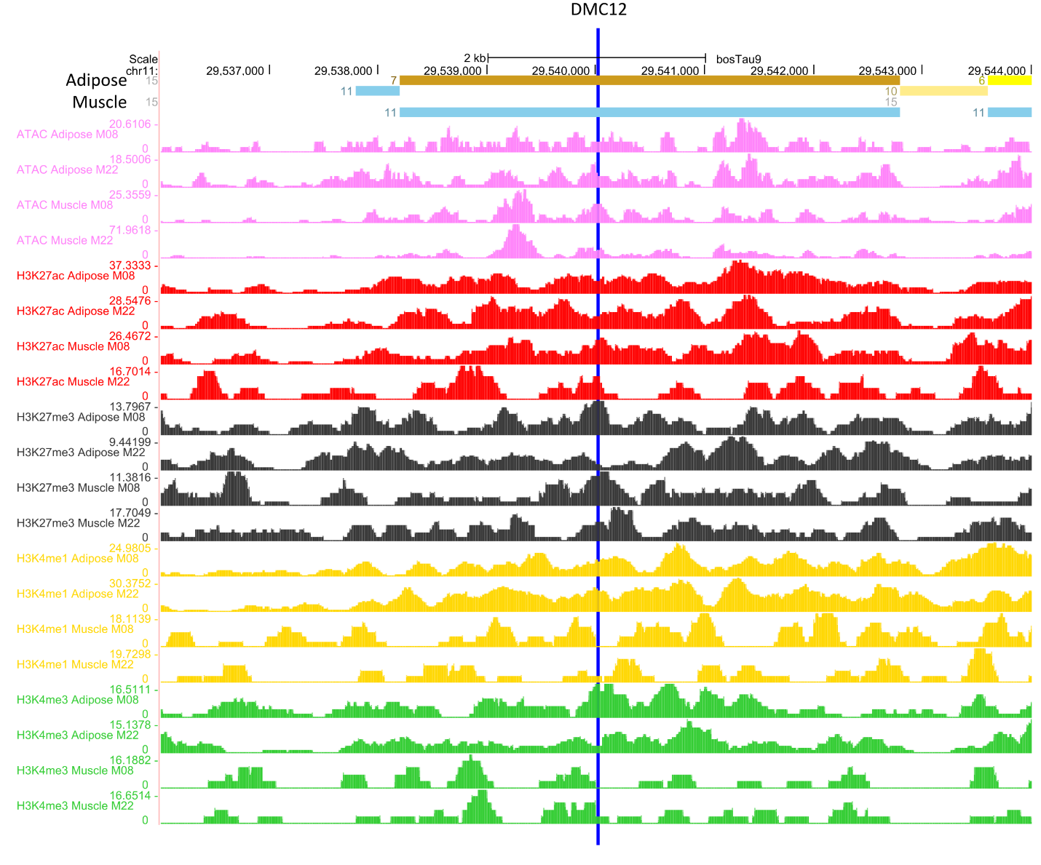
Figure S10. Regulatory element features of the region overlapped by the differentially methylated cytosines DMC12, which was correlated with EPCAM expression. DMC12 (represented by the vertical blue line) in an intergenic region and more than 200,000 bp far away from its target EPCAM. Histone marks and ATAC peaks enrichment suggested that this region was classified as ATAC island (represented by the light blue solid horizontal bar #11) in muscle (M) and medium enhancer with ATAC in adipose (A; dark yellow solid horizontal bar #7) in two male Bos taurus (Kern et al., 2021). Pink tracks represent the ATAC peaks. The peaks of histone marks H3K27ac, H3K27me, H3K4me1 and H3K4me3 are represented by the red, black, yellow, and green tracks, respectively. The image was obtained from UCSC Genome Browser and edited by the present authors.

