Supplementary information

SI-1 Estimation of τ uncertainty
To account for uncertainty that derived from different ecosystem components, we used different global datasets of C_{soil}, C_{veg} and GPP/TER (see Methods) which produce an ensemble (144 members) of τ by combining all different components. The large ensemble of τ estimations allow us to estimate the uncertainties that are derived from different data sources of soil, vegetation and carbon fluxes.
We assessed the uncertainty of τ estimations at grid-cell level (Figure SI-1.1). The spatial distribution of τ shows a large range of carbon turnover times globally which ranges from 8 years (1st percentile) to 1392 years (99th percentile). The spatial distribution (Figure SI-1.2) of relative uncertainty (interquartile range/mean) derived from different data sources shows large heterogeneity 30% (1st percentile) to 179% (99th percentile). The relative higher uncertainties in circumpolar regions and arid regions compared with lower latitudes indicate more spread among τ ensemble members whereas there is higher confidence on the estimations of τ in temperate and tropical regions.
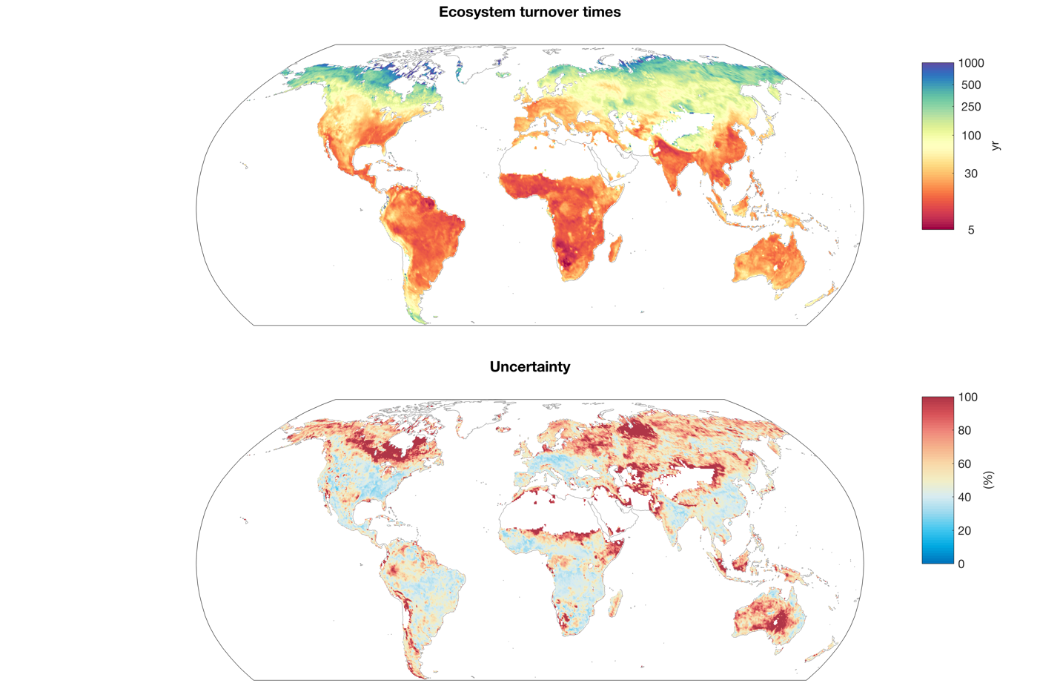
Figure SI-1.1: Spatial distribution of ensemble median τ and its relative uncertainty (interquartile range/mean) across different ensemble members.

To better understand the role of each ecosystem component on the overall uncertainty of τ estimation, we conducted multiway (N-way) ANOVA analysis to test the contribution of variance from different C_{soil}, C_{veg} and GPP/TER datasets to the mean estimation of τ. The result (Figure SI-1.2) shows that the overall uncertainty of τ is mainly caused by different representations of carbon stocks (64.3%) and carbon fluxes (34.4%) whereas vegetation only has a minor contribution to the uncertainty (1.3%) globally. The result of dominance of variance (Figure SI-1.2) explains the high relative uncertainty in the circumpolar and arid region (Figure SI-1.1) which stems from large spread in the estimations of soil carbon stocks.
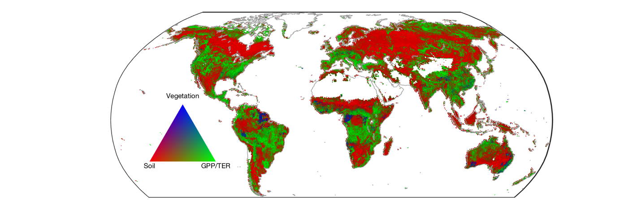
Figure SI-1.2: Contribution to the τ uncertainty from different ecosystem components. The green, red and blue color indicates the grid cells where the uncertainty is dominated by GPP/TER (64.3 % of total land area), soil carbon (34.4% of total land area) and vegetation carbon (1.3% of total land area), respectively.

SI-2 Relationship between τ, carbon stock, TER and climate variables
Using both ensemble median and site-level data, we assessed the relationship between logarithmic τ, carbon stock, TER and different climate variables by using regression models which are shown in Figure SI-2.1 and Figure SI-2.2. The correlation between τ and MAP (r² = 0.25) is partially derived from the fact that there is a strong non-linear relationship between TER and 1/ MAP (or a linear relationship between TER and MAP, Figure SI-2.1, 2.2). This result indicates the potentially strong control of precipitation on ecosystem respiration. Different from precipitation, we find a strong relationship between ecosystem carbon stock and the inverse of PET (r² = 0.3, Figure SI-2.1) which partially explains the strong emergent nonlinear relationship between τ and PET. This finding confirms the results from previous studies that moisture can largely influence or even dominate carbon turnover globally (Koven et al., 2017; Carvalhais et al., 2014). Our results indicate that precipitation (MAP) and evaporative demand (PET), which together determine soil water availability or aridity, have important controls on τ by affecting global carbon stock and TER/GPP. The high resemblance of the scatter patterns between the results that derived from ensemble median data and site-level data confirms the robustness of the τ-climate relationship.
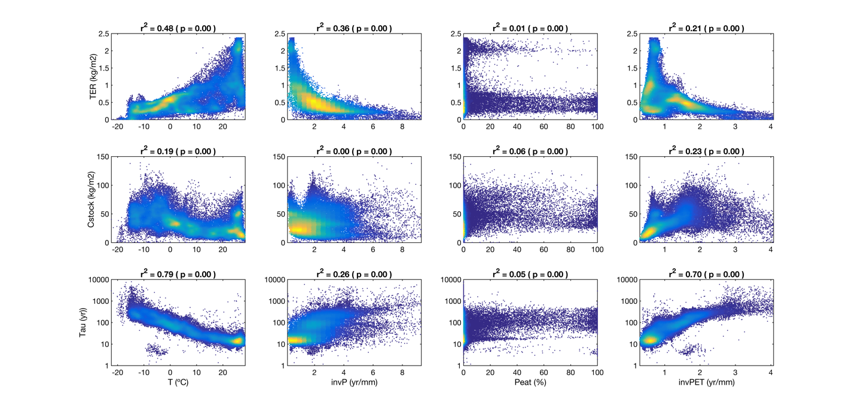
Figure SI-2. 1: Global patterns of TER, ecosystem carbon stock and τ with different climate variables at global scale using ensemble median τ estimates. Note that the MAP and PET are inverted (invP and invPET). The R² values between each climatic component and τ are given in the title of each subplot.

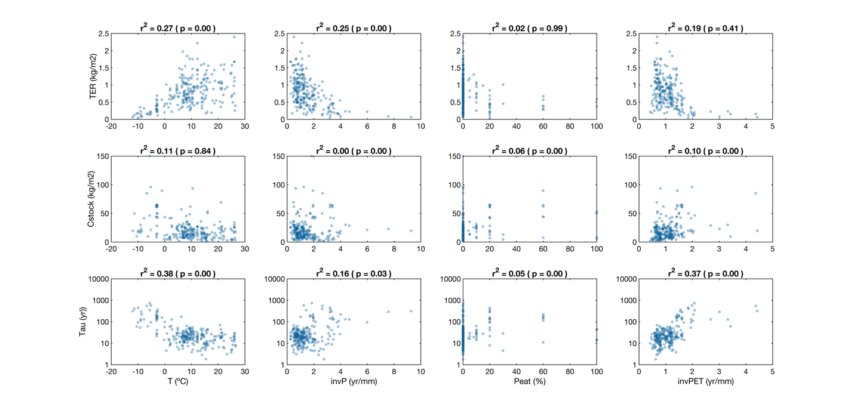
Figure SI-2. 2: The same as Figure SI-2.1 but with site-level τ estimates. The regression is weighted to account for the uneven distribution of observational data points.

SI-3 The cause of non-linearity in the τ-temperature relationship
We reproduced the results of Koven et al. (2017) using the exact same dataset and method in their study to investigate the linearity of the global τ-temperature relationship. In addition to the data of the previous study (Koven et al., 2017), we used the estimated total soil carbon stock (C_{total}) of the current study which is the averaged soil carbon stock from three different sources (see Methods) and GPP from FLUXCOM. Four global estimations of τ are obtained by combining each pair of the soil carbon stock and carbon fluxes. Note that we also used the same mask as the previous study to exclude the water dominant region defined by the previous study. By fitting a quadratic regression model between logarithmic τ and temperature (log₁₀(τ) ~ MAT²+MAT), the results show that we are able to reproduce the results from previous study and the Q₁₀ values that are estimated by the quadratic function range from 1.00 to 5.30 (Figure SI-3.1, Table SI-3.1). The quadratic function is obviously better than the linear function shown by the higher R2 and lower RMSE and AIC (Table SI-3. 1). We found similar patterns for all the four global estimations of τ that used different combinations of datasets.

However, the pattern of the τ-temperature relationship changed significantly after we included hydrometeorological variables including precipitation (MAP), potential evapotranspiration (PET) and peatland fraction (PSF) into the quadratic regression model between logarithmic τ and temperature (log₁₀(τ) ~ MAT²+MAT+1/MAP+1/PET+PSF). The results (Figure SI-3.2) show a substantial reduction in the non-linearity by controlling hydrometeorological effect as shown by the little difference in R², RMSE between linear and quadratic fitting (Table SI-3.2). The range of the estimated Q₁₀ values using Koven’s original data reduced to 1.09 to 2.56 and much reduced non-linearity for the other three combinations of data (Q₁₀ values ranges from 1.4 to 1.9).

We also used a site-level τ database to investigate the non-linearity between τ and temperature. Similar to the results that derived from gridded datasets as previously showed, the hydrometeorological effect on the non-linearity can be also found at site-level that the range of the estimated Q₁₀ values is reduced, although not as much as that using gridded datasets (Table SI-3.3, Table SI-3.4). It is worth to note that the number of site-level observations are much less (N=230) than the gridded datasets and the spatial distribution are highly heterogeneous since there are more observations in the lower latitudes than in the higher latitudes. We therefore retrieved the data points from the global gridded dataset at the same geographical location as the site-level data (site-grid dataset, hereafter) to investigate the effect of spatial heterogeneity to the non-linearity. The results show that the spatial distribution of site-level data contributed significantly to the non-linearity of the τ-MAT relationship shown by the very similar results that derived from site-level data and site-grid data. We thus concluded that although hydrometeorological effect on the non-linearity can be also found at site-level the magnitude is much less due to the limited spatial representativeness of the data.

By including hydrometeorological variables into the global fitting, we show a much-reduced non-linearity of the τ-temperature relationship and therefore much constrained Q₁₀ values. The statistical results indicate that the response of log₁₀(τ) to temperature is adjusted to a linear function from a second order polynomial function when hydrometeorological variables are controlled (Figure SI-3.2, Table SI-3.2). In conclusion, our results show that the non-linearity in the τ-temperature relationship is caused by hydrometeorological variables and the response of log₁₀(τ) to temperature can be better represented by a linear function.
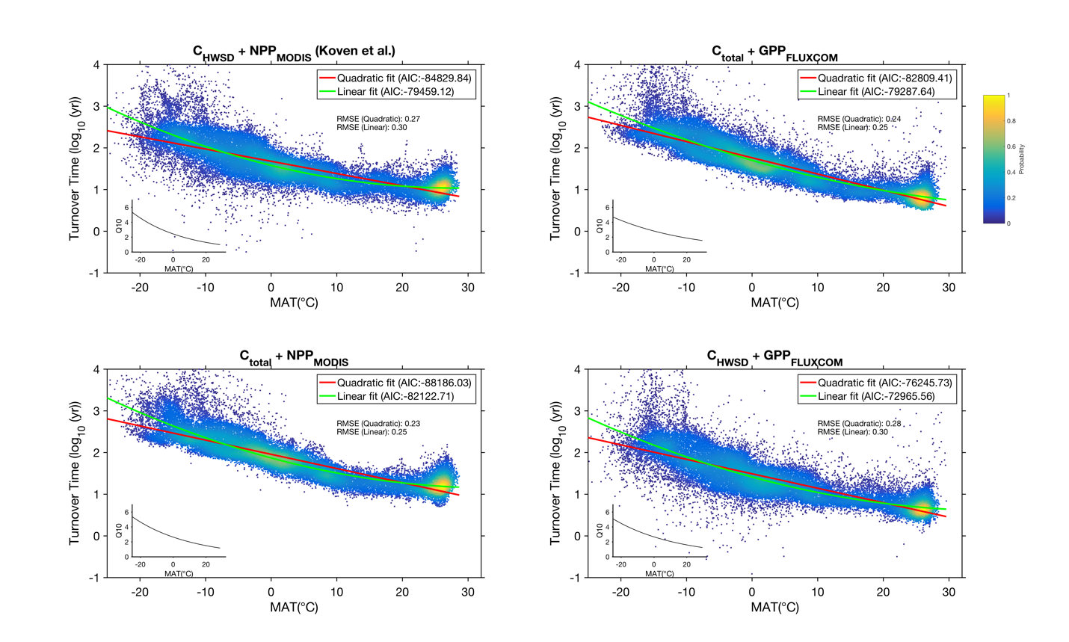

Figure SI-3. 1: Comparison between fittings of log (τ) as a function of temperature with linear and quadratic models and corresponding Q₁₀ values on global scale. Solid red lines represent quadratic fitting curves (log10(τ) ~ MAT²+MAT) while green lines represent linear fit (log10(τ) ~ MAT). The density plot of observational data is overlaid. The embedded smaller figure at the lower left corner is Q₁₀ values (derived from quadratic fitting) against temperature. Different data is used to estimate τ with two different carbon stocks (C_{total} and C_{HWSD}) and two carbon flux products (GPP_{MODIS} and GPP_{FLUXCOM}).

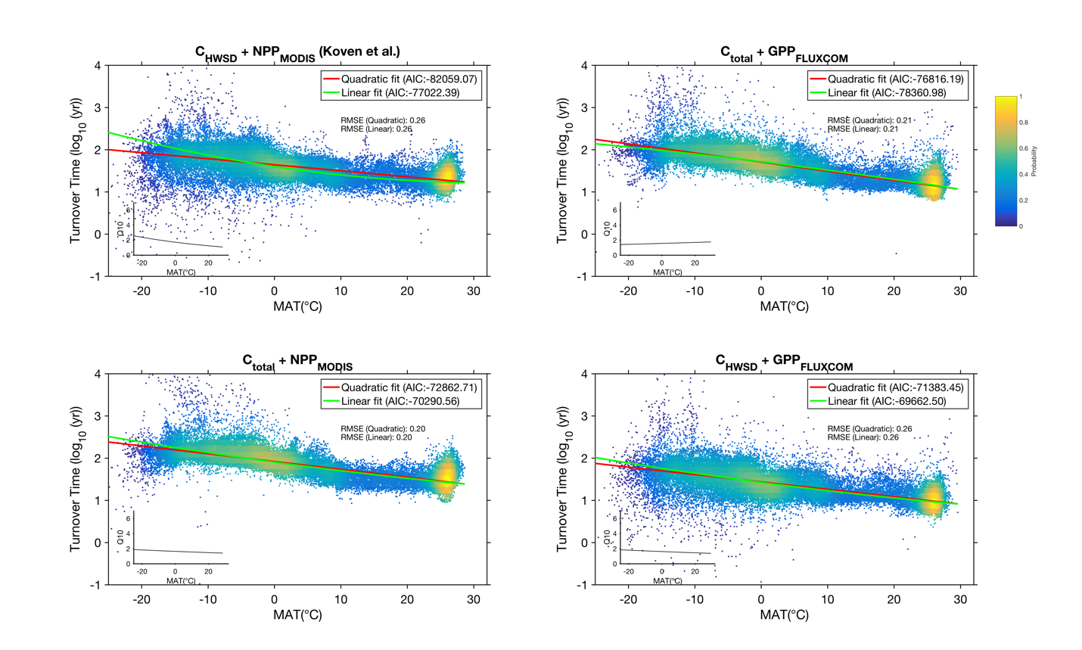
Figure SI-3. 2: The adjusted response of log (τ) to MAT when the hydrometeorological effect is controlled in multiple regression models. Solid red lines represent quadratic fitting curve (log10(τ) ~ MAT²+MAT+1/MAP+1/PET+PSF) while green lines represent linear fit (log10(τ) ~ MAT+1/MAP+1/PET+PSF). The density plot of observational data is overlaid. The embedded smaller figure at the lower left corner is Q₁₀ values (derived from quadratic fitting) against temperature. Different data is used to estimate τ with two different carbon stocks (C_{total} and C_{HWSD}) and two carbon flux products (GPP_{MODIS} and GPP_{FLUXCOM}).

Table SI-3. 1: Statistics associated with Figure SI-3.1.
 | RMSE |  | R² |  | AIC |  | P1(coefficient of x²) |  | P2(coefficient of x) |  | P3(intercept) |  | Q10 values
 | Linear | Quadratic | Linear | Quadratic | Linear | Quadratic | Linear | Quadratic | Linear | Quadratic | Linear | Quadratic | 50th(median) | 1th | 99th
C_{HWSD}+NPP_{MODIS} | 0.296 | 0.266 | 0.655 | 0.732 | -79459 | -84830 | NaN | 0.001 | -0.029 | -0.039 | 1.677 | 1.578 | 2.302 | 1.001 | 5.296
C_{total}+GPP_{FlUXCOM} | 0.255 | 0.245 | 0.815 | 0.833 | -79288 | -82809 | NaN | 0.000 | -0.039 | -0.045 | 1.762 | 1.700 | 2.712 | 1.556 | 4.729
C_{total}+NPP_{MODIS} | 0.253 | 0.233 | 0.777 | 0.818 | -82123 | -88186 | NaN | 0.001 | -0.034 | -0.042 | 1.956 | 1.869 | 2.516 | 1.188 | 5.332
C_{HWSD}+GPP_{FlUXCOM} | 0.295 | 0.277 | 0.722 | 0.763 | -72966 | -76246 | NaN | 0.001 | -0.035 | -0.043 | 1.489 | 1.412 | 2.545 | 1.261 | 5.133

Table SI-3. 2: Statistics associated with Figure SI-3.2.

 | RMSE |  | R² |  | AIC |  | P1(coefficient of x²) |  | P2(coefficient of x) |  | P3(intercept) |  | Q10 values
 | Linear | Quadratic | Linear | Quadratic | Linear | Quadratic | Linear | Quadratic | Linear | Quadratic | Linear | Quadratic | 50th(median) | 1th | 99th
C_{HWSD}+NPP_{MODIS} | 0.263 | 0.256 | 0.785 | 0.781 | -77022 | -82059 | NaN | 0.000 | -0.014 | -0.023 | 1.179 | 1.275 | 1.669 | 1.088 | 2.561
C_{total}+GPP_{FlUXCOM} | 0.207 | 0.207 | 0.901 | 0.903 | -78360 | -76816 | NaN | 0.000 | -0.022 | -0.019 | 1.141 | 1.114 | 1.567 | 1.404 | 1.748
C_{total}+NPP_{MODIS} | 0.200 | 0.200 | 0.902 | 0.899 | -70290 | -72862 | NaN | 0.000 | -0.019 | -0.021 | 1.419 | 1.449 | 1.622 | 1.408 | 1.867
C_{HWSD}+GPP_{FlUXCOM} | 0.260 | 0.259 | 0.826 | 0.824 | -69662 | -71383 | NaN | 0.000 | -0.018 | -0.021 | 0.899 | 0.934 | 1.594 | 1.377 | 1.846

Table SI-3. 3: Comparison between linear and quadratic regression models without hydrometeorological effect using site-level observations and median ensemble datasets (at the same location of site-level observations).
 |  | RMSE | R² | AIC | P1 | P2 | P3 | Q10 values
Site-level | Linear | 0.398 | 0.583 | -440.017 | NaN | -0.030 | 1.792 | 2.004 | NaN | NaN
Site-level | Quadratic | 0.353 | 0.665 | -492.895 | 0.001 | -0.049 | 1.748 | 2.034 | 0.940 | 5.047
Grid cell data | Linear | 0.208 | 0.876 | -613.357 | NaN | -0.034 | 1.961 | 2.206 | NaN | NaN
Grid cell data | Quadratic | 0.151 | 0.943 | -668.110 | 0.001 | -0.055 | 1.932 | 2.349 | 1.037 | 6.099

Table SI-3. 4: Comparison between linear and quadratic regression models with hydrometeorological effect using site-level observations and median ensemble datasets (at the same location of site-level observations).
 |  | RMSE | R² | AIC | P1 | P2 | P3 | Q10 values
Site-level | Linear | 0.372 | 0.636 | -462.879 | NaN | -0.019 | 1.419 | 1.548 | NaN | NaN
Site-level | Quadratic | 0.342 | 0.695 | -498.278 | 0.001 | -0.047 | 1.645 | 1.925 | 0.905 | 4.684
Grid cell data | Linear | 0.169 | 0.916 | -667.215 | NaN | -0.020 | 1.515 | 1.592 | NaN | NaN
Grid cell data | Quadratic | 0.147 | 0.942 | -694.948 | 0.001 | -0.046 | 1.764 | 2.041 | 1.050 | 4.435

SI-4 The response of τ to climatic factors and model performance at biome level
We analyzed the response of τ to climatic factors at different biomes (Figure SI-4.1). The goodness of fitting log (τ) as a function of temperature and hydrometeorological variables across different biomes are heterogeneous (Figure SI-4.2). Our analysis shows that the model performance can be significantly improved by including hydrometeorological factors in the regression model (compare Figure SI-4.2 a and b). However, the results show low model performances in tropical biomes compared with other biomes where the model can only explain less than 40% percent of the total variance of spatial τ. Further analysis shows the spatial variability of τ is significantly lower in tropical forests (τ_{range} = 44 years) and tropical grasslands (τ_{range} = 34 years) than the other biomes due to low spatial temperature gradient (Figure SI-4.3).
Figure 3a shows that the relative dominance of different climate factors is heterogeneous across different biomes. In majority of biomes, temperature and hydrometeorological factors co-determine the spatial τ variability. However, we show that hydrometeorology dominates the τ variabilities in the biomes of tundra and boreal forest (RD_{H}>80%). By controlling hydrometeorological effect, we show a generally reduced temperature sensitivity of τ except for tropical forest (compare Figure SI-4.3 and Figure SI-4.5). The adjusted temperature sensitivities for the biomes of tundra and boreal forest become much lower as shown by the reduced slope of the τ-temperature fitting (Figure SI-4.5). Our analysis shows a strong response of τ to the spatial gradient of potential evapotranspiration (when other climate factors are controlled) in the biomes of tundra and boreal forest where τ decreases strongly with increasing PET (Figure SI-4.4).
To further investigate the potential link between PET and τ, we analyzed the response of each ecosystem component that determines τ including soil carbon stock (C_{soil}), vegetation carbon stock (C_{veg}), GPP/TER to different climatic factors. We first show a strong positive relationship (r>0.4) between PET and TER in both boreal forest and tundra ecosystems (Figure SI-4.6, 4.7, similar patterns are found between PET and GPP, not shown). This is expected because GPP/TER should increase with more available energy to evaporate water which is represented by higher PET. We next show that vegetation biomass strongly increases with PET (Figure SI-4.6, 4.7, r>0.4) since there is a linear relationship between GPP/TER and C_{veg} (r²=0.51) whereas no such pattern is found between PET and C_{soil}. By analyzing the relationship between τ and C_{veg}, we further show that τ linearly decreases with higher C_{veg} (Figure-SI 4.8).
We found that the Q₁₀ values in tundra and boreal forest ecosystems are adjusted to very low values (boreal: Q10 changes from 1.9 to 1.1; tundra: 1.5 to 0.9) when accounting for the H-effect. This result indicates that τ are almost insensitive to mean annual temperature change (especially in tundra) whereas the spatial variability of τ is dominated by H-factors. To test the robustness of the results, we changed the temperature proxy from mean annual temperature to mean temperature of April to October considering little biological activity in the frozen season. Our results indeed show higher magnitude of temperature sensitivity before accounting for H-factors, but the Q10 values are largely reduced after accounting for H-effect even though we changed the temperature proxy (boreal: Q10 changes from 3.2 to 1.4; tundra: 2.2 to 1.0). Our findings reveal a robust role of hydrometeorology in tundra and boreal ecosystems.

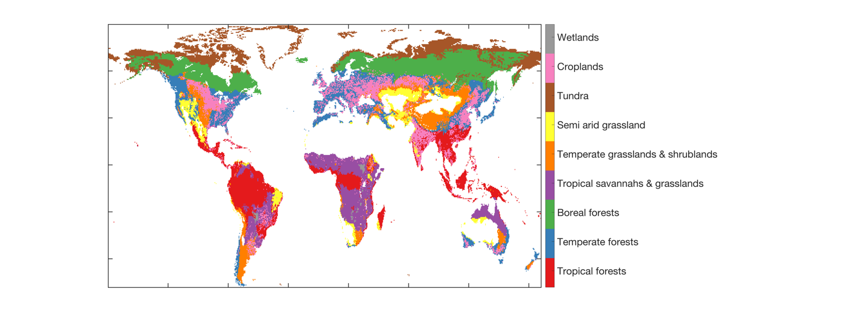
Figure SI-4. 1: Spatial distribution of different biomes.

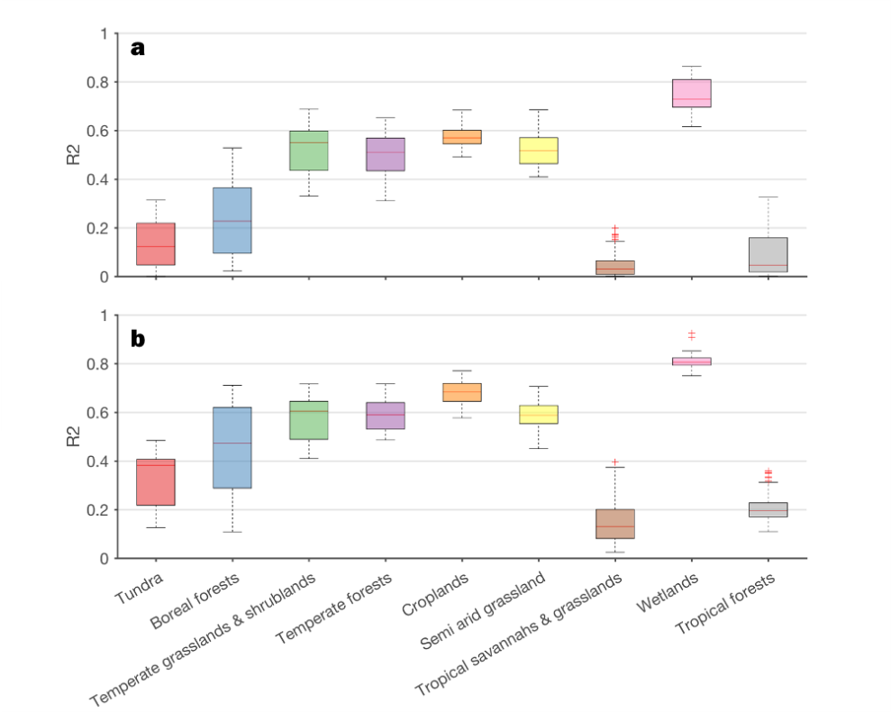
Figure SI-4. 2: The R² values of models without (Eq.1) and with (Eq.2) hydrometeorological control and in different biomes.

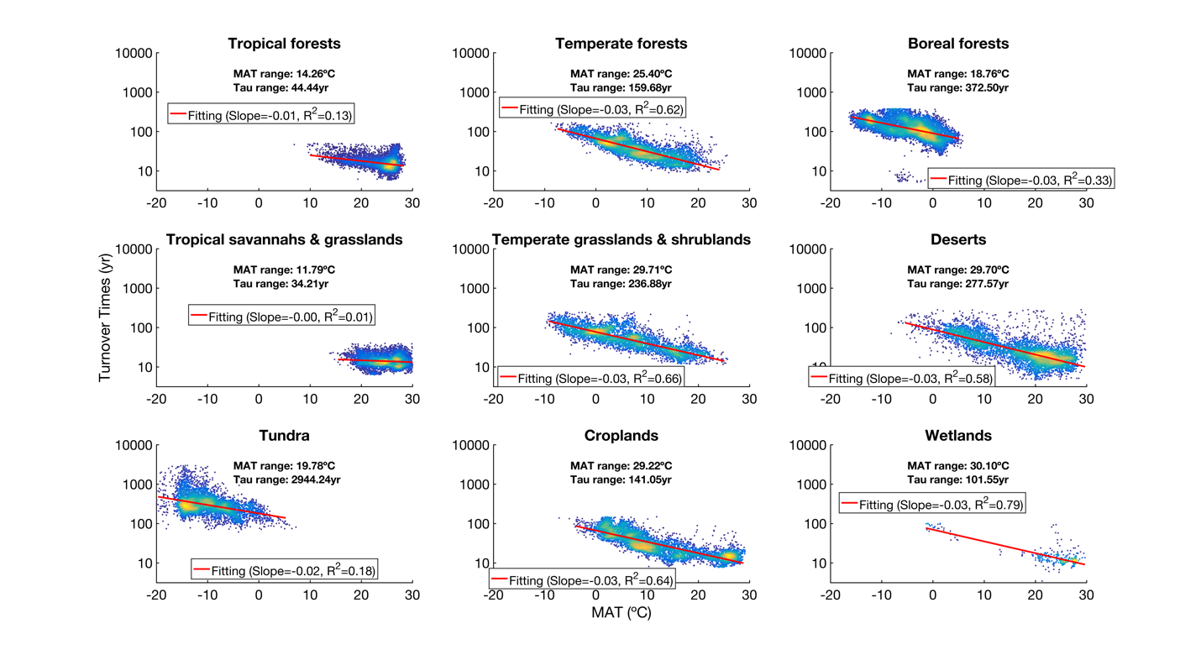
Figure SI-4. 3: Density plot between τ and mean annual temperature in different biomes. The ranges (99th – 1st) of temperature and τ are shown in each subplot. The slope of the fitting and R² values are shown in each subplot.

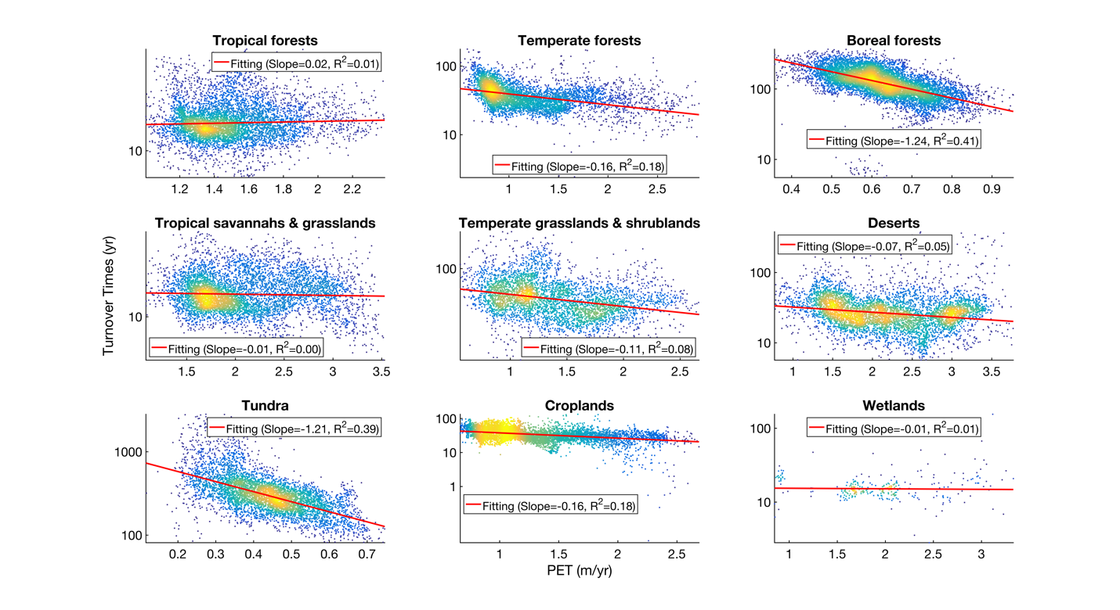
Figure SI-4. 4: The adjusted response of τ to PET when other climatic factors (MAT, MAP and PSF) are controlled in the multiple regression model. The slope of the fitting and R² values are shown in each subplot.

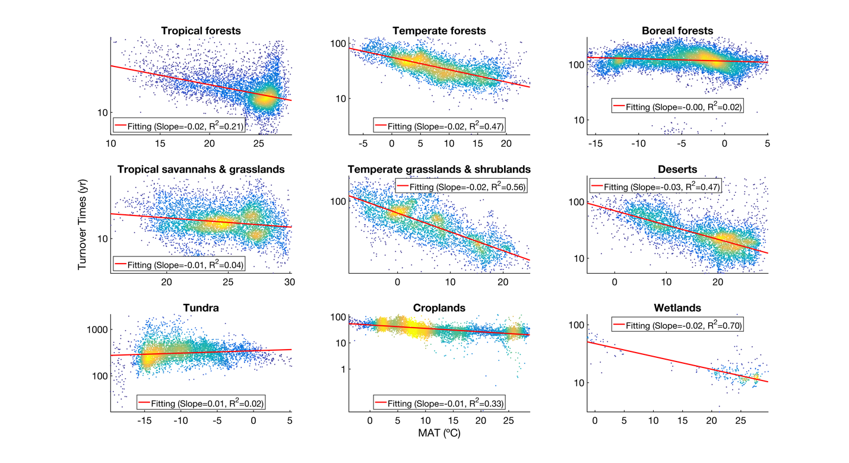
Figure SI-4. 5: The adjusted response of τ to MAT when other climatic factors (MAP, PET and PSF) are controlled in the multiple regression model. The slope of the fitting and R² values are shown in each subplot.

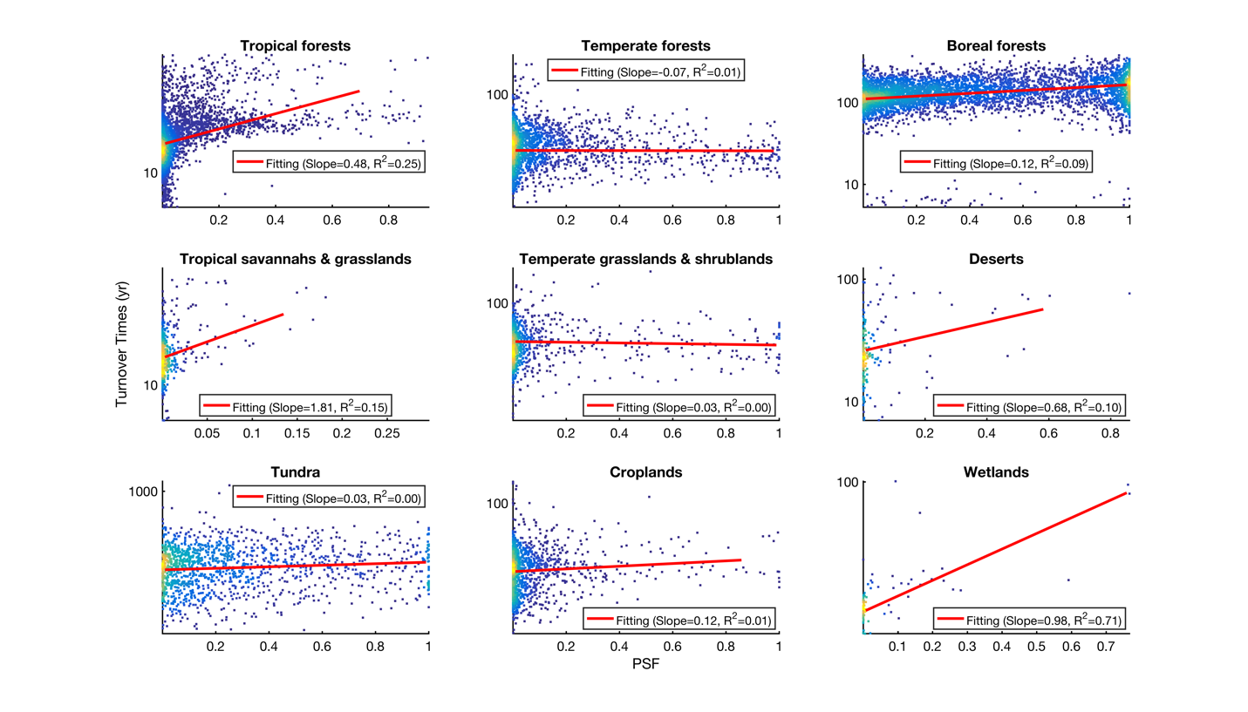
Figure SI-4. 6: The adjusted response of τ to PSF when other climatic factors (MAP, PET and MAT) are controlled in the multiple regression model. The slope of the fitting and R² values are shown in each subplot.

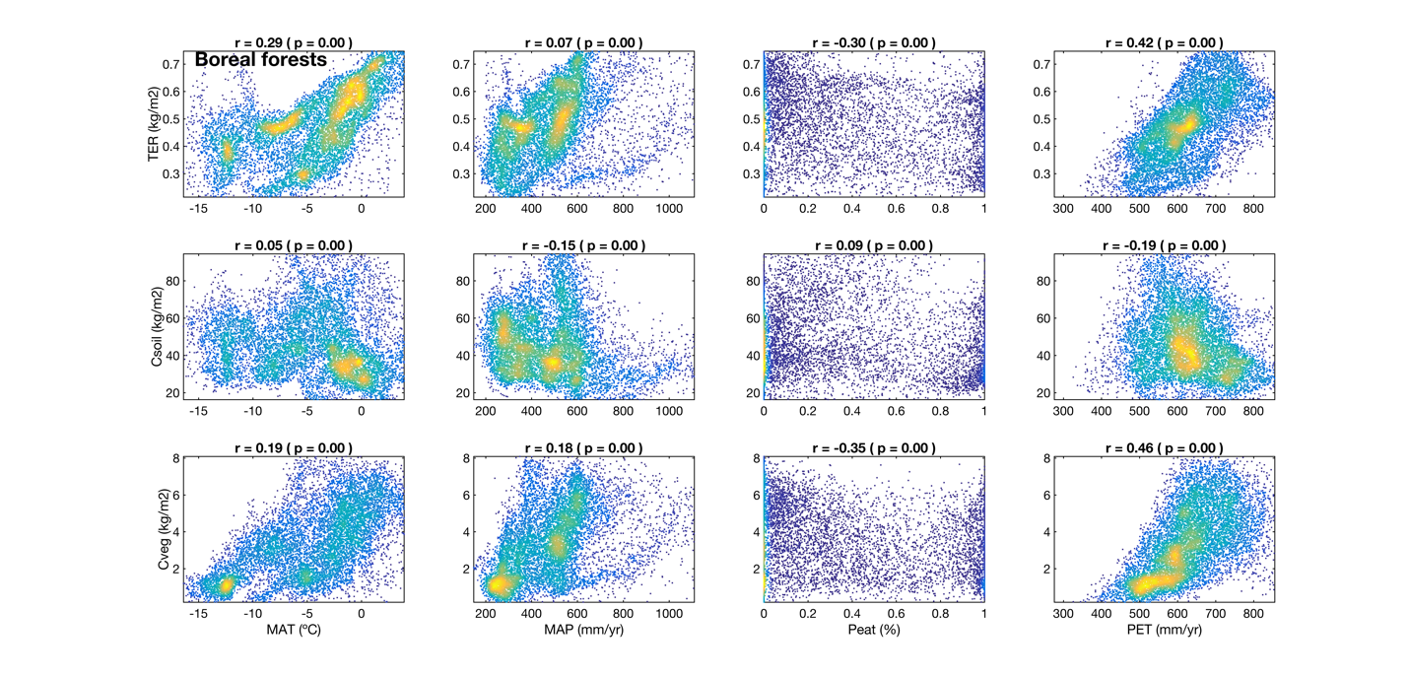
Figure SI-4. 7: Partial correlation (Spearman) between C_{soil}, C_{veg}, TER and each climate variable (while controlling for the remaining climate variables) in boreal forest biome. The correlation coefficient and p-value are given in each subplot.

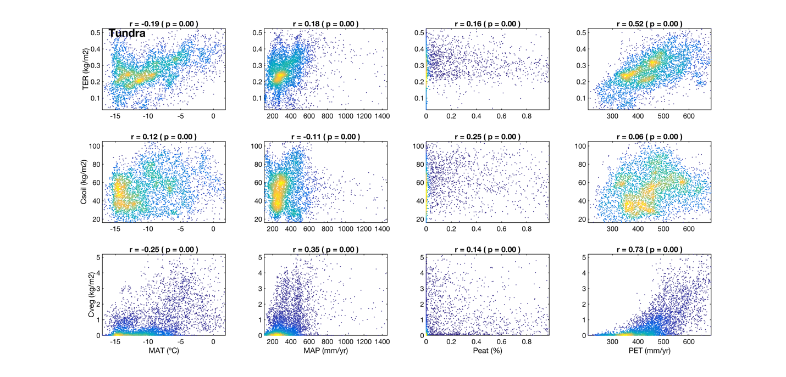
Figure SI-4. 8. The same as Figure SI-4.6 except that the analysis is performed in Tundra biome.

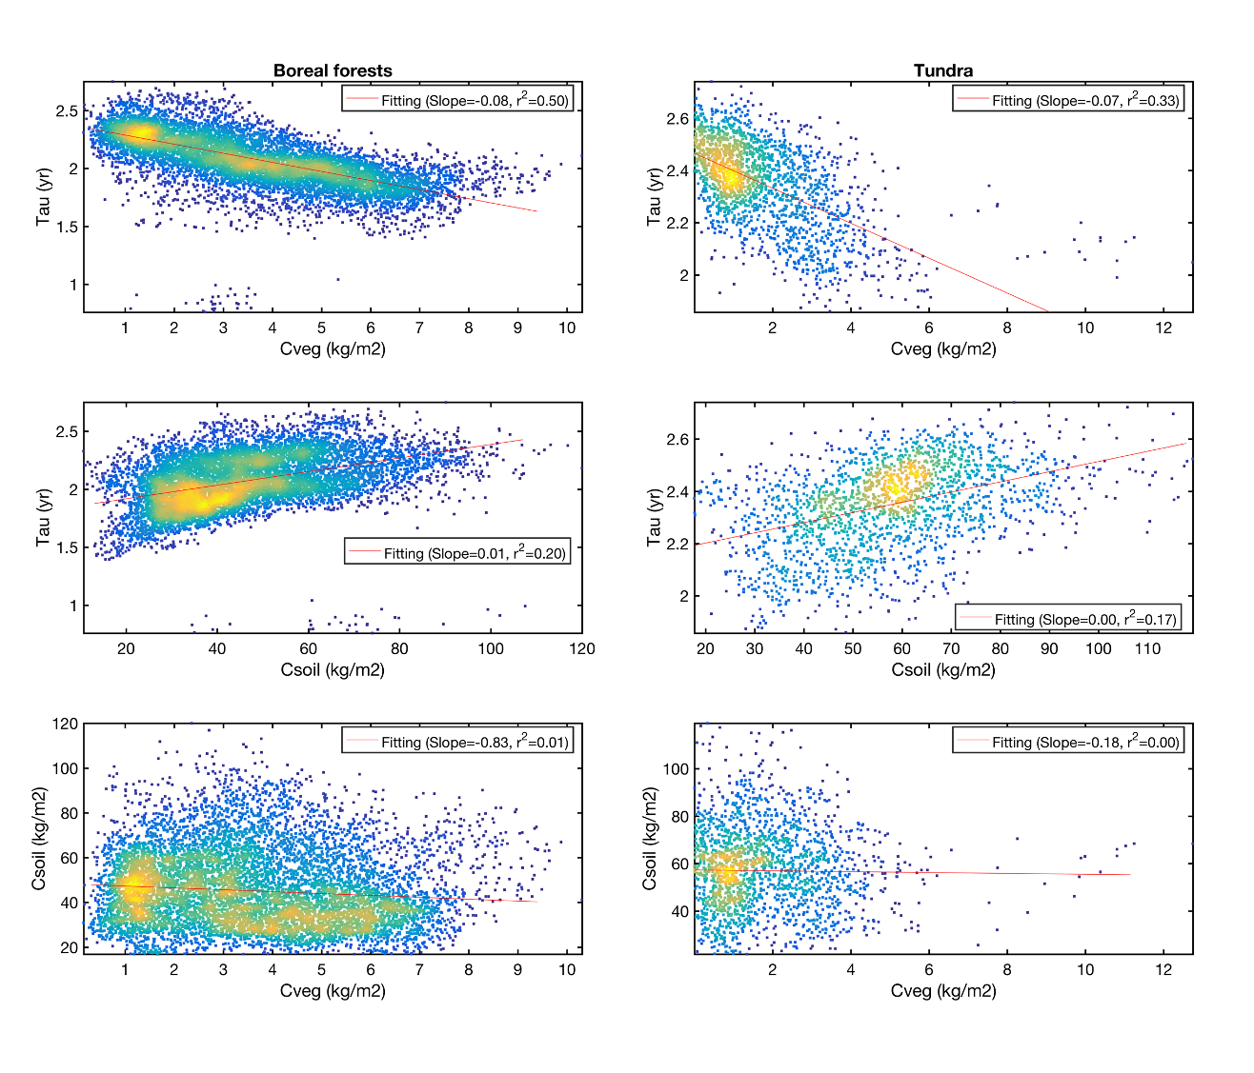
Figure SI-4. 9. Scatter plot and linear regression between τ and C_{veg}, τ and C_{soil}, C_{veg} and C_{soil}. The slope and R² value are derived from the linear regression model between each pair of variables.

SI-5 Estimation of Q₁₀ at latitudinal level

We quantified the log (τ) -T relationships and hydrometeorological effect in each moving window across latitude (see Methods). We show that the model performance at latitudinal scale largely depends on the magnitude of τ spatial variability in different latitudinal windows (Figure SI-5.1). Our results show the R² values are relatively lower (R²<0.4) in the tropics, where the range of τ (99th – 1th) is less than 50 years, than the higher northern latitude where the τ variability is much higher (τ_{range}>100 years). This finding is consistent with our previous analysis at biome level where we showed tropical biomes are characterized by much lower τ variability than other biomes due to less τ variability (Figure SI-4.2).
To investigate the effect of moving window size to our results, we used different latitudinal extensions of 10º, 20º, 30º and 40º (longitude extension remains the same as 360º). The results (Figure SI-5.2) show that the latitudinal pattern of Q10 estimations is consistent with different selection of window size although local variability may change. Interestingly, we found the constraining effect of the Q10 values by accounting for H-factors becomes clearer as the window size becomes larger. This is caused by the fact that both temperature and hydrometeorological gradient increases with window size (Figure SI-5.3).

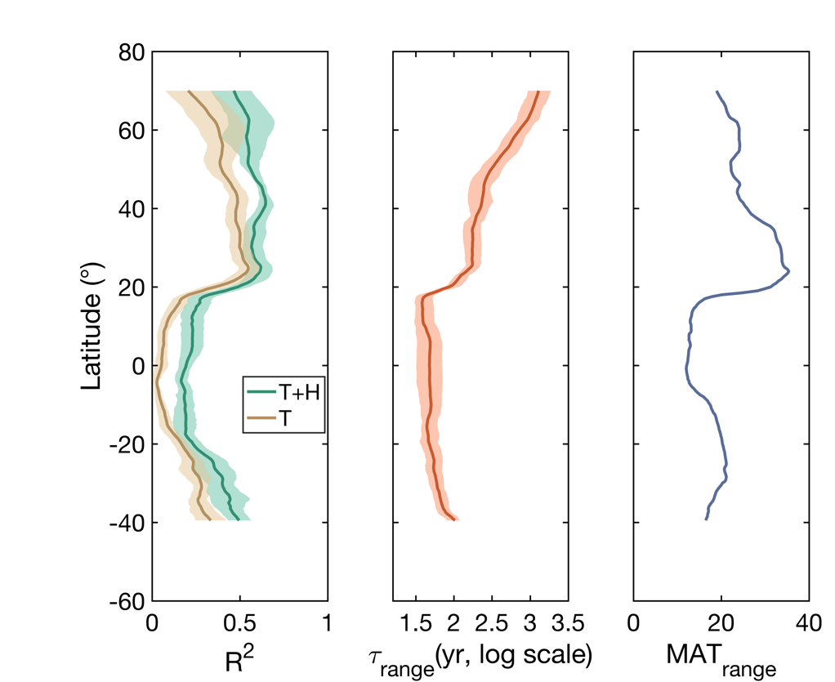
Figure SI-5. 1: Latitudinal distributions of R² values, range of τ and range of MAT. The R2 is derived by performing regression analysis using Eq1 (legend: T) and Eq.2 (legend: T+H) in each latitudinal moving window (360º in longitude and 20º in latitude, see Methods). The range of τ and MAT is the difference between 99th and 1th for each variable.

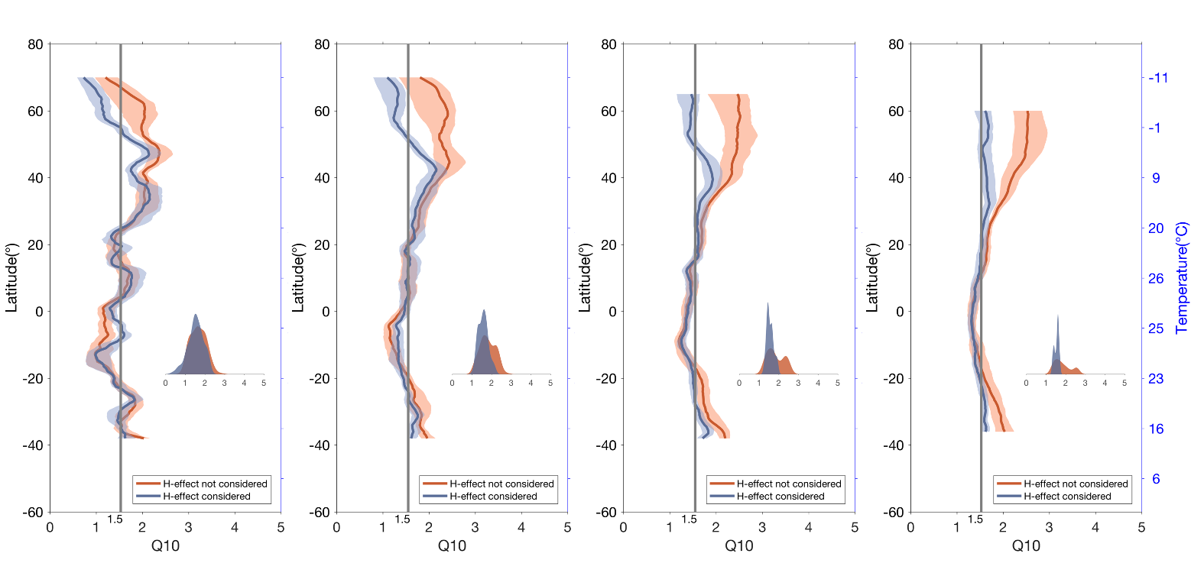
Figure SI-5. 2. The effect of window size to the estimation of Q10 values. From left to right we used window sizes of 10º, 20º, 30º and 40º in latitude (size in longitude remain 360º). The Red/Blue curve represent Q10 estimations without/with accounting for H-effect.

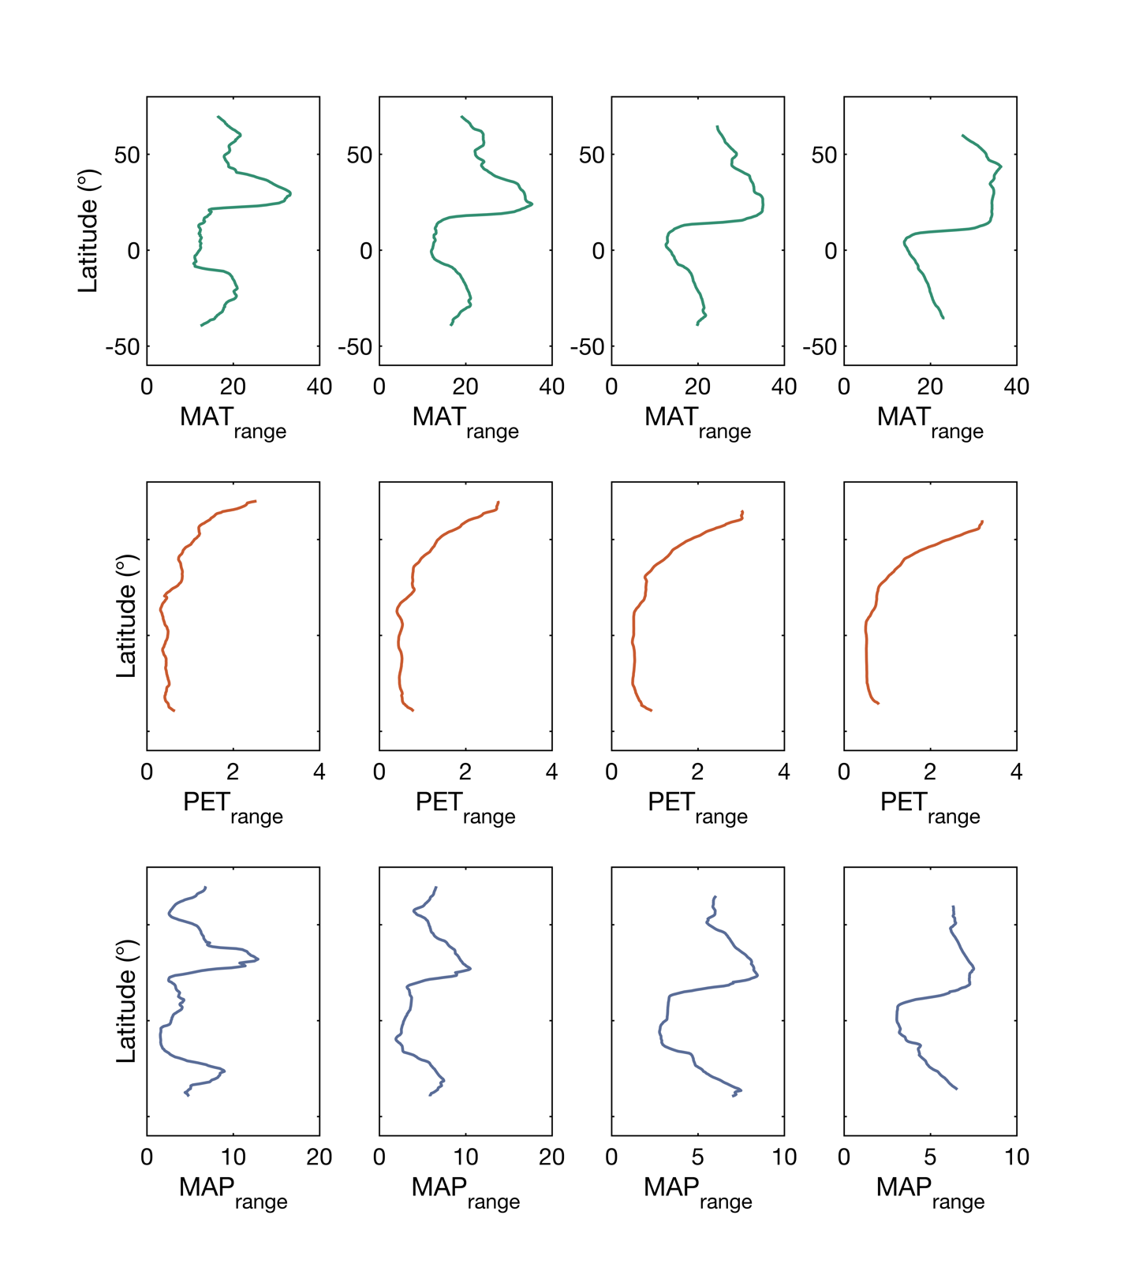
Figure SI-5. 3. The change of ranges in climatic factors along latitude when different window sizes are used. From left to right we used window sizes of 10º, 20º, 30º and 40º in latitude (size in longitude remains 360º).

