Supplementary Materials
Annexe - A

Table 3 Concrete having the same ${GFIM}_{g}$ and ${FD}_{g} values$of some works by American authors
Authors, Year & Ref. | Total number T_{N} |  | Modulus${GFIM}_{g}$ | Fractal Dimension${FD}_{g}$ |  | $$D/d_{g}$$
Authors, Year & Ref. | Concretes | $${GFIM}_{g}$$ | Modulus${GFIM}_{g}$ | $${FD}_{g}$$ | R² | (mm)
Quiroga [25] - ACI | 18 | 2 | 7.79 | 3.00 | 0,95 | 31,5/0 ,08
Quiroga [25] - ACI | 18 | 2 | 7.27 | 2.80 | 0,98 | 31,5/0 ,08
Quiroga [25] - Euro | 18 | 2 | 7.60 | 2.93 | 0,95 | 31,5/0 ,08
Quiroga [25] - Euro | 18 | 2 | 7.58 | 2.92 | 0,95 | 31,5/0 ,08
Quiroga [25] - Euro | 18 | 2 | 6.88 | 2.87 | 0,98 | 20/0,08
Quiroga [25] - Euro | 18 | 2 | 6.79 | 2.83 | 0,98 | 20/0,08
Quiroga [25] - Euro | 18 | 2 | 7.32 | 2.82 | 0,99 | 31,5/0,08
Quiroga [25] - Euro | 18 | 2 | 6.01 | 2.74 | 0,96 | 12.5/0,08
Quiroga [25] - Euro | 18 | 2 | 6.88 | 2.65 | 0,99 | 31,5/0,08
Quiroga [25] - Euro | 18 | 2 | 6.72 | 2.59 | 0,99 | 31,5/0,08
Quiroga [25] - 18-8 | 12 | 2 | 7.29 | 3.00 | 0,97 | 20/0,08
Quiroga [25] - 18-8 | 12 | 2 | 6.58 | 3.00 | 0,98 | 12,5/0,08
Quiroga [25] - 18-8 | 12 | 3 | 7.32 | 2.82 | 0,97 | 31,5/0,08
Table 4 Concrete having the same ${GFIM}_{g}$ and ${FD}_{g}$values of some works by Asian authors
Authors, Year & Ref. | Total number T_{N} |  |  | Modulus${GFIM}_{g}$ |  | Fractal Dimension${ FD}_{g}$ |  | $$D/d_{g}$$
Authors, Year & Ref. | Concretes | $${GFIM}_{g}$$ |  |  |  | $${FD}_{g}$$ | R² | (mm)
Chopra [36] | 49 | 4 | 6,79 |  | 2,80 |  | 0,97 | 20/0,075
Chopra [36] | 49 | 6 | 6,82 |  | 2,81 |  | 0,97 | 20/0,075
Chopra [36] | 49 | 2 | 6,84 |  | 2,82 |  | 0,97 | 20/0,075
Chopra [36] | 49 | 8 | 6,91 |  | 2,85 |  | 0,97 | 20/0,075
Chopra [36] | 49 | 11 | 6,94 |  | 2,86 |  | 0,97 | 20/0,075
Chopra [36] | 49 | 5 | 7,01 |  | 2,89 |  | 0,97 | 20/0,075
Chopra [36] | 49 | 3 | 7,13 |  | 2,94 |  | 0,97 | 20/0,075
Moutassem [37] | 28 | 2 | 5.95 |  | 2.70 |  | 0,99 | 20/0,125
Moutassem [37] | 28 | 2 | 6.22 |  | 2.82 |  | 0,99 | 20/0,125
Moutassem [37] | 28 | 2 | 6.53 |  | 2.84 |  | 0,99 | 25/0,125
Moutassem [37] | 28 | 3 | 6.35 |  | 2.88 |  | 0,99 | 20/0,125
Moutassem [37] | 28 | 2 | 6.67 |  | 2.90 |  | 0,99 | 20/0,125
Moutassem [37] | 28 | 2 | 6.46 |  | 2.93 |  | 0,99 | 20/0,125
Yang S ([38] | 06 | 2 | 6.67 |  | 2.78 |  | 0,99 | 25/0.1
T_{N}: Total number of concretes. ${GFIM}_{g}$ : Total number of concretes with the same ${GFIM}_{g}$value

- Annexe - B
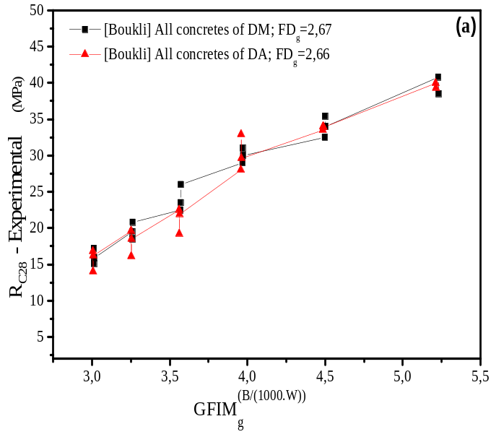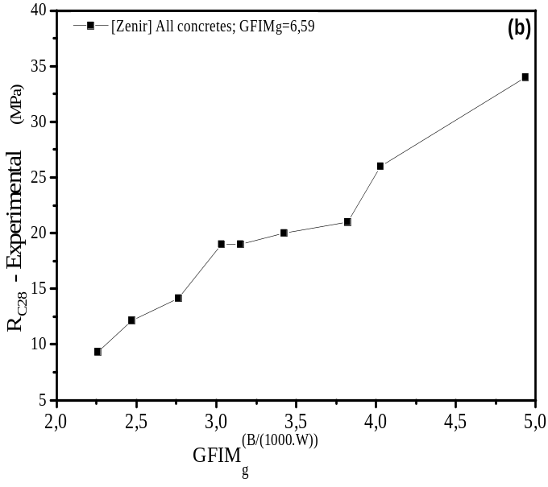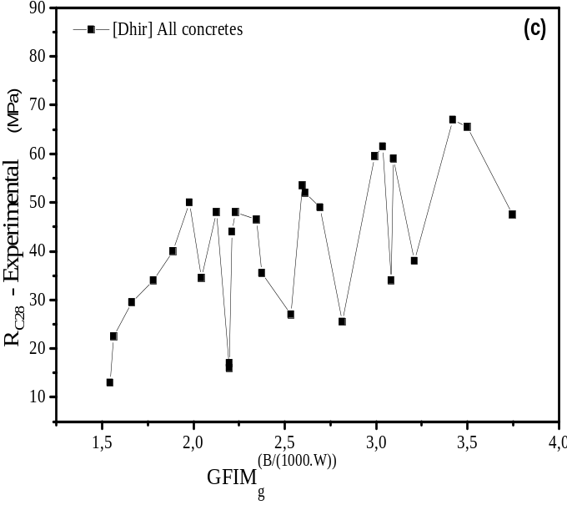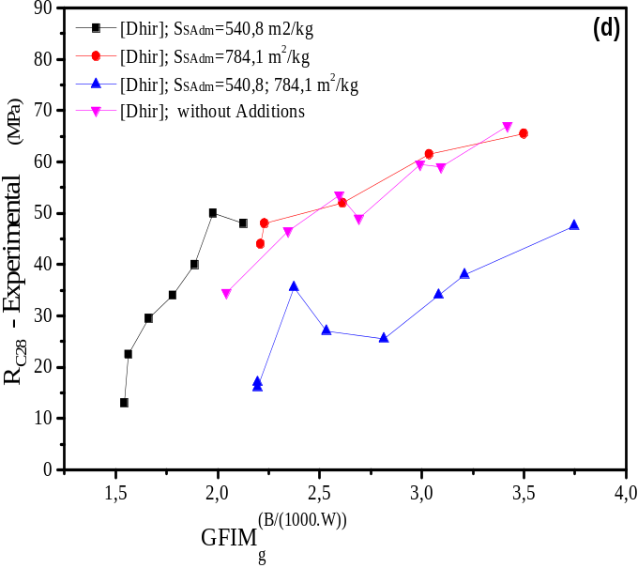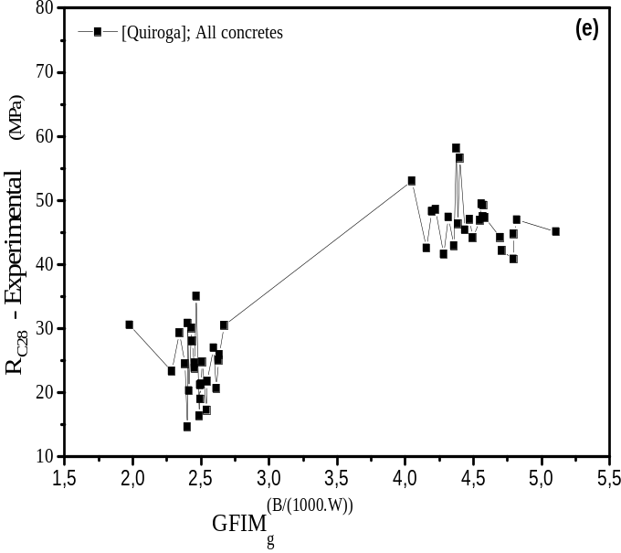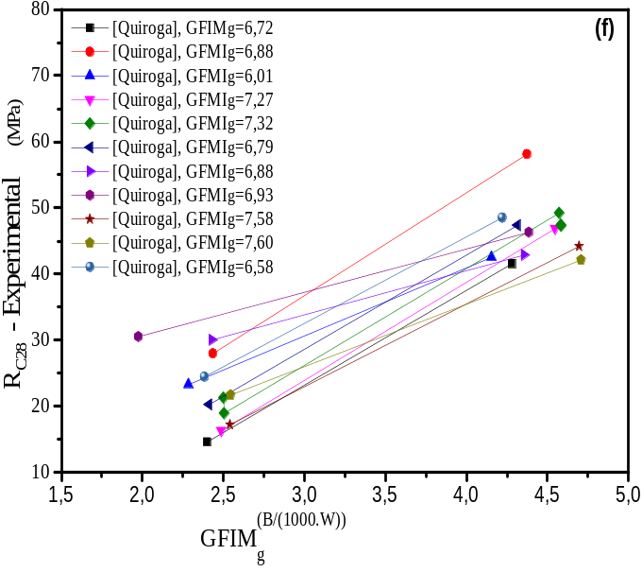
Fig. 16 Experimental curves and fitting of concrete types, (a), (c), (e), Experimental curves using values of all concretes of [22, 28, 20, 26]., (b, d, f) Experimental curves using values of ${FD}_{g}$, ${GFIM}_{g}$, ${ S}_{SC}$ [22, 28, 20, 26].
Annexe - C
  - Adjustment of the experimental curves
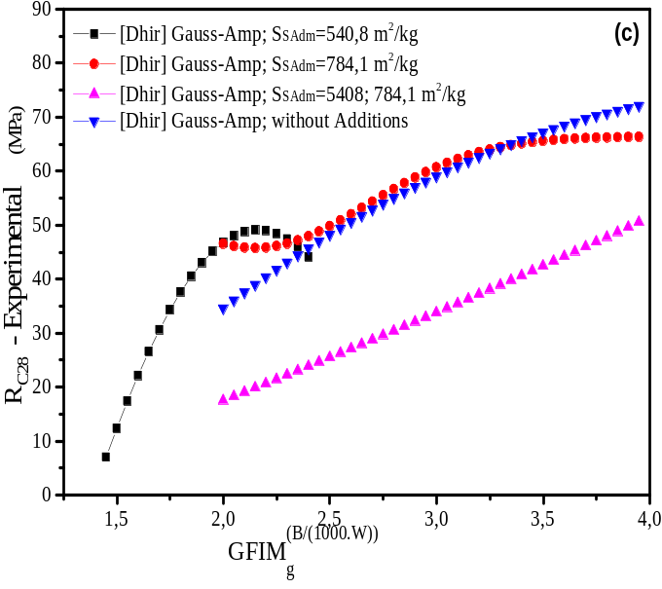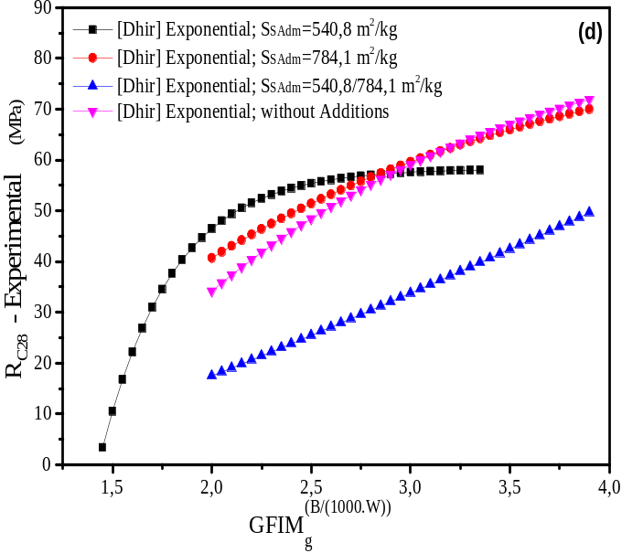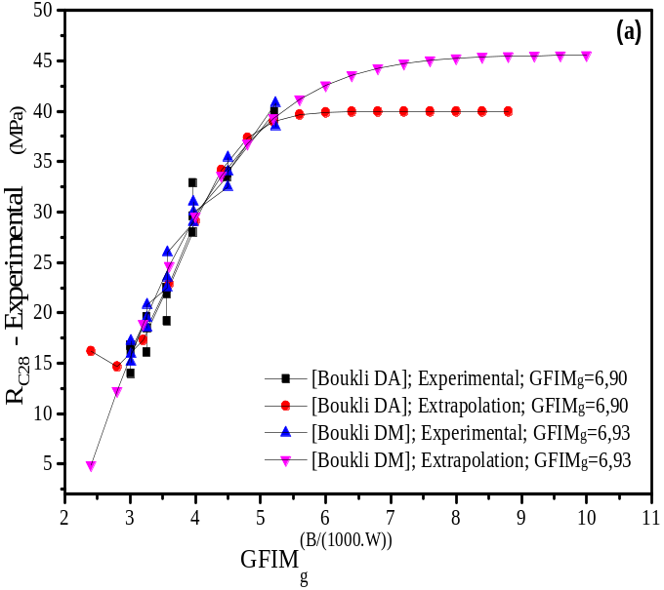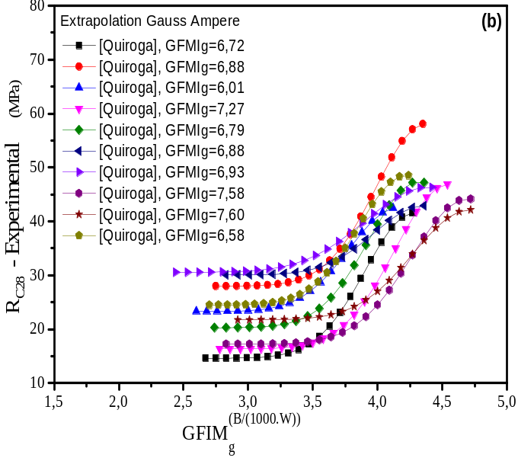
Fig. 17 Extrapolation curves and fitting of all the concrete types, (a), (b), (c), Extrapolation curves to the Gauss-Amper functions using of [22, 28, 20, 26], (a), (b), (c) Extrapolation curves to the Exponential functions using of [22, 28, 20, 26].

