Supplementary Section
Functional analysis of (pristine) estuarine marine sediments

Rohan M. Shah^{1,2}, Katie E. Hillyer¹, Sarah Stephenson³, Joseph Crosswell⁴, Avinash V. Karpe¹, Enzo A. Palombo², Oliver A. H. Jones⁵, Daniel Gorman⁶, Lev Bodrossy⁷, Jodie van de Kamp⁷, Warish Ahmed¹, Andrew Bissett⁷, Andy Whiteley⁸, Andy D. L. Steven⁴, David J. Beale¹

¹ Land and Water, Commonwealth Scientific and Industrial Research Organisation, Dutton Park, QLD 4102, Australia.
² Department of Chemistry and Biotechnology, Faculty of Science, Engineering and Technology, Swinburne University of Technology, Hawthorn, VIC 3122, Australia.
³ Oceans and Atmosphere, Commonwealth Scientific and Industrial Research Organisation, Lucas Heights, NSW 2234, Australia.
⁴ Oceans and Atmosphere, Commonwealth Scientific and Industrial Research Organisation, Dutton Park, QLD 4102, Australia.
⁵ Australian Centre for Research on Separation Science (ACROSS), School of Science, RMIT University, Bundoora West Campus, PO Box 71, Bundoora, VIC 3083, Australia.
⁶ Oceans and Atmosphere, Commonwealth Scientific and Industrial Research Organisation, Indian Ocean Marine Research Centre, Crawley, WA 6009, Australia
⁷ Oceans and Atmosphere, Commonwealth Scientific and Industrial Research Organisation, Battery Point, TAS 7004, Australia.
⁸ Land and Water, Commonwealth Scientific and Industrial Research Organisation, Floreat WA 6014, Australia.

Sample Metadata

Description of the study area – the Western Cape York Peninsula, Australia
The Cape York Peninsula, Far North Queensland (FNQ), Australia, was included in the first indicative inventory of the world’s most outstanding natural areas worthy of ‘World Heritage Quality’ (published in 1982 by the International Union for the Conservation of Nature) [1]. To this day, the Cape York Peninsula remains a remote pristine natural wilderness area in the monsoon tropical zone of northernmost Queensland, Australia (Figure 1). The region, spanning more than 13.72 Mha, is a treasure-trove of biodiversity and a high level of ecological integrity [2]. Comprising expansive and largely intact tropical savannas that are rare elsewhere in the world, with the coastline largely untransformed and viewed as some the world’s most species-rich ecosystems. The region has high endemism and ecosystem diversity of rare integrity [3]. For example, two particular aquatic ecosystems (i.e., the Wenlock and Olive River)are known to contain the richest diversity of freshwater fish fauna in Australia [4]. Furthermore, this is a region distinguished by the continuity of Indigenous occupation. It has a sparse population of ca. 18,000 people, of which two-thirds are of indigenous clans (namely, the Mpakwithi, Taepithiggi, Thaynhakwith, Warrangku, Wimarangga, and Yupungathi people), who live along the coast [5, 6].
Most of this region is managed and protected within the Aboriginal Areas and The Australian National Parks framework [7]. While still regarded as a highly pristine ecosystem, this does not imply that threatening processes do not exist. The area comprises widespread agricultural grazing, numerous mines of bauxite, tin, and gold, and is a natural resource managed by the Northern Prawn Fishery Management Authority for commercial fishing [8]. Whilst low-level landscape development has ensured high levels of ecological integrity, the Cape York regional plan enlists efforts to provide economic opportunities for future development [9]. Planning is currently underway to expand and diversify economic activities in agriculture, mining, and tourism. Increased development in this region is likely to affect ecological integrity, and the opportunity currently exists to gather physicochemical and biological information before any potential changes occur. In addition to these direct development-based threats, there are risks associated with a rising climate that may impact these pristine environments more than other perturbed systems [10].
The current study herein investigates the estuarine sediments of the Western Cape York region. Estuarine sediment samples were collected in June 2018 from 50 sites representing four estuaries – Skardon, Wenlock, Embley-Hey, and Archer-Watson. All sampled estuaries are located within the West Cape York region (Figure 1). The region comprises nine Australian Water Resource Council (AWRC) river basins. Whilst the average annual rainfall for the region is 1,417 mm over the water year (September to August), with ca 1,370 mm of rain falling during the wet season (November to April) [11]. Most of these rivers drain from the western slopes of the Great Dividing Range of the Cape York Peninsula into the Gulf of Carpentaria [11]. The study area is remote and undeveloped that is least disturbed by modern technology. Bauxite mining at Weipa is the most significant disturbance, which is located north in the Embley-Hey estuary. Other minor activities such as pastoralism, weeds, and altered fire regimes have selectively affected some areas [4].

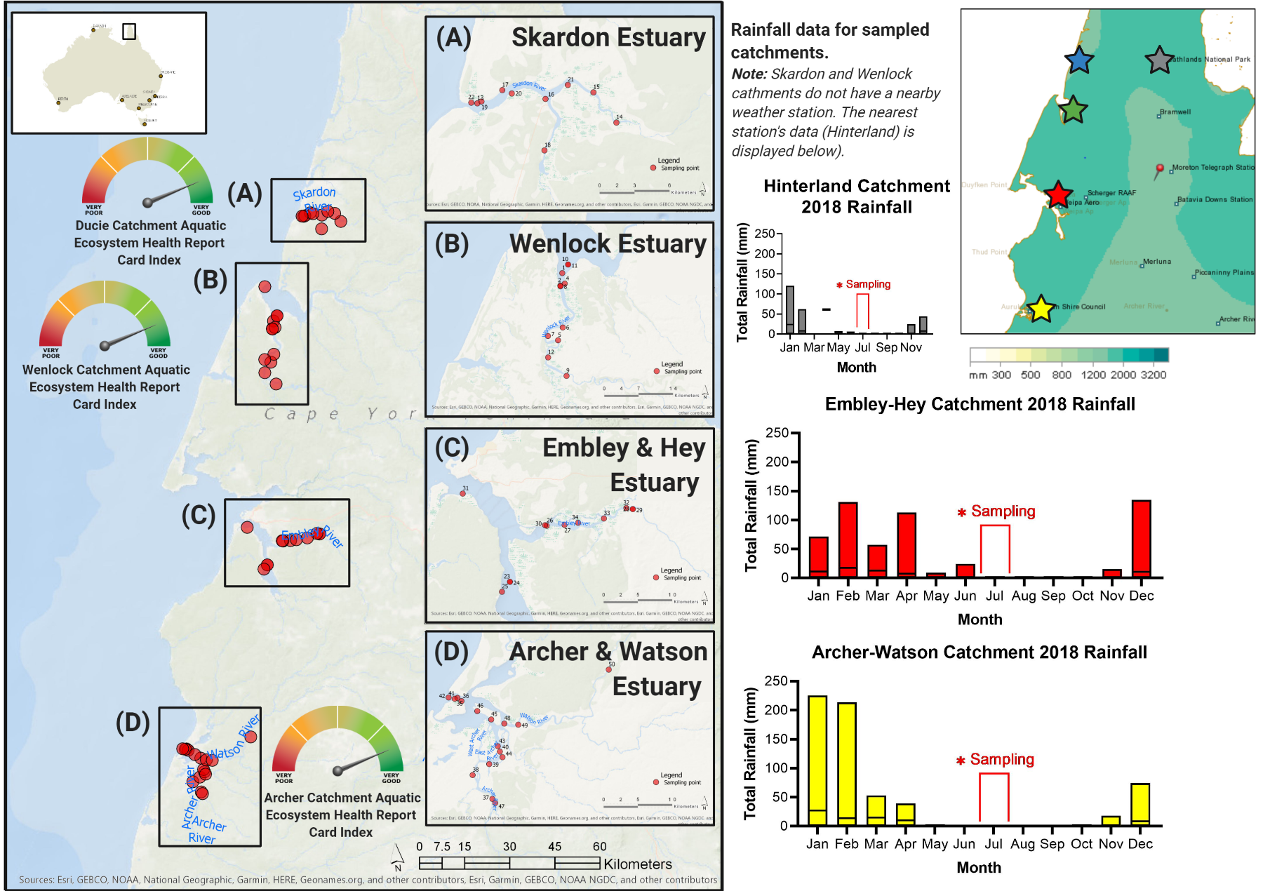
Figure 1. Map of the Western Cape York Peninsula (Far North Queensland, Australia), with the four sampled estuary systems, identified with the associated rainfall data for region and summary report card status based on the Queensland Government's State of the Environment report [12]. The sediment sampling sites are annotated by the red circles. The location of the rainfall weather stations are annotated by coloured five-point stars.

Reporting Requirements
Sample type: | Bacteria
Environemnt | Estuarine sediment (see particle size characterics and metadata (Tables S1-S4; Figure S1)
Pollution | Not detected.
Weather | No preceeding rain one month prior to sampling.
Collection approach | Push core;sampling and cold storage (-20°C) was undertaken from a live-aboard boat. Once at dock, all samples were transported to the laboratory and kept at -80°C until analysed.

Assessment against the current Australian sediments guidelines (physicochemical analyses)
The physicochemical characteristics of each estuary in terms of the data collected in situ and the sample metadata are summarised in Supplementary Table S1, and the full dataset is available at Crosswell et al. [13]. The data relating to individual sites is presented in Supplementary Table S2 and S3. These data are principally used to assess the health of the system against the Australian and New Zealand Guidelines for Fresh and Marine Water Quality in sediments [14]. Noting that the stated guideline trigger values represent the best currently available estimates of what are thought to be ecologically low-risk levels of these indicators for chronic (sustained) exposures. For these indicators, the guideline trigger values provide the starting point for negotiations about the threshold value and criterion for a management decision (i.e. water quality objectives). As such, levels above the trigger values are not a reason for concern in themselves, but more a decision point for determining water quality goals for their management into the future. With that in mind, the parameters that are at or above the noted trigger values for the sampled estuaries in FNQ are discussed here. Information related more broadly to the parameters below the trigger values are discussed in detail in the current guideline documents [14].
As highlighted in the physicochemical data presented in the supplementary section, the four estuaries sampled are generally considered healthy and in line with the guideline values for tropical Australian estuaries. The water quality and sediment parameters that were at or above the guideline trigger values related to chlorophyll-a, total nitrogen (TN), nitric oxide (NOx), and total phosphorous (TP). It is also noted that turbidity was high across the estuaries and measured concentrations of iron and aluminium were also high. However, these parameters don’t have associated guideline trigger values.
The chlorophyll-a content was noted above the guideline trigger values (0.002 mg L⁻¹, [14]) for all sampled sites. These results can indicate the presence of nuisance aquatic plants and/or photosynthetic microbiota. The high primary production indicated by high chlorophyll-a might benefit the functions of microbial communities with low abundance in the bottom of the water column. Here, the chlorophyll-a levels were slightly higher at the bottom compared with the surface. This difference in chlorophyll-a level between surface and bottom waters could be due to the heterogeneity of the microenvironment, vertical density gradients driven by estuarine circulation and the composition of microbial communities at the bottom water compared to the surface water.
The relationship between chlorophyll-a and primary nutrients (nitrogen and phosphorus) is well established [15]. Increased concentrations of TN and TP can result in increased growth of nuisance aquatic plants and algae, causing substantially degraded water quality. The elevated levels of chlorophyll-a measured in the sampled estuaries may be a result of the elevated measures of nitrogen and phosphorus at or above trigger values. It is noted that in some estuaries and inshore coastal waters, wind-induced resuspension or direct input of turbid water from the surrounding river systems [14], can lead to elevated turbidity levels. The distinct wet-dry seasonality of semi-arid Cape York estuaries has also been shown to trap and redistribute sediments over tidal and seasonal cycles, leading to extreme but highly variable turbidity [16, 17]. As such, the turbidity above 20 NTU for all estuary sites was expected and may account for elevated chlorophyll-a and primary nutrients.
High concentrations of iron and aluminium were found in all samples, while not linked to any trigger value explicitly. The sampled sites lie within the bauxite mining region in FNQ and therefore it is no surprise that the levels of these metals are high. The concentrations of other analysed heavy metals were negligible and below the trigger values for marine estuarine sediments. The sediments were also characterised by particles ranging in size from gravel to silt (Supplementary Table S4), with most sediments classified as gravelly sand to textural types of sand (Supplementary Figure S1). The analysed sediments were also below LOD from any pesticide residues that were screened against the Agilent Pesticide PCDL as part of the analysis (data not shown).

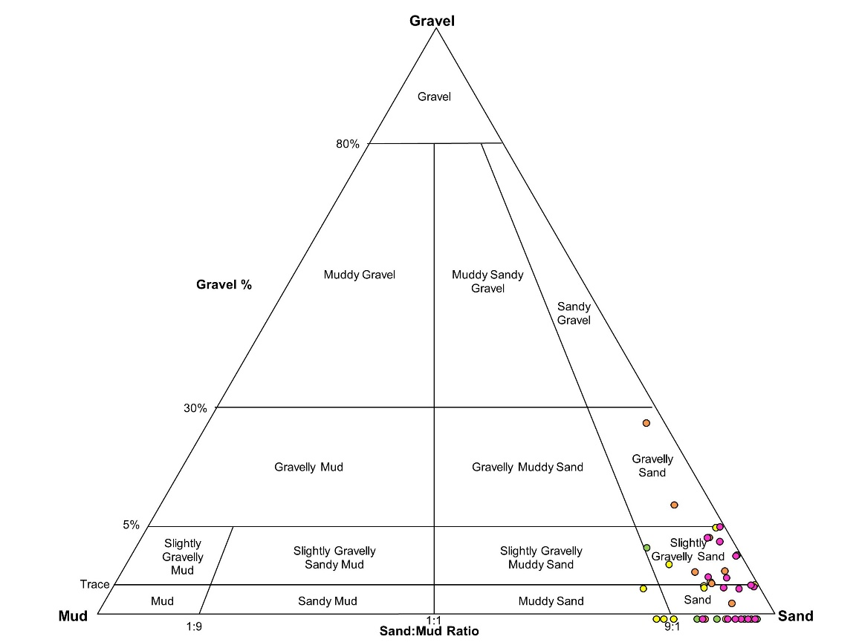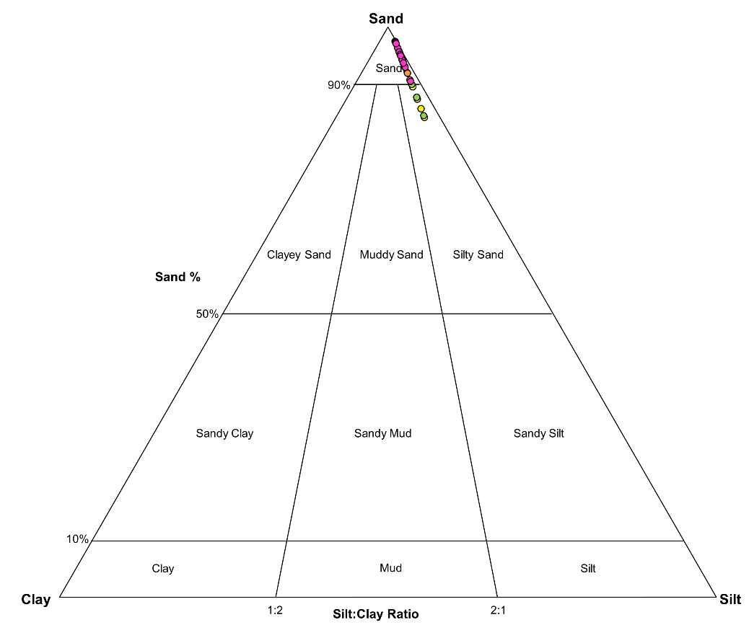
(B)
(A)
Figure S2. Grain size distribution from the sediments of the four Western Cape York Peninsula estuaries. (A) Gravel-sand-mud triangular diagram and (B) sand-silt-clay triangular diagram. Sediment samples from Wenlock, Skardon, Embley-Hey and Archer-Watson estuaries are represented by yellow, green, orange, and pink circles, respectively. For definition of various textural groups indicated in the figure, the readers are referred to [18].
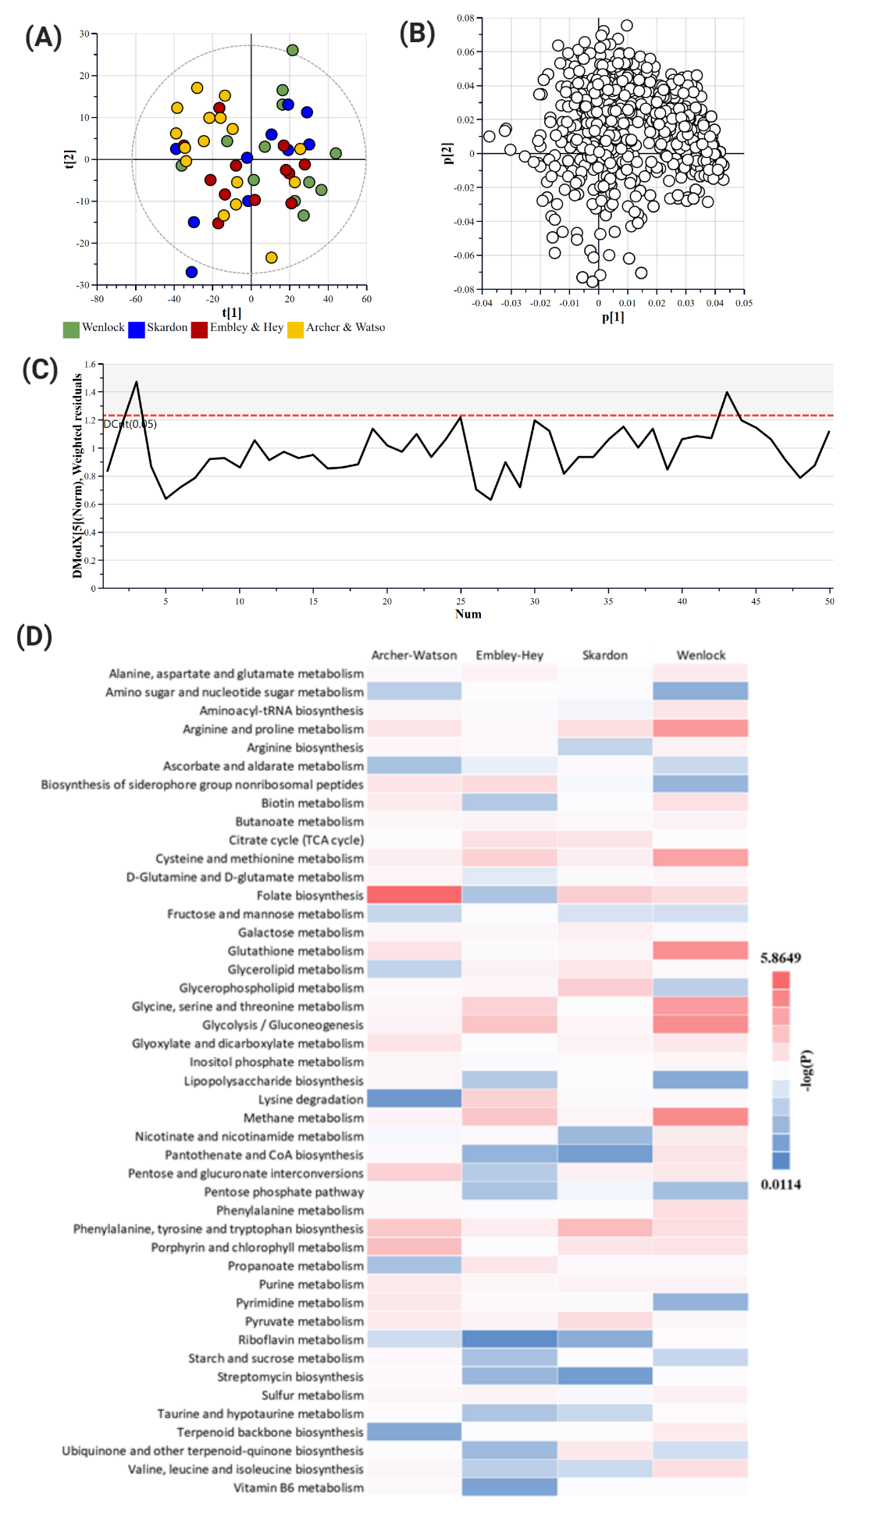
Figure S3. Multivariate analysis of the metabolomic-derived datasets collected from the sediments of the four Western Cape York Peninsula estuaries. (A) Principle Component Analysis (PCA) scatter plot; (B) PCA loadings plot. The white circles represent metabolites, while the blue circles represent the catchment cluster; (C) distance of observation (DModX); and, (D) Heat map of pathway mapping. For the PCA plots, the measures of fit were R₂X (cum) = 0.639 and Q₂ (cum) = 0.484. The plot ellipse represents the 95% confidence interval as represented by Hotelling’s T2 tolerance ellipse.
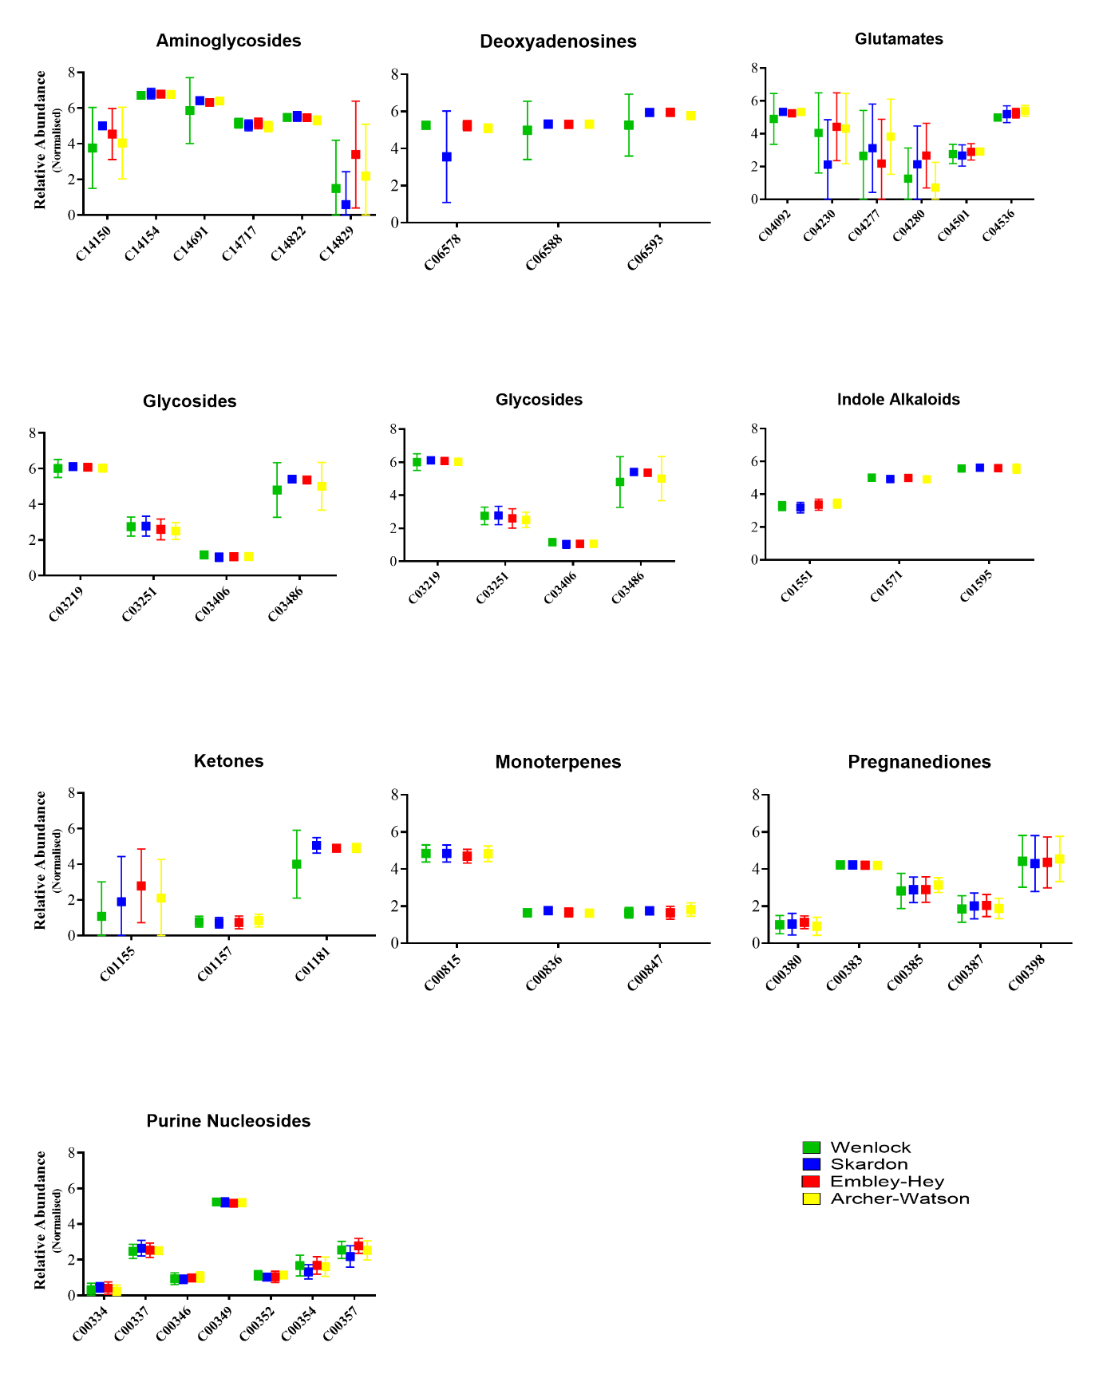
Figure S4. Significant chemical clusters identified from the Chemical Similarity Enrichment (ChemRICH) Analysis of KEGG-identified metabolites in estuarine sediments. Enrichment analysis is based on chemical similarities and uses Tanimoto substructure chemical similarity coefficients to cluster metabolites into non-overlapping chemical groups.

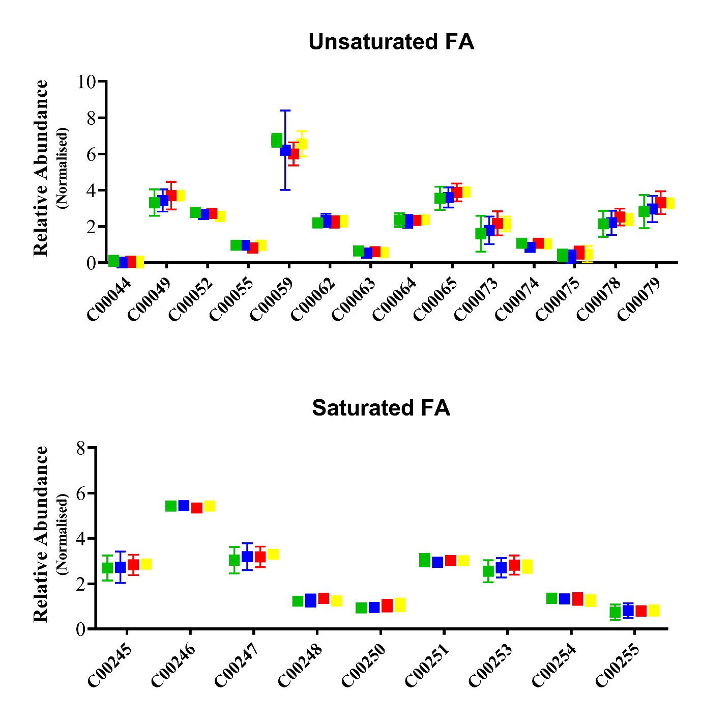
Figure S4 (continued). Significant chemical clusters identified from the Chemical Similarity Enrichment (ChemRICH) Analysis of KEGG-identified metabolites in estuarine sediments. Enrichment analysis is based on chemical similarities and uses Tanimoto substructure chemical similarity coefficients to cluster metabolites into non-overlapping chemical groups.

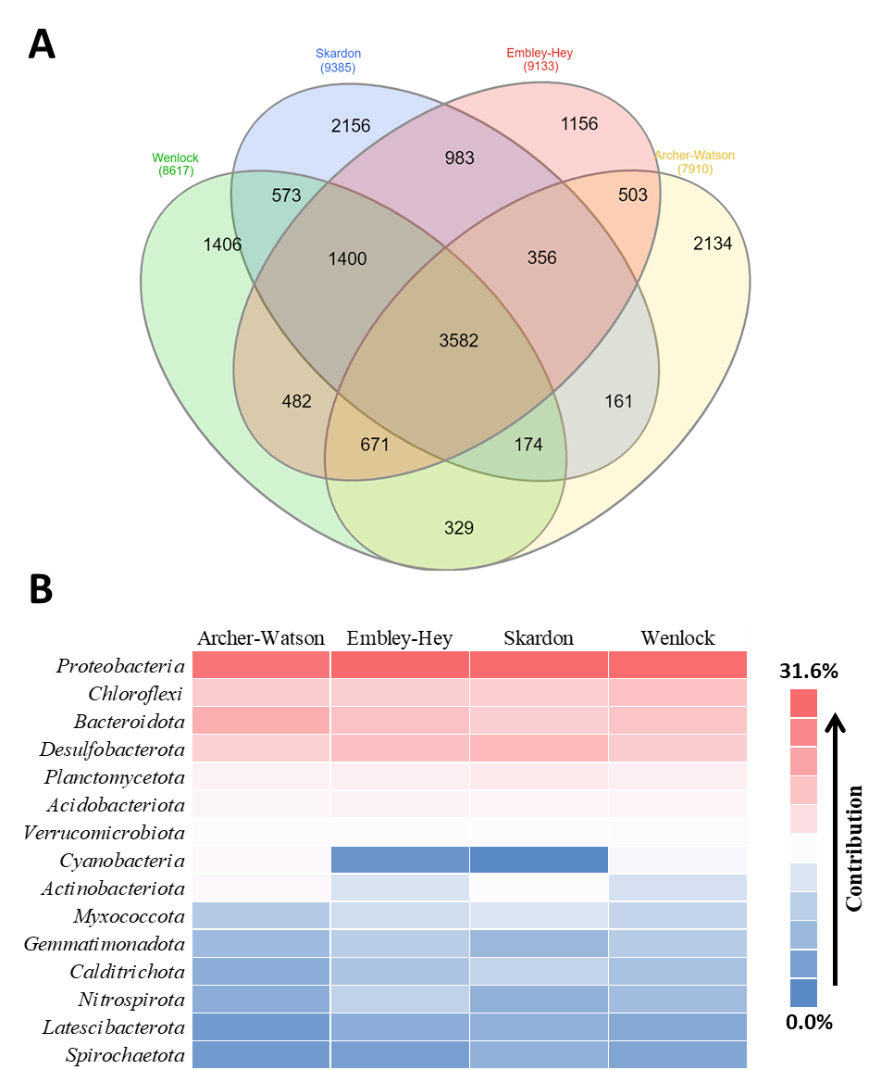
Figure S5. (A) Venn diagram showing unique and common phylotypes (OTUs) identified from four estuaries; and, (B) heat map showing relative abundance of bacterial phyla across four estuaries.

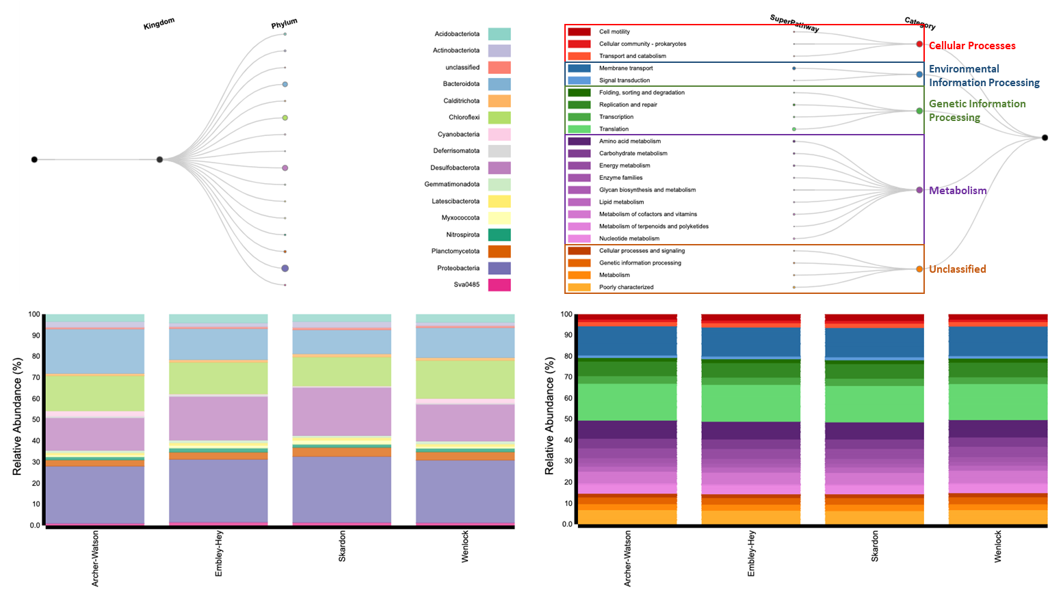
Figure S6. Predicted functional profiling of the entire taxonomic composition of estuarine microbiome as determined by Burrito webtool [19].

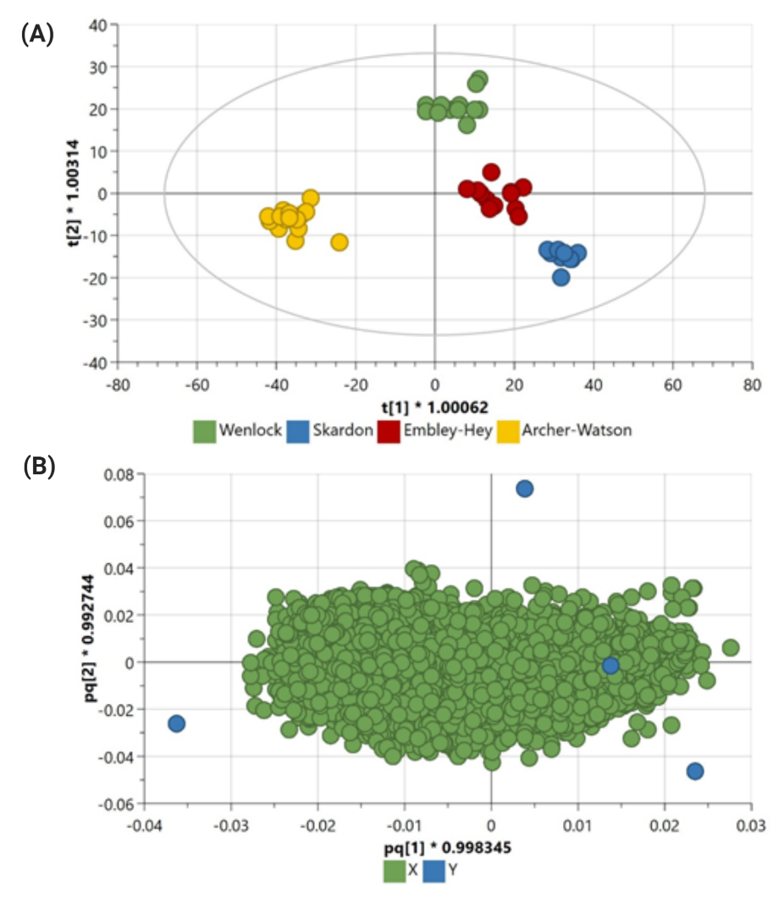
Figure S7. OPLS-DA plot based on identified functional genes in the four estuaries. (A) Scatter plot and (B) Loadings plot. R²X (cum) = 0.848, R²Y (cum) = 0.947, Q² (cum) = 0.713. The plot ellipse represents the 95% confidence interval as represented by Hotelling’s T2 tolerance ellipse.
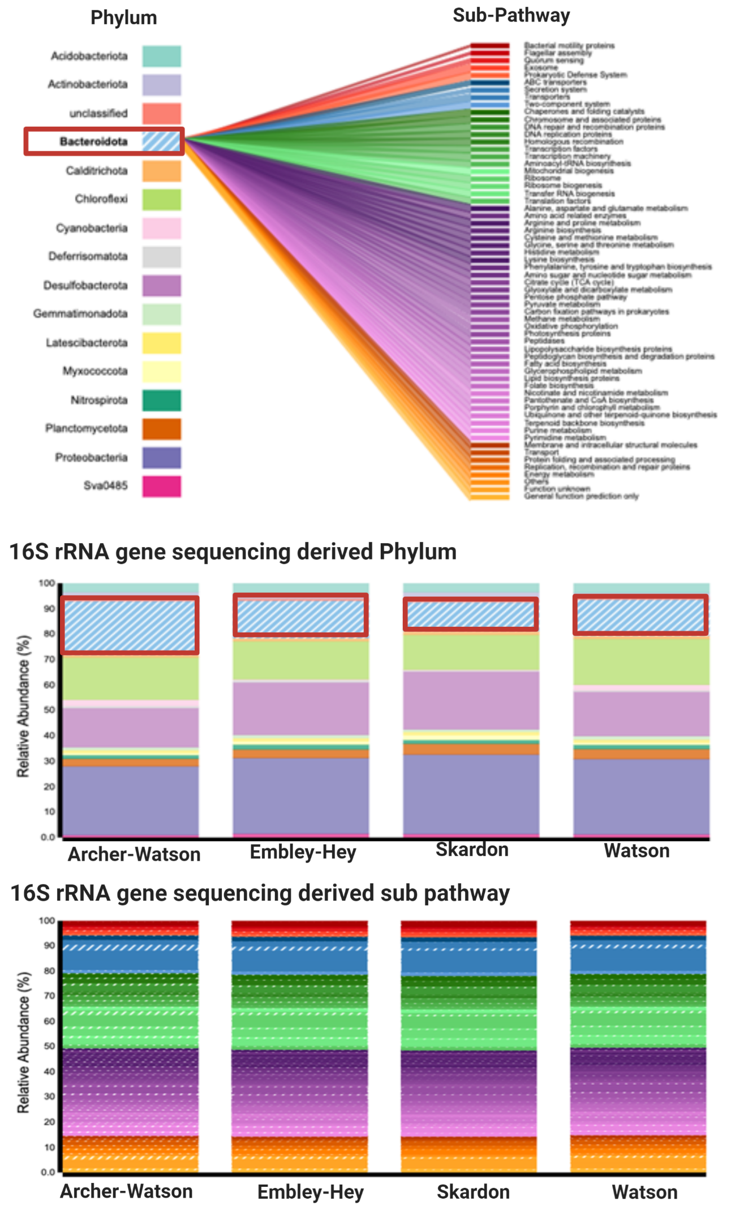
Figure S8. Predicated metabolism pathways of the Phylum Bacteroidata and their contribution to all metabolic pathways for the sampled estuaries as determined by Burito webtool [19].
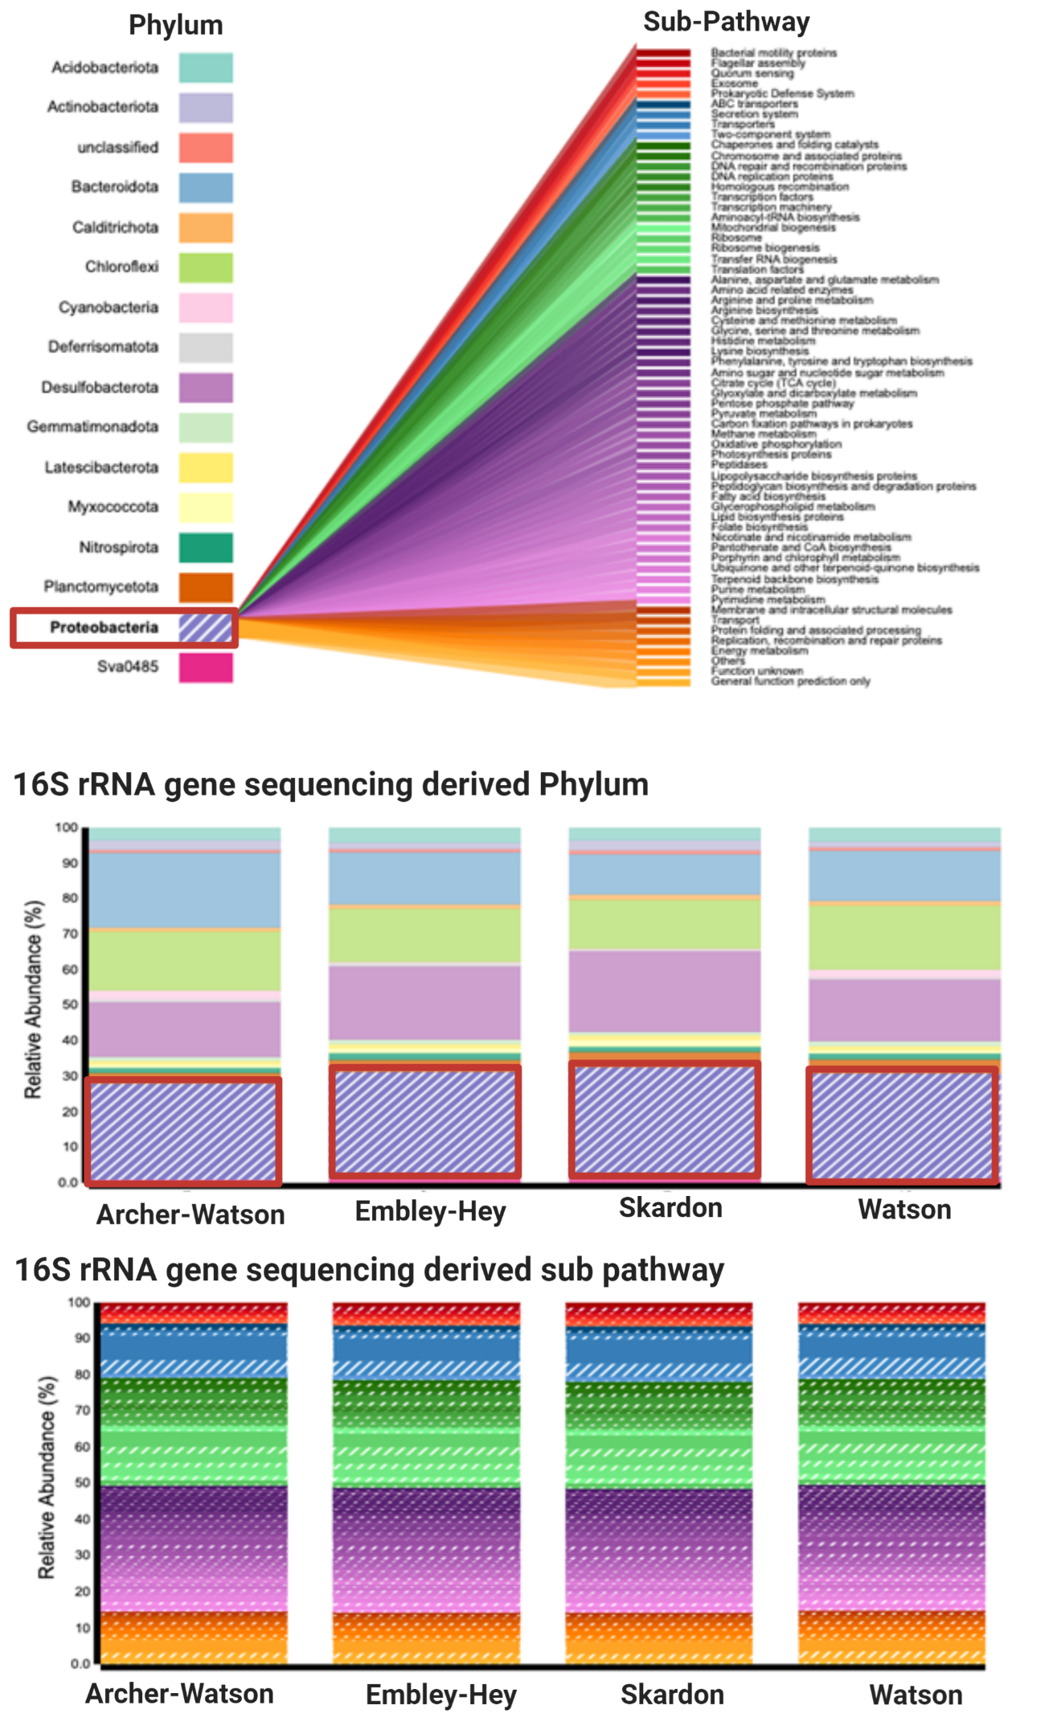
Figure S9. Predicated metabolism pathways of the Phylum Protoebacteria and their contribution to all pathways for the sampled estuaries as determined by Burito webtool [19].
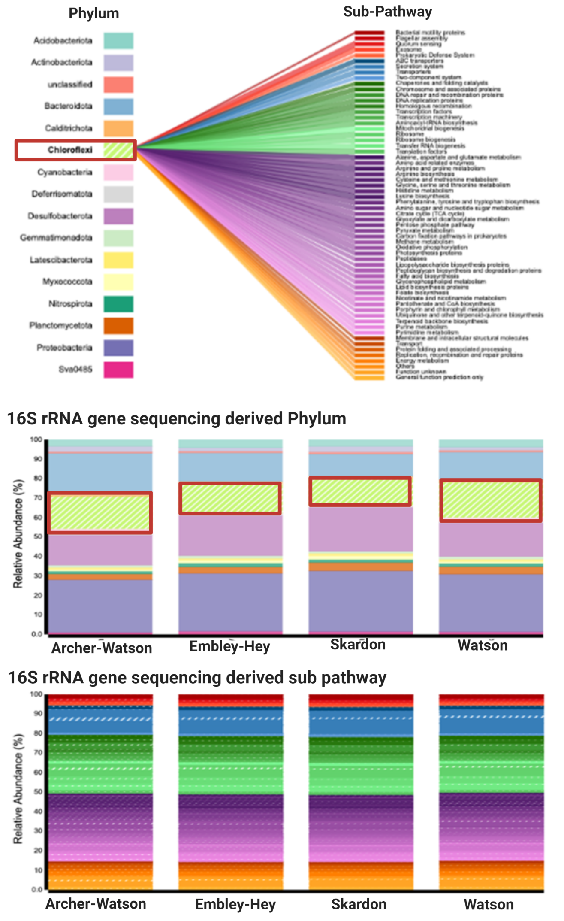
Figure S10. Predicated metabolism pathways of the Phylum Chloroflexi and their contribution to all metabolic pathways for the sampled estuaries as determined by Burito webtool [19].

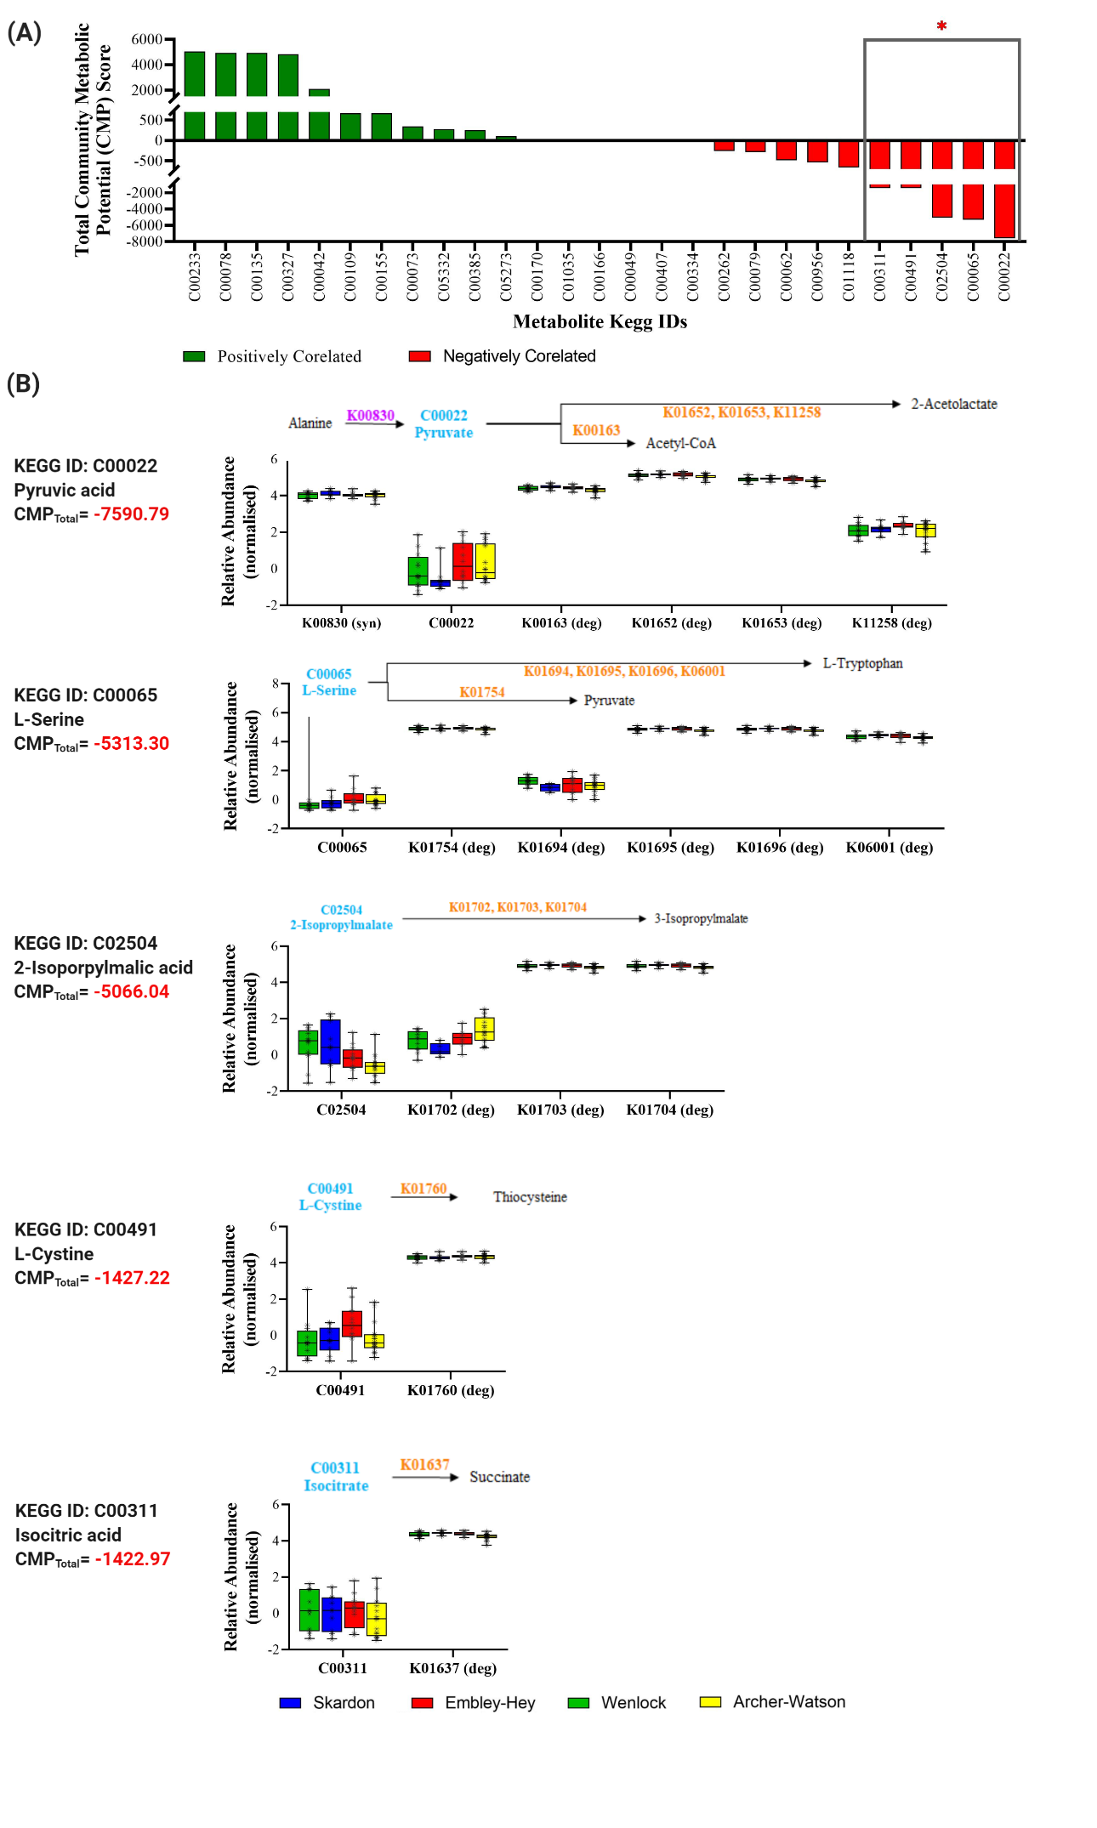
Figure S11. Negatively correlated community metabolic potentials (CMP). (A) Bottom 5 identified metabolites with a negatively correlated CMP score, as derived using the MIMOSA2; (B) Identified metabolic pathways (metabolites and genes). Note, metabolites with predicted CMP scores are annotated in blue text, genes contributing to synthesis are marked as (syn) and shown in a purple text in the reaction pathway, genes contributing to degradation are marked with (deg) and shown in orange text.
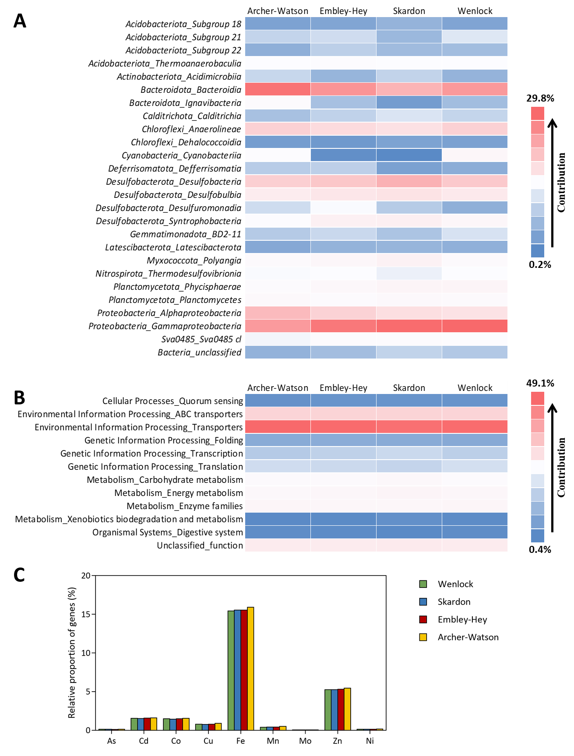
Figure S12. Functional genes related to the response towards metal accumulation in estuaries. (A) Taxonomic contribution to metals-related pathways, (B) Metagenomic functions related to metals, and (C) Relative proportion of genes contributing to various metal-related-pathways.
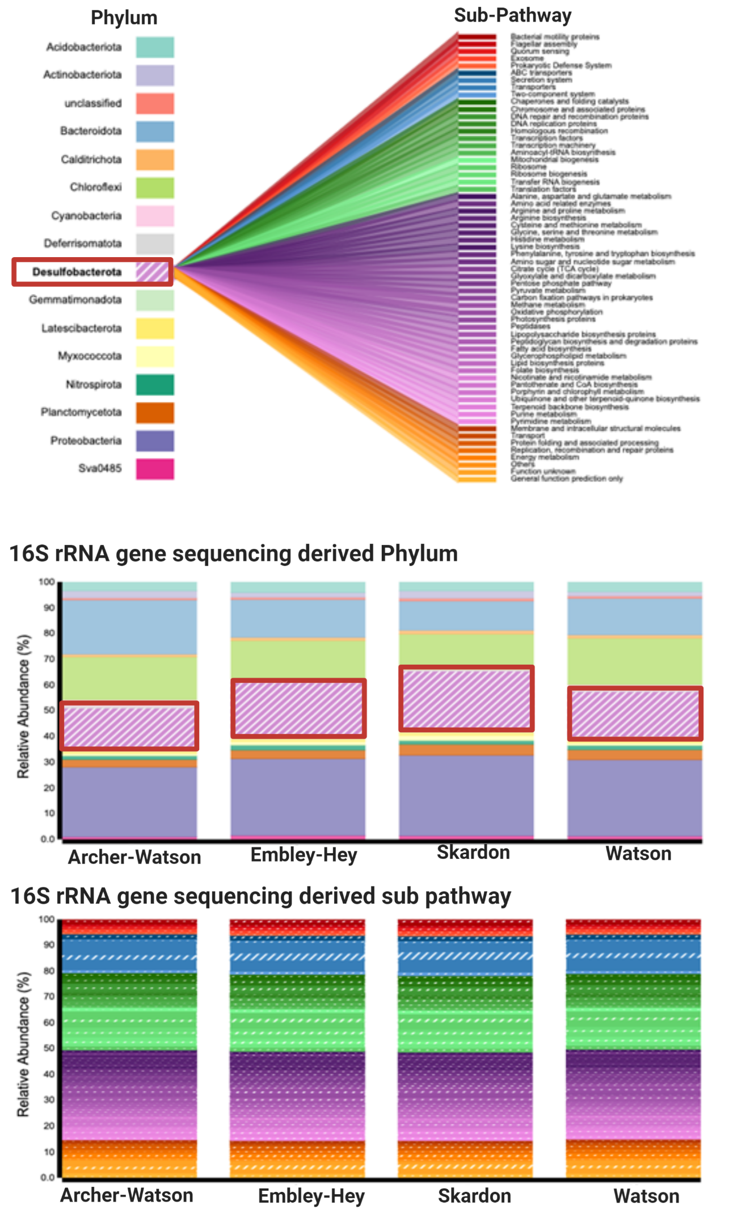Figure S13. Predicated metabolism pathways of the Phylum Desulfobacterota and their contribution to all metabolic pathways for the sampled estuaries as determined by Burito webtool [19].
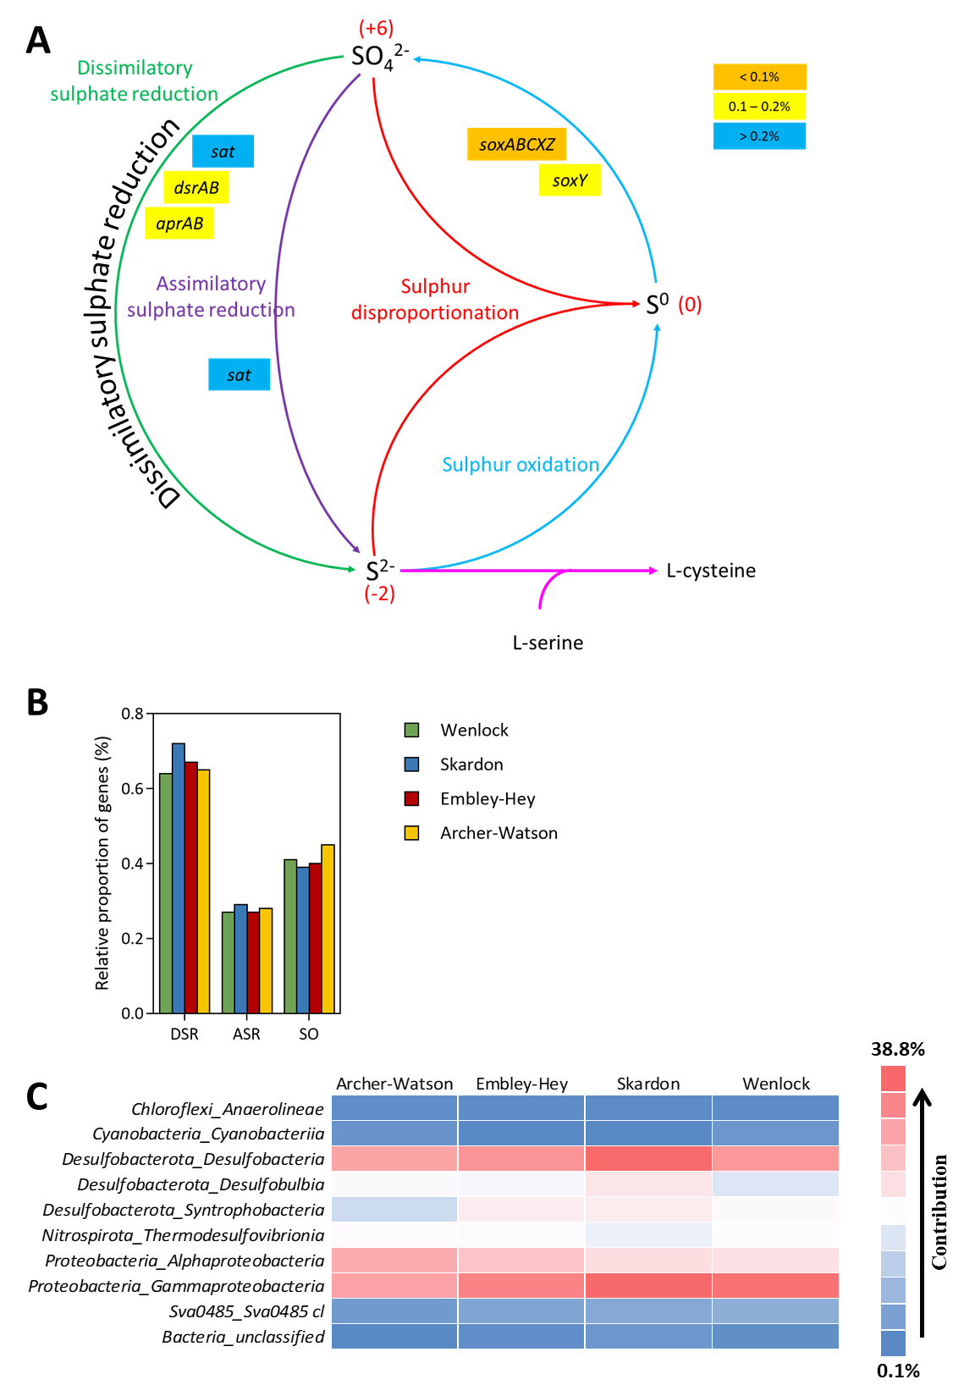
Figure S14. Sulphur metabolism in estuarine sediments. (A) Sulphur cycle (the number in brackets represent oxidation states of nitrogen), (B) Relative proportion of genes contributing to various pathways within sulphur metabolism, and (C) Taxonomic contribution to sulphur metabolism.
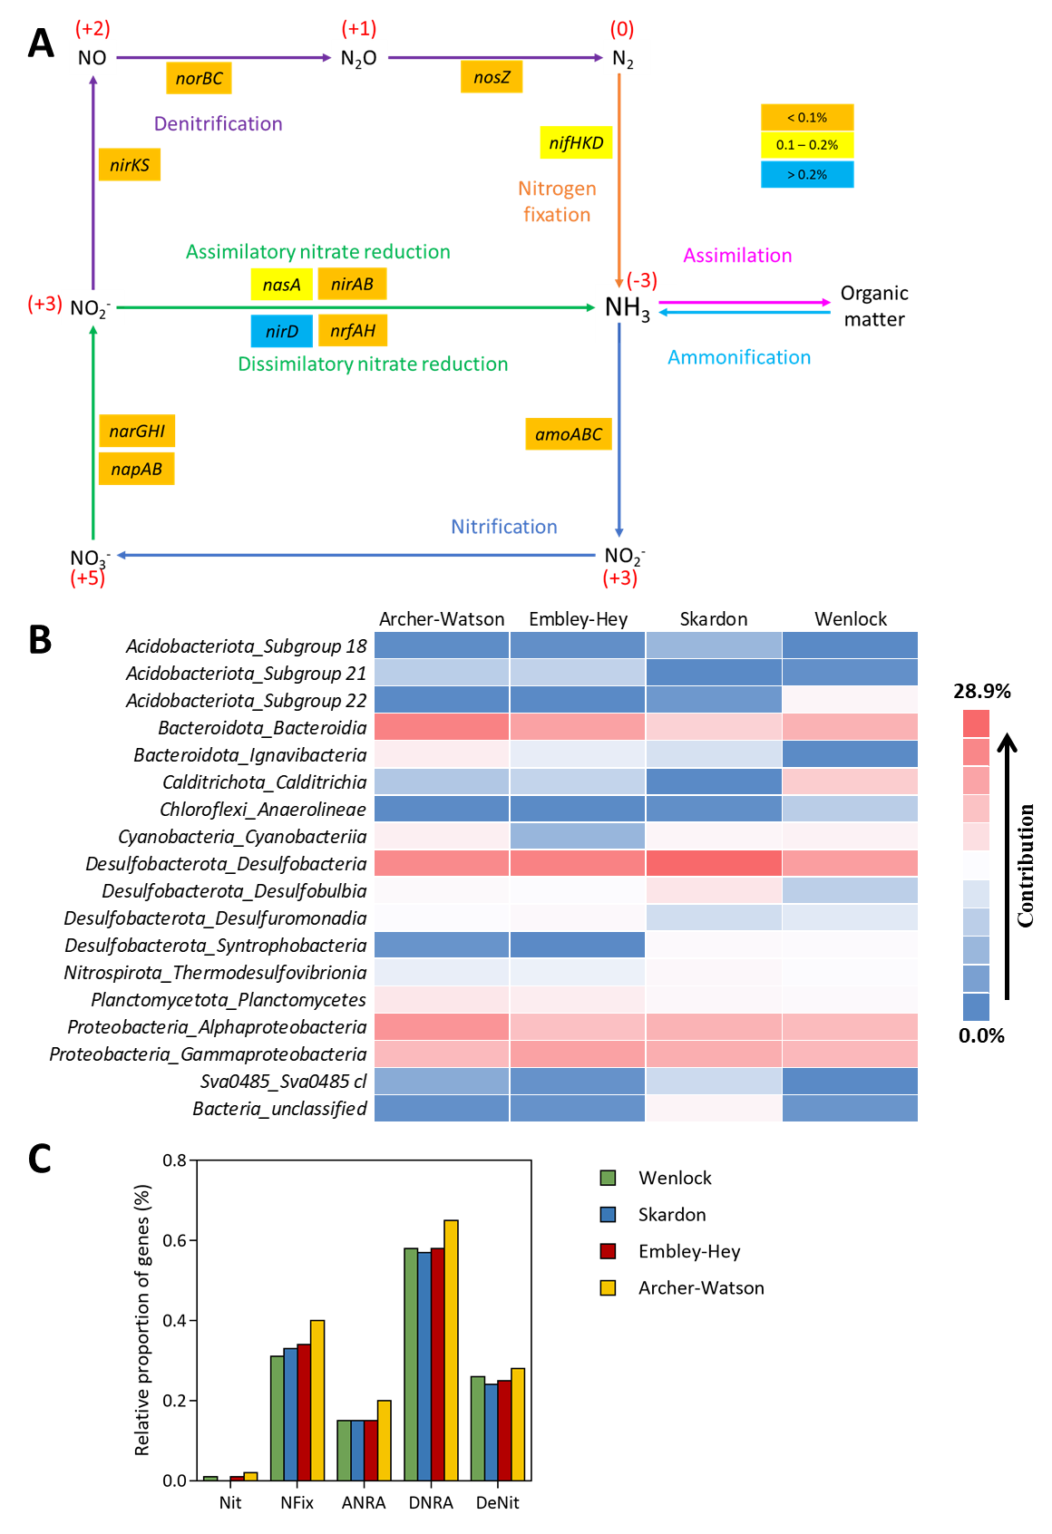
Figure S15. Nitrogen metabolism in estuarine sediments. (A) Nitrogen cycle (the number in brackets represent oxidation states of nitrogen), (B) Relative proportion of genes contributing to various pathways within nitrogen metabolism, and (C) Taxonomic contribution to nitrogen metabolism.

Table S1. Summary of characteristics of water column and sediment bottom for estuaries and the discrete measurements collected in-situ.
Parameter | Trigger values [14] | Wenlock (n = 12) | Skardon (n = 10) | Embley-Hey (n = 12) | Archer-Watson (n = 14)
Physical characteristics
Water quality Data (Bottom, at Sediment)
water column depth (m) | NA | 3.8 – 10.4 | 0.2 – 6.6 | 1.5 – 7.2 | 0.1 – 5.4
water temperature (°C) | NA | 24.7 – 26.3 | 24.8 – 27.4 | 25.3 – 26.4 | 25.7 – 28
salinity (PSU) | NA | 14.3 – 31.3 | 11.3 – 32.8 | 23.8 – 32.6 | 1.4 – 34.1
dissolved oxygen (DO) (% saturation) | 80 – 120% | 25.4 – 91.5 | 60.5 – 85.9 | 70.1 – 89.4 | 70.6 – 103.8
pH | 7 – 8.5 | 7.1 – 8.1 | 7.1 – 7.9 | 7.3 – 8.0 | 7.4 – 8.1
turbidity (NTU) | 1 – 20 | 5.0 – 688.9 | 3.4 – 247.4 | 6.1 – 554.7 | 5.5 – 493.7
chlorophyll a (mg L⁻¹) | 0.002 | 0.7 – 7.7 | 2.6 – 5.9 | 3.7 – 12.2 | 2.2 – 19.4
Water Quality Data (Surface Water)
water temperature (°C) | NA | 25.5 – 26.3 | 24.7 – 27.4 | 25.1 – 27.2 | 25.4 – 28.1
salinity (PSU) | NA | 7.6 – 29.7 | 22.5 – 32.8 | 9.7 – 32.7 | 2.1 – 29.9
dissolved oxygen (DO) (% saturation) | 80 – 120% | 79.7 – 91.9 | 74.1 – 91.6 | 73.8 – 97.5 | 73.1 – 106.6
pH | 7 – 8.5 | 7.2 – 7.9 | 7.0 – 7.9 | 7.1 – 7.9 | 7.3 – 8.0
turbidity (NTU) | 1-20 | 4.2 – 59.0 | 1.7 – 15.5 | 4 – 26.1 | 5.1 – 50.8
chlorophyll a (mg L⁻¹) | 0.002 | 2.0 – 4.9 | 1.6 – 4.1 | 2.2 – 5.4 | 2.3 – 6.6
Nutrients
Nitrogen as N (μM)
dissolved organic nitrogen (DON) | NA | 11.4 – 14.6 | 11.6 – 15.8 | 10.2 – 16.0 | 9.7 – 16.0
nitrogen in the form of ammonium (NH₄⁺) | 1.07 | 0 – 1.6 | 0.1 – 0.7 | 0.1 – 2.6 | 0.1 – 2.8
nitrogen in the form of oxide (NO_{X}) | 2.14 | 0 – 0.7 | 0.1 – 0.8 | 0.3 – 6.2 | 0.1 – 4.6
total nitrogen (TN) | 17.8 | 16.4 – 25.7 | 13.6 – 30.7 | 12.1 – 24.3 | 14.3 – 23.6
total dissolved nitrogen (TDN) | NA | 11.4 – 15.7 | 12.1 – 16.4 | 10.7 – 22.1 | 11.4 – 20.0
total particulate nitrogen (TPN) | NA | 5.0 – 12.1 | 0.1 – 5.7 | 0.1 – 8.6 | 2.1 – 11.4
Carbon as C (mg L⁻¹)
dissolved organic carbon (DOC) | NA | 2 – 3.7 | 1.2 – 3.0 | 0 – 2.3 | 1.4 – 5.0
total organic carbon (TOC) | NA | 1.7 – 4.1 | 1.2 – 3.9 | 0 – 3.1 | 1.6 – 7.1
Note: The full water column data, metadata and methods can be found at Crosswell et al. [13]. PSU: practical salinity unit; NTU: nephelometric turbidity unit; FNU: formazin nephelometric unit
Table S1 (continued). Summary of characteristics of water column and sediment bottom for estuaries and the discrete measurements collected in-situ.
Parameter | Trigger values [14] | Wenlock (n = 12) | Skardon (n = 10) | Embley-Hey (n = 12) | Archer-Watson (n = 14)
Nutrients (continued)
Phosphorus as P (μM)
dissolved organic phosphorus (DOP) | NA | 0 – 0.2 | 0 – 0.2 | 0 – 0.3 | 0 – 0.2
phosphorus in the form of phosphate (PO₄³⁻) | NA | 0 – 0.1 | 0 – 0.1 | 0 – 0.3 | 0 – 0.2
total phosphorus (TP) | 0.65 | 0.3 – 0.8 | 0.2 – 0.8 | 0.3 – 1.5 | 0.2 – 1.5
total dissolved phosphorus (TDP) | NA | 0 – 0.2 | 0 – 0.2 | 0 – 0.6 | 0 – 0.4
total particulate phosphorus (TPP) | NA | 0.2 – 0.8 | 0.2 – 0.8 | 0– 1.1 | 0.2 – 1.2
Heavy metals
Iron (Fe) (mg kg⁻¹) | NA | 25.8 – 199.2 | 17.2 – 231.8 | 38.9 – 128.2 | 20.4 – 160.1
Aluminium (Al) (mg kg⁻¹) | NA | 8.9 – 106.5 | 3.4 – 127.0 | 26.3 – 73.8 | 20.6 – 115.9
Nickel (Ni) (mg kg⁻¹) | 21 | < 0.1 | < 0.1 | < 0.1 | < 0.1
Zinc (Zn) (mg kg⁻¹) | 200 | < 0.1 | < 0.1 | < 0.1 | < 0.1
Cadmium (Cd) (mg kg⁻¹) | 1.5 | < 0.1 | < 0.1 | < 0.1 | < 0.1
Lead (Pb) (mg kg⁻¹) | 50 | < 0.1 | < 0.1 | < 0.1 | < 0.1
Arsenic (As) (mg kg⁻¹) | 20 | < 0.1 | < 0.1 | < 0.1 | < 0.1
Copper (Cu) (mg kg⁻¹) | 65 | < 0.1 | < 0.1 | < 0.1 | < 0.1
Mercury (Hg) (mg kg⁻¹) | 0.15 | < 0.1 | < 0.1 | < 0.1 | < 0.1
Note: The full water column data, metadata and methods can be found at Crosswell et al. [13].
Table S2. Summary of characteristics of water column and sediment bottom at each sampling site and the discrete measurements collected in-situ.
Estuary | Site | GPS Co-ordinates |  | Water quality Data (Bottom, at Sediment) |  |  |  |  |  |  | Water Quality Data (Surface Water)
Estuary | Site | Latitude | Latitude | Water column depth (m) | Water Temp. (°C) | Salinity  (PSU) | DO (%) | pH | Turbidity (NTU) | Chlorophyll a (μg L⁻¹) | Temp. (°C) | Salinity  (PSU) | DO (%) | pH | Turbidity (FNU) | Chlorophyll a (μg L⁻¹)
Wenlock | 1 | -12.0691 | -12.0691 | 6.0 | 25.7 | 30.9 | 91.5 | 8.0 | 194.7 | 3.59 | 26.1 | 27.2 | 80.5 | 7.8 | 56.8 | 2.0
Wenlock | 2 | -12.0922 | -12.0922 | 3.8 | 26.1 | 23.8 | 73.8 | 7.5 | 404.2 | 3.57 | 26.1 | 26.7 | 79.7 | 7.8 | 52.3 | 2.8
Wenlock | 3 | -11.9664 | -11.9664 | 5.1 | 24.7 | 31.3 | 93.9 | 8.1 | 7.9 | 6.12 | NC | NC | NC | NC | NC | NC
Wenlock | 4 | -12.0883 | -12.0883 | 7.1 | 25.5 | 21.9 | 94.9 | 7.1 | 16.3 | 0.73 | 25.7 | 27.7 | 85.2 | 7.9 | 5.2 | 3.4
Wenlock | 5 | -12.1922 | -12.1922 | 10.4 | 26.3 | 14.3 | 91.0 | 7.7 | 77.2 | 6.13 | 26.1 | 17.8 | 81.9 | 7.8 | 7.5 | 3.5
Wenlock | 6 | -12.1687 | -12.1687 | 7.4 | 26.3 | 21.3 | 82.9 | 7.8 | 688.9 | 7.67 | 26.1 | 22.6 | 84.3 | 7.8 | 51.9 | 3.8
Wenlock | 7 | -12.1843 | -12.1843 | 5.7 | 26.3 | 18.0 | 25.4 | 7.8 | 34.1 | 1.5 | 26.1 | 20.7 | 78.3 | 7.7 | 7.8 | 3.1
Wenlock | 8 | -12.0931 | -12.0931 | NA | NA | NA | NA | NA | NA | NA | 26.1 | 26.7 | 79.7 | 7.8 | 52.3 | 2.8
Wenlock | 9 | -12.2575 | -12.2575 | NA | NA | NA | NA | NA | NA | NA | 26.1 | 7.6 | 86.7 | 7.2 | 59.0 | 4.9
Wenlock | 10 | -12.0534 | -12.0534 | NA | NA | NA | NA | NA | NA | NA | 25.5 | 29.7 | 91.9 | 7.9 | 4.2 | 3.2
Wenlock | 11 | -12.0534 | -12.0534 | NA | NA | NA | NA | NA | NA | NA | 26.3 | 22.8 | 83.3 | 7.8 | 56.5 | 4.1
Wenlock | 12 | -12.2236 | -12.2236 | 8.0 | 25.9 | 25.3 | 80.4 | 7.8 | 5.0 | 3.81 | NC | NC | NC | NC | NC | NC
Skardon | 13 | -11.7560 | -11.7560 | 5.4 | NA | NA | NA | NA | NA | NA | 25.8 | 32.5 | 87.1 | 7.9 | 2.6 | 1.6
Skardon | 14 | -11.7713 | -11.7713 | 0.2 | 27.4 | 22.9 | 85.9 | 7.2 | 14.4 | 2.6 | 27.4 | 22.5 | 87.0 | 7.2 | 15.5 | 2.7
Skardon | 15 | -11.7502 | -11.7502 | 1.3 | 26.3 | 29.9 | 74.1 | 7.3 | 6.0 | 3.05 | 26.3 | 29.9 | 74.1 | 7.3 | 5.6 | 2.8
Skardon | 16 | -11.7524 | -11.7524 | 7.0 | 25.4 | 30.9 | 64.1 | 7.4 | 4.0 | 2.96 | 25.4 | 30.7 | 63.3 | 7.4 | 4.0 | 2.6
Skardon | 17 | -11.7454 | -11.7454 | 3.5 | 25.6 | 32.1 | 77.8 | 7.7 | 3.6 | 2.67 | 25.6 | 32.0 | 77.8 | 7.7 | 3.7 | 2.5
Skardon | 18 | -11.7935 | -11.7935 | NA | NA | NA | NA | NA | NA | NA | 25.6 | 25.2 | 48.2 | 7.0 | 7.3 | 4.1
Skardon | 19 | -11.7545 | -11.7545 | 6.1 | 24.6 | 11.3 | 76.0 | 7.1 | 247.4 | 5.91 | 25.0 | 32.8 | 91.6 | 7.9 | 1.8 | 2.0
Skardon | 20 | -11.7481 | -11.7481 | 6.6 | 24.8 | 32.8 | 85.3 | 7.9 | 3.4 | 2.7 | 24.8 | 32.7 | 86.0 | 7.9 | 2.9 | 2.8
Skardon | 21 | -11.7413 | -11.7413 | 1.9 | 25.5 | 30.4 | 60.5 | 7.3 | 3.8 | 2.76 | 24.7 | 31.2 | 74.6 | 7.5 | 3.0 | 3.5
Skardon | 22 | -11.7554 | -11.7554 | 1.4 | NA | NA | NA | NA | NA | NA | 24.9 | 33.0 | 90.5 | 7.9 | 1.7 | 1.7
Note: The full water column data, metadata and methods can be found at Crosswell et al. [13]. DO: dissolved oxygen; GPS: global positioning system; PSU: practical salinity unit; NTU: nephelometric turbidity unit; FNU: formazin nephelometric unit; NA and NC denote ‘not available’ and ‘not collected’ respectively.

Table S2 (continued). Summary of characteristics of water column and sediment bottom at each sampling site and the discrete measurements collected in-situ.
Estuary | Site | GPS Co-ordinates |  | Bottom of water column |  |  |  |  |  |  | Surface Water
Estuary | Site | Latitude | Latitude | Water column depth (m) | Water Temp. (°C) | Salinity  (PSU) | DO (%) | pH | Turbidity (NTU) | Chlorophyll a (μg L⁻¹) | Temp. (°C) | Salinity  (PSU) | DO (%) | pH | Turbidity (FNU) | Chlorophyll a (μg L⁻¹)
Embley-Hey | 23 | -12.7984 | -12.7984 | 7.2 | NA | NA | NA | NA | NA | NA | 25.1 | 32.7 | 88.0 | 7.9 | 12.4 | 2.8
Embley-Hey | 24 | -12.7984 | -12.7984 | NA | NA | NA | NA | NA | NA | NA | 25.1 | 32.7 | 88.0 | 7.9 | 12.4 | 2.8
Embley-Hey | 25 | -12.8111 | -12.8111 | 7.2 | NA | NA | NA | NA | NA | NA | 25.1 | 32.7 | 88.0 | 7.9 | 12.4 | 2.8
Embley-Hey | 26 | -12.7271 | -12.7271 | 5.1 | 26.4 | 29.1 | 81.2 | 7.5 | 16.4 | 5.25 | 26.2 | 30.0 | 80.6 | 7.6 | 26.1 | 3.5
Embley-Hey | 27 | -12.7259 | -12.7259 | 5.0 | 25.3 | 32.6 | 89.4 | 8.0 | 6.8 | 3.69 | 26.4 | 29.1 | 81.0 | 7.5 | 16.3 | 5.0
Embley-Hey | 28 | -12.7059 | -12.7059 | 2.1 | 25.8 | 23.8 | 70.1 | 7.3 | 10.3 | 5.74 | 27.2 | 9.7 | 95.4 | 7.3 | 5.3 | 3.4
Embley-Hey | 29 | -12.7059 | -12.7059 | NA | NA | NA | NA | NA | NA | NA | 27.2 | 20.1 | 78.2 | 7.1 | 10.2 | 5.4
Embley-Hey | 30 | -12.7263 | -12.7263 | NA | NA | NA | NA | NA | NA | NA | 25.3 | 32.5 | 93.5 | 7.9 | 5.0 | 2.2
Embley-Hey | 31 | -12.6862 | -12.6862 | 1.5 | 26.2 | 29.2 | 87.6 | 7.5 | 9.0 | 4.45 | NC | NC | NC | NC | NC | NC
Embley-Hey | 32 | -12.7045 | -12.7045 | 1.8 | 25.9 | 25.5 | 70.6 | 7.4 | 6.1 | 4.35 | 25.7 | 25.0 | 73.8 | 7.3 | 4.7 | 4.5
Embley-Hey | 33 | -12.7178 | -12.7178 | 1.6 | 25.7 | 29.2 | 84.6 | 7.6 | 554.7 | 12.22 | 25.9 | 28.1 | 86.3 | 7.6 | 4.9 | 3.2
Embley-Hey | 34 | -12.7232 | -12.7232 | 2.0 | 26.4 | 28.0 | 76.9 | 7.3 | 18.8 | 6.51 | 25.8 | 31.5 | 97.5 | 7.9 | 4.0 | 3.4
Archer-Watson | 35 | -13.3488 | -13.3488 | 3.7 | 25.7 | 34.1 | 85.9 | 8.1 | 187.0 | 10.79 | 26.7 | 28.7 | 87.7 | 7.9 | 50.8 | 3.3
Archer-Watson | 36 | -13.3529 | -13.3529 | NA | NA | NA | NA | NA | NA | NA | 26.7 | 28.7 | 87.7 | 7.9 | 50.8 | 3.3
Archer-Watson | 37 | -13.4774 | -13.4774 | 0.2 | 27.8 | 1.4 | 102.3 | 7.5 | 5.5 | 2.24 | 27.9 | 2.1 | 99.3 | 7.4 | 5.1 | 2.3
Archer-Watson | 38 | -13.4470 | -13.4470 | NA | NA | NA | NA | NA | NA | NA | 28.1 | 6.9 | 99.0 | 7.5 | 5.2 | 2.5
Archer-Watson | 39 | -13.4331 | -13.4331 | 0.1 | 28.0 | 7.0 | 97.1 | 7.4 | 276.1 | 10.9 | 27.7 | 11.3 | 101.3 | 7.8 | 6.3 | 4.3
Archer-Watson | 40 | -13.4172 | -13.4172 | NA | NA | NA | NA | NA | NA | NA | 27.9 | 16.8 | 106.6 | 7.9 | 9.6 | 5.5
Archer-Watson | 41 | -13.3499 | -13.3499 | 1.9 | 25.7 | 33.7 | 83.6 | 8.1 | 47.4 | 3.4 | 26.5 | 29.5 | 88.4 | 7.9 | 29.2 | 2.7
Archer-Watson | 42 | -13.3484 | -13.3484 | NA | NA | NA | NA | NA | NA | NA | 26.5 | 29.5 | 88.4 | 7.9 | 29.2 | 2.7
Archer-Watson | 43 | -13.4102 | -13.4102 | 5.3 | 27.6 | 19.3 | 103.8 | 7.9 | 417.9 | 8.63 | 27.7 | 19.5 | 105.4 | 7.9 | 12.9 | 5.9
Archer-Watson | 44 | -13.4243 | -13.4243 | NA | NA | NA | NA | NA | NA | NA | 27.8 | 11.4 | 100.2 | 7.6 | 10.7 | 4.0
Archer-Watson | 45 | -13.3763 | -13.3763 | NA | NA | NA | NA | NA | NA | NA | 25.4 | 29.9 | 89.3 | 8.0 | 11.8 | 3.6
Archer-Watson | 46 | -13.3656 | -13.3656 | 3.7 | 27.3 | 22.5 | 70.6 | 7.9 | 493.7 | 6.57 | 25.4 | 29.9 | 89.3 | 8.0 | 11.8 | 3.6
Archer-Watson | 47 | -13.4826 | -13.4826 | NA | NA | NA | NA | NA | NA | NA | 27.9 | 2.1 | 99.3 | 7.4 | 5.1 | 2.3
Archer-Watson | 48 | -13.3815 | -13.3815 | 4.0 | 27.8 | 18.6 | 102.1 | 7.9 | 242.6 | 19.35 | 27.5 | 23.8 | 93.3 | 7.9 | 10.2 | 6.6
Archer-Watson | 49 | -13.3829 | -13.3829 | 5.4 | 26.9 | 26.7 | 82.5 | 7.9 | 13.1 | 5.43 | 27.4 | 24.7 | 96.9 | 8.0 | 18.3 | 5.5
Archer-Watson | 50 | -13.3129 | -13.3129 | NA | NA | NA | NA | NA | NA | NA | 27.4 | 13.2 | 73.1 | 7.3 | 5.1 | 4.5
Note: The full water column data, metadata and methods can be found at Crosswell et al. [13]. DO: dissolved oxygen; GPS: global positioning system; PSU: practical salinity unit; NTU: nephelometric turbidity unit; FNU: formazin nephelometric unit; NA and NC denote ‘not available’ and ‘not collected’ respectively.
Table S3. Percentage of sediment grain particles with a diameter smaller than the sieve size fraction indicated for each site.
Estuary | Site | Site Sediment grain particles (%) |  |  |  | Textural group
Estuary | Site | 2.00 < x < 4.00 mm | 0.5 < x < 2.00 mm | 0.063 < x < 0.5 mm | x < 0.063 mm | Textural group
Estuary | Site | Gravel | Coarse sand | Fine sand | Silt | Textural group
Wenlock | 1 | 0.0 | 6.6 | 54.2 | 39.2 | Muddy Sand
Wenlock | 2 | 0.6 | 6.2 | 38.5 | 54.8 | Slightly Gravelly Muddy Sand
Wenlock | 3 | 0.9 | 3.8 | 90.7 | 4.5 | Slightly Gravelly Sand
Wenlock | 4 | 0.8 | 22.5 | 48.2 | 28.5 | Slightly Gravelly Sand
Wenlock | 5 | 0.0 | 16.2 | 57.2 | 26.6 | Sand
Wenlock | 6 | 2.5 | 16.4 | 53.9 | 27.2 | Slightly Gravelly Sand
Wenlock | 7 | 0.7 | 34.8 | 42.7 | 21.8 | Slightly Gravelly Sand
Wenlock | 8 | 1.1 | 21.9 | 59.9 | 17.0 | Slightly Gravelly Sand
Wenlock | 9 | 0.0 | 14.4 | 58.3 | 27.3 | Muddy Sand
Wenlock | 10 | 6.0 | 46.3 | 41.3 | 6.3 | Gravelly Sand
Wenlock | 11 | 0.0 | 4.8 | 45.3 | 49.8 | Sand
Wenlock | 12 | 0.0 | 5.2 | 88.4 | 6.5 | Sand
Skardon | 13 | 3.2 | 32.9 | 60.9 | 2.9 | Slightly Gravelly Sand
Skardon | 14 | 3.8 | 19.0 | 51.7 | 25.6 | Slightly Gravelly Muddy Sand
Skardon | 15 | 0.0 | 3.2 | 67.4 | 29.4 | Sand
Skardon | 16 | 0.0 | 15.6 | 64.7 | 19.7 | Sand
Skardon | 17 | 0.0 | 9.1 | 43.7 | 47.2 | Muddy Sand
Skardon | 18 | 0.0 | 18.2 | 60.7 | 21.1 | Sand
Skardon | 19 | 0.0 | 1.8 | 50.1 | 48.1 | Sand
Skardon | 20 | 0.0 | 11.4 | 69.3 | 19.2 | Sand
Skardon | 21 | 0.0 | 14.5 | 55.5 | 30.0 | Sand
Skardon | 22 | 0.3 | 0.8 | 51.4 | 47.6 | Slightly Gravelly Sand
Note: For definition of various textural groups indicated in the table, the readers are referred to [18].

Table S3 (continued). Percentage of sediment grain particles with a diameter smaller than the sieve size fraction indicated for each site.
Estuary | Site | Site Sediment grain particles (%) |  |  |  | Textural group
Estuary | Site | 2.00 < x < 4.00 mm | 0.5 < x < 2.00 mm | 0.063 < x < 0.5 mm | x < 0.063 mm | Textural group
Estuary | Site | Gravel | Coarse sand | Fine sand | Silt | Textural group
Embley-Hey | 23 | 0.0 | 1.7 | 65.3 | 33.0 | Sand
Embley-Hey | 24 | 0.6 | 3.2 | 58.8 | 37.3 | Slightly Gravelly Sand
Embley-Hey | 25 | 2.0 | 7.5 | 68.1 | 22.4 | Slightly Gravelly Sand
Embley-Hey | 26 | 4.6 | 33.8 | 49.7 | 11.9 | Slightly Gravelly Sand
Embley-Hey | 27 | 0.0 | 3.6 | 64.7 | 31.7 | Sand
Embley-Hey | 28 | 0.0 | 0.6 | 49.7 | 49.7 | Sand
Embley-Hey | 29 | 1.0 | 9.9 | 65.4 | 23.6 | Slightly Gravelly Sand
Embley-Hey | 30 | 28.6 | 40.6 | 20.9 | 9.9 | Gravelly Sand
Embley-Hey | 31 | 10.9 | 6.5 | 55.9 | 26.7 | Gravelly Sand
Embley-Hey | 32 | 1.9 | 3.4 | 58.5 | 36.2 | Slightly Gravelly Sand
Embley-Hey | 33 | 0.0 | 0.7 | 77.8 | 21.4 | Sand
Embley-Hey | 34 | 0.0 | 1.0 | 81.9 | 17.1 | Sand
Archer-Watson | 35 | 1.5 | 19.7 | 59.4 | 19.4 | Slightly Gravelly Sand
Archer-Watson | 36 | 0.8 | 8.8 | 83.5 | 6.9 | Slightly Gravelly Sand
Archer-Watson | 37 | 0.7 | 11.7 | 56.7 | 30.9 | Slightly Gravelly Sand
Archer-Watson | 38 | 6.2 | 52.2 | 38.1 | 3.6 | Gravelly Sand
Archer-Watson | 39 | 4.3 | 20.8 | 63.4 | 11.6 | Slightly Gravelly Sand
Archer-Watson | 40 | 0.6 | 4.1 | 53.5 | 41.9 | Slightly Gravelly Sand
Archer-Watson | 41 | 4.6 | 11.0 | 59.6 | 24.8 | Slightly Gravelly Sand
Archer-Watson | 42 | 3.1 | 11.6 | 71.9 | 13.4 | Slightly Gravelly Sand
Archer-Watson | 43 | 0.0 | 7.3 | 76.7 | 16.0 | Sand
Archer-Watson | 44 | 0.0 | 1.2 | 60.0 | 38.7 | Sand
Archer-Watson | 45 | 0.0 | 0.6 | 54.0 | 45.4 | Sand
Archer-Watson | 46 | 0.0 | 2.2 | 65.0 | 32.8 | Sand
Archer-Watson | 47 | 0.0 | 10.9 | 70.3 | 18.8 | Sand
Archer-Watson | 48 | 0.0 | 15.3 | 58.0 | 26.8 | Sand
Archer-Watson | 49 | 1.5 | 26.9 | 49.8 | 21.8 | Slightly Gravelly Sand
Archer-Watson | 50 | 0.9 | 7.1 | 78.9 | 13.1 | Slightly Gravelly Sand
Note: For definition of various textural groups indicated in the table, the readers are referred to [18].

Table S4. Microbial community diversity as calculated by α and β diversity indices.
Within | α diversity
Within | Species Richness | Simpson's Dominance (D₂) | Simpson's Diversity (D₁) | Shannon-Wiener (H’) | Simpson's Evenness (E) | Pielou's Evenness (J)
Skardon | 9,385 | 18.66 ± 3.15 | 0.94 ± 0.01 | 7.64 ± 0.31 | 0.002 ± 0 | 1.92 ± 0.04
Wenlock | 8,617 | 15.77 ± 3.62 | 0.93 ± 0.01 | 7.41 ± 0.35 | 0.001 ± 0 | 1.89 ± 0.04
Embley-Hey | 9,133 | 17.18 ± 3.41 | 0.93 ± 0.01 | 7.52 ± 0.30 | 0.002 ± 0 | 1.91 ± 0.04
Archer-Watson | 7,910 | 14.63 ± 3.09 | 0.92 ± 0.01 | 7.23 ± 0.34 | 0.002 ± 0 | 1.90 ± 0.04
Kruskal-Wallis statistic | NA | 8.655 | 7.872 | 9.668 | 2.502 | 3.398
P value | NA | 0.0342 | 0.0487 | 0.0216 | 0.4749 | 0.3343
Between |  |  | β diversity
 |  |  | Jaccard’s Similarity (C_{J}) |  | Jaccard’s Similarity (C_{J})
Skardon and Wenlock |  |  | 0.46 |  | 0.46
Skardon and Embley-Hey |  |  | 0.52 |  | 0.52
Skardon and Archer-Watson |  |  | 0.33 |  | 0.33
Wenlock and Embley-Hey |  |  | 0.53 |  | 0.53
Wenlock and Archer-Watson |  |  | 0.40 |  | 0.40
Embley-Hey and Archer-Watson |  |  | 0.43 |  | 0.43

Table S5. Functional gene diversity as calculated by α and β diversity indices.
Within | α diversity
Within | Shannon-Wiener (H’) | Simpson's Diversity (D₁) |  | Simpson's Dominance (D₂) | Simpson's Evenness (E) |  | Pielou's Evenness (J)
Skardon | 28.22 ± 0.68 | 0.96 ± 0 |  | 0.004 ± 0 | 7.54 ± 0.03 |  | 0.001 ± 0
Wenlock | 28.27 ± 0.93 | 0.96 ± 0 |  | 0.004 ± 0 | 7.55 ± 0.04 |  | 0.001 ± 0
Embley-Hey | 28.29 ± 0.55 | 0.96 ± 0 |  | 0.004 ± 0 | 7.55 ± 0.02 |  | 0.001 ± 0
Archer-Watson | 29.09 ± 0.87 | 0.96 ± 0 |  | 0.004 ± 0 | 7.61 ± 0.04 |  | 0.001 ± 0
Kruskal-Wallis statistic | 13.98 | 8.43 |  | 8.364 | 0.5072 |  | 4.089
P value | 0.0029 | 0.0379 |  | 0.0391 | 0.9173 |  | 0.2520
Between |  |  | β diversity
 |  |  | Jaccard’s Similarity (C_{J}) |  |  | Sorensen’s Similarity (C_{S})
Skardon and Wenlock |  |  | 0.46 |  |  | 0.63
Skardon and Embley-Hey |  |  | 0.52 |  |  | 0.68
Skardon and Archer-Watson |  |  | 0.33 |  |  | 0.49
Wenlock and Embley-Hey |  |  | 0.53 |  |  | 0.69
Wenlock and Archer-Watson |  |  | 0.40 |  |  | 0.57
Embley-Hey and Archer-Watson |  |  | 0.43 |  |  | 0.60

Supplementary References:
[1] IUCN, The World's Greatest Natural Areas: An Indicative Inventory of Natural Sites of World Heritage Quality. International Union for Conservation of Nature, 1982.
[2] Preece, L.D., et al., Ecosystem service valuation reinforces world class value of Cape York Peninsula's ecosystems but environment and indigenous people lose out. Ecosystem Services, 2016. 18: p. 154-164.
[3] Hitchcock, P., et al., The natural attributes for World Heritage nomination of Cape York Peninsula, Australia. Department of Environment, Canberra, 2013.
[4] Mackey, B., H. Nix, and P. Hitchcock, The Natural Heritage Significance of Cape York Peninsula, prepared for the Government of Queensland, ANUTECH Pty Ltd., Canberra. 2001.
[5] The State of Queensland, Biodiversity Planning Assessment using BAMM for the Cape York Peninsula Heritage Area. Department of Environment and Heritage Protection, 2012.
[6] Woinarski, J., et al., The Nature of Northern Australia - Its natural values, ecological processes and future prospects. 2007: ANU Press.
[7] Negus, P.M., et al., Subtle variability in water quality structures tropical diatom assemblages in streams of Cape York Peninsula, Australia. Marine and Freshwater Research, 2019. 70(10): p. 1358-1377.
[8] Australian Fisheries Management Authority. Northern Prawn Fishery. [cited 2020; Available from: https://www.afma.gov.au/fisheries/northern-prawn-fishery.
[9] The State of Queensland, Cape York Regional Plan. Department of State Development, Infrastructure and Planning, 2014.
[10] Rull, V., T. Vegas-Vilarrúbia, and E. Safont, The Lost World's pristinity at risk. Diversity and Distributions, 2016. 22(10): p. 995-999.
[11] CSIRO, Water in the Western Cape region, in Water in the Gulf of Carpentaria Drainage Division. A report to the Australian Government from the CSIRO Northern Australia Sustainable Yields Project. 2009: Australia. p. 417-479.
[12] Queensland Governemnt. State of the Environment: Condition of aquatic ecosystem health 2014 [cited 2020; Available from: https://www.stateoftheenvironment.des.qld.gov.au/pollution/water-quality/condition-of-aquatic-ecosystem-health.
[13] Crosswell, J., et al., Biogeochemical surveys in eastern Gulf of Carpentaria estuaries, in Data Collection, CSIRO, Editor. 2020.
[14] NWQMS, Australian and New Zealand Guidelines for Fresh and Marine Water Quality, N.W.Q.M. Strategy, Editor. 2000, Australian and New Zealand Environment and Conservation Council and Agriculture and Resource Management Council of Australia and New Zealand, Canberra, ACT. p. 1-103.
[15] Hao, Y., et al., The Relationship of Chlorophyll-A, Total Nitrogen and Total Phosphorus in Wuliangsuhai Lake. Advanced Materials Research, 2014. 955-959: p. 1393-1396.
[16] Crosswell, J.R., G. Carlin, and A. Steven, Controls on carbon, nutrient, and sediment cycling in a large, semiarid estuarine system; princess Charlotte Bay, Australia. Journal of Geophysical Research: Biogeosciences, 2020. 125(1): p. e2019JG005049.
[17] Wolanski, E., An evaporation-driven salinity maximum zone in Australian tropical estuaries. Estuarine, Coastal and Shelf Science, 1986. 22(4): p. 415-424.
[18] Blott, S.J. and K. Pye, GRADISTAT: a grain size distribution and statistics package for the analysis of unconsolidated sediments. Earth surface processes and Landforms, 2001. 26(11): p. 1237-1248.
[19] McNally, C.P., et al., BURRITO: An interactive multi-omic tool for visualizing taxa–function relationships in microbiome data. Frontiers in microbiology, 2018. 9: p. 365.

