Supporting Information

Immunotherapy for Type 1 Diabetes Mellitus by Adjuvant-free Schistosoma japonicum-eggs Tip-loaded Asymmetric Microneedle Patch (STAMP)
Haoming Huang^{1,†}, Dian Hu^{1,†}, Zhuo Chen^{1,†}, Jiarong Xu², Rengui Xu², Yusheng Gong², Zhengming Fang³, Ting Wang^{1,3*} and Wei Chen^{1,2,4*}
† Haoming Huang, Dian Hu and Zhuo Chen contributed to this work equally.
¹National Demonstration Center for Experimental Basic Medical Education, School of Basic Medicine, Tongji Medical College, Huazhong University of Science and Technology, Wuhan, Hubei 430030, China
²Department of Pharmacology, School of Basic Medicine, Tongji Medical College, Huazhong University of Science and Technology, Wuhan, Hubei 430030, China
³Department of Pathogen Biology, School of Basic Medicine, Tongji Medical College, Huazhong University of Science and Technology, Wuhan, Hubei 430030, China
⁴Hubei Key Laboratory for Drug Target Researches and Pharmacodynamic Evaluation, Huazhong University of Science and Technology, Wuhan Hubei 430030, China

*Correspondence: weichen86@hust.edu.cn; wangting139@hust.edu.cn

Supplementary Figures & Legends

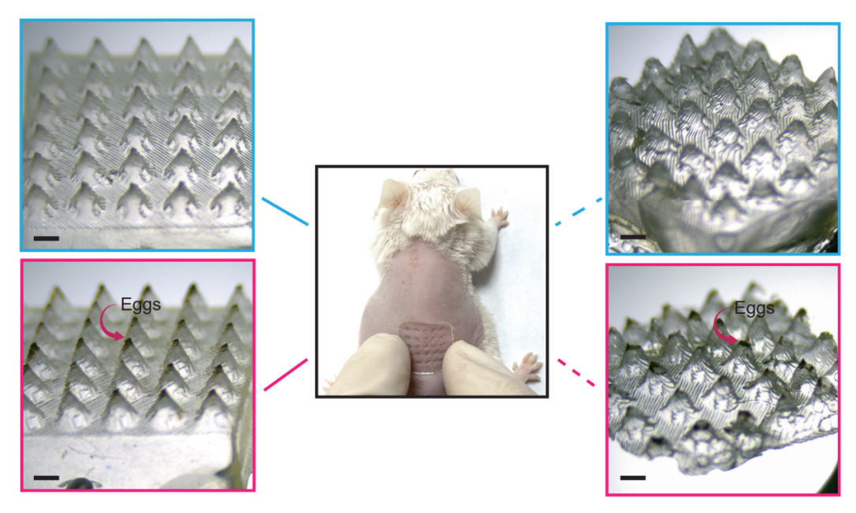
Fig. S1. Stereomicroscopic images of conventional microneedles without lyophilized Schistosoma japonicum eggs before delivery (top left), after delivery (top right) and conventional microneedles loaded with eggs before delivery (bottom left), after delivery (bottom right). Scale bar, 1 mm.

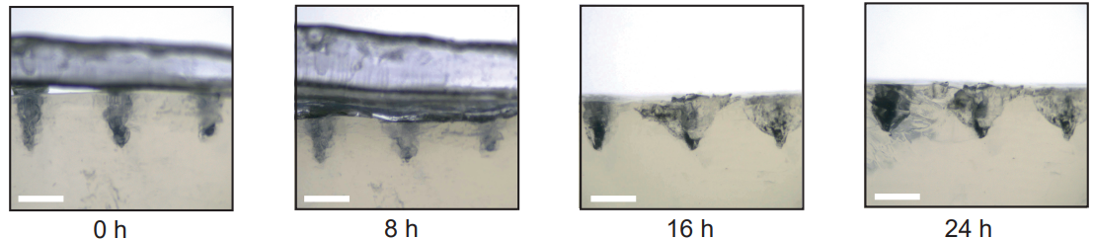

Fig. S2. Stereomicroscopic images of microneedle tip dissolving in the sepharose gel at 0, 8h, 16h and 24h. Scale bar, 1 mm.

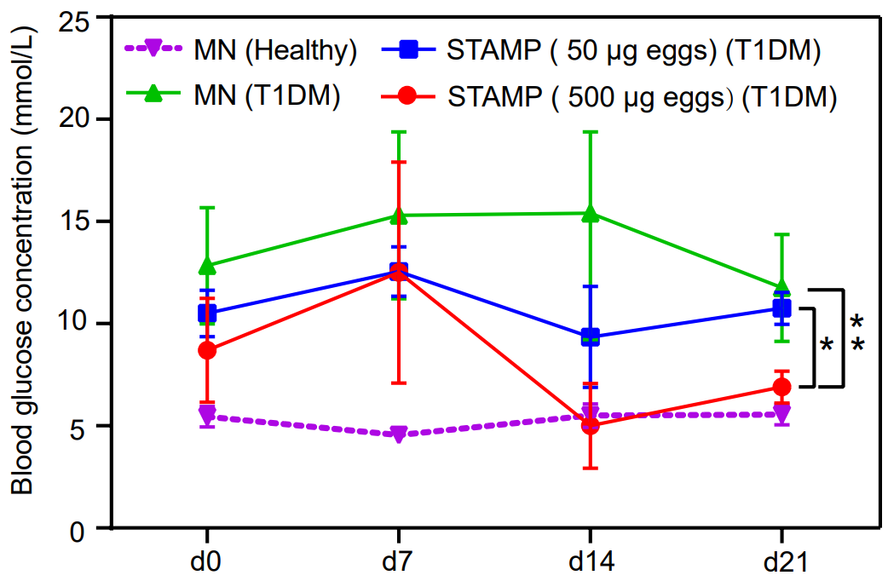
Fig. S3. Blood glucose concentration vs. time curves of different treatments in the preliminary experiment. Data were presented as mean ± SEM. (n = 3). *p < 0.05, **p < 0.01, compared with the mice in the MN (T1DM) group (two-tailed Student’s t-test).

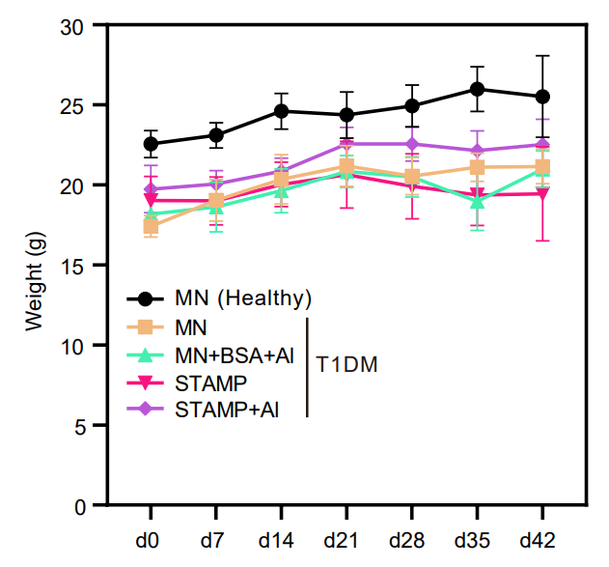
Fig. S4. Weight vs. time curves of different treatments. Data were presented as mean ± SEM. (n = 6).

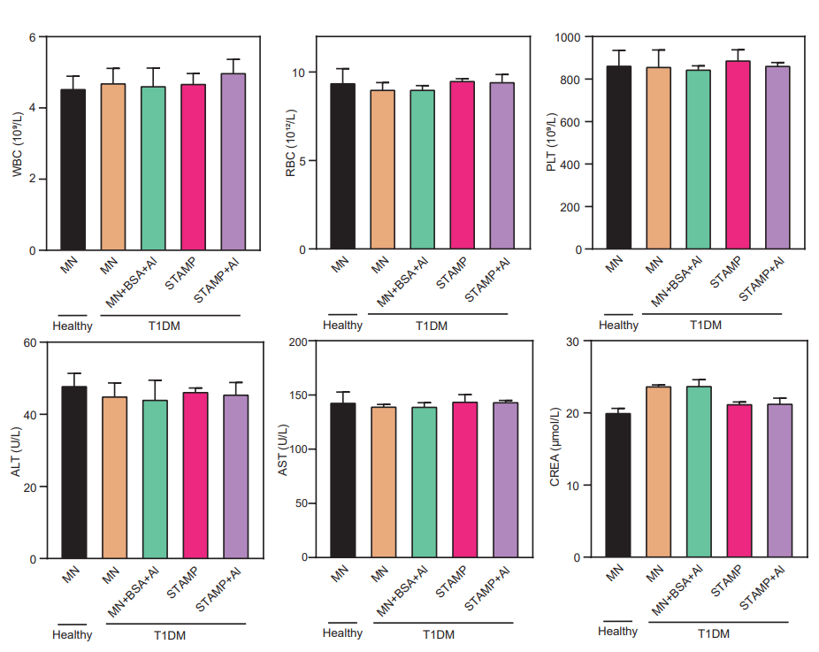
Fig. S5. Blood test (WBC, RBC, PLT) and blood biochemical test (ALT, AST, CREA) after in vivo treatments.
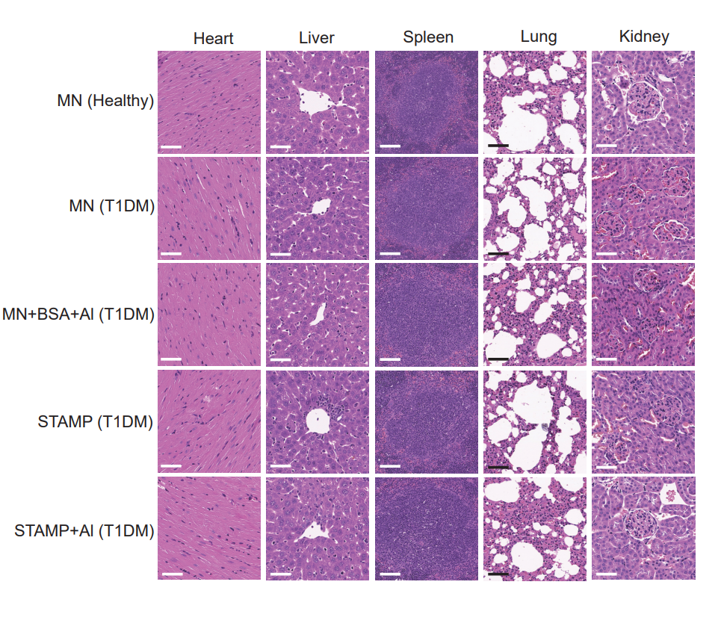
Fig. S6. Histological sections (H&E staining) of main organ of the mice in different groups. Scale bar, 50 μm.

