Remodelling of the tumour-lymph node immune microenvironment promotes T- and NK-cell comobilization for tumour immunotherapy
Shunli Fu, Lili Chang, Shujun Liu, Tong Gao, Xiao Sang, Zipeng Zhang, Weiwei Mu, Xiaoqing Liu, Shuang Liang, Han Yang, Hui Zhen Yang, Qingping Ma, Yongjun Liu *, Na Zhang *

Department of Pharmaceutics, Key Laboratory of Chemical Biology (Ministry of Education), NMPA Key Laboratory for Technology Research and Evaluation of Drug Products, School of Pharmaceutical Sciences, Cheeloo College of Medicine, Shandong University, 44 Wenhuaxi Road, Jinan, Shandong Province 250012, China

Table of contents
Figure S1. Characterization of DSPE-PEG₂₀₀₀-MMP2-sensitive pep-Mal and DSPE-PEG₂₀₀₀-MMP2-nonsensitive pep-Mal.
Figure S2. Characterization of DSPE-PEG₂₀₀₀-MMP2-sensitive pep-BSA.
Figure S3. Characterization of DSPE-Hyd-PEG₅₀₀₀-NGR.
Figure S4. N-I-Lip-S showed similar tumour accumulation and more LNs accumulation than N-I-Lip-L.
Figure S5. Migration of N-I-Lip-S from tumour to the inguinal LNs.
Figure S6. Evaluation of IDO1 expression both in LNs and tumour after photothermal therapy.
Figure S7. The UV-Vis absorption spectra of free 1-MT, free IR780 and NIL-IM-Lip.
Figure S8. The HPLC chromatograms of MMP2 enzyme alone and The HPLC chromatograms of 1.0 mg/mL MMP2 sensitive peptide after incubated with different concentrations MMP2 enzyme.
Figure S9. The free IR780 showed good photothermal stability.
Figure S10. The Infrared thermal imaging and the temperature profile of tumour under 0.6 and 1.0 W/cm² laser.
Figure S11. NIL-IM-lip induced stronger ROS generation in vitro.
Figure S12. The purity of NK cells separated by MACS method.
Figure S13. The individual tumour growth curves of B16F10-bearing C57BL/6 mice after intravenous injection with different formulations.
Figure S14. NIL-IM-Lip treatment with laser irradiation showed enhanced antitumour efficacy compared with NIL-IM-Lip without laser irradiation.
Figure S15. The evaluation of hemolysis assay of NIL-IM-Lip in vitro.
Figure S16. The H&E staining of heart, liver, spleen, lung and kidneys from B16F10 bearing mice with different formulations treatment.
Figure S17. The establishment process of postsurgical model.
Figure S18. The individual tumour growth curves of B16F10-bearing C57BL/6 mice in postsurgical model.
Figure S19. NIL-IM-Lip with laser showed enhanced antitumour efficacy than NIL-IM-Lip without laser in postsurgical model.
Figure S20. The ratio of Kyn and Trp in tumour tissues obtained from B16F10-bearing mice were determined by HPLC method (n = 3).
Figure S21. The level of cytokines in tumour tissues.
Figure S22. Evaluation of CRT exposure in tumour tissues.
Figure S23. Evaluation of HMGB1 release in tumour tissues.
Figure S24. Gating strategies for immune cells in LNs.
Figure S25. Gating strategies for immune cells in tumours.
Figure S26. Gating strategies for memory T cells in spleen (CD3⁺CD8⁺CD44⁺CD62L⁻).
Table S1. The characteristic of NIL-IM-Lip with different particle size and mass ratio.
Table S2. The characteristic of NIL-IM-Lip
Table S3. The tumour inhibition rate of B16F10-bearing mice after intravenous injection with different groups.

Supplementary Fig. 1. Characterization of DSPE-PEG₂₀₀₀-MMP2-sensitive pep-Mal and DSPE-PEG₂₀₀₀-MMP2-nonsensitive pep-Mal. a, Synthetic route to prepare DSPE-PEG₂₀₀₀-MMP2-sensitive pep-Mal. b, ¹H NMR spectrum of Mal-MMP2-sensitive pep-COOH. c, Synthetic route to prepare DSPE-PEG₂₀₀₀-MMP2 nonsensitive pep-Mal. d, ¹H NMR spectrum of Mal-MMP2 nonsensitive pep-COOH. e, The ¹H NMR spectrum of DSPE-PEG₂₀₀₀-MMP2-sensitive pep-Mal showed the peak from Mal at 7.0 ppm and the peak from PEG from 3.25 ppm to 3.75 ppm, indicating the successful synthesis of DSPE-PEG₂₀₀₀-MMP2-sensitive pep-Mal. f, The ¹H NMR spectrum of DSPE-PEG₂₀₀₀-MMP2 nonsensitive pep-Mal showed the characteristic peak of Mal-MMP2 nonsensitive pep-COOH from 6.5 ppm to 7.5 ppm and the peak from PEG from 3.25 ppm to 3.75 ppm, indicating the successful synthesis of DSPE-PEG₂₀₀₀-MMP2 nonsensitive pep-Mal. ¹H NMR: ¹H nuclear magnetic resonance.

Supplementary Fig. 2. Characterization of DSPE-PEG₂₀₀₀-MMP2-sensitive pep-BSA. a, ¹H NMR spectrum of BSA. b, ¹H NMR spectrum of DSPE-PEG₂₀₀₀-MMP2-sensitive pep-Mal. c, The ¹H NMR spectrum of DSPE-PEG₂₀₀₀-MMP2 nonsensitive pep-BSA showed that the peak from Mal at 7.0 ppm disappeared and the characteristic peak of BSA from 0.5 ppm to 2.0 ppm appeared, indicating the successful synthesis of DSPE-PEG₂₀₀₀-MMP2 sensitive pep-BSA.

Supplementary Fig. 3. Characterization of DSPE-Hyd-PEG₅₀₀₀-NGR. a, ¹H NMR spectrum of DSPE-Hyd-PEG₅₀₀₀-Mal. b, The ¹H NMR spectrum of DSPE-Hyd-PEG₅₀₀₀-NGR showed that the peak from Mal at 7.0 ppm disappeared and the characteristic peaks of NGR from 1.5 ppm to 1.8 ppm and PEG from 3.25 ppm to 3.75 ppm appeared, indicating the successful synthesis of DSPE-Hyd-PEG₅₀₀₀-NGR. c, Synthetic route to prepare DSPE-Hyd-PEG₅₀₀₀-Mal. d, EDS of DSPE-Hyd-PEG₅₀₀₀-NGR.

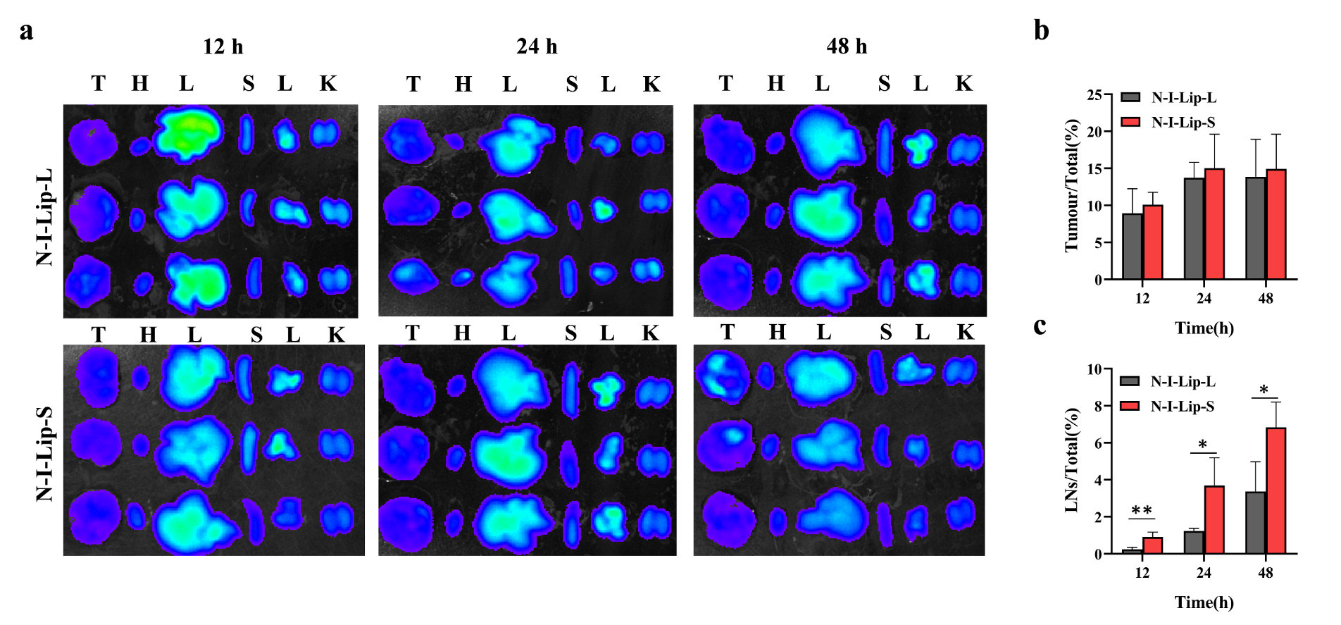
Supplementary Fig. 4. N-I-Lip-S showed similar tumour accumulation and more LNs accumulation than N-I-Lip-L. a, Ex vivo imaging of the main organs (including the heart, liver, spleen, lung and kidneys) and tumours at 12, 24, and 48 h post-administration. b, Ratio of tumour fluorescence intensity to total fluorescence intensity. c, Ratio of LNs fluorescence intensity to total fluorescence intensity. *P < 0.05, **P < 0.01.

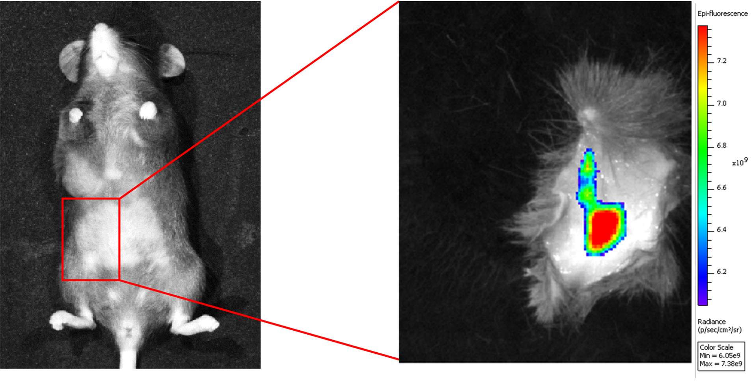
Supplementary Fig. 5. Migration of N-I-Lip-S from the tumour to the inguinal LNs. The mice were sacrificed, and the portion marked in red in the left picture was removed for NIFR imaging. NIRF: near–infrared fluorescence.

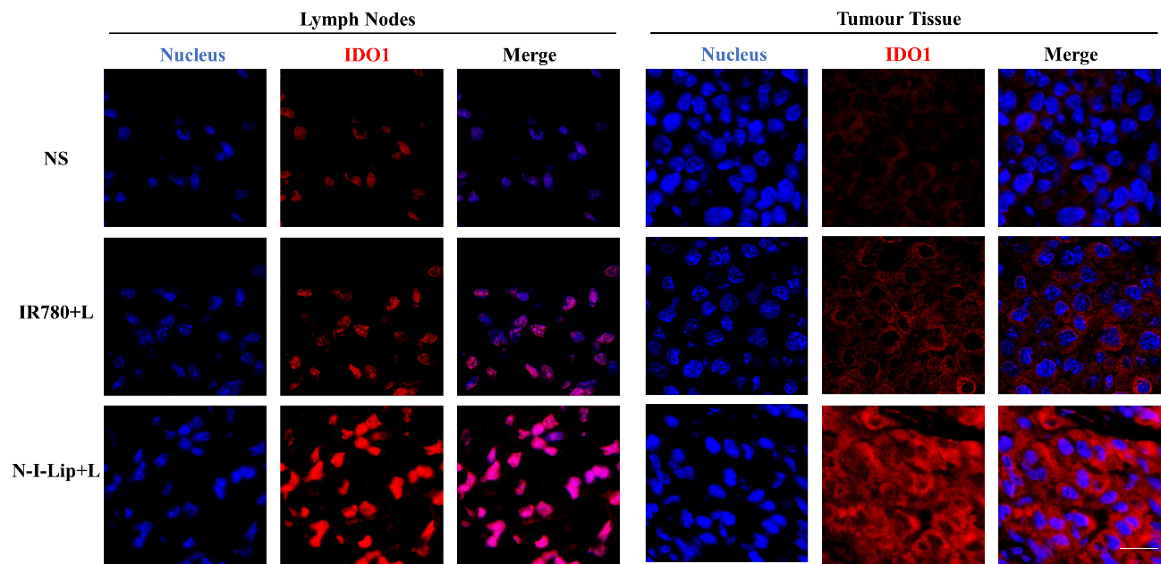
Supplementary Fig. 6. Evaluation of IDO1 expression both in the LNs and tumours after photothermal therapy. Immunohistochemical imaging of the LNs and tumours in the NS group, free IR780+laser group and N-I-Lip+laser group. The mice were treated with the corresponding formulation every 4 days and irradiated with an 808 nm laser within 5 min after intravenous formulation administration. After 16 days, the LNs and tumours were removed for immunohistochemical imaging. The scale bar represents 20 μm. IDO1: indoleamine 2,3-dioxygenase-1.

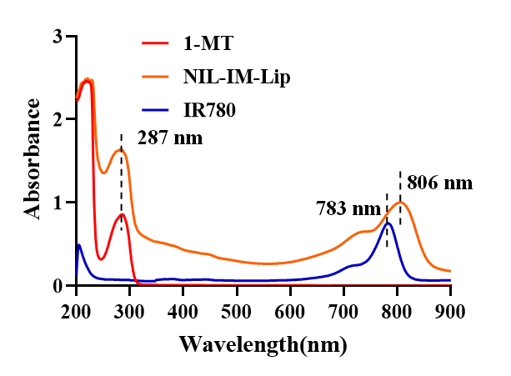
Supplementary Fig. 7. The UV-Vis absorption spectra of free 1-MT, free IR780 and NIL-IM-Lip.

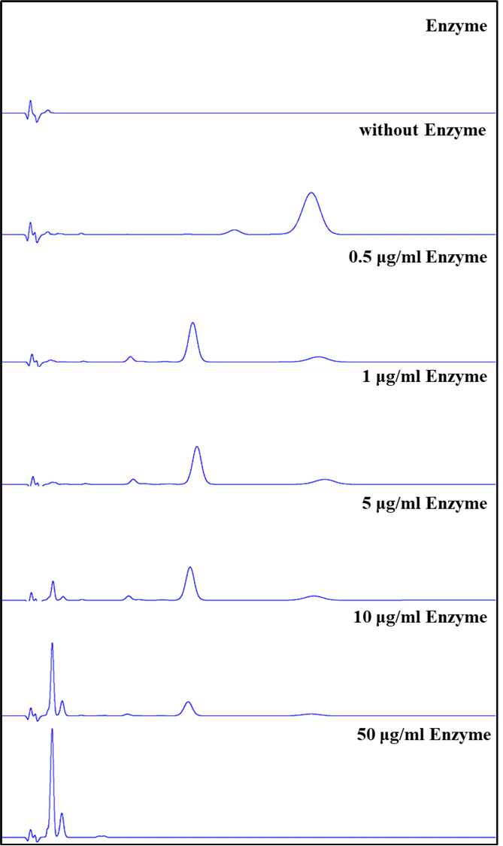
Supplementary Fig. 8. The HPLC chromatograms of MMP2 enzyme alone and The HPLC chromatograms of 1.0 mg/mL MMP2 sensitive peptide after incubated with different concentrations MMP2 enzyme.

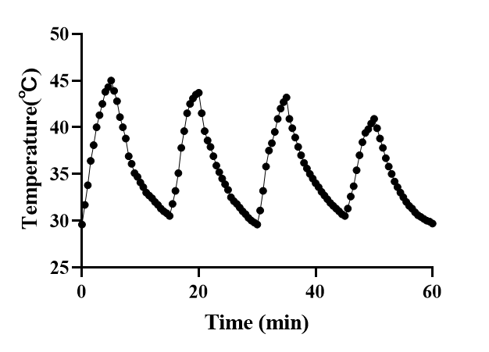
Supplementary Fig. 9. The free IR780 showed good photothermal stability. The temperature variation curves of free IR780 were recorded under four cycles of the laser (808 nm) on/off.

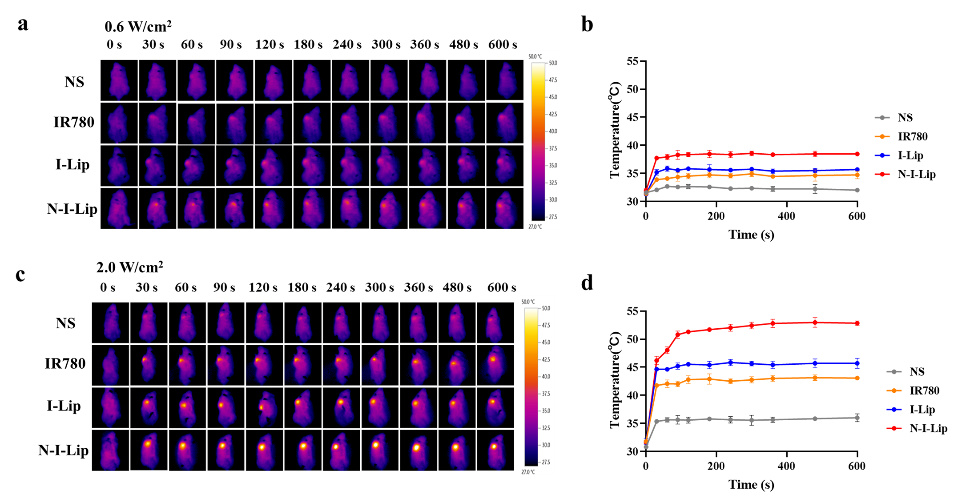
Supplementary Fig. 10. The Infrared thermal imaging and the temperature profile of tumour under 0.6 and 1.0 W/cm² laser. a, Infrared thermal imaging of B10F10 bearing mice treated with NS, IR780, I-Lip and N-I-Lip under 0.6 W/cm² laser (808 nm). b, Temperature profile of tumour on B10F10 bearing mice treated with NS, IR780, I-Lip and N-I-Lip under 0.6 W/cm² laser (808 nm). c, Infrared thermal imaging of B10F10 bearing mice treated with NS, IR780, I-Lip and N-I-Lip under 2.0 W/cm² laser (808 nm). d, Temperature profile of tumour on B10F10 bearing mice treated with NS, IR780, I-Lip and N-I-Lip under 2.0 W/cm² laser (808 nm).

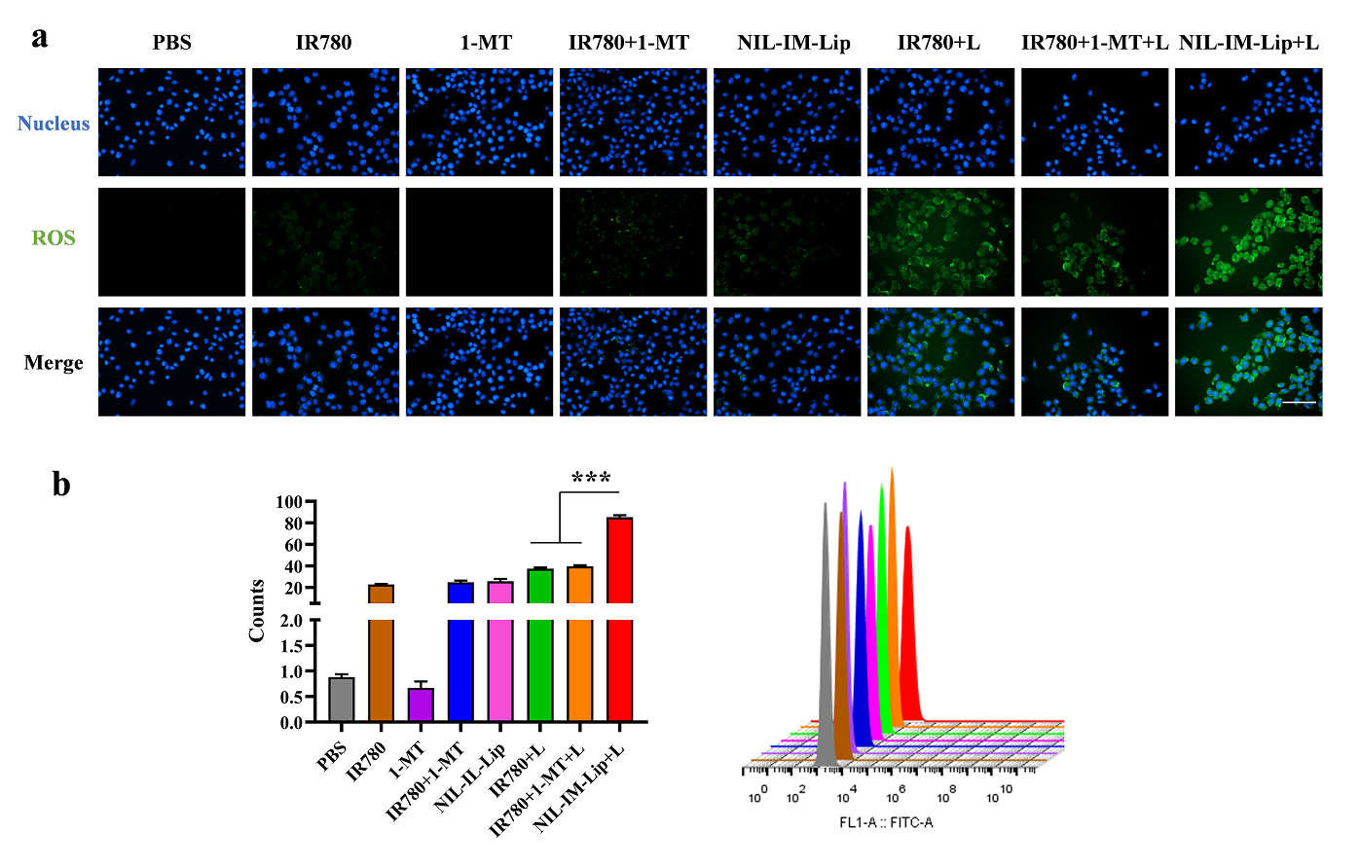
Supplementary Fig. 11. NIL-IM-lip induced stronger ROS generation in vitro. a, The fluorescence microscopy images of ROS generation in B16F10 cells. b, The flow cytometric analysis of ROS generation in B16F10 cells (n = 3). Blue: cell nuclei (DAPI); green: ROS. ***P < 0.001

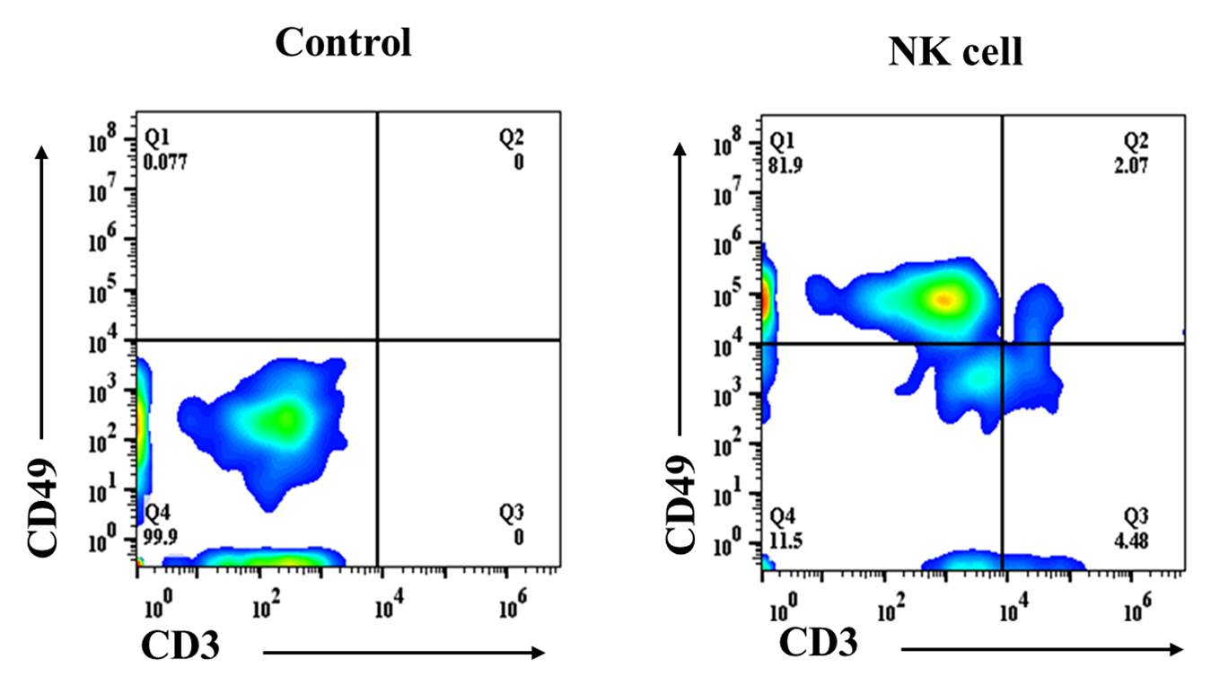
Supplementary Fig. 12. The purity of NK cells separated by MACS method. The mice were sacrificed and the NK cells were separated from spleen of female C57BL/6 mice by MACS method. The obtained NK cells were marked as CD3⁻CD49⁺. MACS: Magnetic activated cell sorting.

Supplementary Fig. 13. The individual tumour growth curves of B16F10-bearing C57BL/6 mice after intravenous injection with different formulations, including: NS, Blank-Lip, IR780, IR780+L, 1-MT, IL-15, N-I-Lip+L, IR780+1-MT+L, N-IM-Lip+L, IR780+IL-15+L, NIL-I-Lip+L, IR780+1-MT+IL-15+L, NIL-IM-Lip+L (n=6).

Supplementary Fig. 14. NIL-IM-Lip treatment with laser irradiation showed enhanced antitumour efficacy compared with NIL-IM-Lip without laser irradiation. a, The antitumour B16F10 tumour-bearing C57BL/6 mouse experiment schedule. b, Tumour volume curves of different formulation-treated B16F10 tumour-bearing C57BL/6 mice (n=6). c, Tumour weights of different formulation-treated groups. c, Individual tumour volume curves of different formulation-treated B16F10 tumour-bearing C57BL/6 mice (n=6). ***P < 0.001.

Supplementary Fig. 15. The evaluation of hemolysis assay of NIL-IM-Lip in vitro. a, The hemolysis photograph of NIL-IM-Lip. b, The hemolysis rates of different concentrations NIL-IM-Lip.

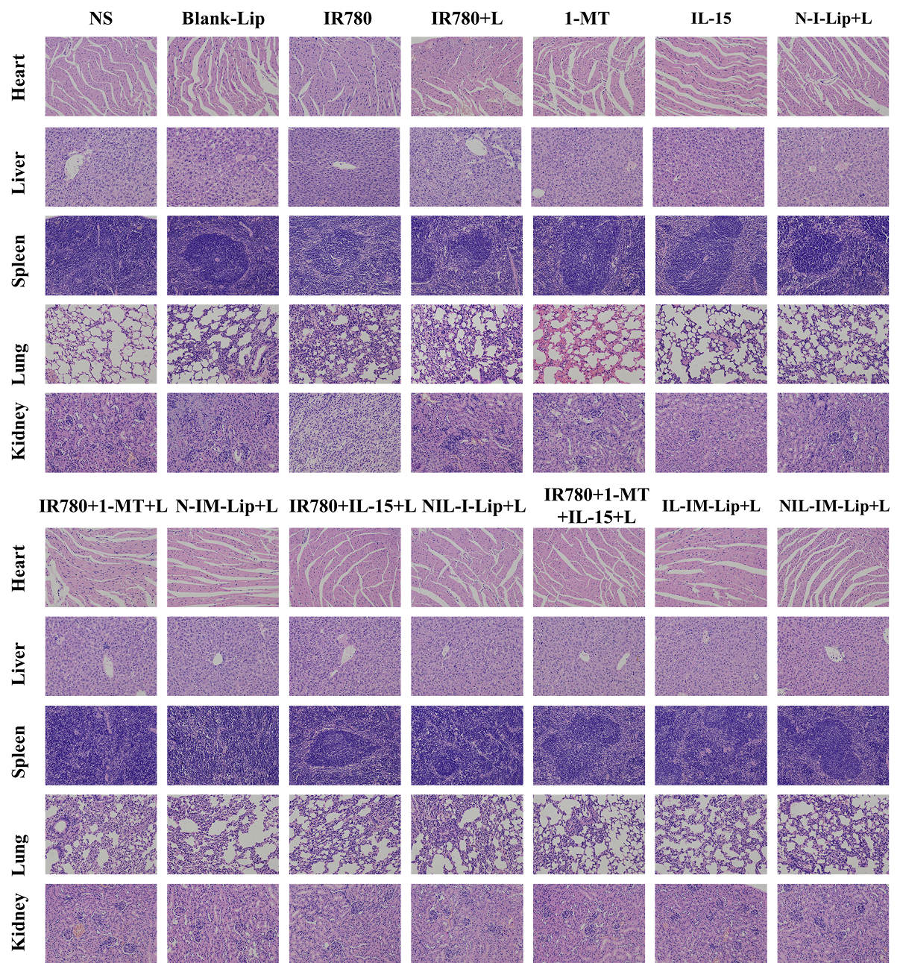
Supplementary Fig. 16. The H&E staining of heart, liver, spleen, lung and kidneys from B16F10 bearing mice with different formulations treatment.

Supplementary Fig. 17. The establishment process of postsurgical model. a, Anesthesia and surgery. b, Remove 90% tumour. c, Suture the wound. d, Disinfection the wound.

Supplementary Fig. 18. The individual tumour growth curves of B16F10-bearing C57BL/6 mice in postsurgical model. The mice were intravenously injected with different formulations, including: NS, Blank-Lip, IR780, IR780+L, 1-MT, IL-15, N-I-Lip+L, IR780+1-MT+L, N-IM-Lip+L, IR780+IL-15+L, NIL-I-Lip+L, IR780+1-MT+IL-15+L, NIL-IM-Lip+L (n=5).

Supplementary Fig. 19. NIL-IM-Lip with laser showed enhanced antitumour efficacy than NIL-IM-Lip without laser in postsurgical model. a. The photograph of mice on Day-1, 0,7 and 14. b-d, The individual tumour volume curve of mice treated with NS, NIL-IM-Lip, NIL-IM-Lip+L. e, The tumour volume curve of NS, NIL-IM-Lip and NIL-IM-Lip+L groups (n=5). ***P < 0.001.

Supplementary Fig. 20. The ratio of Kyn and Trp in tumour tissues obtained from B16F10-bearing mice were determined by HPLC method (n = 3). HPLC: High performance liquid chromatography. *P < 0.05, ***P < 0.001..

Supplementary Fig. 21. The level of cytokines in tumour tissues. a, The level of IL-6, b, IL-12, c, IFN-γ, d, IL-10, e, TGF-β in tumour tissues (n=3). *P < 0.05, **P < 0.01, ***P < 0.001.
Supplementary Fig. 22. Evaluation of CRT exposure in tumour tissues. Immunohistochemical imaging of CRT in tumours with treatment of NS, Blank-Lip, IR780, IR780+L, 1-MT, IL-15, N-I-Lip+L, IR780+1-MT+L, N-IM-Lip+L, IR780+IL-15+L, NIL-I-Lip+L, IR780+1-MT+IL-15+L, NIL-IM-Lip+L. The Scale bar was 50μm.

Supplementary Fig. 23. Evaluation of HMGB1 release in tumour tissues. Immunohistochemical imaging of HMGB1 release in tumours with treatment of NS, Blank-Lip, IR780, IR780+L, 1-MT, IL-15, N-I-Lip+L, IR780+1-MT+L, N-IM-Lip+L, IR780+IL-15+L, NIL-I-Lip+L, IR780+1-MT+IL-15+L, NIL-IM-Lip+L. The Scale bar was 50 μm.
Supplementary Figure 24. Gating strategies for immune cells in LNs. a, Gating strategy for DC cells (CD11c⁺CD80⁺CD86⁺). b, Gating strategy for CD4⁺T cells and CD8⁺T cells. c, Gating strategy for NK cells (CD3⁻CD49b⁺). d, Gating strategy for Tregs (CD4⁺Foxp3⁺).

Supplementary Figure 25. Gating strategies for immune cells in tumours. a, Gating strategy for CTLs (CD8⁺IFN-γ⁺). b, Gating strategy for CD4⁺T (CD3⁺ CD4⁺) cells and CD8⁺T (CD3⁺ CD8⁺) cells. c, Gating strategy for NK cells (CD3⁻CD49b⁺). d, Gating strategy for Treg cells (CD4⁺Foxp3⁺).

Supplementary Figure 26. Gating strategies for memory T cells (CD3⁺CD8⁺CD44⁺CD62L⁻) in spleen.

Supplementary Table 1. The characteristic of NIL-IM-Lip with different particle size and mass ratio.
 | DPPC:Chol=8:1 |  | N-I-Lip-S
 | N-I-Lip-L | N-I-Lip-S | DPPC:Chol=2:1 | DPPC:Chol=16:1
Size(nm) | 134.9±2.7 | 63.6±4.5 | 63.3±4.7 | 69.3±0.8
PDI | 0.181±0.06 | 0.211±0.05 | 0.286±0.03 | 0.200±0.05

Supplementary Table 2. The characteristic of NIL-IM-Lip
Size (nm) | PDI | Zeta (mV) | 1-MT EE% | 1-MT DL% | IR780 EE% | IR780 DL%
66.9±2.2 | 0.267±0.01 | -2.0±1.0 | 30.5±3.2 | 3.0±0.3 | 81.8±2.8 | 0.64±0.02

Supplementary Table 3. The tumour inhibition rate of B16F10-bearing mice after intravenous injection with different groups.
Groups | Tumour inhibition rate (%)
Blank-Lip | 4.56
IR780 | 15.42
IR780+L | 30.29
1-MT | 30.8
IL-15 | 32
N-I-Lip+L | 37.06
IR780+1-MT+L | 42.4
N-IM-Lip+L | 46.02
IR780+IL-15+L | 45.1
NIL-I-Lip+L | 46.44
IR780+1-MT+IL-15+L | 61.67
IL-IM-Lip+L | 71.31
NIL-IM-Lip+L | 85.99

