Evaluation of the association between Kawasaki disease and Infections

During the study period, 464 children were admitted to the Pediatrics Department of First Affiliated Hospital of Guangxi Medical University with a diagnosis of Kawasaki disease (KD). In total, 111 children were excluded from this study, including 35 who were treatmented without IVIG, 47 who did not undergo pathogen examinations after admission, and 29 with incomplete clinical or laboratory data. Ultimately, 353 (76.1%) children were included in this study. Of them, 83 (23.5%) children had confirmed co-infections with 71 (20.1%) single and 12 (3.4%) mixed infections (Figure 1A). Among the single infections, Mycoplasma hyopneumoniae (n=46), Adenovirus (n=4), EBV (n=3), RSV (n=2), PIV 1-3 (n=4), and Streptococcus pneumoniae (n=5), Helicobacter pylori (n=1), Stenotrophomonas maltophilia (n=1), Pseudomonas aeruginosa (n=1), Staphylococcus aureus (n=1), Staphylococcus epidermidis (n=1), Garcinia parvifolia micrococcus (n=1), Escherichia (n=1) (Figure 1B); as well as the mixed infections included 2 mixed infections with Mycoplasma hyopneumoniae and Streptococcus pneumoniae, 2 with Mycoplasma hyopneumoniae and Adenovirus, 1 with Mycoplasma hyopneumoniae and EBV, 1 with Mycoplasma hyopneumoniae and Parainfluenza, 1 with Parainfluenza and Staphylococcus hemolyticus, 1 with Parainfluenza and Klebsiella pneumoniae, 1 with Parainfluenza and Helicobacter pylori, 1 with Parainfluenza and EBV, 1 with Parainfluenza and RSV and 1 with Adenovirus and Rotavirus (Figure 1C). Patients were classified as cases and controls according to the results of their pathogen examinations and the baseline characteristics analysis results of the two groups of patients are shown in Table 1. There were no significant differences in coronary artery changes from baseline at 2 weeks, 4 weeks, 3 months in KD patients with and without infections (Figure 2). Other than age, weight and height, comparison of clinical characteristics, laboratory values and clinical outcomes between the two groups did not achieve statistical significance. For this a very important reason is that KD patients can have concurrent infections, especially pulmonary symptoms and mycoplasma hyopneumoniae is a major cause of respiratory infections in school-aged children and young adults, with 46 instances, accounted for more than half of the co-infected cases (55.4%).
Figure 1 Distribution of pathogens co-infected with Kawasaki disease
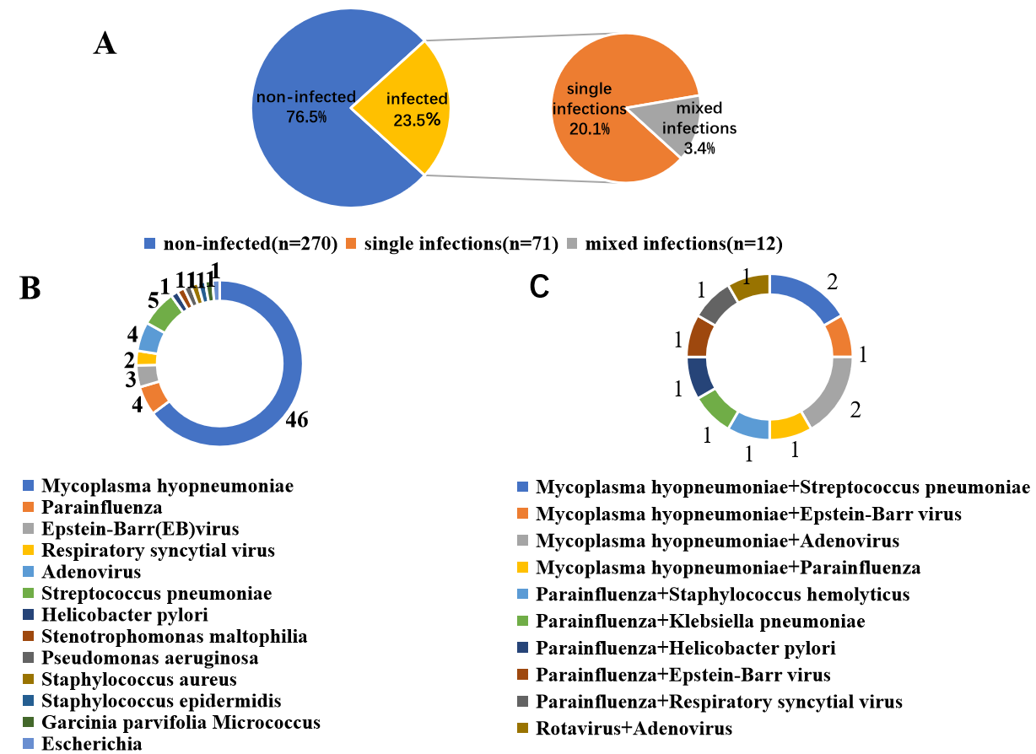
Figure 2 Coronary artery changes from baseline over time in Kawasaki disease patients, by subgroups
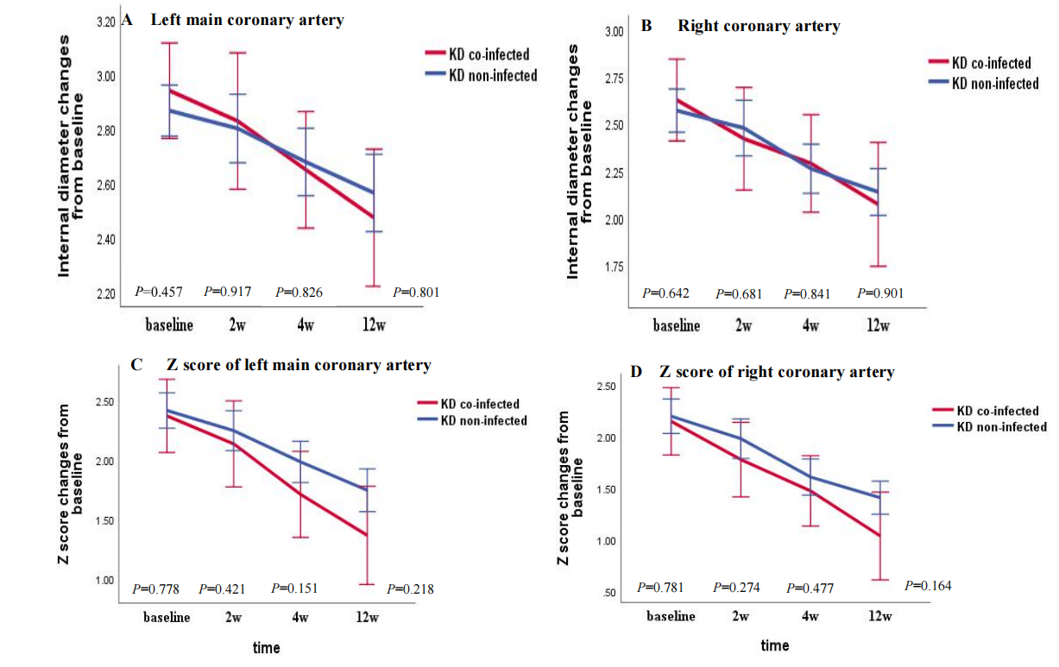
KD Kawasaki disease.
Table 1 Comparison of the baseline characteristics between Kawasaki disease with and without infections
 | Total  (n=353) | co-infected  (n=83) | non-infected  (n=270) | P value
Demographic characteristics
Age [month, mean±SD] | 28.57±23.77 | 33.47±27.43 | 27.06±22.37 | 0.032
<1 year [n(%)] | 28 (7.9) | 5 (6.0) | 23 (8.5) | 0.462
Male [n(%)] | 249 (70.5) | 60 (72.3) | 189 (70.0) | 0.689
Height [m, mean±SD] | 0.87±1.66 | 0.91±0.17 | 0.86±0.16 | 0.022
Weight [kg, mean±SD] | 12.14±4.97 | 13.14±5.06 | 11.84±4.92 | 0.036
BMI [kg/m², P₅₀ (P₂₅, P₇₅)] | 15.52 (14.49, 16.44) | 15.50 (14.21, 16.79) | 15.55 (14.51, 16.44) | 0.931
Clinical characteristics
Conjunctival injection [n(%)] | 197 (55.8) | 46 (55.4) | 151 (55.9) | 0.936
Changes in lips and oral cavity  [n(%)] | 188 (53.3) | 48 (57.8) | 140 (51.9) | 0.340
Polymorphous exanthem [n(%)] | 209 (59.2) | 47 (56.6) | 162 (60.0) | 0.584
Cervical lymphadenopathy [n(%)] | 149 (42.2) | 33 (39.8) | 116 (43.0) | 0.605
Changes in extremities [n(%)] | 109 (30.9) | 25 (30.1) | 84 (31.1) | 0.864
Incomplete KD [n(%)] | 149 (42.2) | 40 (48.2) | 109 (40.4) | 0.207
Fever duration before admission  [day, mean±SD] | 7.95±4.65 | 8.31±4.84 | 7.84±4.60 | 0.416
Days of illness at primary treatment  [day, mean±SD] | 9.66±5.69 | 9.86±5.64 | 9.60±5.71 | 0.711
≤4 days [n(%)] | 34 (9.6) | 9 (10.8) | 25 (9.3) | 0.669
Laboratory values
White blood cell count  [×10⁹/L, ref. 5–12×10⁹/L],  mean±SD | 14.46±6.61 | 13.97±6.67 | 14.61±6.59 | 0.441
Neutrophils count  [×10⁹/L, ref.1.8–6.3×10⁹/L], mean±SD | 9.03±5.87 | 8.76±5.99 | 9.12±5.84 | 0.631
≥80% [n(%)] | 58 (16.4) | 18 (21.7) | 40 (14.8) | 0.140
NLR [P₅₀ (P₂₅, P₇₅)] | 2.34 (1.16, 4.40) | 2.53 (1.08, 5.00) | 2.26 (1.16, 4.21) | 0.433
Hematocrit [mean±SD] | 0.32±0.04 | 0.33±0.04 | 0.32±0.04 | 0.052
Platelet count  [×10¹²/L, ref. 125–350×10⁹/L], mean±SD | 377.41±171.65 | 377.87±205.63 | 377.27±160.20 | 0.978
PLR [P₅₀ (P₂₅, P₇₅)] | 100.00 (71.43, 146.99) | 111.11 (71.43, 200.00) | 100.00 (71.07, 142.86) | 0.146
CRP [mg/L, ref. 0–10 mg/L], mean±SD | 73.56±62.48 | 70.70±62.03 | 74.43±62.71 | 0.635
Sodium  [mmol/L, ref. 137–147 mmol/L],  mean±SD | 136.32±3.09 | 136.00±2.84 | 136.42±3.16 | 0.284
ALT [U/L, ref. 7–45 U/L],  mean±SD | 54.39±64.80 | 50.43±68.57 | 55.60±63.68 | 0.526
AST [U/L, ref. 13–40 U/L], mean±SD | 49.82±63.87 | 55.05±90.03 | 48.21±53.44 | 0.394
Total bilirubin  [umol/L, ref. 3.4–20.5 umol/L],  P₅₀ (P₂₅, P₇₅) | 4.70 (3.10, 7.97) | 5.10 (3.10, 8.50) | 4.50 (3.10, 7.80) | 0.799
Albumin [g/L, ref. 40–55 g/L], mean±SD | 36.33±5.21 | 36.43±5.02 | 36.30±5.28 | 0.854
CRP/ALB ratio [mean±SD] | 2.14±1.90 | 2.03±1.79 | 2.17±1.93 | 0.540
Clinical outcomes
PICU admission [n(%)] | 22 (6.2) | 4 (4.8) | 18 (6.7) | 0.543
IVIG resistance [n(%)] | 64 (18.1) | 18 (21.7) | 46 (17.0) | 0.336
Corticosteroid therapy [n(%)] | 22 (6.2) | 8 (9.6) | 14 (5.2) | 0.142
CAL [n(%)] | 220 (62.3) | 47 (56.6) | 173 (64.1) | 0.221
CAA [n(%)] | 90 (25.5) | 20 (24.1) | 70 (25.9) | 0.738
BMI body mass index, KD Kawasaki disease, NLR neutrophil-to-lymphocyte count ratio, PLR platelet-to-lymphocyte count ratio, CRP C-reactive protein, ALT alanine aminotransferase, AST aspartate aminotransferase, CRP/ALB C-reactive protein-to-albumin, PICU pediatric intensive care unit, IVIG intravenous immunoglobulin, CAL coronary artery lesions, CAA coronary artery aneurysm.

