Figure S1. Consensus matrix heatmaps based on numbers of clusters.
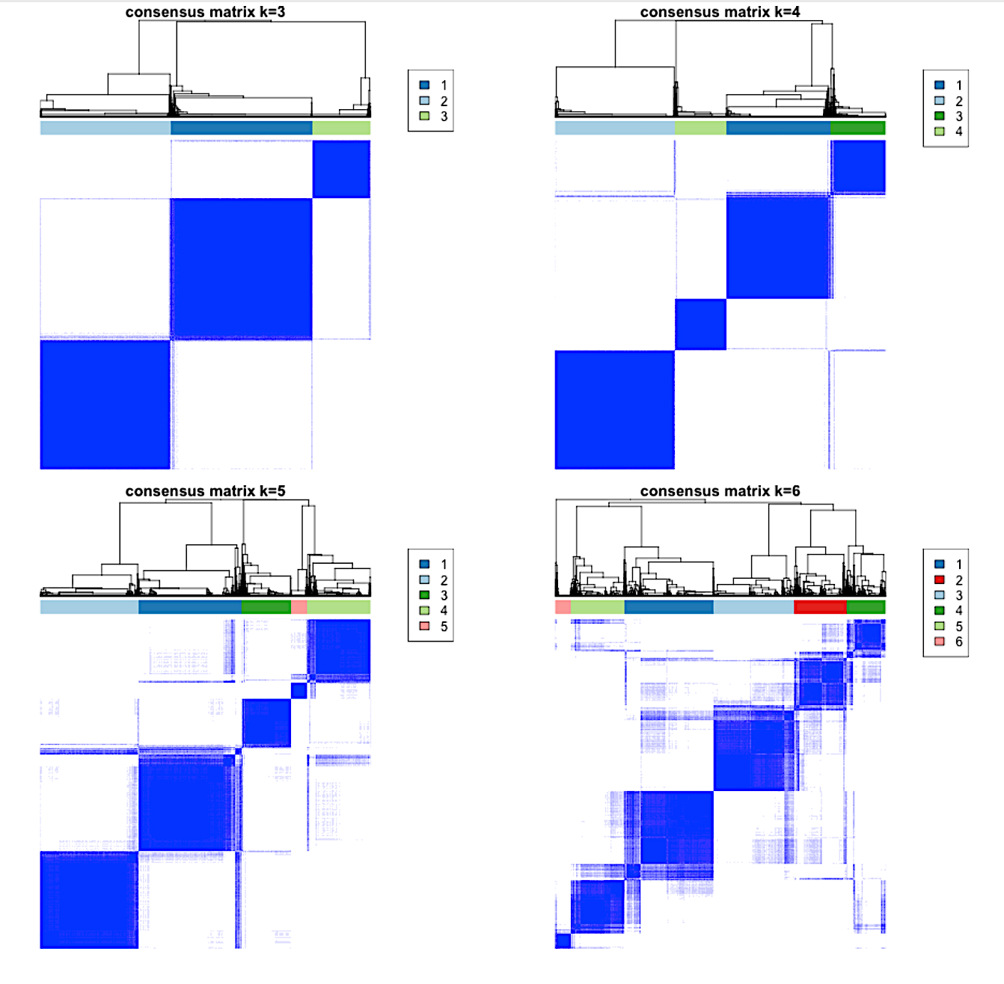

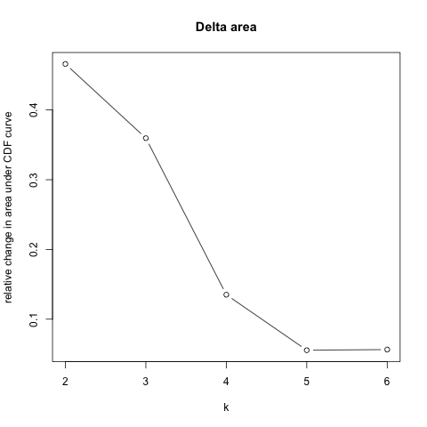
Figure S2. Elbow method.
Relative change in area under CDF curve
Delta area
k

Figure S3. Consensus cumulative distribution function plot.
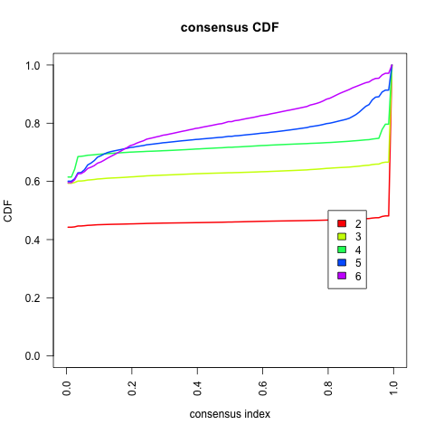
Cumulative distribution function
Consensus CDF
Consensus index

Figure S4. Cluster consensus plot.
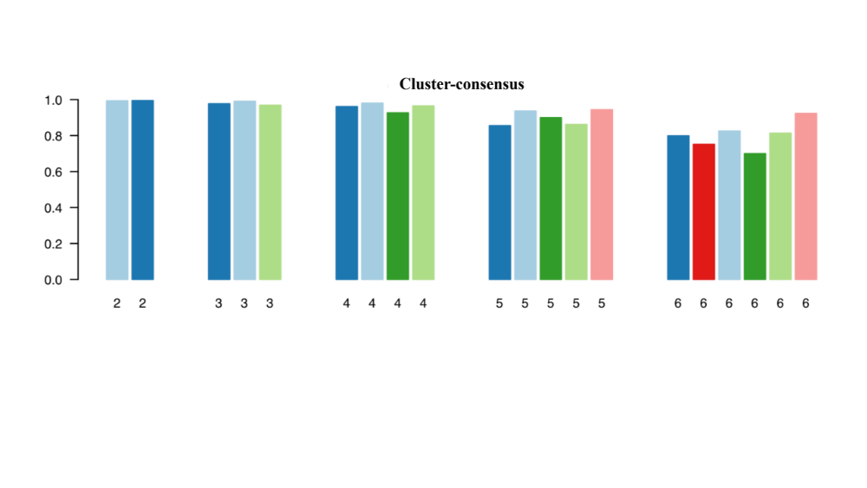
Figure S5. Cluster dendrogram using a divisive hierarchical clustering.

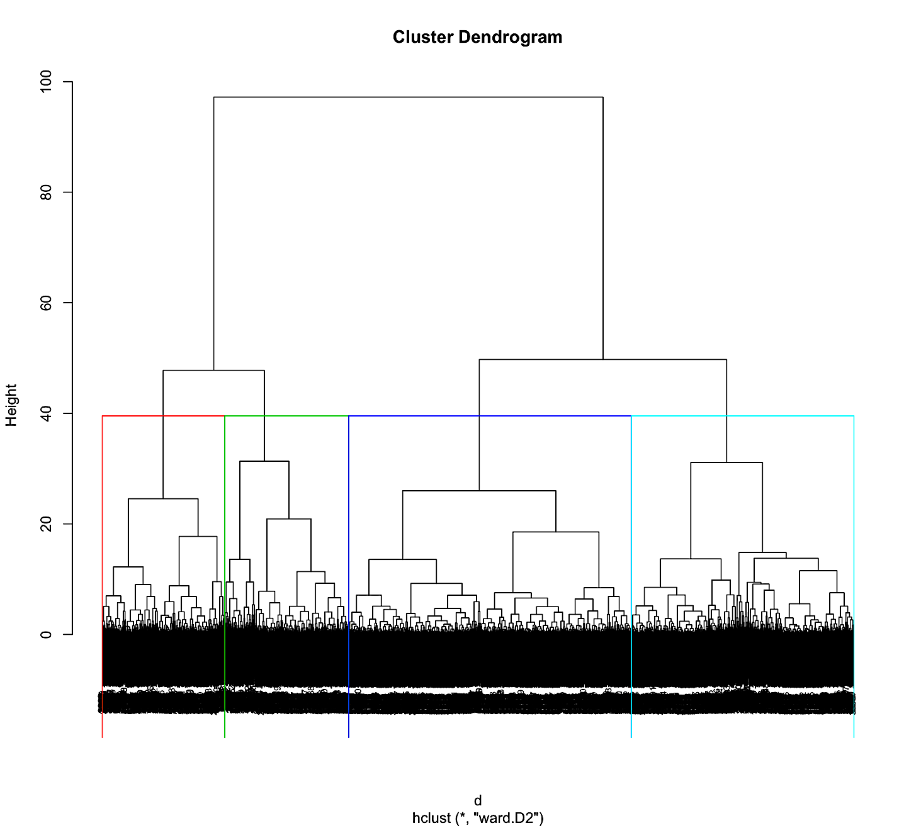

Figure S6. Elbow method to identify the optimal number of clusters using divisive hierarchical clustering.
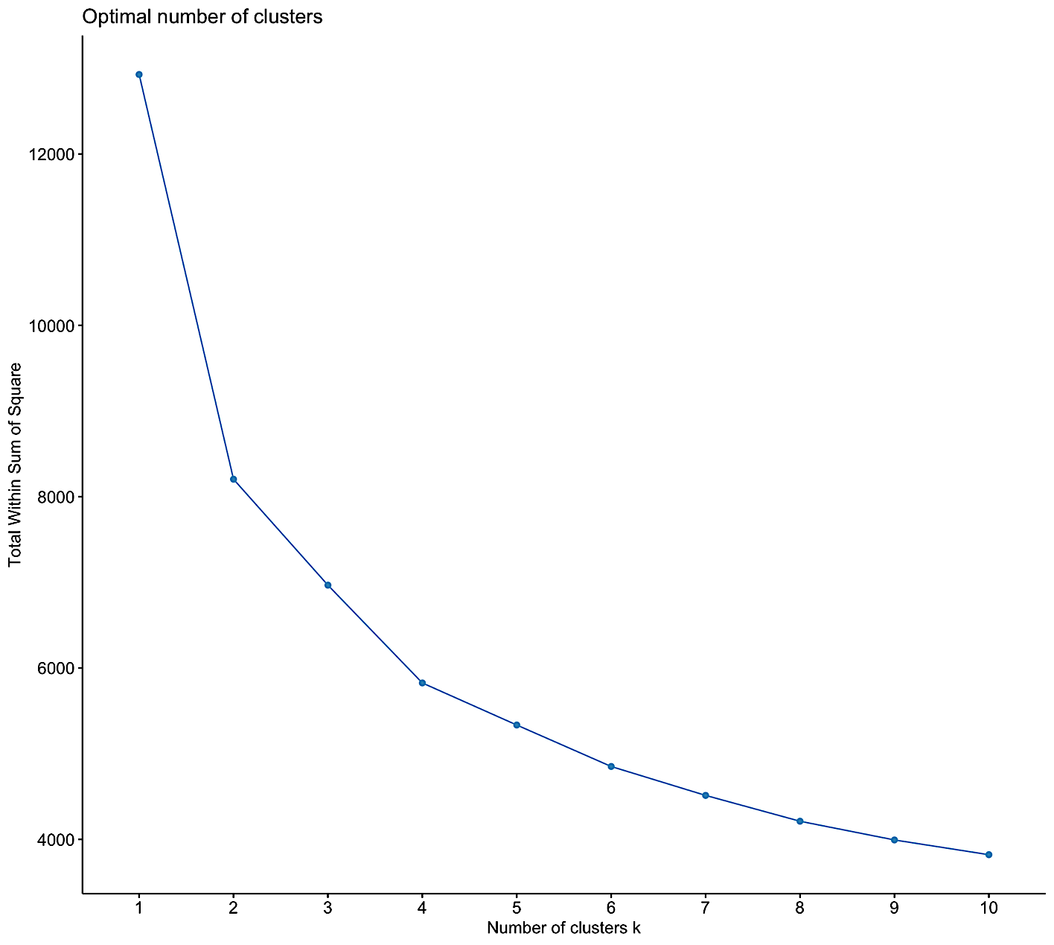
Optimal number of clusters
Total within sum of square
Number of clusters k
Figure S7. Gap statistic method to identify optimal number of clusters using divisive hierarchical clustering.

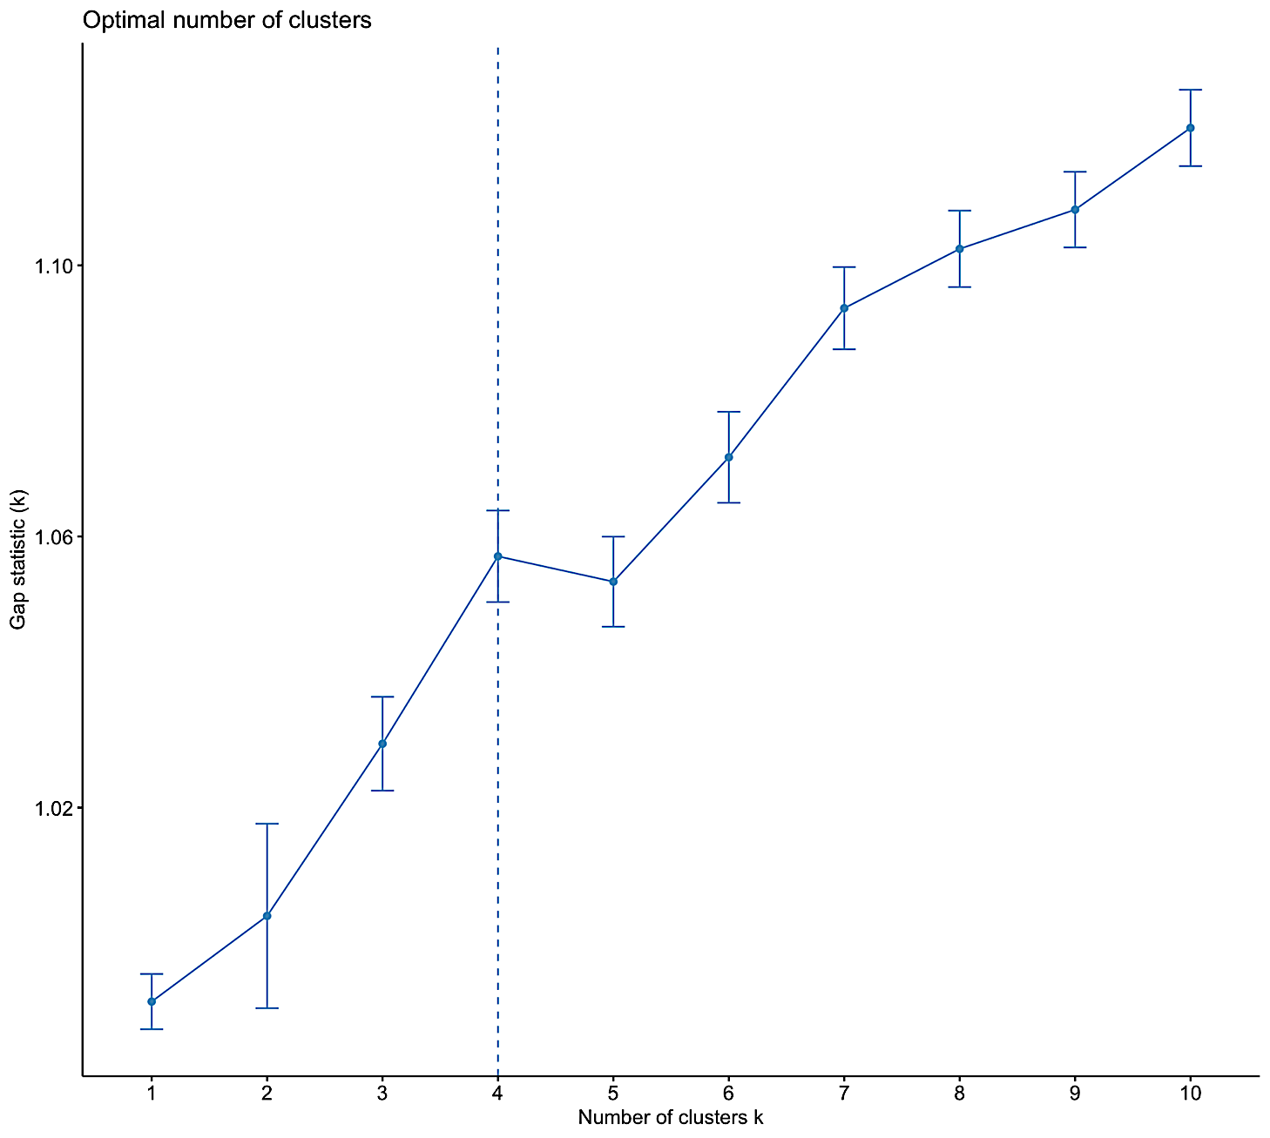
Figure S8. Bayesian heterogeneity results of rhTM effects in validation cohort.

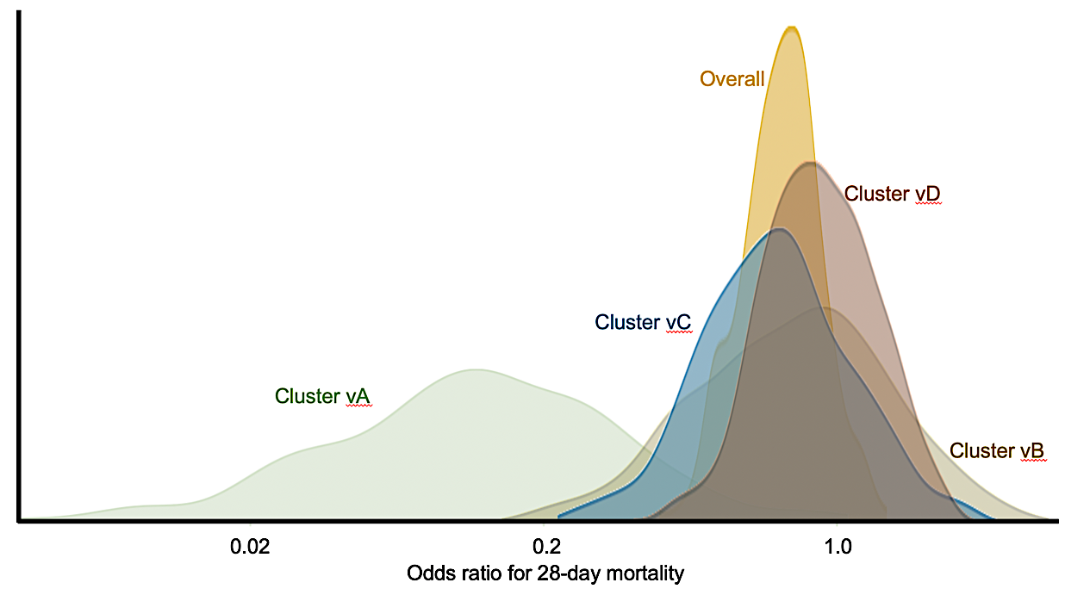

Supplemental figure legends

Figure S1. Consensus matrix heatmaps based on hierarchical clustering.
Heatmaps indicate that patients with sepsis comprise four clusters with relatively clear boundaries.

Figure S2. Elbow method.
Elbow method shows ratios (%)of variance as functions of numbers of clusters. choose Several clusters should be selected such that adding another cluster will not greatly improve modeling data. Relative change in area under cumulative density function (CDF) was highest for four clusters.

Figure S3. Consensus cumulative distribution function (CDF) plot.
This plots cumulative density function of consensus values for given numbers of clusters. Optimal number of clusters is represented by CDF plot with first step close to zero followed by plateau until reaching second step close to one. This consensus CDF plot implies that four or five clusters are optimal.

Figure S4. Cluster consensus plot.
This plots mean consensus values of all pairs within each cluster. Clusters with higher cluster consensus (> 0.8) for all clusters are preferred. These results imply the absence of clearly separated clusters.

Figure S5. Cluster dendrogram using divisive hierarchical clustering approach.
Hierarchical relationships between patients in terms of coagulation. Patients were divided into two large clusters that were further subdivided into two.

Figure S6. Elbow method reveals ratios (%)of variance explained as functions of numbers of clusters..
Optimal number of clusters is determined using divisive hierarchical clustering Several clusters should be selected such that adding another cluster will not greatly improve modeling data. Relative change in area under cumulative density function (CDF) was highest for two or four clusters.

Figure S7. Gap statistic method to identify optimal number of clusters using divisive hierarchical clustering.
Total intra-cluster variation for different k values with their predicted values under null reference distribution of the data. Estimate optimal clusters will be the value that yields the largest gap statistic). The findings indicate that the optimal number of clusters was four.

Figure S8. Bayesian heterogeneity results of rhTM effects in the validation cohort.
X-axis, odds ratio; Y-axis, density. Results indicate significant association between rhTM and 28-day mortality in validation cohort, but not overall.

