Extended Data Figures and Table

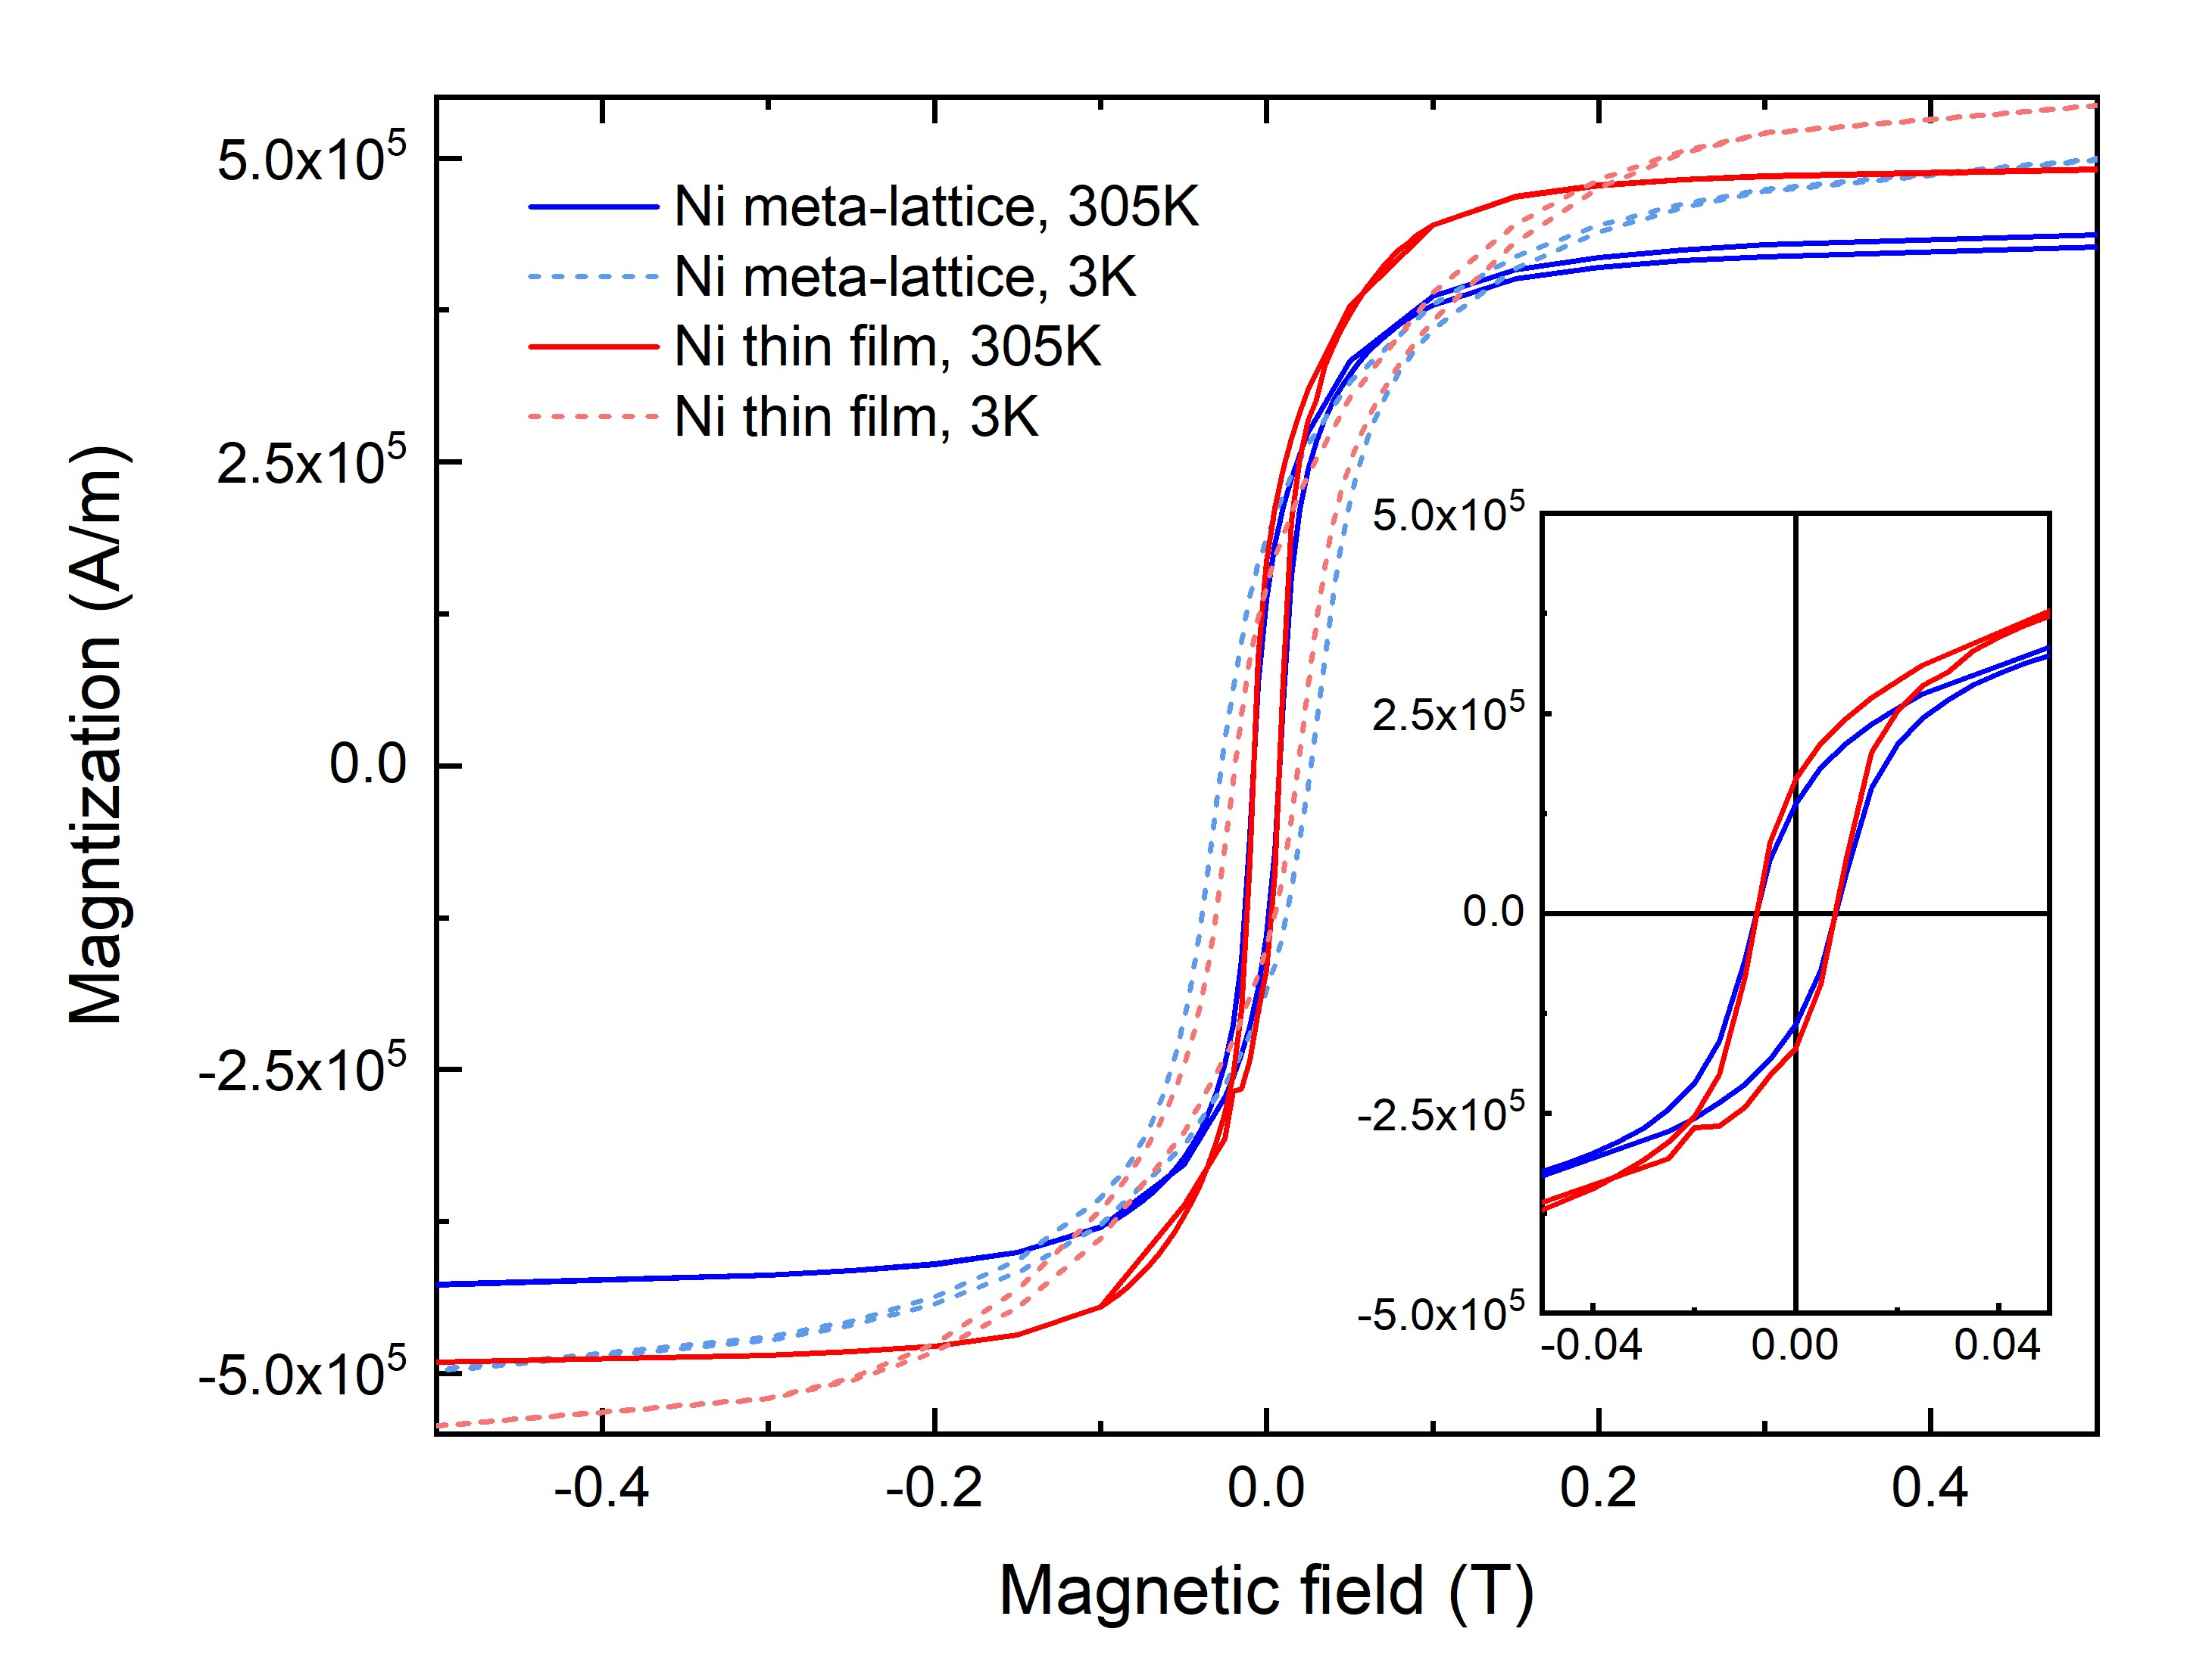
Extended Data Fig. 1. Magnetic hysteresis measurements of a Ni meta-lattice and a Ni thin film. 5 T field sweep measurements of the hysteresis loops of the Ni meta-lattice and Ni thin film at 3 K and 305 K, where the inset shows the magnified hysteresis loops at 305 K. The experiments were performed with a Quantum Design MPMS SQUID magnetometer, and a diamagnetic background subtraction was implemented by subtracting off the average of two linear fits to the data at high positive and negative fields, beyond the saturation of the samples. The thickness of the meta-lattice varies from 400 to 450 nm, measured by a scanning electron microscope. As the meta-lattice has an fcc structure (Extended Data Fig. 6), the effective thickness of Ni in the meta-lattice was estimated to be 110.5 nm by considering the fcc packing efficiency of 74%. As a comparison, a pure Ni thin film of 200 nm thick was characterized by the same experimental procedure. The hysteresis loops of the Ni meta-lattice and the Ni thin film show similar remanent magnetization and saturation magnetization at both 3 K and 305 K. The slight differences of the remanent magnetization and saturation magnetization between the Ni meta-lattice and the Ni thin film are due to two factors: i) the thickness of the meta-lattice varies from 400 to 450 nm; and ii) the experimental packing efficiency of the sample may deviate from the theoretical value of 74%.

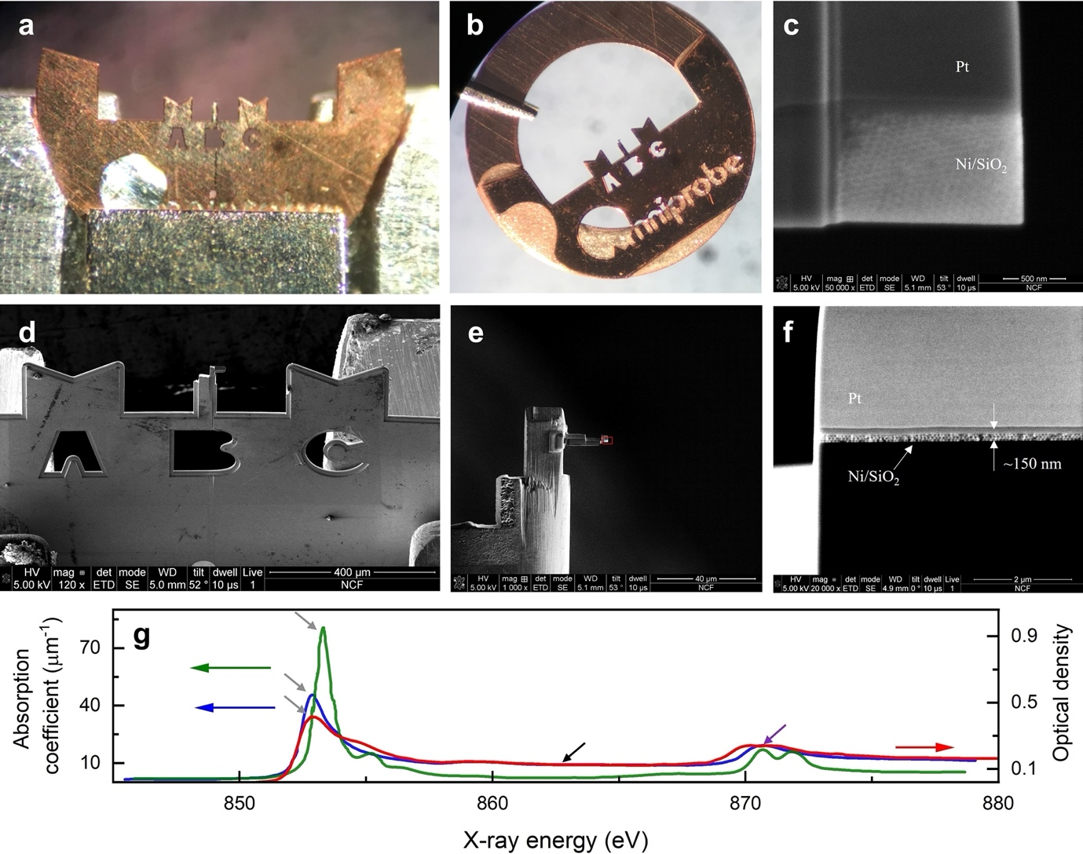
Extended Data Fig. 2. Sample preparation. a, b, Optical microscopy images of the meta-lattice sample, prepared by FIB milling. The sample was mounted on a 3-mm transmission electron microscopy grid and glued on a copper ring (b). c-f, Scanning electron microscopy images of the sample. The mounting geometry of the sample is important for the 3D soft x-ray vector ptychography experiment with three in-place rotation angles. The meta-lattice sample was thinned to 150 nm by a FIB (f), allowing the sample to be tilted to high angles. g, X-ray absorption spectroscopy of the Ni meta-lattice sample (red curve). For a comparison, the x-ray absorption spectra of a pure Ni film (blue curve) and a NiO film (green curve) are adapted from ref. 41. The three grey arrows indicate that the L₃ peak position of the meta-lattice agrees well with that of pure Ni, while the NiO L₃ peak is shifted to a higher energy. The black arrow shows that the absorption coefficients of the meta-lattice are in good agreement with those of pure Ni in the energy range from 885 eV to 870 eVs, but NiO has smaller values due to sp-hybridization. The purple arrow indicates that the L₂ peak of the meta-lattice is more consistent with that of pure Ni than of NiO.

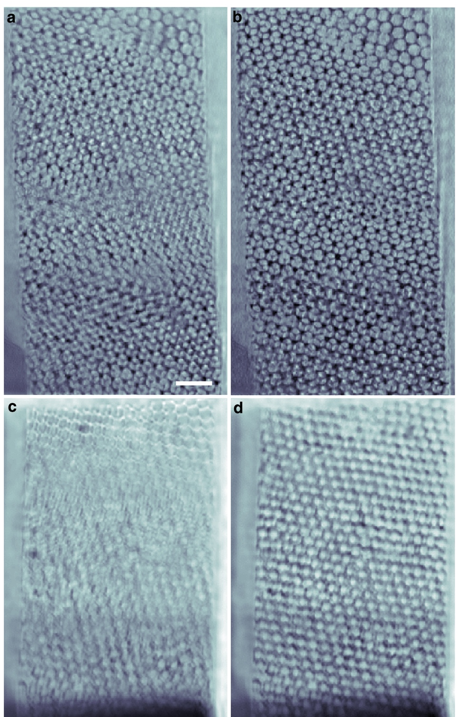
Extended Data Fig. 3. Improvement of the ptychography reconstruction. a, The ptychography reconstruction of a representative projection with a small number of corrupted diffraction patterns, where reconstruction artifacts are clearly visible. The corrupted diffraction patterns were resulted from detector readout malfunction or unstable x-ray flux. b, The same reconstructed projection after the removal of the corrupted diffraction patterns. c, The ptychography reconstruction of a representative high tilt projection, in which artefacts were induced by phase unwrapping. b, The same reconstructed projection after phase unwrapping was enforced in the reconstruction. Scale bar, 200 nm.

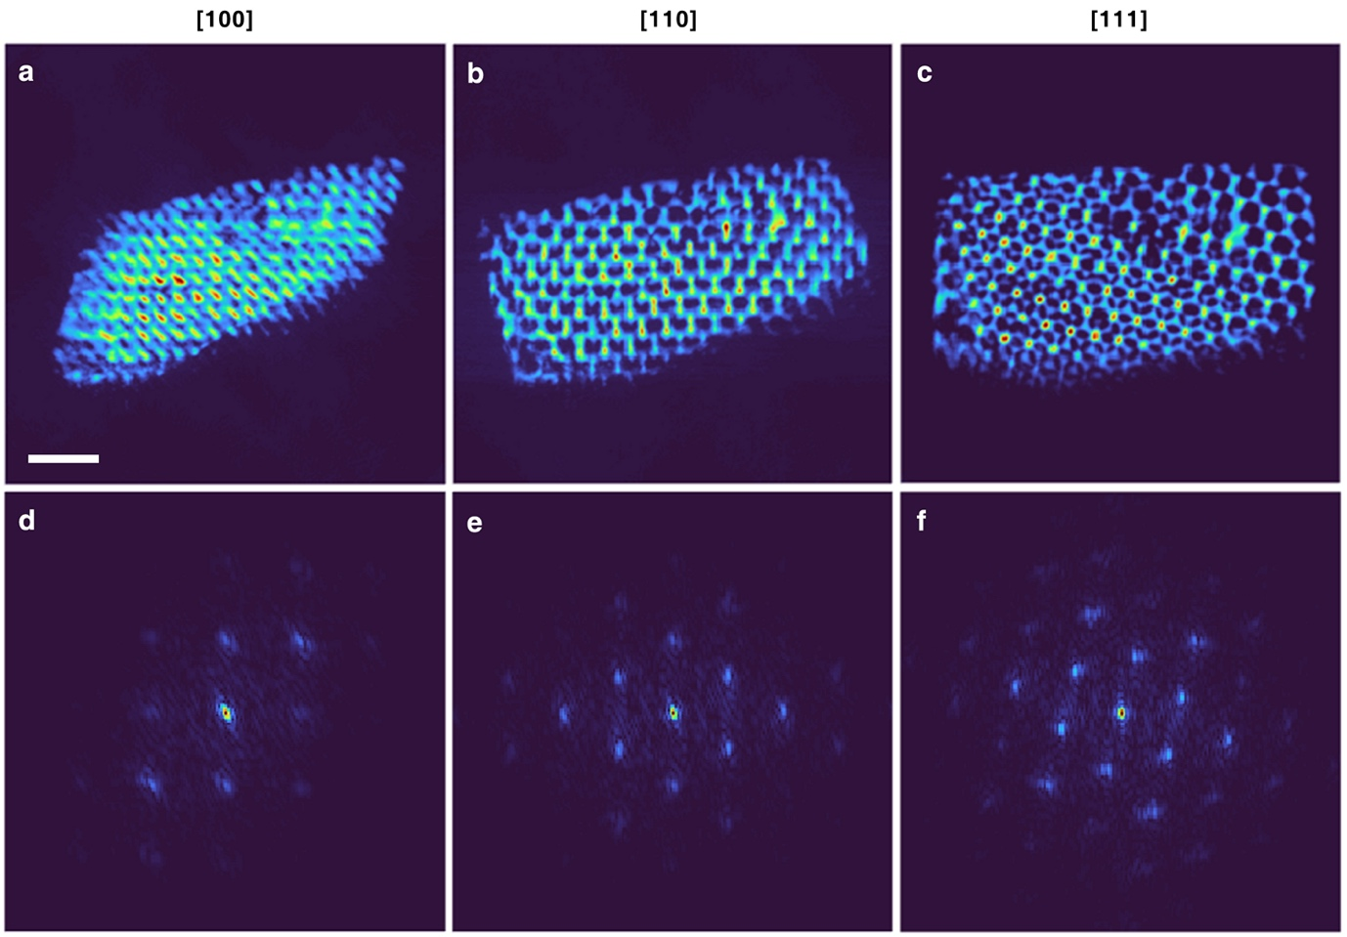
Extended Data Fig. 4. 3D structural characterization of the ferromagnetic meta-lattice. a-c, The experimentally reconstructed 3D electron density of the meta-lattice is oriented along the [100], [110] and [111] directions with red, yellow and blue representing high, medium and low density, respectively. d-f, The corresponding 2D power spectrum of the projections along the [100], [110] and [111] directions, in which the Bragg peaks are clearly visible. Scale bar, 200 nm.

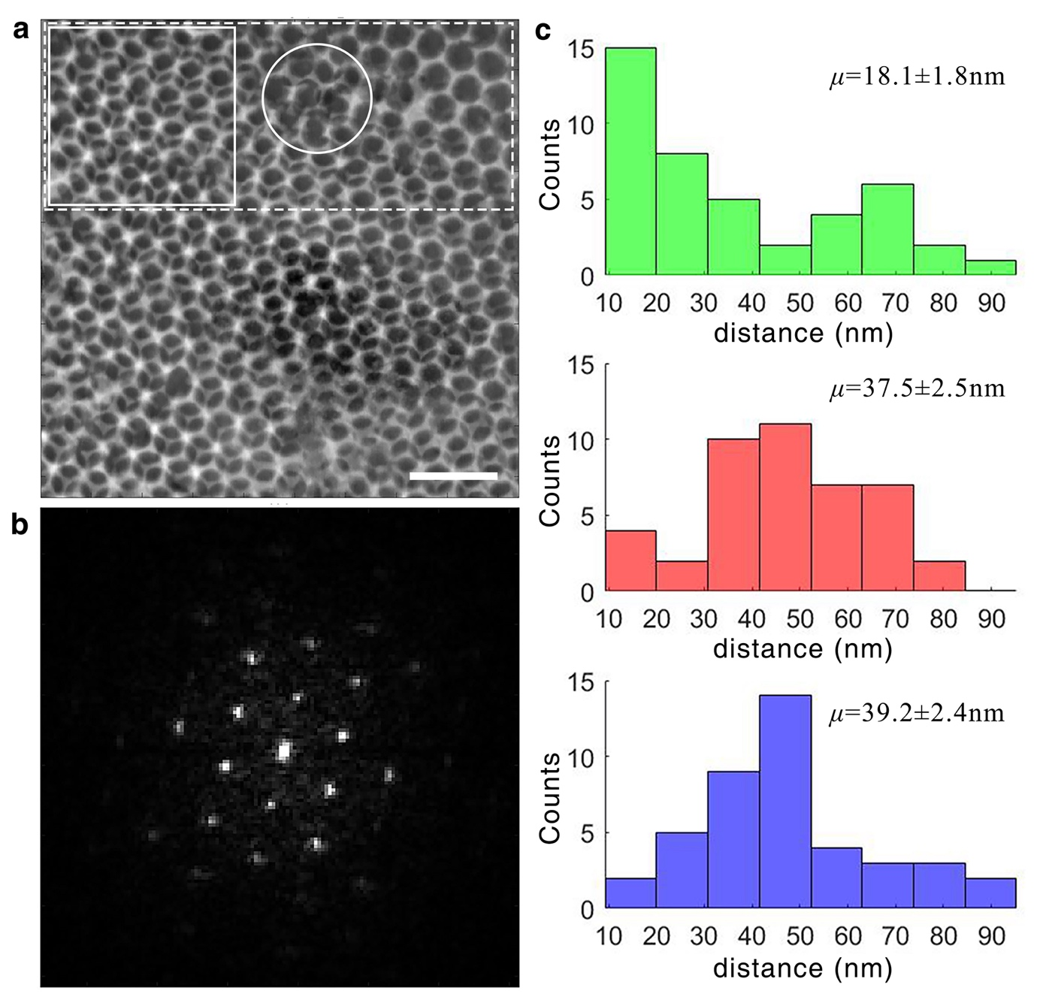
Extended Data Fig. 5. Structural characterization of the sample with scanning transmission electron microscopy (STEM). a, An annual dark-field STEM image of the meta-lattice, where the rectangle with dashed lines represents the reconstruction region by 3D vector ptychography and the square with solid lines shows a more ordered region. The circle indicates some imperfections in the sample. Scale bar, 200 nm. b, 2D power spectrum of the STEM image, where the sharp Bragg peaks indicate that the meta-lattice is ordered. c, Histogram of the nearest-neighbour distance between oppositely and similarly charged magnetic monopoles in the more ordered region (square with solid lines in (a)), which is consistent with Fig. 3d-f, obtained from the region with some imperfections (rectangle with dashed lines in (a)).

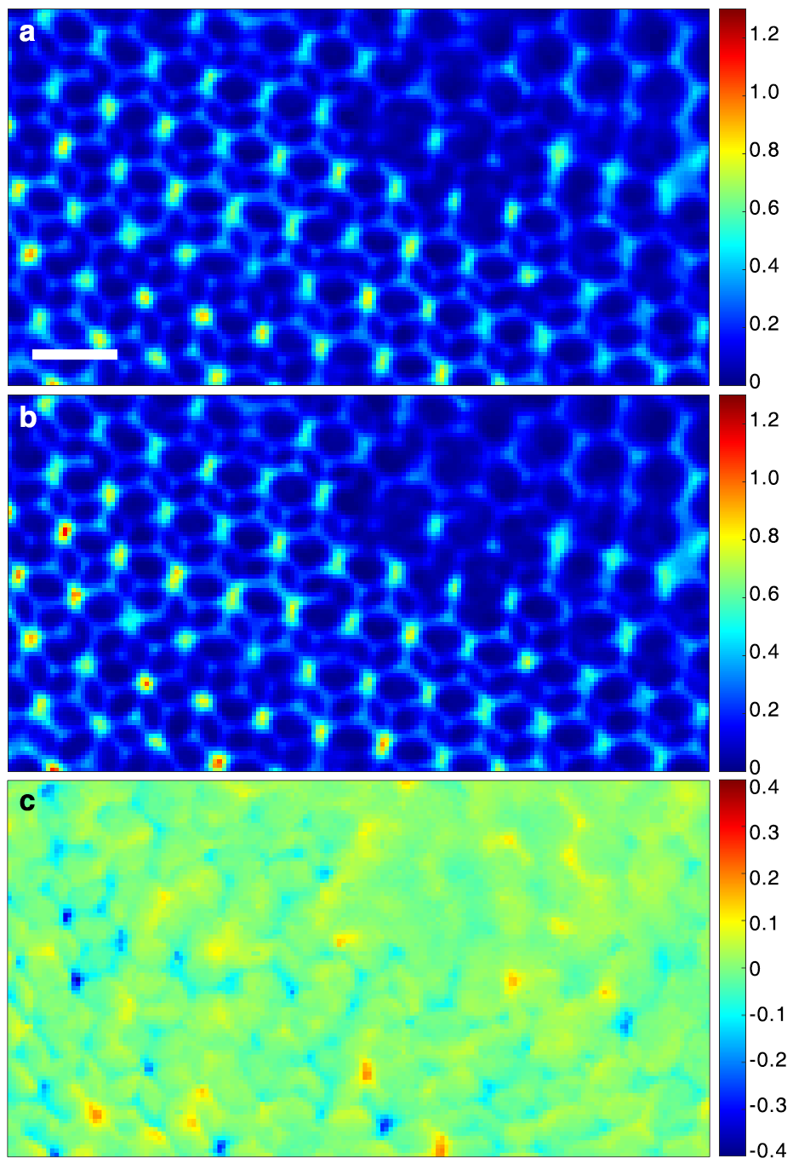
Extended Data Fig. 6. Difference of a left- and a right-circularly polarized projection of the ferromagnetic meta-lattice. a, b, Representative left- and right-circularly polarized projections, respectively. c, The difference of the left- and right-circularly polarized projections, showing the comparable charge and magnetic contrast of the meta-lattice in our experiment. The colour bars are in arbitrary units and the values of the color bars are consistent in (a-c). Scale bar, 100 nm.

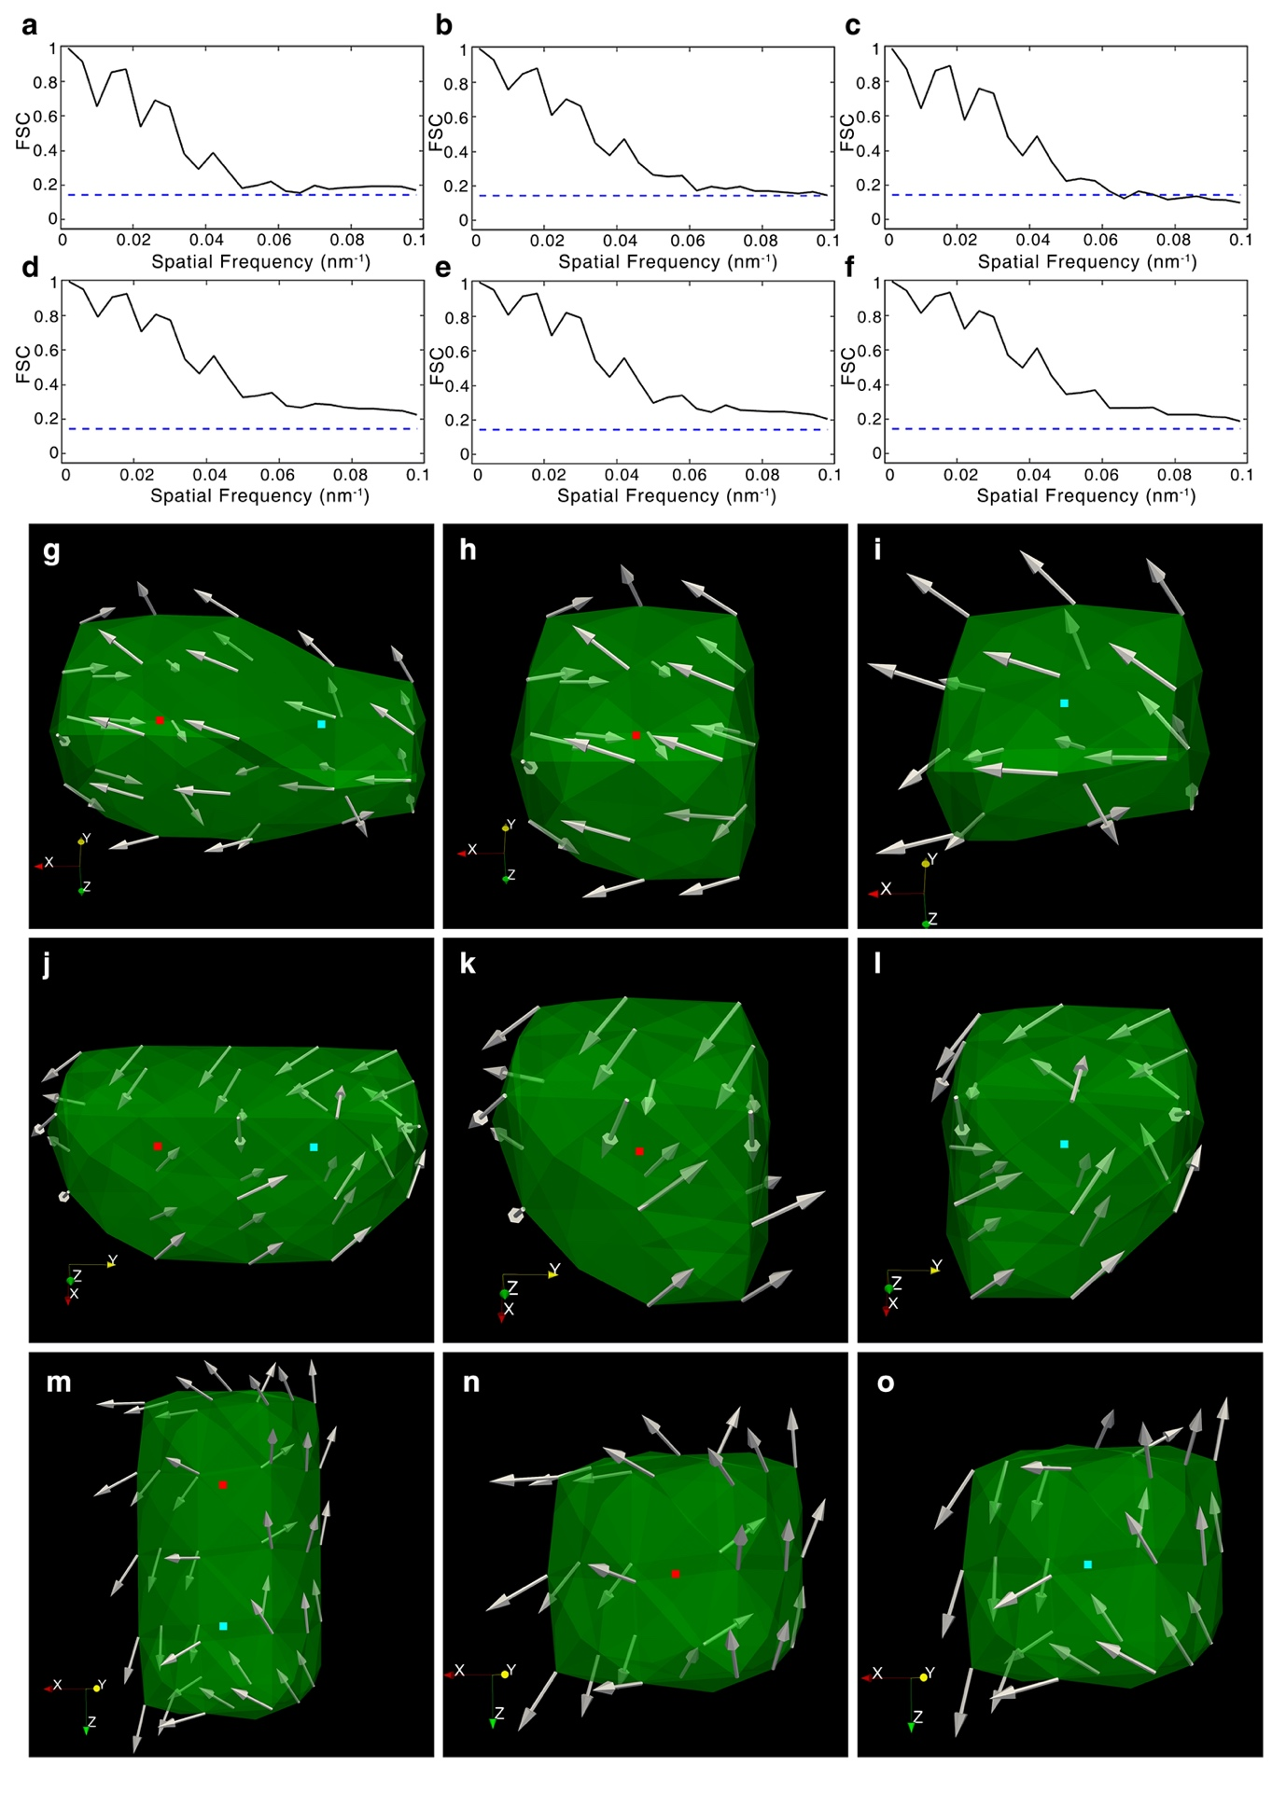
Extended Data Fig. 7. Quantification of the 3D spatial resolution of the vector reconstruction. a-f, FSC for ${|m}_{x}|$, ${|m}_{y}|$, ${|m}_{z}|$, ${|m}_{xy}|$, ${|m}_{xz}|$ and ${|m}_{yz}|$, respectively, where $m_{x}$, $m_{y}$, and $m_{z}$ are the x-, y-, and z-component of the unnormalized magnetization vector field with ${|m}_{xy}|=\sqrt{m_{x}^{2}+m_{y}^{2}}$, ${|m}_{xz}|=\sqrt{m_{x}^{2}+m_{z}^{2}}$ and ${|m}_{yz}|=\sqrt{m_{y}^{2}+m_{z}^{2}}$. The FSC curves were calculated from two independent vector reconstructions of the meta-lattice. According to the criterion of FSC = 0.143 (dashed lines), a 3D spatial resolution of 10 nm was achieved with vector ptychography, which corresponds to a spatial frequency of 0.1 nm⁻¹. The FSC values for ${|m}_{z}|$ are slightly smaller than 0.143 at some high spatial frequency because only a half of the projections were used to perform each 3D vector reconstruction (Methods). Three pairs of topological magnetic monopoles with positive and negative charges distributed along the x- (g-i), y- (j-l) and z-axis (m-o) in the 3D vector reconstruction. The net topological charge of each monopole pair was calculated to be Q = 0, while the topological charge of the positive and negative monopole in each pair was computed to be Q = +1 (red dot) and -1 (green dot), respectively. The distance between the red and green dot in each pair is 2 voxels with a voxel size of 5 nm, demonstrating that a spatial resolution of 10 nm was achieved along the x-, y- and z-axis.

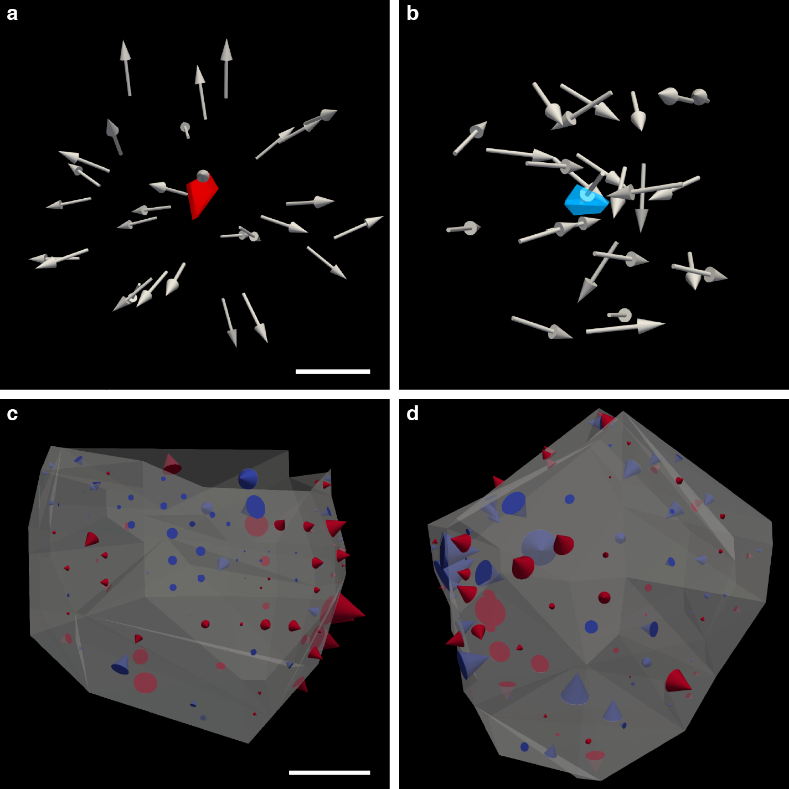
Extended Data Fig. 8. The emergent magnetic field of real and virtual topological magnetic monopoles. a, b, The emergent magnetic field of the topological monopoles with a positive and negative charge shown in Fig. 2c and e in the main text, respectively. The vector plots indicate that the topological magnetic monopoles form a source and a sink of the emergent magnetic field. c, d, The emergent magnetic field of the virtual topological monopoles with a positive and negative charge shown in Fig. 4a and b, respectively. The red and blue cones represent outflow and inflow of the emergent magnetic field, respectively, while the cone size indicates the total emergent flux through the facet. Note that while there is both outflow and inflow of the emergent magnetic field in each case, the net flow corresponds to a source and sink, respectively. The scale bars, 5 nm (a) and 15 nm (c).
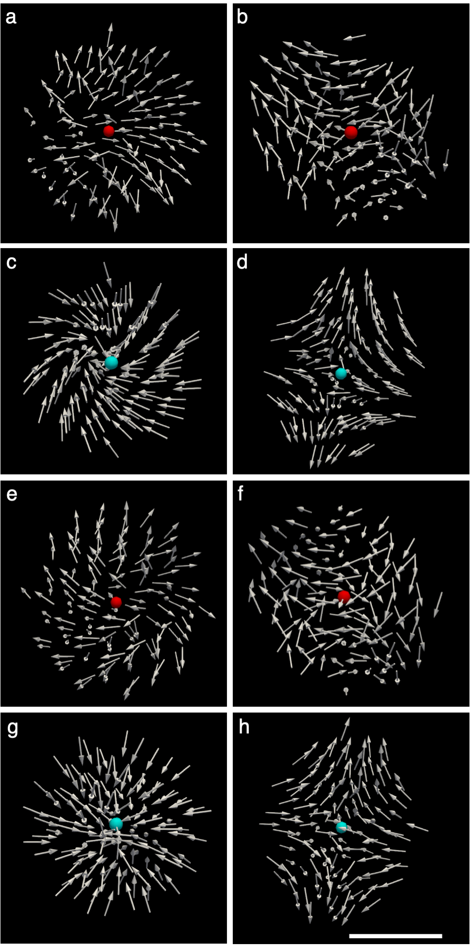
Extended Data Fig. 9. Atomistic simulations using the experimental data as direct input. Four 15×15×15 nm³ volumes were extracted from the ferromagnetic meta-lattice, containing four topological magnetic monopoles with two positive and two negative charges. The atomistic spins were fixed on the outer boundary of each volume, while all the other spins were allowed to relax to an equilibrium configuration. After 50 ps, a stable magnetic monopole formed in each volume with a topological charge matching the experimental value. a-d, Four stable topological magnetic monopoles with two positive (red dots) and two negative charges (blue dots) after relaxation, respectively, which are consistent with the experimental results. With the atomistic spins fixed on four of the six surfaces of each volume, the four topological magnetic monopoles remained stable inside the volumes (e-h). Scale bar, 5 Å.

Location | Number of topological magnetic monopoles with positive charges | Number of topological magnetic monopoles with negative charges | Total number of topological magnetic monopoles
Octahedral sites | 44 | 46 | 90
Tetrahedral sites & the space between the two sites | 24 | 24 | 48

Extended Data Table 1: Site specific location of topological magnetic monopoles with positive and negative charges in the ferromagnetic meta-lattice.

Supplementary Video legends

Supplementary Video 1. 3D scalar (green) and vector (arrow) reconstructions of the ferromagnetic meta-lattice. The global view of the 3D magnetization vector field zooms in to show three representative topological magnetic monopole pairs with a positive and negative charge (Fig. 3a), two positive (Fig. 3b) and two negative charges (Fig. 3c). In each magnified view, the global field fades away and the local magnetization vector field around each topological monopole is given by gray arrows. The field lines follow the emergent magnetic field.

Supplementary Video 2. 3D spatial distribution of 68 and 70 topological magnetic monopoles with positive (red dots) and negative charges (blue dots) in the ferromagnetic meta-lattice, where 8 and 11 virtual topological monopoles with positive and negative charges are labelled with red and blue triangulated surfaces, respectively. The silica nanospheres are rendered as gray iso-surfaces.

