Supplemental data
Supplemental Fig. 1a: TPA-induced mRNA expression of SNA, FN and LEF

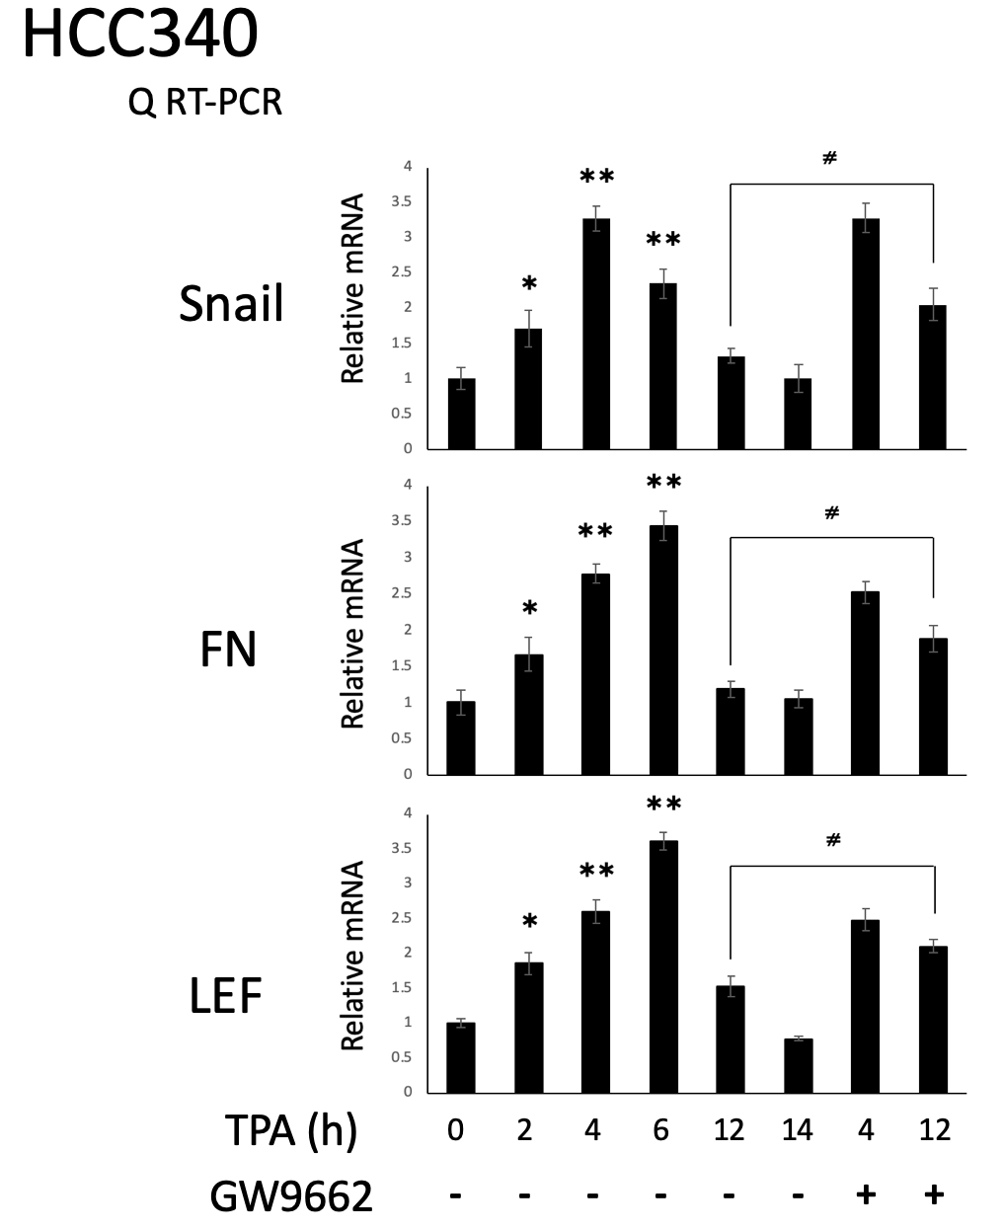
HCC340 cells were treated with 50 nM TPA or TPA plus 5.0 μM GW9662 for the time indicated. Quantitative RT-PCR of SNA, FN and LEF were performed (normalized with GAPDH). The data represent the statistically significant difference (p < 0.05, p<0.001, N=3) between the indicated samples.
Supplemental Fig. 1b: GW9662 rescued TPA-induced SNA and 4 mesenchymal genes at 12 h
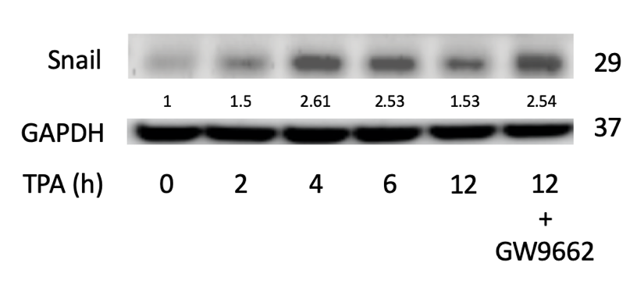
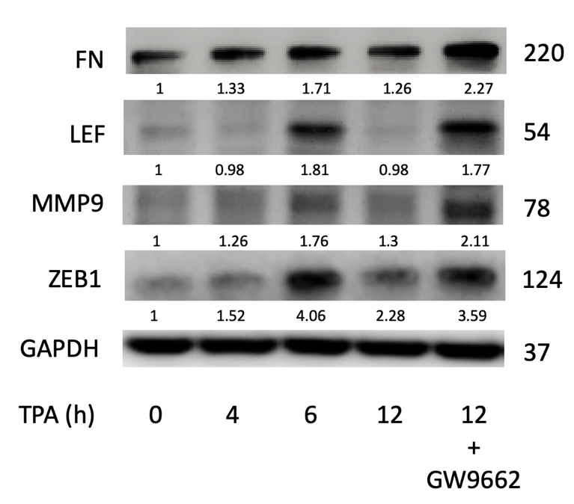
HCC340 cells were treated with TPA (50 nM) alone or TPA coupled with GW9662 (5 μM) for the time indicated. Western blot of shown molecules was performed and using GAPDH as an internal control. The data is representative of two reproducible experiments.
Supplemental Fig. 1c: SNA is required for elevating mRNA level of FN and LEF
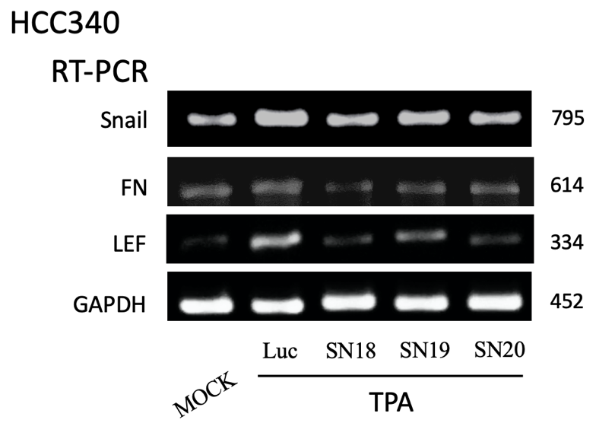

HCC340 cells were transfected with various shRNA SNA fragments (18,19 and 20) for 24 h before treated with TPA in 4 h. RT/PCRs of the SNA, FN and LEF were performed using GAPDH as an internal control. The data shown is representative of two reproducible results.
Supplemental Fig. 2: TPA-induced mRNA expression of PPAR-γ at a later time and negatively regulated by SNA
a b
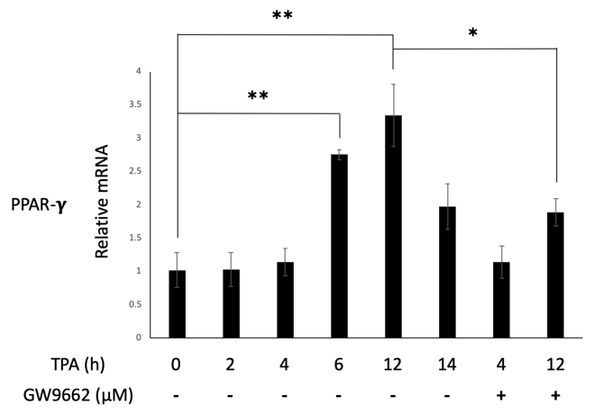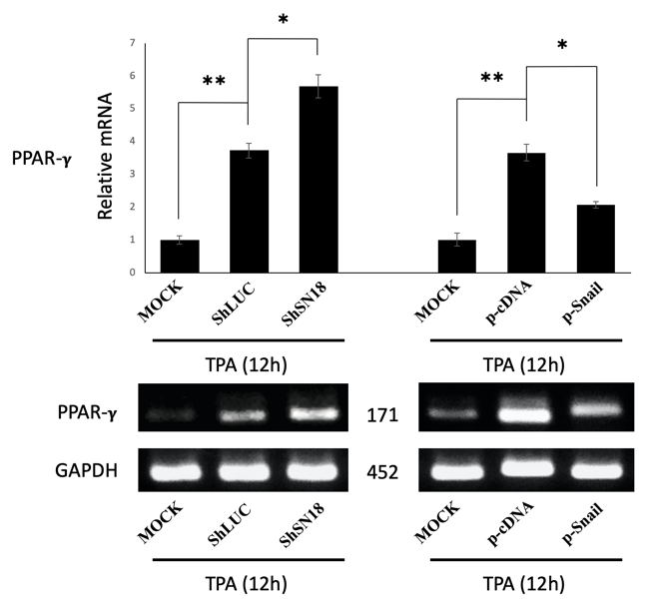
HCC340 cells were treated with 50 nM TPA or with the GW9662 (5 μM) (a) co-treated sample for indicated time and transfected with luciferase shRNA (Luc) or shRNA18 of SNA or SNA expressing plasmid for 24 h (b). RT/PCRs (b, lower panel) and Q-RT-PCR (a, b) of the indicated genes were performed using GAPDH as an internal control. The data shown in (a, b), (*, **) represent the statistically significant difference (p < 0.05, p<0.001, N=3) between the indicated samples and Luc and p-cDNA3 (b) control group.
Supplemental Fig 3: promoter sequences of FN and LEF containing PPAR-γ, Snail and EGR/SP1 overlapping region
a. Homo sapiens fibronectin 1 (FN1), RefSeqGene on chromosome 2, NCBI Reference Sequence: NG_012196.1

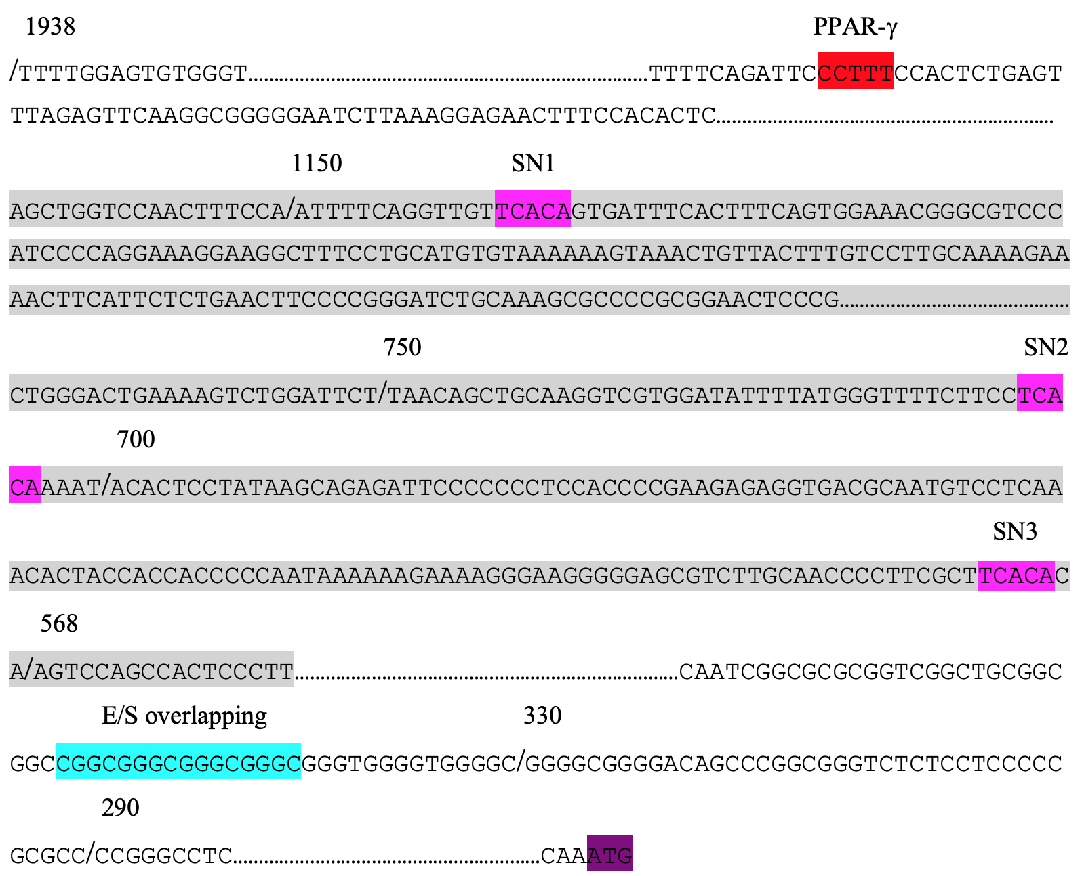

b. Homo sapiens lymphoid enhancer binding factor 1 (LEF1), RefSeqGene on chromosome 4 NCBI Reference Sequence: NG_015798.1

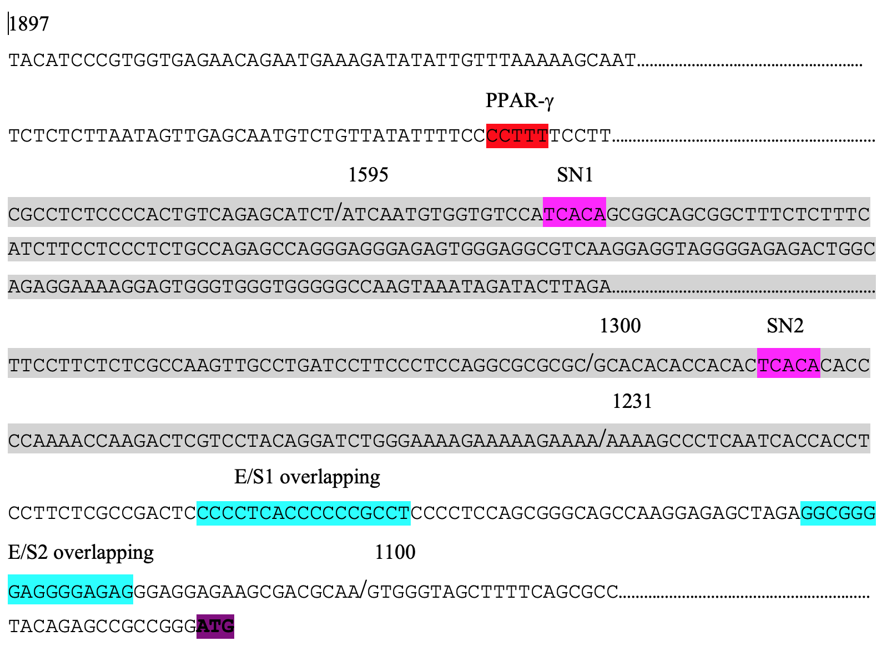

c. Homo sapiens prostaglandin endoperoxide synthase 2 (COX2), RefSeqGene on chromosome 1 NCBI Reference Sequence: NG_028206.2
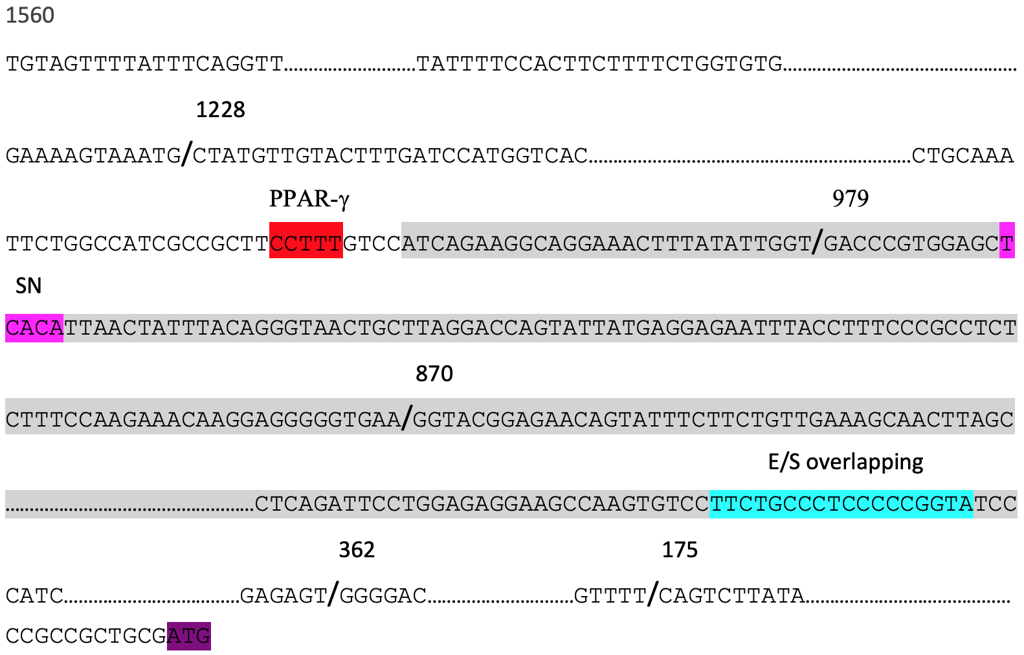

d. Homo sapiens collagen type I alpha 1 chain (COL1A1), RefSeqGene on chromosome 17 NCBI Reference Sequence: NG_007400.1
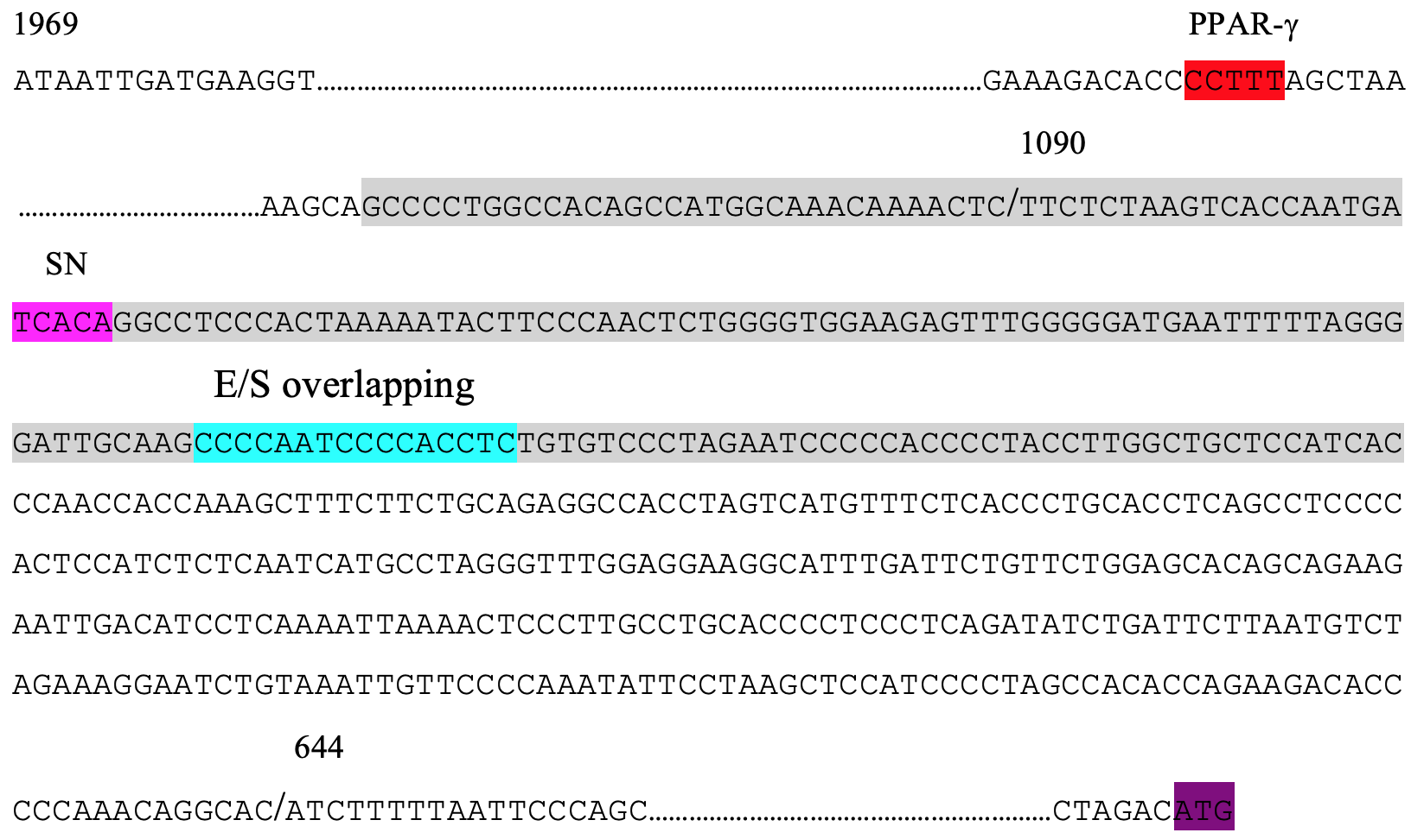

Promoter region of FN (a), LEF (b), COX2 (c) and COL1A1 (d) quoted from gene bank
e. The putative binding motif of PPAR-γ for Homo sapiens according to the JASPAR database: MA0065.1 (http://jaspar.genereg.net/matrix/MA0065.1/?revcomp=1)

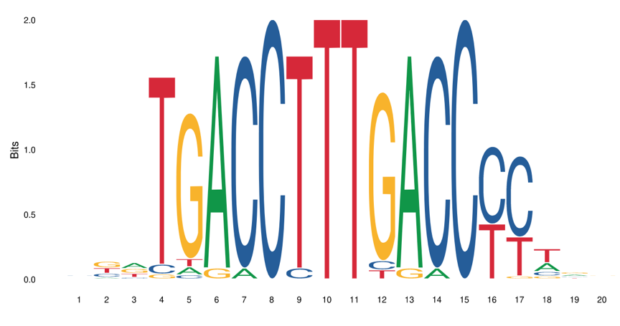

Supplemental Fig. 4: PPAR-γ plays the role as the negative feedback against the SNA-upregulated transcription for FN, LEF, MMP9 and ZEB1 at late stage of TPA treatment
a
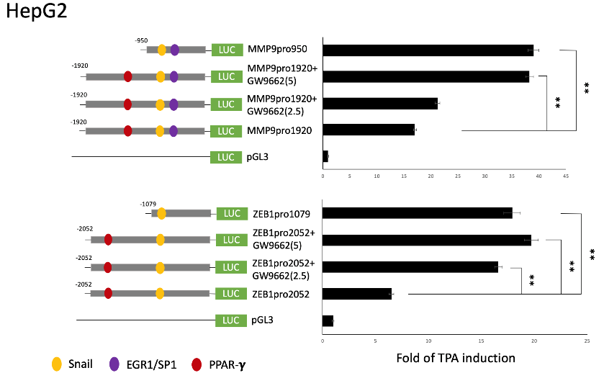
b
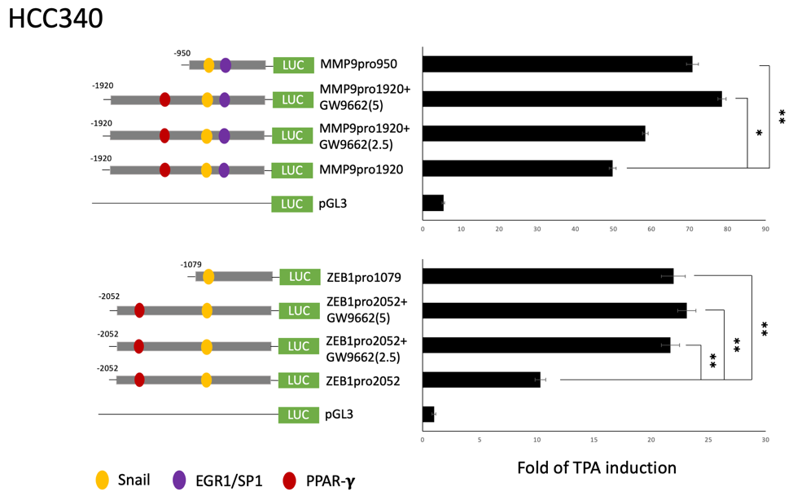
c
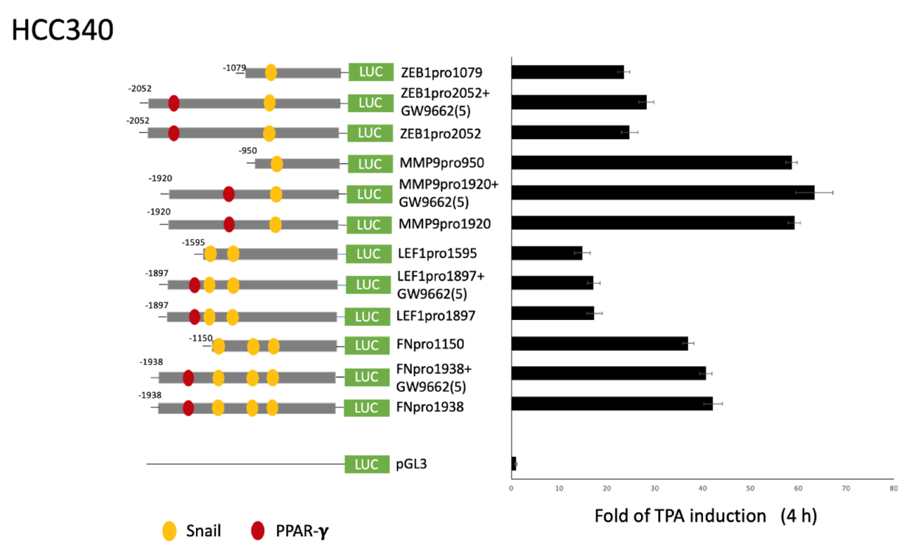
HepG2 (a) and HCC340 (b, c) were transfected with indicated promoter fragments (a, b, c) for 24 h followed by treatment with TPA 50 nM or TPA plus 2.5 or 5.0 μM GW9662 for 12 h (a, b) or 4 h (c). Dual luciferase was performed. Relative fold of TPA induced luciferase activity was calculated, taking the data of pGL3 group as 1.0. (*, **) represent the statistically significant difference (p < 0.05, p < 0.01, N=3) between the indicated full length promoter group with indicated short length promoter or with the GW9662 (2.5 or 5 μM) co-treated sample.
Supplemental Fig. 5: TPA-induced mRNA expression of COX2 and COl1A1
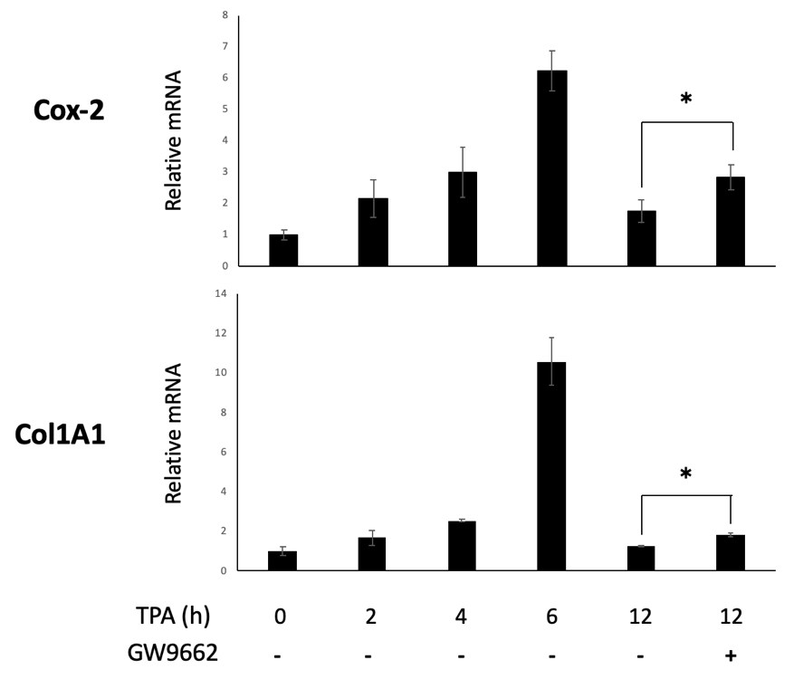
HCC340 cells were treated with 50 nM TPA or with 5.0 μM GW9662 co-treated sample for indicated time. Quantitative RT-PCR of COX2 and COL1A1 were performed (normalized with GAPDH). The data represent the statistically significant difference (p < 0.05, p<0.001, N=3) between the indicated samples.
Supplemental Fig. 6: MAP for ChIP fragment and EMSA probe for FN and LEF promoter
a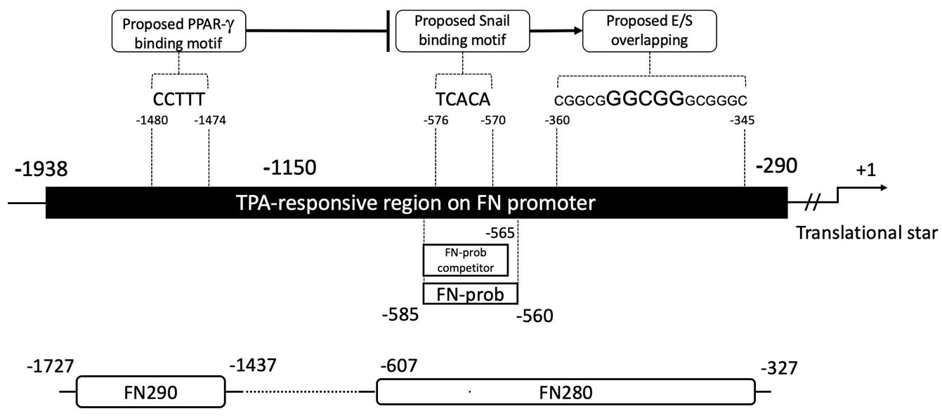
b
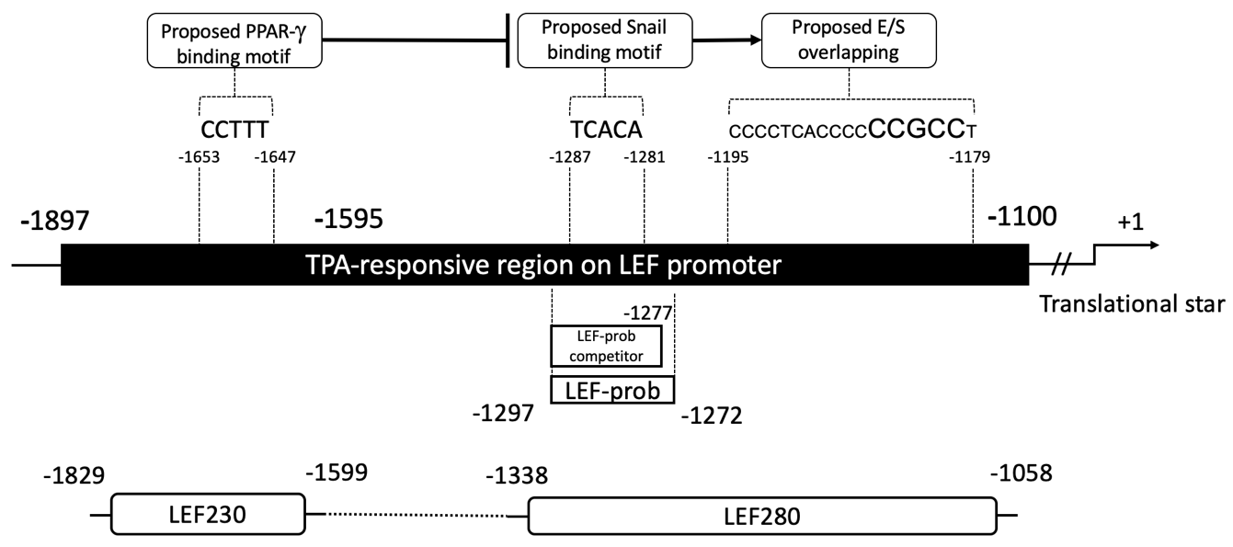
Schematic MAP showing the PCR fragment amplified for the ChIP assay of SNA, EGR1/SP1 overlapping and EMSA probe on FN (a) and LEF (b) promoters. The black bars represent the distal promoter region of FN (a) and LEF (b) from -1938 bp and -1897 bp, respectively, upstream of the translation start site. In (a), the sequence of FN290 and FN280 are located between -1727 to -1437 bp (containing the proposed PPAR-γ target region) and -585 to -560 bp, respectively (containing both the proposed SNA target region and EGR1/SP1 overlapping binding site), whereas the EMSA probe of FN, FN-prob, containing the sequence of proposed SNA motif but not EGR1/SP1 binding site. Also, in (b), the sequence of LEF230 and LEF280 are located between -1829 to -1599 bp (containing the proposed PPAR-γ target region) and -1338 to -1058 bp, respectively (containing both the proposed Snail target region and EGR/SP1 overlapping binding site), whereas the EMSA probe of LEF, LEF-prob, containing the sequence of proposed SNA motif but not EGR1/SP1 binding site.

