Appendix figures
Figure S1
Figure S1. Study selection flowchart.
Figure S2
Figure S2. The effect of splenectomy on overall cancer incidence based on random-effects model. CI = confidence interval, SP = splenectomy, RR = relative risks.

Figure S3
Figure S3. The effect of splenectomy on Non Hodgkin lymphoma (NHL) incidence based on random-effects model. CI = confidence interval, SP = splenectomy, RR = relative risks.

Figure S4
Figure S4. The effect of splenectomy on Hodgkin lymphoma (HL) incidence based on random-effects model. CI = confidence interval, SP = splenectomy, RR = relative risks.

Figure S5
Figure S5. The effect of splenectomy on lung cancer incidence based on fixed-effects model. CI = confidence interval, SP = splenectomy, RR = relative risks.

Figure S6
Figure S6. The effect of splenectomy on leukemia incidence based on fixed-effects model. CI = confidence interval, SP = splenectomy, RR = relative risks.

Figure S7
Figure S7. The effect of splenectomy on breast cancer incidence based on fixed-effects model. CI = confidence interval, SP = splenectomy, RR = relative risks.

Figure S8
Figure S8. The effect of splenectomy on oral and pharyngeal cancer incidence based on fixed-effects model. CI = confidence interval, SP = splenectomy, RR = relative risks.

Figure S9
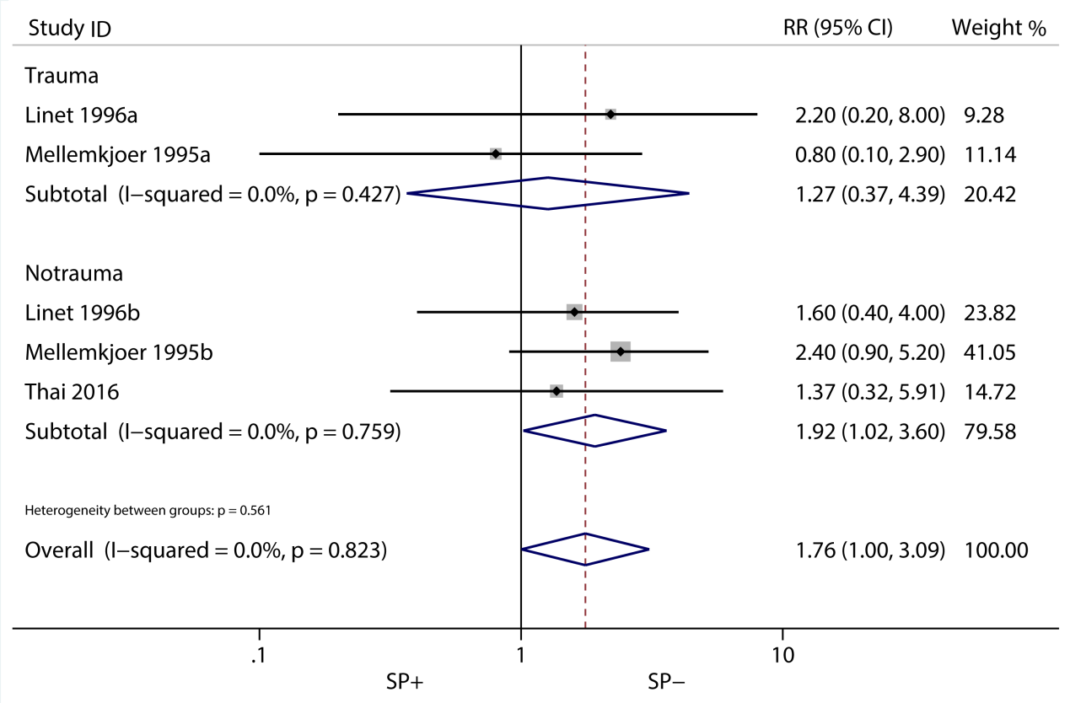
Figure S9. The effect of splenectomy on skin cancer incidence based on fixed-effects model. CI = confidence interval, SP = splenectomy, RR = relative risks.

Figure S10
Figure S10. The effect of splenectomy on esophagus cancer incidence based on fixed-effects model. CI = confidence interval, SP = splenectomy, RR = relative risks.

Figure S11
Figure S11. The effect of splenectomy on prostate cancer incidence based on fixed-effects model. CI = confidence interval, SP = splenectomy, RR = relative risks.

Figure S12
Figure S12. The effect of splenectomy on bladder cancer incidence based on fixed-effects model. CI = confidence interval, SP = splenectomy, RR = relative risks.

Figure S13
Figure S13. The effect of splenectomy on gastric cancer incidence based on fixed-effects model. CI = confidence interval, SP = splenectomy, RR = relative risks.

Figure S14
Figure S14. The effect of splenectomy on pancreas cancer incidence based on fixed-effects model. CI = confidence interval, SP = splenectomy, RR = relative risks.

Figure S15
Figure S15. The effect of splenectomy on brain and nervous system cancer incidence based on fixed-effects model. CI = confidence interval, SP = splenectomy, RR = relative risks.

Figure S16
Figure S16. The effect of splenectomy on liver cancer incidence based on random-effects model. CI = confidence interval, SP = splenectomy, RR = relative risks.

Figure S17
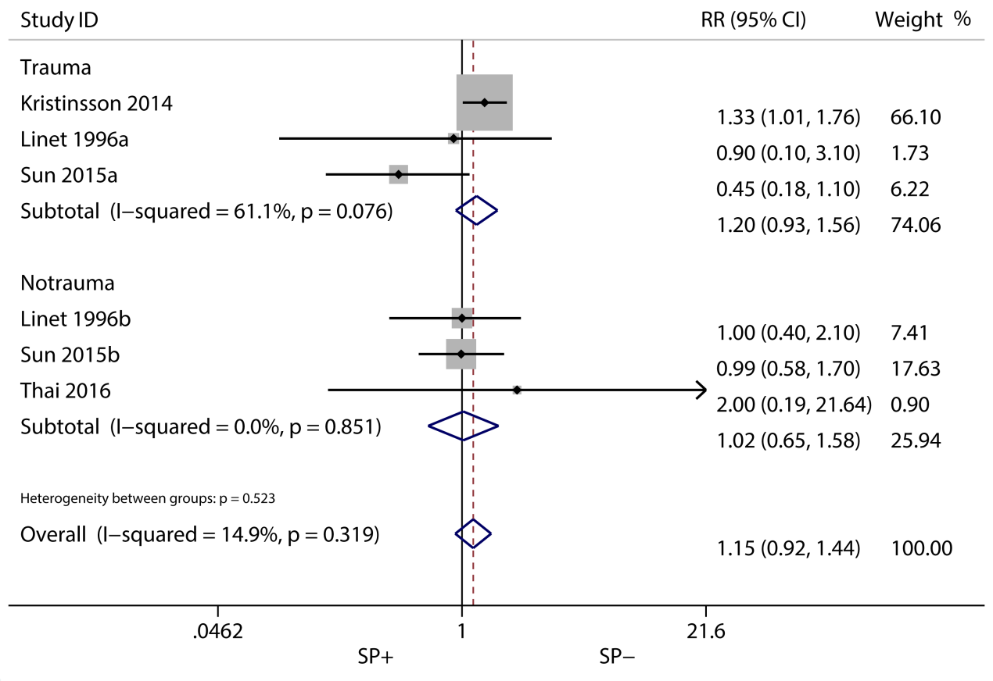
Figure S17. The effect of splenectomy on colorectal cancer incidence based on fixed-effects model. CI = confidence interval, SP = splenectomy, RR = relative risks.

Figure S18
Figure S18. The effect of splenectomy on kidney cancer incidence based on fixed-effects model. CI = confidence interval, SP = splenectomy, RR = relative risks.

Figure S19
Figure S19. The effect of splenectomy on the 5-year OS of gastric cancer based on random-effects model. CI = confidence interval, SP = splenectomy, RR = relative risks, OS = overall survival, RCT = randomized controlled trials.

Figure S20
Figure S20. The effect of splenectomy on the 5-year OS of colorectal cancer based on fixed-effects model. CI = confidence interval, SP = splenectomy, RR = relative risks, OS = overall survival.

Figure S21
Figure S21. The effect of splenectomy on the 5-year OS of esophageal and esophago‑gastric junction cancer based on fixed-effects model. CI = confidence interval, SP = splenectomy, RR = relative risks, OS = overall survival.

Figure S22
Figure S22. The effect of splenectomy on the 5-year OS of liver cancer based on fixed-effects model. CI = confidence interval, SP = splenectomy, RR = relative risks, OS = overall survival.

Figure S23
Figure S23. Subgroups analyses of splenectomy on the 5-year OS of gastric cancer based on tumor stage (Ⅰ, Ⅱ, Ⅲ, Ⅳ). CI = confidence interval, SP = splenectomy, RR = relative risks, OS = overall survival.

Figure S24
Figure S24. The effect of splenectomy on the hospital mortality of gastric cancer based on fixed-effects model. CI = confidence interval, SP = splenectomy, RR = relative risks.

Figure S25
Figure S25. The effect of splenectomy on the hospital mortality of liver cancer patients based on fixed-effects model. CI = confidence interval, SP = splenectomy, RR = relative risks.

Figure S26
Figure S26. The effect of splenectomy on the hospital mortality of esophageal and esophago‑gastric junction cancer patients from fixed-effects model. CI = confidence interval, SP = splenectomy, RR = relative risks.

Figure S27
Figure S27. Subgroups analyses of splenectomy on the hospital mortality of gastric cancer patients based on total gastrectomy. CI = confidence interval, SP = splenectomy, RR = relative risks.

