Occurrence and seasonal disparity of emerging endocrine disrupting chemicals in a drinking water supply system and associated health risk
Manoj Kumawat¹, Poonam Sharma ¹, Namrata Pal ¹, MeenuMariya James ¹, Vinod Verma ^{2*}, Rajnarayan R Tiwari ¹, Swasti Shubham ^{1*}, Devojit Kumar Sarma^{1*}, Manoj Kumar ^{1#*}
¹ ICMR- National Institute for Research in Environmental Health, Bhopal Bypass Road, Bhouri,
Bhopal - 462030, Madhya Pradesh, India
² Stem Cell Research Centre, Department of Hematology, Sanjay Gandhi Post-Graduate Institute of Medical Sciences, Lucknow - 226014, Uttar Pradesh, India
# Corresponding author
Manoj Kumar
ICMR- National Institute for Research in Environmental Health, Bhopal
Bypass Road, Bhouri, Bhopal - 462030, Madhya Pradesh, India
Email: manoj15micro@yahoo.co.in
* Equal contribution

SUPPLEMENTARY FILE
Supplementary Table:1Area-wise detection frequency (Df) of phthalates and BPA in drinking water samples (where N= Total no. samples, and n = no. of samples in which PAE and BPA detected).
ANALYTES | AREA WISE DETECTION FREQUENCY
ANALYTES | WINTER
ANALYTES | BHONGDWAR |  |  | RANJHI |  |  | LALPUR |  |  | RAMNAGRA
ANALYTES | n | N | % | n | N | % | n | N | % | n | N | %
BPA | 22 | 23 | 95.65 | 19 | 25 | 76 | 25 | 25 | 100 | 22 | 23 | 95.65
DMP | 23 | 23 | 100 | 25 | 25 | 100 | 25 | 25 | 100 | 23 | 23 | 100
DEP | 21 | 23 | 91.30 | 15 | 25 | 60 | 21 | 25 | 84 | 23 | 23 | 100
DBP | 23 | 23 | 100 | 25 | 25 | 100 | 25 | 25 | 100 | 23 | 23 | 100
BBP | 12 | 23 | 52.17 | 9 | 25 | 36 | 16 | 25 | 64 | 11 | 23 | 47.83
DEHP | 23 | 23 | 100 | 25 | 25 | 100 | 25 | 25 | 100 | 23 | 23 | 100
DNOP | 14 | 23 | 60.87 | 6 | 25 | 24 | 16 | 25 | 64 | 21 | 23 | 91.30
ANALYTES | SUMMER
ANALYTES | BHONGDWAR |  |  | RANJHI |  |  | LALPUR |  |  | RAMNAGRA
ANALYTES | n | N | % | n | N | % | n | N | % | n | N | %
BPA | 24 | 24 | 100 | 25 | 25 | 100 | 25 | 25 | 100 | 23 | 23 | 100
DMP | 3 | 24 | 12.5 | 3 | 25 | 12 | 20 | 25 | 80 | 4 | 23 | 17.39
DEP | 24 | 24 | 100 | 25 | 25 | 100 | 25 | 25 | 100 | 23 | 23 | 100
DBP | 24 | 24 | 100 | 25 | 25 | 100 | 25 | 25 | 100 | 23 | 23 | 100
BBP | - | - | - | - | - | - | - | - | - | - | - | -
DEHP | 22 | 24 | 91.67 | 25 | 25 | 100 | 17 | 25 | 68 | 20 | 23 | 86.96
DNOP | 21 | 24 | 87.5 | 24 | 25 | 96 | 25 | 25 | 100 | 23 | 23 | 100

Supplementary Table: 2 Area wise concentrations of ∑6PAEs (Dimethyl phthalate (DMP), Diethyl phthalate (DEP), Di(2-ethylhexyl) phthalate (DEHP), Benzyl butyl phthalate (BBP), Di-n-butyl phthalate (DBP), and Di-n-octyl phthalate (DNOP) in water samples collected from Household Over Head (OH) Tanks and Drinking water (DW) during summer and winter. Results are reported in ug/l.
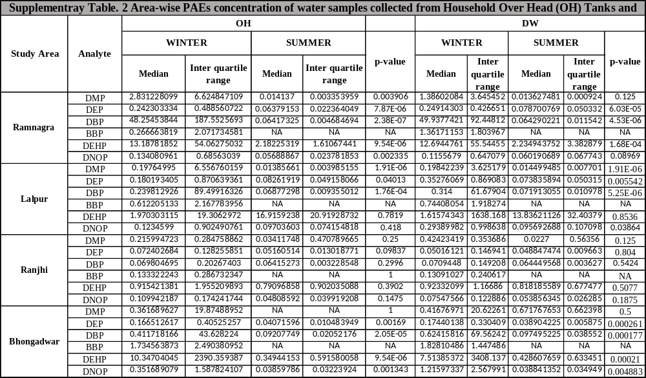
Supplementary Fig. 1Calibration curve of (a) dimethyl phthalate (DMP); (b) diethyl phthalate (DEP); (c) dibutyl phthalate (DBP); (d) benzyl butyl phthalate (BBP); (e) bis (2-ethylhexyl) phthalate (DEHP); (f) di-n-octyl phthalate (DNOP) at a concentration range from 10-900 ppb and; (g) bisphenol A (BPA) at concentration range from 50- 900 ppb.
