Galectin-3 in the gut-liver axis regulates autistic-like behaviors by mechanism associated with cerebral Shank-3+ cell niches in BALB/c mice

Lemos FS¹; Prins CA²; Carpi-Santos R³; Waclawiak I⁴; Santos SN⁵; Bernardes ES⁵; Peça J⁶; Martinez AMB²; Benjamim CF⁴; Luisetto R⁷; Mello-Coelho V⁸; Chammas R⁹; Oliveira FL¹

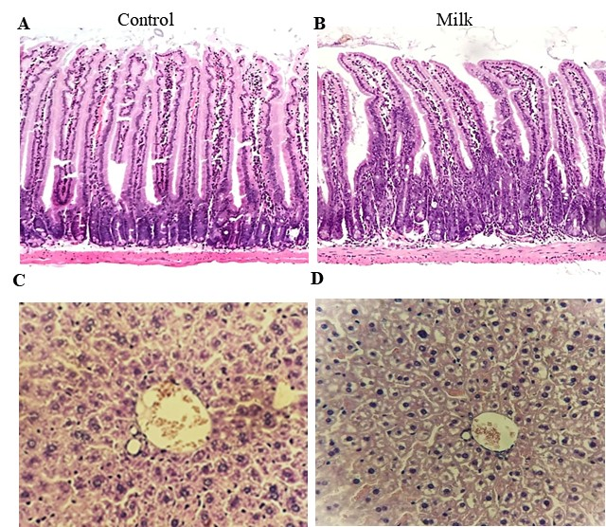

Supplementary Figure 1: Photomicrographs of small intestine obtained from control (A) and milk-treated mice (B). Representative images of the liver of control (C) and milk-treated mice (D). Data are representative of three independent analysis. n=3 mice per group. Magnification 200x (A and B) and 400x (C and D).

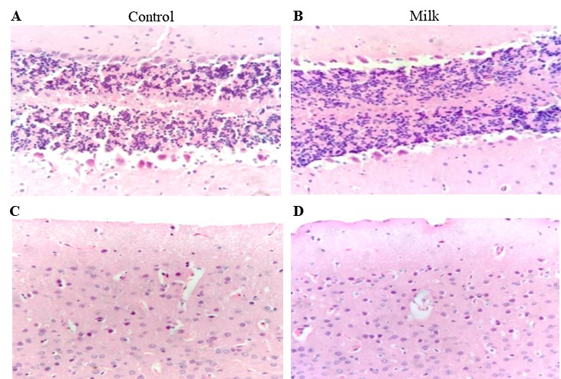

Supplementary Figure 2: Photomicrographs of the cerebellum obtained from control (A) and milk-treated mice (B). Representative images of cerebral cortex of control (C) and milk-supplemented mice (D). Data are representative of three independent analysis. n=3 mice per group. Magnification 200x (A and B) and 400x (C and D).

