Supplementary material
Supplementary Information 1. Detailed neuropsychological testing, psychiatric questionnaires, fatigue, dyspnea, olfaction and other variables
A comprehensive neuropsychological battery (based only on tests of norms validated in a French-speaking population) was administered in French to participants 6-9 months after their positive PCR test result. This battery included a series of tests and questionnaires that assessed most of the domains of cognition, emotion recognition, fatigue, and quality of life (see paragraph below). The tests were administered by clinical psychologists (mean duration: approximately 180 minutes), and the questionnaires were administered online via Qualtrics software (Qualtrics, Provo, UT) (mean duration: approximately 60 minutes).
Executive functions. The Stroop task, Trail Making Test, and categorical and lexical verbal fluency from the GREFEX battery ⁶⁴ were administered to evaluate inhibition, shifting, and updating, in accordance with Miyake, et al. ⁶⁵. Verbal working memory and visuospatial working memory were assessed with the backward digit span ⁶⁶ and backward Corsi tests ⁶⁷. We also administered computer-based tasks designed to gauge focused attention, divided attention, phasic alertness, working memory, and incompatibility, using version 2.1 of the Test for Attentional Performance ⁶⁸.
Memory systems. Short-term memory was assessed with forward digit spans ⁶⁶ and the Corsi test ⁶⁷. Verbal episodic memory was assessed with the 16-item Grober and Buschke free/cued recall (RL/RI 16) paradigm ⁶⁹, as it distinguishes between the cognitive subprocesses of encoding, storage, and recall ⁷⁰. Visual episodic memory was assessed with the delayed recall of the Rey-Osterrieth Complex Figure test ⁷¹.
Instrumental functions. Language was assessed with the BECLA battery ⁷², ideomotor praxis with a short validated battery ⁷³, visuoconstructive abilities with the Rey-Osterrieth Complex Figure test ⁷¹, and visuoperceptual functions with four subtests from the Visual Object and Space Perception battery ⁷⁴ that measured object perception (fragmented letters, object decision) and spatial perception (localization of numbers, analysis of cubes).
Logical reasoning. This was assessed using the Puzzle and Matrices subtests of the Wechsler Adult Intelligence Scale–Fourth Edition ⁷⁵.
Emotion. Multimodal emotion recognition was assessed with the Geneva Emotion Recognition Test (GERT) ⁷⁶. Participants watched 42 video clips in which 10 actors displayed 14 different emotions (pride, fun, happiness, pleasure, relief, interest, anger, irritation, fear, anxiety, disgust, despair, sadness, surprise) while expressing nonverbal content. After each clip, participants were asked to choose one emotion from the list of 14 that best described the emotion displayed by the actor.
Anosognosia and cognitive complaints. We administered the Cognitive Complaints Questionnaire (QPC) ⁷⁷ and the Behavior Rating Inventory of Executive Function-Adult Version (BRIEF-5) ⁷⁸. To quantify anosognosia, we calculated a self-appraisal discrepancy (SAD) score for each memory and executive domain evaluated by the QPC and BRIEF-5 ⁷⁹⁻⁸¹. First, we calculated standardized scores for the cognitive complaints, dividing the raw scores of the self-report questionnaires into four categories: 0 = normal behavior, 1 = limited influence on daily life, 2 = noticeable influence on daily life, and 3 = substantial influence on daily life. We then subtracted each of these standardized scores from the standardized score for the relevant function. For example, if a patient reported no memory disorders (QPC score = 3), but performed very poorly on the RL/RI 16 delayed free recall test (score = 0), he or she would be deemed to exhibit anosognosia for memory dysfunction: 0 - 3 = -3. SAD scores could therefore range from -3 to 3, and any score below 0 indicated anosognosia.
Symptom validity. The BRIEF-A was used to measure the validity of patients' responses, as well as the presence of any noncredible symptoms ^{82,83}.
Other clinical outcomes
We collected patients’ sociodemographic data and medical history. Psychiatric data (including current fatigue, insomnia, and somnolence), dyspnea, and data on olfactory abilities at the time of the interview were also collected. Finally, a neurological assessment of CNS and peripheral nervous system functions and walking was carried out by two certified neurologists (FA and GA).
Sociodemographic and clinical data. In addition to age, collected during the inclusion interview, we recorded patients’ gender, handedness, and education level. To complement information about previous neurological, psychiatric, and developmental conditions and cancer collected during the inclusion interview, we asked patients about previous cardiovascular disease, respiratory disorders, immunosuppression status, sleep apnea syndrome, diabetes, and smoking. Participants were asked to describe the symptoms they had experienced, both during the acute phase of the infection and currently (6-9 months post-infection), and the number of days they had spent in hospital, where relevant.
Psychiatric data. Depressive symptoms were assessed with the Beck Depression Inventory-Second edition ⁸⁵, anxiety with the State-Trait Anxiety Inventory ⁸⁶, apathy and its distinct subtypes with the Apathy Motivation Index (AMI) ⁸⁷, PTSD with the Posttraumatic Stress Disorder Checklist for DSM-5 ⁸⁸, manic symptoms with the Goldberg Mania Inventory ⁸⁹, dissociative symptoms in the patient's daily life with the Dissociative Experience Scale ⁹⁰, current stress perception with the Perceived Stress Scale – 14 items ⁹¹, cognitive reappraisal of an emotional episode and expressive emotional suppression abilities with the Emotion Regulation Questionnaire ⁹², and susceptibility to others’ emotions with the Emotional Contagion Scale ⁹³. Finally, fatigue was assessed with the French version of the Fatigue Impact Scale ⁹⁴, potential sleeping disorders with the Insomnia Severity Index ⁹⁵, and symptoms of sleepiness in daily life with the Epworth Sleepiness Scale ⁹⁶.
Dyspnea. Dyspnea was evaluated with a self-report questionnaire ⁹⁷ that distinguishes between the physical and affective aspects of self-reported dyspnea.
Olfaction. Olfactory performance was measured with the Sniffin’ Sticks test battery. This test consists of commercially available pens with 16 common odors, which were each presented for 2 s in front of both nostrils. For each odor, patients had to choose between four descriptors in a multiple-choice task. Participants’ scores ranged from 0 to 16. Based on the work by Kobal, et al. ⁹⁸, we set three thresholds: patients with an identification score of 0-7 were considered anosmic, 8-12 hyposmic, and 13-16 normosmic.

Supplementary Information 2. Acquisition parameters for the structural images (T1w MPRAGE).
Acquisition time | 4min 36sec
Repetition time | 2300 ns
Echo time | 2.24 ms
Acquisition matrix | 256 x 256
FOV | 186 x 239 x 239 mm
Flip angle | 8 deg
Number of Slices | 208 (Sagittal)
Voxel Size | 0.9 x 0.9375 x 0.9375 mm
Slice thickness | 0.9 mm

Supplementary Information 3. Acquisition parameters for the functional images (rs-fMRI).
Acquisition time | 7min 59sec
Repetition time | 1 s
Echo time | 30 ms
Acquisition matrix | 88 x 88
FOV | 220 x 220 x 160 mm
Flip angle | 50 deg
Number of Slices | 64 (Transversal)
Voxel Size | 2.5 x 2.5 x 2.5 mm
Slice thickness | 2.5 mm

Supplementary Information 4. MRI motion data as a function of severity in the acute phase and as a function of memory dysfunction awareness
 | Severity of acute infection
 | Mild  (n = 20) | Moderate  (n = 21) | Severe  (n = 9) | K-W
Average FD | 0.23 (± 0.1) | 0.29 (± 0.15) | 0.27 (± 0.08) | .418
Excluded Volumes | 7.11 (± 19.94) | 26.6 (± 63.29) | 11.88 (± 21.72) | .496
Legend. M-W: FD: framewise displacement; Mann Whitney U test; K-W: Kruskal-Wallis ANOVA test.

Supplementary Information 5. Mean scores, standard deviations, and intergroup comparisons for cognitive performances among patients who had mild, moderate, or severe COVID-19 at 6-9 months post-infection
 |  | Mild  (n = 44)  Mean (± SD) | Moderate  n = 42  Mean (± SD) | Severe  n = 24  Mean (± SD) | K-W analysis | M-W  Mild  vs.  Moderate  FDR corrected | M-W  Mild  vs.  Severe  FDR corrected | M-W  Moderate vs.  Severe  FDR corrected
Memory
Verbal episodic memory | Grober & Buschke (RL/RI 16) - Immediate recall | 15.93 (± 0.25) | 15.90 (± 0.30) | 15.33 (± 0.96) | < .001* | .832 | .015* | .024**
 | Grober & Buschke (RL/RI 16) - Sum of 3 free recalls | 33.09 (± 5.03) | 30.55 (± 6.53) | 28.25 (± 7.18) | .009* | .053 | .003** | .205
 | Grober & Buschke (RL/RI 16) - Sum of 3 total recalls | 46.66 (± 1.48) | 44.69 (± 3.82) | 44.96 (± 3.42) | .040* | .044* | .029* | .973
 | Grober & Buschke (RL/RI 16) - Delayed free recall | 13.16 (± 2.02) | 12.26 (± 2.56) | 10.96 (± 2.65) | .003* | .140 | .001** | .042*
 | Grober & Buschke (RL/RI 16) - Delayed total recall | 15.82 (± 0.45) | 15.36 (± 1.25) | 15.42 (± 1.10) | .057 | - | - | -
Visuospatial episodic memory | Rey Figure - Copy time | 158.25 (± 49.63) | 174.05 (± 62.31) | 161.79 (± 79.83) | .281 | - | - | -
 | Rey Figure - Score | 34.48 (± 2.21) | 34.19 (± 3.03) | 33.44 (± 3.44) | .579 | - | - | -
 | Rey Figure - Immediate recall (3') | 20.41 (± 5.74) | 18.29 (± 6.59) | 17.15 (± 6.08) | .096 | - | - | -
 | Rey Figure - Delayed recall (20') | 25.45 (± 5.71) | 22.86 (± 7.27) | 22.52 (± 7.02) | .101 | - | - | -
Verbal short-term memory | MEM III -Spans | 9.57 (± 2.02) | 8.62 (± 2.56) | 8.83 (± 2.01) | .079 | - | - | -
Visuospatial short-term memory | WAIS IV - Spans | 8.39 (± 2.23) | 7.95 (± 2.15) | 7.46 (± 1.10) | .379 | - | - | -
Executive functions
Inhibition | Stroop Interference - Time | 110.86 (± 22.61) | 123.08 (± 31.28) | 131.83 (± 34.27) | .022* | .042* | .016* | .273
 | Stroop Interference - Errors | 0.39 (± 0.78) | 1.03 (± 2.21) | 0.88 (± 1.39) | .150 | - | - | -
 | Stroop Interference/Naming - Score | 44.52 (± 14.73) | 52.33 (± 24.75) | 59.46 (± 26.28) | .078 | - | - | -
Working memory | MEM III – Verbal working memory | 8.52 (± 1.87) | 8.52 (± 1.97) | 7.83 (± 1.95) | .264 | - | - | -
 | WAIS IV – Visuospatial working memory | 8.00 (± 1.83) | 7.64 (± 2.24) | 7.71 (± 1.81) | .679 | - | - | -
 | TAP – Working memory item omissions | 2.02 (± 1.98) | 2.53 (± 2.31) | 2.54 (± 2.70) | .649 | - | - | -
 | TAP – Working memory false alarms | 3.16 (± 4.55) | 3.60 (± 4.71) | 3.58 (± 3.41) | .778 | - | - | -
Mental flexibility | TMT B - Time | 73.66 (± 29.39) | 105.83 (± 75.89) | 102.92 (± 51.03) | .006* | .007** | .008* | .627
 | TMT B - Error | 0.16 (± 0.48) | 0.45 (± 0.99) | 0.46 (± 0.98) | .338 | - | - | -
 | TMT B - Perseverations | 0.07 (± 0.25) | 0.67 (± 1.68) | 0.50 (± 0.59) | .002* | .105 | .008* | .351
 | TMT B-A - Score | 42.02 (± 23.65) | 69.24 (± 68.05) | 59.46 (± 26.28) | .007* | .009** | .008* | .558
 | Verbal fluency - Literal (2') | 21.27 (± 5.47) | 21.14 (± 8.00) | 20.79 (± 5.99) | .952 | - | - | -
 | Verbal fluency - Categorical (2') | 32.82 (± 8.91) | 31.74 (± 10.89) | 28.29 (± 8.83) | .191 | - | - | -
Incompatibility | TAP – Compatibility – False alarms | 0.64 (± 1.16) | 2.88 (± 5.89) | 2.00 (± 6.01) | .413 | - | - | -
 | TAP – Incompatibility – False alarms | 1.86 (± 2.31) | 4.70 (± 7.39) | 3.58 (± 6.36) | .535 | - | - | -
Attentional functions
Phasic alertness | TAP – Without warning sound – Reaction time | 257.93 (± 46.62) | 278.49 (± 65.38) | 262.96 (± 51.14) | .163 | - | - | -
 | TAP – Without warning sound – SD of reaction time | 47.09 (± 31.50) | 51.28 (± 28.42) | 49.38 (± 32.10) | .634 | - | - | -
 | TAP – With warning sound – Reaction time | 256.27 (± 46.62) | 272.23 (± 53.85) | 256.21 (± 36.80) | .396 | - | - | -
 | TAP – With warning sound – SD of reaction time | 41.05 (± 17.69) | 48.62 (± 25.39) | 42.33 (± 20.30) | .327 | - | - | -
Sustained attention | TAP – Item omissions | 10.50 (± 8.83) | 13.59 (± 11.01) | 11.92 (± 9.20) | .411 | - | - | -
 | TAP – False alarms | 5.55 (± 8.05) | 12.41 (± 23.23) | 10.58 (± 13.56) | .085 | - | - | -
Divided attention | TAP - Total omissions | 1.64 (± 1.92) | 2.13 (± 2.57) | 2.88 (± 3.80) | .191 | - | - | -
 | TAP - Total false alarms | 0.84 (± 1.22) | 1.13 (± 1.68) | 1.75 (± 2.59) | .405 | - | - | -
Instrumental functions
Language | BECLA - Semantic image matching | 19.77 (± 0.60) | 19.69 (± 0.64) | 19.63 (± 0.65) | .434 | - | - | -
 | BECLA - Semantic word matching | 19.82 (± 0.50) | 19.69 (± 0.64) | 19.63 (± 0.58) | .193 | - | - | -
 | BECLA - Object and action image naming | 19.36 (± 0.97) | 19.38 (± 1.17) | 19.21 (± 1.02) | .590 | - | - | -
 | BECLA - Word repetition | 15.00 (± 0.00) | 14.93 (± 0.26) | 14.95 (± 0.20) | .210 | - | - | -
 | BECLA - Nonword repetition | 9.86 (± 0.51) | 9.79 (± 0.61) | 9.71 (± 0.55) | .228 | - | - | -
Ideomotor praxis | Evaluation of ideomotor praxis - Symbolic gestures | 4.93 (± 0.25) | 4.88 (± 0.50) | 4.79 (± 0.41) | .147 | - | - | -
 | Evaluation of ideomotor praxis - Action pantomimes | 9.39 (± 0.81) | 9.48 (± 0.92) | 9.38 (± 0.88) | .571 | - | - | -
 | Evaluation of ideomotor praxis - Meaningless gestures | 9.39 (± 0.81) | 7.93 (± 0.34) | 7.75 (± 0.74) | .165 | - | - | -
Object perception | VOSP - Fragmented letters | 19.41 (± 0.66) | 19.05 (± 2.00) | 19.33 (± 0.76) | .731 | - | - | -
 | VOSP - Object decision | 17.61 (± 1.47) | 17.17 (± 2.33) | 17.42 (± 1.98) | .723 | - | - | -
Spatial perception | VOSP - Number localization | 9.30 (± 0.95) | 9.05 (± 1.55) | 9.08 (± 1.67) | .929 | - | - | -
 | VOSP - Cubic counting | 9.66 (± 0.57) | 9.40 (± 1.74) | 9.67 (± 0.76) | .814 | - | - | -
Logical reasoning | WAIS IV - Puzzle | 15.27 (± 5.80) | 12.95 (± 4.52) | 11.92 (± 4.15) | .035* | .060 | .019* | .394
 | WAIS IV - Matrix | 16.75 (± 4.49) | 16.12 (± 5.50) | 13.88 (± 4.35) | .039* | .704 | .010* | .057
Anosognosia | Memory functions | 0.64 (± 0.90) | 0.63 (± 1.15) | 0.35 (± 0.85) | .317 | - | - | -
Cognitive complaints | QPC | 3.02 (± 2.18) | 3.15 (± 2.87) | 2.54 (± 2.25) | .645 | - | - | -
 | Executive complaints (BRIEF-A) | 106.66 (± 17.20) | 106.53 (± 24.33) | 105.42 (± 19.98) | .849 | - | - | -
Emotion recognition | GERT – Emotion recognition task | 25.16 (± 4.98) | 22.10 (± 6.66) | 21.04 (± 6.50) | .015* | .022* | .011* | .535

Note. FDR: false discovery rate; M-W: Mann-Whitney U test; BECLA: Batterie d’Evaluation Cognitive du Langage; BRIEF-A: Behavior Rating Inventory of Executive Function-Adult Version; GERT: Geneva Emotion Recognition Test; ICU: intensive care unit; MEM-III: Wechsler Memory Scale – Third Edition; QPC: Cognitive Complaints Questionnaire; Rey Figure: Rey-Osterrieth Complex Figure test; RL/RI 16: free/cued recall 16 items; SD: standard deviation; TAP: Test for Attentional Performance, Version 2.1; TMT: Trail Making Test; VOSP: Visual Object and Space Perception battery; WAIS-IV: Wechsler Adult Intelligence Scale–Fourth Edition. * p < .05. ** p < .05 FDR corrected.

Supplementary Information 6. Results of the visual analysis of MRIs and group comparison between mild, moderate and severe patients.
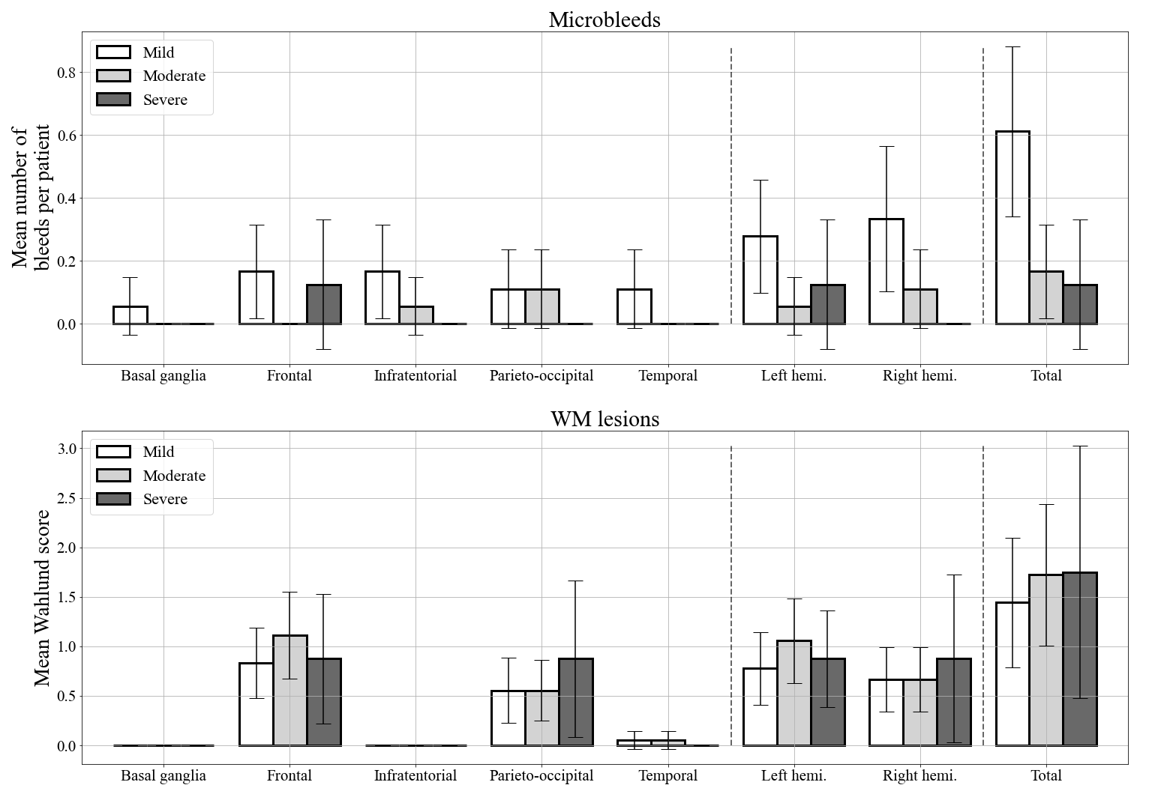
Microbleeds and white matter lesions were quantified respectively from the Susceptibility Weighted Imaging (SWI) and Fluid-attenuated Inversion Recovery (FLAIR) MRI scans.

Supplementary Information 7. Anatomical maps of the affected regions in mild-severe (A), mild-moderate (B) and moderate-severe(C) comparisons.
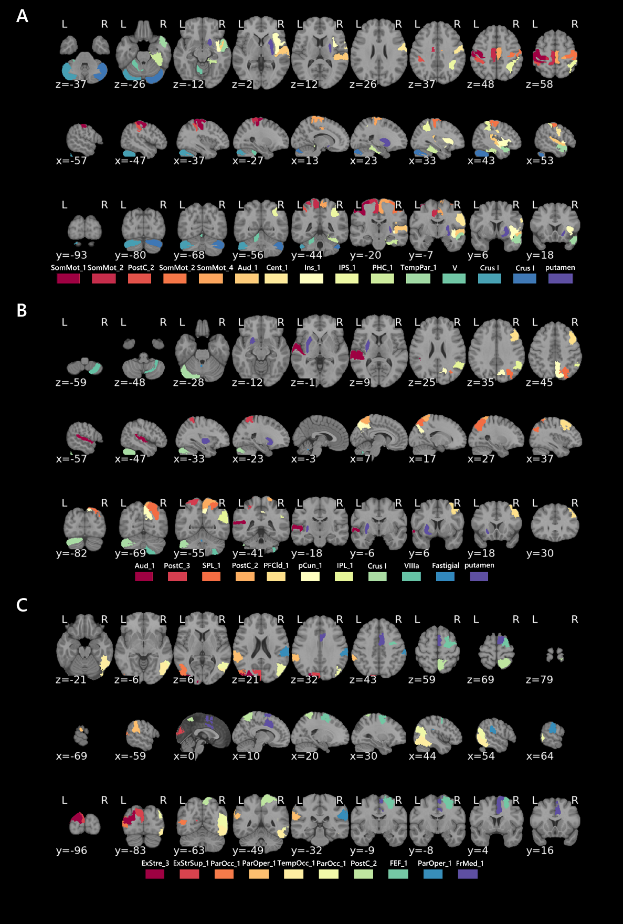
Regions: Aud: auditory cortex; Cent: central sulcus; ExStr: extrastriate cortex; ExStrSup: superior extrastriate cortex; FEF: frontal eye field area; FrMed: frontal medial sulcus; INS: insula; IPL: inferior parietal lobule; IPS: inferior parietal sulcus; ParOcc: parietal occipital cortex; ParOper: parietal operculum; pCun: precuneus; PFCld: dorsolateral prefrontal cortex; PHC: parahippocampal gyrus; PostC: postcentral region; SomMot: somatosensory motor network; SPL: superior parietal lobule; TempOcc: temporo-occipital cortex; TempPar: temporal parietal network.
Supplementary Information 8. Functional connectivity pattern of the latent components extracted by the Partial Least Square Correlation (PLSC) analysis..
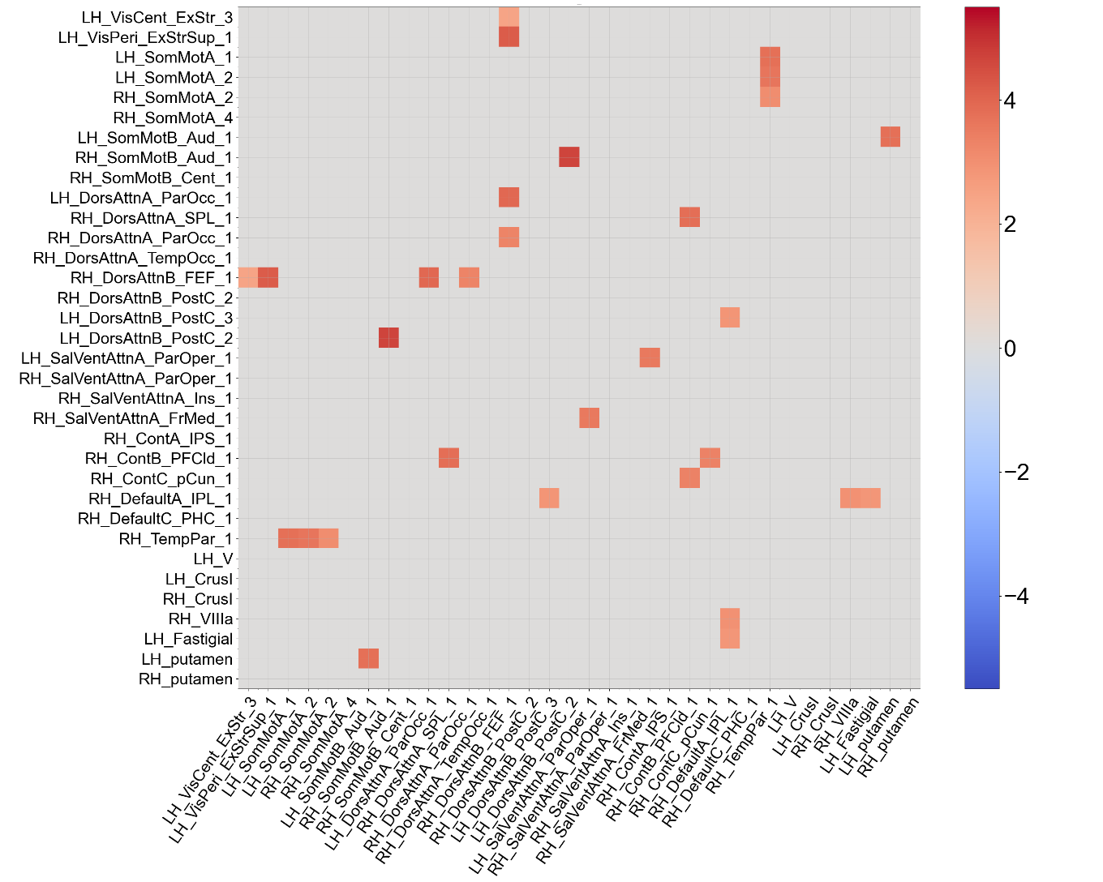
Values show the bootstrap ratios of the functional connectivity pattern and can be interpreted similar to z scores.
Supplementary Information 9. Psychiatric symptoms as a function of disease severity
The three groups differed significantly on state anxiety (H = 9.40, p = .009) and behavioral apathy (H = 7.10, p = .029). The other effects were not significant (p > .05 for all Kruskal-Wallis comparisons).
Anxiety. Mild patients had higher state anxiety scores than severe patients after FDR correction (z = -3.04, p = .002). No significant differences on state anxiety were observed between either mild and moderate patients (z = 0.90, p = .367) or moderate and severe patients (z = -1.91, p = .057).
Behavioral apathy. Mild patients had more symptoms of behavioral apathy (AMI) than severe patients after FDR correction (z = -2.52, p = .011). No significant differences were observed between either mild and moderate patients (z = 0.67, p = .503) or moderate and severe patients (z = -1.66, p = .097).
Supplementary Information 10. Mean scores, standard deviations, and intergroup comparisons for psychiatric symptoms, olfaction, fatigue and dyspnea among patients who had mild, moderate or severe COVID-19 6-9 months post-infection
Psychiatric symptoms | Mild  no  hospitalization  n = 44  Mean (± SD) | Moderate  conventional hospitalization  n = 42  Mean (± SD) | Severe  ICU  hospitalization  n = 24  Mean (± SD) | K-W analysis | M-W  Mild  vs.  Moderate  FDR corrected | M-W  Mild  vs.  Severe  FDR corrected | M-W  Moderate  vs.  Severe  FDR corrected
Depressive symptoms (BDI-II) | 8.11 (± 7.19) | 8.90 (± 9.16) | 4.79 (± 4.34) | .143 | - | - | -
State anxiety (STAI-state) | 34.95 (± 11.94) | 33.55 (± 13.44) | 26.58 (± 7.70) | .014* | .367 | .002** | .057
Trait anxiety (STAI-trait) | 34.39 (± 11.93) | 34.21 (± 13.12) | 30.79 (± 8.25) | .235 | - | - | -
Mania (Goldberg Inventory) | 13.89 (± 8.30) | 17.98 (± 8.81) | 15.54 (± 9.97) | .096 | - | - | -
Apathy (AMI-total) | 28.32 (± 7.80) | 26.83 (± 7.70) | 26.00 (± 7.45) | .603 | - | - | -
Behavioral apathy (AMI-behavioral) | 8.18 (± 4.03) | 7.79 (± 4.70) | 5.88 (± 3.23) | .049* | .503 | .012** | .097
Social apathy (AMI-social) | 10.61 (± 4.35) | 9.62 (± 4.31) | 9.04 (± 4.20) | .334 | - | - | -
Emotional apathy (AMI-emotional) | 9.52 (± 3.44) | 9.43 (± 5.09) | 11.08 (± 3.73) | .186 | - | - | -
Posttraumatic stress disorder (PCL-5) | 16.36 (± 11.60) | 15.74 (± 15.75) | 11.38 (± 10.42) | .233 | - | - | -
Stress (PSS-14) | 18.64 (± 9.54) | 17.78 (± 12.33) | 14.42 (± 8.20) | .348 | - | - | -
Dissociative disorder (DES) | 7.16 (± 8.03) | 7.48 (± 9.54) | 4.42 (± 3.29) | .417 | - | - | -
Emotional contagion (ECS) | 40.98 (± 6.25) | 40.63 (± 6.74) | 38.50 (± 7.51) | .390 | - | - | -
Emotion regulation (ERQ) | 41.86 (± 9.40) | 38.58 (± 11.13) | 40.21 (± 11.77) | .431 | - | - | -
Sleepiness (Epworth) | 8.64 (± 4.20) | 8.83 (± 4.98) | 7.79 (± 3.51) | .723 | - | - | -
Insomnia (ISI) | 9.95 (± 4.48) | 9.05 (± 5.77) | 7.83 (± 4.57) | .170 | - | - | -
Fatigue (EMIF-SEP) | 82.34 (± 25.25) | 81.48 (± 31.22) | 76.54 (± 23.43) | .719 | - | - | -
Dyspnea (Dyspnea-12) | 3.07 (± 4.23) | 5.67 (± 9.49) | 4.63 (± 6.58) | .837 | - | - | -
Sniff test (anosmia) | 12.25 (± 2.14) | 12.37 (± 2.55) | 11.83 (± 2.58) | .698 | - | - | -
Abbreviations: M-W: Mann-Whitney test; K-W: Kruskal-Wallis test; FDR: false discovery rate; AMI-behavioral: Apathy Motivation Index – behavioral score; AMI-emotional: Apathy Motivation Index – emotional score; AMI-social: Apathy Motivation Index – social score; AMI-total: Apathy Motivation Index – total score; BDI-II: Beck Depression Inventory-Second edition; DES: Dissociative Experience Scale; ECS: Emotional Contagion Scale; EMIF-SEP: Fatigue Impact Scale, French adaptation; ERQ: Emotion Regulation Questionnaire; Epworth: Epworth Sleepiness Scale; Goldberg Inventory: Goldberg Mania Inventory; ICU: intensive care unit; ISI: Insomnia Severity Index; PCL-5: Posttraumatic Stress Disorder Checklist for DSM-5; PSS-14: Perceived Stress Scale – 14 items; STAI-trait: State-Trait Anxiety Inventory; STAI-state: State-Trait Anxiety Inventory.
* p > .05. ** p >.05 FDR corrected.
Supplementary information bibliography
1 Tran, V.-T. et al. Development and Validation of the Long Coronavirus Disease (COVID) Symptom and Impact Tools: A Set of Patient-Reported Instruments Constructed From Patients’ Lived Experience. Clinical Infectious Diseases, doi:10.1093/cid/ciab352 (2021).
2 Nalbandian, A. et al. Post-acute COVID-19 syndrome. Nature medicine 27, 601-615 (2021).
3 Vanderlind, W. M. et al. A systematic review of neuropsychological and psychiatric sequalae of COVID-19: implications for treatment. Current opinion in psychiatry 34, 420 (2021).
4 Amalakanti, S., Arepalli, K. V. R. & Jillella, J. P. Cognitive assessment in asymptomatic COVID-19 subjects. VirusDisease 32, 146-149 (2021).
5 Alemanno, F. et al. COVID-19 cognitive deficits after respiratory assistance in the subacute phase: A COVID-rehabilitation unit experience. Plos one 16, e0246590 (2021).
6 Raman, B. et al. Medium-term effects of SARS-CoV-2 infection on multiple vital organs, exercise capacity, cognition, quality of life and mental health, post-hospital discharge. EClinicalMedicine 31, 100683 (2021).
7 Kas, A. et al. The cerebral network of COVID-19-related encephalopathy: a longitudinal voxel-based 18F-FDG-PET study. European journal of nuclear medicine and molecular imaging, 1-15 (2021).
8 Ortelli, P. et al. Neuropsychological and neurophysiological correlates of fatigue in post-acute patients with neurological manifestations of COVID-19: Insights into a challenging symptom. Journal of the neurological sciences 420, 117271 (2021).
9 Beaud, V. et al. Pattern of cognitive deficits in severe COVID-19. Journal of Neurology, Neurosurgery & Psychiatry 92, 567-568 (2021).
10 De Lorenzo, R. et al. Residual clinical damage after COVID-19: A retrospective and prospective observational cohort study. PLoS One 15, e0239570 (2020).
11 Negrini, F. et al. Neuropsychological features of severe hospitalized coronavirus disease 2019 Patients at clinical stability and clues for postacute rehabilitation. Archives of Physical Medicine and Rehabilitation 102, 155-158 (2021).
12 Ferrucci, R. et al. Long-lasting cognitive abnormalities after COVID-19. Brain Sciences 11, 235 (2021).
13 Blazhenets, G. et al. Slow but evident recovery from neocortical dysfunction and cognitive impairment in a series of chronic COVID-19 patients. Journal of Nuclear Medicine (2021).
14 Pirker-Kees, A., Platho-Elwischger, K., Hafner, S., Redlich, K. & Baumgartner, C. Hyposmia Is Associated with Reduced Cognitive Function in COVID-19: First Preliminary Results. Dementia and Geriatric Cognitive Disorders 50, 68-73 (2021).
15 Pistarini, C. et al. Cognitive and emotional disturbances due to COVID-19: an exploratory study in the rehabilitation setting. Frontiers in Neurology 12 (2021).
16 Solaro, C., Gamberini, G. & Masuccio, F. G. Cognitive impairment in young COVID-19 patients: the tip of the iceberg? Neurological Sciences, 1-2 (2021).
17 Udina, C. et al. Rehabilitation in adult post-COVID-19 patients in post-acute care with therapeutic exercise. The Journal of Frailty & Aging, 1-4 (2021).
18 Almeria, M., Cejudo, J., Sotoca, J., Deus, J. & Krupinski, J. Cognitive profile following COVID-19 infection: Clinical predictors leading to neuropsychological impairment. Brain, behavior, & immunity-health 9, 100163 (2020).
19 Woo, M. S. et al. Frequent neurocognitive deficits after recovery from mild COVID-19. Brain communications 2, fcaa205 (2020).
20 Jaywant, A. et al. Frequency and profile of objective cognitive deficits in hospitalized patients recovering from COVID-19. Neuropsychopharmacology, 1-6 (2021).
21 Whiteside, D. M. et al. Neurocognitive deficits in severe COVID-19 infection: Case series and proposed model. The Clinical Neuropsychologist 35, 799-818 (2021).
22 Hampshire, A. et al. Cognitive deficits in people who have recovered from COVID-19. EClinicalMedicine 39, 101044 (2021).
23 Tay, M. R. J. et al. Covert Subclinical Neurocognitive Sequelae During the Rehabilitation Course of Severe Coronavirus Disease 2019. American Journal of Physical Medicine & Rehabilitation 100, 39-43 (2021).
24 Meinhardt, J. et al. Olfactory transmucosal SARS-CoV-2 invasion as a port of central nervous system entry in individuals with COVID-19. Nature neuroscience 24, 168-175 (2021).
25 Cron, R. Q., Caricchio, R. & Chatham, W. W. Calming the cytokine storm in COVID-19. Nature Medicine 27, 1674-1675 (2021).
26 Mazza, M. G. et al. Anxiety and depression in COVID-19 survivors: Role of inflammatory and clinical predictors. Brain, behavior, and immunity 89, 594-600 (2020).
27 Bonaventura, A. et al. Endothelial dysfunction and immunothrombosis as key pathogenic mechanisms in COVID-19. Nature Reviews Immunology 21, 319-329 (2021).
28 Guedj et al. 18 F-FDG brain PET hypometabolism in patients with long COVID. European Journal of Nuclear Medicine and Molecular Imaging, 1-11 (2021).
29 Delorme, C. et al. COVID‐19‐related encephalopathy: a case series with brain FDG‐positron‐emission tomography/computed tomography findings. European journal of neurology 27, 2651-2657 (2020).
30 Hosp, J. A. et al. Cognitive impairment and altered cerebral glucose metabolism in the subacute stage of COVID-19. Brain 144, 1263-1276 (2021).
31 Kohler, J. et al. Cognitive deficits following intensive care. Deutsches Ärzteblatt International 116, 627 (2019).
32 Jackson, J. C. et al. Long-term cognitive, emotional, and functional outcomes in trauma intensive care unit survivors without intracranial hemorrhage. Journal of Trauma and Acute Care Surgery 62, 80-88 (2007).
33 Sakusic, A. et al. in Mayo Clinic Proceedings. 68-82 (Elsevier).
34 Hampshire, A. et al. Cognitive deficits in people who have recovered from COVID-19 relative to controls: An N= 84,285 online study. MedRxiv (2020).
35 Lehmann, E. L. in Selected works of EL Lehmann 437-445 (Springer, 2012).
36 Nehme, M. et al. COVID-19 symptoms: longitudinal evolution and persistence in outpatient settings. Annals of internal medicine 174, 723-725 (2021).
37 Cascella, M. et al. Chemotherapy-related cognitive impairment: mechanisms, clinical features and research perspectives. Recenti progressi in medicina 109, 523-530 (2018).
38 Esteban, O. et al. fMRIPrep: a robust preprocessing pipeline for functional MRI. Nature methods 16, 111-116 (2019).
39 Gorgolewski, K. et al. Nipype: a flexible, lightweight and extensible neuroimaging data processing framework in python. Frontiers in neuroinformatics 5, 13 (2011).
40 Tustison, N. J. et al. N4ITK: improved N3 bias correction. IEEE transactions on medical imaging 29, 1310-1320 (2010).
41 Fonov, V. S., Evans, A. C., McKinstry, R. C., Almli, C. & Collins, D. Unbiased nonlinear average age-appropriate brain templates from birth to adulthood. NeuroImage, S102 (2009).
42 Avants, B. B., Epstein, C. L., Grossman, M. & Gee, J. C. Symmetric diffeomorphic image registration with cross-correlation: evaluating automated labeling of elderly and neurodegenerative brain. Medical image analysis 12, 26-41 (2008).
43 Zhang, Y., Brady, J. M. & Smith, S. in Medical Imaging 2000: Image Processing. 1126-1137 (International Society for Optics and Photonics).
44 Cox, R. W. & Hyde, J. S. Software tools for analysis and visualization of fMRI data. NMR in Biomedicine: An International Journal Devoted to the Development and Application of Magnetic Resonance In Vivo 10, 171-178 (1997).
45 Jenkinson, M., Bannister, P., Brady, M. & Smith, S. Improved optimization for the robust and accurate linear registration and motion correction of brain images. Neuroimage 17, 825-841 (2002).
46 Greve, D. N. & Fischl, B. Accurate and robust brain image alignment using boundary-based registration. Neuroimage 48, 63-72 (2009).
47 Behzadi, Y., Restom, K., Liau, J. & Liu, T. T. A component based noise correction method (CompCor) for BOLD and perfusion based fMRI. Neuroimage 37, 90-101 (2007).
48 Power, J. D. et al. Methods to detect, characterize, and remove motion artifact in resting state fMRI. Neuroimage 84, 320-341 (2014).
49 Abraham, A. et al. Machine learning for neuroimaging with scikit-learn. Frontiers in neuroinformatics 8, 14 (2014).
50 Wahlund, L.-O. et al. A new rating scale for age-related white matter changes applicable to MRI and CT. Stroke 32, 1318-1322 (2001).
51 Schaefer, A. et al. Local-global parcellation of the human cerebral cortex from intrinsic functional connectivity MRI. Cerebral cortex 28, 3095-3114 (2018).
52 Yeo, B. T. et al. The organization of the human cerebral cortex estimated by intrinsic functional connectivity. Journal of neurophysiology (2011).
53 Diedrichsen, J., Balsters, J. H., Flavell, J., Cussans, E. & Ramnani, N. A probabilistic MR atlas of the human cerebellum. Neuroimage 46, 39-46 (2009).
54 Amunts, K. et al. BigBrain: an ultrahigh-resolution 3D human brain model. Science 340, 1472-1475 (2013).
55 Benjamini, Y. & Yekutieli, D. The control of the false discovery rate in multiple testing under dependency. Annals of statistics, 1165-1188 (2001).
56 McIntosh, A. R. & Lobaugh, N. J. Partial least squares analysis of neuroimaging data: applications and advances. Neuroimage 23, S250-S263 (2004).
57 Pilotto, A. et al. Steroid‐responsive encephalitis in coronavirus disease 2019. Annals of neurology 88, 423-427 (2020).
58 Khoo, A. et al. Postinfectious brainstem encephalitis associated with SARS-CoV-2. Journal of Neurology, Neurosurgery & Psychiatry 91, 1013-1014 (2020).
59 Mohamud, A. Y. et al. Intraluminal carotid artery thrombus in COVID-19: another danger of cytokine storm? American Journal of Neuroradiology 41, 1677-1682 (2020).
60 Manganelli, F. et al. Brainstem involvement and respiratory failure in COVID-19. Neurological Sciences 41, 1663-1665 (2020).
61 Jeong, W., Chung, C. K. & Kim, J. S. Episodic memory in aspects of large-scale brain networks. Frontiers in human neuroscience 9, 454 (2015).
62 Rugg, M. D. & Vilberg, K. L. Brain networks underlying episodic memory retrieval. Current opinion in neurobiology 23, 255-260 (2013).
63 Hillary, F. G. et al. Hyperconnectivity is a fundamental response to neurological disruption. Neuropsychology 29, 59 (2015).
64 Roussel, M. & Godefroy, O. La batterie GREFEX: données normatives. Fonctions exécutives et pathologies neurologiques et psychiatriques, 231-252 (2008).
65 Miyake, A. et al. The unity and diversity of executive functions and their contributions to complex “frontal lobe” tasks: A latent variable analysis. Cognitive psychology 41, 49-100 (2000).
66 Drozdick, L. W., Raiford, S. E., Wahlstrom, D. & Weiss, L. G. The Wechsler Adult Intelligence Scale—Fourth Edition and the Wechsler Memory Scale—Fourth Edition. (2018).
67 Kessels, R. P., Van Zandvoort, M. J., Postma, A., Kappelle, L. J. & De Haan, E. H. The Corsi block-tapping task: standardization and normative data. Applied neuropsychology 7, 252-258 (2000).
68 Zimmermann, P. & Fimm, B. A test battery for attentional performance. Applied neuropsychology of attention. Theory, diagnosis and rehabilitation 110, 151 (2002).
69 Grober, E. & Buschke, H. Genuine memory deficits in dementia. Developmental neuropsychology 3, 13-36 (1987).
70 Van der Linden, M. et al. II. L’épreuve de rappel libre/rappel indicé à 16 items (RL/RI-16). (2004).
71 Meyers, J. E. & Meyers, K. R. Rey Complex Figure Test and recognition trial professional manual. (Psychological Assessment Resources, 1995).
72 Macoir, J., Gauthier, C., Jean, C. & Potvin, O. BECLA, a new assessment battery for acquired deficits of language: Normative data from Quebec-French healthy younger and older adults. Journal of the neurological sciences 361, 220-228 (2016).
73 Mahieux-Laurent, F., Fabre, C., Galbrun, E., Dubrulle, A. & Moroni, C. Validation of a brief screening scale evaluating praxic abilities for use in memory clinics. Evaluation in 419 controls, 127 mild cognitive impairment and 320 demented patients. Revue neurologique 165, 560-567 (2009).
74 Warrington, E. K. & James, M. The visual object and space perception battery. (1991).
75 Wechsler, D. Wechsler adult intelligence scale–Fourth Edition (WAIS–IV). San Antonio, TX: NCS Pearson 22, 1 (2008).
76 Schlegel, K. & Scherer, K. R. Introducing a short version of the Geneva Emotion Recognition Test (GERT-S): Psychometric properties and construct validation. Behavior research methods 48, 1383-1392 (2016).
77 Thomas-Antérion, C., Ribas, C., Honoré-Masson, S., Million, J. & Laurent, B. Evaluation de la plainte cognitive de patients Alzheimer, de sujets MCI, anxiodépressifs et de témoins avec le QPC (Questionnaire de Plainte Cognitive). NPG Neurologie-Psychiatrie-Gériatrie 4, 30-34 (2004).
78 Roth, R. M., Gioia, G. A. & Isquith, P. K. BRIEF-A: Behavior Rating Inventory of Executive Function--adult Version. (2005).
79 Leicht, H., Berwig, M. & Gertz, H.-J. Anosognosia in Alzheimer's disease: the role of impairment levels in assessment of insight across domains. Journal of the International Neuropsychological Society: JINS 16, 463 (2010).
80 Rosen, H. J. et al. Neuroanatomical correlates of cognitive self-appraisal in neurodegenerative disease. Neuroimage 49, 3358-3364 (2010).
81 Tondelli, M. et al. Neural correlates of Anosognosia in Alzheimer's disease and mild cognitive impairment: A multi-method assessment. Frontiers in Behavioral Neuroscience 12, 100 (2018).
82 Harrison, A. G., Beal, A. L. & Armstrong, I. T. Predictive value of performance validity testing and symptom validity testing in psychoeducational assessment. Applied Neuropsychology: Adult, 1-15 (2021).
83 Abeare, K. et al. Introducing alternative validity cutoffs to improve the detection of non-credible symptom report on the BRIEF. Psychological Injury and Law 14, 2-16 (2021).
84 Oldfield, R. C. The assessment and analysis of handedness: the Edinburgh inventory. Neuropsychologia 9, 97-113 (1971).
85 Beck, A. T., Steer, R. A. & Brown, G. K. Manual for the beck depression inventory-II. San Antonio, TX: Psychological Corporation 1, 82 (1996).
86 Spielberg, C., Gorsuch, R. & Lushene, R. STAI. State-Trait Anxiety Questionnaire. Manual (4th Revised Edition). Madrid: TEA Ediciones SA (1993).
87 Ang, Y.-S., Lockwood, P., Apps, M. A., Muhammed, K. & Husain, M. Distinct subtypes of apathy revealed by the apathy motivation index. PLoS One 12, e0169938 (2017).
88 Ashbaugh, A. R., Houle-Johnson, S., Herbert, C., El-Hage, W. & Brunet, A. Psychometric validation of the English and French versions of the posttraumatic stress disorder checklist for DSM-5 (PCL-5). PloS one 11, e0161645 (2016).
89 Goldberg, I. K. Questions & Answers about Depression and its Treatment: a consultation with a leading psychiatrist. (Charles PressPub, 1993).
90 Carlson, E. B. & Putnam, F. W. Dissociative experiences scale. Journal of Nervous and Mental Disease 174 (1986).
91 Lesage, F.-X., Berjot, S. & Deschamps, F. Psychometric properties of the French versions of the Perceived Stress Scale. International journal of occupational medicine and environmental health 25, 178-184 (2012).
92 Gross, J. & John, O. Emotion regulation questionnaire. NeuroImage 48, 9-9 (2003).
93 Doherty, R. W. The emotional contagion scale: A measure of individual differences. Journal of nonverbal Behavior 21, 131-154 (1997).
94 Debouverie, M., Pittion-Vouyovitch, S., Louis, S. & Guillemin, F. Validity of a French version of the fatigue impact scale in multiple sclerosis. Multiple Sclerosis Journal 13, 1026-1032 (2007).
95 Morin, C. M. Insomnia: psychological assessment and management. (Guilford press, 1993).
96 Johns, M. W. A new method for measuring daytime sleepiness: the Epworth sleepiness scale. sleep 14, 540-545 (1991).
97 Beaumont, M. et al. Validation of the French version of the London Chest Activity of Daily Living scale and the Dyspnea-12 questionnaire. International journal of chronic obstructive pulmonary disease 13, 1399 (2018).
98 Kobal, G. et al. Multicenter investigation of 1,036 subjects using a standardized method for the assessment of olfactory function combining tests of odor identification, odor discrimination, and olfactory thresholds. European Archives of Oto-rhino-laryngology 257, 205-211 (2000).

