Supplementary Materials of
Robustness of the long-term nonlinear evolution of global sea surface temperature trend

Here are the Supplementary Materials for Robustness of the long-term nonlinear evolution of global sea surface temperature trend by Xu et al. (2022).

The following supporting information can be found in this document:
Figure S1: Warming rate of global sea surface temperature tied to the sampling frequency;
Figure S2: The spatial structure of temperature increase based on time-unvarying linear trend over the whole data domain from 1900 to 2019.

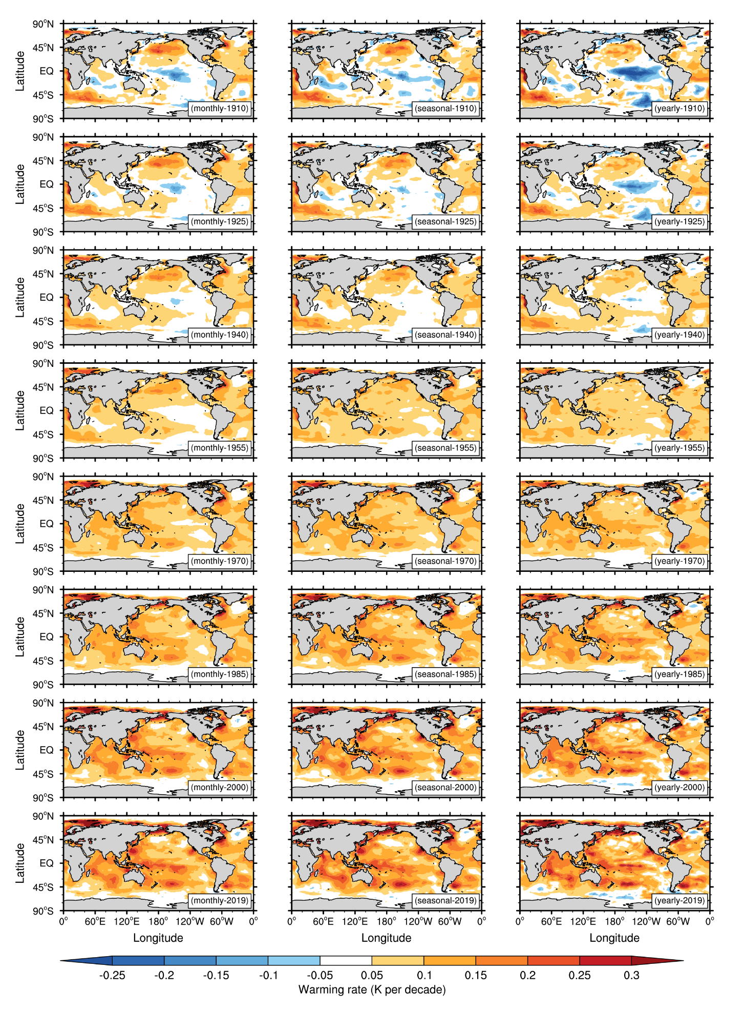
Figure S1. Warming rate of global sea surface temperature tied to the sampling frequency. From left to right, the instantaneous warming rate of the secular trend is derived from monthly, seasonal, and annual data, respectively. From top to bottom, the instantaneous warming rate in 1910, 1925, 1940, 1955, 1970, 1985, 2000, and 2019, respectively.
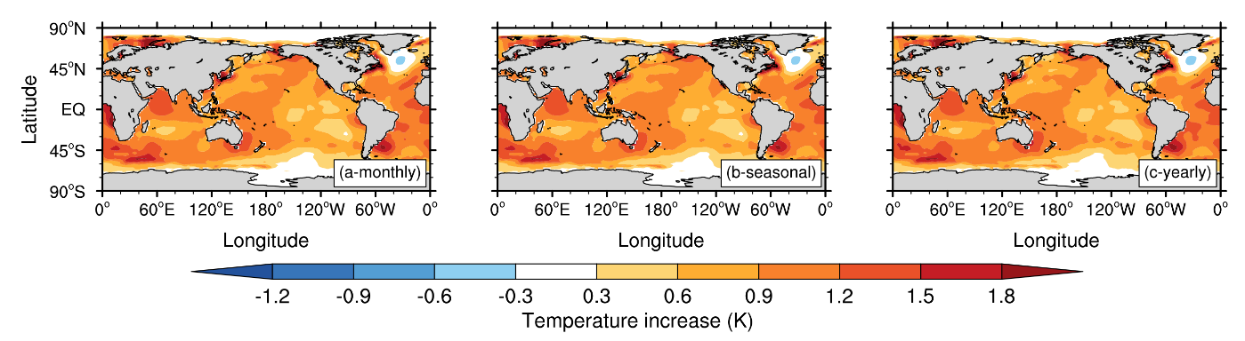
Figure S2. The spatial structure of temperature increase based on time-unvarying linear trend over the whole data domain from 1900 to 2019: (a) from monthly data; (b) from seasonal data; (c) from annual data.

