Supplementary Information

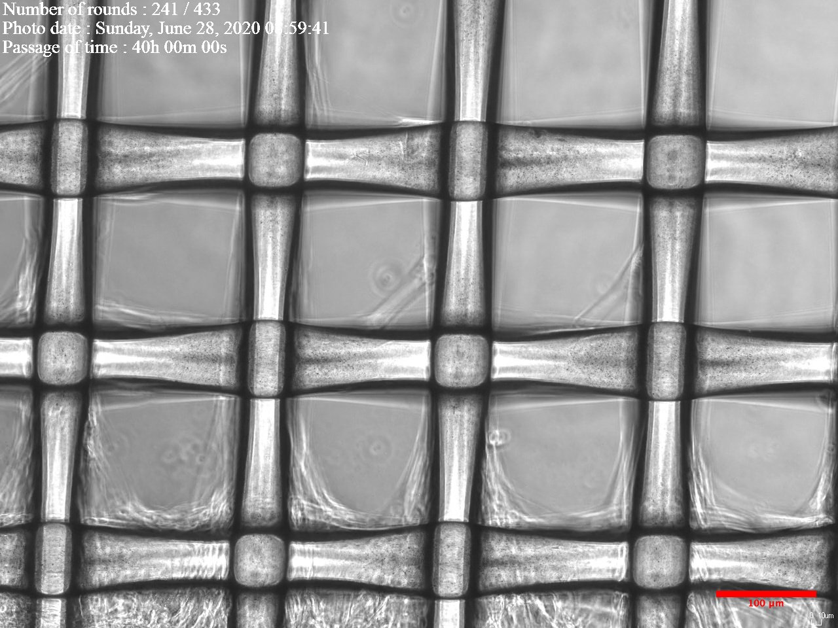

Figure. S1 Fibroblast migratory behavior on nylon dressing. Fibroblasts moved along the nylon fiber, as indicated by the red arrows. The scale bar shows 100 μm.

VDO files

S2 Time-lapse video clips of fibroblast migration on nylon dressing and MEEK gauzes at 1:3, 1:6 and 1:9 expansion ratios. Before observation, the cells were stained with NucBlue™ Live ReadyProbes™ Reagent to track the cell location. All the video clips were recorded from 0 – 72 h. The scale bars show 10 μm.

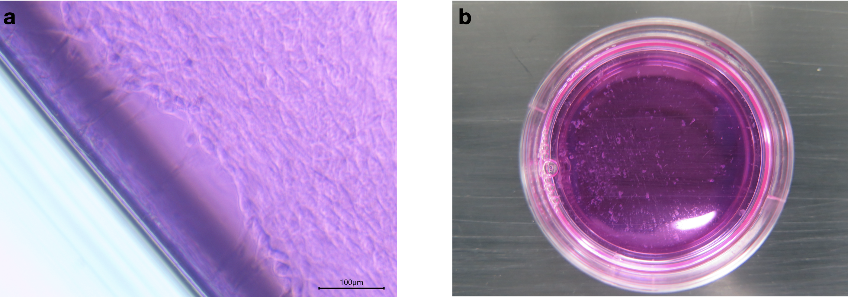
Figure. S3 Preliminary experiment on cell sheet expansion using a larger temperature-responsive tissue culture surface. Fibroblast cells were cultured on a temperature-responsive PNIAM-co-AM grafted culture dish with 35 mm diameter. After temperature reduction, the cell sheet broke into small pieces. The scale bar is 100 μm.

