Early diversification and karyotype evolution of flowering plants
Pengchuan Sun^{1,#}, Yongzhi Yang^{2,#}, Liang Liu³, Zhenxiang Xi¹, Hao Lin¹, Landi Feng¹, Jianxiang Ma², Hongyin Hu², Guiqi Bi⁶, Beibei Jiao⁴, Shang Wang¹, Jiao Yang², Wenjie Mu², Mingjia Zhu², Zhenyue Wang², Xiyin Wang⁴, Charles C. Davis⁵ and Jianquan Liu^{1,2*}

¹Key Laboratory for Bio-resources and Eco-environment & State Key Lab of Hydraulics & Mountain River Engineering, College of Life Sciences, Sichuan University, Chengdu, 610065, China.
² State Key Laboratory of Grassland Agro-Ecosystem, College of Ecology, Lanzhou University, Lanzhou, China.
³Department of Statistics and Institute of Bioinformatics, University of Georgia, Athens, GA 30602, USA.
⁴Center for Genomics and Bio-computing, North China University of Science and Technology, Tangshan, Hebei, China.
⁵Department of Organismic and Evolutionary Biology, Harvard University Herbaria,
Cambridge, MA, USA.
⁶Shenzhen Branch, Guangdong Laboratory for Lingnan Modern Agriculture, Shenzhen Key Laboratory of Agricultural Synthetic Biology, Genome Analysis Laboratory of the Ministry of Agriculture and Rural Affairs, Agricultural Genomics Institute at Shenzhen, Chinese Academy of Agricultural Sciences, Shenzhen 518124, China.
*Correspondence: liujq@nwipb.ac.cn (J.L.)

This PDF file includes:
Supplementary Notes
Supplementary Figs. 1-22
Supplementary References

Table of Contents
1 Introduction to Illicium verum and Acorus gramineus 3
1.1 Illicium verum 3
1.2 Acorus gramineus 3
2 Genome sequencing and assembly 4
2.1 Genome and transcriptome sequencing 4
2.2 Genome size estimation 5
2.3 Genome assembly 6
2.4 Hi-C analysis 6
3 Genome annotation 7
3.1 Repetitive elements 7
3.2 RNA-seq based gene prediction 8
3.3 Protein-coding genes 8
3.4 Gene functional annotation 9
3. Phylogenetic analysis of LTR-RTs 9
4. Comparative analysis of genes with distinctive structural features 9
4 Whole-genome duplication in I. verum and A. gramineus 11
4.1 Identification of whole-genome duplication events 11
4.2 Times of these two WGDs 13
5 Phylogenetic relationships of early-diverging angiosperm lineages 14
5.1 Phylogenomic analyses of collinear nuclear genes 14
5.2 Phylogenomic analyses of the single-copy genes 18
6 Karyotype evolution of early-diverging angiosperm lineages 21
6.1 Karyotype evolution model 21
6.2 Ancestral karyotype gene repertoire 23
6.3 Ancestral angiosperm karyotype (AAK) with 16 protochromosomes 24
6.4 Ancestral Mesangiospermae karyotype (AMAK) with 14 protochromosomes 26
6.5 Ancestral monocot karyotype except for Acoraceae (AMKA) with 8 protochromosomes 28
6.6 Rapid karyotype evolution also in eudicots 30
References 31

1 Introduction to Illicium verum and Acorus gramineus

Illicium verum
Austrobaileyales and Amborellales, Nymphaeales collectively called the ANA-grade, which were assumed to diverge firstly from the remaining flowering plants. Austrobaileyales are sister to all remaining extant angiosperms, and contain ~100 species that could be divided into three families: Austrobaileyaceae, Schisandraceae, and Trimeniaceae. Austrobaileyaceae is a monotypic family containing the sole genus with a single woody lianas species (Austrobaileya scandens), naturally distributed in the Queensland tropical rain forests, Australia. Trimeniaceae comprises only one type genus (Trimenia) but with eight known woody species with essential oils, mainly distributed in Southeast Asia, eastern Australia, and several Pacific Islands. Schisandraceae comprises three genera Illicium, Kadsura, and Schisandrathe with around 92 species distributed in the tropical to temperate regions of East and Southeast Asia and the Caribbean.
The genus Illicium contains around 50 shrub or tree species mainly distributed in subtropical evergreen forests with further extension into north temperate deciduous and tropical montane forests. Among all Illicium species, star anise or Chinese anis (I. verum) comprises the best-known one as a traditional spice for a long history. It has evergreen, aromatic leaves, and bisexual flowers with both stamens and carpels. The fruit is capsule-like and the seeds are shiny brown or reddish.

Acorus gramineus
Acoraceae is sister to the remaining monocots. Acorus are perennial herbs found in wetlands, particularly marshes and all species contain a syncarpous gynoecium of three fused carpels with sword-like leaves. The inflorescence is a terminal spadix borne on a leaf-like peduncle and subtended by a long, linear spathe. Within this genus, A. gramineus is a semiaquatic plant of aquatic habitats throughout tropical to subtropical climates with a creeping and much-branched aromatic rhizome and this species has been used as a hallucinogen since ancient times in China.

2 Genome sequencing and assembly

2.1 Genome and transcriptome sequencing
The fresh leaves of I. verum were collected in 2016 from one mature individual grown in Mount Emei, Sichuan Province while those of A. gramineus from one flowering individual in Chengdu, Sichuan Province. All leaves were then immediately frozen in liquid nitrogen and sent to the BGI-Shenzhen company (Wuhan, China) for genomic sequencing. The total genomic DNA was extracted by the CTAB method and then the quality assessment was performed. The short reads, the paired-end libraries with an insertion size of 150 bp were constructed and then sequenced on an MGISEQ-2000 platform and an Illumina NovaSeq 4000 System, respectively. For the long-read sequencing, the Oxford Nanopore Technology (ONT) was selected for A. gramineus as a simple and small genome (see the following genome size estimation). The PacBio high-fidelity (HiFi) technology was performed for I. verum because of its huge genome size and a high repeat ratio (see the following genome size estimation). The Nanopore library with 20 Kb insertions was constructed and sequenced on the PromethION instrument (ONT, Oxford Nanopore Technologies), which generated a total of 2.69 million long reads with 78.54 Gb clean data (Supplementary Table 3) for A. gramineus. A total of 27 SMRTbell libraries (15 Kb) were constructed and sequenced with the PacBio Sequel platform (Pacific Biosciences) for I. verum and a total of 582.53 Gb HiFi reads were generated (~46coverage) with an N50 and average read length of 15.92 Kb and 15.61 Kb, respectively.
For the Hi-C sequencing, the libraries of these two species were both produced via the standard protocol and sequenced by Illumina NovaSeq platform, which finally yielded 76.80 Gb and around 570 Gb Hi-C reads for A. gramineus and I. verum, respectively (Supplementary Table 3).
We further performed the transcriptome sequencing for the different tissues of A. gramineus (young leaf, root, stem petiole, whole seedling and young flower) and I. verum (fruit, leaf, phloem, xylem, root, stem and young flower) and each tissue contained three replicates. Total RNA was separately extracted using the TIANGEN Kit. Library construction and sequencing were also performed by BGI-Shenzhen Company (Wuhan, China) on the MGI2000 platform. The transcriptome sequencing results are listed in Supplementary Table 4. Additionally, the full-length transcriptome sequencing for I. verum also was performed on a PacBio RS II instrument to improve the accuracy of transcript identification. We totally obtained 33.95 Mb polymerase reads with full passes >= 0 and consensus accuracy > 0.75.

2.2 Genome size estimation
Before assembling the genome, it is necessary to evaluate the genome size and heterozygosity using the K-mer based estimation. We first used the Jellyfish¹ to generate the 17-mer depth-frequency distribution. The genome features were then estimated by the GenomeScope² (Supplementary Fig. 1). The genome size of A. gramineus was estimated as 397 Mb with heterozygosity of 1%. However, a large genome size (14.98 Gb) and the highly repetitive sequences (89.00%) were estimated for I. verum, and it represents an ultra-large angiosperm genome.
Supplementary Figure 1. Estimation of A. gramineus genome size by K-mer analysis. The figure shows the frequency of 23 k-mers, which are 23 bp sequences from clean reads of short-insert-size libraries. We identified 48,486,511,298 K-mers and the peak of K-mer depth is 142. Genome size can be estimated as (total K-mer number) / (the volume peak). The genome size of A. gramineus was thus estimated as 397.30 Mb.

2.3 Genome assembly
For the A. gramineus genome assembly, NextDenovo was mainly used to assemble from the cleaned (mean quality score > 7) ONT long reads with the following three steps: first, NextCorrect module was used to correct the raw reads (reads_cutoff:1k，seed_cutoff:16k); then, the error-corrected consensus sequences were assembled into contigs by NextGraph with parameters “-d 1,000 -n 3,000 -a 1 -u 1”; finally, the preliminary genome was polished iteratively three times with Illumina short reads and four times with ONT long reads via the Nextpolish³ (sgs_options= -max_depth 100 -bwa). The final assembly of A. gramineus has a contig N50 of 35.5 Mb across 14 contigs, and the total assembly size is 380.6 Mb, which equated to 92.9% of the predicted genome size. BUSCO (Benchmarking Universal Single-Copy Orthologs, 1614 complete embryophytaodb_10 genes) analysis in the genome model showed that 96.7% of the genes could be completely predicted in the assembly. A primary assembly of the I. verum genome was achieved using hifiasm⁴ by integrating PacBio HiFi reads. Subsequently, redundant sequences were removed using the Purge Haplotigs pipeline (https://bitbucket.org/mroachawri/purge_haplotigs/overview). The resulting assembly was 12,495.24 Mb with a contig N50 of 10.68 Mb, covering 83.42% of the estimated genome size. Similarly, 99.85% of Illumina short reads were properly mapped to the genome of I. verum with a low single base error rate. The assessment result of the BUSCO genome model is relatively low, which is widely present in the ultra-super large genomes, such as ungfish⁵ and Pinus⁶.

2.4 Hi-C analysis
Raw Hi-C data were quality-trimmed using fastp⁷ and mapped to the genome assembly by Juicer⁸ with default parameters. Pseudo-chromosomes were organized through the 3D de novo assembly (3D-DNA) pipeline⁹ with parameters: “-m haploid –r 0”. The resulting assembly was then visualized and adjusted in Juicebox Assembly Tools¹⁰ based on neighboring interactions. The final assembly of I. verum and A. gramineus consisted of 14 and 12 pseudo-chromosomes (Supplementary Figure 2), and 96% and 100% of the contigs were anchored successfully, respectively.
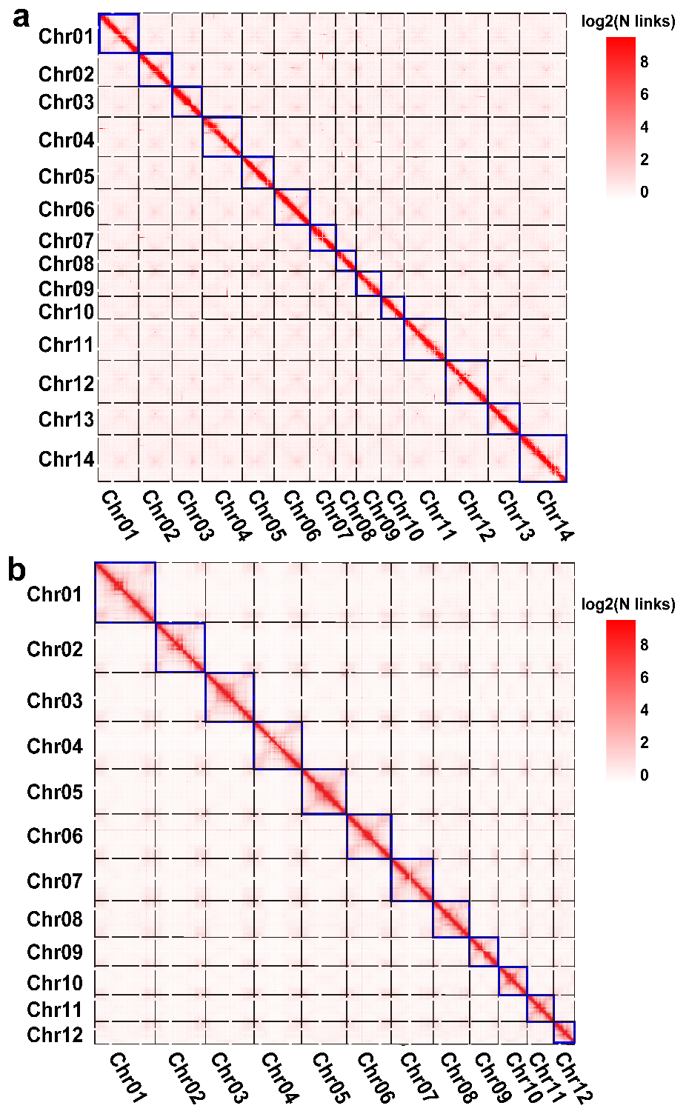
Supplementary Figure 2. Chromosome-level assembly of I. verum and A. gramineus using Hi-C technology.

3 Genome annotation

3.1 Repetitive elements
Repetitive elements in A. gramineus and I. verum were both identified via the combination of similarity-based and de novo approaches. For the homologous search, RepeatProteinMask and RepeatMasker¹¹ were both applied to search the repeats against the RepBase library (http://www.girinst.org/repbase). The de novo repeat library was also constructed using RepeatModeler (http://www.repeatmasker.org/RepeatModeler/) and LTR-FINDER, and then RepeatMasker was used to identify the repeats with our constructed library.
There are a total of 223.83 Gb and 10.68 Gb of repetitive sequences in I. verum and A. gramineus, respectively, occupying 58.81% and 85.44% of their respective genomes (Supplementary Table 7). The most prevalent class of repetitive elements is LTR-RTs, accounting for 47.33% and 20.24% of the genome, respectively, with very few SINE, LINE simple but a considerable proportion of unclassified repeats.

3.2 RNA-seq based gene prediction
All Illumina sequencing reads from different samples were merged and mapped onto the genome using HISAT2¹² with default parameters. StringTie¹³ was used to reconstruct the transcripts. The full-length reads were processed according to the SMRTlink v10.2 pipeline (https://www.pacb.com/support/software-downloads/). Briefly, raw subreads were corrected to generate the circular consensus sequence (CCS) with parameters: min_length 200, max_drop_fraction 0.8, min_passes 1, min_predicted_accuracy 0.8. Lima was used to remove the barcode and primer. The final full-length transcripts were collected using the refine (--require-polya) and cluster (--verbose --use-qvs`) models. The coding sequence was finally identified and de-redundant by TransDecoder v5.5.0 (https://github.com/TransDecoder/TransDecoder) and cd-hit¹⁴.

3.3 Protein-coding genes
Gene structure prediction of these two genomes was performed by combining with ab initio, homology-based and RNA-based pipelines. Augustus¹⁵ and GlimmerHMM¹⁶ were applied to perform the ab initio prediction of the gene model. For the collection of homologous genes, coding sequences from six species (Am. trichopoda, E. ferox, O. sativa, C. sessilifolius, Ar. fimbriata, and Arabidopsis thaliana) were aligned to the genome using GeMoMa¹⁷. In addition, de novo assembled transcripts generated from the Trinity software were mapped to the assembly using the PASA pipeline (http://pasapipeline.github.io). Noticeably, based on past experience, the maximum intron length of I. verum should be set higher than other common species owing to its ultra-super large genome size, and we set it to 2 Mb in this study. Finally, all gene models predicted with the three methods, plus two versions of the transcripts as mentioned above, were integrated by EVidenceModeler¹⁸ to generate high-confidence gene sets.

3.4 Gene functional annotation
Predicted protein sequences were mapped to databases of Swiss-prot and NR using BLAST with parameter: -evalue 1e-5. InterProScan¹⁹ was used to search against the open database InterPro which includes the databases PRINTS, Pfam and GO. Kyoto Encyclopedia of Genes and Genomes (KEGG) entries were obtained via the KEGG Automatic Annotation Server (https://www.genome.jp/kegg/kaas/). We found that all of the protein-coding genes in A. gramineus and 83.52% of those in I. verum were assigned to functional categories.

3. Phylogenetic analysis of LTR-RTs
For comparative analysis of LTR-RTs, Amborella, Nymphaea, Cinnamomum, Zea and Populus were also chosen to perform the de novo detection of LTR-RTs using LTR_FINDER with default parameters. The full-length LTR-RTs sequences were subsequently translated into amino acids in six frames using the script “Six-frame_translate.pl”, as implemented in LTR-retriever. Two conserved domains (PF000078 and PF07727) in the Pfam database were used to classify the Gypsy and Copia via HMMER v3.3.2 (http://hmmer.org/) (E-values ≤ 1e⁻⁵). Sequences assigned to these two superfamilies were aligned and trimmed using MAFFT²⁰ and Phyx²¹. The phylogenetic trees were further inferred by FastTree²² with default parameters. As a result, both superclassed showed many Illicium-specific clades with short branches, indicating a recent dramatic burst of TE.

4. Comparative analysis of genes with distinctive structural features
The average intron length is 22.73 Kb in I. verum, which is much greater than other early-diverging lineages Amborella (1.53 Kb) and Nymphaea (0.76 kb) as well as other core angiosperms, such as Arabidopsis (0.16 Kb) and rice (0.41 Kb) (Supplementary Fig. 3). This is a species-specific genomic characteristic that has also been reported in other species, including the gymnosperm plant (Pinus tabuliformis), magnoliids (Chimonanthus salicifolius) and Chloranthales (Chloranthus sessilifolius). These long introns, accounting for 28.68% (37,129) of all introns in I. verum, have extraordinarily affected the gene transcription (Supplementary Fig. 4). For instance, genes with intron larger than 20 Kb always tended to have relatively higher expression levels than those without long intron in all tissue-specifically-expressed genes (Supplementary Fig. 4a). The continuous expansion of transposons and the slow removal of highly methylated transposons are largely responsible for the formation of these long genes.
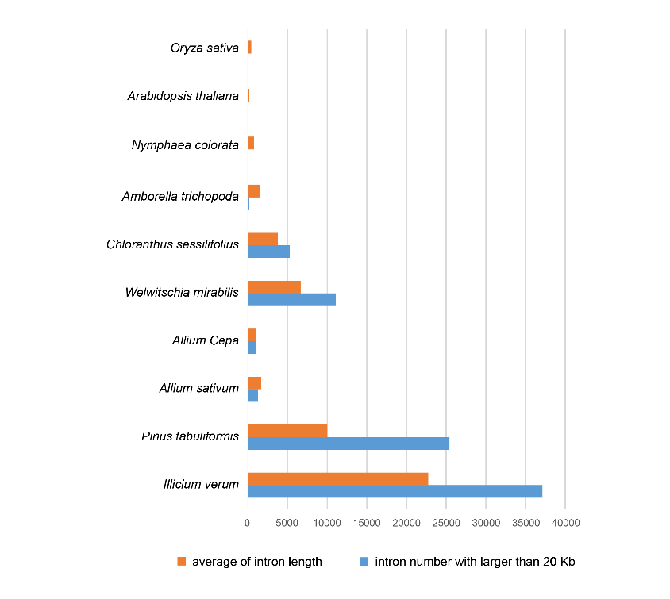
Supplementary Figure 3. Comparison of intron characteristics in ten species.
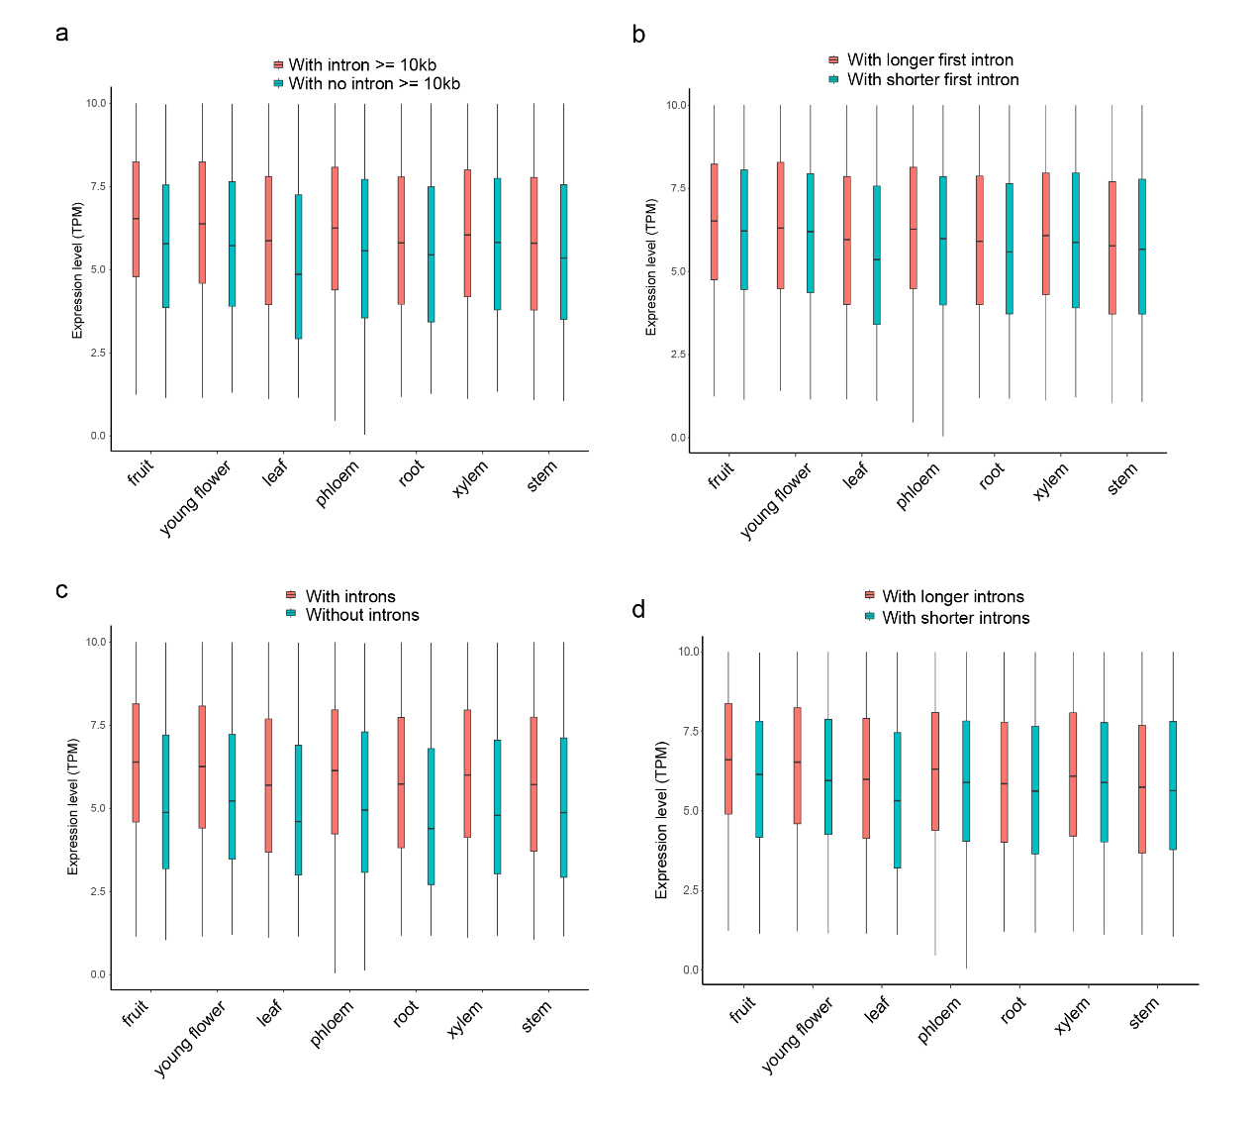
Supplementary Figure 4. The effect of long introns on expression levels of seven tissue-specific genes.

4 Whole-genome duplication in I. verum and A. gramineus

4.1 Identification of whole-genome duplication events
WGDI (Sun et al., A user-friendly toolkit for evolutionary analyses of whole-genome duplications and ancestral karyotypes, Biorxiv, doi: https://doi.org/10.1101/2021.04.29.441969) was used to identify the polyploidy events that occurred in the selected 17 angiosperm species by inferring the collinear regions and calculating the Ks values of collinear genes (Supplementary Fig. 6). Firstly, BLASTP with a cut-off e-value of 1e-5 was used to identify the similarity of genes within or between each genome. We used the “-icl” parameter in WGDI to find collinear genes within each genome. Synonymous substitutions per synonymous site (Ks) between collinear genes were estimated by Nei-Gojobori approach in PAML with the parameter “-ks”. Then, dotplots of collinear genes were plotted with the parameter “-bk”. The polyploidy level of each species was confirmed by counting the syntenic ratios between different species. Finally, Ks peaks were fitted using the “-pf” parameter in WGDI (Supplementary Fig. 5). Genome-wide comparison of syntenic depth was also used to reveal the shared or specific occurrences of polyploidization. For example, Am. trichopoda and N. colorata show a 1:2 syntenic pattern, with one paralogous region in Am. trichopoda matching two regions in N. colorata. Am. trichopoda and I. verum show a 1:2 syntenic pattern while N. colorata and I. verum show a 2:2 syntenic pattern (Extended Data Fig. 2d).
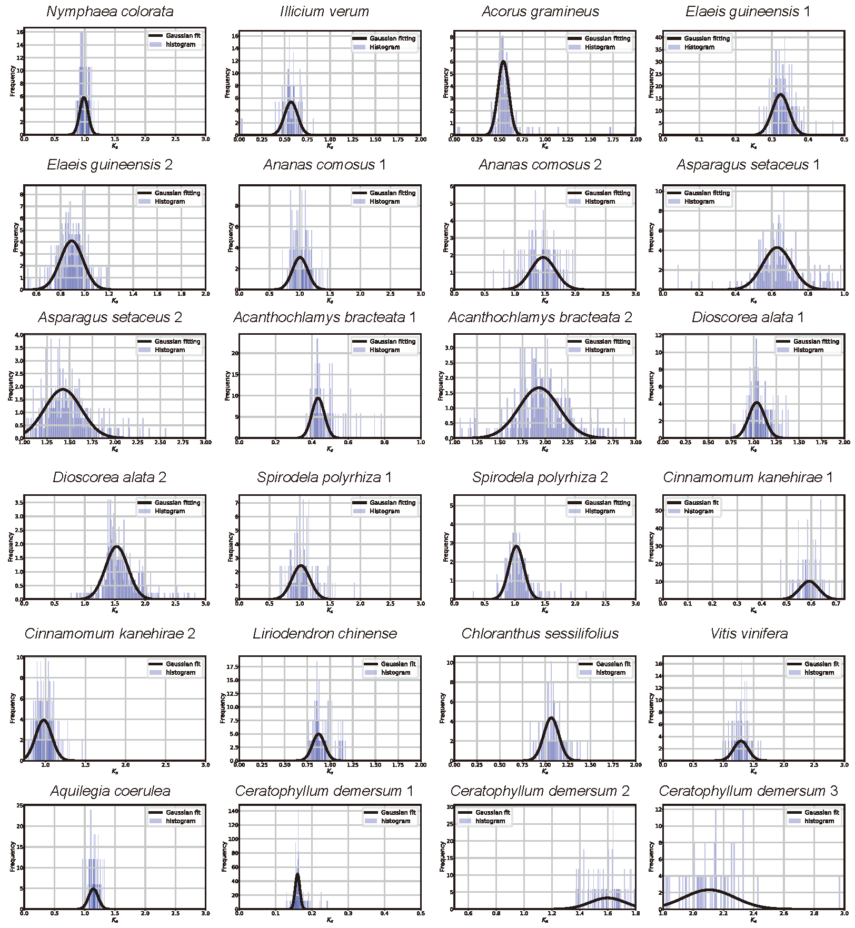
Supplementary Fig. 5 | Distribution of Ks of intergenomic syntenic blocks.
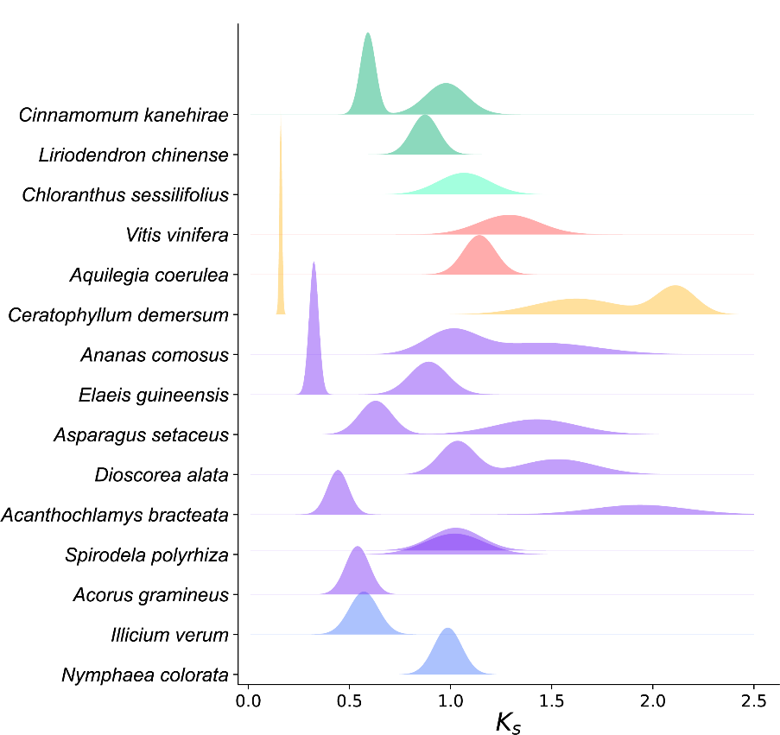
Supplementary Fig. 6 | Ks distributions of intragenomic synteny blocks.

4.2 Times of these two WGDs
Angiosperms were found to evolve with different evolutionary rates, especially after polyploidy. Here, we make an evolutionary rate correction by applying the Ks distribution. based on Ks distribution of C. demersum and V. vinifera in a previous study²³, the Ks correction coefficient of star anise and calamus were calculated and got the corrected Ks rate, and date evolutionary events (Supplementary Fig. 7). One notable example is the biased distribution of WGD events across independent plant lineages at the Cretaceous–Paleogene or K-Pg boundary, about 66 million years ago (Ma)²⁴. Interestingly, these two WGD events experienced also occurred near the K-Pg extinction event.
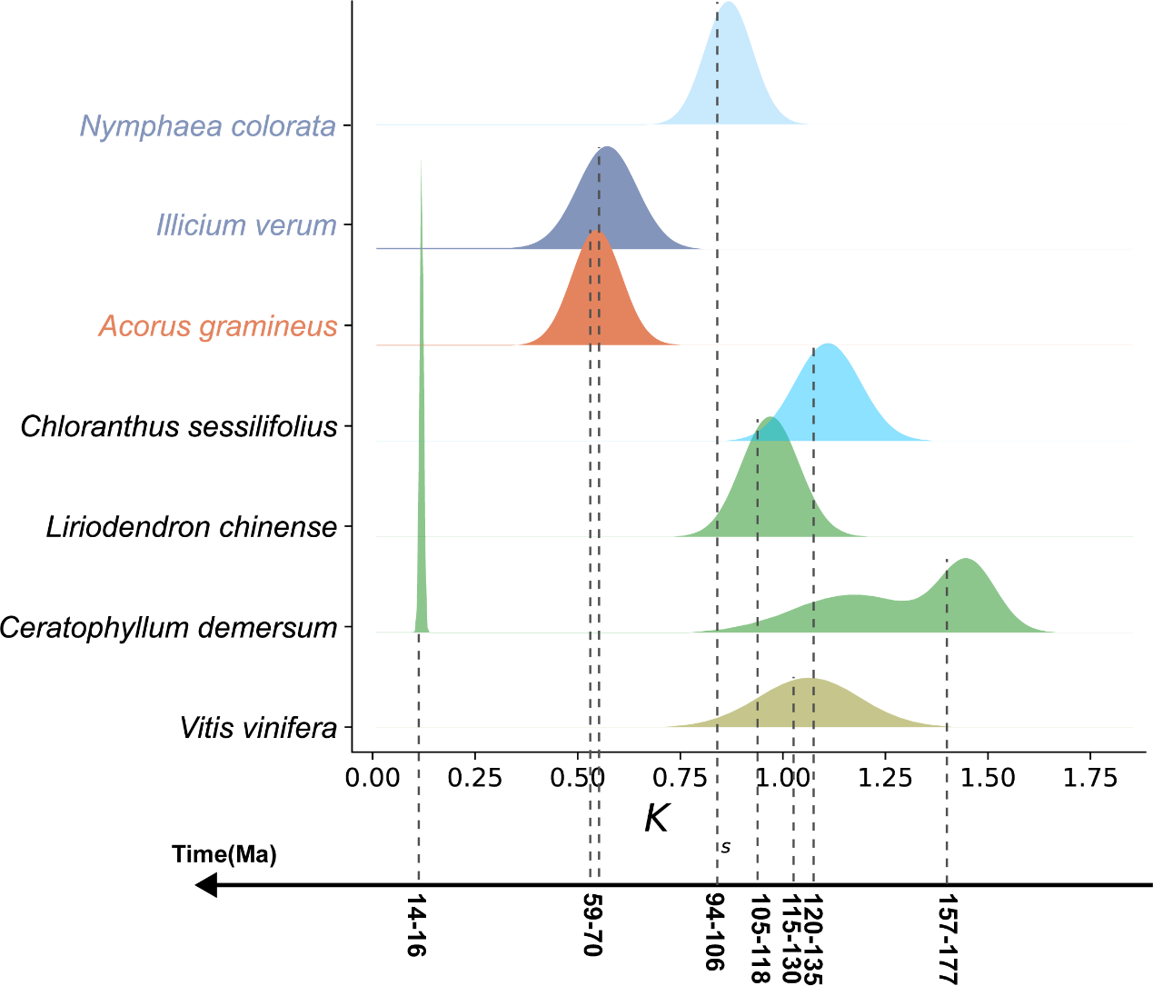
Supplementary Fig. 7 | Kernel density of syntenic blocks after evolutionary rate correction.

5 Phylogenetic relationships of early-diverging angiosperm lineages

5.1 Phylogenomic analyses of collinear nuclear genes
Although there is increasing consensus about monophylogenetic circumscription of major angiosperm lineages, the relationship between them is still not fully resolved (Supplementary Fig. 8). It remains highly debated whether Amborellales alone or Amborellales + Nymphaeales are sisters of all other existing angiosperms, although most recent studies support Amborellales alone as sisters. The relationships among the five clades of Mesangiospermae are far more uncertain, and many contrasting topologies have been recovered from depending on the used datasets (nuclear, plastid, or mitochondrial sequence variations), analytical methods (concatenation vs. coalescent), and terminal species.
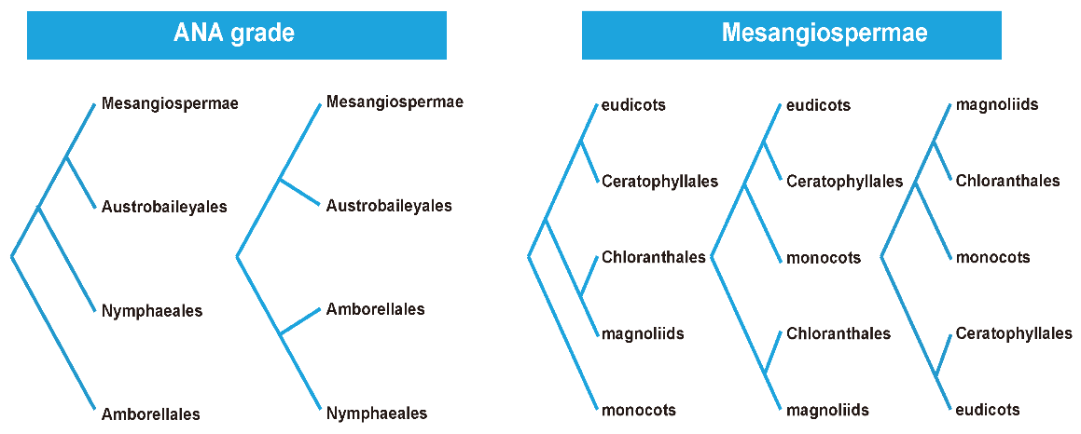
Supplementary Fig. 8 | Inconsistent relationship between early-diverged angiosperms lineages (ANA grade and Mesangiospermae) (left) and five major clades of Meangiospermae) (Summarized from the references 4-21, in the main context)
Phylogenetic relationships of these lineages and clades in the previous studies (e.g. references 4-21, in the main context) were constructed based on the highly orthologous plastome or mitochondrial DNA sequences or assumed orthologous nuclear-genome single-copy （including a few low-copy) genes and clustering-identified homologs. In these phylogenetic analyses, orthologs and incomplete lineage sorting (ILS) could not be well excluded because of the well-known frequent lineage-specific polyploidizations). In this study, we used all collinear genes (including all paralogs due to lineage-polyploidizations) for phylogenetic analyses. Such collinear genes could overcome the weaknesses of the non-orthologous genes and also ILS (if not complete) in the previous studies. For example, when using single-copy genes, paralogs due to polyploidizations were randomly retained and the used sequences are obviously not strict orthologs. In addition, clustering-identified homologs are also not strict orthologs. As a comparison, we also used single-copy genes to perform phylogenetic analysis and both datasets were analyzed separately (see the pipeline in Supplementary Fig. 9).
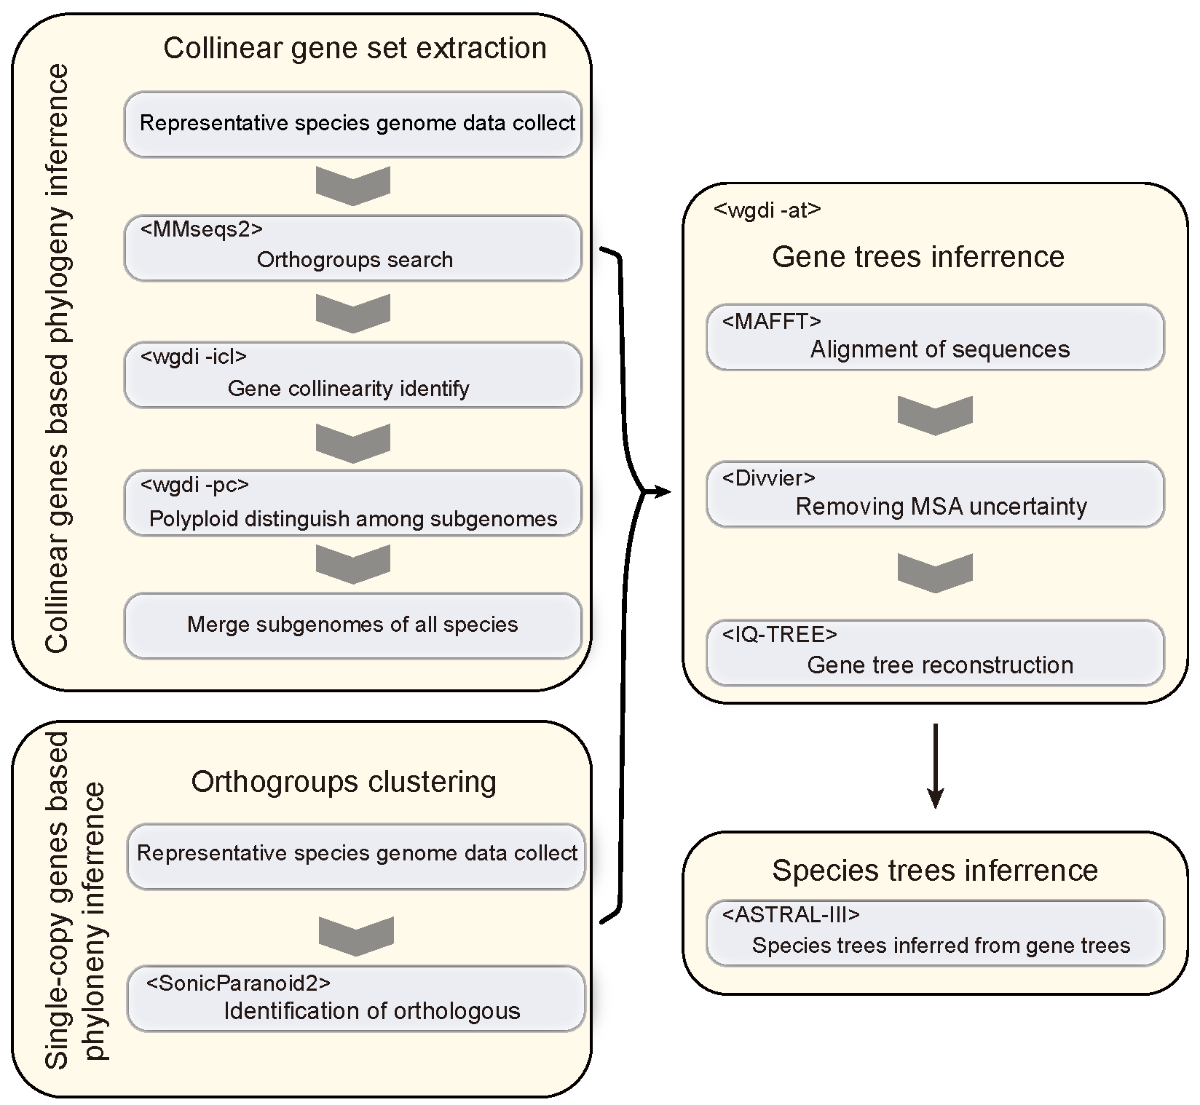
Supplementary Fig. 9 | Workflow for collinear and single-copy genes for species tree reconstruction.
We used 17 species from three ANA lineages, monocots, eudicots, magnoliids, Chloranthales, and Ceratophyllales for phylogenetic analyses. We selected five gymnosperm species (G. biloba, S. giganteum, A. filiculoides, S. moellendoffli, and Physcomitrium patens) as outgroup species. All angiosperm species were aligned with Am. trichopoda as references to obtain colinear genes (Supplementary Fig. 9). For species with independent or shared WGDs or WGTs, we further divided the synteny blocks into different subgenomes according to the Ks distribution and the syntenic depth ratios within and between genomes. For example, for I. verum and A. gramineus (Supplementary Fig. 10), due to independent WGDs, collinear genes with Am. trichopoda as references were extracted and marked with two different colors. We merged these gene lists and constructed phylogenetic trees for each gene. We used ASTRAL-III v.5.7.7 to construct the coalescent species tree of all identified collinear genes (Fig. 2).
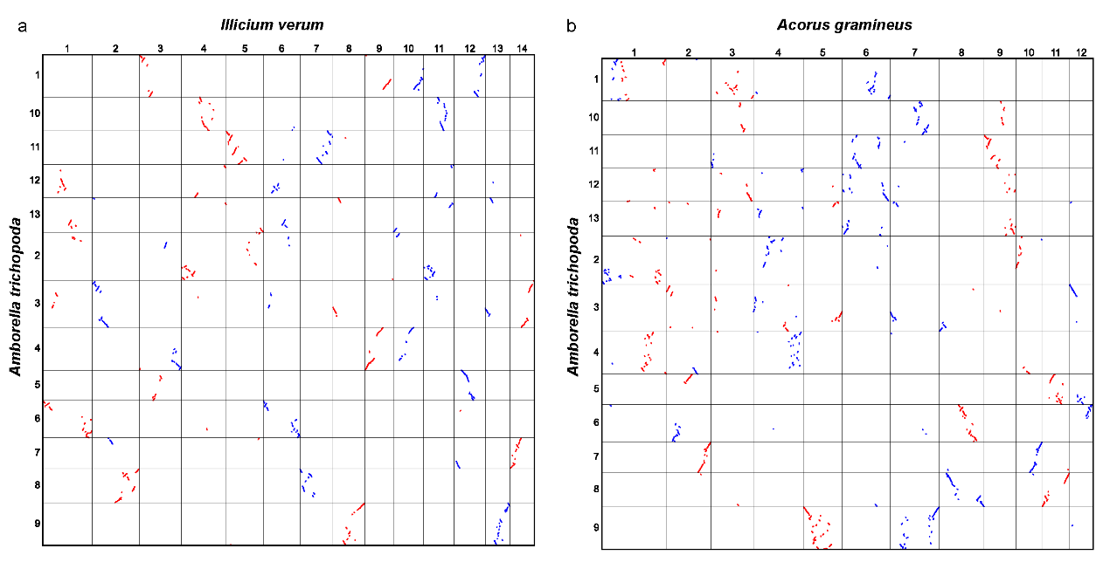
Supplementary Fig. 10 | Collinear gene extraction between Am. trichopoda and I. verum (a), Am. trichopoda and A. gramineus (b). Different colors represent the candidate copied blocks due to polyploidizations.
We also assessed the branch length of the concatenated collinear genes dataset by IQ-TREE²⁵ (-m GTR+G -te Astral.topology.tre -o Physcomitrium_patens) with the fixed coalescent topology (Supplementary Fig. 11).
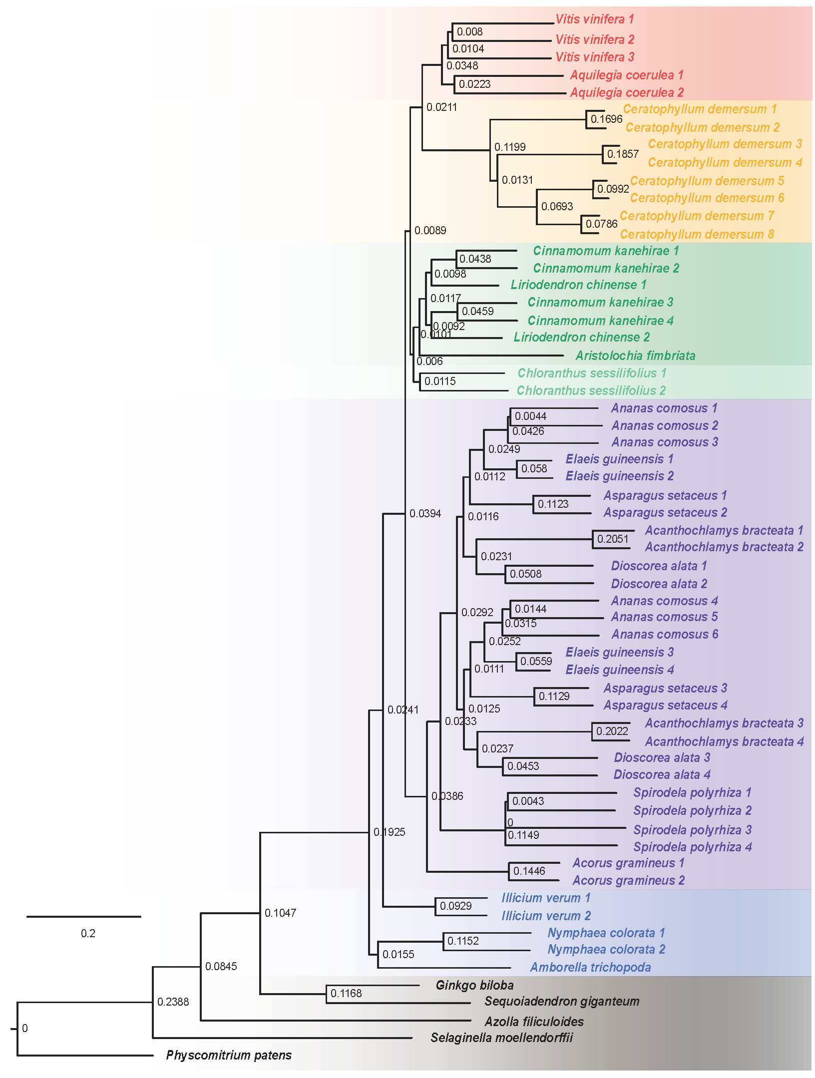
Supplementary Fig. 11 | The concatenated tree of branch lengths with 1235 collinear genes and a defined fixed coalescent topology.

5.2 Phylogenomic analyses of the single-copy genes
We also used the single-copy genes (SCGs) dataset from 17 representative angiosperm genomes to construct phylogenetic relationships. SCGs represent the single-copy genes identified by SonicParanoid2²⁶. Only one single-copy gene present in at least 14 species was selected. We aligned gene sequences using MAFFT and the alignments of coding sequence was generated by PAL2NAL²⁷. The hierarchical gene lists were used to infer maximum likelihood (ML) trees by IQ-TREE with automatic selection of the best-fit substitution model (-m MFP) through WGDI (-at). So, we use ASTRAL-III v.5.7.7²⁸ with the parameter of “-t 8” to construct the coalescent species tree and estimate branch support.
A total of 643 single-copy genes were identified. The individual maximum likelihood gene tree was constructed by IQ-TREE. Among these gene trees, 200 ones were randomly selected and summarized into a coalescent species tree using ASTRAL-III 5.7.7. Unstable tree topologies were obvious within the Mesangiospermae when randomly sampled 200 gene trees were used (Supplementary Fig. 12). For example, in some coalescent species trees, Ceratophyllales and eudicots were sisters and they together were sister to the other Mesangiospermaes clades (Supplementary Figs. 12a). However, Ceratophyllales was sister to other Mesangiospermae clades (Supplementary Figs. 12d) in other coalescent species trees. We also noted that in all coalescent species trees of 200 randomly selected gene trees, Amborellales was always sister to all other angiosperms. We found that the internal branch lengths that differentiated Amborellales and Nymphaeales-Austrobaileyales and five clades of Mesangiospermae were extremely short in all coalescent species trees based on the randomly selected 200 single-copy gene trees. Therefore, fast radiation should have occurred between divergences of these lineages and clades.
It should be noted when the same single-copy gene was found for both Am. trichopoda and N. colorata and also at least for other 12 species, we recovered only 512 single-copy genes. We constructed the gene tree for each of these single-copy genes. We found that only 105 gene trees supported that Amborellales and Nymphaeales were sisters and they together were sisters to Austrobaileyales and Mesangiospermae clades. However, 259 gene trees supported that Amborellales alone was sister to other angiosperms while 148 gene trees supported that Nymphaeales alone was sister to other angiosperms. The consensus species tree of these 512 gene trees (Supplementary Figs. 13a) supported Amborellales alone were sister to other angiosperms. We found identified 194 single-copy genes, each of them was consistently retained across each of all 22 selected angiosperm species. We further the DensiTree of these single-copy gene trees (Supplementary Figs. 13b) and found reticulate relationships between sampled angiosperm species.
Supplementary Fig. 12 | Four consensus trees from randomly selected 200 single-copy trees indicating inconstant relationships between early-diverged lineages and clades of angiosperms. a, magnoliids and monocots are sister clades. b, magnoliids and eudicots are sister clades. c, Chloranthales is sister to sister groups, Ceratophyllales + eudicots. d, Ceratophyllales is sister to all other Mesangiospermaes.
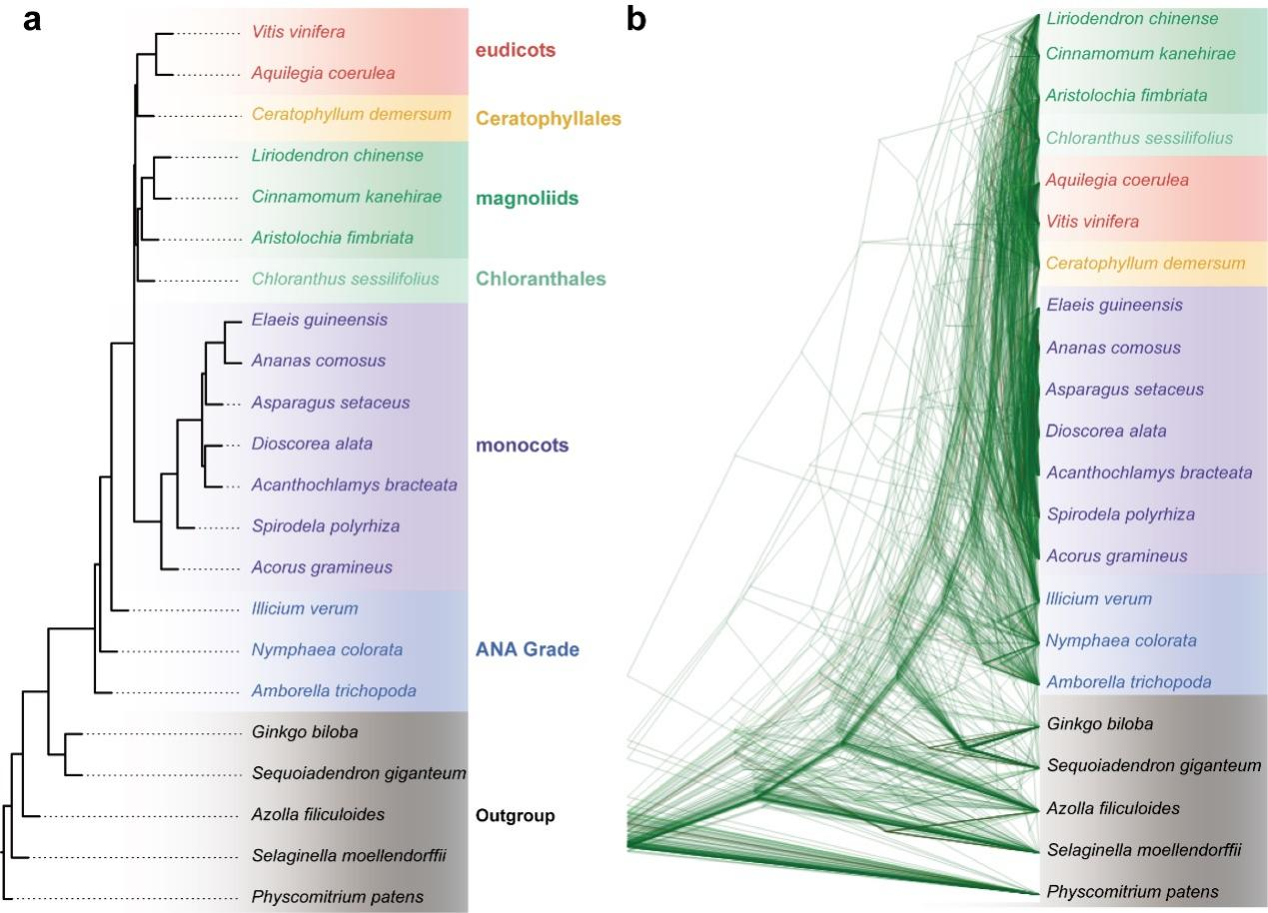
Supplementary Fig. 13 | The consensus species tree of 512 single-copy genes with each gene found for both Am. trichopoda and N. colorata (a) and DensiTree of 190 gene trees with each single-copy gene was retained all sampled angiosperm species.

6 Karyotype evolution of early-diverging angiosperm lineages

6.1 Karyotype evolution model
Eukaryotes have linear chromosomes. The ends of these linear chromosomes comprise telomeres with repeated sequences, which can protect the integrity of chromosomes²⁹. Because of chromosomal structural constraints and aneuploidy evolution during diploidization after common polyploidization usually involve fusion of different chromosomes³⁰ (Supplementary Figs. 14a). If two chromosomes cross at a certain distance from telomeres, reciprocal translocation of chromosome arms (RTA) occurs and two new chromosomes form (Fig. 2a). If two chromosomes cross at their ends, end-end joining (EEJ) of these two chromosomes occur and a new fused chromosome from the previous twos form to comprise most DNA contents while a very small chromosome mainly contains telomeric DNAs become lost. Besides, if a crossover occurs between two telomeres or near the telomeres of the same chromosome, a circular chromosome will form, and the resolution of the crossover may result in a free-end chromosome, i.e., with the telomeres removed to form a satellite chromosome, which similarly will be lost. The free-end chromosome’s ends are sticky and invasive, and therefore invade another chromosome, eventually resulting in a nested chromosome fusion (NCF). These changes were implicated by genome sequencing data from different angiosperm plants³¹⁻³³. A recent paper by Yin and co-authors on chromosomal rearrangements of muntjac deer³⁴, illustrates that DNA double-strand breaks occur at palindromes nearby the short telomeric repeats, which mediates nonallelic homologous recombination between different ancestral muntjac chromosomes and leads to the tandem fusions (Supplementary Figs. 14b). The fusion mechanism supports karyotype evolution from RTA to EEJ.
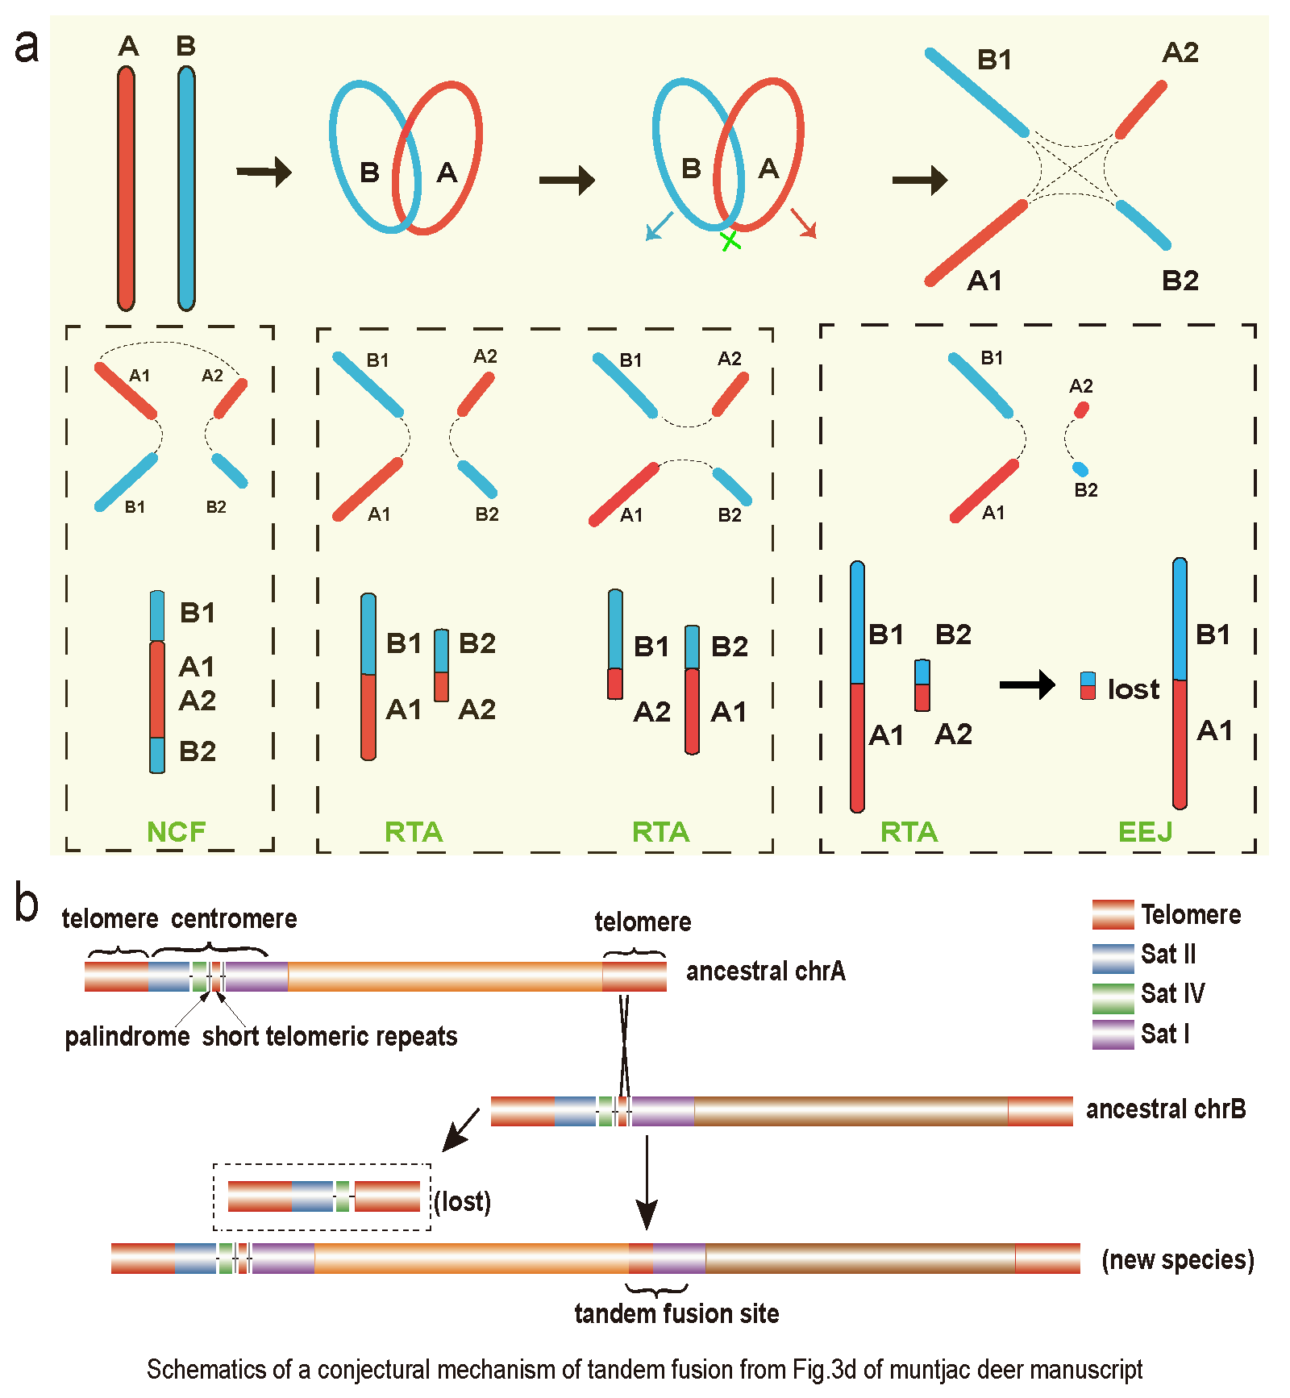
Supplementary Fig. 14 | Mechanism of karyotype evolution for ancestral genome reconstruction in Fig. 2a. a, A conjecture on the mechanism of karyotype evolution. b, Schematics of a conjectural mechanism of tandem fusion from Fig. 3d of muntjac deer manuscript.

6.2 Ancestral karyotype gene repertoire
Ancestral karyotype gene repertoire is an important resource for examining karyotype evolution. Previous researches³⁵⁻³⁷ provide the complete set of ordered protogenes on the protochromosomes. However, due to the small number of the ordered protogenes, subsequent chromosome construction will result in large blank areas, which may lead to an erroneous inference of the ancestral karyotypes. The ancestral karyotype inference is closely related to gene collinearity. More and longer collinearity blocks will greatly improve the inference. Here, we augment the gene repertoire of protochromosomes with a strategy of exploiting gene colinearity from well assembled and representative genomes. Three steps were undertaken to reconstruct ancestral karyotype gene repertoire on a particular evolutionary node (Supplementary Fig. 15). First, identifying synteny blocks across all sampled genomes. Second, reconstructing protochromosomes based on colinear genes. If a cluster of 5 or fewer genes bounded by collinear genes on the extant chromosome corresponds to two ordered protogenes in a protochromosome, these intermediate genes will be added to the middle of the two protogenes. This will increase the gene repertoire of protogenes and extend the protochromosomes. Third, continuing to reconstruct the protochromosomes by adding more genomes. The protogene repertoires on different evolutionary nodes have been deposited in GitHub [https://github.com/SunPengChuan].
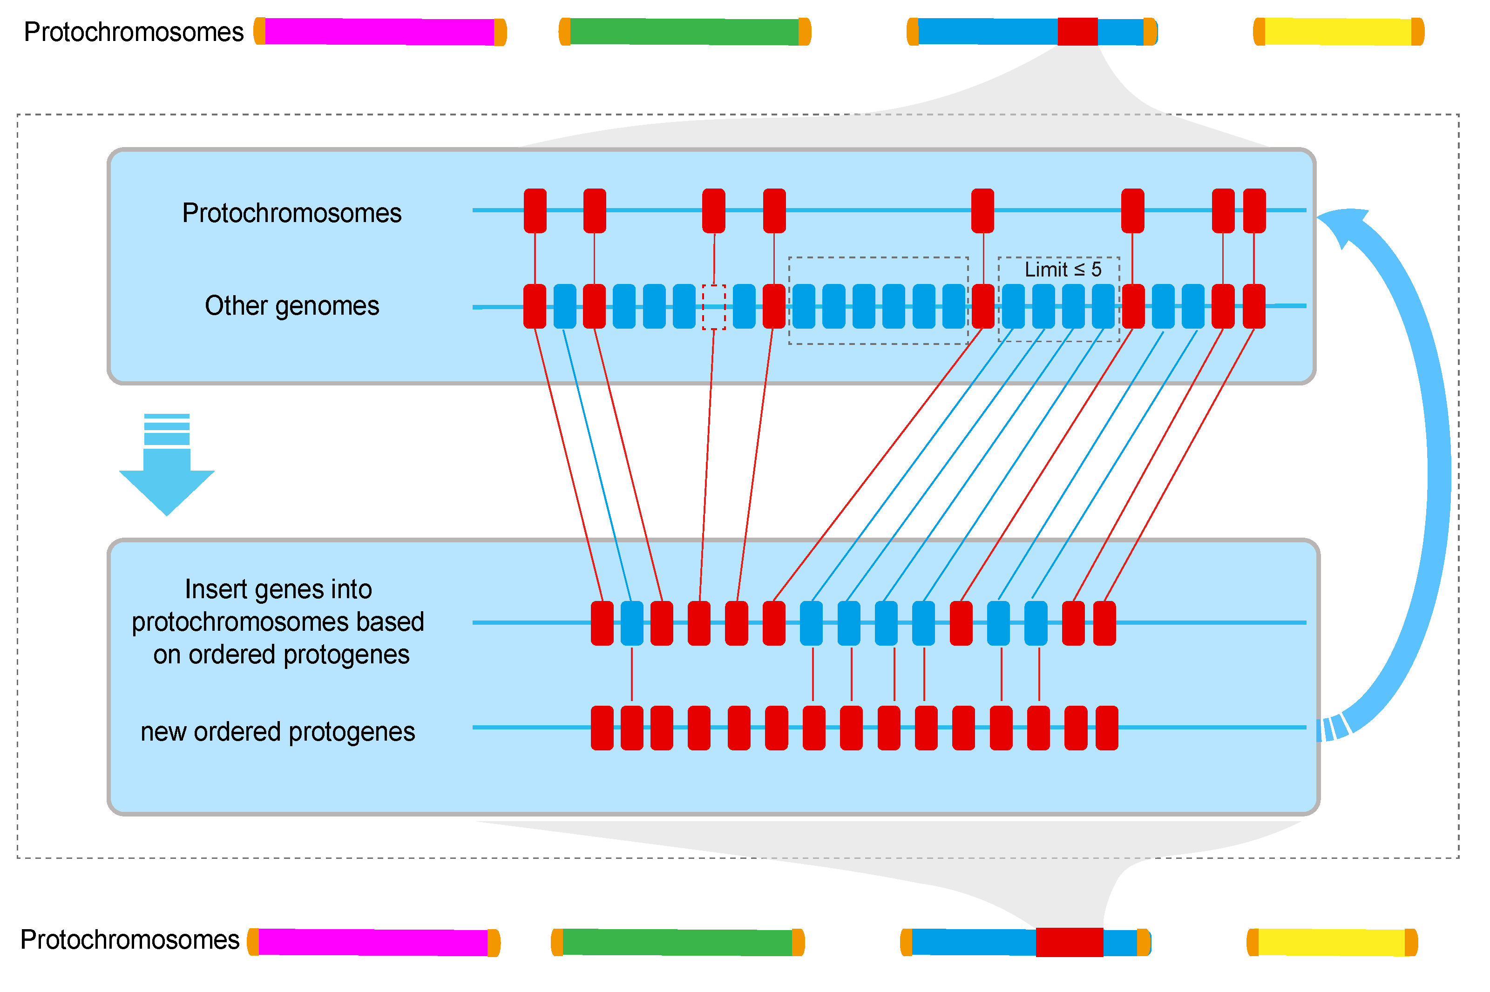
Supplementary Fig. 15 | Schematic representation of ancestral karyotype gene repertoire

6.3 Ancestral angiosperm karyotype (AAK) with 16 protochromosomes
Based on the above method (Fig. 2; see Methods), we constructed the ancestral karyotype of all angiosperms based on 17 extant genomes. We used Am. trichopoda as a reference and reconstruct protochromosomes 4(AAK11), 5(AAK12), 6(AAK13), 7(AAK14), 8(AAK15), 9(AAK16), 10 (AAK3), 11(AAK4), which nearly intactly exist in some species (Supplementary Fig. 16). Chr19 of L. chinense and Chr17 of S. polyrhiza are retained as big patches within Chr2 of Am. trichopoda, and are nearly intact in several other species and this chromosome was denoted as AAK8. The rest of Chr2 in Am. trichopoda is also nearly intact in other species, thus being denoted as AAK9. Similarly, after removing AAK16 (Chr9 of Am. trichopoda), the Chr8 and Chr13 of I. verum (homologous chromosomes as the specific WGD) corresponding to partial fragments of Chr3 and Chr13 of Am. trichopoda, which remains nearly intact in many other species and therefore was denoted as AAK7. After removing AAK11 (Chr4 of Am. trichopoda), the Chr9 of I. verum corresponds to the middle area of Chr1 in Am. trichopoda, and therefore was denoted as AAK2 while the remainder of Chr1 in Am. trichopoda was denoted as AAK1. After the removal of AAK2 and AAK12 from Chr17 of D. alata, the rest corresponds to partial fragments of Chr3, Chr12, and Chr13 of Am. trichopoda, which is also often intact in other species, and therefore was denoted as AAK5. The rest of Chr12 and Chr13 of Am. trichopoda is also often intact in other species, and therefore was denoted as AAK6. Ancestral angiosperm karyotype (AAK) was reconstructed to comprise 16 protochromosomes.
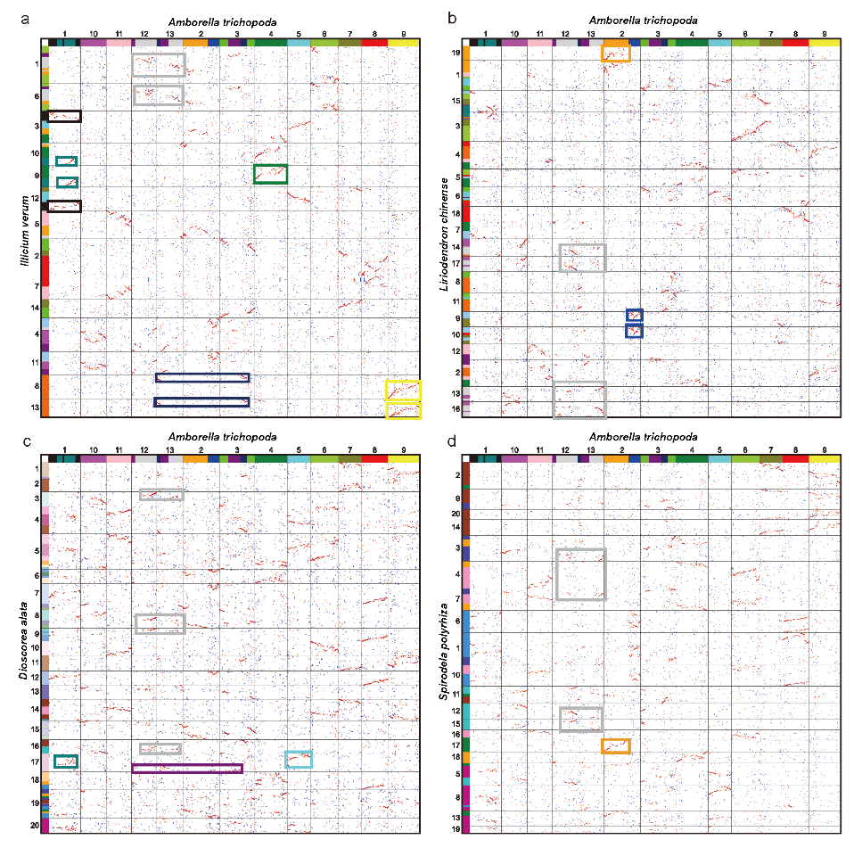
Supplementary Fig. 16 | Genomic comparison of the I. verum, L. chinense, D. alata and S. polyrhiza with Am. trichopoda, respectively.
We also compared the gene repertoire of AAK with the genes of Am. trichopoda, and found that most genes received the best hit (red dots) (Supplementary Figs. 17a). Also, we compared our AAK genes with the MRCA (the most recent common ancestor) gene repertoire provided by Murat et al. (Reconstructing the genome of the most recent common ancestor of flowering plants. Nat. Genet. 49, 490-496, doi:10.1038/ng.3813, 2017) and found that only a small amount of collinearity between them (Supplementary Figs. 17b). Only Chr1, Chr2, and Chr5 of MRCA have more collinearity, while the rest of the chromosomes correspond partly to the AAK chromosomes, even without the correspondence for AAKs1, 4, 7, 10, and 13.
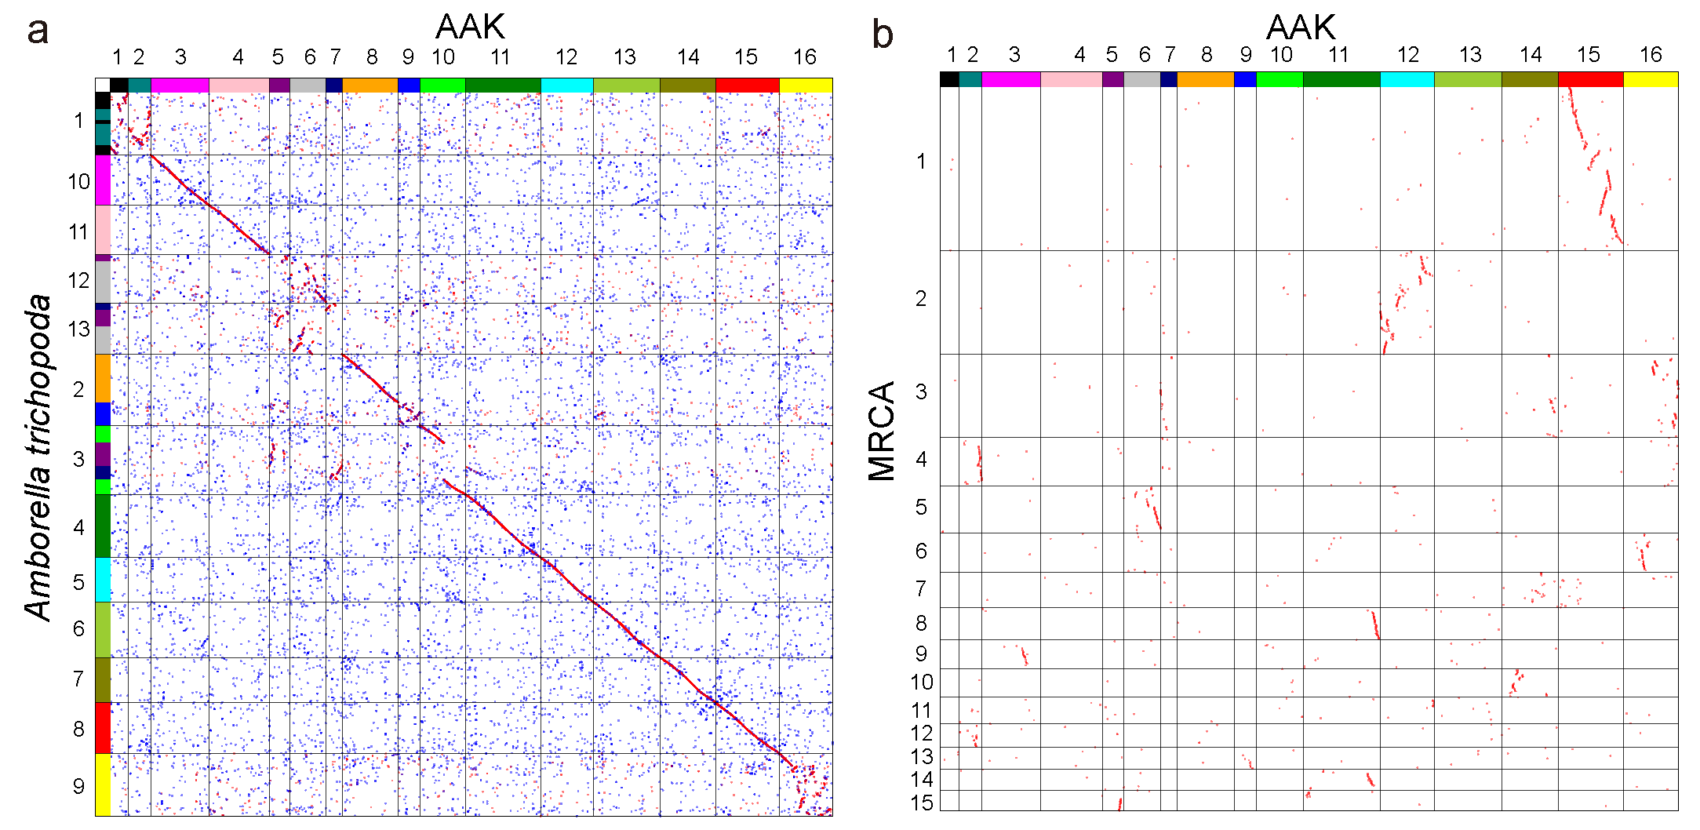
Supplementary Fig. 17 | Genomic comparison of the AAK with Am. trichopoda and MRCA, respectively. a, dotplot between the Am. trichopoda and AAK. b, dotplot between the MRCA and AAK.

6.4 Ancestral Mesangiospermae karyotype (AMAK) with 14 protochromosomes
From AAK to ancestral Mesangiospermae karyotype (AMAK), two chromosomal fusions (AAK1+9 and AAK7+16) occurred and reduced the number of chromosomes from 16 to 14 (Fig. 3, Extended Data Fig. 6). In addition, we also found that the fusion of AAK5 and AAK11 through the reciprocally RTA formed two chromosomes AMAK4 and AMAK8 (Supplementary Figs. 18b). Another small fragment produced by AAK1+9 through RTA continues to fuse with AAK6 through EEJ to form a new chromosome AMAK5 (Supplementary Figs. 18b). Although these evolutionary events would not reduce the number of ancestral chromosomes, they comprised an important part of karyotype evolution.
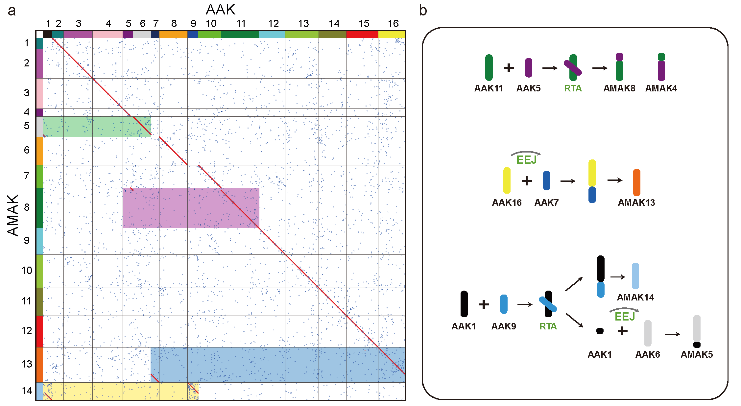
Supplementary Fig. 18 | Genomic comparison of ancestral Mesangiospermae (AMAK) with AAK. a, Synteny relationships between AMAK and AAK. Ancestral chromosomes involved in karyotype evolution are marked by different color shading. b, Evolutionary trajectory of ancestral chromosomes inferred from AAK to AMAK according to the chromosome evolution.
The earliest-diverged monocots, A. gramineus, retained more ancestral Mesangiospermae (AMAK) chromosomes even after species-specific WGD and further chromosomal fusions. We plotted the homologous dotplot of A. gramineus and AMAK (Supplementary Fig. 19), and clearly found that except AMK7 and 8, the remaining 12 primitive chromosomes can easily be found in A. gramineus with chromosome-like 'synteny blocks'. This also confirms that Acorales diverged early from other monocots as a monophyletic primitive group.
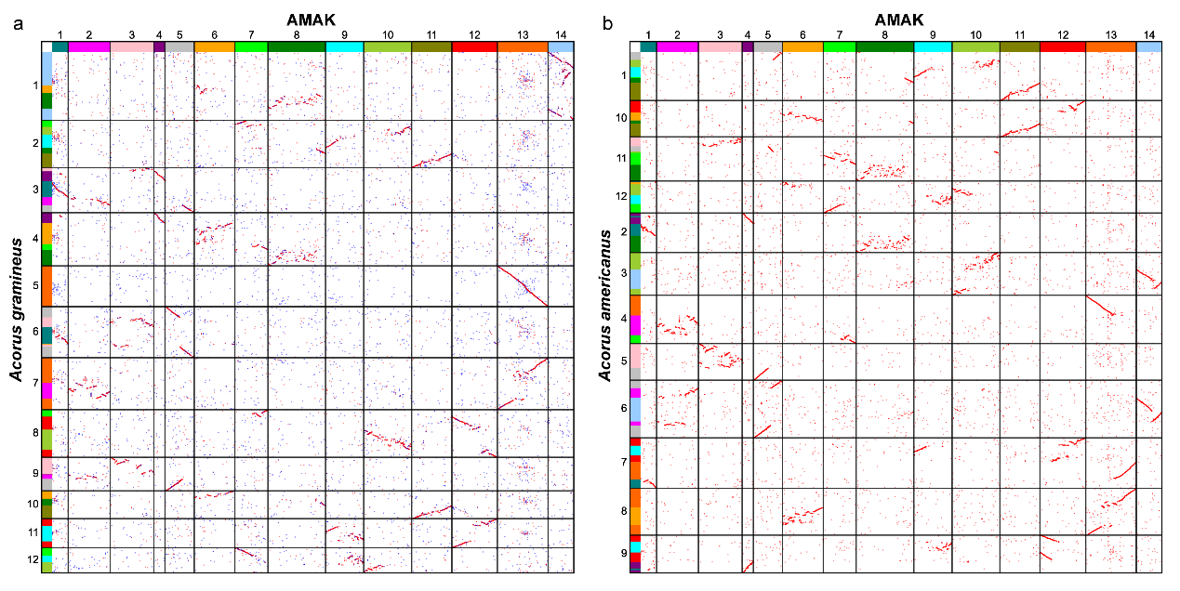
Supplementary Fig. 19 | Genomic comparison between Acorus and AMAK. a, dotplot between the A. gramineus and AMAK. b, dotplot between the A. americanus and AMAK.

6.5 Ancestral monocot karyotype except for Acoraceae (AMKA) with 8 protochromosomes
Due to the absence of shared evolutionary events between Acorales and other monocots, ancestral monocots karyotype (AMK) was inferred as with 14 protochromosomes. From AMAK to ancestral monocot karyotype except for Acoraceae (AMKA), six chromosomal evolutionary events occurred, reducing the number of chromosomes from 14 to 8 (Fig. 3) (Supplementary Figs. 20, 21a). For example, the fusion of AMAK1, AMAK4 and AMAK9 through the end-end joining (EEJ) formed one chromosome (AMAK1+4+9) as the AMKA3, which remains independent in D. alata (Chr17). Similarly, the fusion of AMAK3 and AMAK10 through the end-end joining (EEJ) generated the AMKA4, which remains independent as Chr10 of D. alata. The fusion of AMAK13 and AAK11 through the end-end joining (EEJ) produced the AMKA5, which remains independent as the Chr11 in D. alata. The fusion of AMAK14 and AMAK12 through the end-end joining (EEJ) formed the AMKA6, which remains independent as Chr12 of D. alata. Finally, two evolutionary events between AMAK2, AMAK5 and AMAK7 through the end-end joining (EEJ) and reciprocal translocation of chromosome arms (RTA) produced AMKA7 and AMKA8, which are kept as Chr3 and Chr13 in D. alata, respectively. In addition, Chr17 and Chr18 of S. polyrhiza remain independent in AMAK but evolve into AMKA1 and AMKA2, respectively. The inferred x=8 for AMKA defines exhaustive and accurate syntenic chromosome relationships between the extant monocot genomes. It is worth noting that AMAK1+4 (Supplementary Fig. 19) also occurs in both calamus genomes, since Acorus-specific WGD does not share this fusion, it is not set to be shared by all monocots and AMAK2+5 is similar (Supplementary Fig. 19).
We also provide the gene repertoire of AMKA and compared them with those of AMAK. Both have high collinearity without obvious gaps (Supplementary Figs. 21a). We compared AMKA with the ‘AMK’ provided by Murat et al. (Reconstructing the genome of the most recent common ancestor of flowering plants. Nat. Genet. 49, 490-496, doi:10.1038/ng.3813, 2017) and only a small amount of collinearity blocks were covered (Supplementary Figs. 21b).
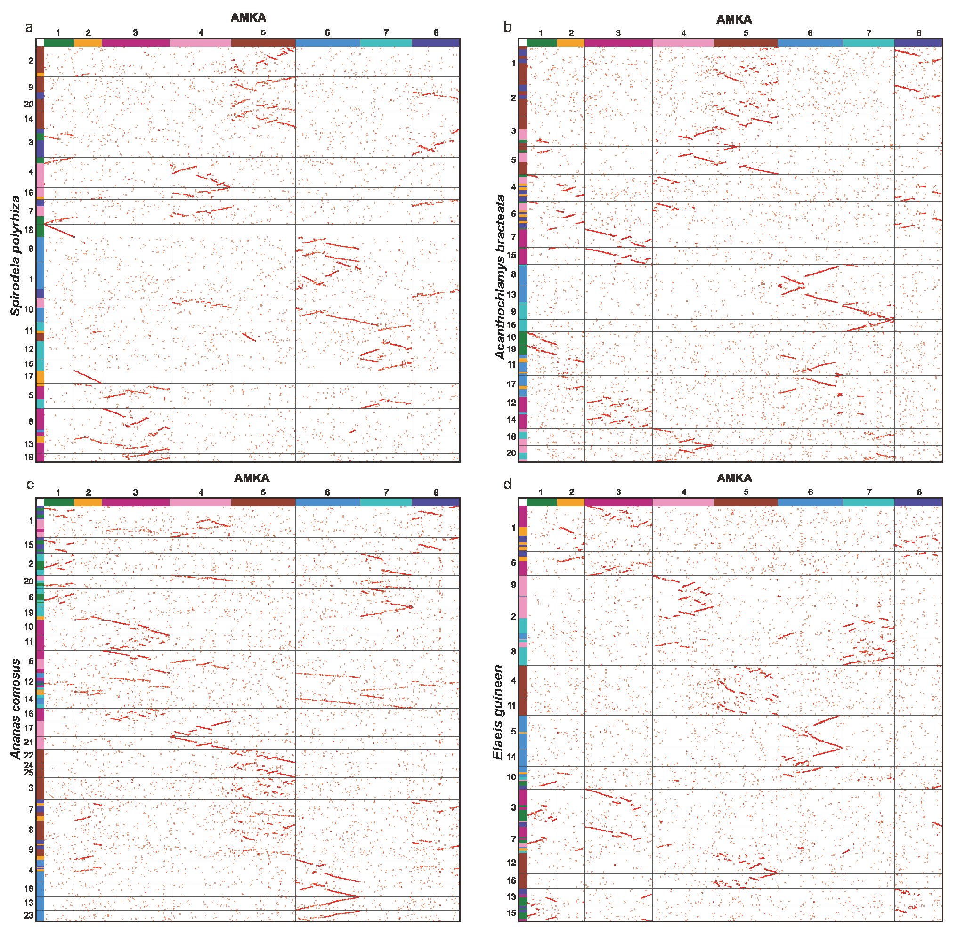Supplementary Fig. 20 | Genomic comparison of the Sp. polyrhiza, A. bracteate, A.comosus and E. guineensis with AMKA, respectively.
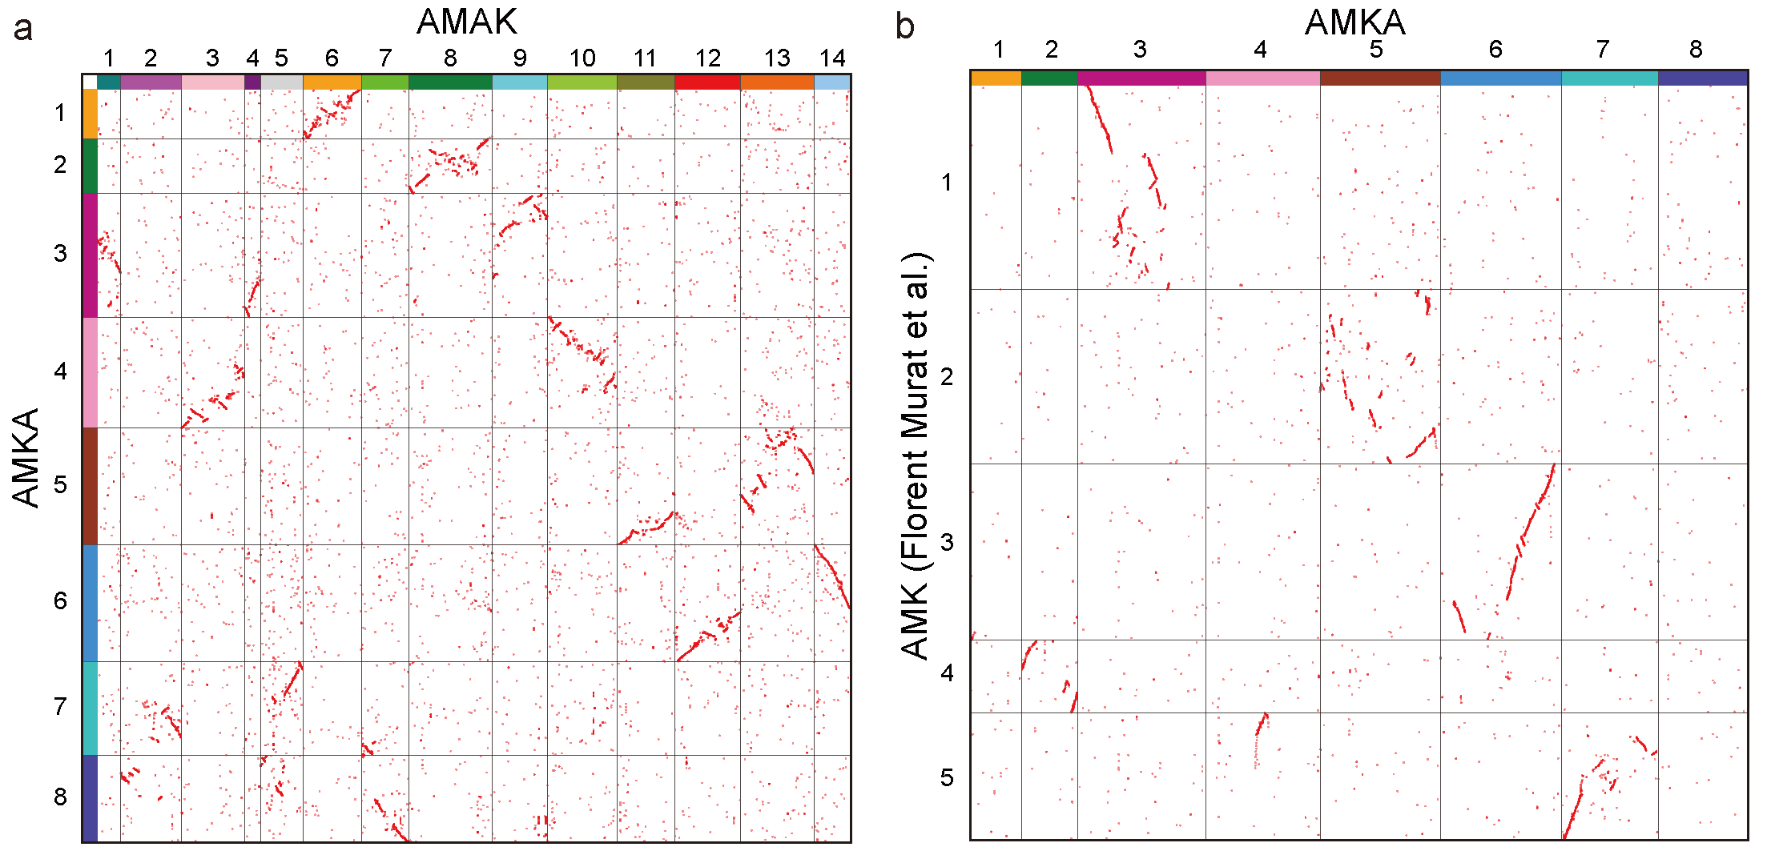
Supplementary Fig. 21 Genomic comparisons between AMKA and AMAK and the ‘AMK’ by Murat et al. (2017), respectively. a, dotplot between the Am. trichopoda and AAK. b, dotplot between AMKA and the ‘AMK’ of Mura et al., 2017.

6.6 Rapid karyotype evolution also in eudicots
As found for ancestral monocot kayotype except for Acoraceae (AMKA) from ancestral Mesangiospermae karyotype (AMAK), we also rapid and many chromosome structural variations from AMAK to ancestral eudicot karyotypes (AEK) from 14 to 7 prochromosomes. Almost all chromosomes underwent rearrangement processes. These changes, from AMKA to AMKA and AEK respectively, may have promoted rapid species radiations in these two lineages.
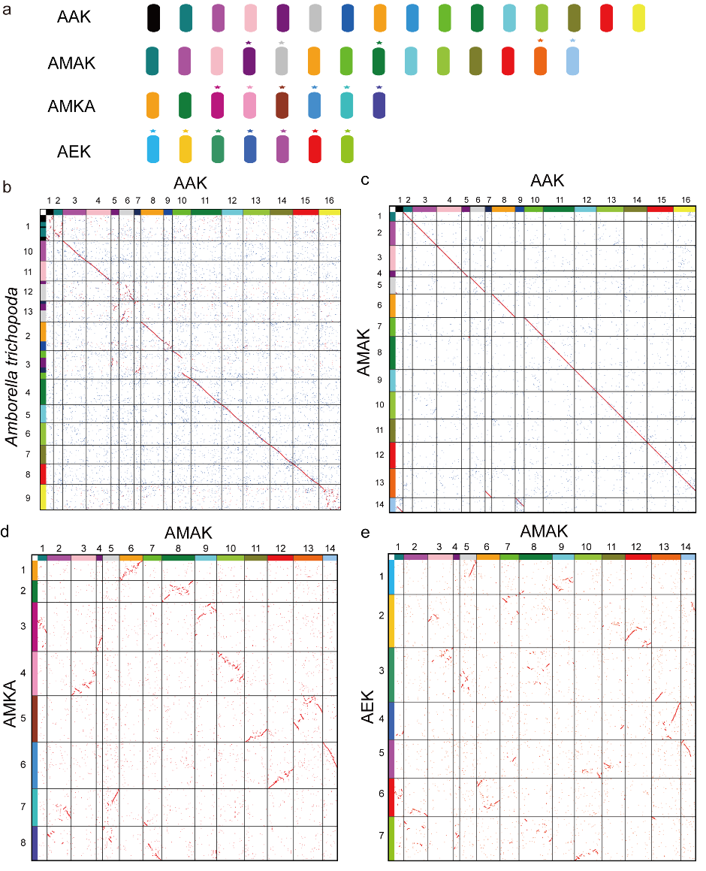
Supplementary Fig. 22 Genomic comparisons between AMKA and AMAK, and also between AMKA and AEK.

References
1. Marçais, G. & Kingsford, C. A fast, lock-free approach for efficient parallel counting of occurrences of k-mers. Bioinformatics 27, 764-770 (2011).
2. Vurture, G.W. et al. GenomeScope: fast reference-free genome profiling from short reads. Bioinformatics 33, 2202-2204 (2017).
3. Hu, J., Fan, J., Sun, Z. & Liu, S. NextPolish: a fast and efficient genome polishing tool for long-read assembly. Bioinformatics (2020).
4. Cheng, H., Concepcion, G.T., Feng, X., Zhang, H. & Li, H. Haplotype-resolved de novo assembly using phased assembly graphs with hifiasm. Nature methods 18, 170-175 (2021).
5. Wang, K. et al. African lungfish genome sheds light on the vertebrate water-to-land transition. Cell 184, 1362-1376.e1318 (2021).
6. Niu, S. et al. The Chinese pine genome and methylome unveil key features of conifer evolution. Cell (2021).
7. Chen, S., Zhou, Y., Chen, Y. & Gu, J. fastp: an ultra-fast all-in-one FASTQ preprocessor. Bioinformatics 34, i884-i890 (2018).
8. Durand, N.C. et al. Juicer provides a one-click system for analyzing loop-resolution Hi-C experiments. Cell systems 3, 95-98 (2016).
9. Dudchenko, O. et al. De novo assembly of the <i>Aedes aegypti</i> genome using Hi-C yields chromosome-length scaffolds. Science 356, 92-95 (2017).
10. Durand, N.C. et al. Juicebox provides a visualization system for Hi-C contact maps with unlimited zoom. Cell systems 3, 99-101 (2016).
11. Smit, A., Hubley, R. & Green, P. (2021).
12. Kim, D., Paggi, J.M., Park, C., Bennett, C. & Salzberg, S.L. Graph-based genome alignment and genotyping with HISAT2 and HISAT-genotype. Nature biotechnology 37, 907-915 (2019).
13. Pertea, M. et al. StringTie enables improved reconstruction of a transcriptome from RNA-seq reads. Nature biotechnology 33, 290-295 (2015).
14. Li, W. & Godzik, A. Cd-hit: a fast program for clustering and comparing large sets of protein or nucleotide sequences. Bioinformatics 22, 1658-1659 (2006).
15. Stanke, M. et al. AUGUSTUS: ab initio prediction of alternative transcripts. Nucleic acids research 34, W435-W439 (2006).
16. Majoros, W.H., Pertea, M. & Salzberg, S.L. TigrScan and GlimmerHMM: two open source ab initio eukaryotic gene-finders. Bioinformatics 20, 2878-2879 (2004).
17. Keilwagen, J., Hartung, F. & Grau, J. in Gene Prediction 161-177 (Springer, 2019).
18. Haas, B.J. et al. Automated eukaryotic gene structure annotation using EVidenceModeler and the Program to Assemble Spliced Alignments. Genome biology 9, 1-22 (2008).
19. Jones, P. et al. InterProScan 5: genome-scale protein function classification. Bioinformatics 30, 1236-1240 (2014).
20. Katoh, K., Rozewicki, J. & Yamada, K.D. MAFFT online service: multiple sequence alignment, interactive sequence choice and visualization. Brief. Bioinform. 20, 1160-1166 (2019).
21. Brown, J.W., Walker, J.F. & Smith, S.A. Phyx: phylogenetic tools for unix. Bioinformatics 33, 1886-1888 (2017).
22. Price, M.N., Dehal, P.S. & Arkin, A.P. FastTree 2–approximately maximum-likelihood trees for large alignments. PloS one 5, e9490 (2010).
23. Yang, Y. et al. Prickly waterlily and rigid hornwort genomes shed light on early angiosperm evolution. Nat. Plants 6, 215-222 (2020).
24. Carretero‐Paulet, L. & Van de Peer, Y. The evolutionary conundrum of whole‐genome duplication. American Journal of Botany 107, 1101 (2020).
25. Minh, B.Q. et al. IQ-TREE 2: New models and efficient methods for phylogenetic inference in the genomic era. Mol. Biol. Evol. 37, 1530-1534 (2020).
26. Cosentino, S. & Iwasaki, W. SonicParanoid: fast, accurate and easy orthology inference. Bioinformatics 35, 149-151 (2018).
27. Suyama, M., Torrents, D. & Bork, P. PAL2NAL: robust conversion of protein sequence alignments into the corresponding codon alignments. Nucleic Acids Res. 34, W609-W612 (2006).
28. Zhang, C., Rabiee, M., Sayyari, E. & Mirarab, S. ASTRAL-III: polynomial time species tree reconstruction from partially resolved gene trees. BMC Bioinformatics 19, 153 (2018).
29. Peska, V. & Garcia, S. Origin, Diversity, and Evolution of Telomere Sequences in Plants. Frontiers in plant science 11, 117-117 (2020).
30. Wang, X. et al. Telomere-centric genome repatterning determines recurring chromosome number reductions during the evolution of eukaryotes. New Phytol. 205, 378-389 (2015).
31. Zhuang, W. et al. The genome of cultivated peanut provides insight into legume karyotypes, polyploid evolution and crop domestication. Nature genetics 51, 865-876 (2019).
32. Song, X. et al. The celery genome sequence reveals sequential paleo‐polyploidizations, karyotype evolution and resistance gene reduction in apiales. Plant biotechnology journal 19, 731-744 (2021).
33. Wang, S. et al. High-quality reference genome sequences of two coconut cultivars provide insights into evolution of monocot chromosomes and differentiation of fiber content and plant height. Genome Biology 22, 304 (2021).
34. Yin, Y. et al. Molecular mechanisms and topological consequences of drastic chromosomal rearrangements of muntjac deer. Nature communications 12, 1-15 (2021).
35. Murat, F., Armero, A., Pont, C., Klopp, C. & Salse, J. Reconstructing the genome of the most recent common ancestor of flowering plants. Nat. Genet. 49, 490-496 (2017).
36. Murat, F. et al. Ancestral grass karyotype reconstruction unravels new mechanisms of genome shuffling as a source of plant evolution. Genome research 20, 1545-1557 (2010).
37. Murat, F. et al. Karyotype and gene order evolution from reconstructed extinct ancestors highlight contrasts in genome plasticity of modern rosid crops. Genome biology and evolution 7, 735-749 (2015).

