The long noncoding RNA AATBC promotes breast cancer migration and invasion by interacting with YBX1 and activating the YAP1/Hippo signaling pathway

Maonan Wang^{†1,2,3}, Manli Dai^{†1,2}, Dan Wang^{†1,2}, Ting Tang^{1,2}, Fang Xiong², Bo Xiang^{1,2}, Ming Zhou², Xiaoling Li², Yong Li⁴, Wei Xiong^{1,2,3}, Guiyuan Li^{1,2,3}, Zhaoyang Zeng^{1,2,3*}, Can Guo^{1,2,3}*

1. NHC Key Laboratory of Carcinogenesis, Hunan Cancer Hospital and the Affiliated Cancer Hospital of Xiangya School of Medicine, Central South University, Changsha, Hunan, China;
2. Key Laboratory of Carcinogenesis and Cancer Invasion of the Chinese Ministry of Education, Cancer Research Institute, Central South University, Changsha, Hunan, China;
3. Hunan Key Laboratory of Nonresolving Inflammation and Cancer, Disease Genome Research Center, the Third Xiangya Hospital, Central South University, Changsha, Hunan, China;
4. Department of Medicine, Comprehensive Cancer Center Baylor College of Medicine, Houston, Texas, USA
† These authors contributed equally to this work.
*Correspondence: guocde@csu.edu.cn or zengzhaoyang@csu.edu.cn

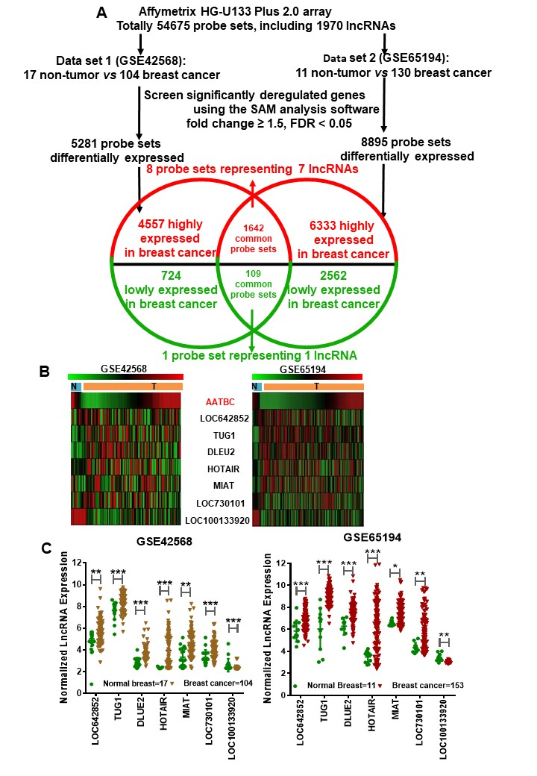
Fig. S1. Dysregulated lncRNA expression analysis using two GEO datasets
a Schematic workflow for identifying and validating differentially expressed lncRNAs in two breast cancer datasets. b The heatmap of eight differentially expressed lncRNAs in breast cancer tissues according to the GSE42568 and GSE65194 databases. The greener the color, the lower the expression level, whereas red represents higher expression. c The dot plots data of seven differentially expressed lncRNAs in breast cancer tissues according to the GSE42568 and GSE65194 databases.
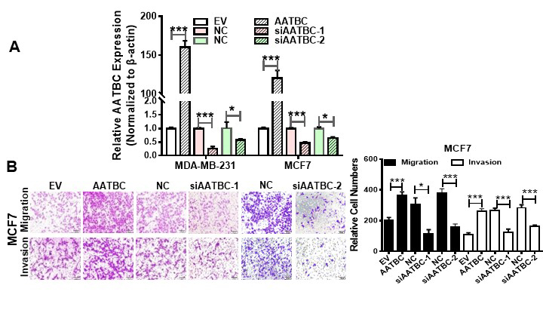
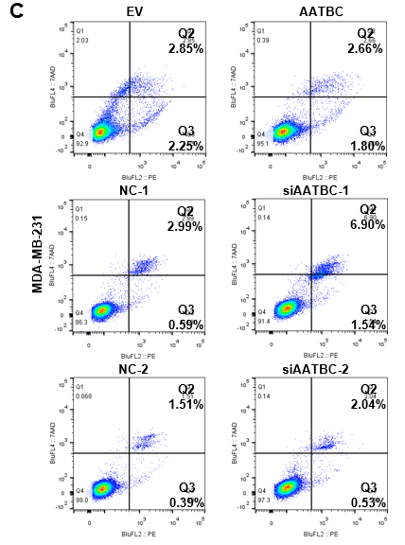
Fig. S2. AATBC promoted the migration, invasion and apoptosis abilities of MCF7 cells
a Real-time PCR was used to confirm the efficiency of AATBC overexpression and siRNA knockdown in MDA-MB-231 and MCF7 cells. ***, p < 0.001. b AATBC affected migration and invasion of MCF7 cells after AATBC overexpression and siRNA knockdown using Transwell assays without (migration) and with Matrigel (invasion). A knockdown using Transwell assays without (migration) and with Matrigel (invasion). c The effect on MDA-MB-231 apoptosis of AATBC. **, p < 0.01; ***, p < 0.001. AATBC, the AATBC overexpression vector; EV, the empty vector; NC, negative control siRNA; siAATBC-1, AATBC siRNA-1; siAATBC-2, AATBC siRNA-2.
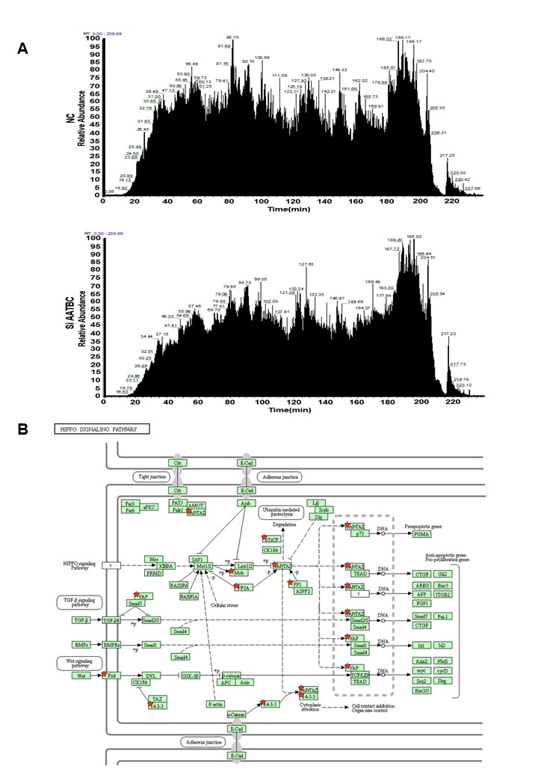
Fig. S3. The proteomics profile in MDA-MB-231 cells after AATBC knockdown
a The ion flow maps of MDA-MB-231 cells transfected with siAATBC or negative control siRNA by the LC-MS/MS. b Differentially expressed proteins of the Hippo signaling pathway (indicated by red stars) were identified by the DAVID software after AATBC knockdown. NC, negative control siRNA; siATTBC, ATTBC siRNA-1.
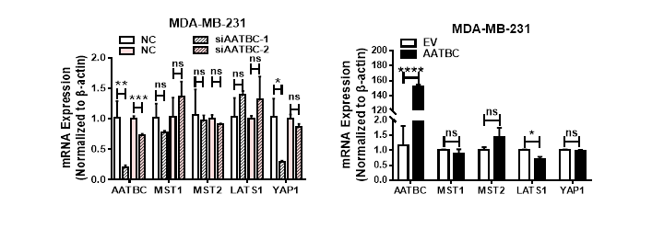
Fig. S4. Real-time PCR was used to measure the mRNA levels of key molecules in the Hippo signaling pathway in MDA-MB-231 cells after ATTBC overexpression or knockdown. *, p < 0.05; ****, p < 0.0001.
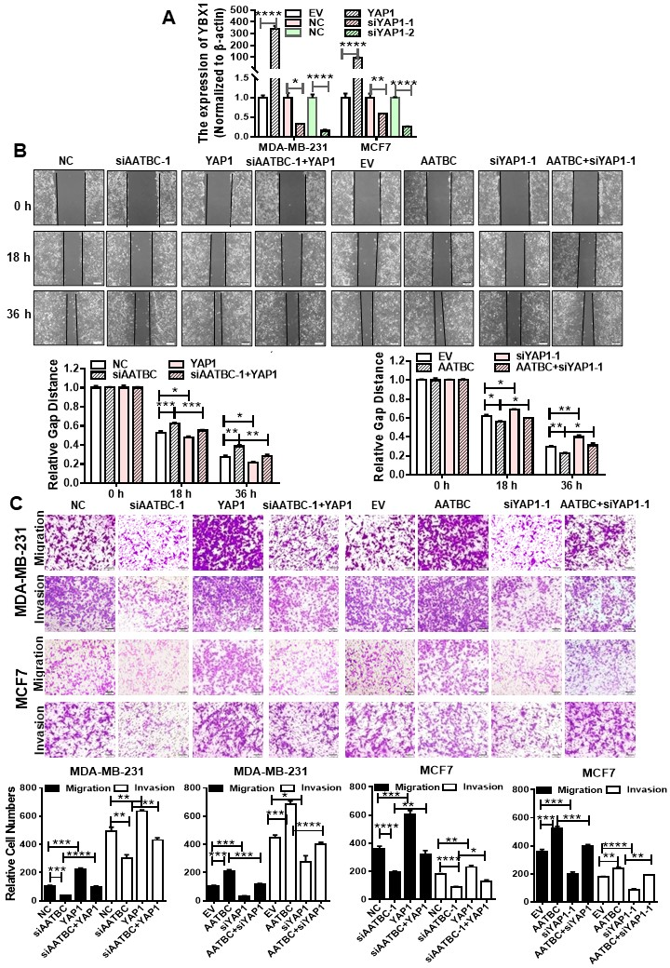
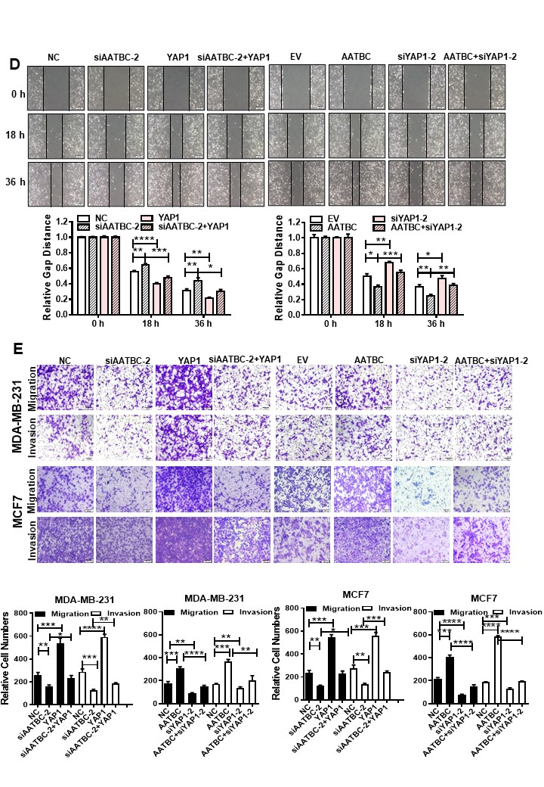
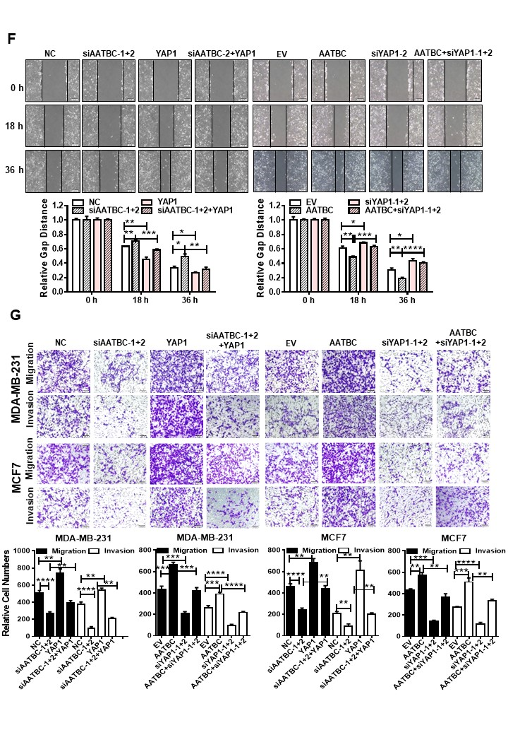
Fig. S5. YAP1 rescued the function of AATBC on breast cancer migration and invasion in MDA-MB-231 cells
a Real-time PCR confirmed the efficiency of YAP1 overexpression and siRNA knockdown in MDA-MB-231 and MCF7 cells. b.d.f Wound healing assays were performed in MDA-MB-231 cells after transfection. c.e.g Transwell assays with Matrigel were performed in MDA-MB-231 cells after transfection. Scale bars = 100 μm. *, p < 0.05; **, p < 0.01; ***, p < 0.001. AATBC, the AATBC overexpression vector; EV, the empty vector; NC, negative control siRNA; siAATBC-1, AATBC siRNA-1; siYAP1-1, YAP1 siRNA-1; siYAP1-2, YAP1 siRNA-2;YAP1, the YAP1 overexpression vector.
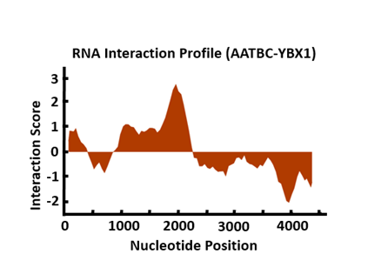
Fig. S6. YBX1 was predicted to bind with AATBC using the catRAPID software

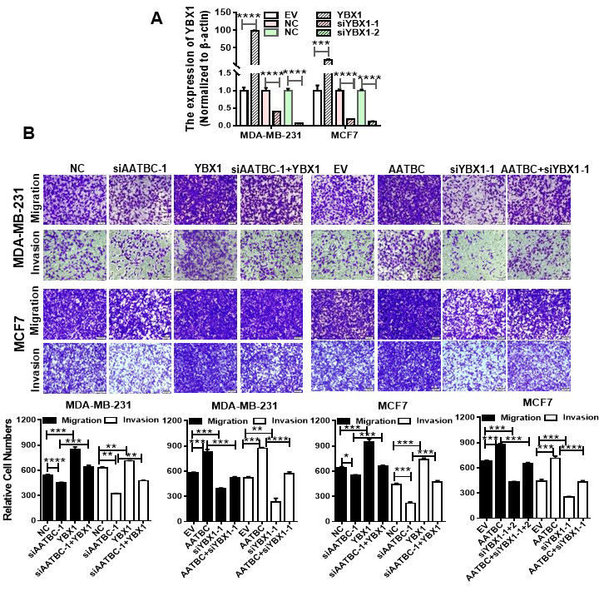
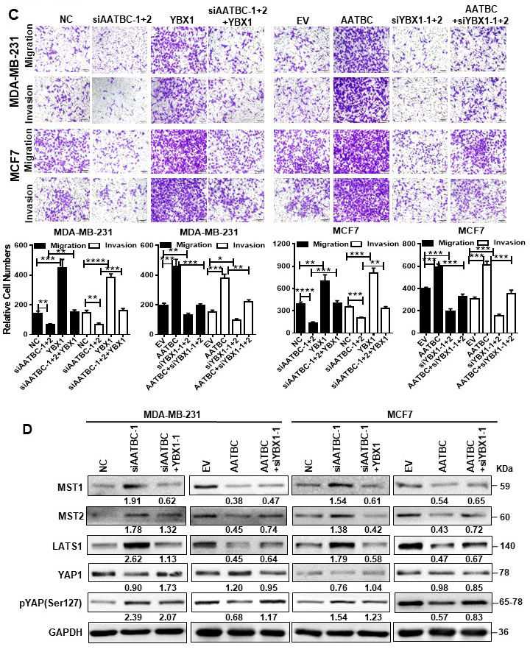
Fig. S7. YBX1 accelerated the AATBC-induced migration and invasion of breast cancer cells
a Real-time PCR confirmed the efficiency of YBX1 overexpression and two siRNAs knockdown in MDA-MB-231 and MCF7 cells. b-c Transwell assay with or without Matrigel demonstrated YBX1 accelerated AATBC-induced migration and invasion of MDA-MB-231 and MCF7 cells. The data are represented as the means ± SEM; Scale bars = 100 μm. *, p < 0.05; **, p < 0.01; ***, p < 0.001.d Western blot analysis was used to determine if YBX1 participates in the regulation of AATBC with respect to activation of the YAP1/Hippo pathway in MDA-MB-231 and MCF7 cells through overexpresion or knockdown of AATBC or YBX1.
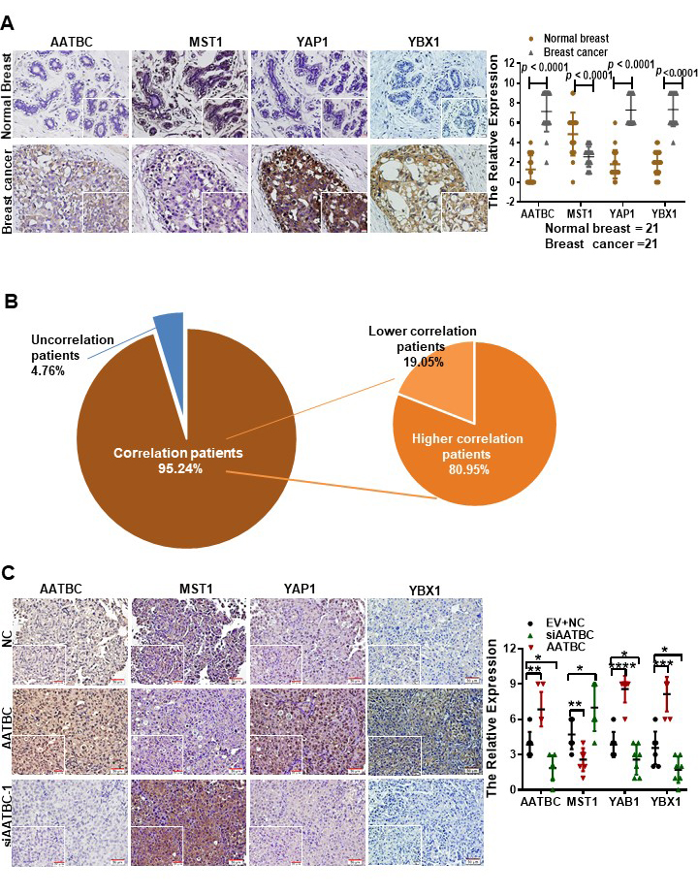
Fig. S8. The expression of AATBC, YAP1, MST1, and YBX1 in clinical samples and nude mice lung tissues
a The expression of YAP1, MST1, and YBX1 was measured by immunohistochemistry and the expression of AATBC was measured by in situ hybridization in 21 pairs of breast cancer tissues. The statistics are shown on the right. b Correlation analysis of AATBC, YBX1, YAP1, and MST1 expression in each patient. c The expression of YAP1, MST1, and YBX1 was measured by immunohistochemistry and the expression of AATBC was measured by in situ hybridization in the nude mice lung tissues. The statistics are shown on the right.

