Mowing inhibits the invasion of the alien species Solidago altissima and is an effective management strategy

Fig. S1. Example of quadrats with various treatments. Control: unmowed; Mowing 1: mowed once in July; Mowing 2: mowed twice in May and September; Mowing 3: mowed three times in May, July, and September; Eco 200: mowed 30% of shoots and treated by Eco 200 in May, July, and September.

Fig. S2. Coverage of S. altissima under various treatments. Bars represent the means ± standard errors of 14 replicates. Mowing 1: mowed once in July; Mowing 2: mowed twice in May and September; Mowing 3: mowed three times in May, July, and September.

Fig. S3. Change in the importance value of S. altissima in the dominated sites after 1 year of mowing treatment.

a
b
c
d
Control
Mowing 3
Eco 20 %
Eco 100 %

Fig. S4. Effects of control practices on flowering rates of S. altissima in patch type communities in October 2019. Mowing 3: mowed three times in May, July, and September; Eco 20%: 20% of shoots were mowed and treated with Eco 200; Eco 100%: 100% of shoots were mowed and treated with Eco 200. Data are presented as means ± standard errors of six replicates. Bars with different letters are significantly different at p < 0.05 (ANOVA with post hoc Tukey’s test).

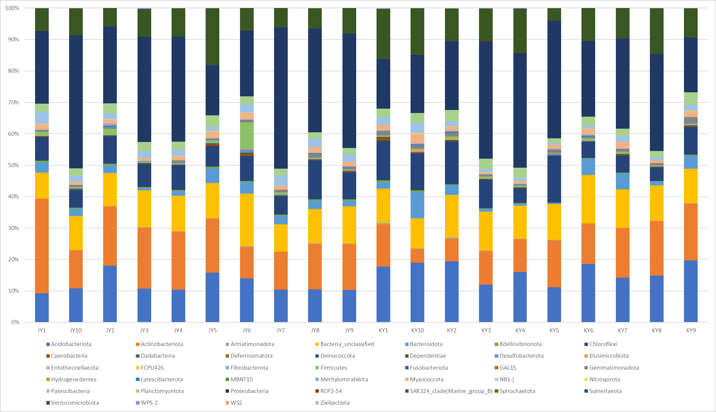
Fig. S5. Relative abundance of the bacterial community in the soil of two different countries. KY: S. altissima from Korea, JY: S.altissima from Japan.

Relative microbial community frequency of two countries (Jeju, Korea and Shiga, Japan) are analyzed in phylum level. In Jeju island, Proteobacteria was most dominant with average value of 26.82%. Then followed by Acidobacteriota (average 16.25%) and Actinobacteriota (average 12.51%). In Shiga prefecture, Proteobacteria (average 30.79%) was also most dominant followed by Actinobacteriota (average 16.75%) and Acidobacteriota (average 12%) (Figure S5). Therefore, microbial community between two regions was similar. Also in cluster tree showing Bray-Curtis similarity, microbial communities of Jeju, Korea and Shiga, Japan did not cluster by region (country) but showed similarity (Figure S6). When the genetic structures of microbial communities of two countries are compared, AMOVA (Fs = 2.291, P-value = 0.019) shows significant differences between countries. ANOSIM (R-value = 0.159, P-value = 0.028) also shows significant differences between countries, but as R-value is close to ) that the difference is not critical. HOMOVA (B-value = 0.0012, P-value = 0.882) results show that there are no significant genetic differences between countries. These results show that even there are some genetic structure differences, microbial communities between Jeju, Korea and Shiga, Japan are not significant. Therefore, microbial communities would not be the factor that makes invasion and population differences of S. altissima between Jeju, Korea and Shiga, Japan.

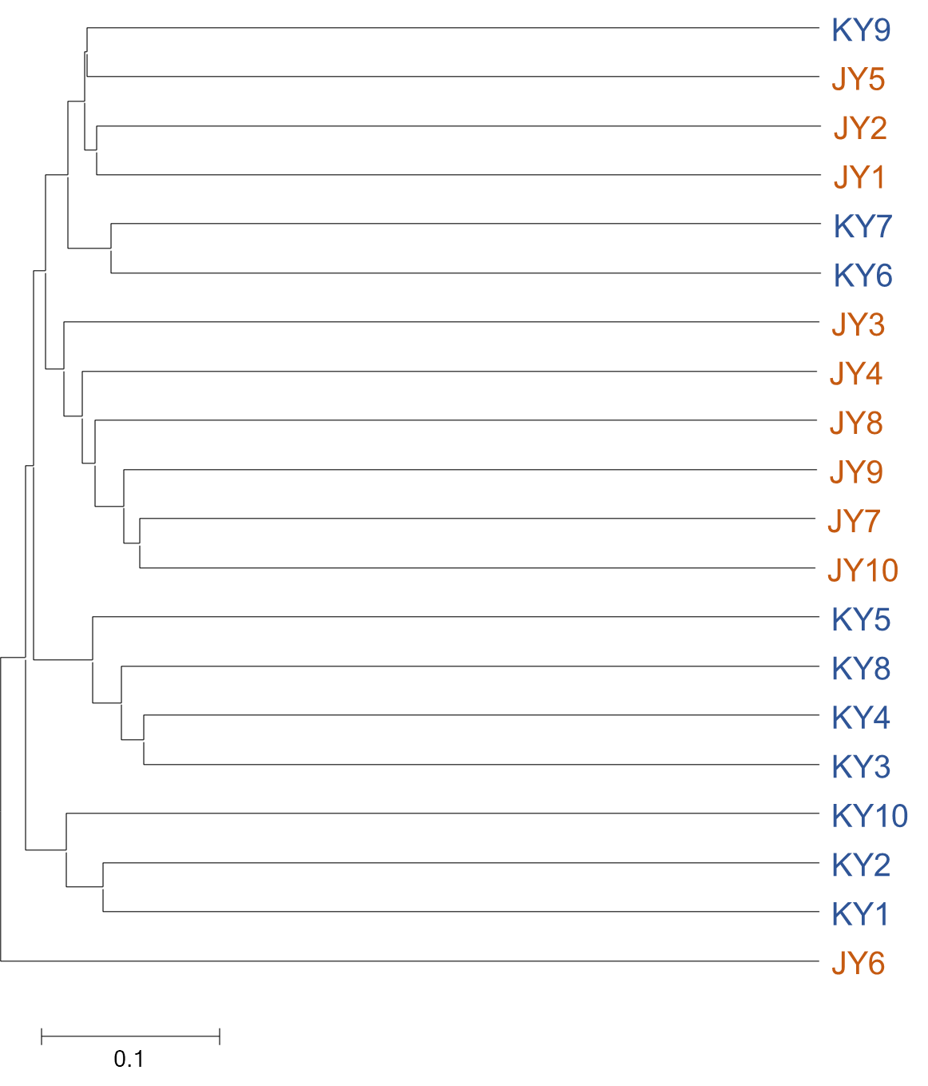
Fig. S6. Bray-Curtis clustering tree of the soil bacterial communities from the soil of two different countries. KY: S. altissima from Korea, JY: S.altissima from Japan.

Table S1. List of experimental sites
Site | Longitude | Latitude | Altitude | S. altissima distribution
1 | 126° 33′ 5″ | 33° 27′ 22″ | 283 m | D, ND
2 | 126° 33′ 11″ | 33° 27′ 25″ | 282 m | D, ND
3 | 126° 31′ 16″ | 33° 27′ 47″ | 203 m | D, ND
4 | 126° 31′ 36″ | 33° 27′ 39″ | 212 m | D, ND
5 | 126° 31′ 35″ | 33° 27′ 38″ | 215 m | D, ND
6 | 126° 31′ 40″ | 33° 27′ 40″ | 212 m | D, ND
7 | 126° 31′ 40″ | 33° 27′ 40″ | 212 m | D, ND
8 | 126° 30′ 47″ | 33° 27′ 52″ | 198 m | P
9 | 126° 33′ 1″ | 33° 27′ 33″ | 283 m | P
10 | 126° 33′ 30″ | 33° 26′ 55″ | 350 m | P
D: Dominance; ND: Non-dominance; P: Patch.

Table S2. Vegetation of areas dominated by S. altissima in July 2018
Family | Species | S. altissima dominant area |  | S. altissima uninvaded area | Origin
Family | Species | 2018 | 2019 | 2018 | Origin
Compositae | Solidago altissima L. | O | O | O | E
 | Ainsliaea acerifolia Sch. Bip. |  |  | O
 | Artemisia feddei H.Lev. |  |  | O | N
 | Artemisia lavandulaefolia DC. | O | O | O | N
 | Artemisia princeps var. orientalis (Pamp.) Hara | O | O | O | N
 | Aster tataricus L.f. |  |  | O | N
 | Bidens frondosa L. |  |  | O | E
 | Centipeda minima L. |  |  | O | N
 | Cirsium japonicum var. ussuriense Kitamura |  | O |  | N
 | Coreopsis drummondii L. |  |  | O | E
 | Coreopsis lanceolata L. | O | O |  | E
 | Crepidiastrum sonchifolium (Bunge) Pak & Kawano | O |  |  | N
 | Erigeron annuus (L.) Pers. | O | O | O | E
 | Erigeron canadensis L. | O | O | O | E
 | Helianthus tuberosus L. |  |  | O | E
 | Hypochaeris radicata L. | O | O | O | E
 | Lactuca indica L. | O | O | O | N
 | Parasenecio auriculata var. matsumurana Nakai | O |  |  | N
 | Rudbeckia bicolor Nutt. |  |  | O | N
 | Sonchus oleraceus L. |  |  | O | N
 | Taraxacum officinale Weber |  | O | O | E
Acanthaceae | Justicia procumbens L. |  |  | O | N
Actinidiaceae | Actinidia arguta Planch. |  | O |  | N
Amaranthaceae | Achyranthes japonica (Miq.) Nakai | O |  |  | N
Apocynaceae | Trachelospermum asiaticum Nakai |  | O | O | N
Araliaceae | Aralia elata (Miq.) Seem. | O |  |  | N
Asclepiadaceae | Metaplexis japonica (Thunb.) Makino | O |  | O | N
Aspleniaceae | Pteridium aquilinum var. latiusculum (Desv.) Underw. | O | O |  | N
Cannabaceae | Humulus japonicus Sieboid & Zucc. | O | O | O | N
Chenopodiaceae | Chenopodium album var. centrorubrum |  |  | O | N
Commelinaceae | Commelina communis L. | O | O | O | N
Convolvulaceae | Ipomoea batatas (L.) Lam. |  |  | O | N
Cucurbitaceae | Trichosanthes kirilowii Maxim. | O | O | O | N
Cyperaceae | Carex lanceolata Boott | O | O |  | N
Geraniaceae | Geranium sibiricum L. | O |  | O | N
Gramineae | Agropyron tsukushiense var. transiens (Hack.) Ohwi |  | O | O | N
 | Briza minor L. | O | O | O | E
 | Bromus unioloides H.B. & K. | O |  | O | E
 | Eleusine indica (L.) Gaertn. |  | O |  | N
 | Festuca arundinacea Schreb. | O |  |  | E
 | Miscanthus sinensis var. purpurascens Rendle | O | O | O | N
 | Phragmites communis Trin. | O |  |  | N
 | Setaria viridis (L.) Beauv. | O |  | O | N
Guttiferae | Hypericum erectum Thunb. |  |  | O | N
Euphorbiaceae | Acalypha australis L. |  |  | O | N
Labiatae | Nepeta cataria L. | O |  |  | N
Liliaceae | Smilax china L. |  |  | O | N
Leguminosae | Amphicarpaea trisperma (Miq.) Baker |  | O |  | N
 | Chamaecrista nomame (Siebold) H.Ohashi |  |  | O | N
 | Glycine soja Siebold & Zucc. |  |  | O | N
 | Lespedeza cuneata G.Don | O | O | O | N
 | Pueraria thunbergiana Bentham | O | O | O | N
 | Trifolium repens L |  |  | O | E
Onagraceae | Oenothera biennis L. |  |  | O | E
Osmundaceae | Osmunda japonica Thunb. | O |  |  | N
Oxalidaceae | Oxalis corniculata L. |  |  | O | N
Phytolaccaceae | Phytolacca americana L. | O | O | O | E
Pinaceae | Pinus densiflora Siebold & Zucc. |  | O |  | N
Plantaginaceae | Plantago asiatica L. | O |  | O | N
Polygonaceae | Persicaria hydropiper (L.) Spach | O |  | O | N
 | Persicaria perfoliata Gross | O |  | O | N
 | Persicaria senticosa Nakai |  | O |  | N
 | Rumex crispus L. | O | O | O | E
 | Duchesnea indica (Andr.) Focke |  |  | O | N
 | Rosa multiflora Thunb. | O |  |  | N
 | Rubus hirsutus Thunb. | O |  |  | N
 | Rubus crataegifolius Bunge | O |  | O | N
 | Rubus phoenicolasius Maxim. |  |  | O | N
Ranunculaceae | Clematis apiifolia DC. | O | O | O | N
Rubiaceae | Paederia scandens (Lour.) Merr. var. scandens | O | O |  | N
 | Galium spurium L. | O |  |  | N
Saxifragaceae | Hydrangea macrophylla (Thunb.) Ser. | O | O |  | N
Solanaceae | Solanum nigrum L. |  |  | O | E
Violaceae | Viola mandshurica W.Becker |  |  |  | O
Umbelliferae | Angelica dahurica Benth. |  | O |  | N
 | Hydrocotyle sibthorpioides Lam. | O |  |  | N
Urticaceae | Boehmeria nivea (L.) Gaudich. | O | O | O | N
*Life form A: annual; B: biannual; P: perennial. *Origin E: Exotic; N: Native.

Table S3. Importance values of plant species in areas dominated by S. altissima in July 2018
Rank | Plant species | Importance value
1 | Solidago altissima L. | 0.409
2 | Pueraria thunbergiana Bentham | 0.141
3 | Artemisia princeps var. orientalis (Pamp.) Hara | 0.087
4 | Metaplexis japonica (Thunb.) Makino | 0.032
5 | Rubus hirsutus Thunb. | 0.028
6 | Pteridium aquilinum var. latiusculum (Desv.) Underw. | 0.024
7 | Rumex crispus L. | 0.022
8 | Lactuca indica L. | 0.021
9 | Miscanthus sinensis var. purpurascens Rendle | 0.021
10 | Paederia scandens (Lour.) Merr. var. scandens | 0.019

Table S4. Importance values of plant species in areas not dominated by S. altissima in July 2018
Rank | Plant species | Importance value
1 | Glycine soja Siebold & Zucc. | 0.166
2 | Pueraria thunbergiana Bentham | 0.158
3 | Erigeron canadensis L. | 0.154
4 | Artemisia princeps var. orientalis (Pamp.) Hara | 0.137
5 | Humulus japonicus Sieboid & Zucc. | 0.130
6 | Solidago altissima L. | 0.104
7 | Hypochaeris radicata L. | 0.103
8 | Erigeron annuus (L.) Pers. | 0.099
9 | Lespedeza cuneata G.Don | 0.061
10 | Setaria viridis (L.) Beauv. | 0.055

Table S5. Comparison of importance values of S. altissima in 2018 and 2019
Year / Site | Site 1 | Site 2 | Site 3 | Site 4 | Site 5 | Site 6 | Site 7
2018 | 0.371 | 0.359 | 0.571 | 0.479 | 0.339 | 0.446 | 0.329
2019 | 0.241 | 0.245 | 0.415 | 0.334 | 0.32 | 0.358 | 0.326

Table S6. Heights of S. altissima shoots 2 months after the first treatment (mowing or Eco 200) in July 2018
Site | Control | Mowing | Eco 200
Site 1 | 102.1 ± 3.2^{b} | 96.9 ± 4.8^{b} | 118.7 ± 5.6ª
Site 2 | 156.9 ± 5.5ª | 99.0 ± 2.2^{b} | 148.0 ± 5.2ª
Site 3 | 129.1 ± 4.9ª | 70.8 ± 2.6^{c} | 106.3 ± 6.4^{b}
Site 4 | 119.5 ± 3.1^{b} | 81.0 ± 1.4^{c} | 129.5 ± 2.1ª
Site 5 | 187.5 ± 5.1ª | 83.5 ± 3.2^{c} | 164.3 ± 5.4^{b}
Site 6 | 183.3 ± 6.2ª | 68.5 ± 2.2^{c} | 119.8 ± 4.0^{b}
Site 7 | 158.5 ± 10.4ª | 74.0 ± 1.7^{c} | 140.5 ± 2.9^{b}
Data are presented as means ± standard errors of 20 replicates. Means within a column followed by different letters are significantly different at p < 0.05. Unit: cm.

Table S7. Heights of S. altissima before mowing treatments in July 2019
Site | Control | Mowing 1 | Mowing 2 | Mowing 3
Site 1 | 128.8 ± 17.52^{b} | 160.4 ± 8.18ª | 65.6 ± 3.64^{c} | 60.3 ± 4.7^{c}
Site 2 | 142.4 ± 11.34^{b} | 170.7 ± 5.24ª | 70.0 ± 6.01^{c} | 119.0 ± 10.86^{b}
Site 3 | 120.3 ± 2.16ª | 111.1 ± 4.31^{b} | 51.7 ± 3.41^{c} | 44.0 ± 1.99^{c}
Site 4 | 154.9 ± 8.60ª | 157.8 ± 6.67ª | 74.9 ± 10.6^{b} | 78.1 ± 2.01^{b}
Site 5 | 185.3 ± 7.21ª | 153.4 ± 9.18^{b} | 81.6 ± 6.82^{c} | 72.2 ± 8.07^{c}
Site 6 | 130.6 ± 8.48ª | 128.9 ± 4.98ª | 80.5 ± 3.24^{b} | 71.6 ± 1.55^{b}
Site 7 | 120.1 ± 6.0ª | 99.6 ± 10.93^{b} | 89.1 ± 4.62^{b} | 64.6 ± 2.84^{c}
Data are presented as means ± standard errors of 10 replicates. Means within a column followed by different letters are significantly different at p < 0.05. Unit: cm.

Table S8. Number of leaves of S. altissima in September 2019
Site | Control | Mowing 1 | Mowing 2 | Mowing 3
Site 1 | 115.7 ± 6.61ª | 45.9 ± 5.2^{bc} | 60.3 ± 5.28^{b} | 37.4 ± 5.38^{c}
Site 2 | 96.7 ± 12.37ª | 36.7 ± 3.35^{c} | 64.5 ± 3.91^{b} | 36.1 ± 5.25^{c}
Site 3 | 78.1 ± 6.64ª | 67.7 ± 7.22^{ab} | 55.5 ± 7.83^{b} | 36.3 ± 2.29^{c}
Site 4 | 81.3 ± 7.32ª | 46.7 ± 3.38^{b} | 57.7 ± 4.79^{b} | 54.0 ± 3.93^{b}
Site 5 | 109.8 ± 4.86ª | 49.7 ± 6.09^{bc} | 57.4 ± 2.62^{b} | 37.9 ± 2.68^{c}
Site 6 | 60.5 ± 3.93ª | 41.7 ± 3.23^{b} | 57.9 ± 3.97ª | 33.7 ± 3.54^{b}
Site 7 | 71.0 ± 4.64ª | 34.9 ± 3.48^{b} | 69.0 ± 3.99ª | 37.7 ± 1.81^{b}
Data are presented as means ± standard errors of ten replicates. Means within a column followed by different letters are significantly different at p < 0.05.

Table S9. Germination rates (%) of L. sativa and O. biennis after treatment with S. altissima extracts
L. sativa |  |  |  |  | O. biennis
 | 3 days | 6 days | 9 days | 12 days | 3 days | 6 days | 9 days | 12 days
Control | 32.9 ± 6.8 | 44.3 ± 7.8 | 44.3 ± 7.8 | 44.3 ± 7.8 | 0 ± 0 | 45.7 ± 5.7 | 54.3 ± 6.9 | 65.7 ± 9.7
20% | 0 ± 0 | 0 ± 0 | 0 ± 0 | 8.6 ± 4.6 | 0 ± 0 | 0 ± 0 | 0 ± 0 | 17.1 ± 9.4
50% | 0 ± 0 | 0 ± 0 | 0 ± 0 | 0 ± 0 | 0 ± 0 | 0 ± 0 | 0 ± 0 | 1.4 ± 1.4
Data are presented as means ± standard errors of seven replicates.

Table S10. Effect of S. altissima extract on root elongation of L. sativa and O. biennis
L. sativa |  |  |  |  | O. biennis
 | 3 days | 6 days | 9 days | 12 days | 3 days | 6 days | 9 days | 12 days
Control | 2.9 ± 0.2ª | 8.6 ± 0.2ª | 8.9 ± 0.4ª | 10.5 ± 0.8ª | 0 ± 0ª | 1.3 ± 0.05ª | 4.4 ± 0.5ª | 5.2 ± 0.2ª
20% | 0 ± 0^{b} | 0 ± 0^{b} | 0 ± 0^{b} | 0.8 ± 0.4^{b} | 0 ± 0ª | 0 ± 0^{b} | 0 ± 0^{b} | 0 ± 0^{b}
50% | 0 ± 0^{b} | 0 ± 0^{b} | 0 ± 0^{b} | 0 ± 0^{b} | 0 ± 0ª | 0 ± 0^{b} | 0 ± 0^{b} | 0 ± 0^{b}
Data are presented as means ± standard errors of five replicates. Means within a column followed by different letters are significantly different at p < 0.05.

