Note S1
Former studies quantified rice chilling injury based on the standard (QX/T 182–2013) issued by the Chinese Meteorological Administration. (Ma et al., 2013). The standard defines rice chilling injury by the number of days subject to low temperature in two sensitive periods (Table S2). Following Liu, (Liu et al., 2013), we assigned weights of 0.5, 1, and 2 to mild, medium, and severe chilling injury (Equation S1) and used it to represent the index for chilling injury during the reproductive phase.
$$Iz=0.5fm_{i}+fmo+2fSe$$ | (Eq. S1)
where $fm_{i}$, $fmo$ and $fSe$ represent the frequency of mild, medium and severe sterile-type chilling in a certain month, respectively.
Our regression results (Table S4) indicate that the index based on the number of days below the lowest temperature threshold returns a negative regression coefficient, which is similar to the results in the main paper. However, when we project the regression results on historical climate trends, no clear time trend is presented (Figure S1). Compared with the results in the main paper, the index for calculating the cumulative temperature shows a clear increasing trend. This suggests that the calculation of temperature summation and counting only day numbers matter and project different results.

Note S2
Based on the climate variables in the main text, we considered moisture-related parameters in the model, including saturation vapour pressure (VP) (Equation S2-3), precipitation (PRE), and humidity index (H) (Equation S4-5). The detailed calculations are as follows. Our regression results (Table S3) indicate that these moisture-related parameters had a statistically insignificant effect.
For VP (kPa), we calculated based on the method of the Food and Agriculture Organization, United Nations (FAO) (Allen et al., 1998).
$$e^{o}\left(T\right)=0.6108\exp\left(\frac{17.27*T}{T+237.3}\right)$$ | (Eq. S2)
$$e_{s}=\frac{e^{o}\left(T_{max}\right)+{\left(e\right)}^{o}\left(T_{min}\right)}{2}$$ | (Eq. S3)
where T is the air temperature (°C),$T_{max} and T_{min}$ which are the daily maximum and minimum temperatures, respectively.$e^{o}$ is the saturation vapour pressure at the air temperature T.${ e}_{s}$is the mean saturation vapour pressure.
For precipitation (PRE; (mm)), we calculated the total precipitation at each observation site from 1 May to 30 September.
For the crop reference evapotranspiration, we used the Penman–Monteith formula recommended by the FAO (Allen et al., 1998):
$ET_{0}=\frac{0.408Δ(R_{n}-G)+γ\frac{900}{\overline{T}+273}U_{2}⋅(e_{s}-e_{a})}{Δ+γ(1+0.34U_{2})}$ | (Eq. S4)
where $ET_{0}$ is the reference evapotranspiration (mm·d−1); $R_{n}$ is the net radiation reaching the crop surface (MJ·m−2·d−1); $G$ is the soil heat flux density (MJ·m−2·d−1); $\overline{T}$ is the daily average temperature (℃); $U_{2}$ is the average daily wind speed at 2 m height (m·s−1); $e_{s}$ is the saturated water vapour pressure (kPa); $e_{a}$ is the actual water vapour pressure (kPa); $Δ$ is the slope of the relationship curve between saturated water vapour pressure and daily average temperature (kPa·℃−1); and $γ$ is the dry and wet metre constant (kPa·℃−1).
We use the ratio of annual precipitation to reference evaporation to express the humidity index (H).
$$H=PRE/ET_{0}$$ | (Eq. S5)

Note S3
For possible multicollinearity in the regression model, we use the variance inflation factor (VIF) to measure the severity of collinearity (Draper and Smith, 2014). The results show that the value of VIF is less than 5, and the colinearity between GDD, HDD and CDD can be ignored (Table S1) (Chatterjee and Simonoff, 2013).

Table S1. Variance inflation factor of climate variables in multiple regression models

Climate variable | VIF
GDD | 4.140396
HDD | 1.588546
CDD | 3.358468

Table S2. Chilling temperature injury indexes in Northeast China were determined by the China Meteorological Administration.

CMA | Chilling grades |  | Mild | Medium | Severe
CMA | 20 days before booting stage to booting | Number of sequential days for Tmin ≤ 17 ℃ | 2d | 3d | ≥4d
CMA | 20 days before booting stage to booting | Number of sequential days for Tmin ≤ 16 ℃ | - | 2d | ≥3d
CMA | heading-flowing stage | Number of sequential days for Tmin ≤ 19℃ | 3d | 4d | ≥5d
CMA | heading-flowing stage | Number of sequential days for Tmin ≤ 18℃ | - | 3d | ≥4d
CMA | heading-flowing stage | Number of sequential days for Tmin ≤ 17℃ | - | - | ≥3d

Table S3. Regression coefficients of the panel model. Impacts of climate variables on rice yield (%). The results presented in the columns are based on all climate variables. Significance test results are shown behind the numbers. * p < 0.05 ** p < 0.01, *** p < 0.001.
Climate variable | Formula (1) | Formula (2) | Formula (3)
GDD | 0.000264***  (0.0000873) | 0.0003084***  (0.00008635) | 0.000267***  (0.0000881)
HDD | -0.00314*  (0.00133) | 0.003104*  (0.001239) | 0.00326*  (0.00124)
CDD | -0.00356***  (0.000343) | 0.00372***  (0.0003402) | 0.00355***  (0.000341)
RAD | 0.00381***  (0.000876) | 0.002505***  (0.0009129) | 0.00393***  (0.000868)
RAD² | -0.000000714***  (0.000000167) | 0.0000007486***  (0.0000001742) | 0.000000740***  (0.000000167)
VP | 0.474  (0.585)
PRE |  | 0.0005303  (0.0002073)
H |  |  | 0.000258  (0.000321)
Table S4. Regression coefficients of the panel model. Impacts of climate variables on rice yield (%). The results presented in the columns are based on the climate variables replaced from CDD to IZ. Significance test results are shown behind the numbers. * p < 0.05 ** p < 0.01, *** p < 0.001.
Climate variable | Estimate | Std. Error | t value | Pr (>|t|)
GDD | 0.0005476 | 0.00008334 | 6.571 | 5.43e-11***
HDD | -0.003205 | 0.001218 | -2.631 | 0.008539**
IZ | -0.008415 | 0.002053 | -4.099 | 4.20e-05***
RAD | 0.004942 | 0.004942 | 5.771 | 8.25e-09***
RAD² | -0.0000009218 | 0.0000001631 | -5.653 | 1.65e-08 ***

Table S5. Regression coefficients of the panel model. Impacts of climate variables on rice yield (%). The results presented in the columns are based on all climate variables (calendar period forward and setback 5 days). Significance test results are shown behind the numbers. * p < 0.05 ** p < 0.01, *** p < 0.001
Climate variable | (1) Forward 5 days | (2) Setback 5 days
GDD | 0.0003045***  (0.00008211) | 0.0003097***  (0.00009218)
HDD | -0.02765*  (0.001193) | -0.02976*  (0.001234)
CDD | -0.003795***  (0.0003413) | -0.00385**  (0.000329)
RAD | 0.003818***  (0.0008533) | 0.004278***  (0.0008565)
RAD² | -0.0000007169***  (0.0000001624) | -0.0000007964***  (0.0000001631)

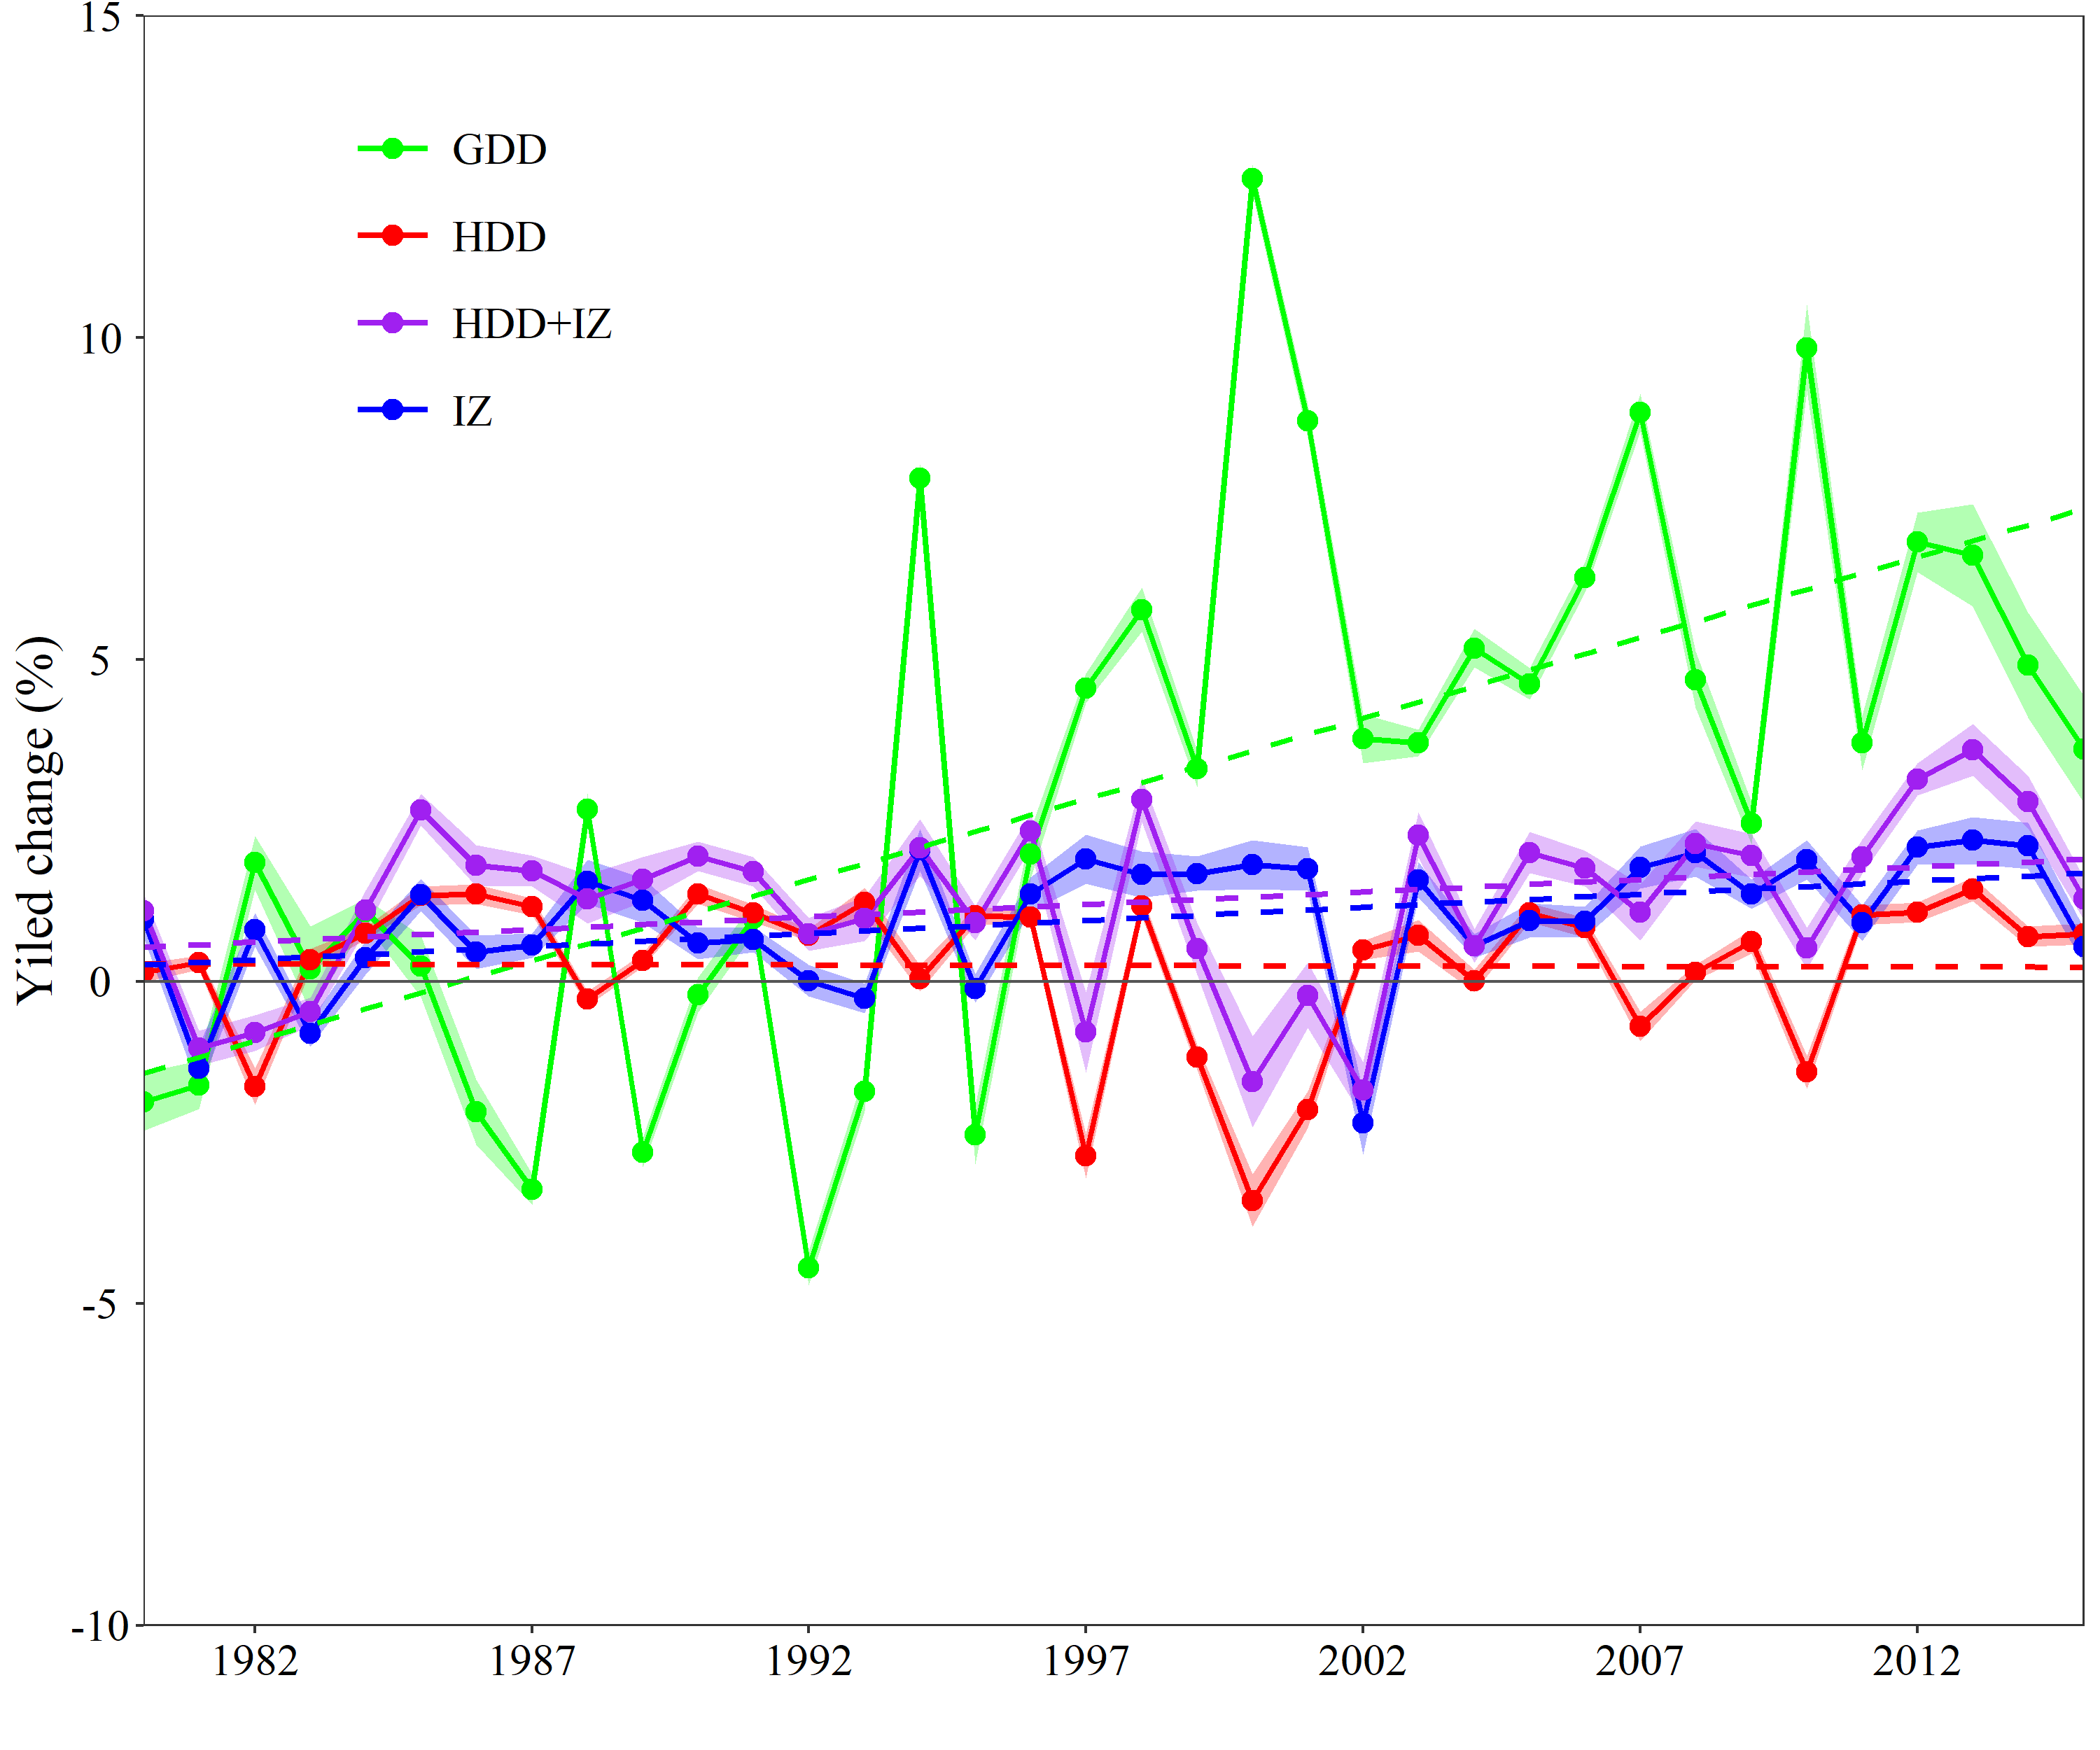
Fig. S1. Projected yield change induced by climate variables relative to the period of 1980-1984. Shaded areas show a 95% confidence interval based on bootstrapping methods.

