Electronic Supporting Information
for
Hollow and Oval-Configured Ultrafine Co₃O₄ as a Highly-Efficient Activator of Monopersulfate for Catalytic Elimination of Azorubin S

Text S1.
  - Materials
All chemical reagents employed in this study were commercially-purchased from commercial suppliers and used directly without any purifications. Cobalt nitrate (Co(NO₃)₂) (>98%) was acquired from Showa Chemicals, Japan. 2-methylimidazole (C₄H₆N₂) (2-MIM) (99%) was obtained from ACROS Organics, Belgium. Oxone (monopersulfate compound) (KHSO₅.0.5KHSO₄.0.5K₂SO₄), azorubin S (ARS) (C₂₀H₁₁N₂Na₃O₁₀S₃), tannimum (C₇₆H₅₂O₄₆), methyl alcohol (99.9%), ethyl alcohol (>99.8%), tert-butyl alcohol (>99.5%), sodium chloride (NaCl) (>99%), cetyltrimethylammonium bromide (CTAB) (>98%), and sodium dodecyl sulfate (SDS) (>99%) were purchased from Sigma-Aldrich, USA. Deionized water was prepared up to less than 18 MOhm-cm.
  - Synthesis of HOCO and characterizations
The synthesis procedure for preparing HOCO is depicted in Fig. 1(a). Initially, a Co-MOF with oval-like morphology was firstly prepared [27], followed by a modification step with tannimum via chemical-etching process before being calcined in air to obtain the final product. In a typical preparation, a solution containing 40 mL of Co(NO₃)₂ was slowly added into another solution bearing 40 mL of 2-MIM where the ratio of Co precursor to 2-MIM = 1:8 (in mole). The mixture was then stirred vigorously at ambient temperature for 4 h. Subsequently, the resultant purple-colored precipitate was assembled via centrifugation, rinsed by deionized water, and dried at 65 ºC overnight to afford oval-like Co-MOF. Next, a certain amount of the as-prepared oval-like Co-MOF (i.e., 200 mg) was then immersed into a solution containing 300 mL mixture of deionized water and ethyl alcohol (ratio = 1:1 in volume) and tannimum (1 mg/mL) for 10 min to complete the chemical-etching process [26]. The resulting product was then collected via centrifugation (8000 rpm), washed thoroughly by ethyl alcohol several times, and dried at 80 ºC in a vacuum oven to acquire hollow oval-like Co-MOF. Finally, this as-prepared hollow oval-like Co-MOF was calcined in air at 600 ºC for 4 h at a ramping rate of 2 ºC/min to afford hollow-structured oval-like Cobalt Oxide, abbreviated as HOCO.
For material characterizations, the appearance of all materials was determined using SEM and TEM (JEOL JSM-7800 F and JEM-1400, Japan). The elemental composition of HOCO was also analyzed using energy-dispersive X-ray spectroscopy (EDS) (Oxford Instruments, UK). Moreover, the crystalline structures of all as-prepared materials were characterized using an X-ray diffractometer (Bruker, USA). Besides, Raman spectroscopies of HOPO and commercial Co₃O₄ NP were verified using a Raman spectrometer (TII Nanofinder 30, Japan). The surface chemistry of HOCO was further examined using X-ray photoelectron spectroscopy (XPS) (ULVAC-PHI, PHI 5000, Japan). Additionally, the reducible behaviors of HOCO and commercial Co₃O₄ NP were further analyzed by H₂-temperature-programmed reduction (H₂-TPR) profiles using a chemisorption analyzer coupled with a TCD detector (Anton Paar, ASIQ TPx, Austria). Next, the BET surface area and pore volume of HOCO were determined by N₂ sorption isotherms using a volumetric analyzer (Anton Paar Autosorb IQ, Austria). The surface charges of HOCO were also verified using a zetasizer (Nano-ZS, Malvern Instruments Ltd, UK).
  - Degradation of ARS
The degradation of ARS using HOCO-activated MPS was conducted using batch-type experiments. Typically, a certain amount of HOCO (i.e., 100 mg/L) was firstly added into ARS solution with the initial concentration (C₀) of ARS was 50 mg/L for 30 min to verify the adsorption of ARS. Next, 100 mg/L of MPS was instantly introduced to the ARS solution to start the degradation experiment. At a certain reaction time (t), sample aliquots (3 mL) were taken out and filtered to separate HOCO from the ARS solution. The remaining ARS concentration in the filtrate at t min (C_{t}) was subsequently determined by UV-vis spectrophotometer with the absorption wavelength of 520 nm. For experimental sections, the effects of different parameters including different HOCO dosages, MPS dosages, various ARS concentrations, initial pH values, co-existing surfactants and salt, and inhibitors are investigated. Moreover, for comparison, commercial Co₃O₄ NP (size 50~80 nm) was also used for MPS activation. The reactive oxygen species (ROS) involving in the degradation of ARS by HOCO+MPS system were revealed by electron paramagnetic resonance (EPR) with a typical radical spin-trapping agent, namely 5,5-Dimethyl-1-pyrroline N-oxide (DMPO). The recyclability of HOCO for multiple ARS degradation cycles was also evaluated by re-using HOCO. Besides, the degradation intermediates produced from ARS degradation were further identified using a mass spectrometer (Thermo Finnigan Corporation, LCQ ion-trap mass spectrometer, USA).

Table S1. Textural properties of HOCO and commercial Co₃O4 NPs.
Materials | Specific surface area (m²/g) | Pore volume (cm³/g)
HOCO | 43.57 | 0.26
Commercial Co₃O₄ | 2.5 | 0.001

Table S2. A comparison of activation energy (E_{a}) values for ARS degradation using different catalytic systems.
Catalytic Systems | E_{a} (kJ/mol) | Reference
HOCO+MPS | 30.9 | This work
Fc+SPC | 70.4 | [1]
MIL-N+MPS+vis-light | 38.8 | [2]

Table S3. Detected by-products of ARS degradation by HOCO+MPS
 | Structure | Formula | m/z
M1 | 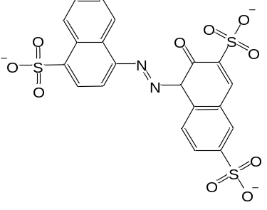 | C₂₀H₁₁N₂O₁₀S₃³⁻ | 178
M2 | 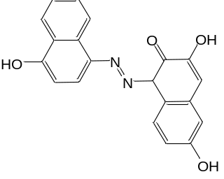 | C₂₀H₁₄N₂O₄ | 347
M3 | 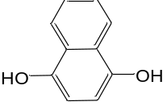 | C₁₀H₈O₂ | 160
M4 | 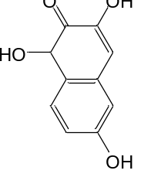 | C₁₀H₈O₄ | 192
M5 | 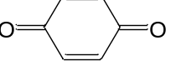 | C₆H₄O₂ | 108
M6 | 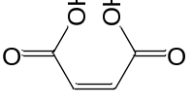 | C₄H₄O₄ | 116
M7 | 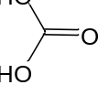 | CH₂O₃ | 62

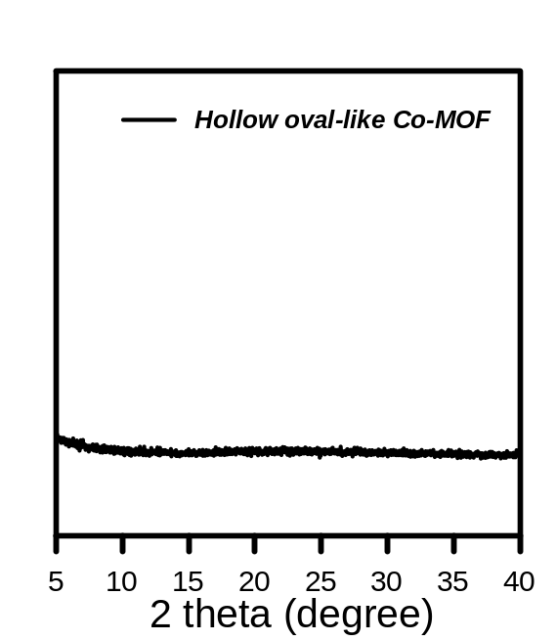
Fig. S1. XRD pattern of hollow oval-like Co-MOF after chemical etching process with tannium.

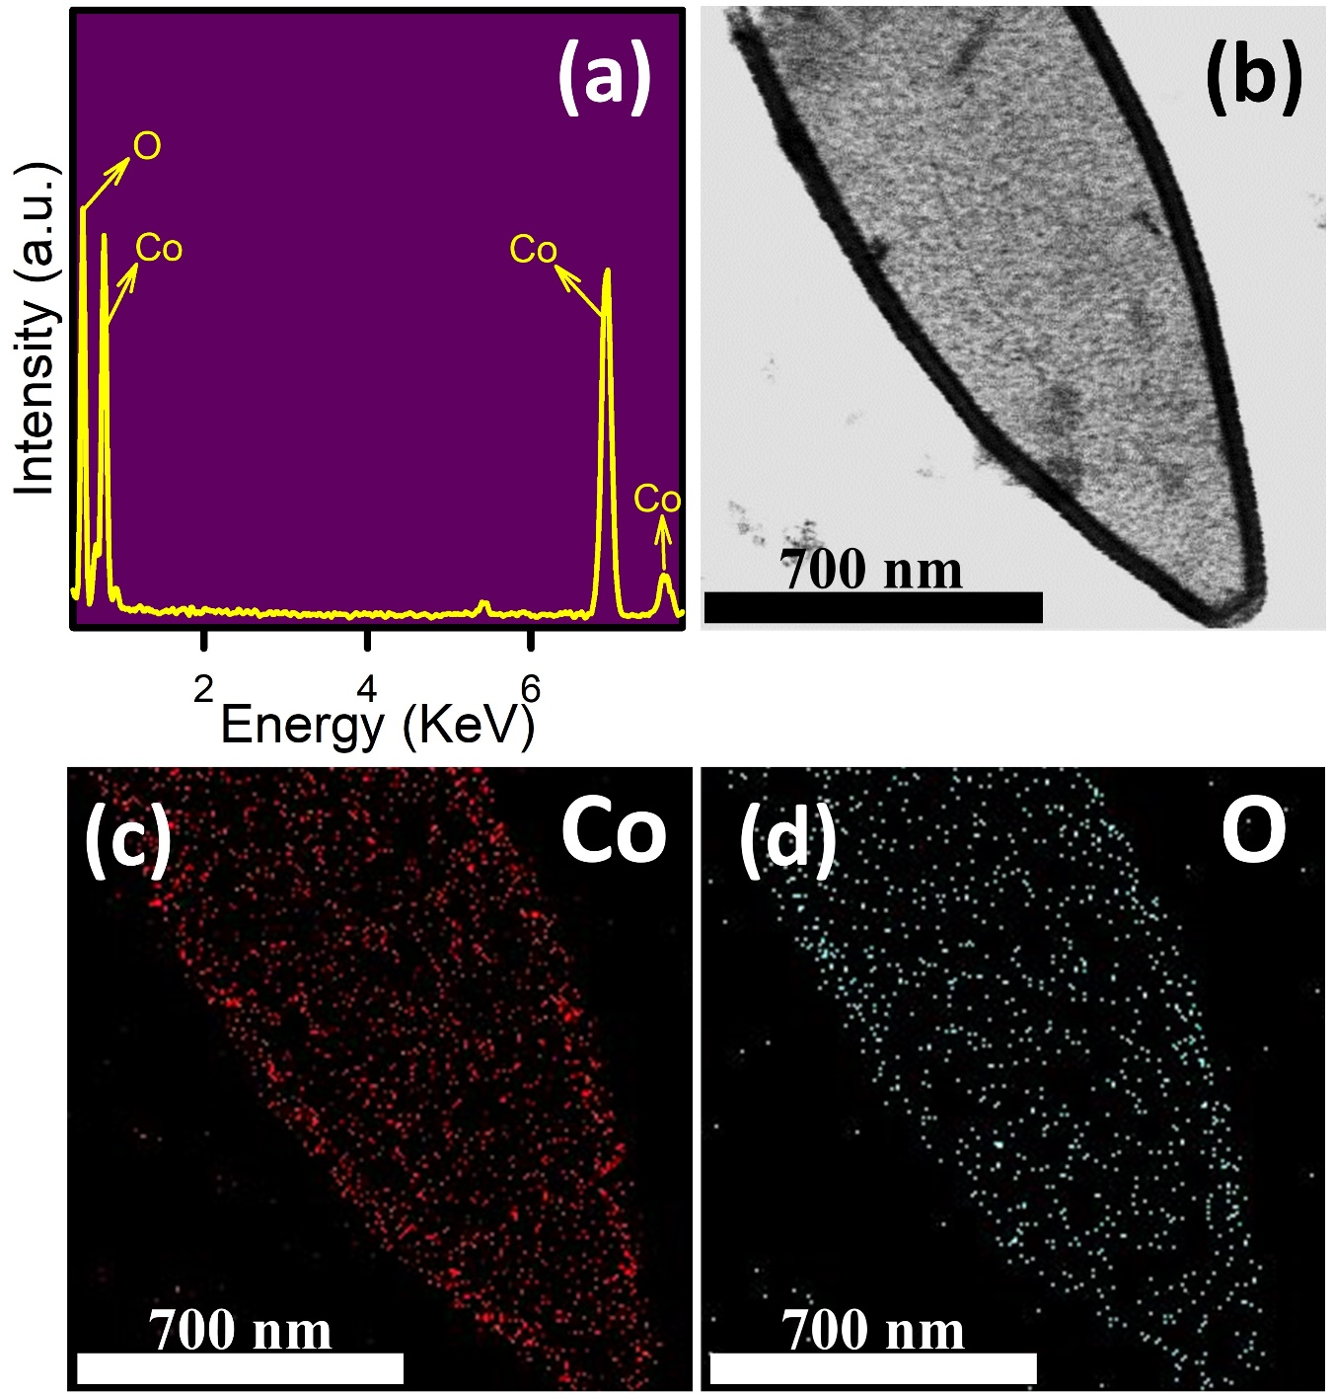
Fig. S2. (a) EDX analysis, (b-d) elemental mapping of HOCO.
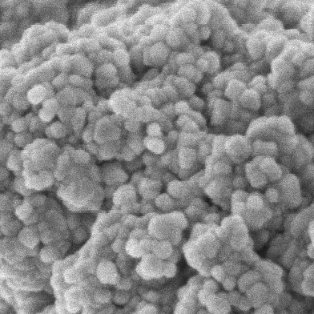
100 nm
Fig. S3. SEM image of commercial Co₃O₄ NP.

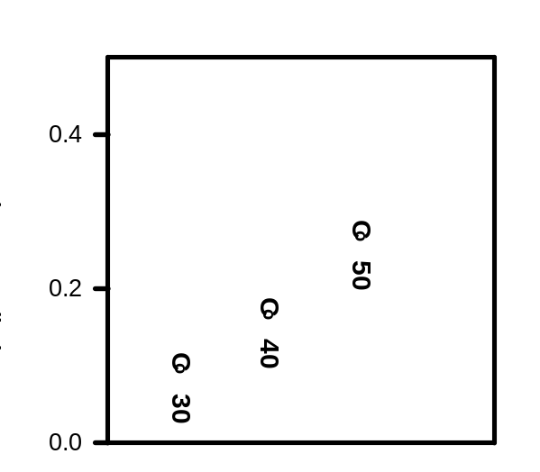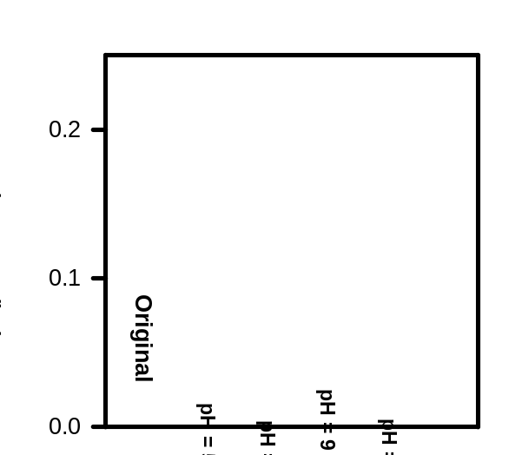
(a)
(b)
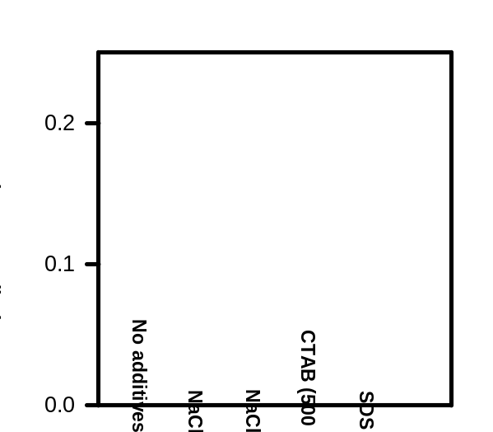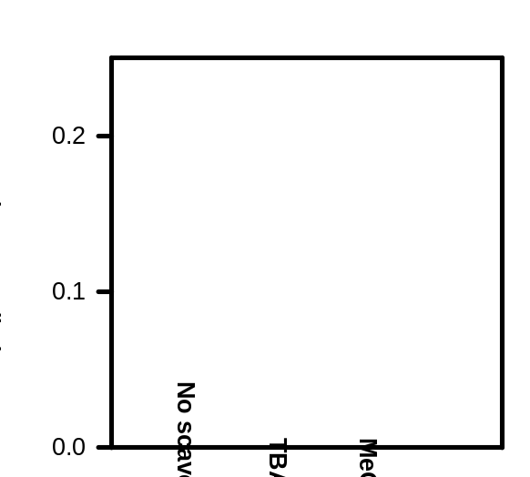
(d)
(c)
Fig. S4. Calculated k_{obs} values of (a) different temperatures, (b) pH variation, (c) co-existing compounds, and (d) scavengers. (Reaction conditions: HOCO = 100mg/L, MPS = 100 mg/L, T = 30 ºC).

(b)
(a)
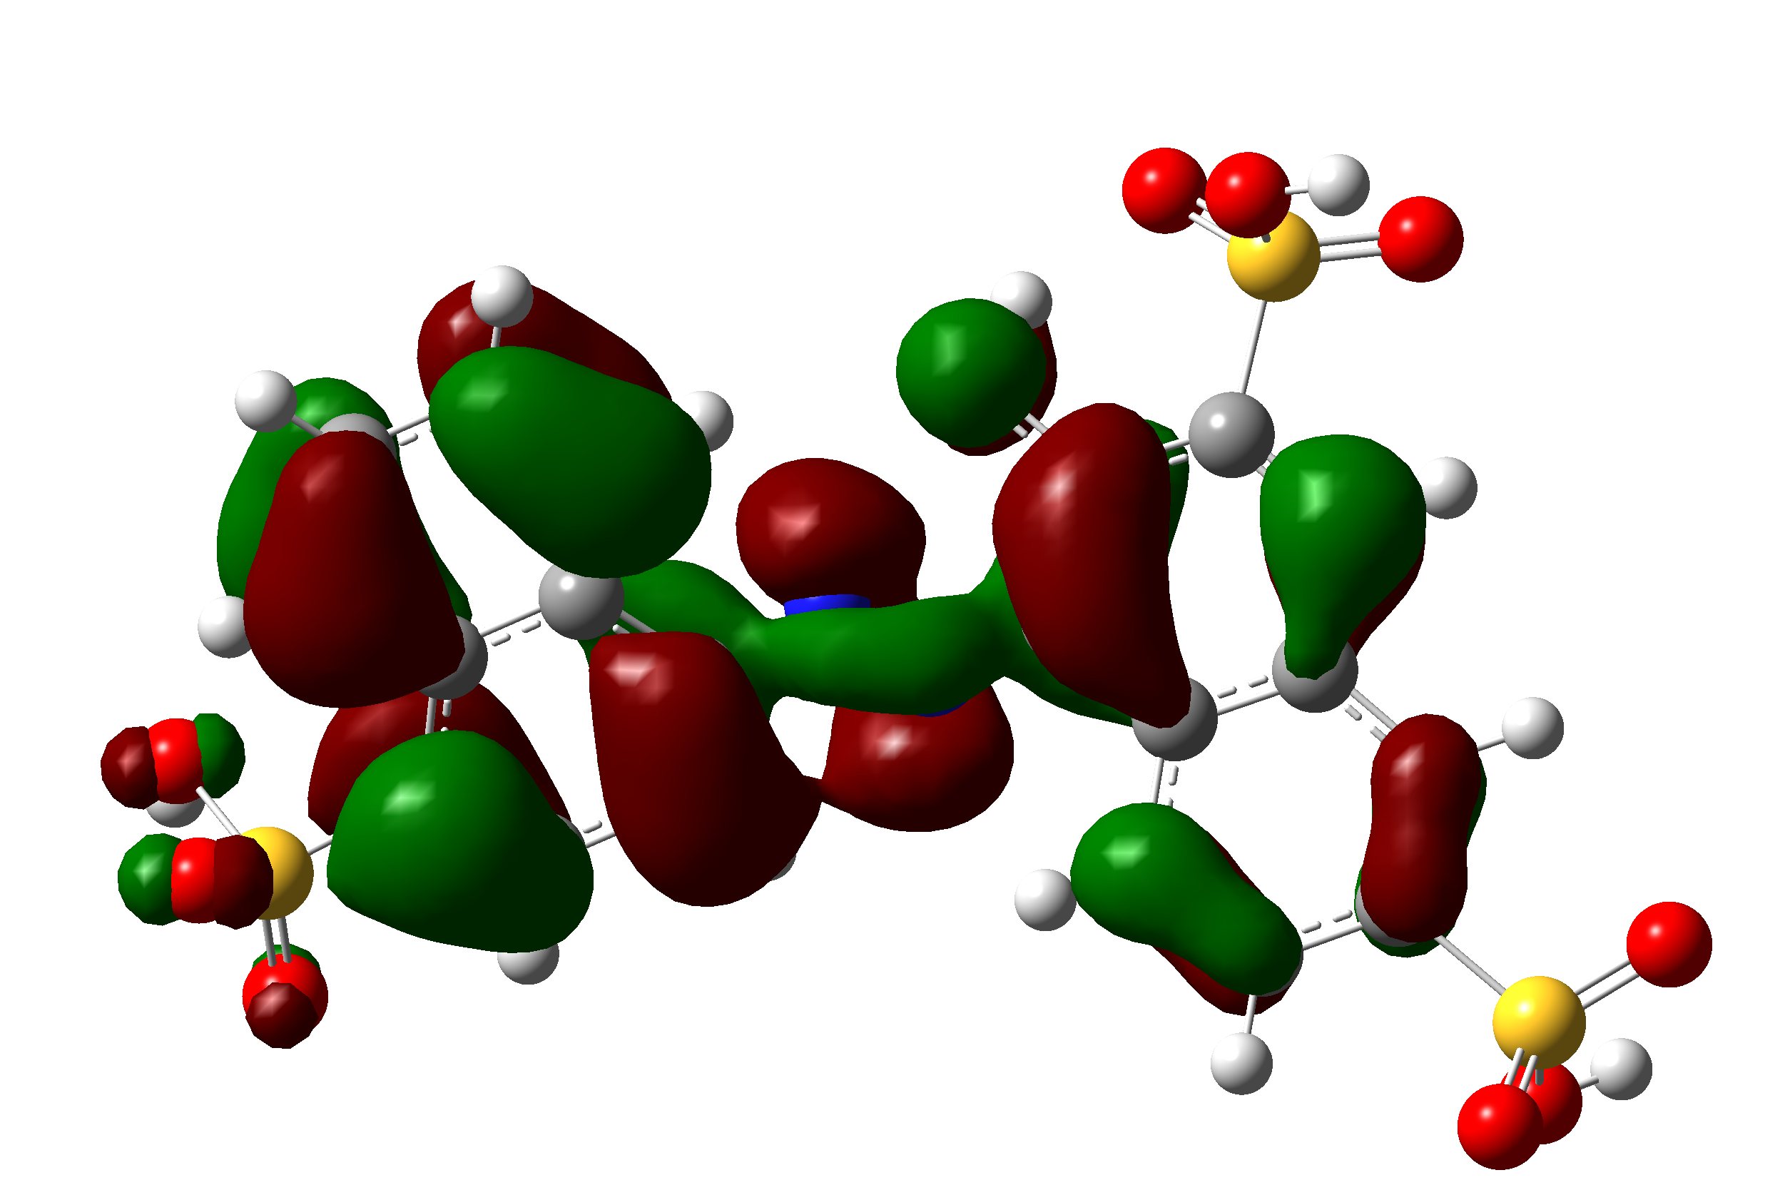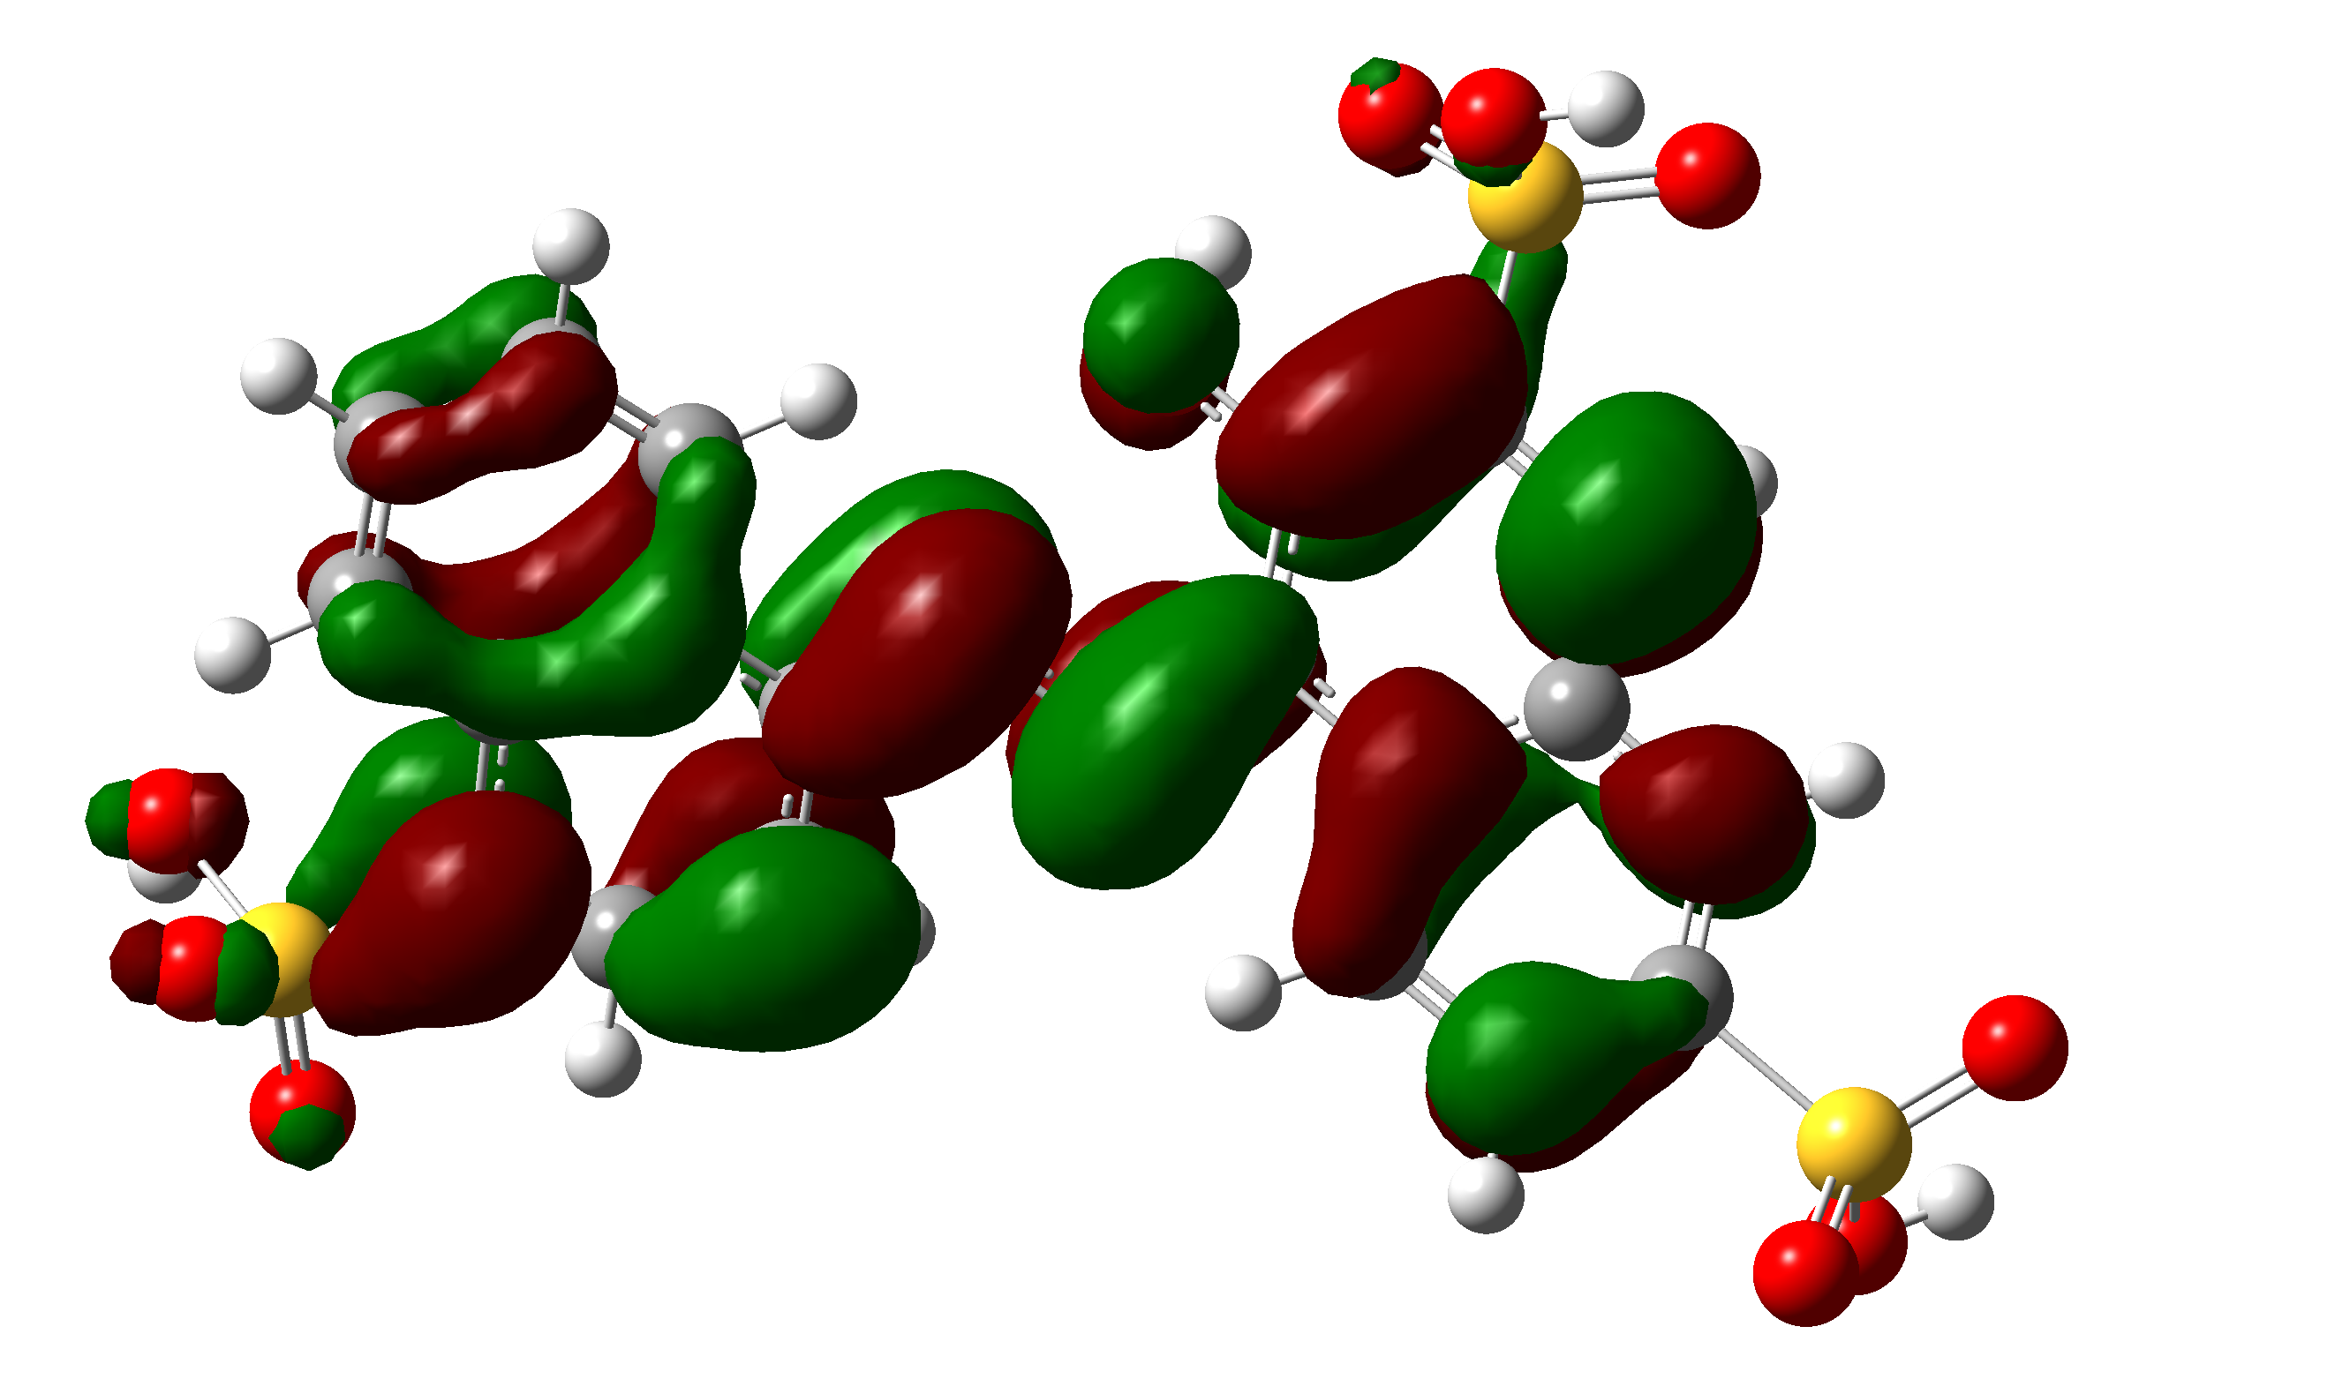
LUMO
HOMO

Fig. S5. Molecular orbitals of geometrically-optimized BP1: (a) HOMO; (b) LUMO.
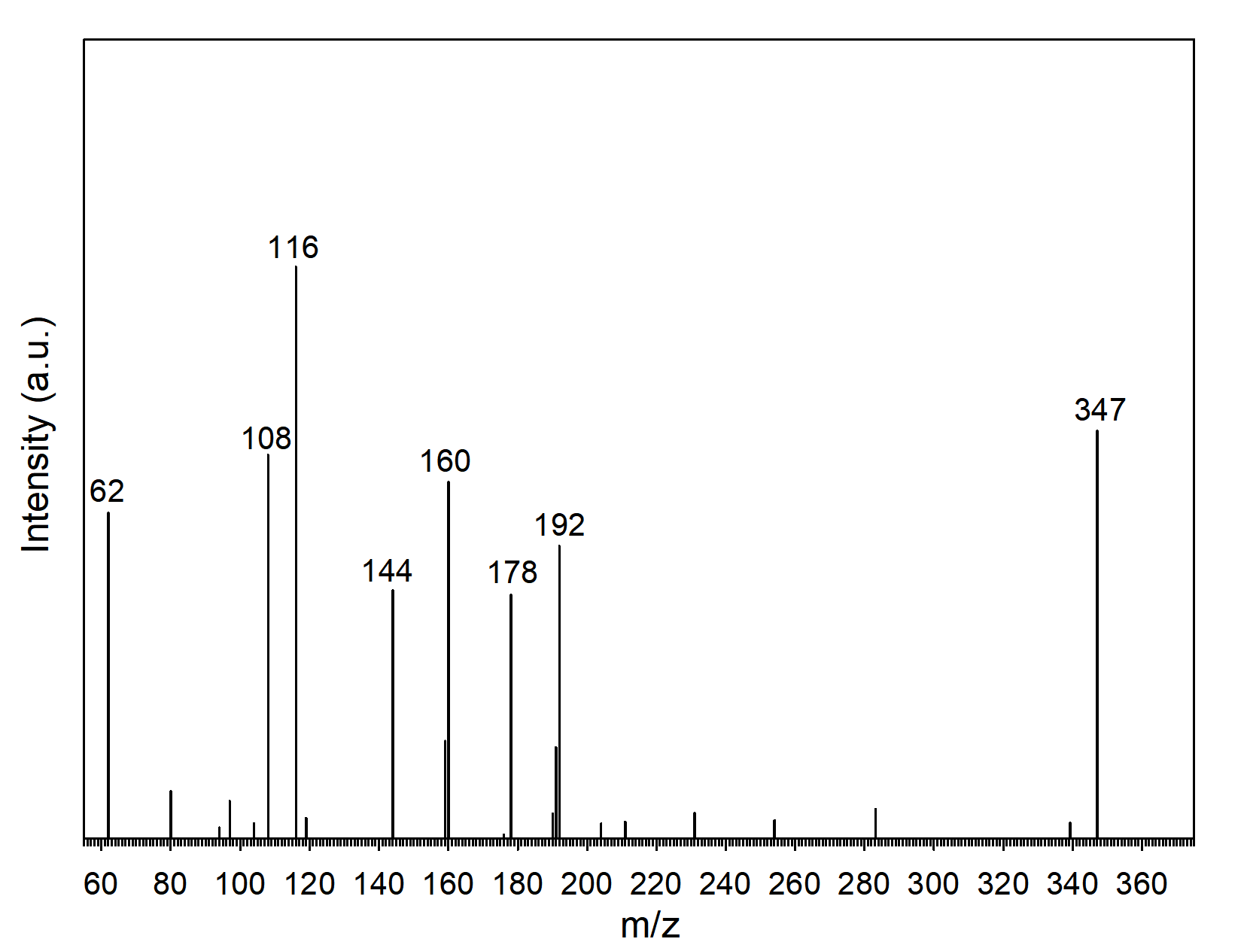
Fig. S6. ESI mass spectrum of intermediates of ARS degradation.

Reference
1. Lin, K.-Y.A., J.-T. Lin, and Y.-F. Lin, Heterogeneous catalytic activation of percarbonate by ferrocene for degradation of toxic amaranth dye in water. Journal of the Taiwan Institute of Chemical Engineers, 2017. 78: p. 144-149.
2. Zhang, M.-W., et al., Enhanced degradation of toxic azo dye, amaranth, in water using Oxone catalyzed by MIL-101-NH2 under visible light irradiation. Separation and Purification Technology, 2019. 227: p. 115632.

