Table 3 Compositions of liquid product (Control)
No. | Retention time (min) | Content (%) | Structure
1 | 8.890 | 1.62 | 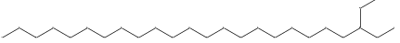
2 | 10.527 | 7.37 | 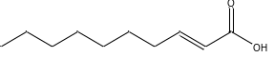
3 | 12.198 | 1.99 | 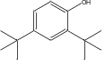
4 | 15.799 | 1.24
5 | 16.528 | 1.12 | 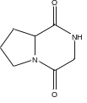
6 | 16.752 | 1.81 | 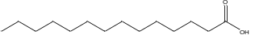
7 | 20.274 | 3.40 | 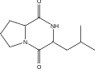
8 | 21.026 | 3.74 | 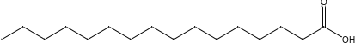
9 | 21.128 | 49.24 | 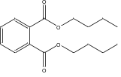
10 | 25.232 | 5.32 | 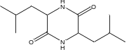
11 | 32.265 | 5.35 | 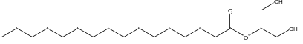
12 | 33.061 | 2.16 | 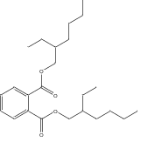
13 | 36.078 | 3.11 | 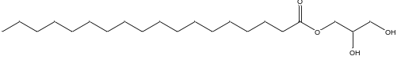

Table 4 Compositions of liquid product (Triton X-100)
No. | Retention time (min) | Content (%) | Structure
1 | 5.749 | 6.67
2 | 6.388 | 2.65 | 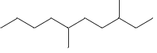
3 | 8.890 | 3.39
4 | 9.641 | 1.23 | 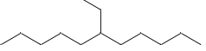
5 | 9.764 | 1.03 | 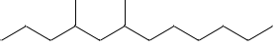
6 | 10.538 | 6.55 | 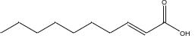
7 | 21.138 | 36.27 | 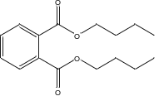
8 | 25.232 | 36.35 | 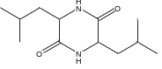
9 | 32.265 | 4.90 | 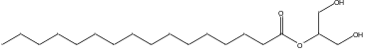
10 | 33.061 | 1.57 | 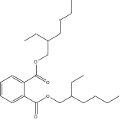
11 | 36.078 | 1.99 | 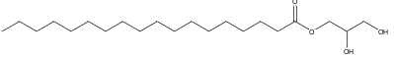

Table 5 Compositions of liquid product (SDS)
No. | Retention time (min) | Content (%) | Structure
1 | 5.749 | 6.67
2 | 10.112 | 1.71 | 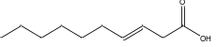
3 | 10.572 | 11.14 | 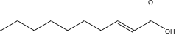
4 | 10.707 | 1.67
5 | 12.019 | 1.21
6 | 16.640 | 2.15 | 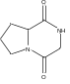
7 | 16.853 | 1.09 | 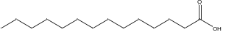
8 | 21.25 | 37.37 | 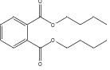
9 | 25.355 | 22.04 | 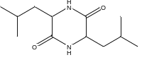
10 | 32.388 | 1.63 | 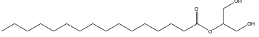

Table 6 Compositions of liquid product (DTAB)
No. | Retention time (min) | Content (%) | Structure
1 | 5.749 | 5.83
2 | 8.890 | 3.65
3 | 10.516 | 3.97 | 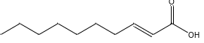
4 | 11.929 | 3.25
5 | 16.775 | 4.07 | 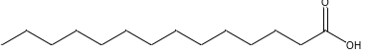
6 | 20.274 | 2.85 | 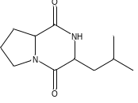
7 | 21.037 | 3.06 | 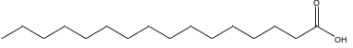
8 | 21.138 | 31.80 | 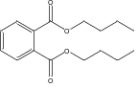
9 | 29.382 | 5.27 | 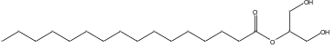
10 | 33.061 | 1.29 | 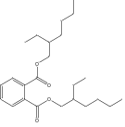
11 | 34.127 | 2.27 | 