Liquid-Crystalline Assembly of Sphere-Shaped Cellulose Nanocrystals
Li Cheng†, Bingrui Liu†, Jian Hu, Lijuan Zhou, Lu Zong, Yongxin Duan, Jianming Zhang*, Yuan Yuan*
Key Laboratory of Rubber-Plastics, Ministry of Education, School of Polymer Science and Engineering, Qingdao University of Science & Technology, Qingdao, China 266042

* To whom all correspondence should be addressed.
Fax: +86-532-84022791
E-mail: yuanyuan@qust.edu.cn (Yuan, Y.), zjm@qust.edu.cn (Zhang, J.)
Fourier Transform Infrared (FTIR) Spectroscopy.
FTIR spectra were measured with a Bruker tensor 27 spectrometer equipped with a DTGs detector. The normal transmission mode was employed for measurement. The spectra were obtained by coadding 64 scans at a 4 cm⁻¹ resolution. Prior to analysis, powder sample was first grounded with KBr and pressed into thin pellet.

Figure S1. FTIR spectrum of the CNSs film.
Figure S1 shows the infrared spectrum of the as-prepared CNSs film, in which two new bands are identified clearly. One band located at 1205 cm⁻¹ is assigned to the stretching vibration of the S=O group (ν(S=O))(Lu and Hsieh, 2010). The other located at 806 cm⁻¹ is assigned to the deformation vibration of the C−O−S group (δ(C−O−S))(Nan et al., 2017). The recognition to these two bands confirms that the sulfate groups are attached successfully on the CNSs surfaces after H₂SO₄ hydrolysis.
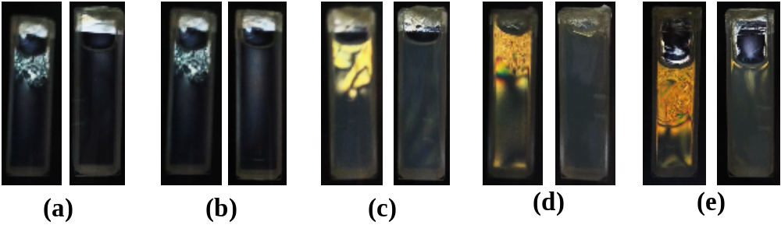
Figure S2. Images of CNSs suspensions after gentle shaking (left) and staying after several seconds (right) photographed between cross-polarizers. The concentration of the suspensions is 0.5 (a), 1.0 (b), 2.0 (c), 3.0 (d), and 4.0 wt.% (e). The cuvette is 5 mm in thickness.

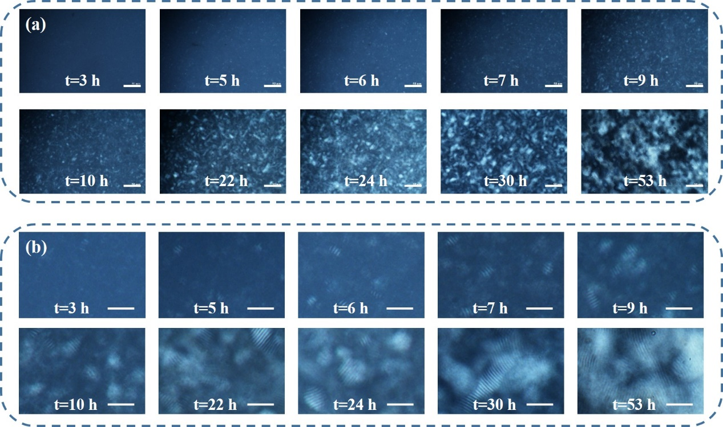
Figure S3. Time resolved POM images of 5 wt.% CNSs suspension. Scale bars are 100 and 50 μm for (a) and (b), respectively.

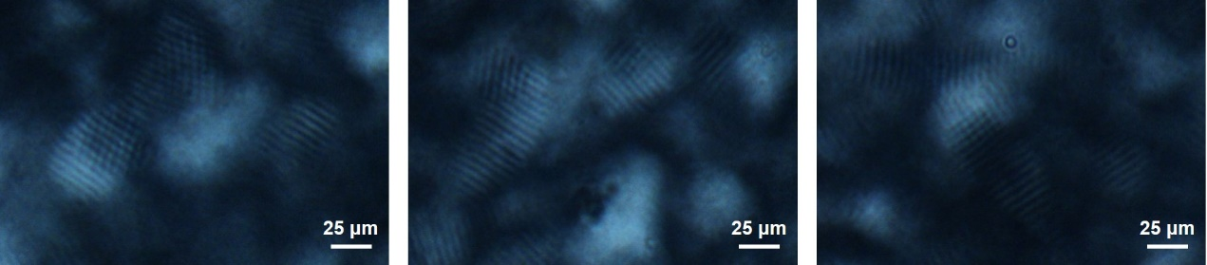
Figure S4. POM images of the CNSs suspension under 5 wt.% concentration during standing.

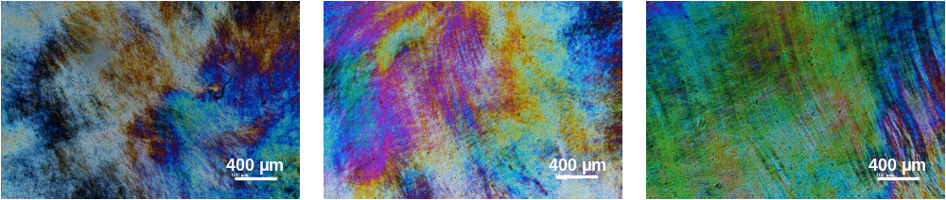
Figure S5. POM images of different regions for rodlike cellulose nanocrystals (LCNRs) droplets extracted from the suspension under 6 wt.% concentration after extrusion.

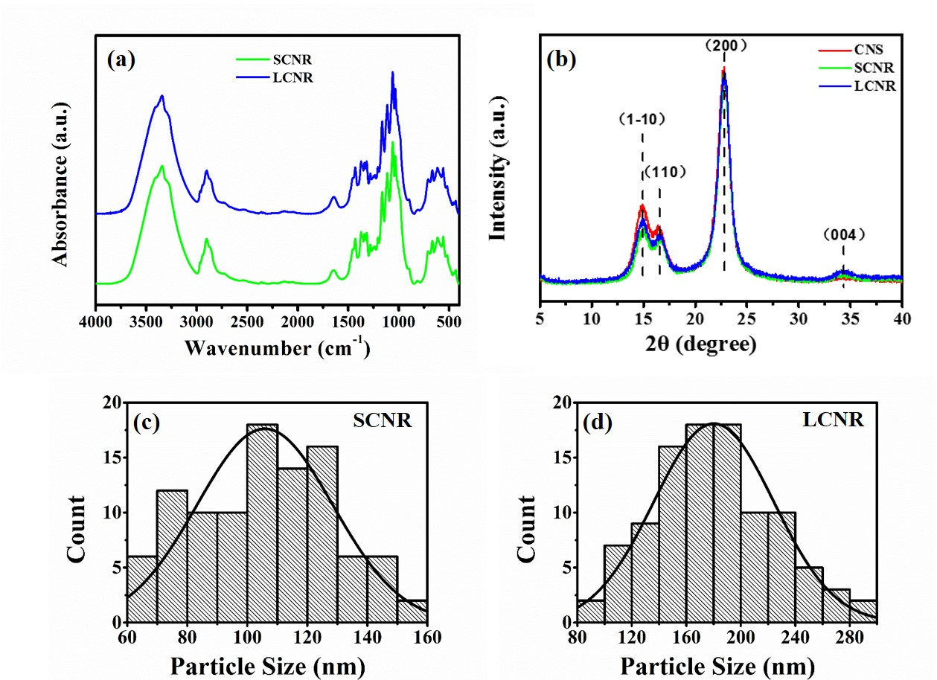
Figure S6. (a, b) FTIR spectra (a) and WAXD profiles (b) of the LCNR and SCNR films. (c, d) The statistical distribution of the SCNR (c) and LCNR (d) diameters from the AFM images as shown in Figure 7.

Rheological Measurements.
The sample was analyzed using ARES G2 rotational rheometer (TA, USA). CNCs suspension with the concentration of 5 wt.% was prepared for the measurement. The shear rate versus steady shear viscosity curve was generated. The shear rate was set to be increased from 0.001 to 1000 s⁻¹ at 25 °C.
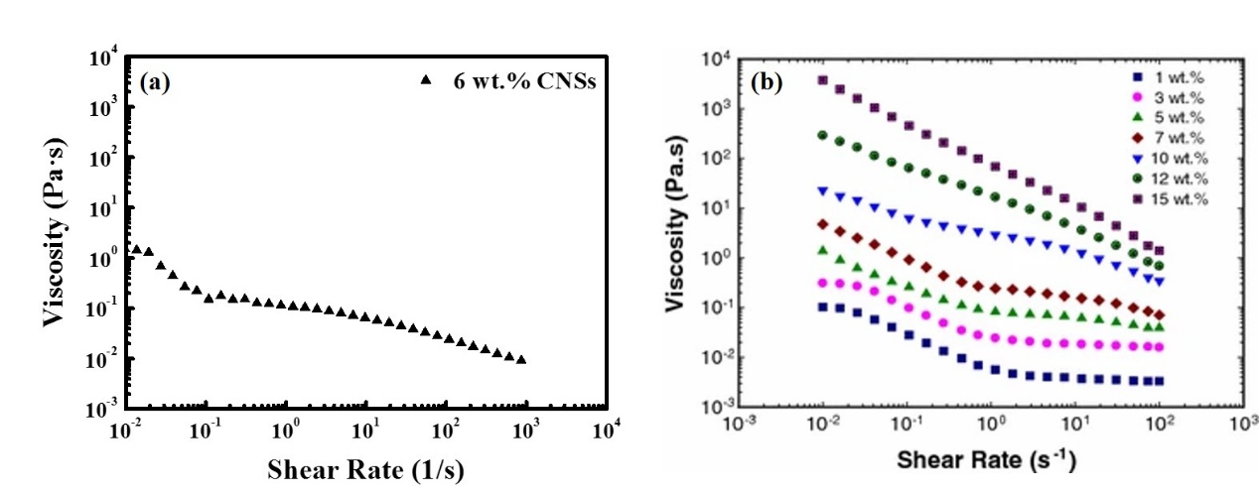
Figure S7. The viscosity changes as a function of the shear rate of 6 wt.% CNSs suspension (a) and of the reported CNRs suspension at different concentrations (b) (Reprinted with permission from Ref. (Shafiei-Sabet et al., 2014); Copyright (2014) American Chemical Society).

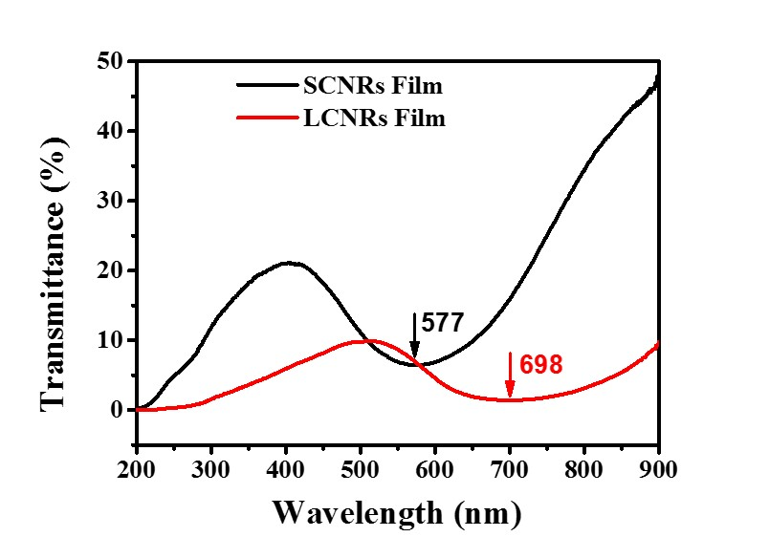
Figure S8. UV-Vis transmission spectrum of the SCNRs and LCNRs films in the transmission mode.

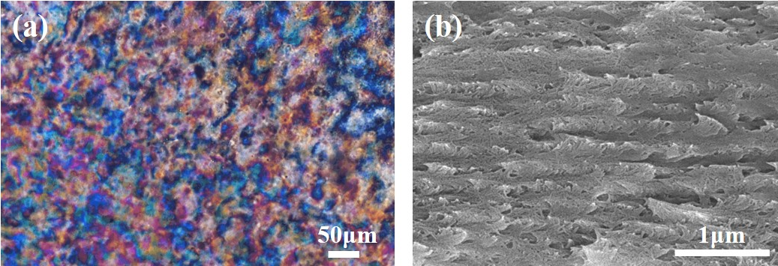
Figure S9. POM (a) and cross-sectional SEM (b) images of the desulfated CNSs film evaporated from 6 wt.% suspension under ambient conditions.
The desulfation treatment which could reduce the amount of charge carried by the particles was performed to investigate the effect of the surface charge density to the CNSs assembly. Specifically, the CNSs suspension was subjected to heat treatment in a water bath at 60 °C for 12 h(Beck et al., 2011). Then, 2 mL of suspension under 6 wt.% concentration was cast in an uncovered polystyrene petri dish with the diameter of 35 mm under ambient conditions. 5-60 mg/mL CNSs suspensions were prepared for Zeta potential measurement. The measurement was conducted in triplicate for each sample. Each sample was scanned for 12 times. Films for POM and SEM characterization were obtained by the suspension evaporation.
The zeta potential of the CNSs suspension was -19.21mV after desulfation treatment, indicating the amount of the CNSs surface charge is reduced successfully. The features of the desulfated CNSs film was investigated subsequently. As shown in Figure S9(a), compared to the untreated CNSs film (see Figure 6b), polydomains with decreased size exhibiting more unhomogeneous color were observed, indicating a more disordered liquid-crystalline organization in the desulfated CNSs film. The cross-sectional SEM photograph (see Figure S9b) shows that the periodically parallel-aligned layer-structure observed in untreated CNSs film (see Figure 6d) is almost lost.
Supporting Video:
Video S1: The iridescence of the CNSs film.
References
Beck, S., Bouchard, J., & Berry, R. (2011). Controlling the reflection wavelength of iridescent solid films of nanocrystalline cellulose. Biomacromolecules, 12(1), 167-172. https://doi.org/10.1021/bm1010905
Lu, P., & Hsieh, Y. L. (2010). Preparation and properties of cellulose nanocrystals: Rods, spheres, and network. Carbohydrate Polymers, 82(2), 329-336. https://doi.org/10.1016/j.carbpol.2010.04.073
Nan, F., Nagarajan, S., Chen, Y., Liu, P., Duan, Y., Men, Y., & Zhang, J. (2017). Enhanced toughness and thermal stability of cellulose nanocrystal iridescent films by alkali treatment. ACS Sustainable Chemistry & Engineering, 5(10), 8951-8958. https://doi.org/10.1021/acssuschemeng.7b01749
Shafiei-Sabet, S., Hamad, W. Y., & Hatzikiriakos, S. G. (2014). Ionic strength effects on the microstructure and shear rheology of cellulose nanocrystal suspensions. Cellulose, 21(5), 3347-3359. https://doi.org/10.1007/s10570-014-0407-z

