Breaking Symmetry of Single-Atom Catalysts Enables Extremely Low Energy Barrier and High Stability for Large-Current-Density Water Splitting

Xueqin Mu,^{1,2} Xiangyao Gu,^{1,3} Shipeng Dai,¹ Jiabing Chen,¹ Qu Chen,¹ Min Yu,¹ Changyun Chen,¹ Wenxin Chen,⁴ Suli Liu,^{1*} Shichun Mu^{2 *}

X. Q. Mu, X. Y. Gu, S. P. Dai and J. B. Chen contributed equally to this work.
¹Key Laboratory of Advanced Functional Materials of Nanjing, Nanjing Xiaozhuang University, Nanjing 211171, China.
²State Key Laboratory of Advanced Technology for Materials Synthesis and Processing, Wuhan University of Technology, Wuhan 430070, China.
³Guangxi Key Laboratory of Low Carbon Energy Materials, Guangxi Normal University, Guilin 541004, China.
⁴Beijing Key Laboratory of Construction Tailorable Advanced Functional Materials and Green Applications, School of Materials Science and Engineering, Beijing Institute of Technology, Beijing 100081, China

Corresponding E-mails: msc@whut.edu.cn; liusuli@njxzc.edu.cn

Experiment Section
Chemicals
2,5-Dihydroxyterephthalic acid (H₄DOT, 98%, Maklin), Iron(II) acetate (Fe(ac)₂, 90%, Energy Chemical), Cobaltous(II)nitrate hexahydrate (Co(NO₃)₂·6H₂O, ≥98.5%), N,N-Dimethyl formamide, RuCl₃·nH₂O.

Preparation of FeCo-LDH/NF
First, a piece of nickel foam (NF, 2.0 cm × 3.0 cm) was taken in anhydrous ethanol, 0.5 M HCl and deionized water, respectively, after ultrasonic treatment for 15min, the NF was vacuum-dried at 60℃. Next, 30 mL DMF was added into a teflon liner (50 mL) containing H₄DOT (0.090 g), Fe(ac)₂ (0.047 g), Co(NO₃)₂·6H₂O (0.210 g) to mix evenly, and then the 2.0 cm × 3.0 cm NF after treatment was vertically dipped into the solution. The mixed reactor was reacted in the oven at 120 ℃ for 24 h. After the reaction, the solution was cooled to room temperature, the surface of the nickel foam was carefully washed with anhydrous ethanol, and then placed in 60 ℃ vacuum drying for 6 h to obtain FeCo-LDH/NF.

Preparation of Ru₁ SACs@FeCo-LDH/NF
The Ru₁FeCo-LDH/NF were prepared at room temperature. First, 100 mg RuCl₃·nH₂O was dissolved in 25 mL methanol, and a piece of 2.0 cm × 3.0 cm FeCo-LDH/NF was vertically immersed into the solution in a small beaker and reacted for 15 min. After the reaction, Ru₁FeCo-LDH/NF was obtained by vacuum drying at 60 ℃ for 6 h.

Preparation of Ru₂ SACs@FeCo-LDH/NF
At the beginning, 100 mg RuCl₃·nH₂O was dissolved in teflon liner containing 25 mL methanol. After uniform mixing, a piece of 2.0 cm × 3.0 cm FeCo-LDH/NF was vertically immersed into the solution, and the high-pressure reactor was reacted at 130 ℃ for 3.5 h. When the reaction completed, the solution was cooled to room temperature, the surface of the nickel foam was carefully washed with anhydrous ethanol, and then placed in 60 ℃ vacuum drying for 6 h to obtain Ru₂FeCo-LDH/NF.

Preparation of Ru₁/NF
In preparation of Ru₁FeCo-LDH/NF, it is only necessary to change the FeCo-LDH/NF into 2.0 cm × 3.0 cm NF, and other steps remain unchanged to obtain Ru/NF.

Preparation of Ru₂/NF
In the preparation of Ru₂FeCo-LDH/NF, it is only necessary to change the FeCo-LDH/NF into 2.0 cm × 3.0 cm NF, and other steps remain unchanged to prepare Ru/NF.

Method and Model
The Co and Fe atoms embed FeCo-LDH (001), Co, Fe and Ru atoms embed Ru_{x}FeCo-LDH (001) have been built. The intermediates of OH, O and OOH groups have absorbed on Co or Fe or Ru atom. The bottom LDH atom layers were fixed and the top LDH atom layers were allowed to relax to the minimum in the enthalpy without any constraints. The first principles calculations in the framework of density functional theory, including structural, electronic performances, were carried out based on the Cambridge Sequential Total Energy Package known as CASTEP.¹ The exchange–correlation functional under the generalized gradient approximation (GGA)² with norm-conserving pseudopotentials and Perdew–Burke–Ernzerhof functional was adopted to describe the electron–electron interaction.³ An energy cutoff of 750 eV was used and a k-point sampling set of 7 x 7 x 1 were tested to be converged. A force tolerance of 0.01 eV Å ⁻¹, energy tolerance of 5.0x10⁻⁷eV per atom and maximum displacement of 5.0x10⁻⁴ Å were considered. The GGA+U with spin polarization was adopted to describe the localized d states,⁴ where U = 3.42, 3.29 and 3.29 eV was applied for Co, Fe and Ru ions. The Grimme method for DFT-D correction is considered for all calculations.⁵

Thermodynamics and photocatalysis
Adsorption energy ΔE of A = OH, O and OOH groups on the surface of substrates was defined as:⁶
ΔE = E_{*A} – (E*+ E_{A}) (1)
where *A and * denote the adsorption of A groups on substrates and the bare substrates, E_{A} denotes the energy of A groups.
Free energy change ΔG of the reaction was calculated as the difference between the free energies of the initial and final states as shown below:⁶⁻⁷
ΔG= ΔE + ΔZPE - TΔS (2)
where ∆E is the energy change between the reactant and product obtained from DFT calculations; ∆ZPE is the change of zero point energy; T and ∆S denote temperature and change of entropy, respectively. In here, T = 300K was considered.

- M. D. Segall, P. J. D. L. M. J. Probert, C. J. Pickard, P. J. Hasnip, S. J. Clark and M. C. Payne, J. Phys.: Condens. Matter, 2002, 14, 2717.
- J. P. Perdew, K. Burke and M. Ernzerhof, Phys. Rev. Lett., 1996,77, 3865.
- D. R. Hamann, M. Schl¨ uter and C. Chiang, Phys. Rev. Lett., 1979,43, 1494.
- Xu, H.X., Cheng, D.J., Cao, D.P., et al., A universal principle for a rational design of single-atom electrocatalysts, Nat. Catal., 2018, 5:339-348.
- S. Grimme, J. Comput. Chem., 2006, 27, 1787–1799.
- H. H. Li, Y. Wu, C. Li, Y. Y. Gong, L. Y. Niu, X. J. Liu, Q. Jiang, C. Q, Sun and S. Q. Xu, Appl. Catal. B: Environ., 2019, 251, 305–312.
- M. Bajdich, M. García-Mota, A. Vojvodic, J.K. Nørskov, A.T. Bell, Journal of the American Chemical Society, 135 (2013) 13521-13530.

Table S1. The mass atomic percentage from ICP analysis for different samples.
Mass% | Ru₁ SACs@FeCo-LDH | Ru₂ SACs@FeCo-LDH | FeCo-LDH
Ru | 30% | 96.7% | -
Fe | 25% | 1.51% | 27.0%
Co | 45% | 0.23% | 73.0%
atomic ratio (Fe:Co:Ru) | 1:1.81:1.19 | 1:0.15:65 | 1:2.7

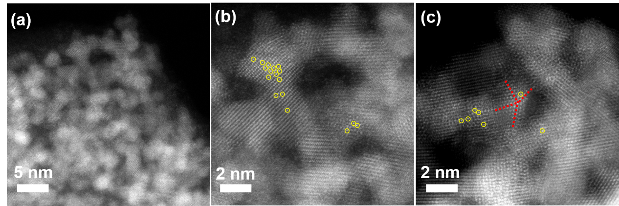
Figure S1. (a) SEM, (b) STEM and (c) TEM images of Ru₂ SACs@FeCo-LDH.

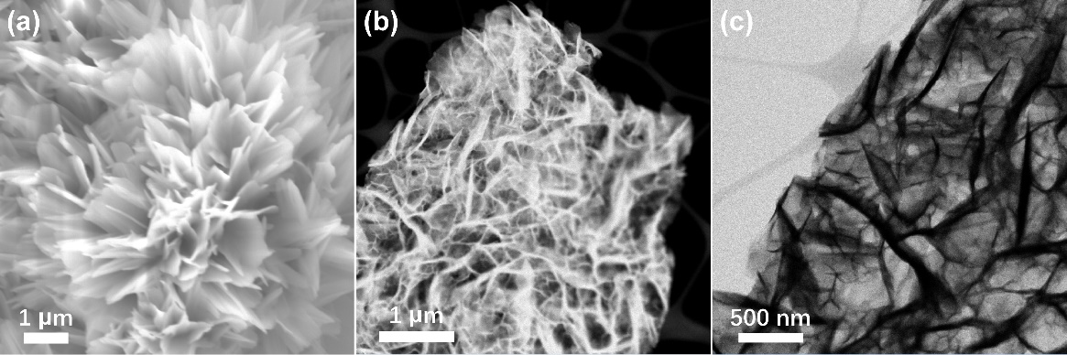
Figure S2. (a) SEM, (b) STEM and (c) TEM images of Ru₁ SACs@FeCo-LDH.

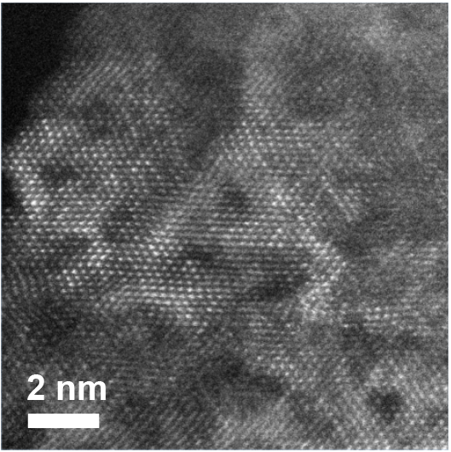
Figure S3. HAADF-STEM image for Ru₁ SACs@FeCo-LDH.
Figure S4. XRD spectra of Ru₁ SACs@FeCo-LDH and FeCo-LDH, respectively.

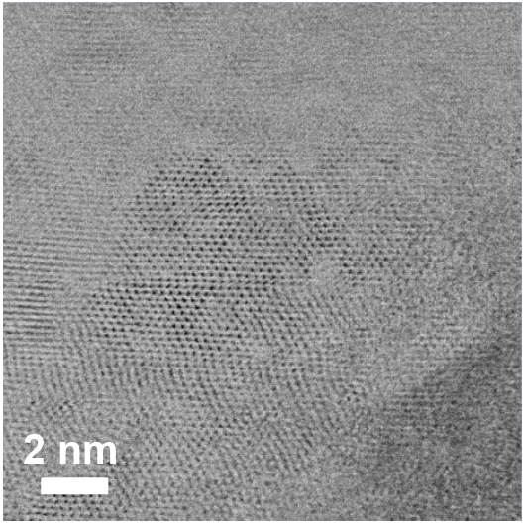
Figure S5. HRTEM images of Ru₁ SACs@FeCo-LDH.

Figure S6. XPS spectra of Ru₁ SACs@FeCo-LDH, Ru₂ SACs@FeCo-LDH and FeCo-LDH
Table S2. The elemental atomic percentage from XPS analysis for different samples.
Atomic%(XPS) | Ru₁ SACs@FeCo-LDH | Ru₂ SACs@FeCo-LDH | FeCo-LDH
Ru | 3.28% | 3.43% | -
O | 72.98% | 80.69% | 77.79%
Fe | 5.64% | 4.48% | 6.11%
Co | 4.79% | 1.46% | 7.78%
Ni | 13.31% | 9.94% | 8.32%
atomic ratio (Fe:Co:Ru) | 1:0.85:0.58 | 1:0.33:0.77 | 1:1.27

Figure S7. Fe 2p XPS spectra of Ru₁ SACs@FeCo-LDH and FeCo-LDH.
Figure S8. Co 2p XPS spectra of Ru₁ SACs@FeCo-LDH and FeCo-LDH.

Figure S9. Ru 3p XPS spectra of Ru₁ SACs@FeCo-LDH and Ru₂ SACs@FeCo-LDH.
Figure S10. O 1s XPS spectra of Ru₁ SACs@FeCo-LDH, Ru₂ SACs@FeCo-LDH and FeCo-LDH.

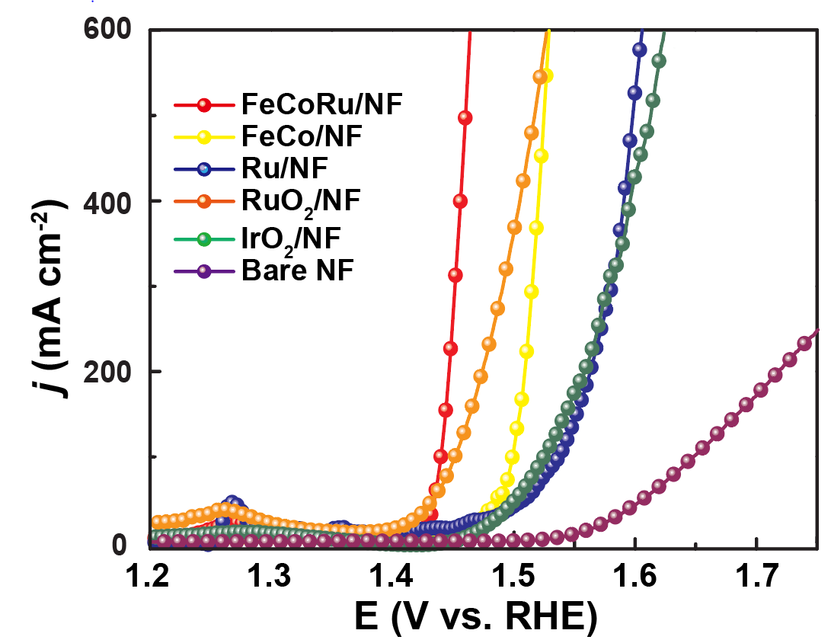
Figure S11. Polarization curves in 1.0 M KOH for OER electrocatalysis.

Table S3. Comparison of OER activities of other catalysts in KOH solution.
Catalysts | η at 500 mA cm⁻² (mV) | Reference
Ru_{x} SACs@FeCo-LDH | 230@500  246@1000 | This work
NiMoO_{x}/NiMoS | 278@500  334@1000 | Nat. Commun. 11, 5462 (2020)
MoNi₄/SSW‖SSW Rs-12h | 285@500 | Adv. Energy Mater. 10, 1904020 (2020)
Ni₃Nb-doped NiFe-OOH | 236@500  249@1000 | Adv. Energy Mater. 11, 2100968 (2021).
Ru-CoO_{x}/NF | 370@1000 | Small 17, 2102777 (2021)
Ni_{0.8}Fe_{0.2}-AHNA | 260 @1078 | Energy Environ. Sci. 13, 86-95 (2020)
FeP/Ni₂P | 293 @1000 | Nat. Commun. 9, 2551 (2018)
F_{0.25}C₁CH/NF | 308 @1000 | Adv. Energy Mater. 8, 1800175 (2018)
nano-KFO/NF | 308 @100  421 @2000 | J. Mater. Chem. A, 9, 7586–7593 (2021)
5h-ANF | 350 @500 | ACS Nano 2021, 15, 3468−3480
Fe-CoP/NF | 295 @500  428 @1000 | Adv. Sci. 5, 1800949 (2018)
(Ni,Fe)OOH | 259 @500  289 @1000 | Energy Environ. Sci. 11, 2858-2864 (2018)
NFN-MOF/NF | 360 @500 | Adv. Energy Mater. 8, 1801065 (2018)
SSW Rs-12 h | 287 @500 | Adv. Energy Mater. 10, 1904020 (2020)
Ni₃S₂/Fe-NiP_{x}/NFc | 270 @500  291 @1000 | Adv. Sci. 2022, 2104846

Table S4. Comparison of HER activities of other catalysts in KOH solution.
Catalysts | η at 500 mA cm⁻² (mV) | Reference
Ru_{x} SACs@FeCo-LDH | 84@500  117@1000 | This work
(Ni,Fe)OOH | 259 @500  289 @1000 | Energy Environ. Sci. 11, 2858-2864 (2018)
NFN-MOF/NF | 293 @500 | Adv. Energy Mater. 8, 1801065 (2018)
Pt@ Cu-0.3 | 438 @1000 | Adv. Funct. Mater. 31, 2105579 (2021)
Ni-Mo-B HF | 257 @500 | Adv. Funct. Mater. 2107308 (2021)
Ni₃Nb doped NiFe-OOH | 236 @500  249 @1000  261 @2000 | Adv. Energy Mater. 11, 2100968 (2021)
Ni₂P/NF | 306 @1000  368 @ 1500 | J. Am. Chem. Soc. 141, 7537 (2019)
h-NiMoFe | 97 @1000 | Energy Environ. Sci. 14, 4610 (2021)
F_{0.25}C₁CH/NF | 256 @1000 | Adv. Energy Mater. 8, 1800175 (2018)

Table S5. Comparison of OWS activities of other catalysts in KOH solution.
Catalysts | Voltage (V) at mA cm⁻² | Reference
Ru_{x} SACs@FeCo-LDH | 1.47 @500  1.52 @1000 | This work
(Ni,Fe)OOH // MoNi₄ | 1.586 @500  1.657 @1000 | Energy Environ. Sci. 11, 2858-2864 (2018)
NFN-MOF/NF | 1.96 @500 | Adv. Energy Mater. 8, 1801065 (2018)
Ni nanowire array(−)//Ni_{0.8}Fe_{0.2}-AHNA(+) | 1.70 @500 | Energy Environ. Sci. 13, 86-95 (2020)
Ni-Mo-B HF | 1.88 @500 | Adv. Funct. Mater. 2107308 (2021)
FeP/Ni₂P | 1.72 @500  1.78 @1000 | Nat. Commun. 2551 (2018)
FeCo carbonate hydroxide | 1.52 @500 | Adv. Energy Mater. 8, 1800175 (2018)

Figure S12. The equivalent circuit of (a)-(c) of Ru₁ SACs@FeCo-LDH, FeCo-LDH and Ru/NF electrocatalysts in 1.0 M KOH solution, respectively.

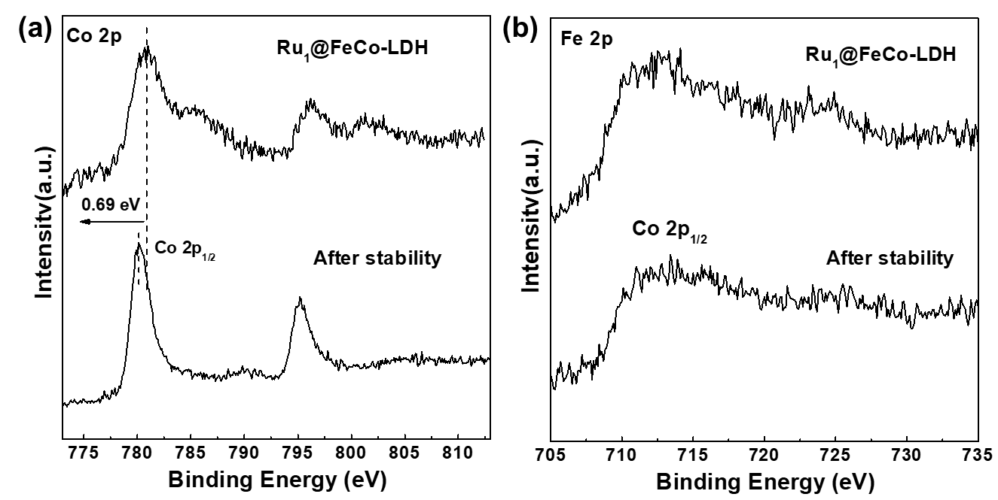
Figure S13. (a)Co 2p and (b) Fe 2p XPS spectra of Ru₁ SACs@FeCo-LDH and after 1000 h.

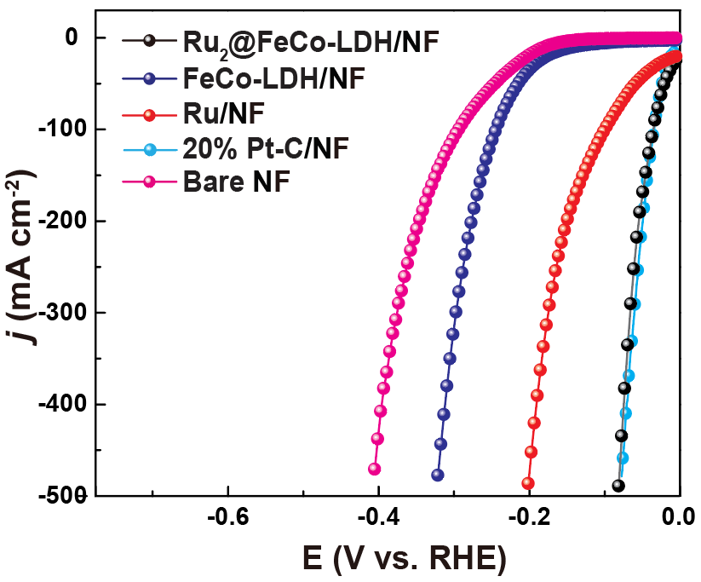
Figure S14. Polarization curves in 1.0 M KOH for HER electrocatalysis.
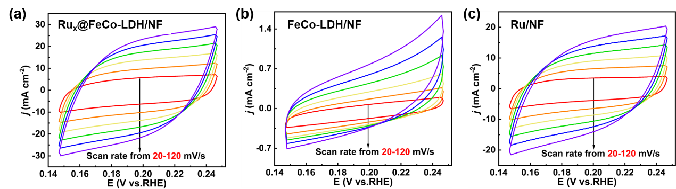
Figure S15. Cyclic voltammograms of (a)-(c) of Ru₂ SACs@FeCo-LDH, FeCo-LDH and Ru/NF electrocatalysts at various scan rates.

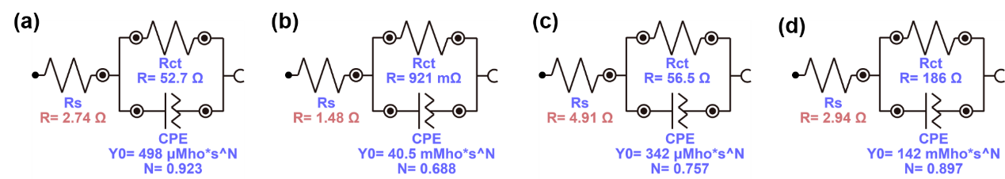
Figure S16. The equivalent circuit of (a)-(c) of Ru₂ SACs@FeCo-LDH, FeCo-LDH, Ru/NF and Bare NF electrocatalysts, respectively.

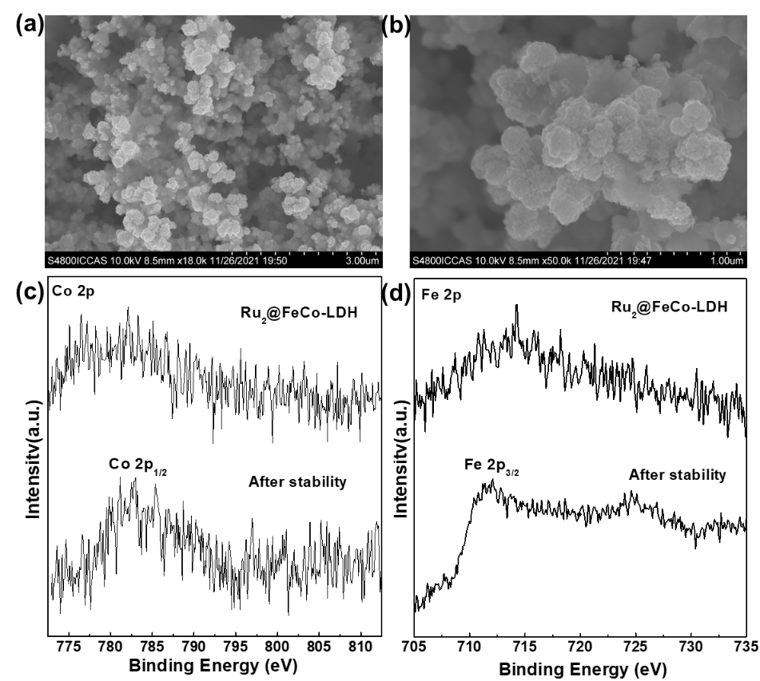
Figure S17. (a, b) SEM images, (c)Co 2p and (d) Fe 2p XPS spectra of Ru₂ SACs@FeCo-LDH and after 1000 h.
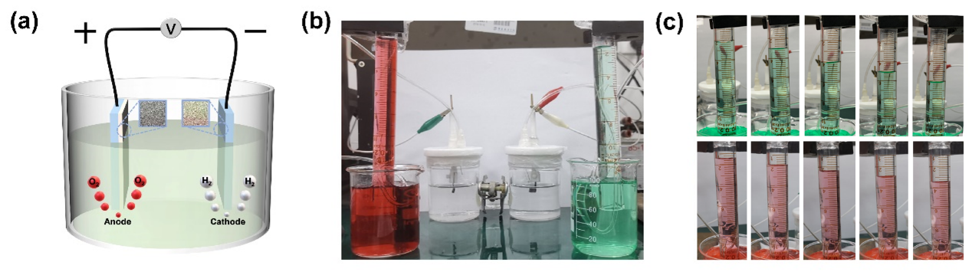
Figure S18. (a) Schematic of the electrolyzed water reaction. (b) H₂ (Green) and O₂ (Red) generated at 5, 10, 15, 20 min, respectively.

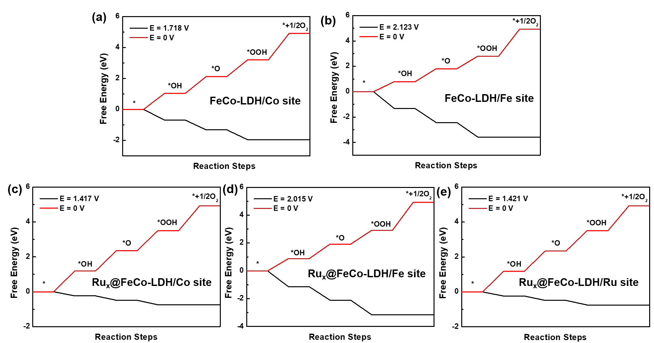
Figure S19. (a-b) Energy profile for the OER process on the FeCo-LDH and (c-e) Ru_{x} SACs@FeCo-LDH.

Figure S20. Top view of representative OER mechanism on Co active site over the FeCo-LDH and Ru_{x} SACs@FeCo-LDH

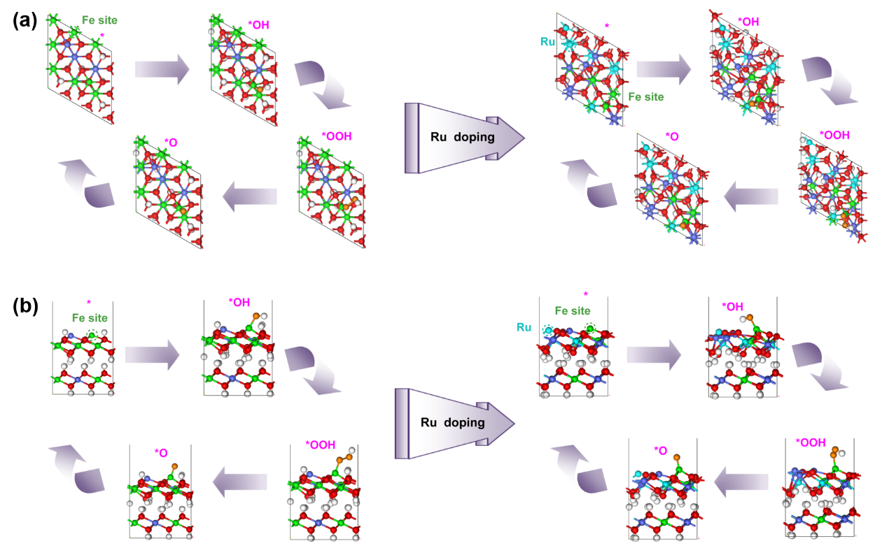
Figure S21. (a) Top and (b) side view of representative OER mechanism on Fe active site over the FeCo-LDH and Ru_{x} SACs@FeCo-LDH

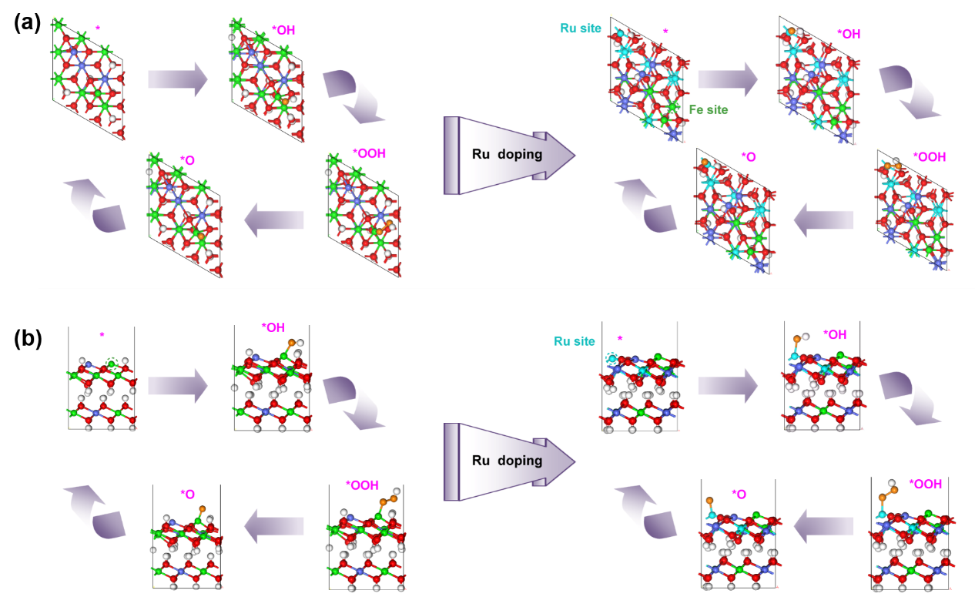
Figure S22. (a) Top and (b) side view of representative OER mechanism on Ru active site over the FeCo-LDH and Ru_{x} SACs@FeCo-LDH

