Physicochemical properties and structural dynamics of organic–inorganic hybrid perovskite [NH₃(CH₂)₃NH₃]ZnX₄ (X=Cl and Br) crystals

Ae Ran Lim^{1, 2, *}, Sun Ha Kim^{3, 4}, Yong Lak Joo⁵
¹Department of Carbon Convergence Engineering, Jeonju University, Jeonju 55069, Korea.
²Department of Science Education, Jeonju University, Jeonju 55069, Korea. email: arlim@jj.ac.kr
³Korea Basic Science Institute, Seoul Western Center, Seoul 03759, Korea.
⁴Department of Chemistry, Kyungpook National University, Daegu 41566, Korea.
⁵Robert Fredrick Smith School of Chemical and Biomolecular Engineering, Cornell University, Ithaca, NY 14853, USA.
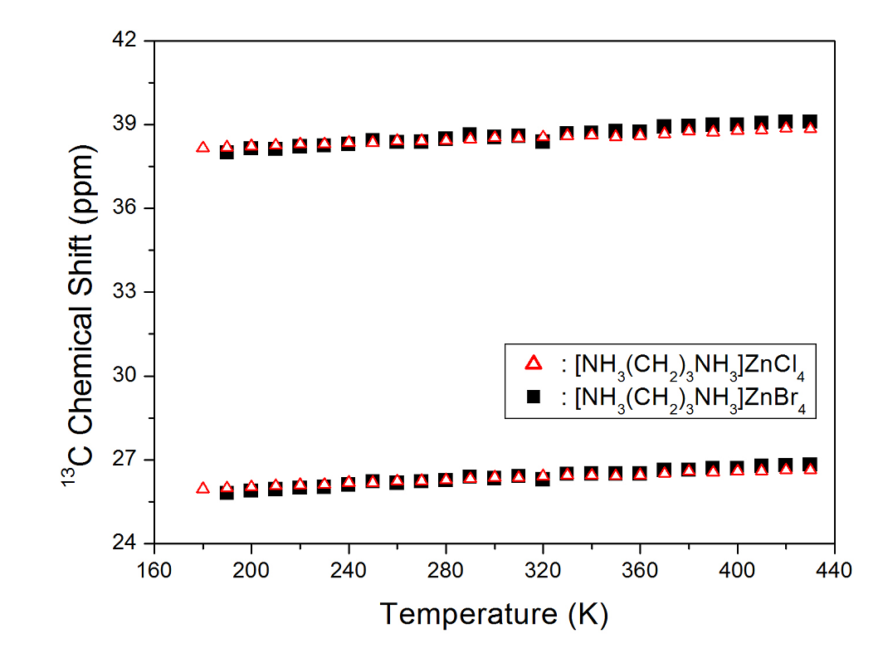
Supplementary Figure 1. Chemical shifts of [NH₃(CH₂)₃NH₃]ZnX₄ (X=Cl and Br) as a function of temperature.

