Withdrawal of inhaled corticosteroids from COPD patients with mild or moderate airflow limitation: primary care feasibility randomised controlled trial reveals high prevalence of suspected undiagnosed asthma

Timothy H Harries^{1*}, Gill Gilworth¹, Christopher J Corrigan², Patrick B Murphy³, Nicholas Hart³, Mike Thomas⁴, Patrick T White¹

Additional file

Figure S1. General practice search algorithm
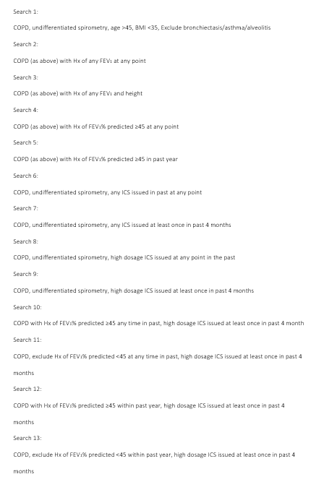

Figure S2. Inhaled corticosteroid therapy step down guide
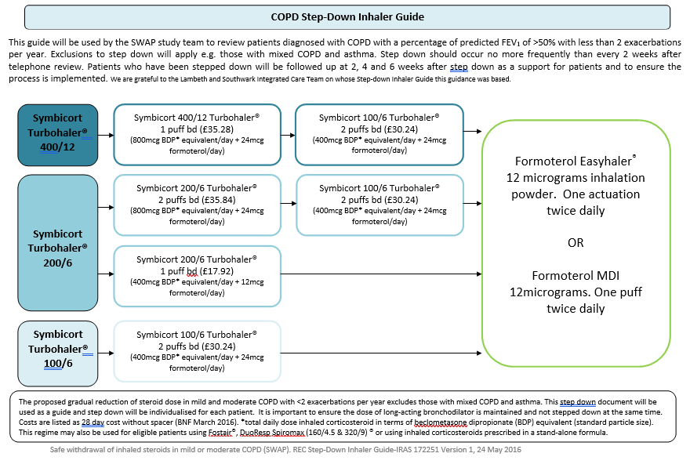

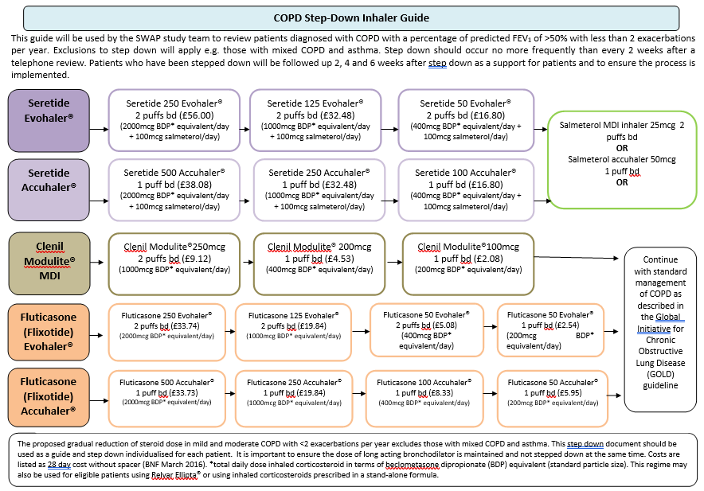

Table S1. Comparison at recruitment and at 3 months.

 |  | FEV₁ variability  after ICS withdrawal  n = 10 | Usual care or no FEV₁ variability  after ICS withdrawal  n = 28 | p-value
Age (years): mean (SD)* |  | 71 (±8.11) | 70 (±9.69) | 0.71
Male sex, n (%)† |  | 5 (50%) | 15 (54%) | 0.85
BMI (kg/m²): mean (SD)* |  | 27.78 (±5.79) | 26.17 (±4.87) | 0.44
Tobacco Exposure (Pack Years): mean (SD)* |  | 27.88 (±20.65) | 34.92 (±20.99) | 0.37
AECOPD in prior year: mean (SD)* |  | 0.40 (±0.52) | 0.54 (±0.51) | 0.48
History of Atopy, n (%)† |  | 10 (100%) | 16 (57%) | 0.01
FEV₁ (L): mean (SD)* | Baseline | 1.81 (±0.35) | 1.88 (±0.59) | 0.69
FEV₁ (L): mean (SD)* | 3 months | 1.66 (±0.44) | 1.88 (±0.62) | 0.24
FEV₁ % predicted: mean (SD)* | Baseline | 72.00 (±11.32) | 73.57 (±14.66) | 0.73
FEV₁ % predicted: mean (SD)* | 3 months | 67.30 (±17.40) | 74.30 (±16.25) | 0.29
FeNO (ppb): median (IQR)** | Baseline | 11 (6-35) | 15 (11-25) | 0.69
FeNO (ppb): median (IQR)** | 3 months | 24 (8-97) | 14 (9-18) | 0.04
FeNO (ppb): median (IQR)** | 6 months | 26 (19-40) | 13 (9-18) | <0.01
CAT score: mean (SD)* | Baseline | 18.40 (±7.71) | 14.82 (±7.39) | 0.22
CAT score: mean (SD)* | 3 months | 21.50 (±6.88) | 15.50 (±7.48) | 0.04
CAT score: mean (SD)* | 6 months | 18.70 (±6.43) | 16.11 (±8.52) | 0.33
Blood eosinophil count (cells/µL): median (IQR)** | Baseline | 200 (100-290) | 200 (100-200) | 0.78
Blood eosinophil count (cells/µL): median (IQR)** | 3 months | 230 (160-350) | 210 (180-300) | 0.91
CRQ dyspnoea score: median (IQR)** | Baseline | 4.90 (4.19-5.70) | 5.68 (4.19-6.50) | 0.45
CRQ dyspnoea score: median (IQR)** | 3 months | 4.55 (4.20-5.64) | 5.67 (4.80-7.00) | 0.04
CRQ dyspnoea score: median (IQR)** | 6 months | 5.30 (4.75-6.10) | 5.80 (4.85-6.50) | 0.46
CRQ fatigue score: mean (SD)* | Baseline | 3.83 (±1.09) | 4.21 (±1.53) | 0.40
CRQ fatigue score: mean (SD)* | 3 months | 3.18 (±1.09) | 4.19 (±1.56) | 0.04
CRQ fatigue score: mean (SD)* | 6 months | 4.20 (±1.39) | 4.42 (±1.50) | 0.68
CRQ emotional functioning score: mean (SD)* | Baseline | 4.70 (±1.02) | 4.84 (±1.33) | 0.74
CRQ emotional functioning score: mean (SD)* | 3 months | 4.67 (±1.34) | 4.89 (±1.31) | 0.67
CRQ mastery score: median (IQR)** | Baseline | 5.00 (3.63-6.50) | 5.75 (4.81-6.75) | 0.27
CRQ mastery score: median (IQR)** | 3 months | 4.75 (3.06-5.56) | 5.50 (4.25-6.50) | 0.11
HADS anxiety score: mean (SD)* | Baseline | 7.20 (±3.01) | 5.96 (±3.78) | 0.31
HADS anxiety score: mean (SD)* | 3 months | 6.20 (±3.43) | 5.26 (±4.11) | 0.49
HADS depression score: median (IQR)** | Baseline | 4.50 (1.00-6.25) | 4.00 (2.00-5.00) | 0.62
HADS depression score: median (IQR)** | 3 months | 5.00 (2.00-6.00) | 6.00 (2.00-7.00) | 0.43
Periostin concentration (ng/ml): median (IQR)** | Baseline | 39.38 (15.56-60.00) | 25.82 (18.72-55.75) | 0.36
Periostin concentration (ng/ml): median (IQR)** | 3 months | 32.70 (5.98-60.00) | 28.43 (18.17-60.00) | 0.82
*t-test; ** Mann-Whitney U-test, †Chi-squared test. BMI: Body Mass Index. CAT score: COPD Assessment Test. FEV₁: Forced Expiratory Volume 1 second. AECOPD: acute exacerbations in COPD. FeNO: Fractional exhaled Nitric Oxide. CRQ dyspnoea: Chronic Respiratory Disease Questionnaire Self-Administered Standardized Dyspnoea score. HADS: Hospital Anxiety and Depression Scale.
Comparison at recruitment and at 3 months between those patients with FEV₁ variability (> 12% and 200ml) exhibited following ICS withdrawal and those patients who continued usual care or who had no FEV₁ variability after ICS withdrawal (Mann-Whitney U or t-test or Chi-squared test)

