Supplementary Figures
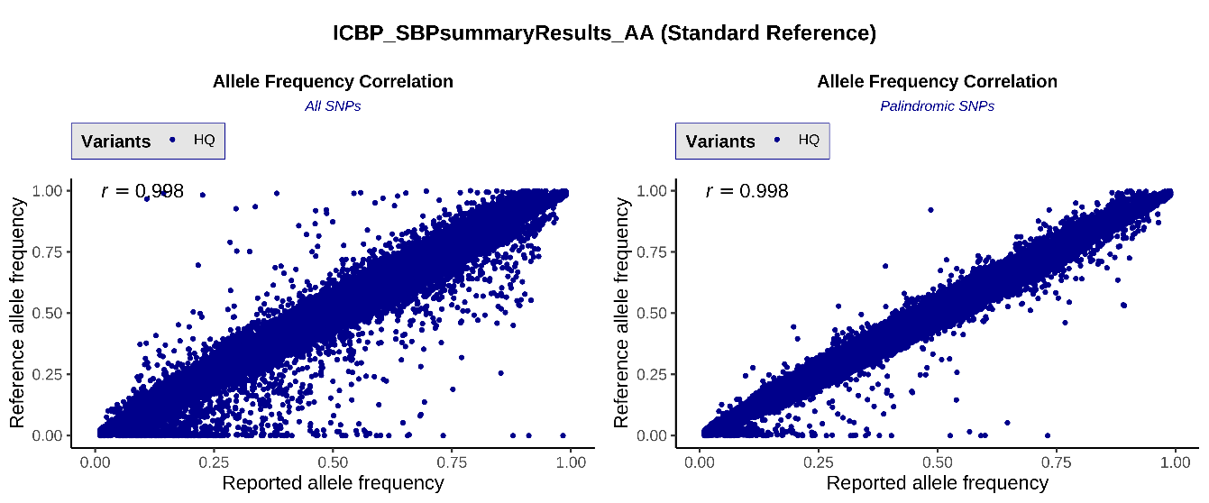
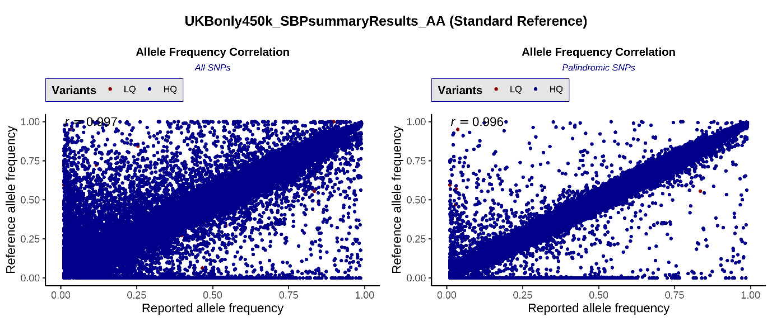
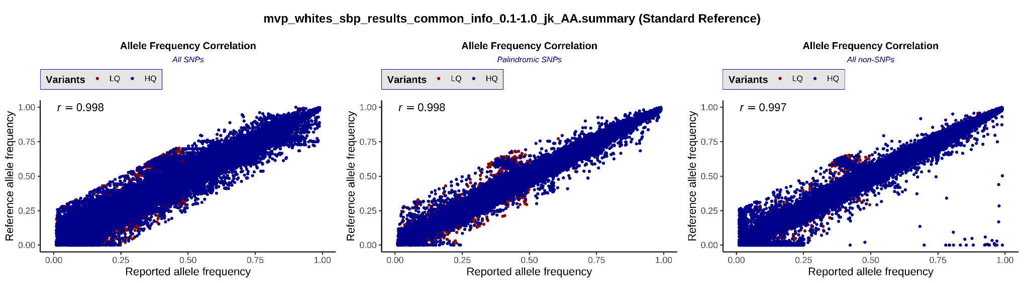
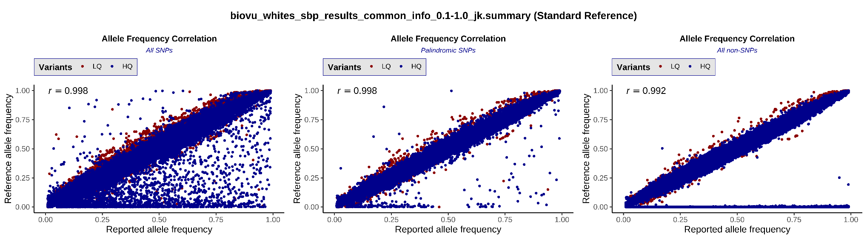
a
b
d
c

Supplementary Figure 1a-d. Allele frequency correlation of ICBP (A), UKB (B), MVP (C), and BioVU (D) systolic blood pressure datasets with the 1000 Genomes reference panel of European individuals in study-level QC. Corresponding plots for DBP and PP were similar (data not shown)
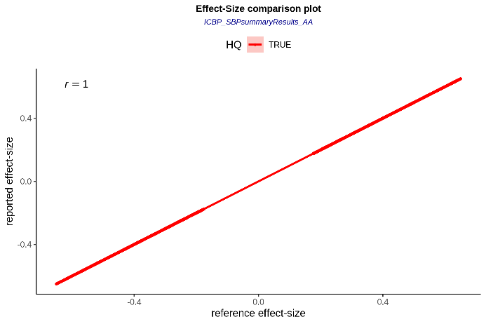
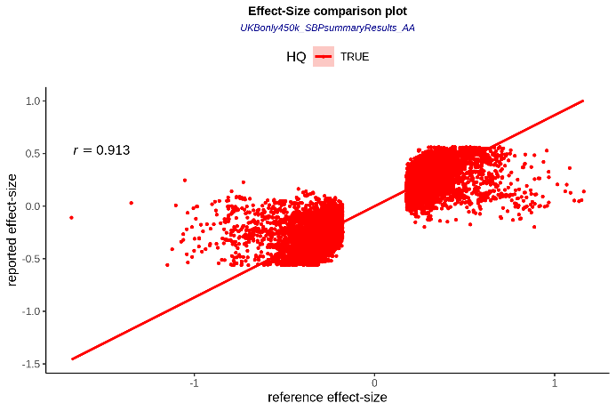
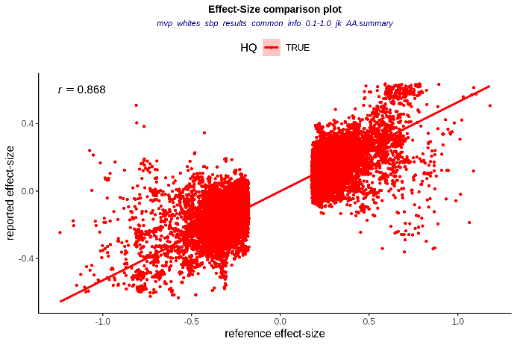
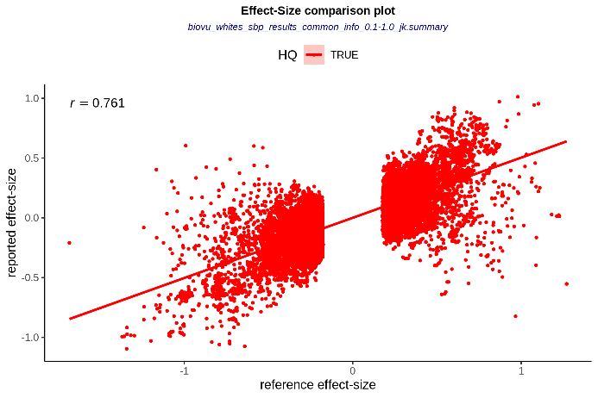
a
b
d
c

Supplementary Figure 2a-d. Effect size correlation of the ICBP (a), UKB (b), MVP (c), and BioVU (d) systolic blood pressure GWAS datasets with the ICBP GWAS results as reference. Corresponding plots for DBP and PP were similar (data not shown).

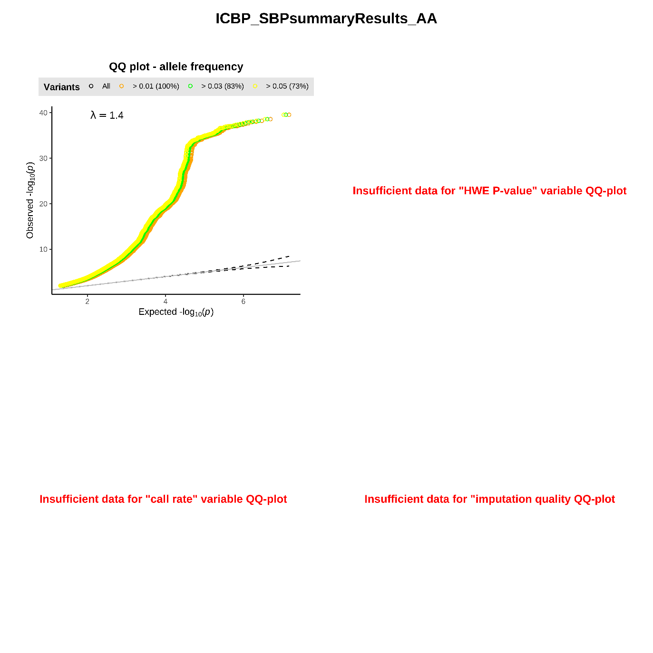
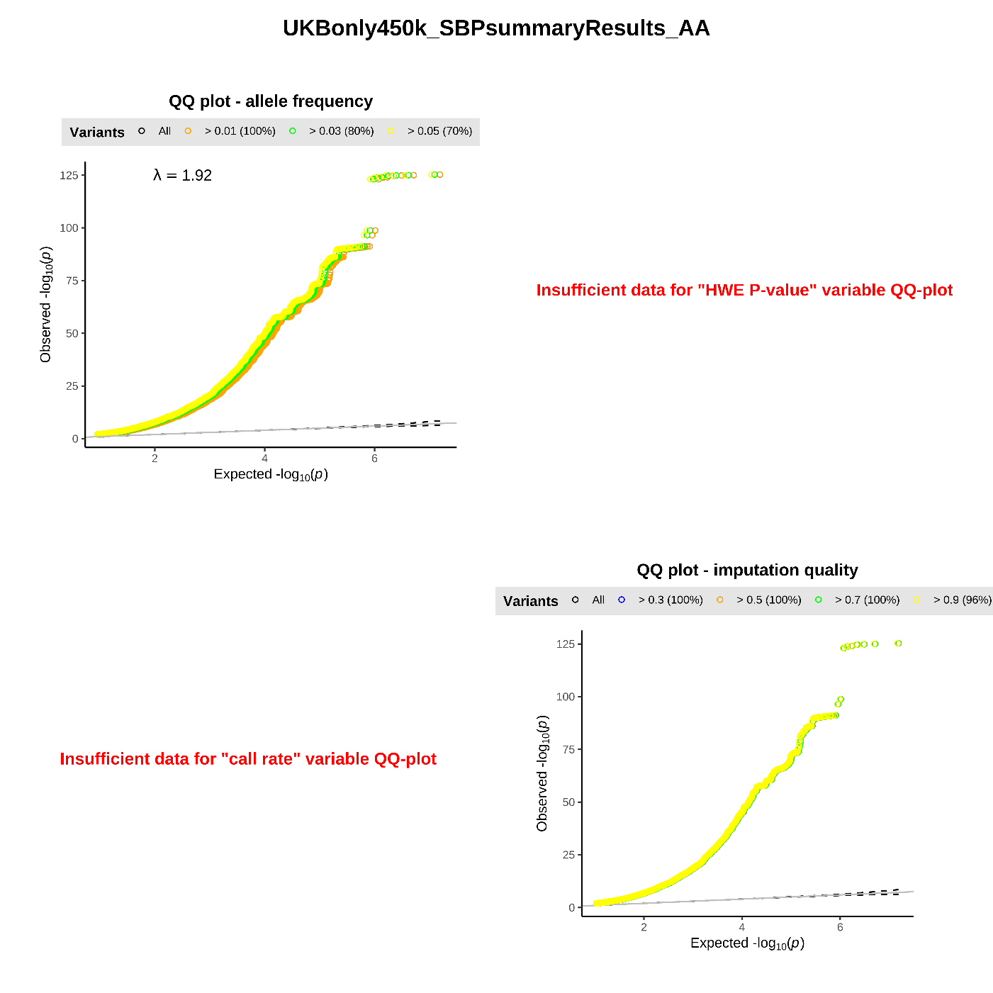
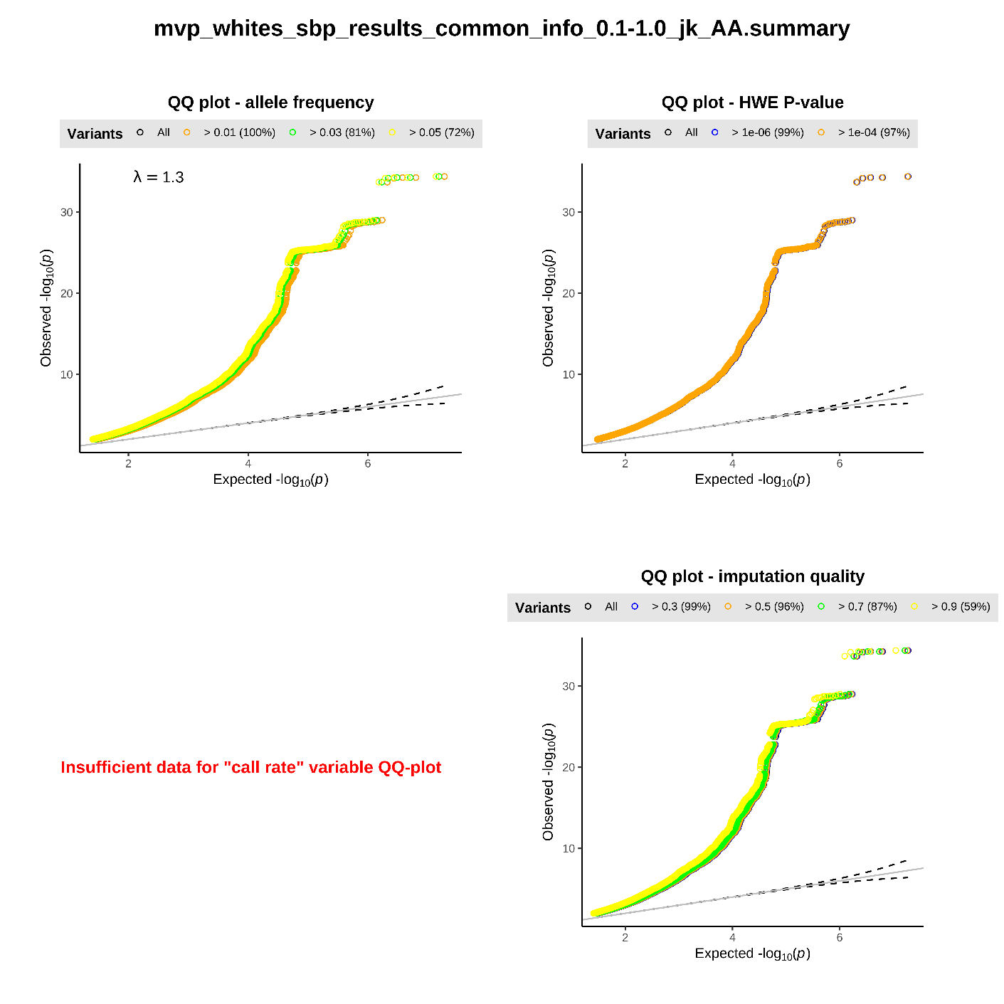
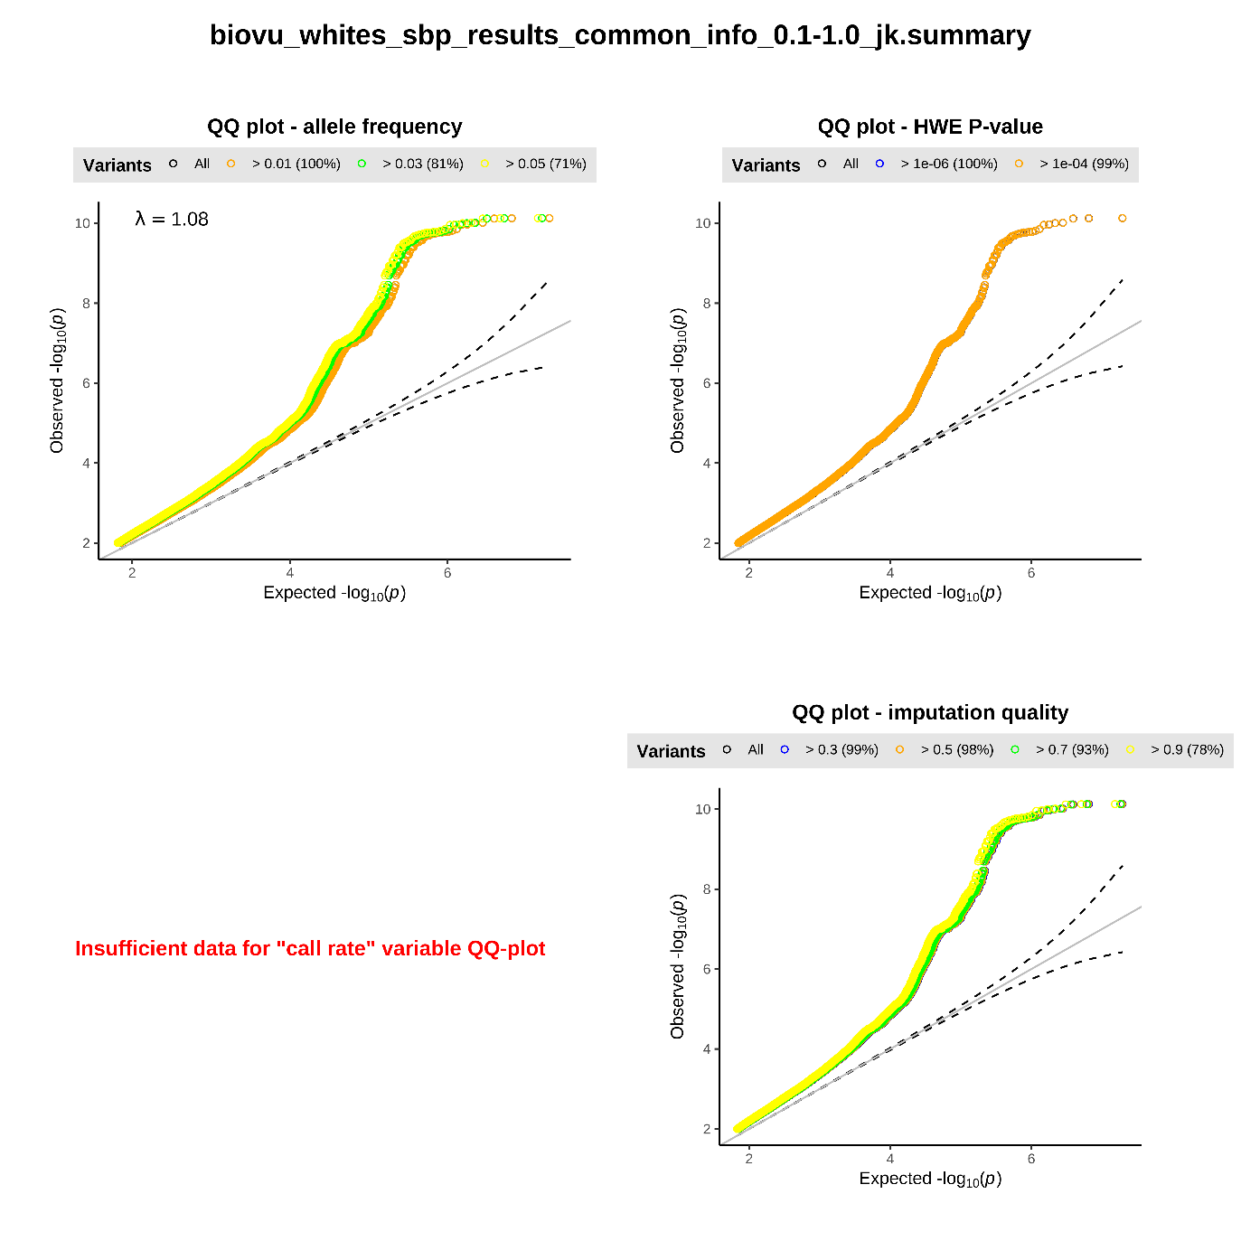
a
b
d
c

a
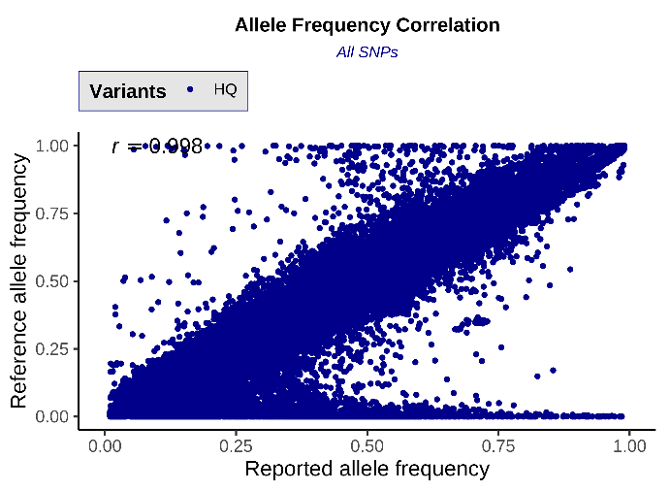
B
Supplementary Figure 3. QQ plots of the ICBP (a), UKB (b), MVP (c), and BioVU (d) systolic blood pressure GWAS datasets. Corresponding plots for DBP and PP were similar (data not shown).

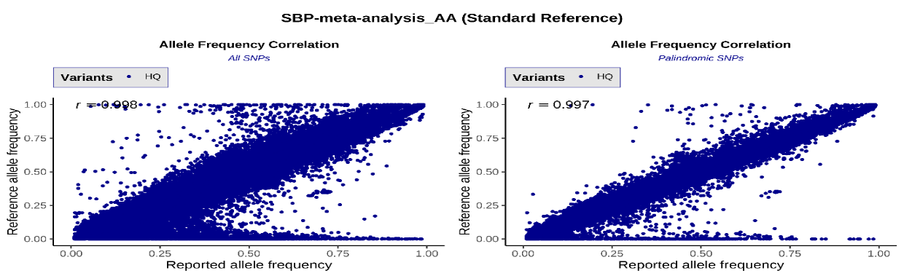
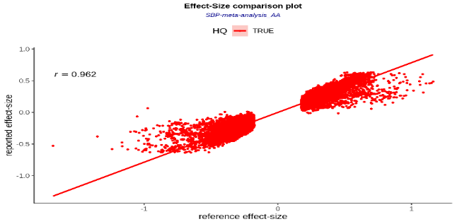
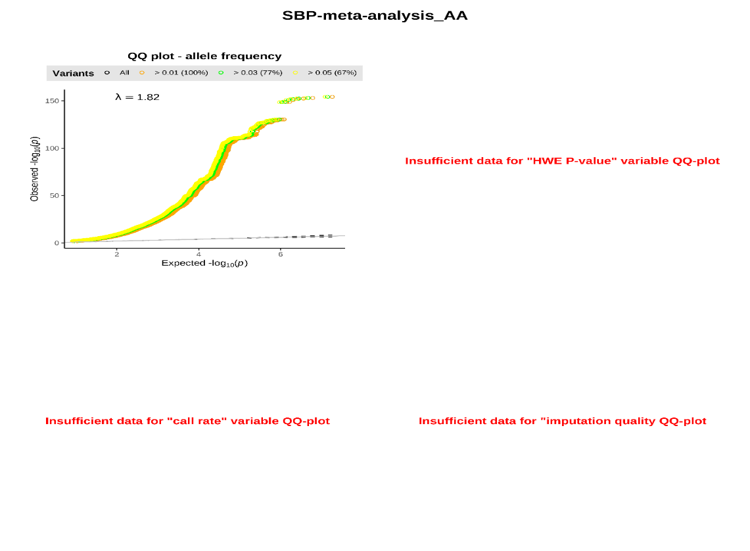
a
c
b

Supplementary Figure 4a-c. Quality checks of the systolic blood pressure meta-analysis results. A) Weighted allele frequency correlation with 1KG reference panel; B) correlation of Meta effect sizes with ICBP data, the same reference as for study-level QC; C) QQ plot of the meta-analysis results. Corresponding plots for DBP and PP were similar (data not shown).

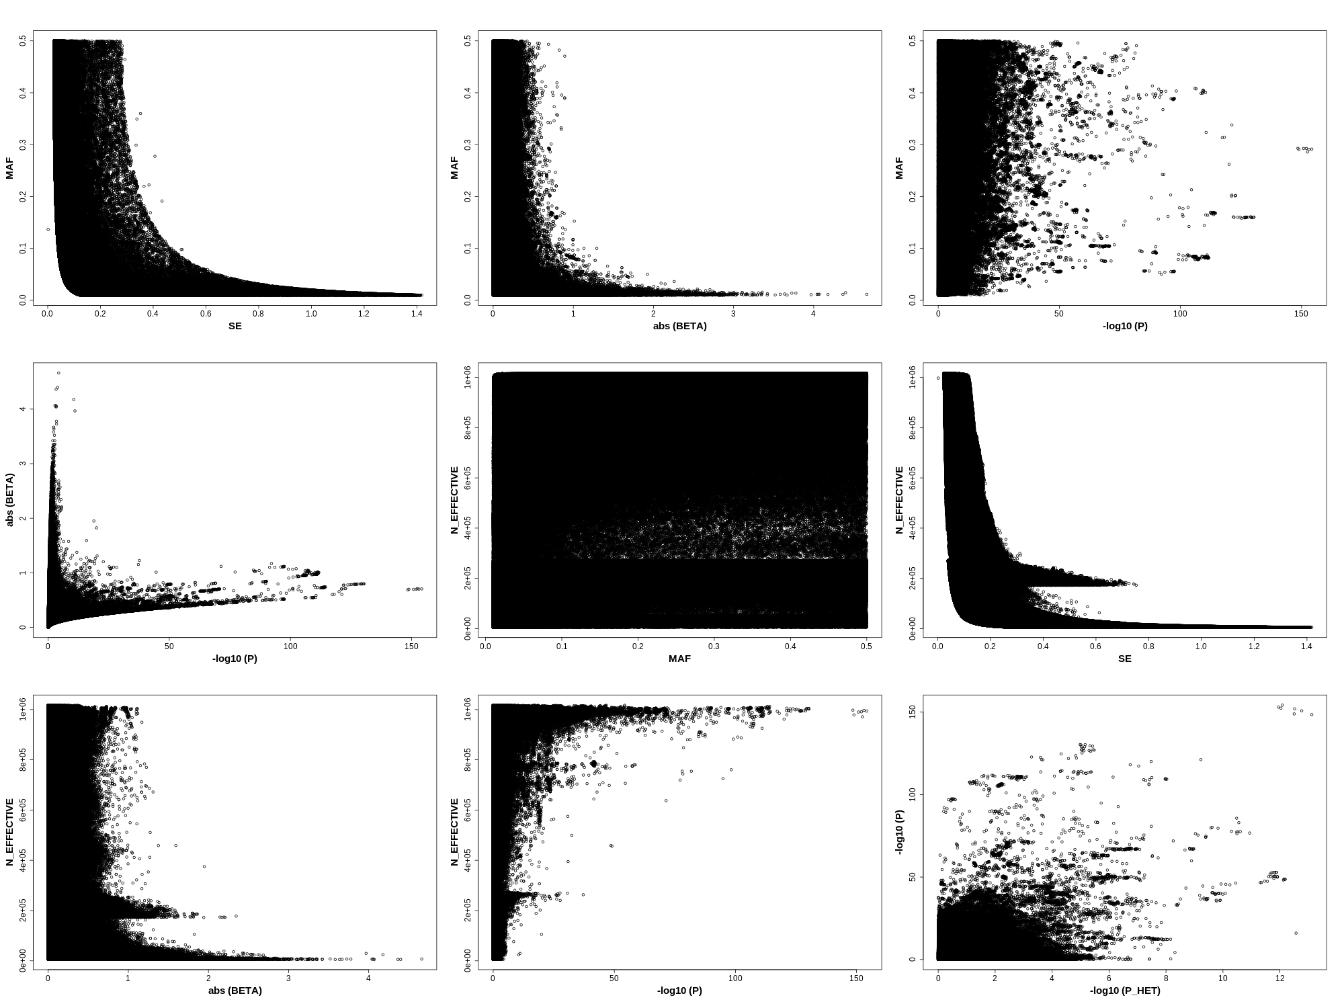

Supplementary Figure 5. Bivariate scatter plots of the key summary statistics in meta-analysis results. All data shown is for systolic blood pressure meta-analysis results. Corresponding plots for DBP and PP were similar (data not shown).

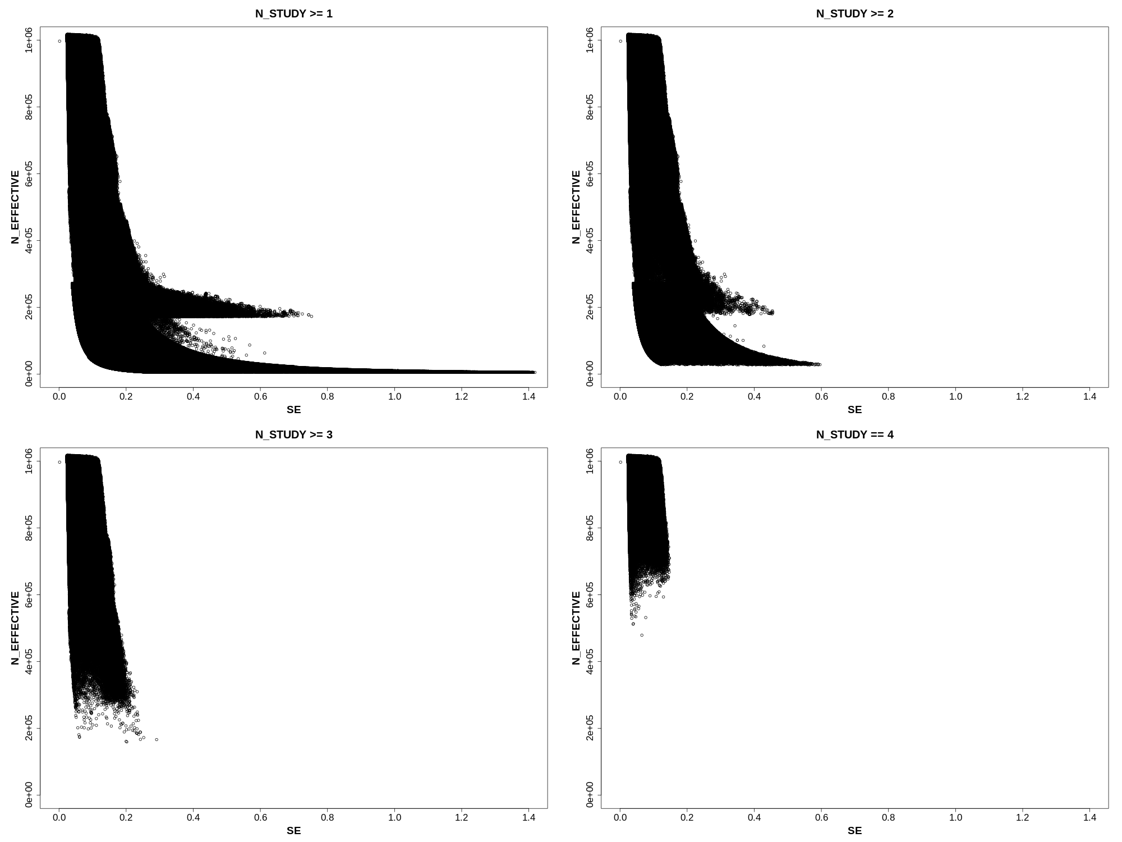
Supplementary Figure 6. Selection of filtering criteria based on N_STUDY. All data shown is for systolic blood pressure meta-analysis results. Corresponding plots for DBP and PP were similar (data not shown).
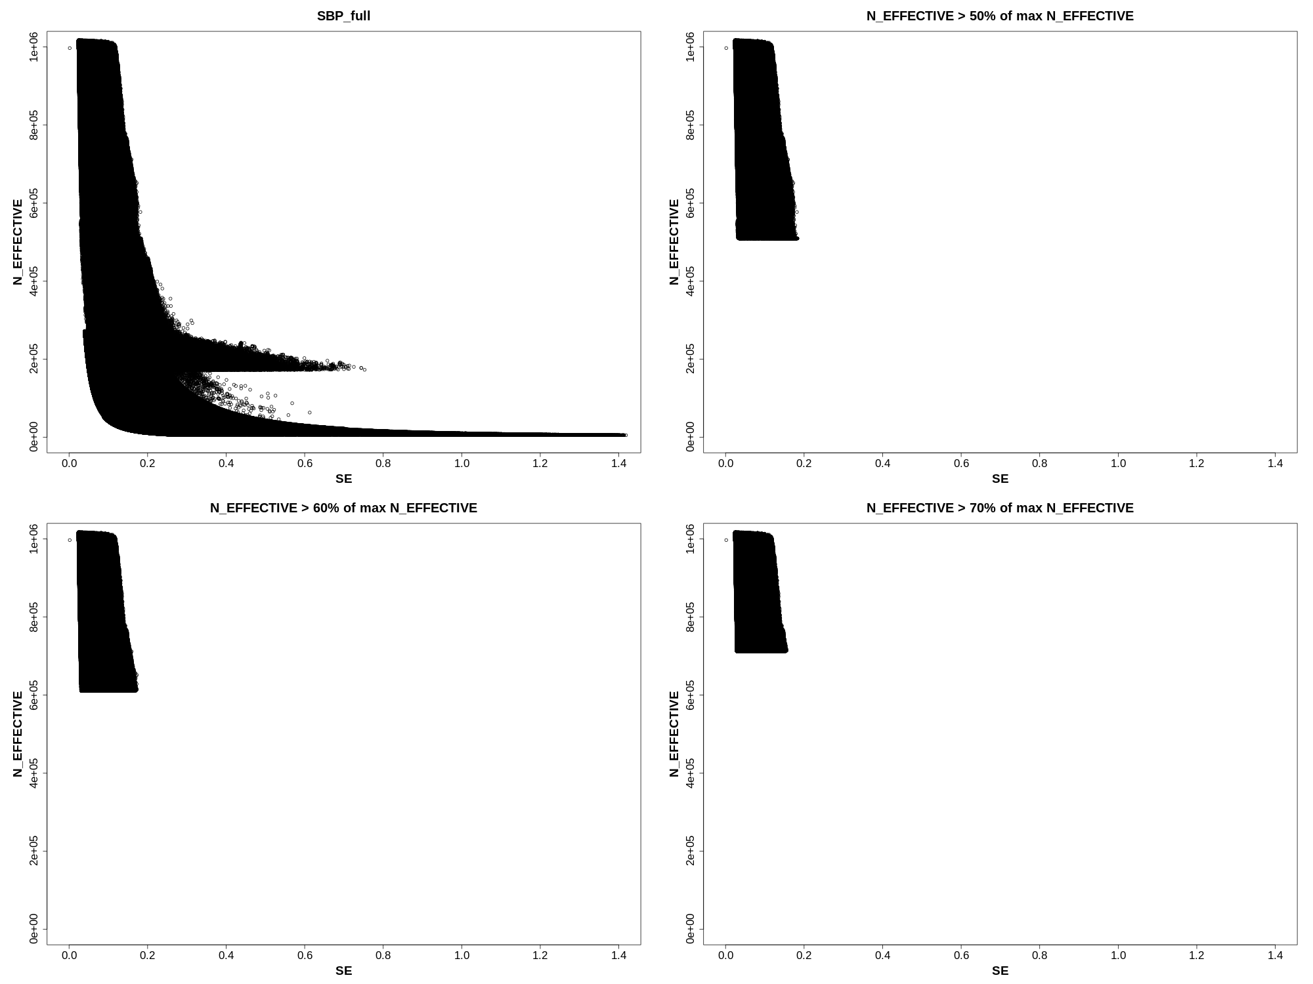
Supplementary Figure 7. Selection of filtering criteria based on N_EFFECTIVE. All data shown is for systolic blood pressure meta-analysis results. Corresponding plots for DBP and PP were similar (data not shown).
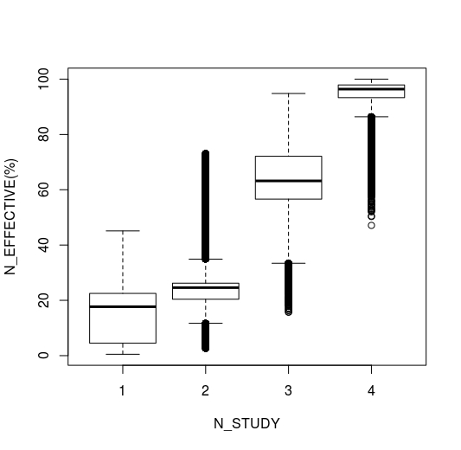
Supplementary Figure 8. The distribution of percent max(N_EFFECTIVE), per N_STUDY in systolic blood pressure meta-analysis results. Corresponding plots for DBP and PP were similar (data not shown).

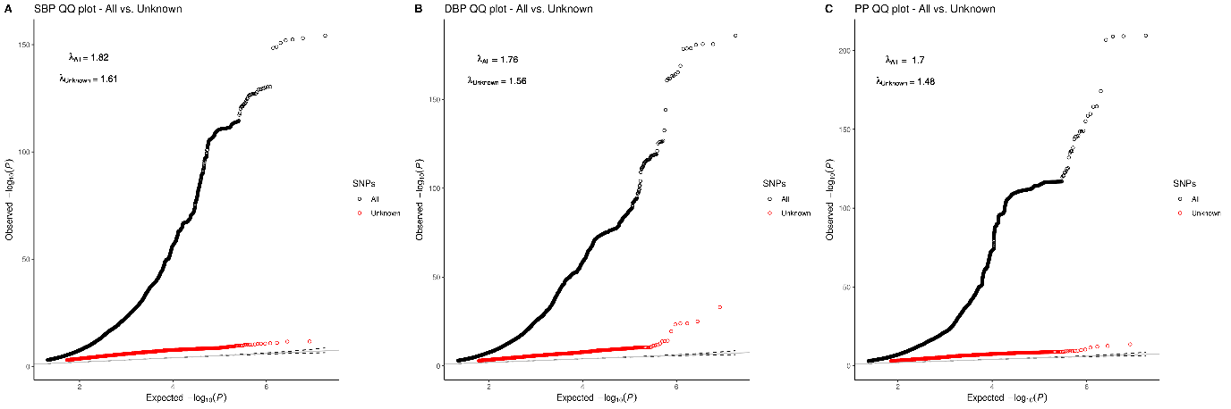
Supplementary Figure 9a-c. QQ plots of meta-analysis results for all versus novel variants.

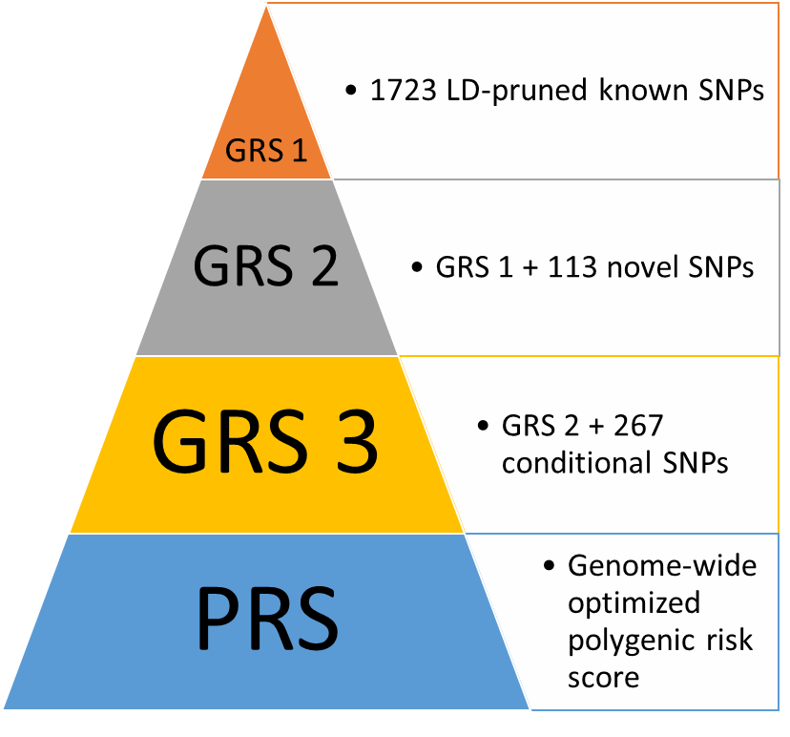
Supplementary Figure 10. GRSs and PRS tested for percent variance explained in Lifelines cohort.

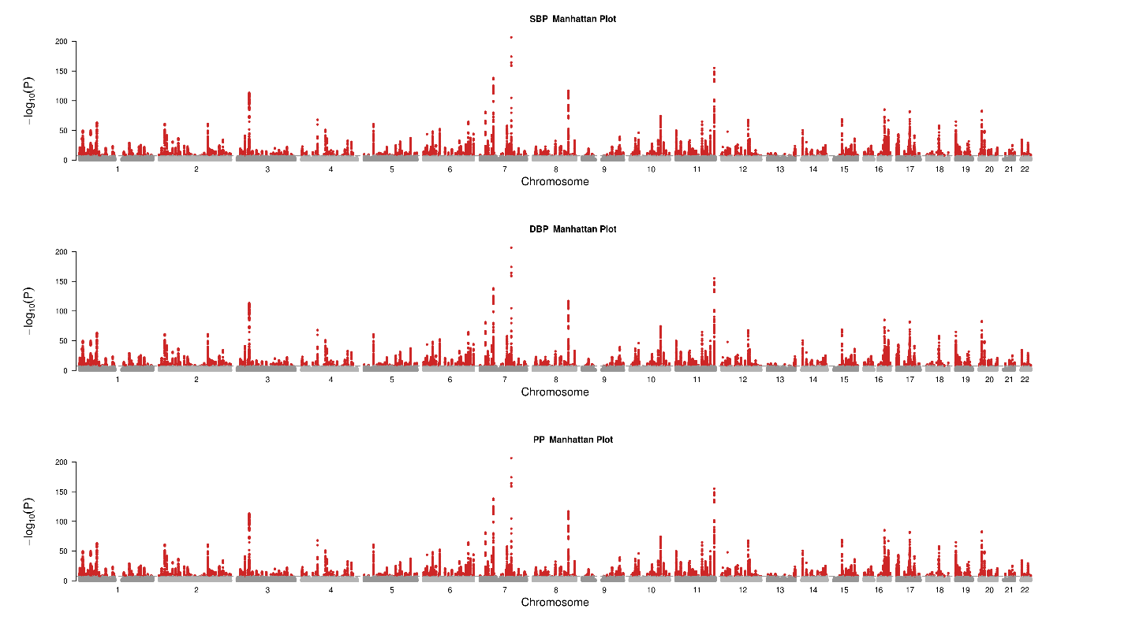
a
b
c
Supplementary Figure 11. Manhattan plots of meta-analysis full results, showing 1,495, 1,504, and 1,318 significant loci for systolic (a), diastolic (b), and pulse pressure (c) in total (r² < 0.05 and 1Mb distance).

a
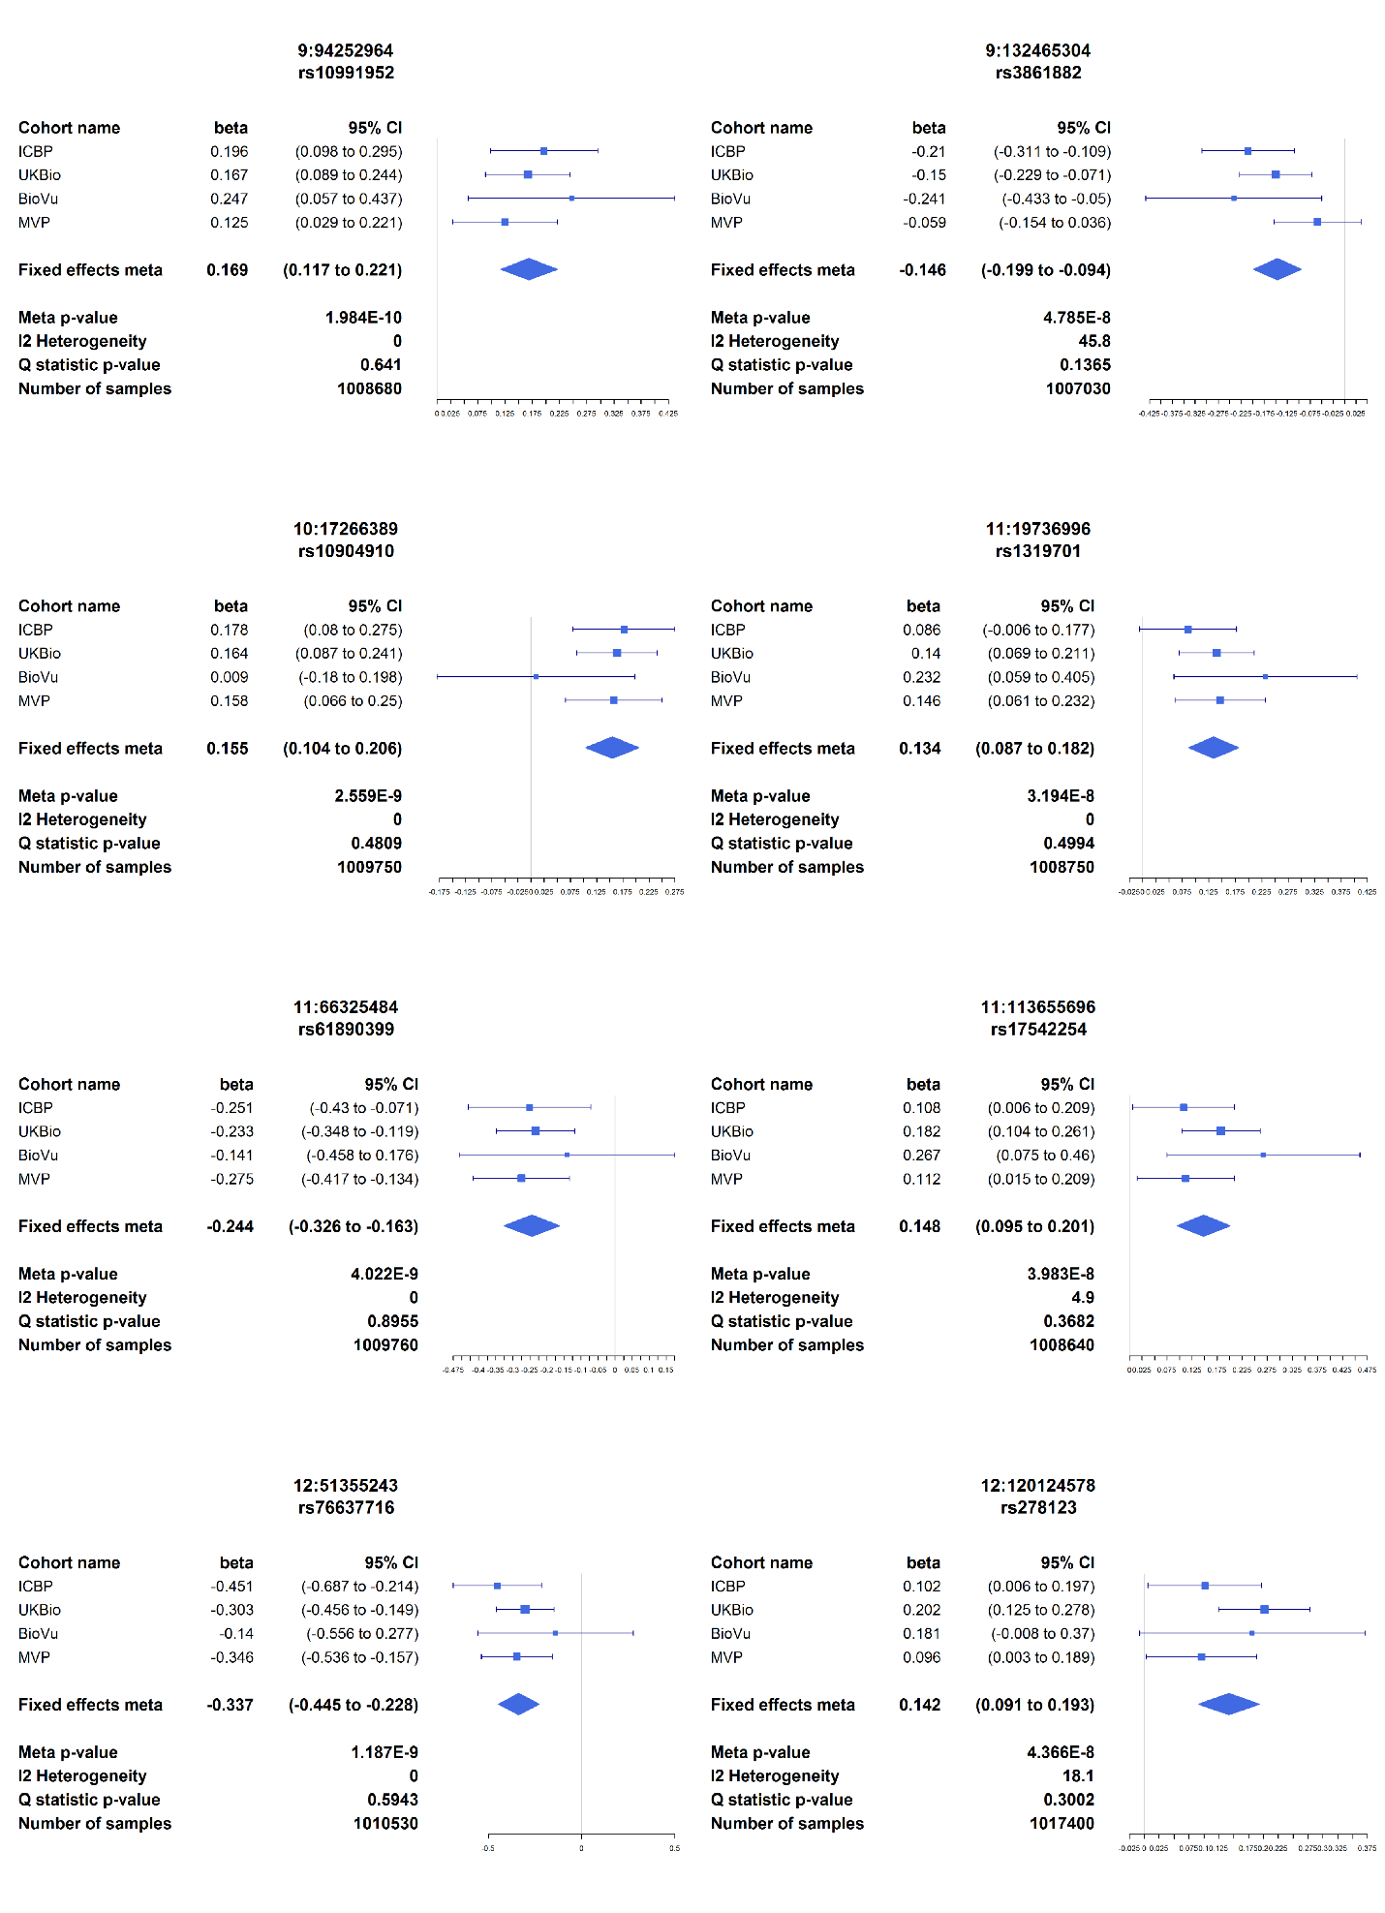
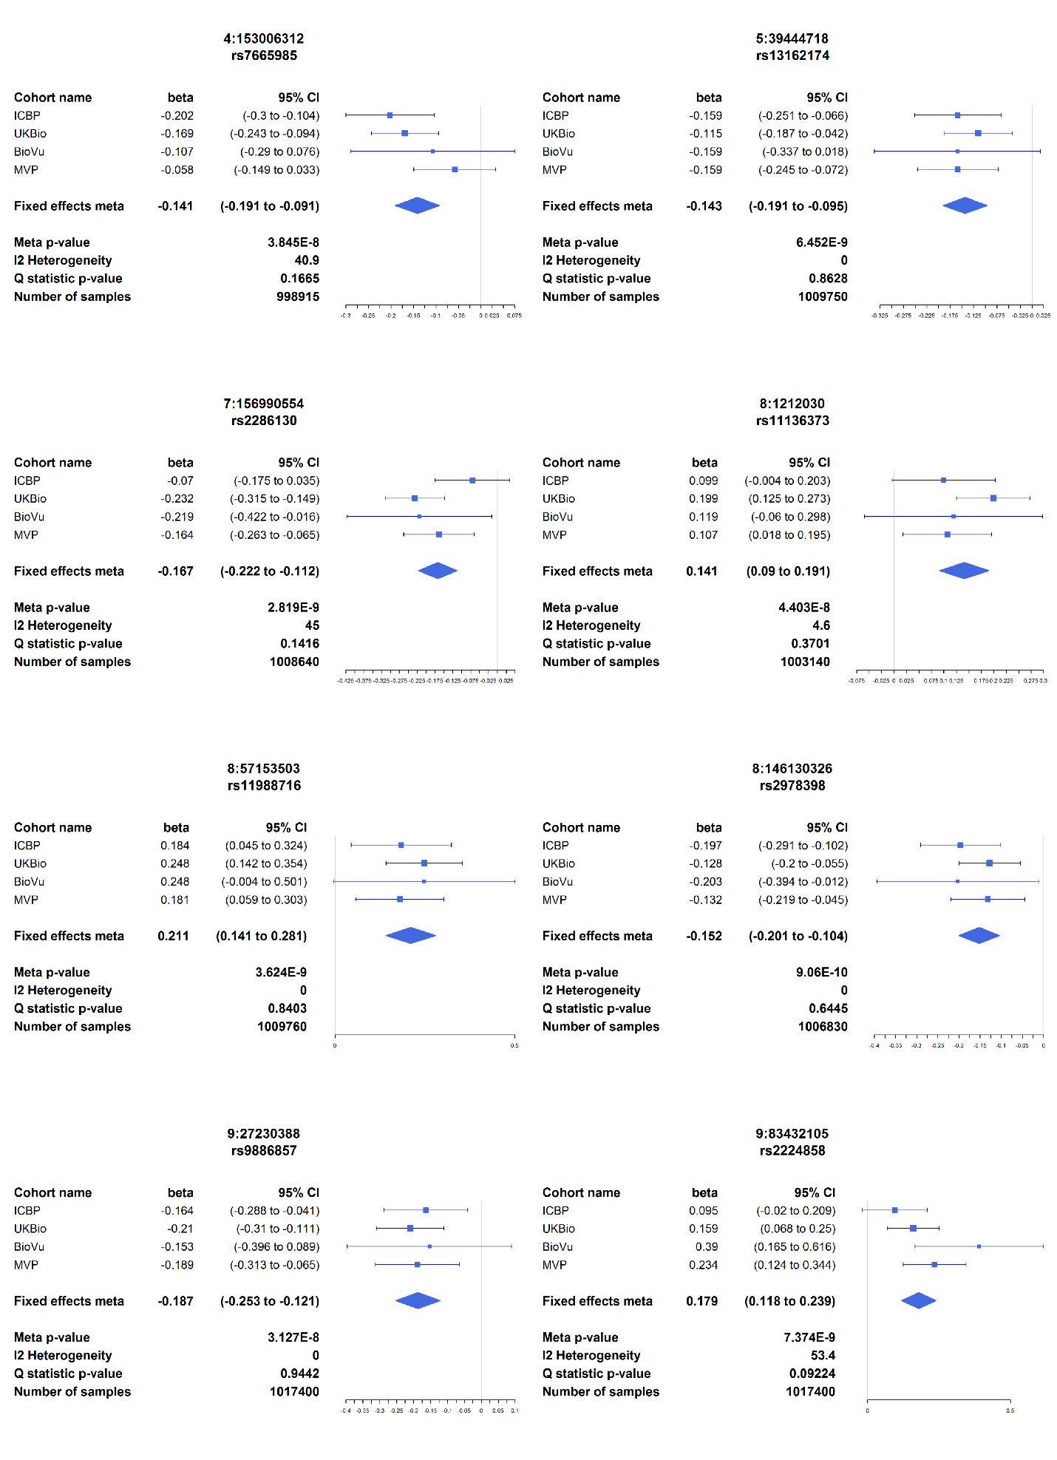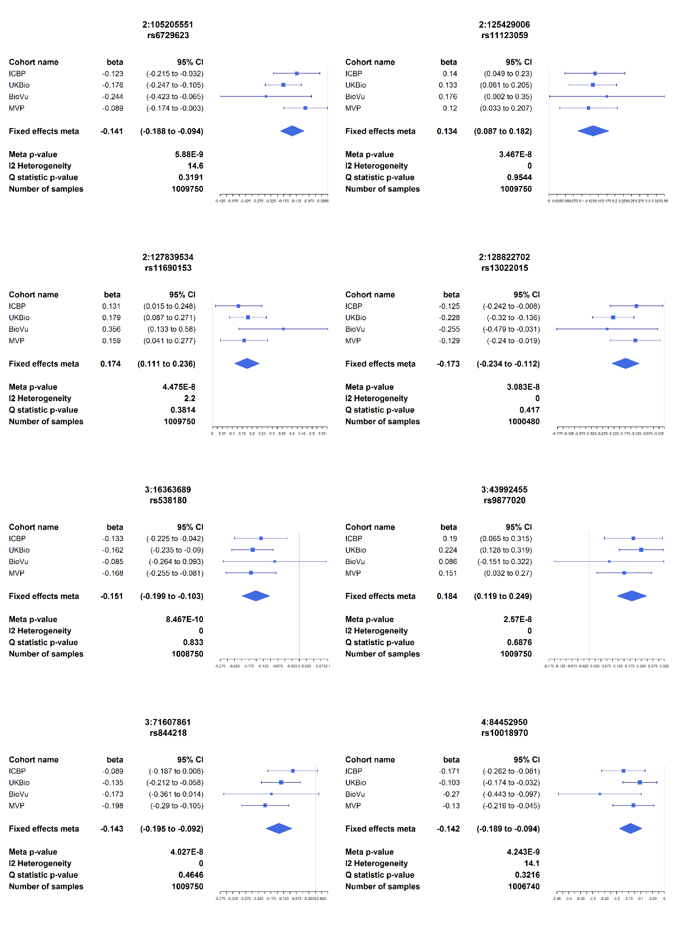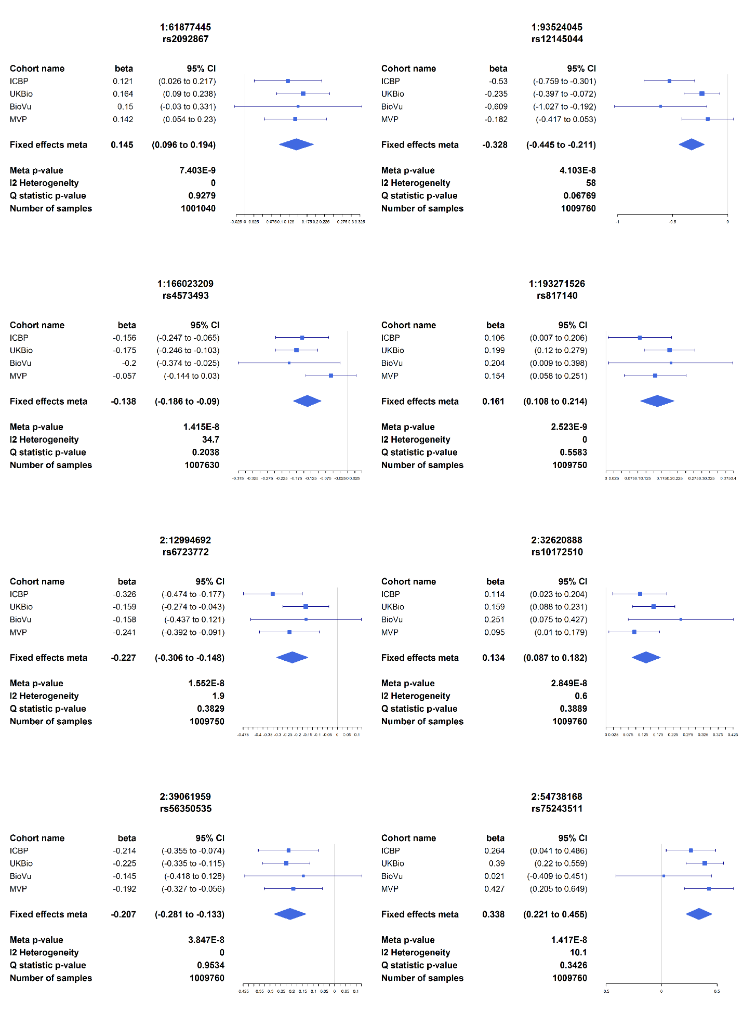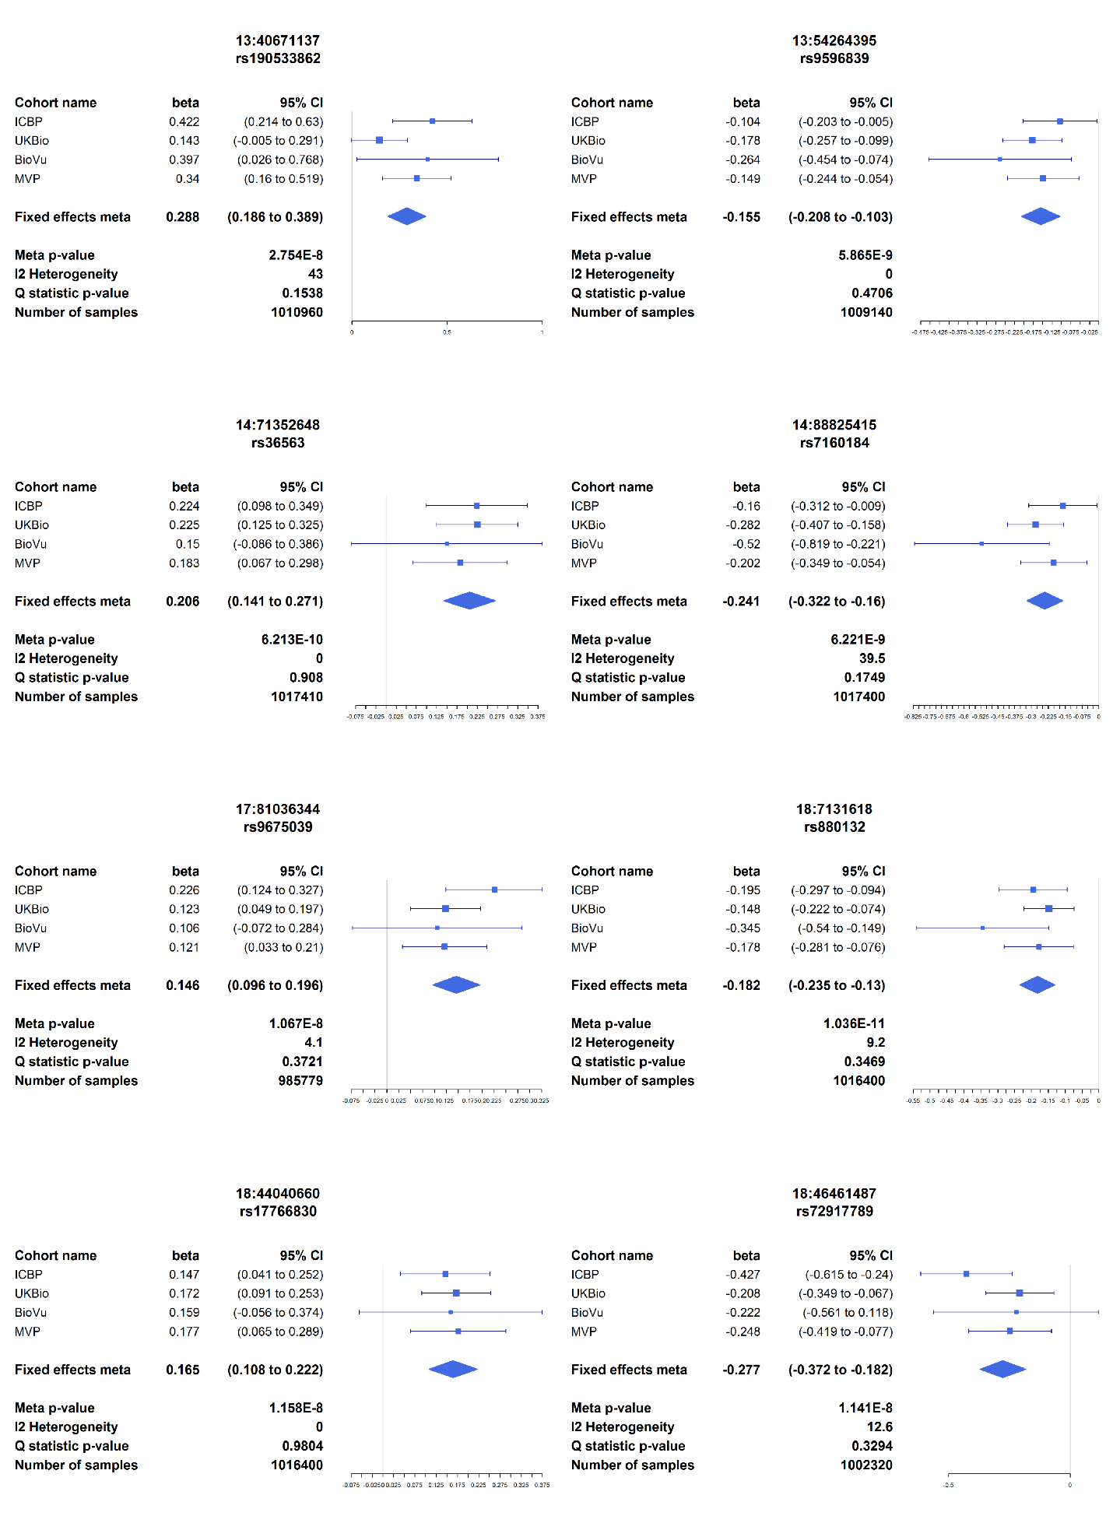
b
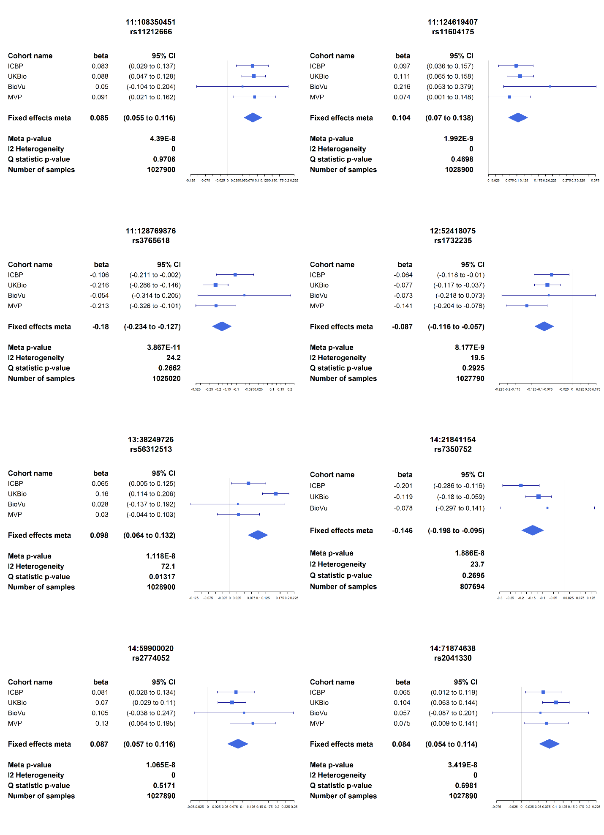
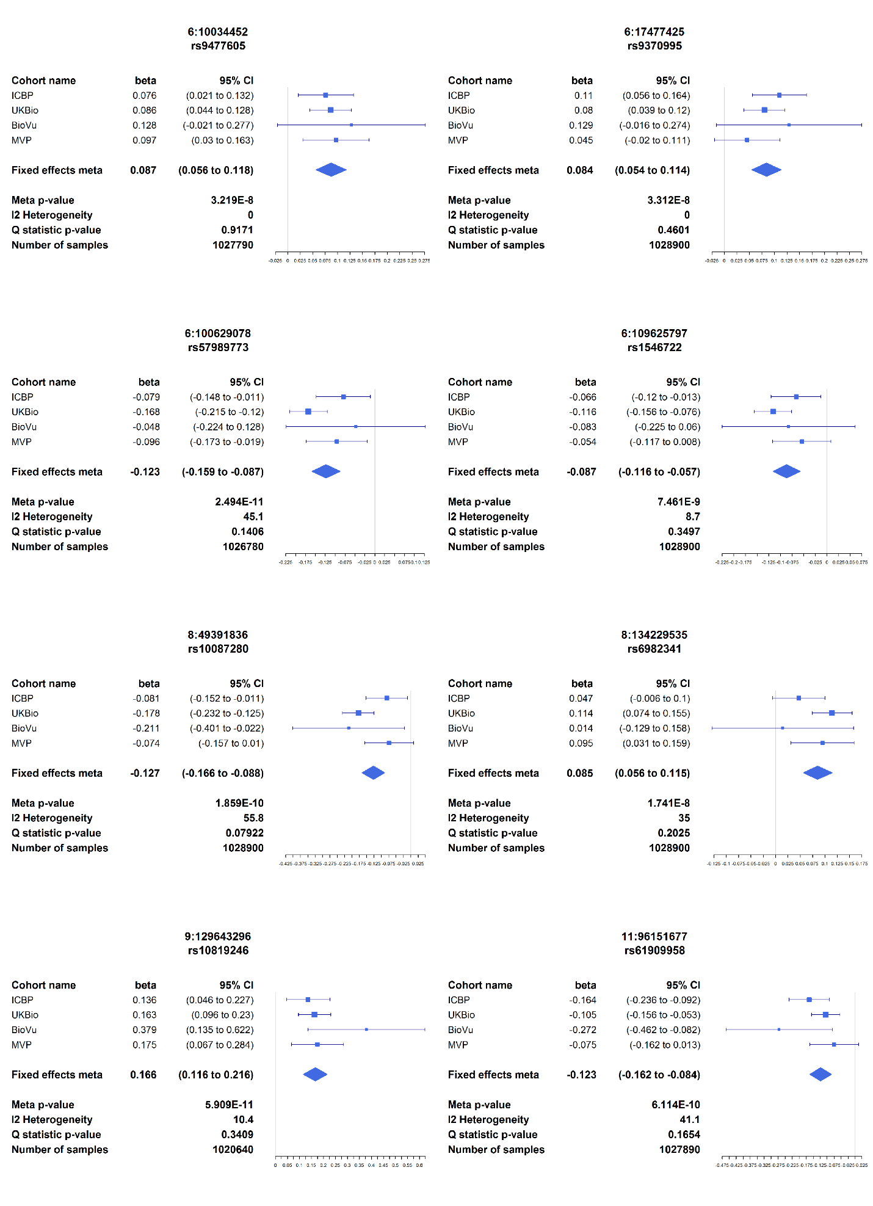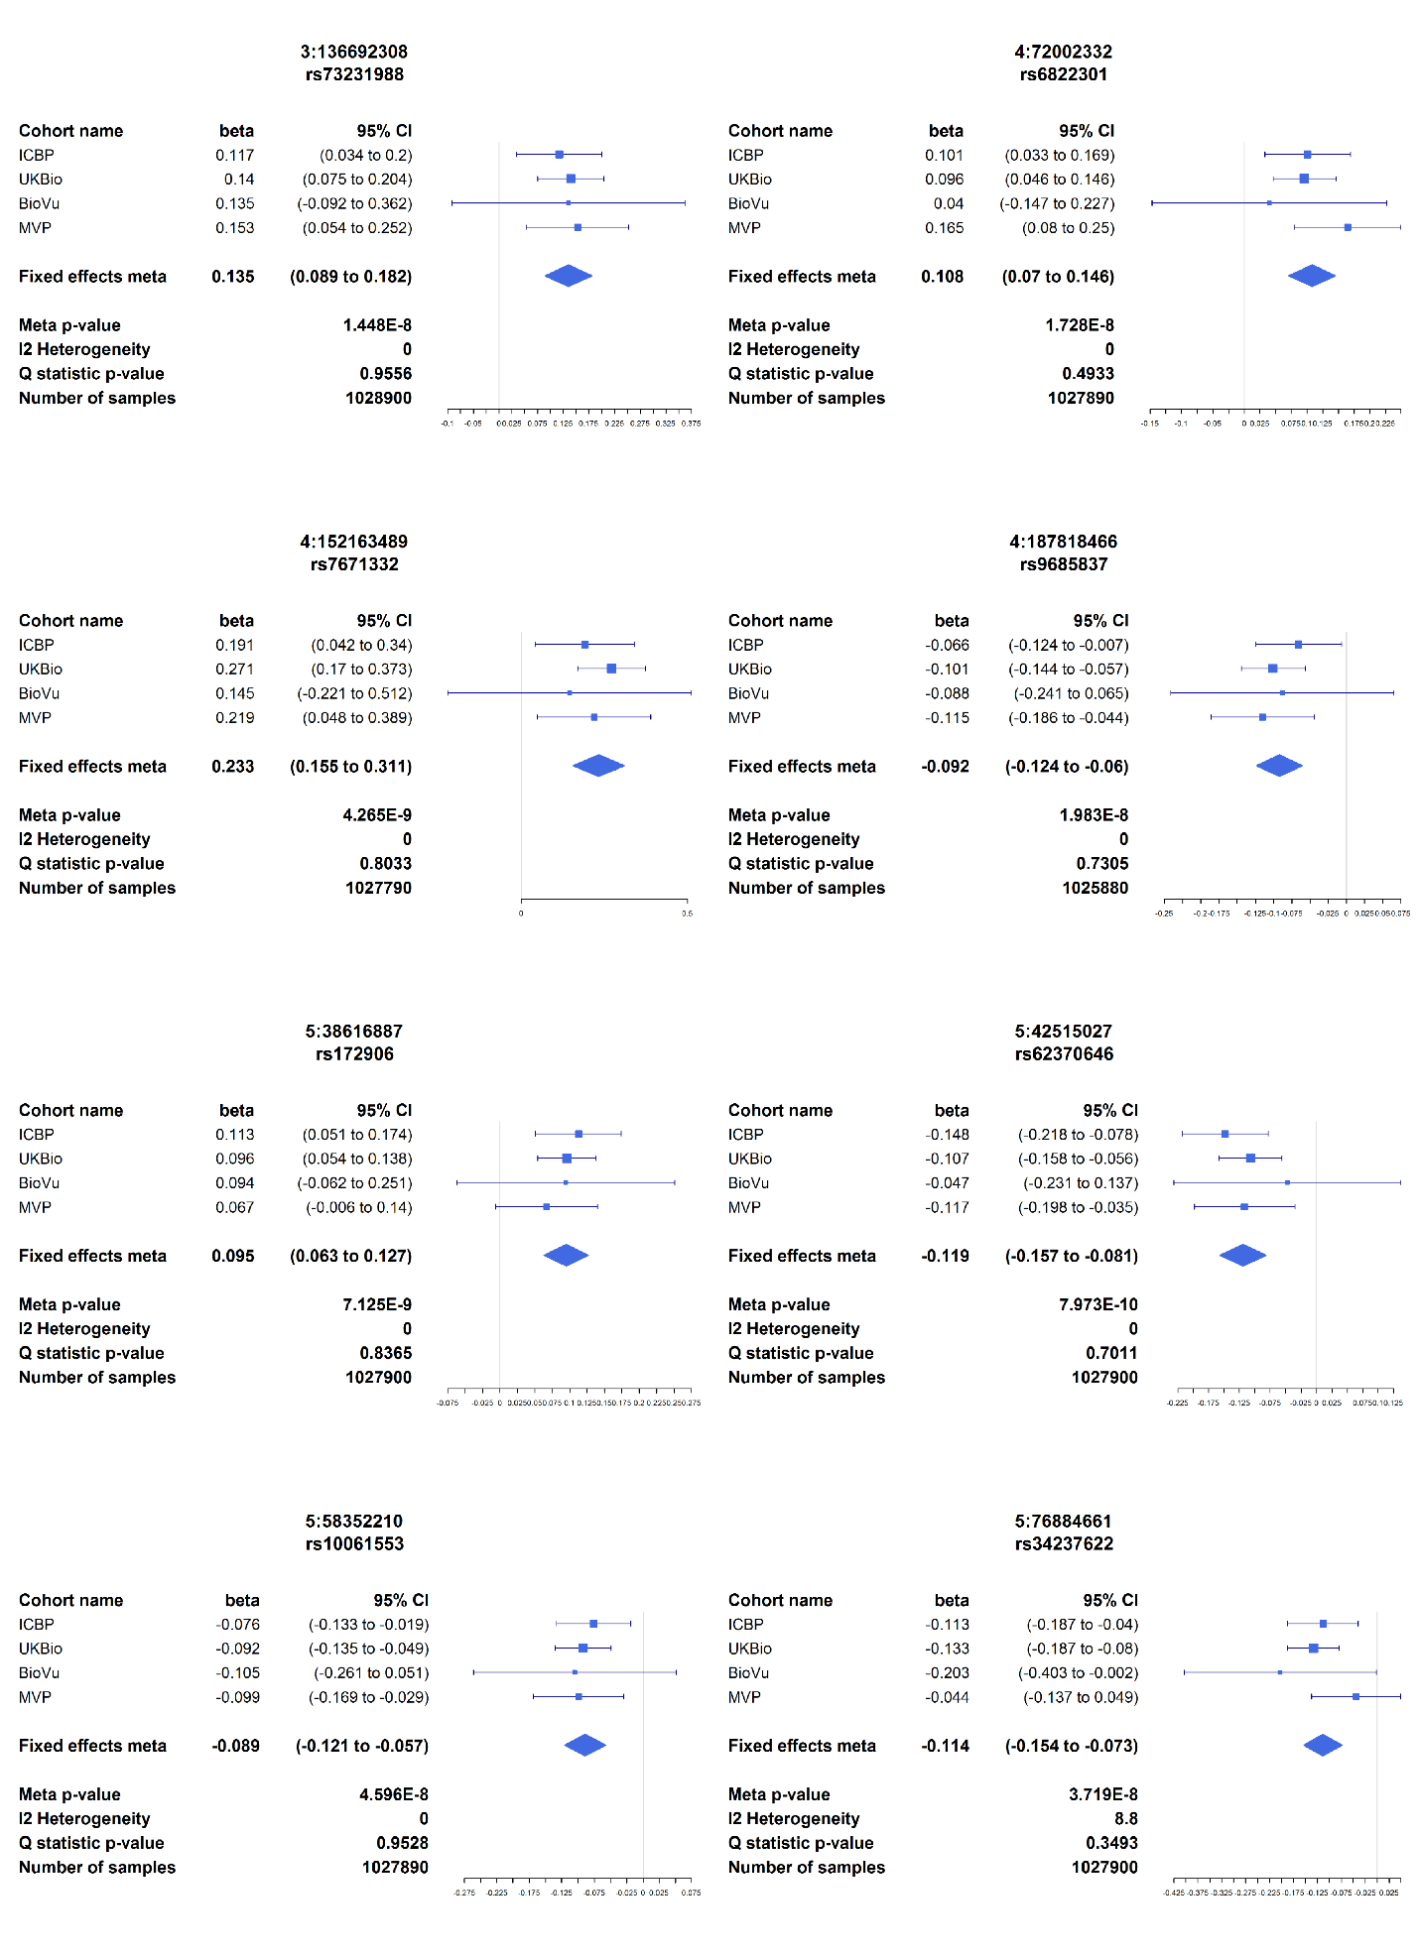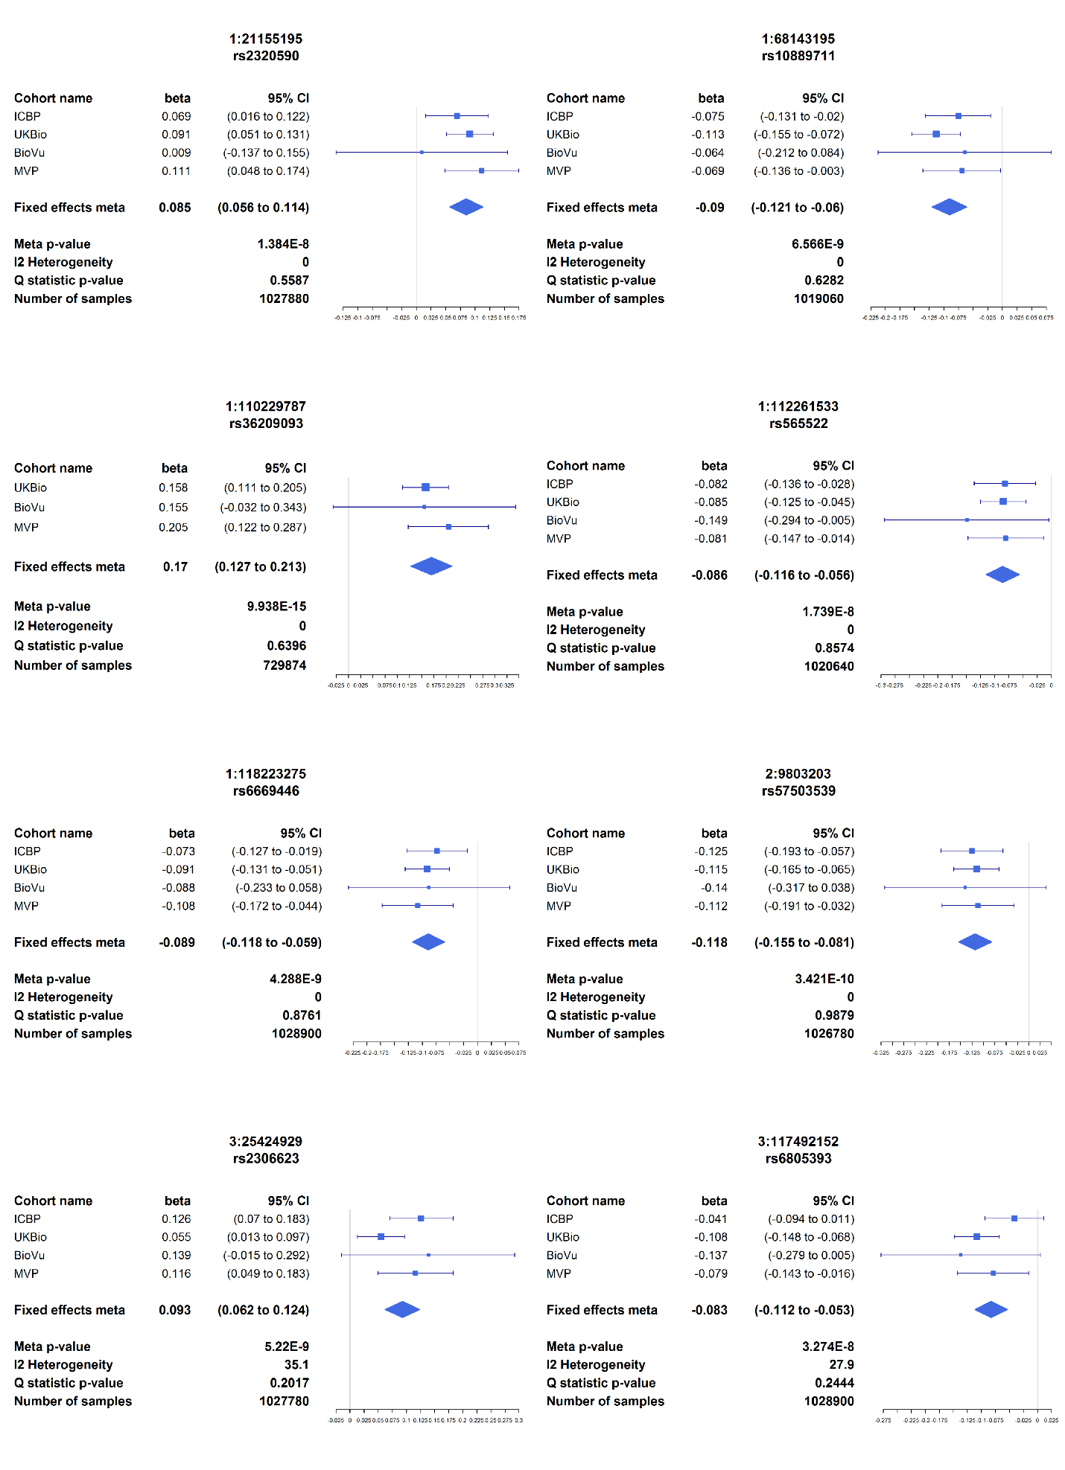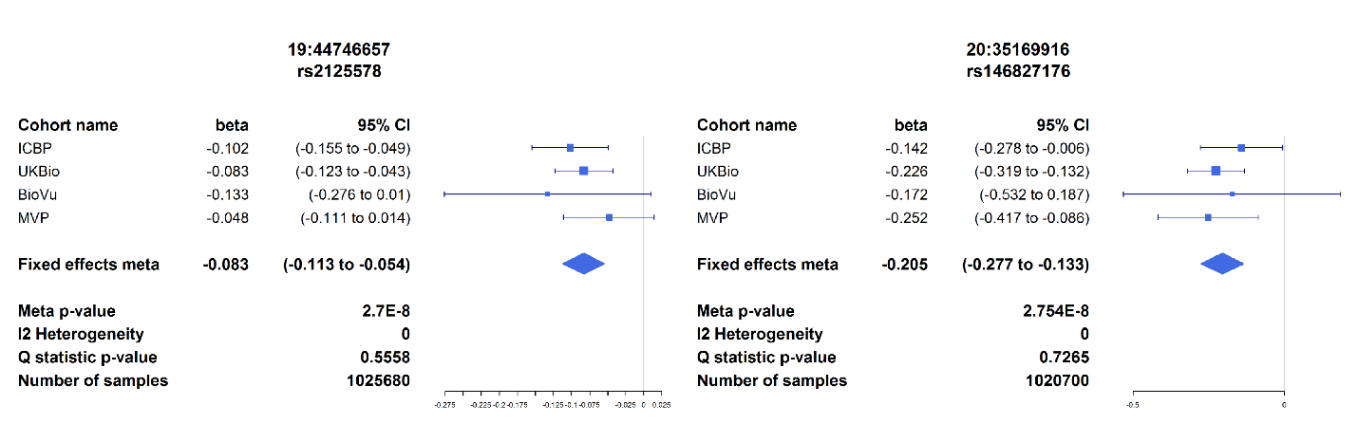

c
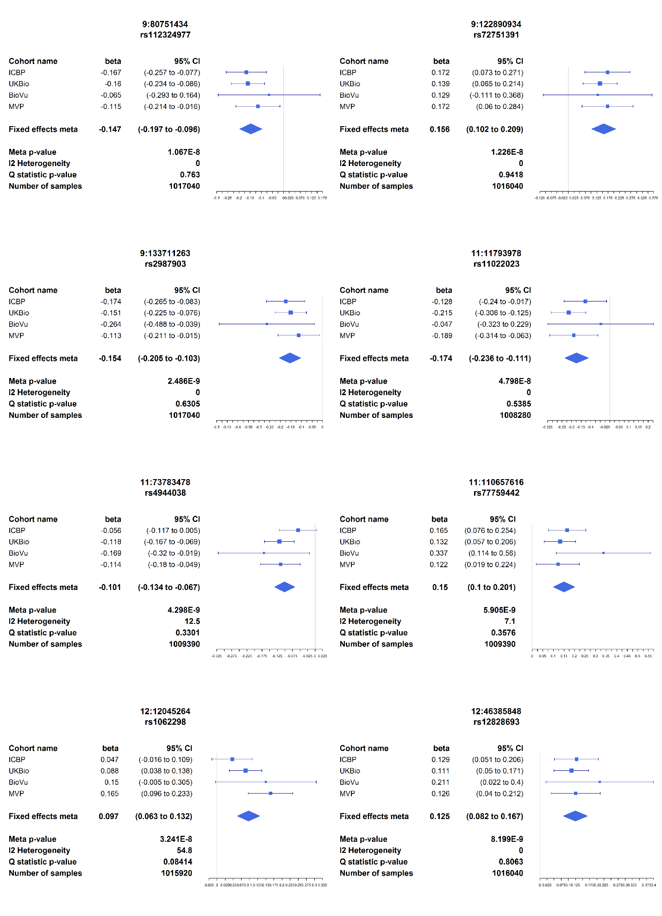
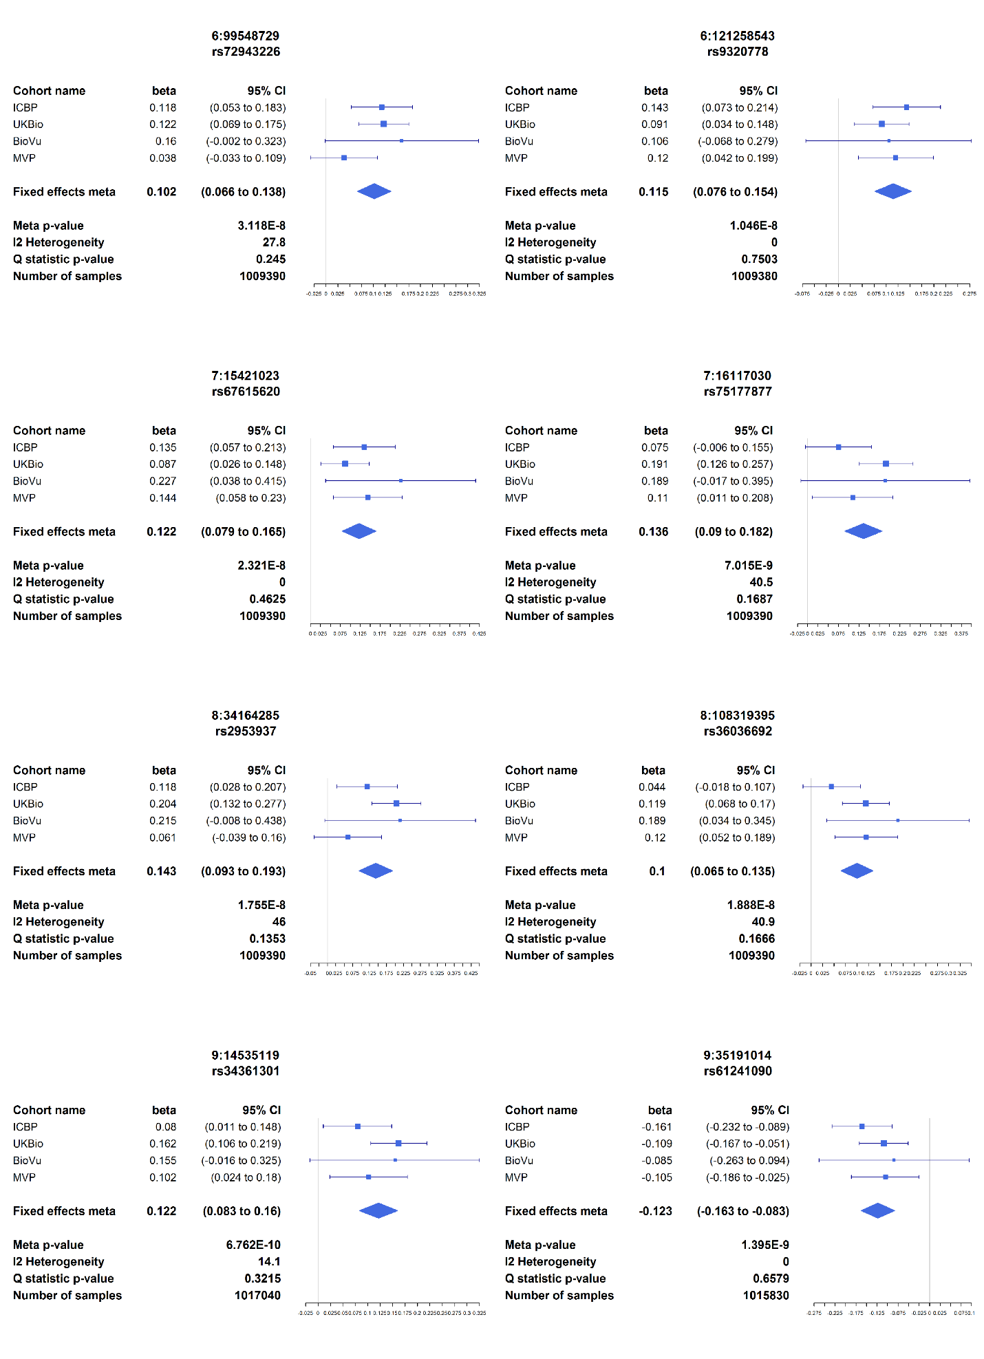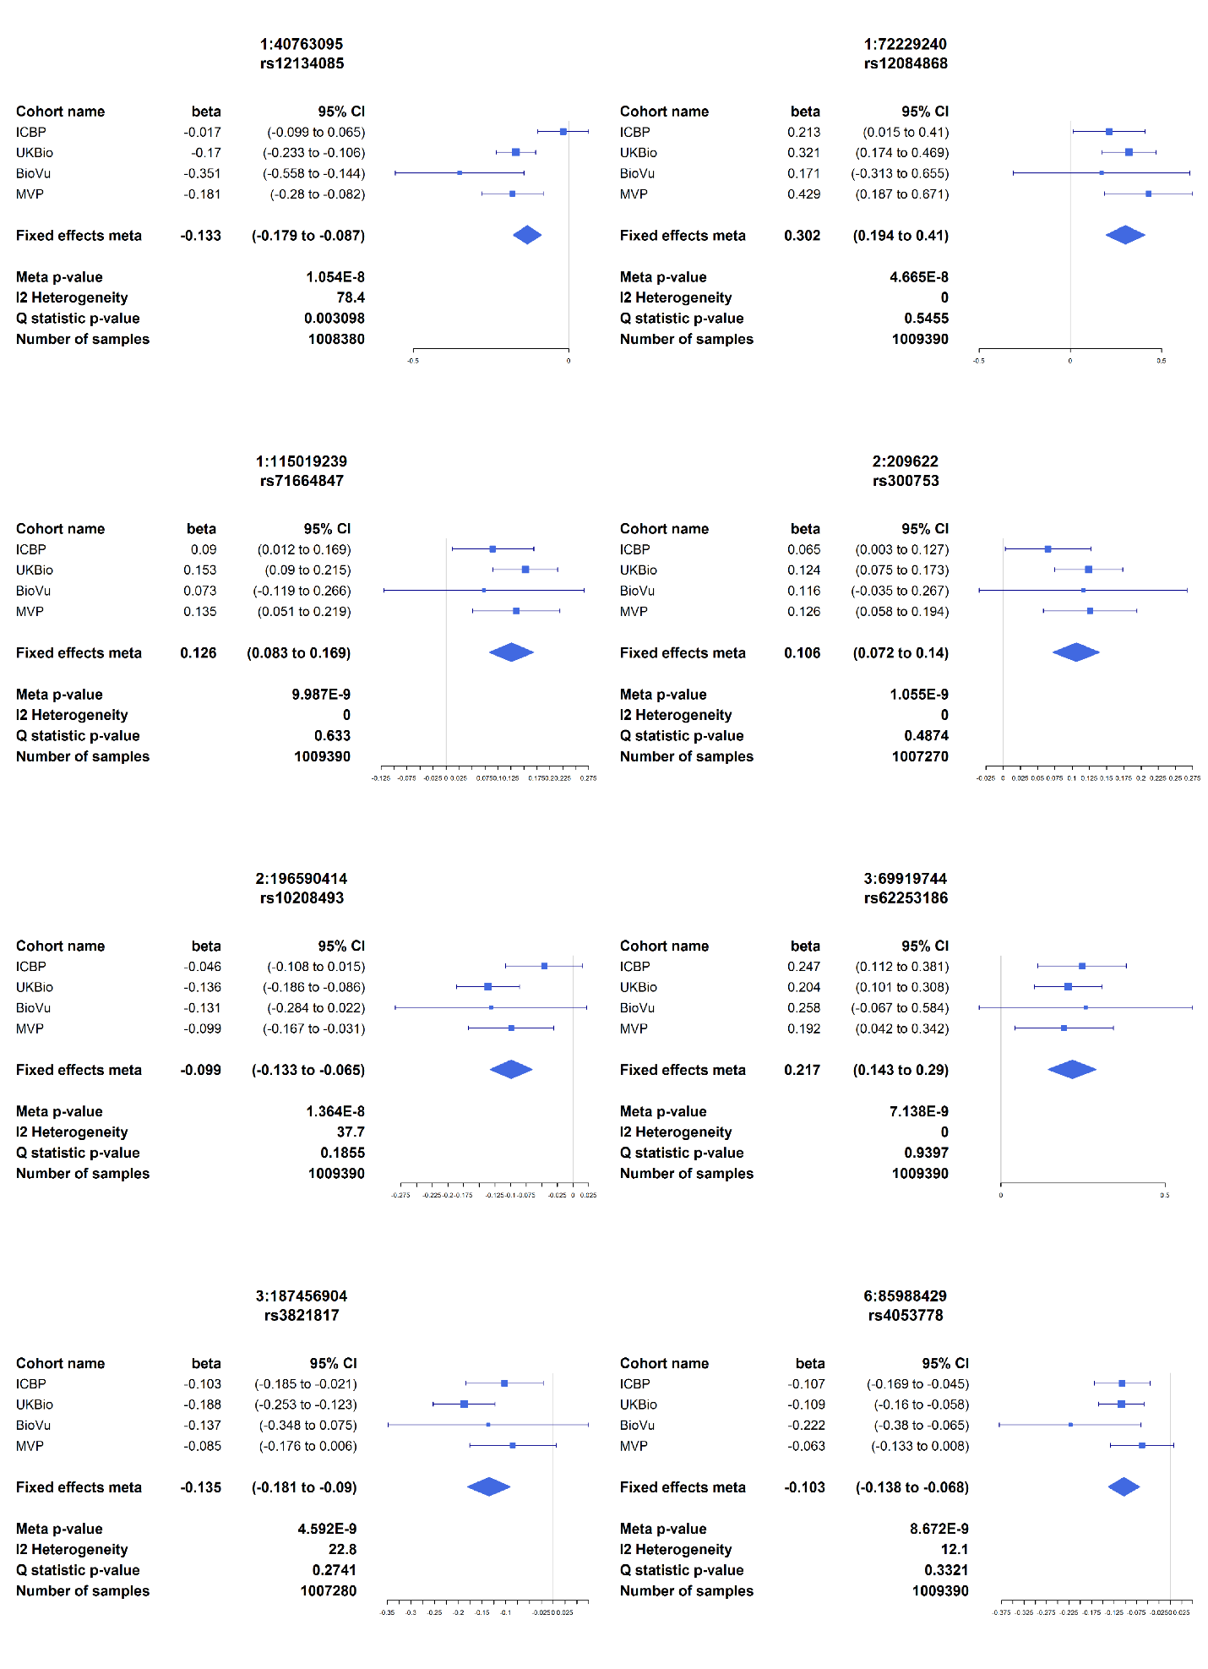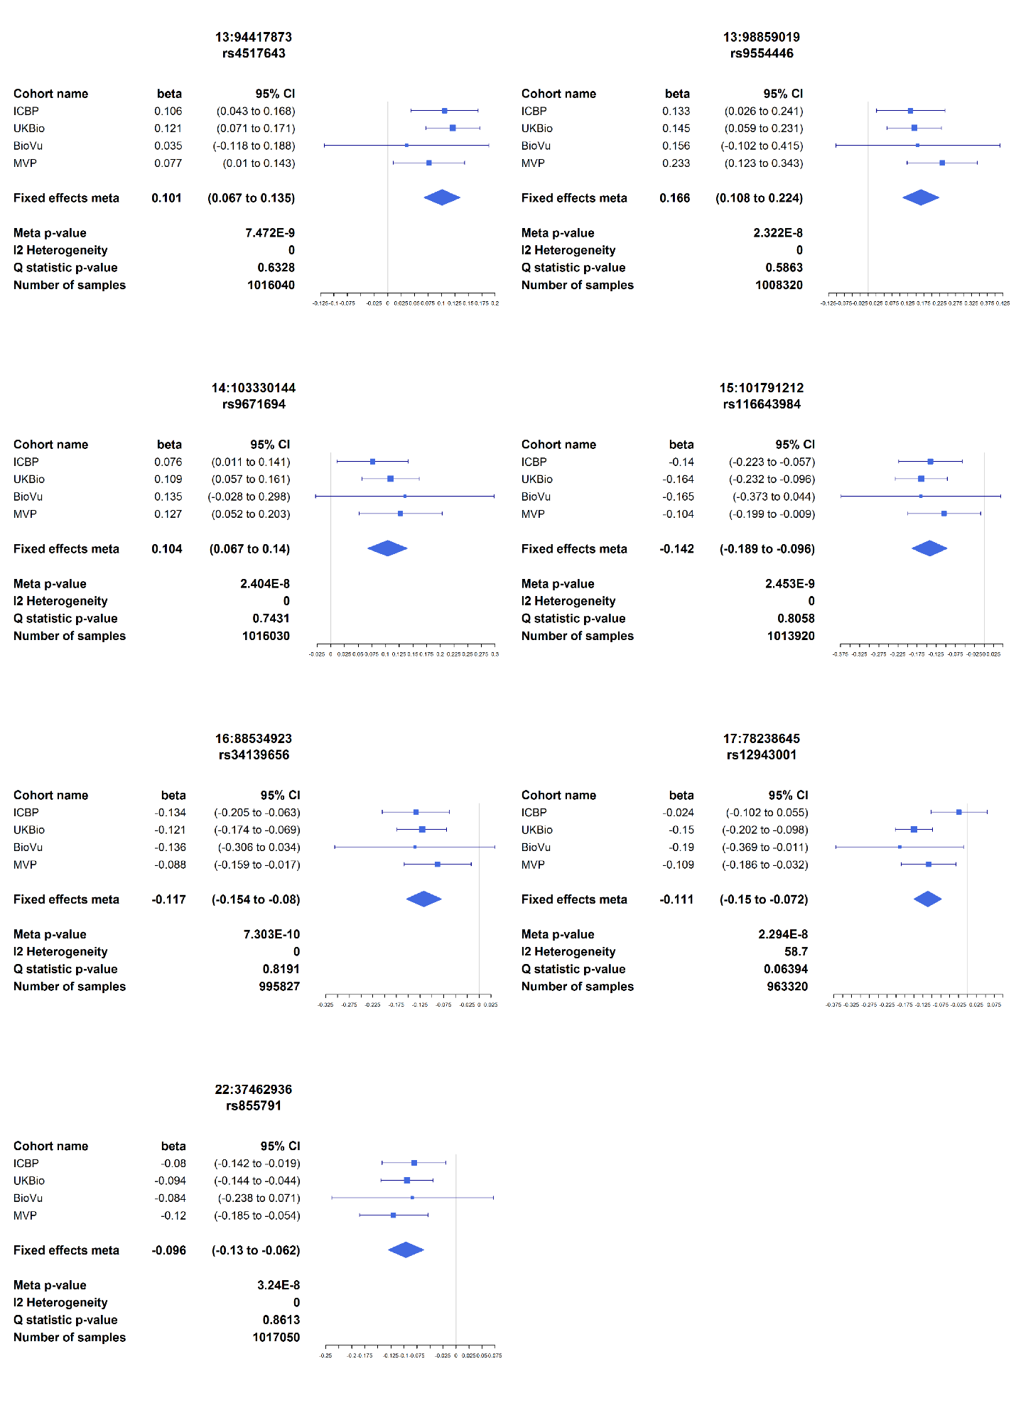
Supplementary Figure 12a-c. Forest plots for all novel loci for systolic (a), diastolic (b), and pulse pressure (c)
a
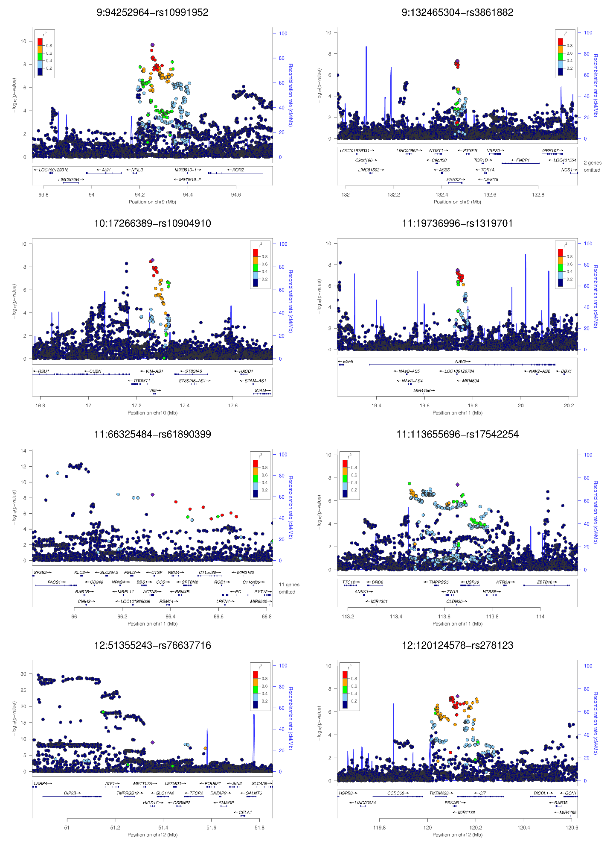
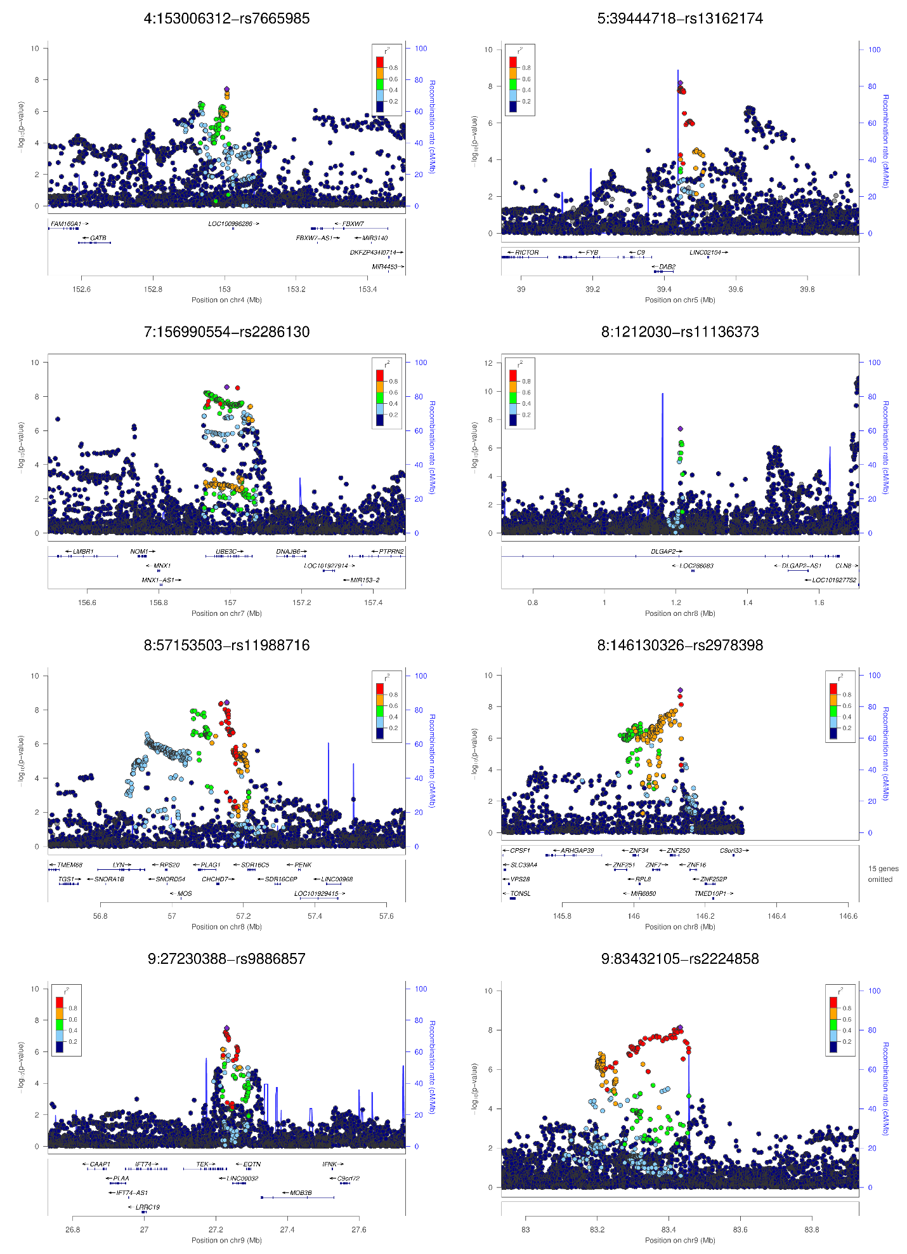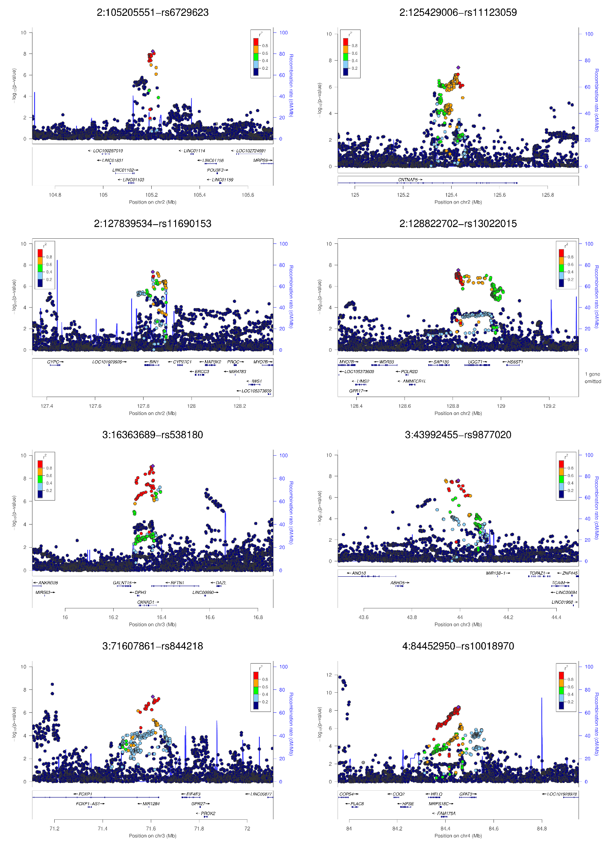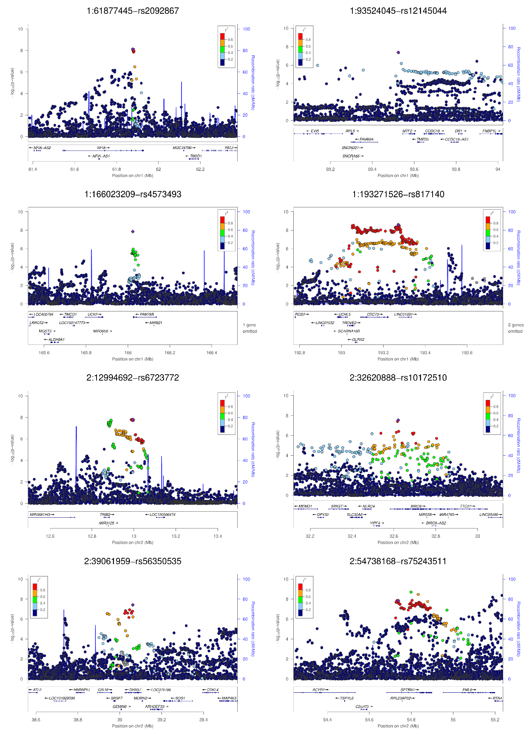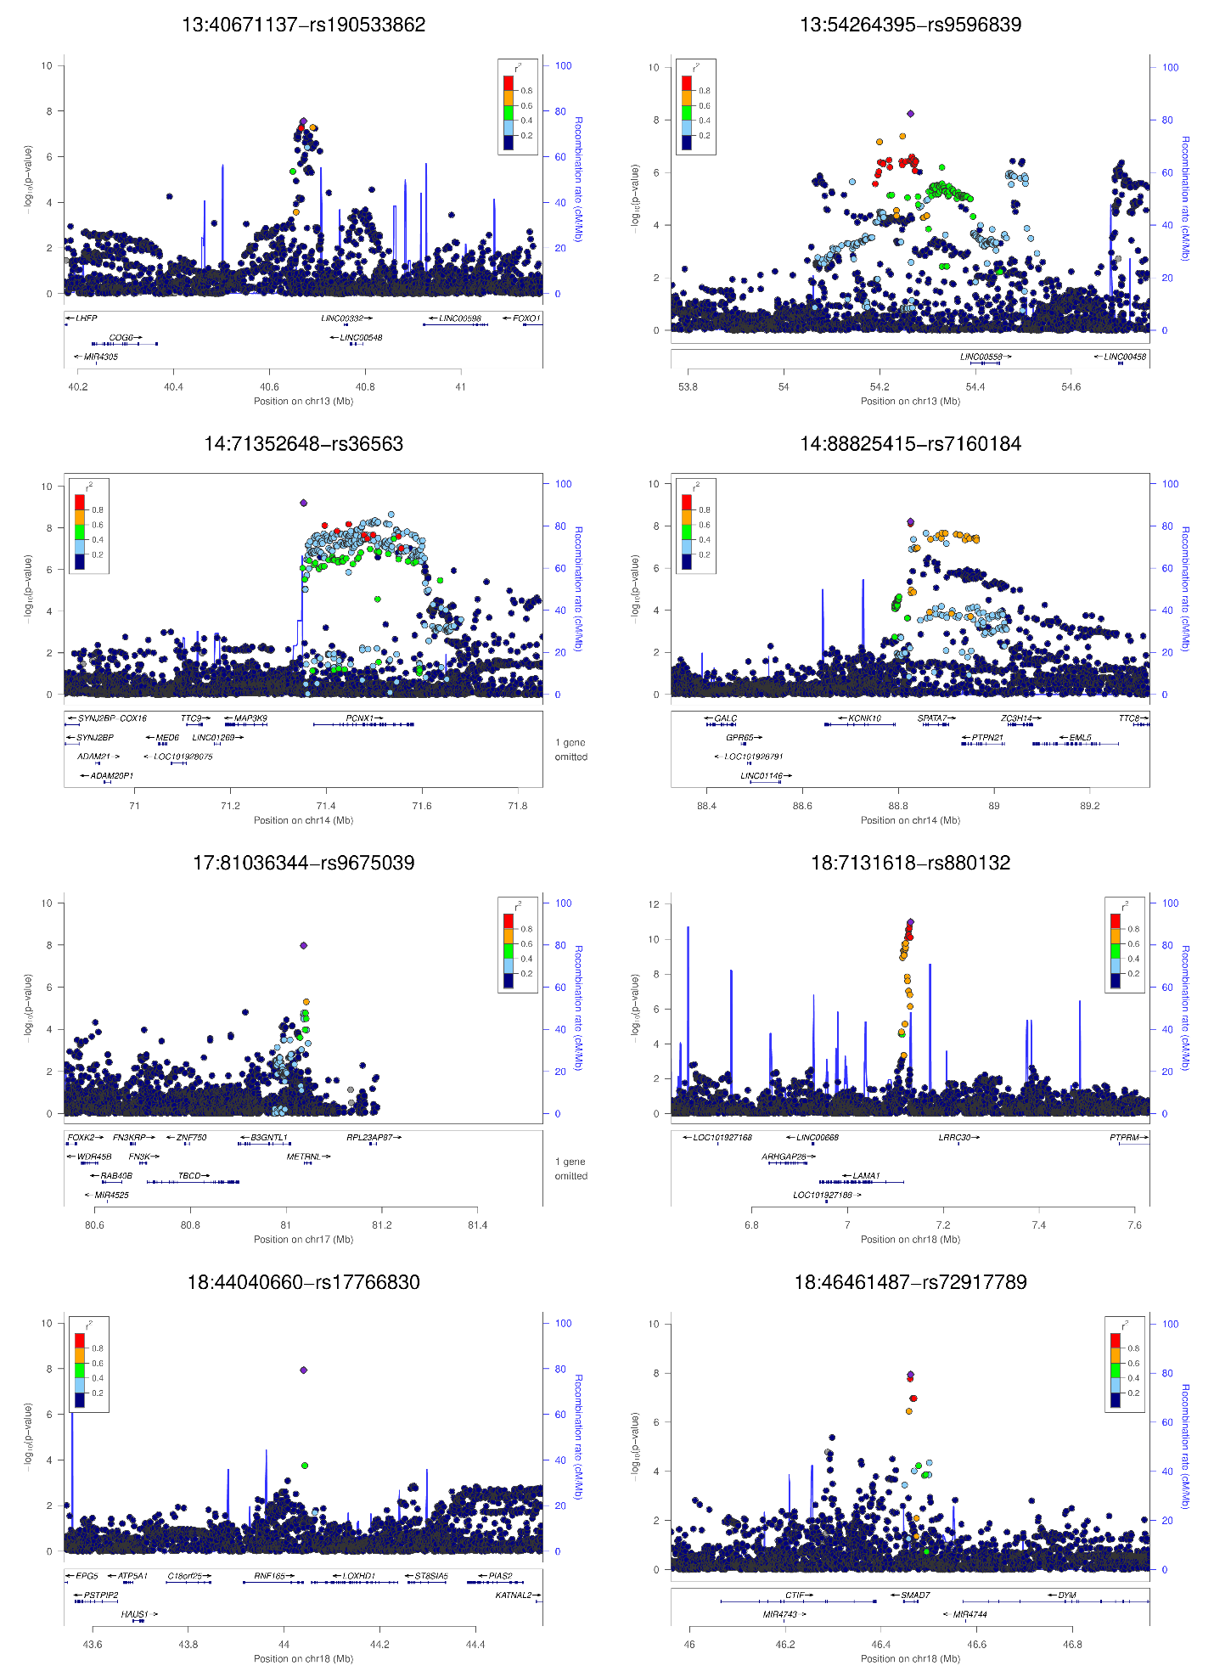
b
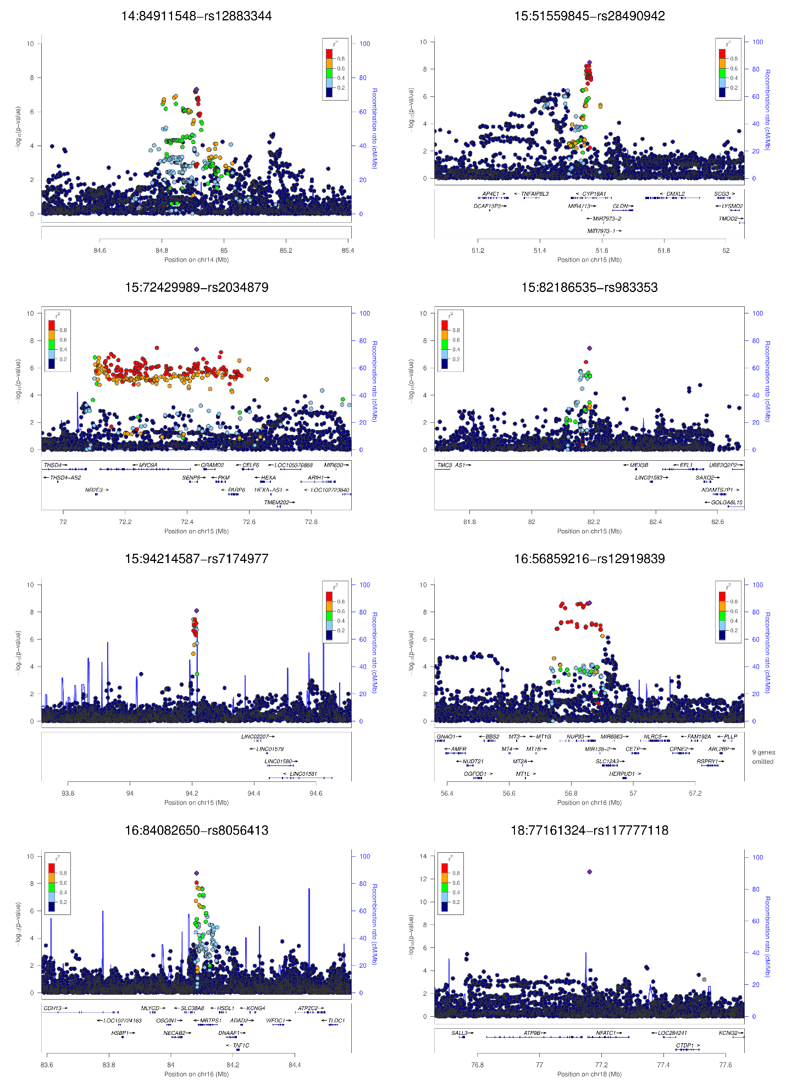
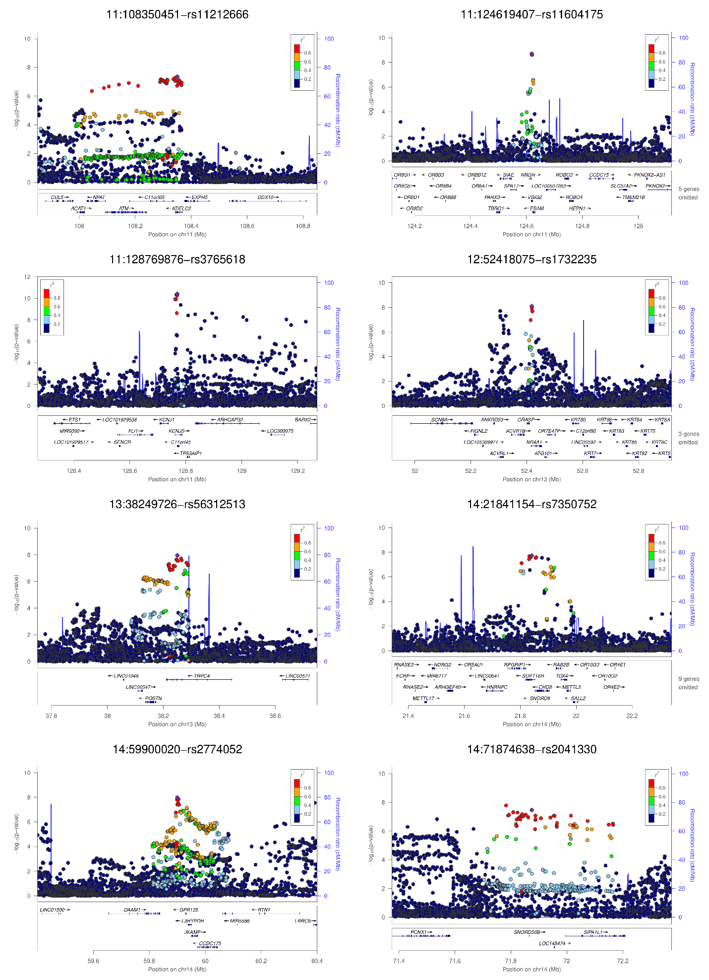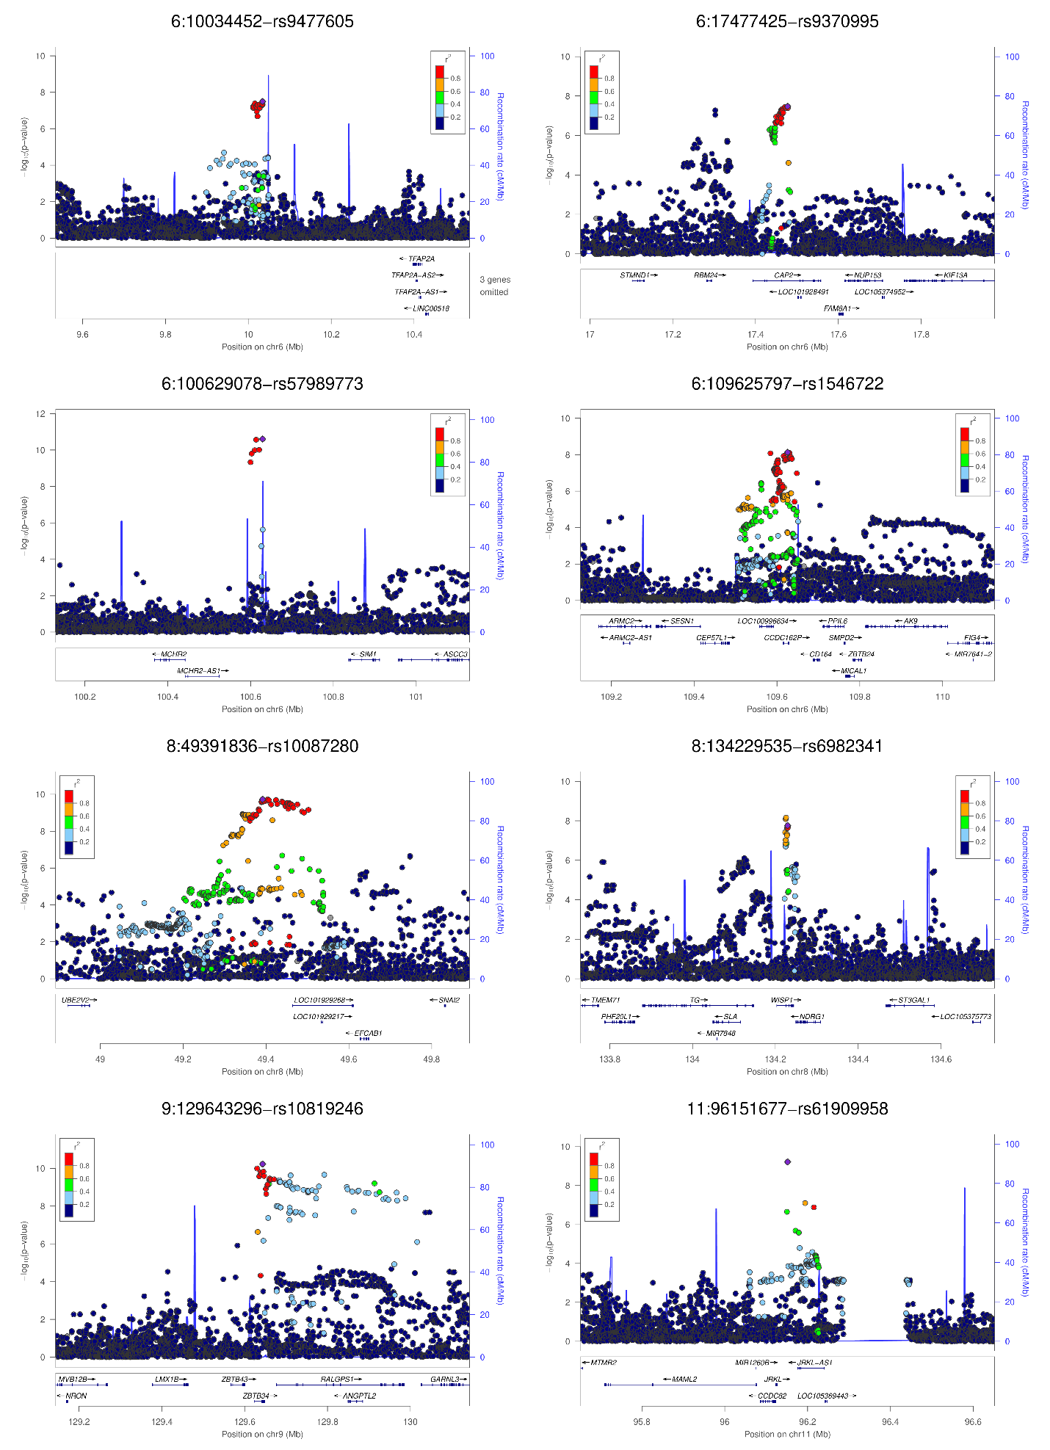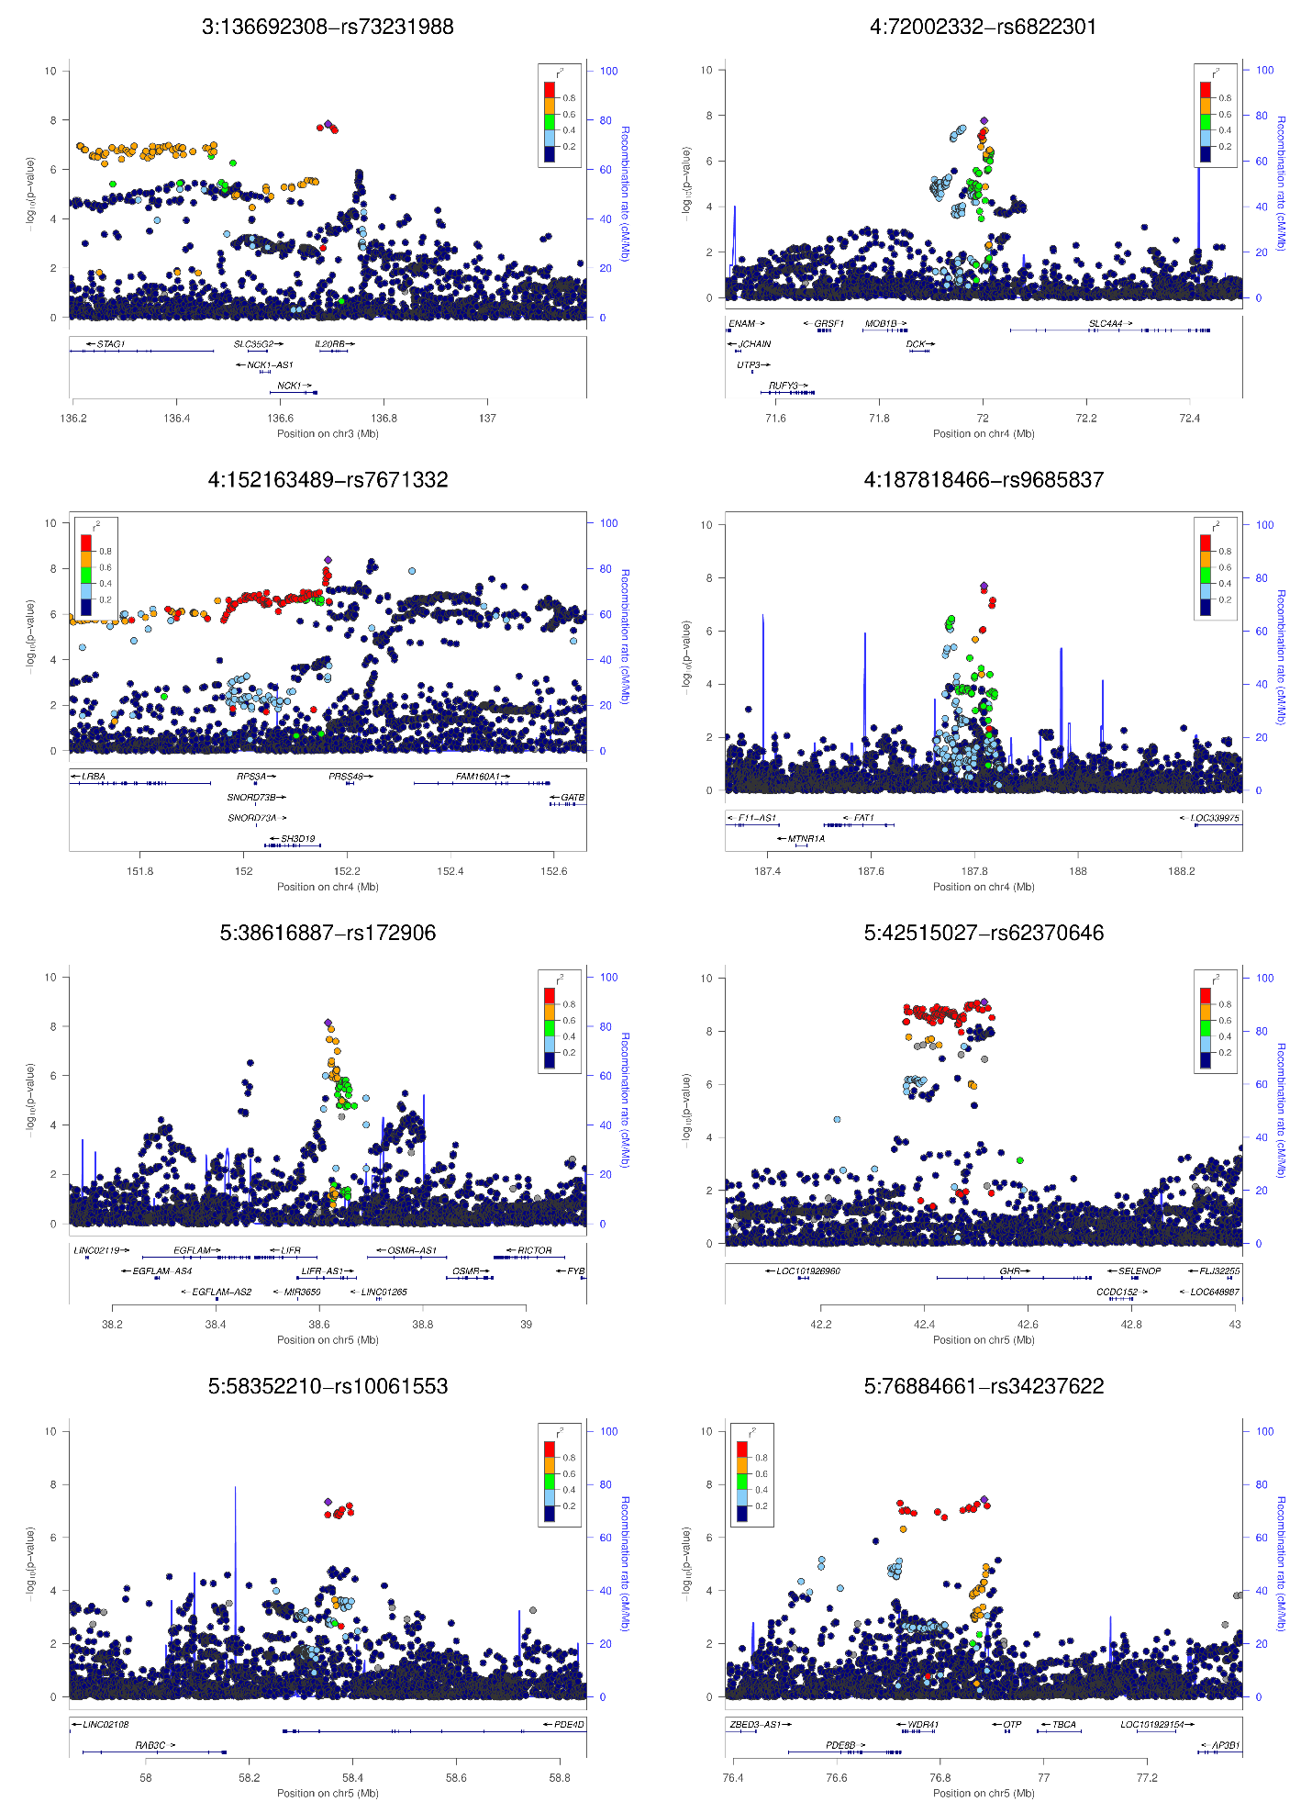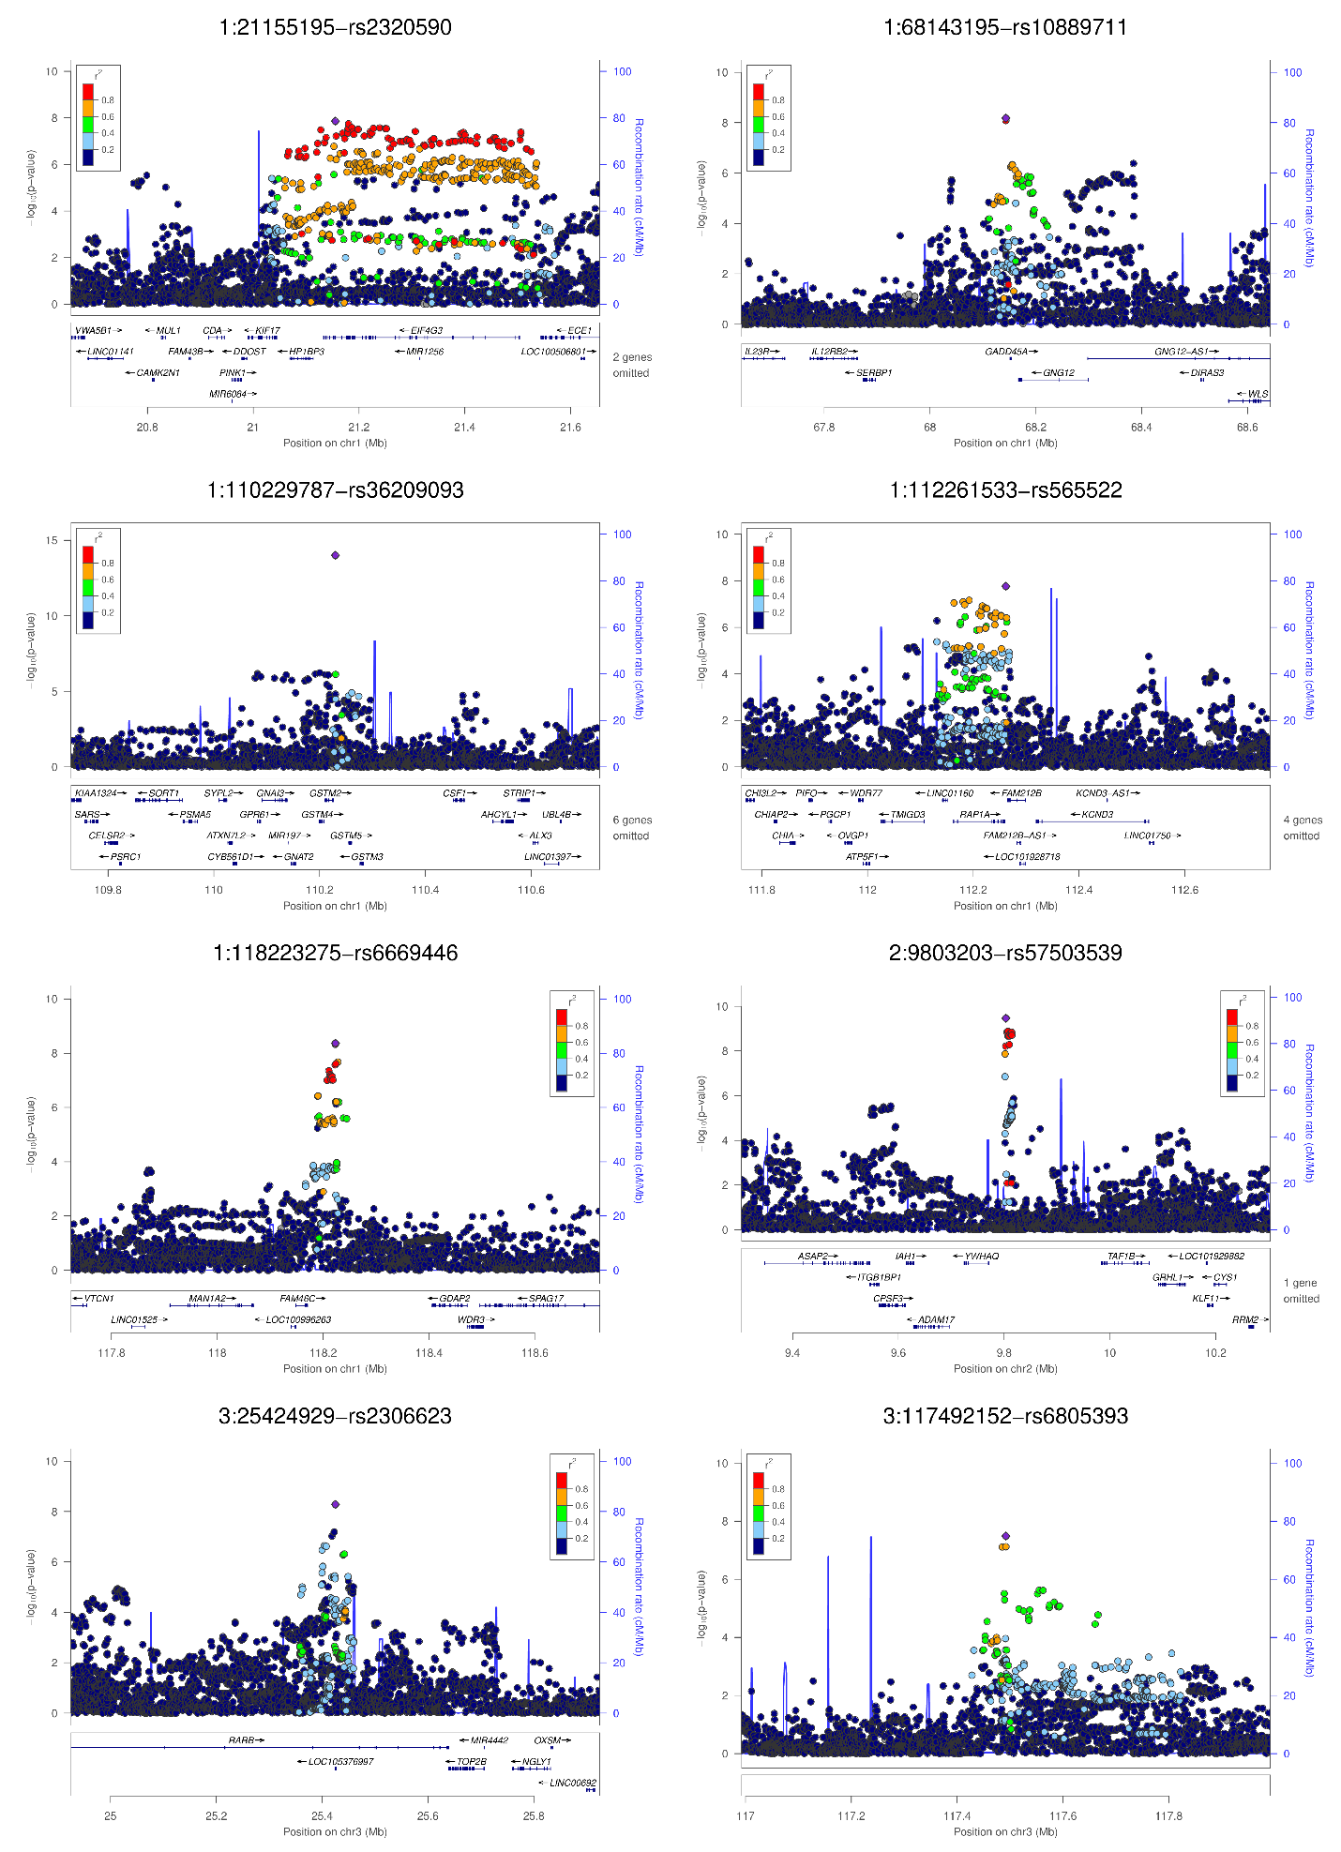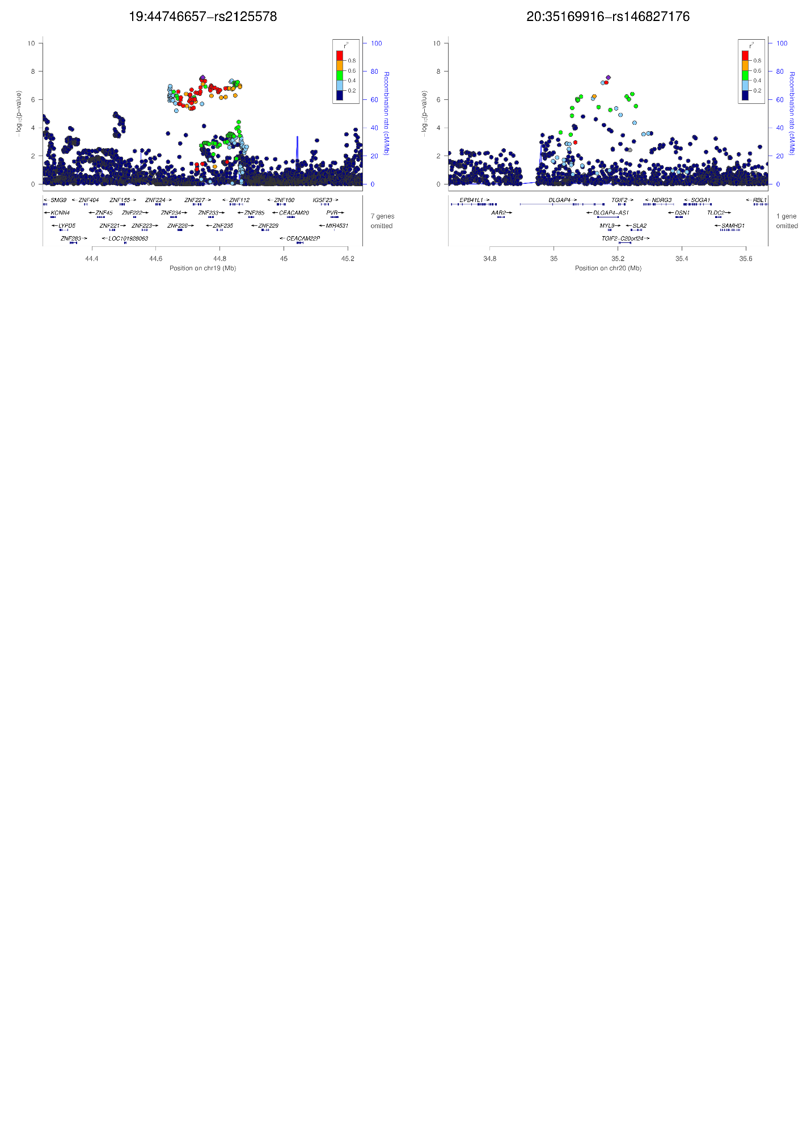
c
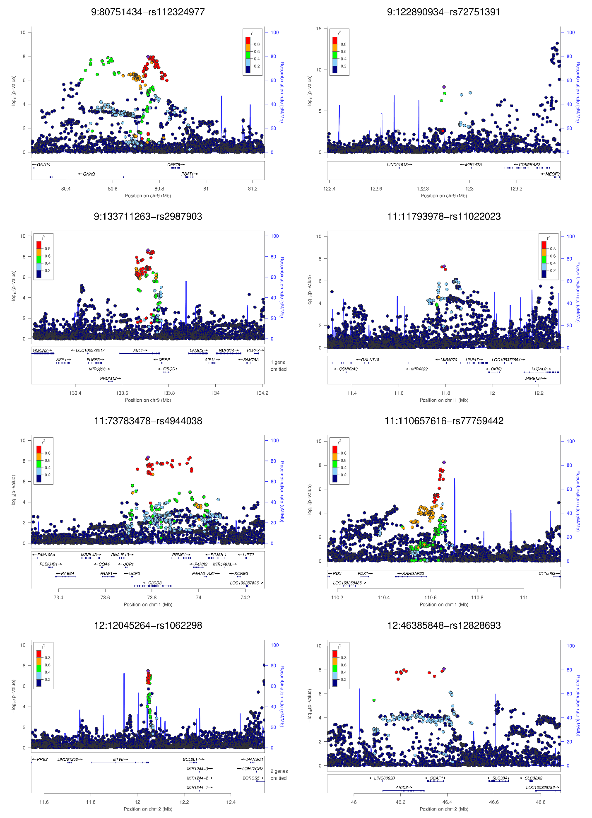
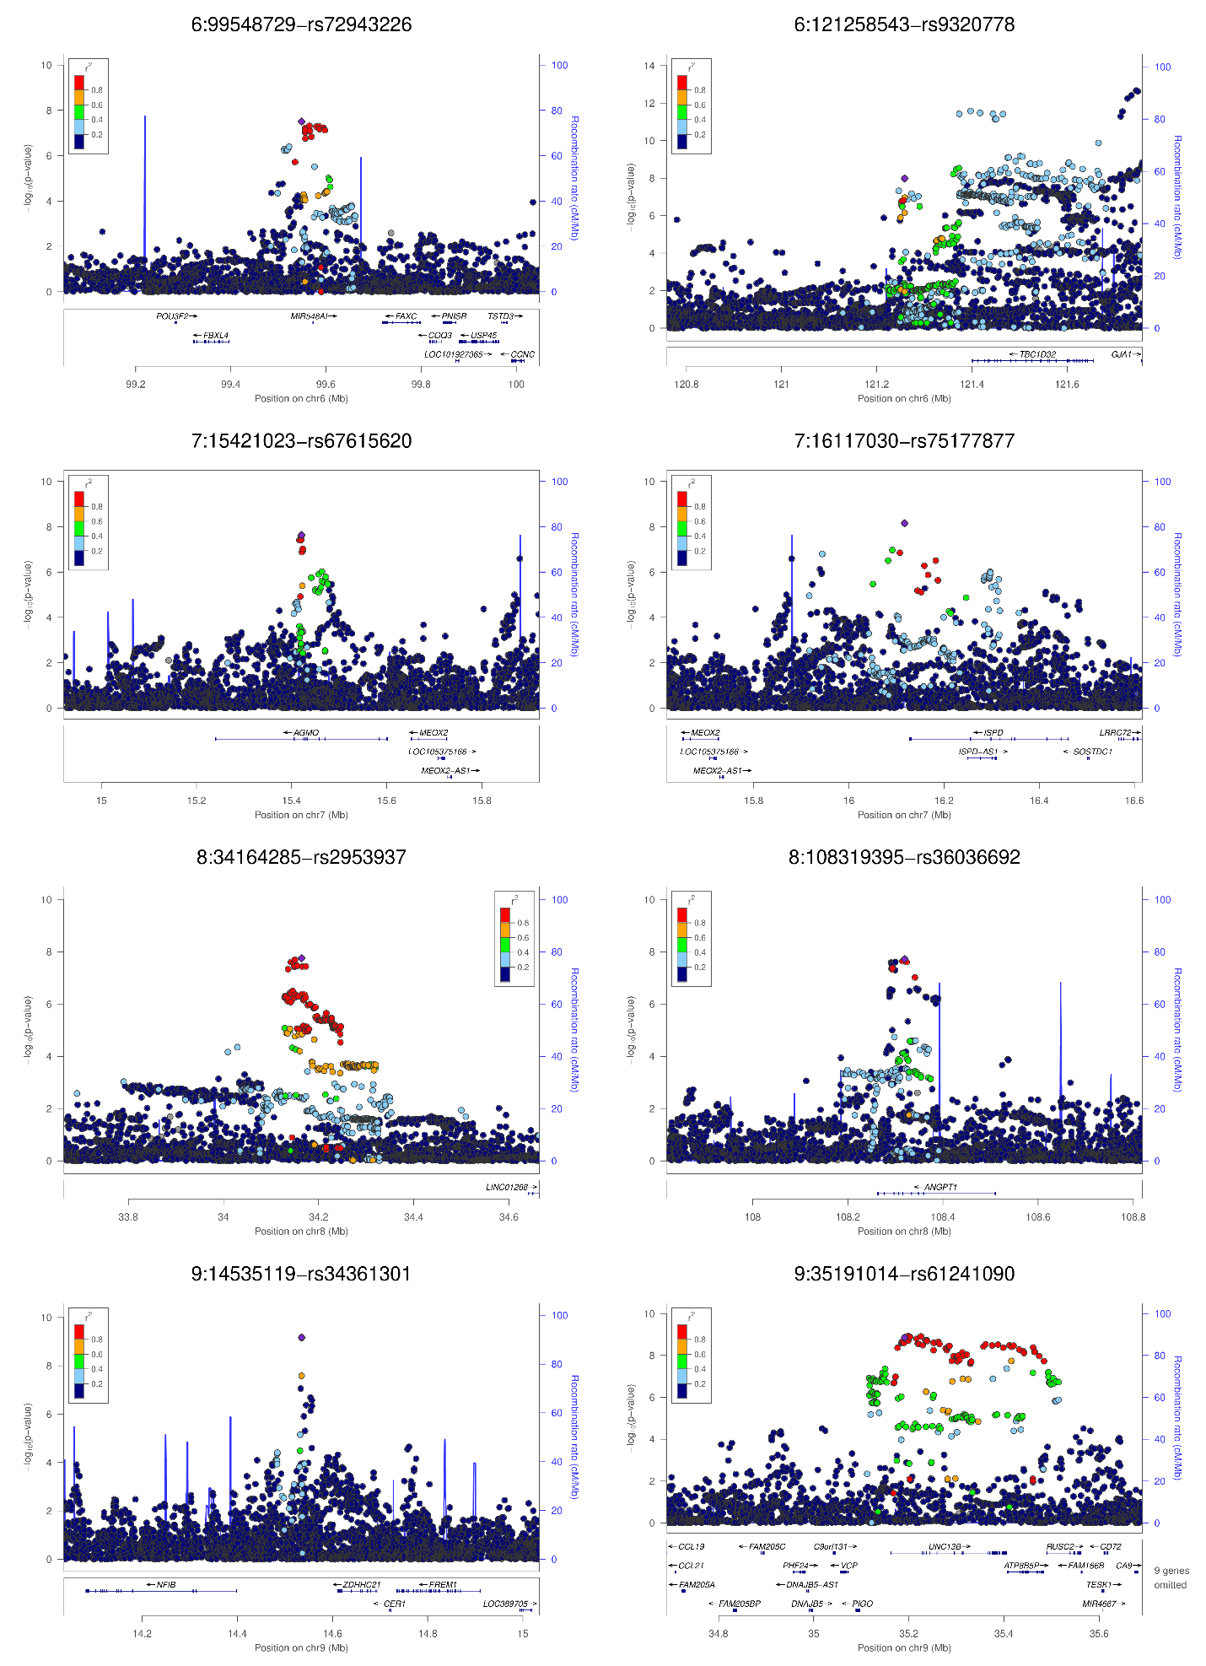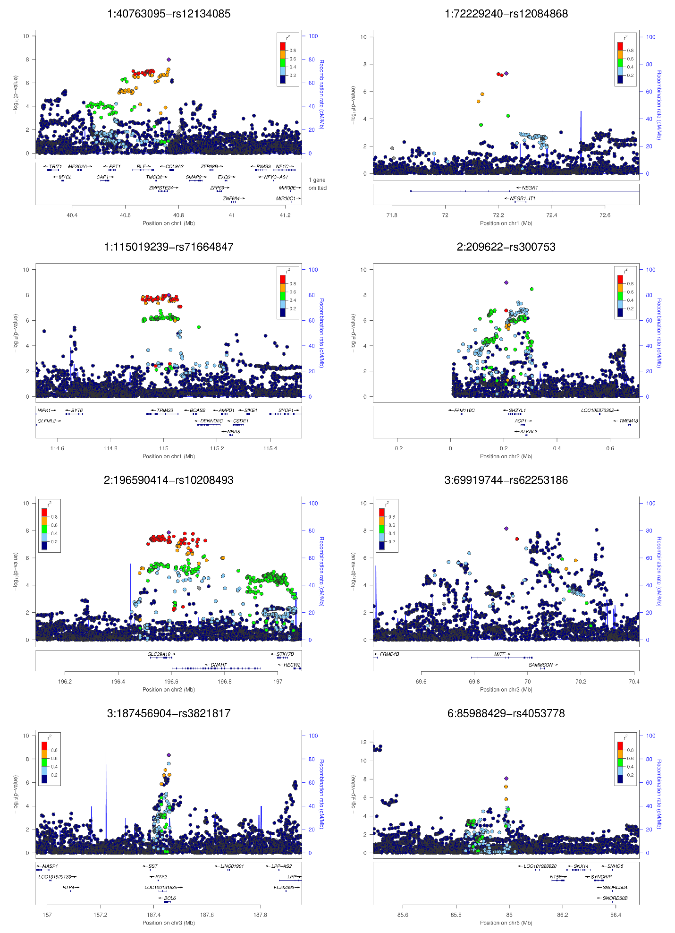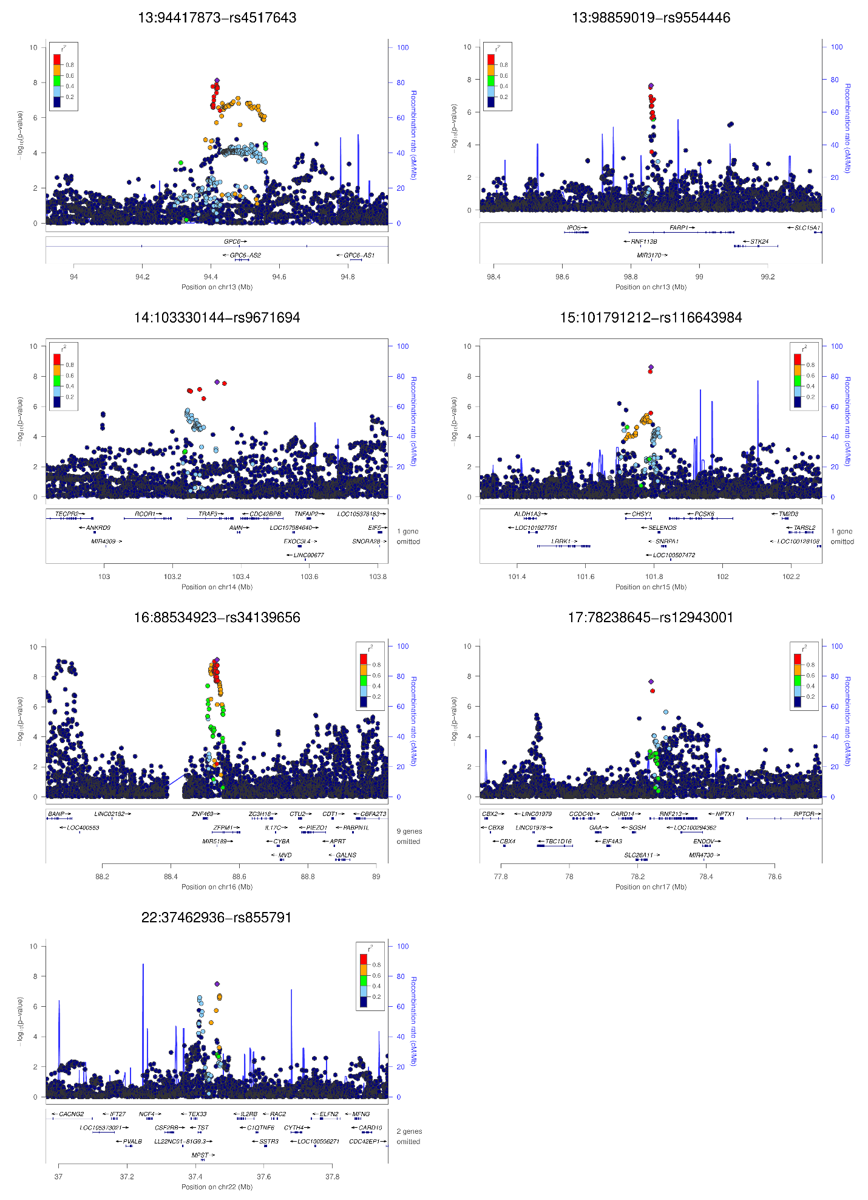
Supplementary Figure 13a-c. Locus Zoom plots for all novel loci for systolic (a), diastolic (b), and pulse pressure (c)

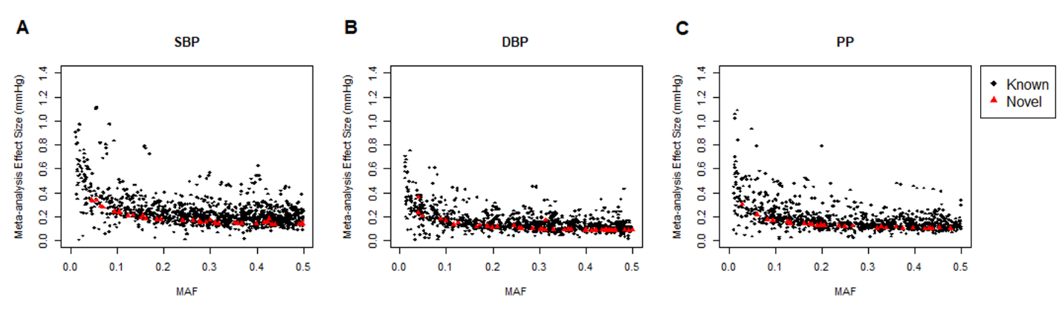
Supplementary Figure 14. Comparison of the newly discovered loci with the known loci in effect size distribution, plotting Minor Allele Frequency (MAF) on the x-axis vs GWAS effect estimate size on the y-axis, from the meta-analysis for SBP (A), DBP (B), PP (C).

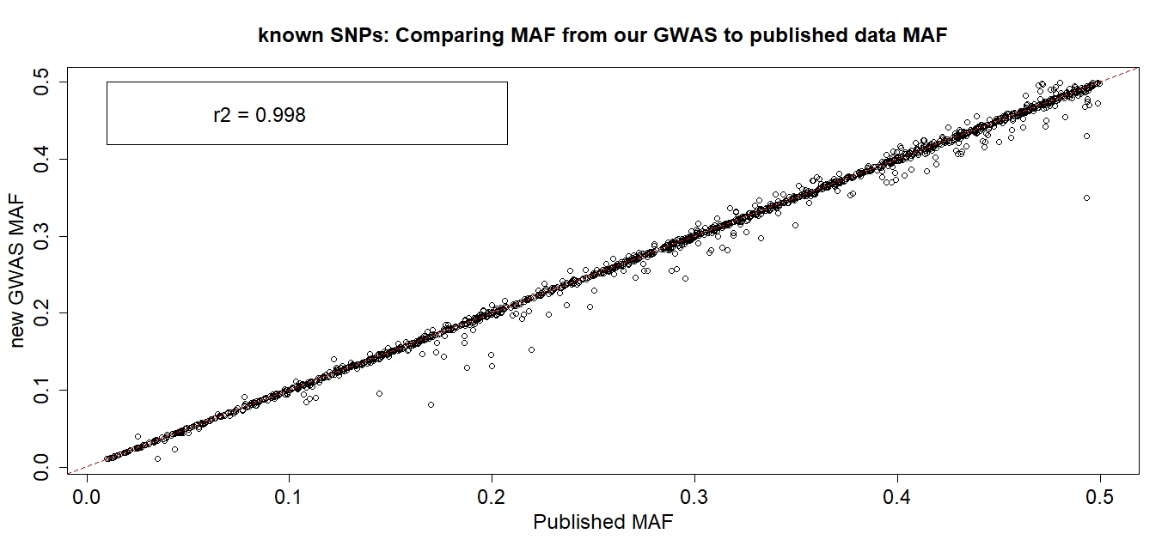
Supplementary Figure 15. Known SNPs: Comparing MAF from our GWAS to published data MAF. The x-axis shows the published MAF according to data taken from the publication where SNP is first reported (see PMID in Sup Table of all 3,800 known SNPs). The y-axis shows the MAF from our GWAS meta-analysis. The correlation between the published and observed MAF values is shown in the plot legend. For fair comparison, SNPs shown in this plot are restricted only to known SNPs published from main-effect primary GWAS analyses (i.e. excluding SNPs from conditional analyses, stratified or interaction analyses) in studies of predominantly European ancestry, with MAF > 1%, covered in our GWAS meta-analysis data, and with available data on both MAF and untransformed Effect Sizes on the mmHg scale reported in the original publication’s published Tables, resulting in 1,483 SNPs plotted of the total 3,800 published SNPs. MAF: Minor Allele Frequency; GWAS: Genome-Wide Association Study; r2: Pearson’s Correlation Coefficient

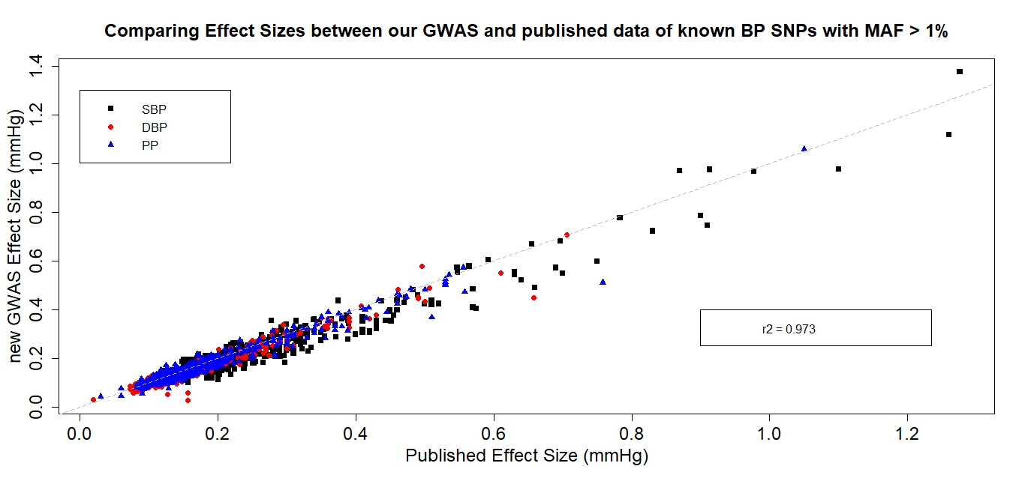
Supplementary Figure 16. Comparing Effect Sizes between our GWAS and published data of known BP SNPs. The x-axis shows the magnitude of the published effect size estimate (mmHg) according to data taken from the publication where SNP is first reported (see PMID in Sup Table of all 3,800 known SNPs). The y-axis shows the magnitude of the effect size estimate (mmHg) from our GWAS meta-analysis. Each SNP is only plotted once according to the primary, most significant BP trait that the SNP was reported for from the original publication, as indicated by the differentiating colour-coded plot shapes per BP trait, explained in the plot legend. The correlation between the published and observed effect sizes is shown in the plot legend. For fair comparison, SNPs shown in this plot are restricted only to known SNPs published from main-effect primary GWAS analyses (i.e. excluding SNPs from conditional analyses, stratified or interaction analyses) in studies of predominantly European ancestry, with MAF > 1%, covered in our GWAS meta-analysis data, and with available data on both MAF and untransformed Effect Sizes on the mmHg scale reported in the original publication’s published Tables, resulting in 1,483 SNPs plotted of the total 3,800 published SNPs. BP: blood pressure; MAF: Minor Allele Frequency; GWAS: Genome-Wide Association Study; r2: Pearson’s Correlation Coefficient

Supplementary Figure 17. Variance explained by Polygenic Risk Scores (PRSs) at different P value thresholds for SBP, DBP and PP, in the independent Lifelines cohort data.
Supplementary Figure 18. Relationship of deciles of the optimal PRSs with PP in Lifelines (n=10,210). Plot shows sex-adjusted mean PP comparing each of the upper nine PRS deciles with the lowest decile. Dotted lines represent 95% confidence intervals.

Supplementary Figure 19. Area under the ROC curve (AUROC) of the two models for HTN in Lifelines (n=10,210).

Supplementary Figure 20. Relationship of deciles of the optimal PRSs with risk of hypertension in UKB African-ancestry individuals (n=3,341). Plot shows sex-adjusted odds ratios of hypertension comparing each of the upper nine PRS deciles with the lowest decile. Dotted lines represent 95% confidence intervals.

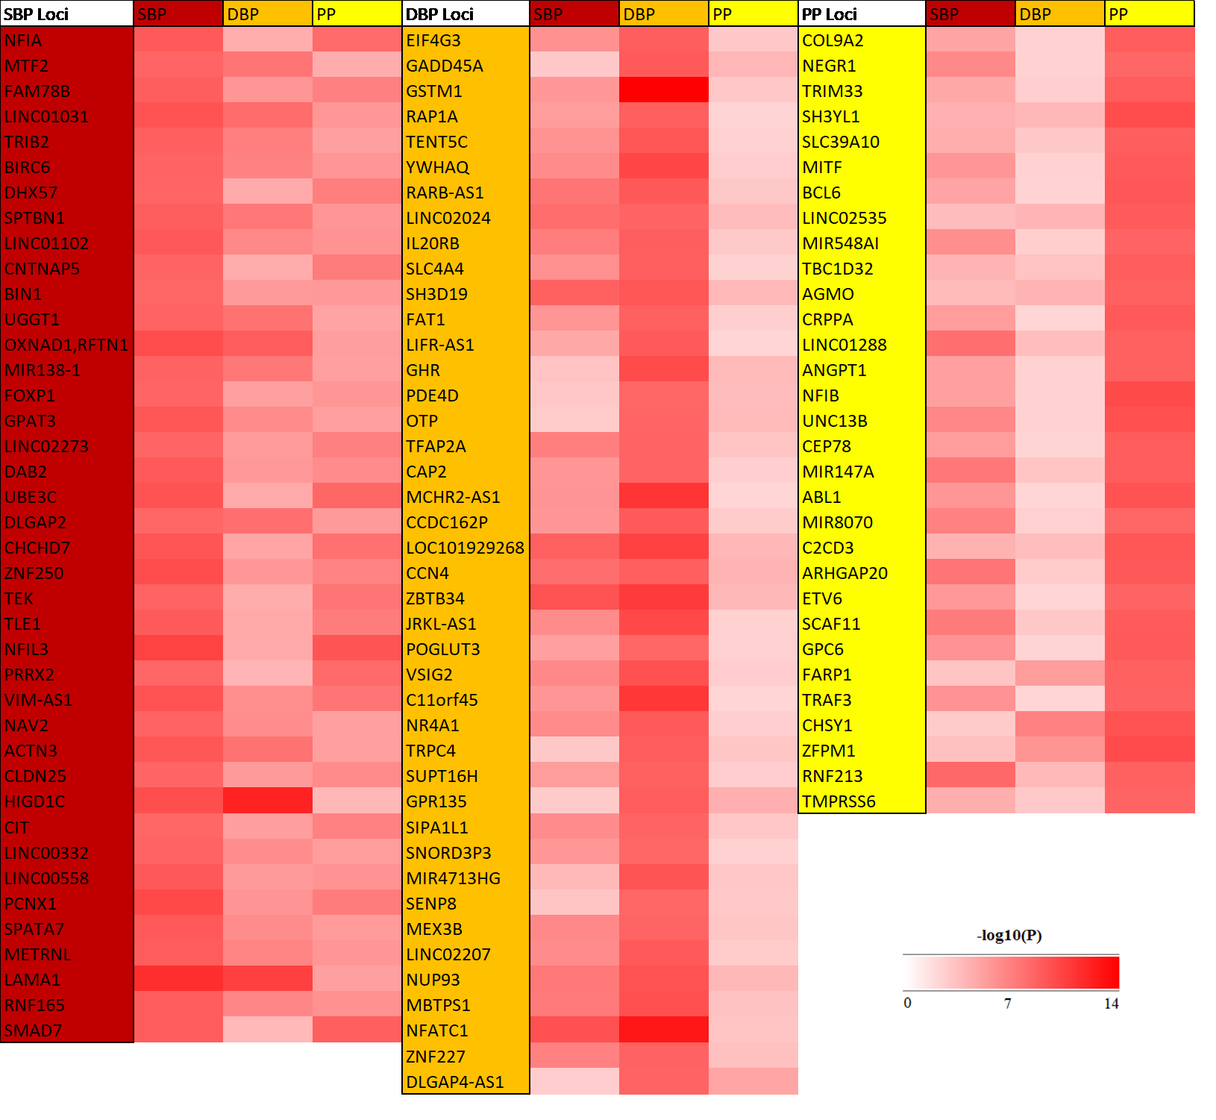
Supplementary Figure 21. Heatmap comparing significance of associations for 113 BP novel loci across the other BP traits.

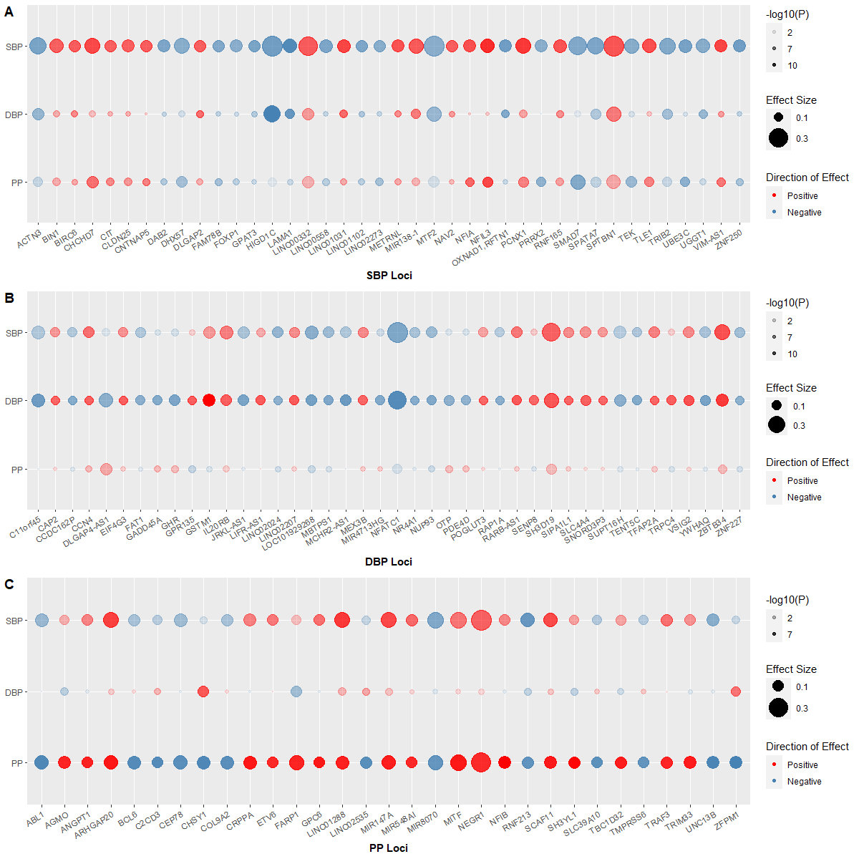
Supplementary Figure 22a-c. Bubble plots of associations for 113 BP novel loci across other BP traits.

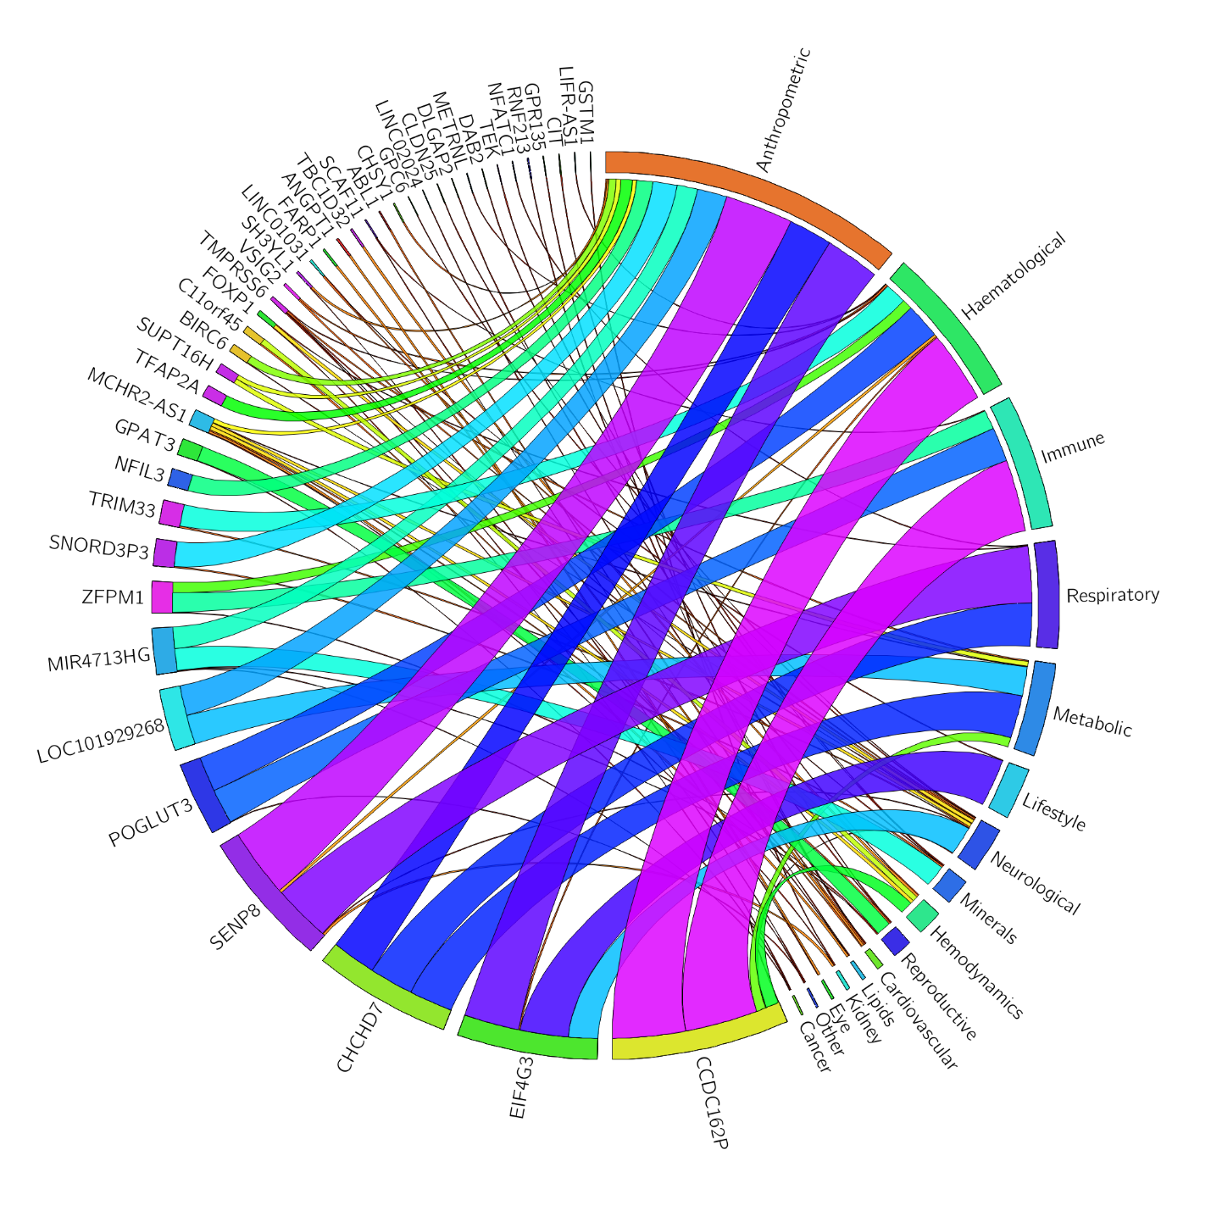
Supplementary Figure 23. Cross-trait associations for 113 BP novel loci with other disease/trait categories from lookups within GWAS Catalog and Phenoscanner. Segment size is set to the number of SNP-trait category associations.

a
b

c
Supplementary Figure 24a-c. Opposed Manhattan plots for S-PrediXcan (–log10p) and GWAS (log10p) for BP-traits for the TWAS results. Log₁₀ p-values for associations between genetically predicted gene expression analyses with BP-traits in 5 tissues are juxtaposed with –log₁₀ p-values from GWAS analyses for SBP (a); DBP (b) and PP (c).

