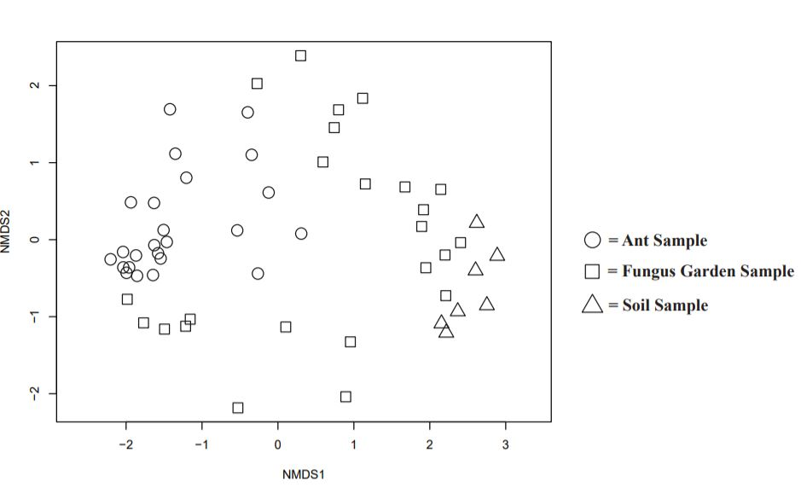
Fig. S1 Non-metric dimensional scaling (NMDS) plot depicting ant, fungus garden, and soil samples. Stress is 0.184

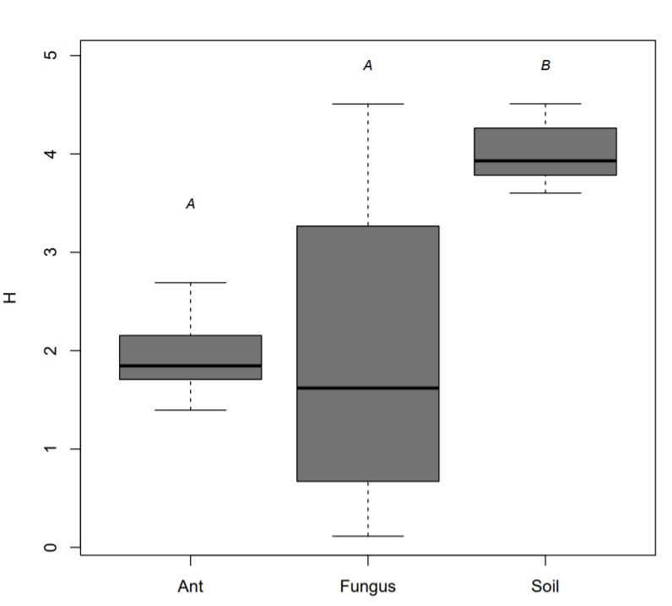
Fig. S2 Box plots of the Shannon Diversity Index (H) values for ant, fungus garden, and soil samples. Different letters (A, B) indicate significant differences between the sample type (Tukey's test, p < 0.05).

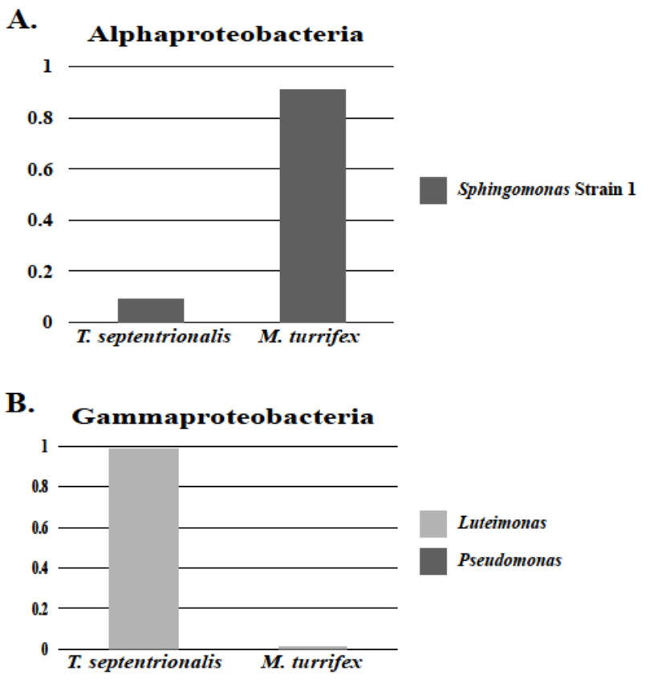
Fig. S3 Bar plots depicting the proportion of the significant OTU abundances within the (A.) Alphaproteobacteria and (B.) Gammaproteobacteria communities (identified using an indicator species analysis) of ant samples that are driving the community differences between the two ant species.

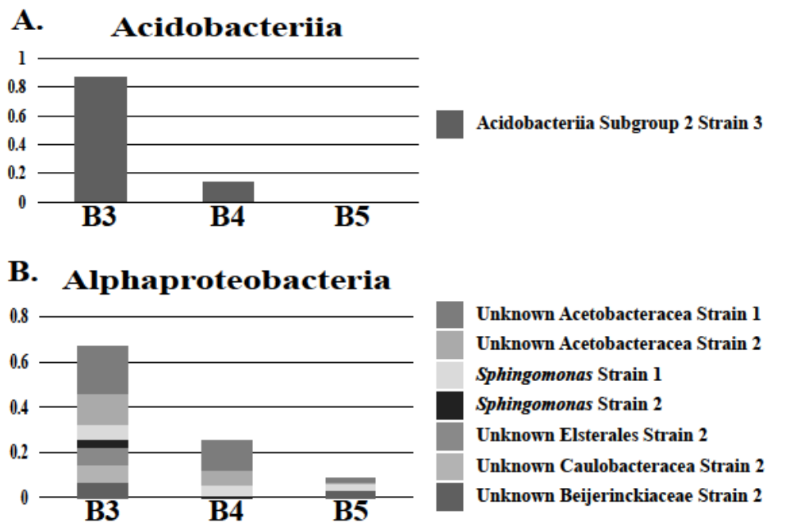

Fig. S4 Bar plots depicting the proportion of the significant OTU abundances within the (A.) Acidobacteriia and (B.) Alphaproteobacteria communities (identified using an indicator species analysis) of fungal samples that are driving the community differences between the different fungal lineages, Clade B3, B4, and B5.

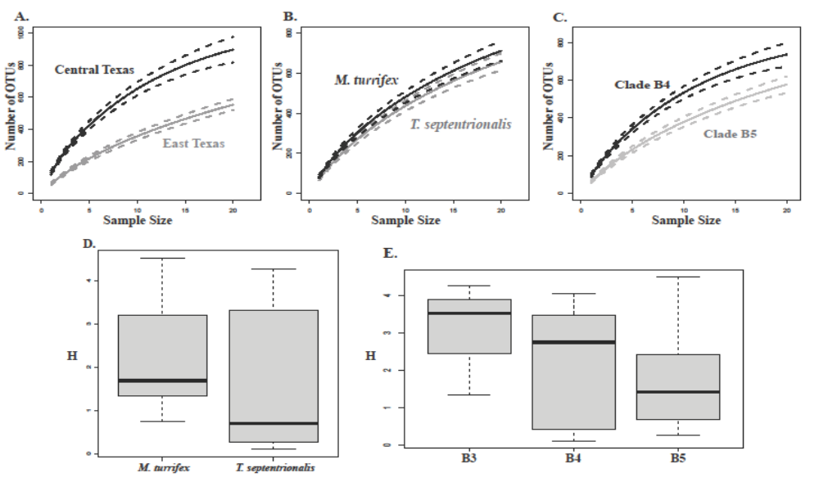
Fig. S5 Rarefaction curves were performed to illuminate any differences in predicted OTU richness between (A.) Central Texas (black) and East Texas (gray) fungal garden samples, (B.) fungal garden samples associated with M. turrifex (black) and T. septentrionalis (gray) ant hosts, and (C.) fungal garden samples genotyped as Clade B4 (black) and Clade B5 (gray). Box plots were made depicting the average Shannon’s Diversity Index (H) for (D.) fungal gardens grown by either M. turrifex (mean H = 2.268) or T. septentrionalis (mean H = 1.675) and (E.) Clade B3 (mean H = 3.056), Clade B4 (mean H = 2.191), and Clade B5 (mean H = 1.659). All figures were made with Mesoplasma assigned OTUs included.
Table S1 The OTUs with a significant (α < 0.05) indicator value for (A.) M. turrifex ant, and (B.) T. septentrionalis ant bacterial microbiomes found using the indicator species analysis (See Methods). OTUs are presented with their full taxonomic information, starting with D_0__ corresponding to the domain the OTU is from, D_1__ corresponding to the phylum the OTU is from, D_2__ corresponding to the class the OTU is from, etc.
A
OTU | Indicator Value (IV) | p-value
D_0__Bacteria.D_1__Actinobacteria.D_2__Actinobacteria.D_3__Pseudonocardiales.D_4__Pseudonocardiaceae.D_5__Amycolatopsis.Ambiguous_taxa | 0.539 | 0.0001
D_0__Bacteria.D_1__Actinobacteria.D_2__Actinobacteria.D_3__Pseudonocardiales.D_4__Pseudonocardiaceae.D_5__Pseudonocardia.__ | 0.500 | 0.0001
D_0__Bacteria.D_1__Proteobacteria.D_2__Alphaproteobacteria.D_3__Sphingomonadales.D_4__Sphingomonadaceae.__.__ | 0.457 | 0.0300
D_0__Bacteria.D_1__Actinobacteria.D_2__Actinobacteria.D_3__Propionibacteriales.D_4__Propionibacteriaceae.D_5__Cutibacterium.__ | 0.456 | 0.0274
D_0__Bacteria.D_1__Actinobacteria.D_2__Actinobacteria.D_3__Corynebacteriales.D_4__Corynebacteriaceae.D_5__Corynebacterium.Ambiguous_taxa | 0.443 | 0.0287
D_0__Bacteria.D_1__Actinobacteria.D_2__Actinobacteria.D_3__Corynebacteriales.D_4__Mycobacteriaceae.D_5__Mycobacterium.D_6__Mycobacterium.sp..ST.F2 | 0.443 | 0.0315
D_0__Bacteria.D_1__Proteobacteria.D_2__Gammaproteobacteria.D_3__Pseudomonadales.D_4__Pseudomonadaceae.D_5__Pseudomonas.__ | 0.372 | 0.0221
D_0__Bacteria.D_1__Actinobacteria.D_2__Actinobacteria.D_3__Propionibacteriales.D_4__Nocardioidaceae.D_5__Aeromicrobium.D_6__uncultured.bacterium | 0.349 | 0.0322
D_0__Bacteria.D_1__Bacteroidetes.D_2__Bacteroidia.D_3__Chitinophagales.D_4__Chitinophagaceae.D_5__Niabella.Ambiguous_taxa | 0.328 | 0.0092
D_0__Bacteria.D_1__Actinobacteria.D_2__Actinobacteria.D_3__Corynebacteriales.D_4__Mycobacteriaceae.D_5__Mycobacterium.__ | 0.314 | 0.0290
D_0__Bacteria.D_1__Actinobacteria.D_2__Actinobacteria.D_3__Corynebacteriales.D_4__Mycobacteriaceae.D_5__Mycobacterium.D_6__uncultured.bacterium | 0.292 | 0.0102

B
OTU | Indicator Value (IV) | p-value
D_0__Bacteria.D_1__Actinobacteria.D_2__Thermoleophilia.D_3__Solirubrobacterales.D_4__Solirubrobacteraceae.D_5__Solirubrobacter.D_6__uncultured.bacterium | 0.894 | 0.0001
D_0__Bacteria.D_1__Actinobacteria.D_2__Thermoleophilia.D_3__Solirubrobacterales.D_4__Solirubrobacteraceae.D_5__Solirubrobacter.__ | 0.816 | 0.0001
D_0__Bacteria.D_1__Actinobacteria.D_2__Actinobacteria.D_3__Propionibacteriales.D_4__Propionibacteriaceae.D_5__Marinilutecoccus.D_6__Ponticoccus.sp. | 0.806 | 0.0001
D_0__Bacteria.D_1__Actinobacteria.D_2__Actinobacteria.D_3__Micrococcales.D_4__Intrasporangiaceae.__.__ | 0.691 | 0.0005
D_0__Bacteria.D_1__Actinobacteria.D_2__Actinobacteria.D_3__Propionibacteriales.D_4__Propionibacteriaceae.D_5__Naumannella.Ambiguous_taxa | 0.617 | 0.0001
D_0__Bacteria.D_1__Actinobacteria.D_2__Actinobacteria.D_3__Propionibacteriales.D_4__Propionibacteriaceae.D_5__Microlunatus.__ | 0.596 | 0.0021
D_0__Bacteria.D_1__Actinobacteria.D_2__Actinobacteria.D_3__Propionibacteriales.D_4__Nocardioidaceae.D_5__Aeromicrobium.__ | 0.548 | 0.0002
D_0__Bacteria.D_1__Proteobacteria.D_2__Gammaproteobacteria.D_3__Xanthomonadales.D_4__Xanthomonadaceae.D_5__Luteimonas.D_6__uncultured.gamma.proteobacterium | 0.477 | 0.0131
D_0__Bacteria.D_1__Actinobacteria.D_2__Actinobacteria.D_3__Micrococcales.__.__.__ | 0.379 | 0.0397
D_0__Bacteria.D_1__Actinobacteria.D_2__Actinobacteria.D_3__Micrococcales.D_4__Microbacteriaceae.D_5__Agrococcus.Ambiguous_taxa | 0.358 | 0.0368
D_0__Bacteria.__.__.__.__.__.__ | 0.309 | 0.0030

Table S2 The OTUs with a significant (α < 0.05) indicator value for (A.) East Texas fungus garden, and (B.) Central Texas fungus garden bacterial microbiomes using the indicator species analysis (See Methods). OTUs are presented with their full taxonomic information, starting with D_0__ corresponding to the domain the OTU is from, D_1__ corresponding to the phylum the OTU is from, D_2__ corresponding to the class the OTU is from, etc.
A
OTU | Indicator Value (IV) | p-value
D_0__Bacteria.D_1__Actinobacteria.D_2__Actinobacteria.D_3__Propionibacteriales.D_4__Propionibacteriaceae.D_5__Naumannella.Ambiguous_taxa | 0.554 | 0.0119
D_0__Bacteria.D_1__Actinobacteria.D_2__Actinobacteria.D_3__Micrococcales.D_4__Intrasporangiaceae.__.__ | 0.517 | 0.0239

B
OTU | Indicator Value (IV) | p-value
D_0__Bacteria.D_1__Proteobacteria.D_2__Gammaproteobacteria.D_3__Pseudomonadales.D_4__Moraxellaceae.D_5__Enhydrobacter.__ | 0.610 | 0.0028
D_0__Bacteria.D_1__Actinobacteria.D_2__Actinobacteria.D_3__Corynebacteriales.D_4__Corynebacteriaceae.D_5__Corynebacterium.Ambiguous_taxa | 0.588 | 0.0073
D_0__Bacteria.D_1__Acidobacteria.D_2__Acidobacteriia.D_3__Subgroup.2.Ambiguous_taxa.Ambiguous_taxa.Ambiguous_taxa | 0.575 | 0.0026
D_0__Bacteria.D_1__Patescibacteria.D_2__Saccharimonadia.D_3__Saccharimonadales.__.__.__ | 0.556 | 0.0035
D_0__Bacteria.D_1__Verrucomicrobia.D_2__Verrucomicrobiae.D_3__Opitutales.D_4__Opitutaceae.__.__ | 0.547 | 0.0033
D_0__Bacteria.D_1__Proteobacteria.D_2__Alphaproteobacteria.D_3__Acetobacterales.D_4__Acetobacteraceae.D_5__uncultured.__ | 0.540 | 0.0010
D_0__Bacteria.D_1__Proteobacteria.D_2__Gammaproteobacteria.D_3__Betaproteobacteriales.D_4__Burkholderiaceae.D_5__Burkholderia.Caballeronia.Paraburkholderia.Ambiguous_taxa | 0.532 | 0.0029
D_0__Bacteria.D_1__Proteobacteria.D_2__Alphaproteobacteria.D_3__Acetobacterales.D_4__Acetobacteraceae.__.__ | 0.528 | 0.0037
D_0__Bacteria.D_1__Firmicutes.D_2__Clostridia.D_3__Clostridiales.D_4__Lachnospiraceae.D_5__Tyzzerella.3.D_6__uncultured.Clostridium.sp. | 0.527 | 0.0004
D_0__Bacteria.D_1__Proteobacteria.D_2__Alphaproteobacteria.D_3__Rhizobiales.D_4__Xanthobacteraceae.__.__ | 0.517 | 0.0152
D_0__Bacteria.D_1__Proteobacteria.D_2__Deltaproteobacteria.D_3__Bdellovibrionales.D_4__Bdellovibrionaceae.D_5__Bdellovibrio.D_6__uncultured.bacterium | 0.500 | 0.0198
D_0__Bacteria.D_1__Planctomycetes.D_2__Phycisphaerae.D_3__Tepidisphaerales.D_4__WD2101.soil.group.D_5__uncultured.bacterium.D_6__uncultured.bacterium | 0.498 | 0.0031
D_0__Bacteria.D_1__Bacteroidetes.D_2__Bacteroidia.D_3__Flavobacteriales.D_4__Weeksellaceae.D_5__Cloacibacterium.D_6__uncultured.bacterium | 0.496 | 0.0233
D_0__Bacteria.D_1__Proteobacteria.D_2__Alphaproteobacteria.D_3__Micropepsales.D_4__Micropepsaceae.D_5__uncultured.__ | 0.490 | 0.0026
D_0__Bacteria.D_1__Proteobacteria.D_2__Gammaproteobacteria.D_3__Betaproteobacteriales.D_4__Burkholderiaceae.D_5__Burkholderia.Caballeronia.Paraburkholderia.__ | 0.487 | 0.0198
D_0__Bacteria.D_1__Proteobacteria.D_2__Deltaproteobacteria.D_3__SAR324.clade.Marine.group.B..D_4__uncultured.bacterium.D_5__uncultured.bacterium.D_6__uncultured.bacterium | 0.484 | 0.0182
D_0__Bacteria.D_1__Proteobacteria.D_2__Deltaproteobacteria.D_3__Myxococcales.D_4__Haliangiaceae.D_5__Haliangium.D_6__uncultured.Nannocystineae.bacterium | 0.482 | 0.0173
D_0__Bacteria.D_1__Planctomycetes.D_2__Planctomycetacia.D_3__Gemmatales.D_4__Gemmataceae.D_5__uncultured.__ | 0.472 | 0.0184
D_0__Bacteria.D_1__Proteobacteria.D_2__Alphaproteobacteria.D_3__Elsterales.D_4__uncultured.D_5__uncultured.bacterium.D_6__uncultured.bacterium | 0.469 | 0.0108
D_0__Bacteria.D_1__Actinobacteria.D_2__Actinobacteria.D_3__Corynebacteriales.D_4__Mycobacteriaceae.D_5__Mycobacterium.__ | 0.469 | 0.0165
D_0__Bacteria.D_1__Planctomycetes.D_2__Planctomycetacia.D_3__Pirellulales.D_4__Pirellulaceae.D_5__uncultured.__ | 0.467 | 0.0173
D_0__Bacteria.D_1__Proteobacteria.D_2__Gammaproteobacteria.D_3__Betaproteobacteriales.D_4__Burkholderiaceae.D_5__uncultured.D_6__Ideonella.sp. | 0.461 | 0.0172
D_0__Bacteria.D_1__Bacteroidetes.D_2__Bacteroidia.D_3__Chitinophagales.D_4__Chitinophagaceae.D_5__uncultured.D_6__metagenome | 0.456 | 0.0097
D_0__Bacteria.D_1__Cyanobacteria.D_2__Melainabacteria.D_3__Obscuribacterales.D_4__uncultured.bacterium.D_5__uncultured.bacterium.D_6__uncultured.bacterium | 0.454 | 0.0225
D_0__Bacteria.D_1__Proteobacteria.D_2__Deltaproteobacteria.D_3__Oligoflexales.D_4__0319.6G20.D_5__uncultured.bacterium.D_6__uncultured.bacterium | 0.451 | 0.0031
D_0__Bacteria.D_1__Bacteroidetes.D_2__Bacteroidia.D_3__Sphingobacteriales.D_4__env.OPS.17.D_5__uncultured.bacterium.D_6__uncultured.bacterium | 0.444 | 0.0289
D_0__Bacteria.D_1__Verrucomicrobia.D_2__Verrucomicrobiae.D_3__Chthoniobacterales.D_4__Chthoniobacteraceae.D_5__Candidatus.Udaeobacter.__ | 0.435 | 0.0180
D_0__Bacteria.D_1__Firmicutes.D_2__Bacilli.D_3__Bacillales.D_4__Family.X.D_5__Thermicanus.Ambiguous_taxa | 0.426 | 0.0330
D_0__Bacteria.D_1__Verrucomicrobia.D_2__Verrucomicrobiae.D_3__Pedosphaerales.D_4__Pedosphaeraceae.D_5__uncultured.bacterium.D_6__uncultured.bacterium | 0.423 | 0.0101
D_0__Bacteria.D_1__WPS.2.D_2__uncultured.Firmicutes.bacterium.D_3__uncultured.Firmicutes.bacterium.D_4__uncultured.Firmicutes.bacterium.D_5__uncultured.Firmicutes.bacterium.D_6__uncultured.Firmicutes.bacterium | 0.421 | 0.0172
D_0__Bacteria.D_1__Proteobacteria.D_2__Alphaproteobacteria.D_3__Azospirillales.D_4__Inquilinaceae.D_5__Inquilinus.D_6__uncultured.eubacterium.WD278 | 0.417 | 0.0189
D_0__Bacteria.D_1__Acidobacteria.D_2__Acidobacteriia.D_3__Subgroup.2.D_4__uncultured.bacterium.D_5__uncultured.bacterium.D_6__uncultured.bacterium | 0.416 | 0.0318
D_0__Bacteria.D_1__Patescibacteria.D_2__Saccharimonadia.D_3__Saccharimonadales.D_4__uncultured.bacterium.D_5__uncultured.bacterium.D_6__uncultured.bacterium | 0.416 | 0.0031
D_0__Bacteria.D_1__Acidobacteria.D_2__Acidobacteriia.D_3__Acidobacteriales.D_4__Acidobacteriaceae..Subgroup.1..D_5__Edaphobacter.D_6__uncultured.Acidobacteria.bacterium | 0.411 | 0.0157
D_0__Bacteria.D_1__Firmicutes.__.__.__.__.__ | 0.408 | 0.0176
D_0__Bacteria.D_1__Tenericutes.D_2__Mollicutes.D_3__Entomoplasmatales.D_4__Entomoplasmataceae.D_5__Entomoplasma.Ambiguous_taxa | 0.406 | 0.0405
D_0__Bacteria.D_1__Bacteroidetes.D_2__Bacteroidia.D_3__Sphingobacteriales.D_4__Sphingobacteriaceae.D_5__Mucilaginibacter.D_6__uncultured.bacterium | 0.405 | 0.0172
D_0__Bacteria.D_1__Proteobacteria.D_2__Alphaproteobacteria.D_3__Rhodospirillales.D_4__uncultured.D_5__metagenome.D_6__metagenome | 0.404 | 0.0172
D_0__Bacteria.D_1__Bacteroidetes.D_2__Bacteroidia.D_3__Flavobacteriales.D_4__Weeksellaceae.D_5__Chryseobacterium.__ | 0.401 | 0.0271
D_0__Bacteria.D_1__Proteobacteria.D_2__Alphaproteobacteria.D_3__Rhizobiales.D_4__Beijerinckiaceae.__.__ | 0.398 | 0.0323
D_0__Bacteria.D_1__Verrucomicrobia.D_2__Verrucomicrobiae.D_3__Opitutales.D_4__Opitutaceae.D_5__Opitutus.D_6__uncultured.Opitutus.sp. | 0.393 | 0.0157
D_0__Bacteria.D_1__Acidobacteria.D_2__Acidobacteriia.D_3__Acidobacteriales.D_4__Acidobacteriaceae..Subgroup.1..D_5__Granulicella.__ | 0.381 | 0.0449
D_0__Bacteria.D_1__Bacteroidetes.D_2__Bacteroidia.D_3__Sphingobacteriales.D_4__Sphingobacteriaceae.D_5__Mucilaginibacter.__ | 0.380 | 0.0145
D_0__Bacteria.D_1__Acidobacteria.D_2__Holophagae.D_3__Subgroup.7.D_4__uncultured.Acidobacteria.bacterium.D_5__uncultured.Acidobacteria.bacterium.D_6__uncultured.Acidobacteria.bacterium | 0.357 | 0.0167
D_0__Bacteria.D_1__Proteobacteria.D_2__Alphaproteobacteria.D_3__Caulobacterales.D_4__Caulobacteraceae.D_5__uncultured.__ | 0.351 | 0.0165
D_0__Bacteria.D_1__Verrucomicrobia.D_2__Verrucomicrobiae.D_3__Chthoniobacterales.D_4__Chthoniobacteraceae.D_5__Candidatus.Udaeobacter.D_6__uncultured.Spartobacteria.bacterium | 0.347 | 0.0274
D_0__Bacteria.D_1__Actinobacteria.D_2__Actinobacteria.D_3__Propionibacteriales.D_4__Nocardioidaceae.D_5__Nocardioides.D_6__Nocardioides.baekrokdamisoli | 0.332 | 0.0337

